/* SQL Exercises. Week 3

1.For the current maximum annual wage in the company SHOW the full name of an employee, department, current position, for how long the current position is held, and total years of service in the company.USE common table expression this time

*/



/* 2.From MySQL documentation check how ABS() function works. https://dev.mysql.com/doc/refman/8.0/en/mathematical-functions.html#function_abs */

/* 3. Show all information about the employee, salary year, and the difference between salary and average salary in the company overall.

For the employee, whose salary was assigned latest from salaries that are closest to mean salary overall (doesn’t matter higher or lower). Here you need to find the average salary overall and then find the smallest difference of someone’s salary with an average salary */ **I use limit 1**

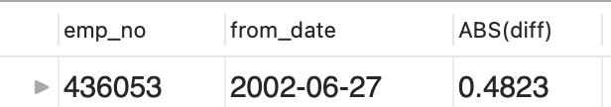

/* 4.Select the details, title, and salary of the employee with

the highest salary who is not employed in the company anymore.*/ **I use limit 1**



Або є розбіжність даних БД

/* 5.Show Full Name, salary, and year of the salary for top 5 employees that have the highest one-time raise in salary (in absolute numbers). Also, attach the top 5 employees that have the highest one-time raise in salary (in

percent). One-time rise here means the biggest difference between the two consecutive years */ **In this task use limit 5**

/* 6.Generate a sequence of square numbers till 9 (1^2, 2^2... 9^2) */

