CHAPTER 10 · THE BANKING BUSINESS | SLIDE 9
Securitization fuels the growth of subprime lending
Through securitization, banks were able to originate and distribute a growing volume of mortgage loans, including riskier subprime mortgages.
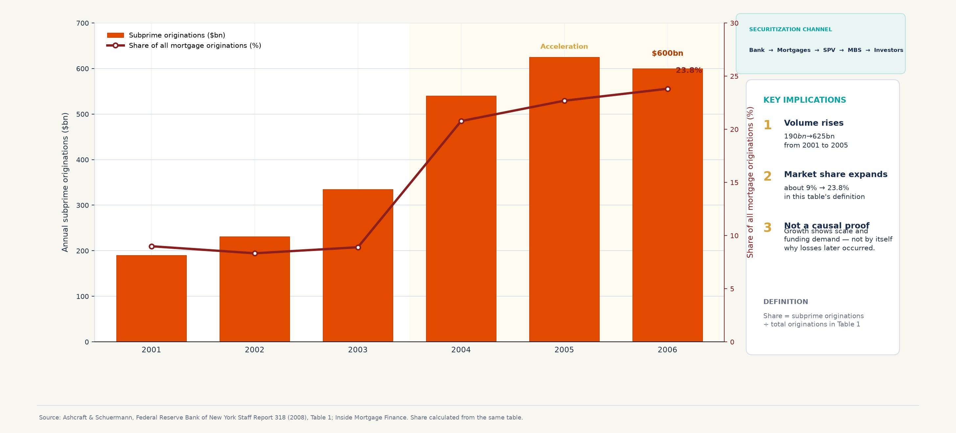
KEY TAKEAWAY  Securitization made it possible to originate, pool and distribute a much larger volume of subprime mortgages. | SPEAKER NOTE — OUTSIDE THE SLIDE  Securitization enabled banks to originate more mortgage loans by packaging and selling them to investors. As a result, subprime mortgage originations increased dramatically between 2001 and 2006.
Sources: Ashcraft & Schuermann, Federal Reserve Bank of New York Staff Report 318 (2008), Table 1; Inside Mortgage Finance. Share calculated from the same table.
Editable in Word: headings, takeaways, notes and sources can be rewritten; the chart body is an inserted image that can be replaced.

CHAPTER 10 · THE BANKING BUSINESS | SLIDE 10
Housing prices fall, mortgage losses rise
The housing downturn weakens borrower equity and refinancing capacity before mortgage losses spread through the system.
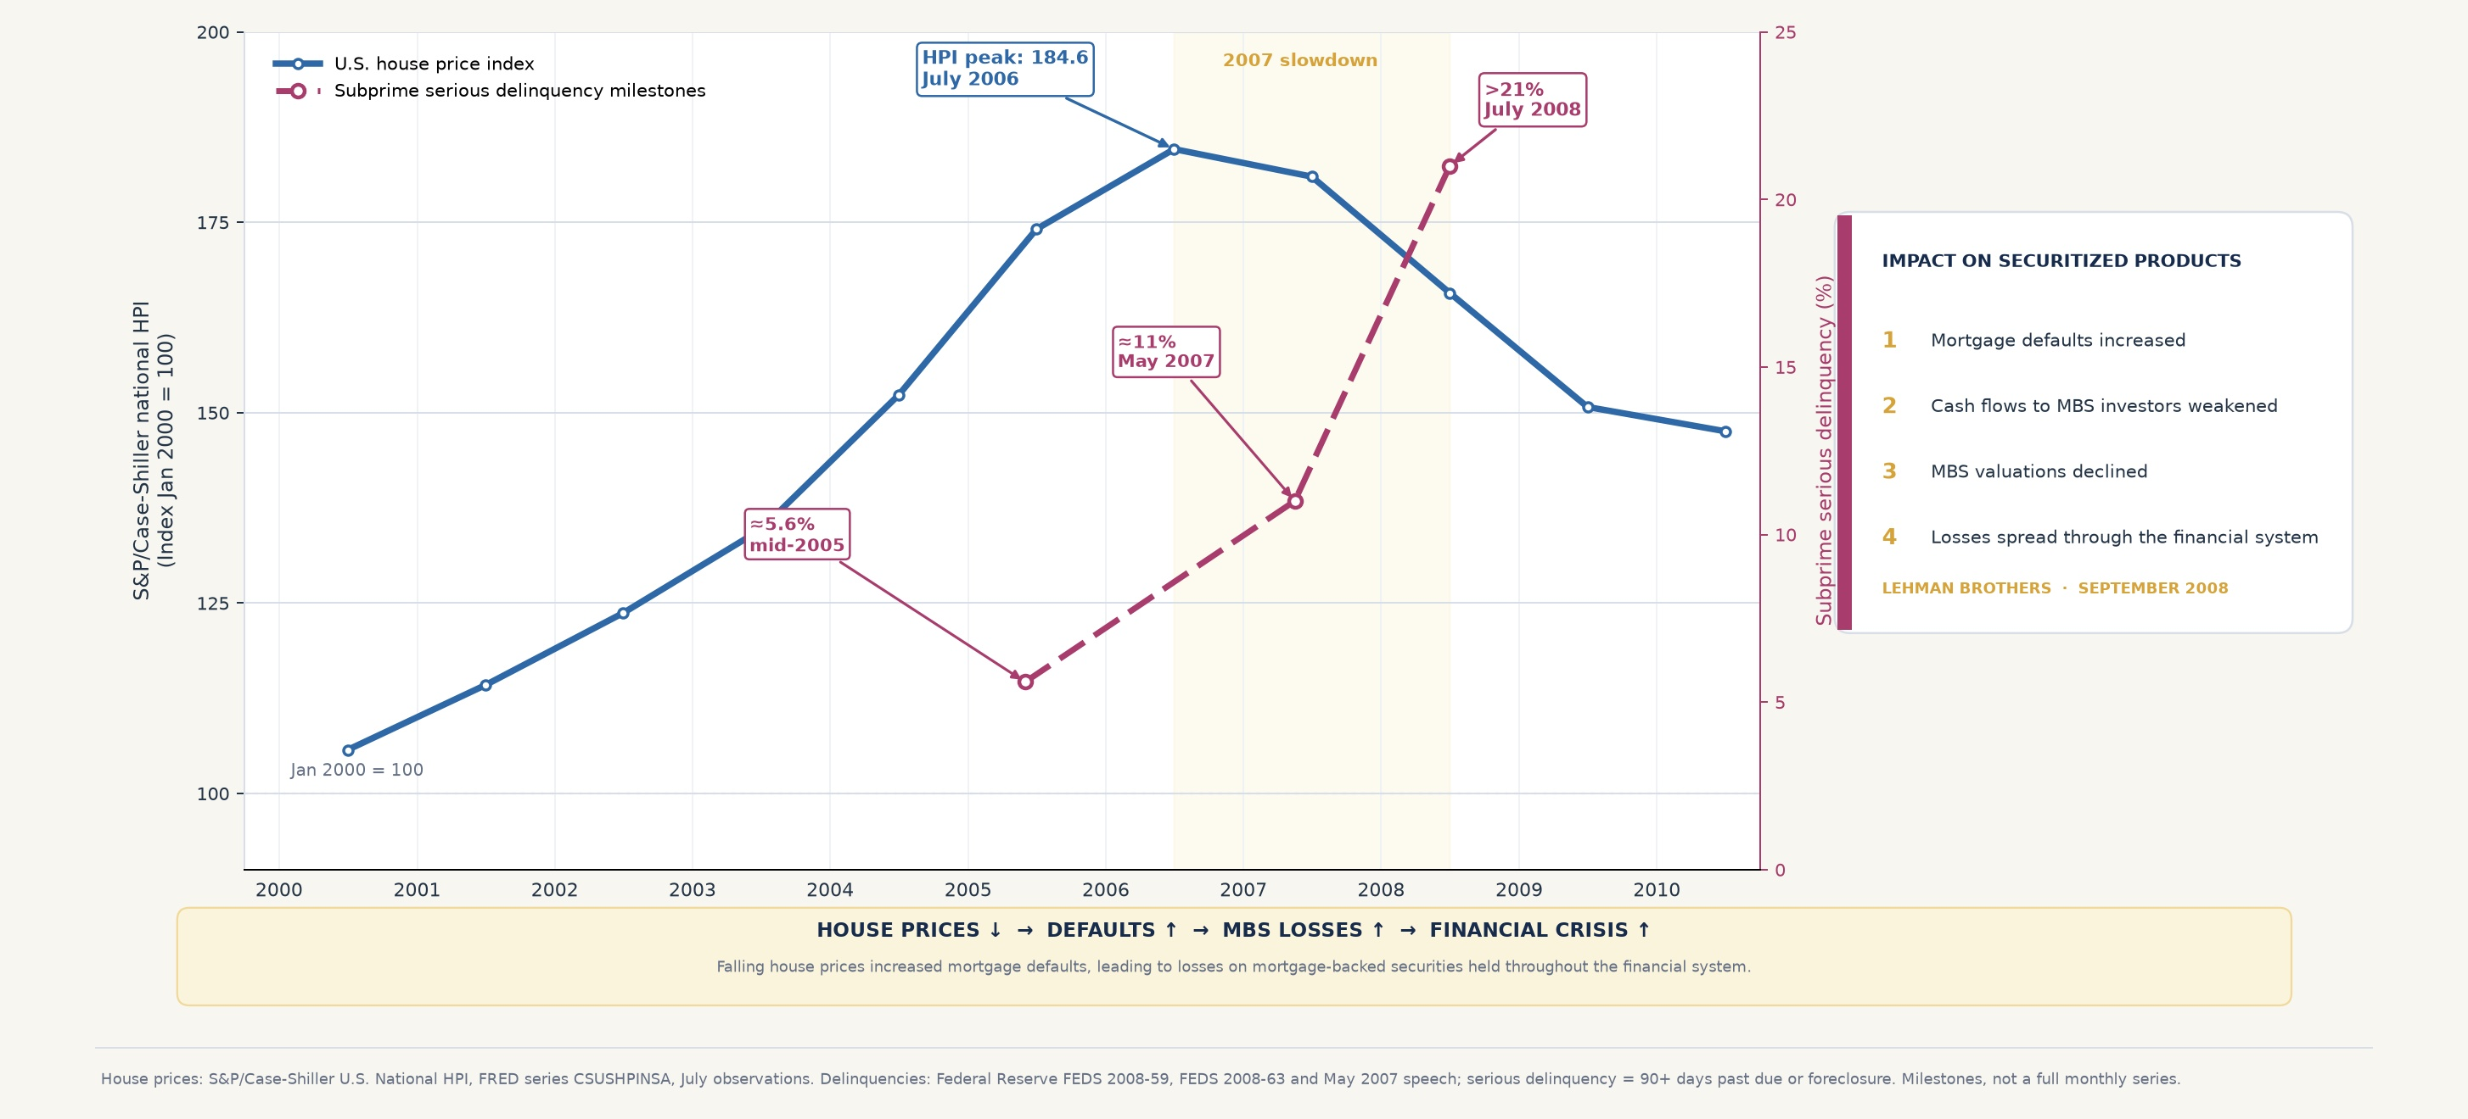
KEY TAKEAWAY  Falling house prices increased mortgage defaults, leading to losses on mortgage-backed securities (MBS) held throughout the financial system. | SPEAKER NOTE — OUTSIDE THE SLIDE  When house prices started falling after 2006, many subprime borrowers were unable to refinance or repay their mortgages. Delinquencies rose sharply, reducing the value of mortgage-backed securities and generating losses across the financial system.  Narrative bridge: subprime growth → securitization boom → mortgage exposure → housing downturn → defaults → MBS losses → financial crisis.
Sources: S&P/Case-Shiller U.S. National HPI, FRED series CSUSHPINSA; Federal Reserve FEDS 2008-59, FEDS 2008-63 and May 2007 speech; First American LoanPerformance.
Editable in Word: headings, takeaways, notes and sources can be rewritten; the chart body is an inserted image that can be replaced.

