BNP Paribas: Balance Sheet Size and Business Lines (FY2025)

Introduction
BNP Paribas closed 2025 with €2,793 billion of total assets, making it one of the largest banks in Europe and a textbook example of a universal bank. This analysis answers three questions: how big is the bank, measured by total assets on its balance sheet; what are its business lines and the weight of each; and how international its activities are.
Bank selected: BNP Paribas SA, the French group headquartered in Paris, listed on Euronext Paris and present in about 64 countries.
Source: Consolidated Financial Statements, year ended 31 December 2025 (unaudited), downloaded from the investor website invest.bnpparibas. The statements are prepared under IFRS as adopted by the EU and were approved by the Board of Directors on 4 February 2026. All figures are in euros; 2024 figures are shown for comparison.
Method:
- Size. We read the consolidated balance sheet (page 6), measure total assets, their growth over one year, and what the assets and liabilities are made of. We then compute a few ratios that show what that size means (leverage, loan-to-deposit, return on assets).
- Business lines. We use Note 3 "Segment information" (pages 61–67), which splits revenues, pre-tax income and assets across the group's three operating divisions and their sub-businesses. The weight of each line is measured three ways: share of revenues, share of pre-tax income, and share of total assets.
- International activities. We use the Company Fundamentals export of 7 October 2026 (geographic and business-line segments, employees by country, foreign-currency effects) to analyse revenues, assets and staff by region over 2016–2025, together with Note 3 (p. 67) and Note 8.f (scope of consolidation).

Part 1 — Size of the bank: total assets

1.1 Total assets and growth
At 31 December 2025, BNP Paribas reports total assets of €2,792,981 million (about €2.8 trillion), up from €2,704,908 million a year earlier. That is an increase of €88.1 billion, or +3.3% in one year.
To put this figure in perspective, the balance sheet is roughly the size of France's entire annual GDP (approximately €2.9–3.0 trillion). A single private company holds assets comparable to everything the French economy produces in a year. This is why BNP Paribas is classified as a Global Systemically Important Bank (G-SIB) and is supervised directly by the European Central Bank: its failure would threaten the whole financial system.

1.2 What the assets are made of
Asset category | 31 Dec 2025 (€m) | % of total | 31 Dec 2024 (€m) | Change
Loans and advances to customers (amortised cost) | 897,358 | 32.1% | 900,141 | −0.3%
Trading book at fair value through P&L (securities, repos, derivatives) | 850,228 | 30.4% | 815,687 | +4.2%
Investments related to insurance activities | 305,471 | 10.9% | 286,849 | +6.5%
Cash and balances at central banks | 211,330 | 7.6% | 182,496 | +15.8%
Other amortised cost (loans to banks, debt securities) | 177,946 | 6.4% | 178,122 | −0.1%
Financial assets at fair value through equity | 79,360 | 2.8% | 73,040 | +8.7%
Other assets (accruals, fixed assets, goodwill, hedging, etc.) | 271,288 | 9.7% | 268,573 | +1.0%
Total assets | 2,792,981 | 100% | 2,704,908 | +3.3%
Source: Consolidated balance sheet, p. 6. Groupings and percentages are our own calculations.
Three points stand out:
- Customer loans are the largest block, but only a third of the balance sheet (32.1%). At €897 billion they were flat over the year (−0.3%). A purely commercial bank would usually have 60–70% of its assets in loans. The lower share is the first sign of a universal bank.
- The trading book is almost as large as the loan book (30.4%). Securities (€321bn), repurchase agreements (€254bn) and derivatives (€275bn) are held at fair value by the market activities of the CIB division. Derivatives alone are 9.8% of total assets. Their value fell by €48bn in 2025, while securities and repos grew by €83bn.
- Insurance investments add 10.9%. These €305bn are the assets backing the life-insurance and savings contracts of BNP Paribas Cardif. This is the bancassurance model typical of French banks.
Most of the 2025 growth came from liquidity and market activities, not from lending: cash at central banks rose by €28.8bn (+15.8%) and the trading book by €34.5bn, while customer loans slightly declined.

1.3 How the assets are financed
Liabilities and equity | 31 Dec 2025 (€m) | % of total
Deposits from customers | 1,075,564 | 38.5%
Trading liabilities at fair value through P&L (repos, derivatives, short securities, structured debt) | 838,439 | 30.0%
Liabilities related to insurance contracts and activities | 282,723 | 10.1%
Debt securities and subordinated debt (amortised cost) | 208,401 | 7.5%
Deposits from banks and central banks | 74,339 | 2.7%
Other liabilities and provisions | 181,342 | 6.5%
Total equity | 132,173 | 4.7%
Total liabilities and equity | 2,792,981 | 100%
Source: Consolidated balance sheet, p. 6. Groupings are our own.
Customer deposits of €1,076 billion are the main source of funding and grew by €40.7bn (+3.9%) in 2025. They exceed customer loans: the loan-to-deposit ratio is 83% (€897bn / €1,076bn). The bank therefore funds all its lending with stable deposits and does not depend on market borrowing to lend.

1.4 What the size means: key ratios
Ratio | Calculation | 2025
Equity / total assets | 132,173 / 2,792,981 | 4.7%
Leverage (assets per €1 of equity) | 2,792,981 / 132,173 | 21x
Loan-to-deposit ratio | 897,358 / 1,075,564 | 83%
Return on assets (net income / total assets) | 12,858 / 2,792,981 | 0.46%
- Leverage of 21x means each euro of shareholders' money supports €21 of assets. A 4.7% fall in asset values would in theory wipe out equity. This accounting ratio is not the regulatory one: regulators measure capital against risk-weighted assets, which are much smaller than total assets because safe assets (cash at central banks, sovereign bonds) carry low weights.
- Return on assets of 0.46% is typical of a large European bank. Net income of €12.9bn is large in absolute terms, but small relative to the size of the balance sheet. Banks earn thin margins on a very large volume of assets.
- Equity fell slightly (€134.1bn to €132.2bn) despite record profit, mainly because of dividends, share buybacks and a €2.0bn decline in unrealised gains and losses recognised in equity.
Geographic footprint. 80.9% of assets are booked in Europe, the Middle East and Africa (€2,260bn), 12.9% in the Americas (€361bn) and 6.2% in Asia-Pacific (€172bn) (Note 3, p. 67). BNP Paribas is a global bank, but with a strong European core.

Part 2 — Business lines and the weight of each
BNP Paribas is organised into three operating divisions. Commercial and retail banking (CPBS) is the biggest earner with about half of revenues, but the corporate and investment bank (CIB) uses almost half of the balance sheet and generates the largest profit per euro of revenue.

2.1 The three divisions
- Corporate & Institutional Banking (CIB) serves large companies and institutions:
  - Global Banking: corporate lending, transaction banking, M&A advice, bond and equity issuance
  - Global Markets: trading and sales of bonds, currencies, equities and derivatives
  - Securities Services: custody and administration of securities for asset managers and investors
- Commercial, Personal Banking & Services (CPBS) serves individuals, professionals and SMEs:
  - Eurozone retail networks: France (CPBF), Italy (BNL), Belgium (BNP Paribas Fortis), Luxembourg (BGL)
  - Europe-Mediterranean: Poland, Türkiye and other countries outside the eurozone
  - Specialised businesses: Personal Finance (consumer credit), Arval (car leasing) and Leasing Solutions, digital banks (Nickel, Floa, Lyf) and Personal Investors
- Investment & Protection Services (IPS) manages and protects savings:
  - Insurance (BNP Paribas Cardif), Wealth Management, Asset Management (including Real Estate and the group's investment portfolio) and AXA IM, acquired and consolidated in 2025
A fourth segment, Other Activities, is not a business line. It holds the central treasury, restructuring and integration costs, the run-off mortgage portfolio of Personal Finance and accounting restatements linked to IFRS 17 insurance rules.

2.2 Weight of each division
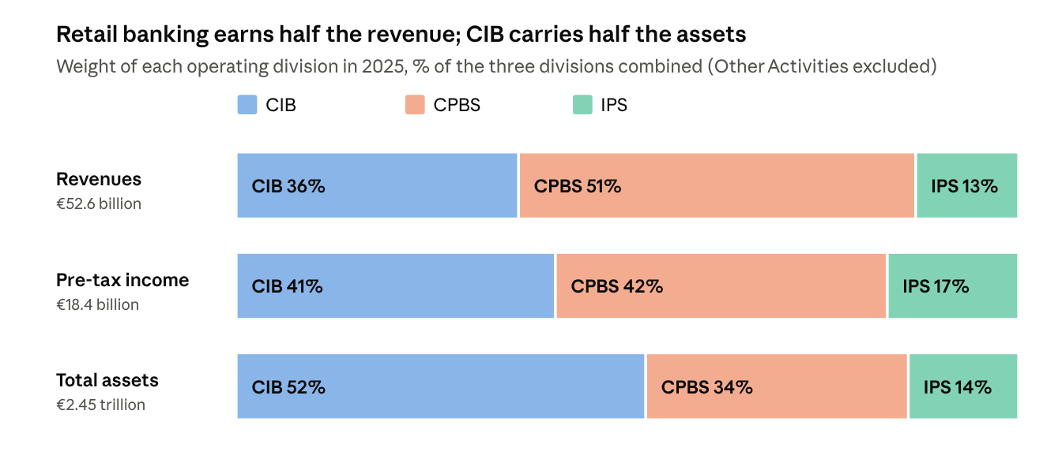
BNP Paribas, Consolidated Financial Statements 2025, Note 3 Segment information, pp. 63 and 66
Division | Revenues 2025 (€m) | % of group | Pre-tax income 2025 (€m) | % of group | Total assets 31/12/2025 (€m) | % of group | Revenue growth vs 2024
Commercial, Personal Banking & Services (CPBS) | 26,717 | 52.2% | 7,805 | 45.7% | 821,207 | 29.4% | +2.6%
Corporate & Institutional Banking (CIB) | 18,997 | 37.1% | 7,506 | 44.0% | 1,280,405 | 45.8% | +5.6%
Investment & Protection Services (IPS) | 6,929 | 13.5% | 3,089 | 18.1% | 345,077 | 12.4% | +19.6%
Other Activities | −1,420 | −2.8% | −1,335 | −7.8% | 346,292 | 12.4% | —
Group total | 51,223 | 100% | 17,065 | 100% | 2,792,981 | 100% | +4.9%
Source: Note 3, Segment information, pp. 63–66. Percentages are of group totals, so Other Activities makes the three divisions add up to slightly more than 100% on revenues and pre-tax income.
The weight of each division depends strongly on the measure used:
- CPBS is the largest by revenues (52%) and pre-tax income (46%) but holds only 29% of assets. Retail and commercial banking earns high margins on loans and fees relative to the assets it uses. Its profit share is lower than its revenue share because it bears 86% of the group's cost of risk (€3,059m of €3,553m), mostly from consumer credit.
- CIB holds 46% of total assets but produces 37% of revenues. Its market activities need a very large balance sheet (securities, repos, derivatives). However, CIB converts revenue into profit efficiently: it makes 44% of pre-tax income with 37% of revenues, thanks to a low cost of risk (€452m).
- IPS is the smallest (13.5% of revenues, 12% of assets) but the fastest growing (+19.6%) and the most profitable relative to revenue (18% of pre-tax income). Growth comes largely from the first-time consolidation of AXA IM (€782m of revenues).

2.3 Inside each division
Business line | Revenues (€m) | % of its division | Pre-tax income (€m) | Assets (€m) | Cost / income ratio
CIB | 18,997 | 100% | 7,506 | 1,280,405 | 58%
Global Markets | 9,568 | 50.4% | 3,399 | 1,035,342 | 62%
Global Banking | 6,244 | 32.9% | 3,102 | 190,744 | 47%
Securities Services | 3,185 | 16.8% | 1,005 | 54,319 | 69%
CPBS | 26,717 | 100% | 7,805 | 821,207 | 60%
CPB in France | 6,464 | 24.2% | 1,555 | 236,289 | 69%
Personal Finance (core) | 5,154 | 19.3% | 968 | 111,693 | 50%
CPB in Belgium | 3,732 | 14.0% | 1,125 | 202,914 | 69%
Europe-Mediterranean | 3,693 | 13.8% | 1,325 | 72,278 | 59%
Arval & Leasing Solutions | 3,254 | 12.2% | 1,330 | 73,257 | 50%
BNL (Italy) | 2,699 | 10.1% | 889 | 89,522 | 61%
New Digital Businesses & Personal Investors | 1,060 | 4.0% | 274 | 4,140 | 64%
CPB in Luxembourg | 661 | 2.5% | 338 | 31,114 | 47%
IPS | 6,929 | 100% | 3,089 | 345,077 | 60%
Insurance | 2,424 | 35.0% | 1,956 | 305,475 | 34%
Asset Management (incl. Real Estate, IPS Investments) | 1,924 | 27.8% | 321 | 9,597 | 81%
Wealth Management | 1,799 | 26.0% | 570 | 28,018 | 68%
AXA IM | 782 | 11.3% | 242 | 1,987 | 70%
Source: Note 3, pp. 63 and 66. Cost/income ratio = operating expenses / revenues, our calculation.
CIB. Global Markets is the single largest business line of the group: half of CIB revenues (€9.6bn, +9.1% vs 2024) and 37% of the entire group balance sheet (€1,035bn). This is the trading book seen in Part 1. Global Banking is the most efficient line, with a cost/income ratio of 47%. Its pre-tax income still fell from €3,532m to €3,102m, because cost of risk moved from a net release of €171m in 2024 to a charge of €229m in 2025.
CPBS. France is the largest retail network (€6.5bn of revenues, 24% of the division), followed by Personal Finance and Belgium. Pre-tax income of CPB in France rose by 33% (€1,167m to €1,555m) as cost of risk fell. Personal Finance shows the risk of consumer lending: €5.2bn of revenues but a cost of risk of €1,642m, almost half of the whole group's. Arval's pre-tax income dropped by 28% (€1,836m to €1,330m). Europe-Mediterranean grew fastest (+16% revenues, +55% pre-tax income).
IPS. Insurance stands apart: €2.4bn of revenues turn into €2.0bn of pre-tax income (cost/income 34%), and it carries almost all IPS assets (€305bn of investments backing policyholders' savings). Asset and wealth management use very little balance sheet: they earn fees on clients' money, which stays off BNP Paribas' own balance sheet.
Revenue per euro of assets summarises the differences: about 3.3% for CPBS, 2.0% for IPS and 1.5% for CIB (Global Markets alone: 0.9%). The businesses that use the most balance sheet are not those that earn the most from it.

Part 3 — International activities
BNP Paribas is a European bank with a worldwide network. About 81% of its revenues and assets are booked in Europe, the Middle East and Africa (EMEA), and the share earned outside Europe has stayed close to one-fifth for ten years (19.2% of revenues and 19.1% of assets in 2025). What has changed is the mix: the group sold its US retail bank in 2023, and the Americas have since been rebuilt around corporate and investment banking, making them the fastest-growing region (+13.0% a year since 2022). This part uses the multi-year geographic, segment and employee data in the Company Fundamentals export to measure where the group operates, how this has evolved, and what it costs in risk.

3.1 Where revenues and assets are booked (2022–2025)
Region | Revenues 2022 (€m) | 2023 | 2024 | 2025 | Annual growth 2022–25 | % of group 2025 | Share of revenue growth 2022–25
EMEA | 37,675 | 37,822 | 39,688 | 41,381 | +3.2% | 80.8% | 64.0%
Americas | 3,818 | 4,286 | 4,898 | 5,513 | +13.0% | 10.8% | 29.3%
Asia-Pacific | 3,937 | 3,766 | 4,245 | 4,329 | +3.2% | 8.5% | 6.8%
Group total | 45,430 | 45,874 | 48,831 | 51,223 | +4.1% | 100% | 100%
Source: Company Fundamentals (CF) export, BNP Paribas SA (BNPP.PA), 7 Oct 2026, sheet "Geographic Line By Segment". Annual growth = compound annual growth rate; shares and growth contributions are our calculations.
Region | Total assets 2022 (€bn) | 2023 | 2024 | 2025 | Change 2024–25 (€bn) | % of group 2025 | Revenues / assets 2025
EMEA | 2,188.6 | 2,148.5 | 2,196.7 | 2,259.8 | +63.1 | 80.9% | 1.83%
Americas | 304.8 | 255.1 | 316.4 | 361.3 | +44.9 | 12.9% | 1.53%
Asia-Pacific | 170.3 | 187.9 | 191.8 | 171.8 | −19.9 | 6.2% | 2.52%
Group total | 2,663.7 | 2,591.5 | 2,704.9 | 2,793.0 | +88.1 | 100% | 1.83%
Source: Company Fundamentals (CF) export, BNP Paribas SA (BNPP.PA), 7 Oct 2026, sheet "Geographic Line By Segment". Revenues/assets is our calculation.
Three findings stand out:
- The Americas punch well above their weight in growth. They hold 10.8% of revenues but delivered 29% of the group's revenue growth since 2022 (+€1.7bn) and 51% of its balance-sheet growth in 2025 (+€44.9bn of +€88.1bn). Revenues rose by 44% in three years, from €3.8bn to €5.5bn.
- That growth is balance-sheet hungry. The Americas earn only 1.53% of revenues per euro of assets, below the group average (1.83%) and far below Asia-Pacific (2.52%). This is the signature of market activities (repos, securities, derivatives), which need large volumes to generate revenues. Asset productivity is improving, though: it was only 1.25% in 2022.
- Asia-Pacific is the most asset-efficient region. It generates 8.5% of revenues with 6.2% of assets. In 2025 it cut its balance sheet by €19.9bn (−10.4%) while still growing revenues (+2.0%), which raised its revenue yield from 2.21% to 2.52%.
- EMEA remains the engine in absolute terms. It generated 64% of revenue growth since 2022, but grows more slowly (+3.2% a year) because it is a mature, mostly retail franchise.

3.2 Ten-year view: how international is BNP Paribas?
The export provides geographic data back to 2016. Before 2022 the regions were Europe, North America, Asia-Pacific and "Others"; from 2022 they are EMEA, Americas and Asia-Pacific. To build a comparable series we take the share of revenues and assets booked outside Europe: North America + Asia-Pacific up to 2021, Americas + Asia-Pacific from 2022.
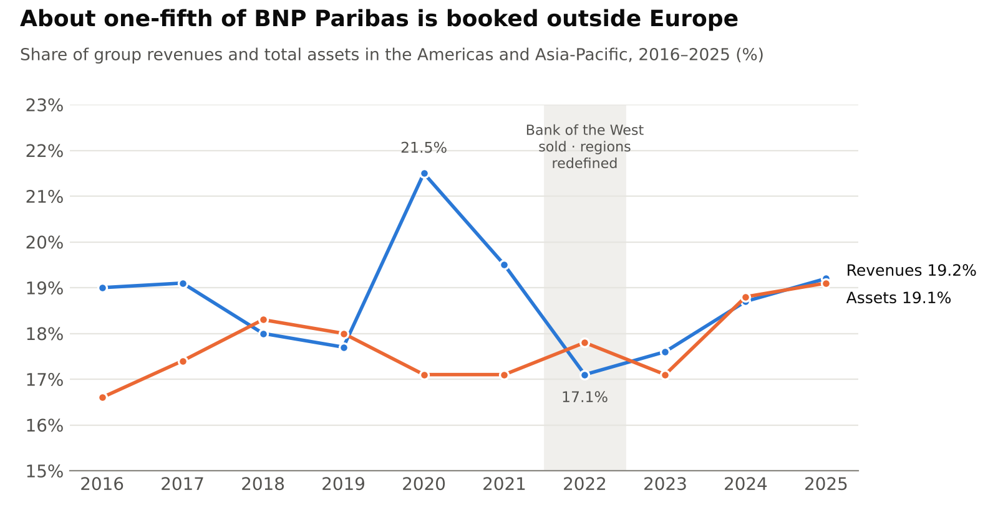
Source: Company Fundamentals (CF) export, BNP Paribas SA (BNPP.PA), 7 Oct 2026, sheets "Geographic Line By Segment" and "By Statement Item". Our calculation; break in series in 2022 (new regional definitions).
- The international share is stable, not rising. Revenues outside Europe have stayed between 17% and 21.5% of the group for a decade; 2025 (19.2%) is almost exactly the 2016 level (19.0%). BNP Paribas has deliberately remained a European bank with global reach, not a global bank with a European base.
- The peak of 2020 (21.5%) was a market effect. In the Covid year, North American revenues jumped by 23% (€4.7bn to €5.7bn) on very strong trading activity, while European revenues fell by 4.6%. Market-driven regions move faster than retail-driven ones, in both directions.
- The asset share drifts upwards (16.6% → 19.1%). The balance sheet outside Europe has grown faster than revenues, which is consistent with the growing weight of capital-market activities in the Americas.
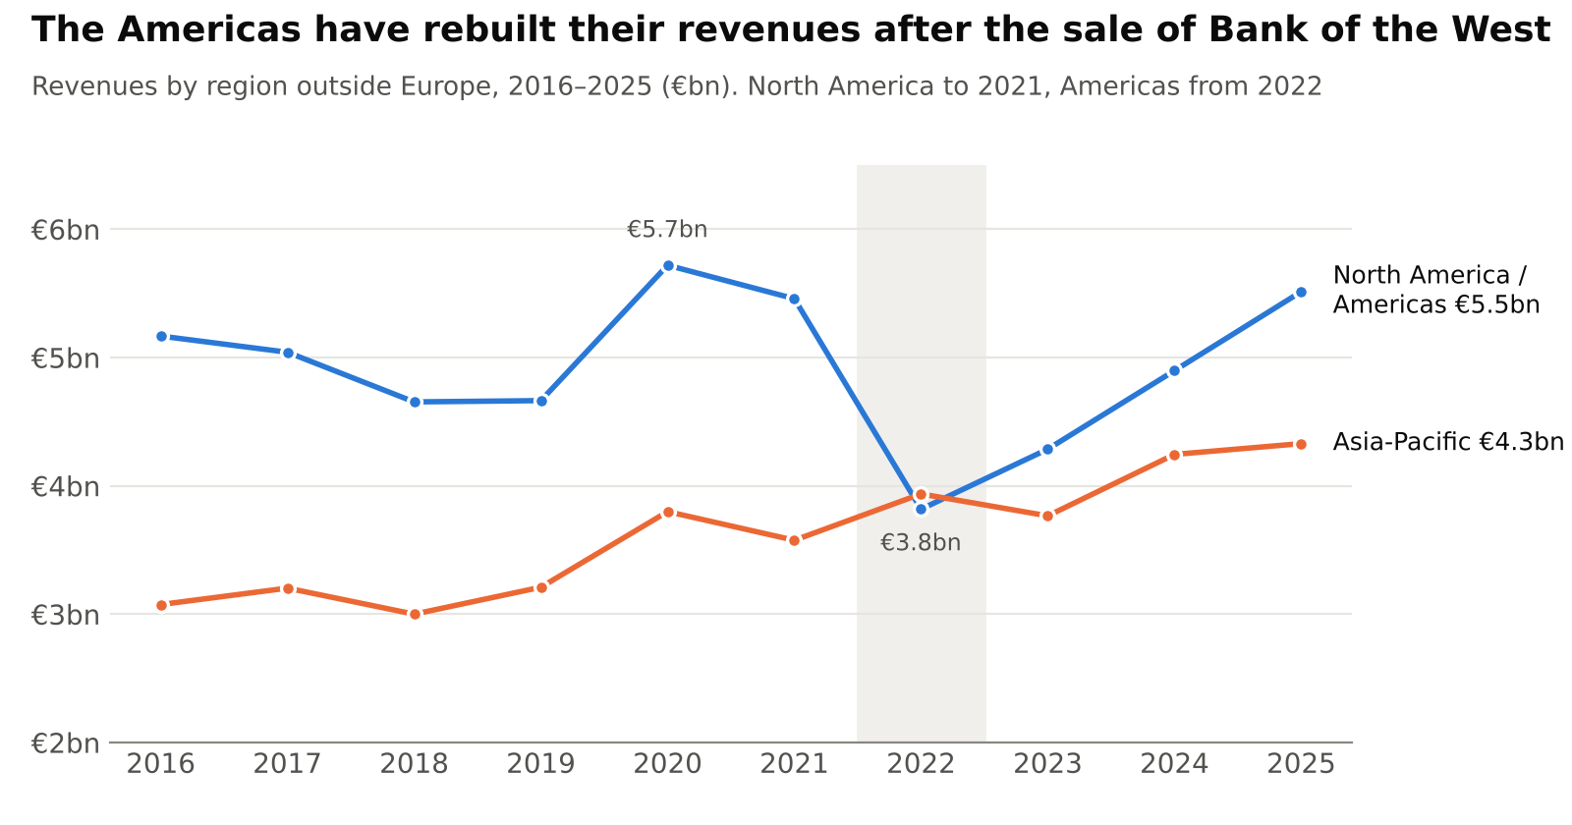
Source: Company Fundamentals (CF) export, BNP Paribas SA (BNPP.PA), 7 Oct 2026. North America to 2021, Americas (North and South) from 2022.
The Americas: from retail bank to investment-banking platform. In 2021 North America still included Bank of the West, the Californian retail bank. Its sale to BMO was completed on 1 February 2023: the export shows its results reclassified as discontinued operations (€720m in 2021, €687m in 2022, €2,947m in 2023 including the disposal gain). Revenues in the region therefore dropped to €3.8bn in 2022 and assets fell by 16% in 2023. Since then the Americas have grown by 13% a year and, at €5.5bn, already exceed the 2021 North-American level that still included a full retail bank (€5.5bn). The region is now almost entirely CIB: 15 of the 21 consolidated US entities belong to CIB (Note 8.f, scope of consolidation). The trade-off is more volatility, because CIB revenues depend on market conditions rather than on a stable deposit and loan base.
Asia-Pacific: slow and steady. Revenues rose from €3.1bn (2016) to €4.3bn (2025), +3.9% a year, against +1.9% for the group, while assets grew by only 1.1% a year. Asia-Pacific has become steadily more profitable per euro of balance sheet. It is a CIB and asset-management presence (Hong Kong, Singapore, China, Japan, Australia), not a retail market.

3.3 Where the people work
The export breaks down employees by country up to 2021 (the most recent year available in this file). These figures add a dimension that revenues and assets miss: where the work is actually done.
Country / region | Employees 2016 | Employees 2021 | % of total 2021 | Change 2016–21
France | 58,338 | 54,659 | 28.8% | −6.3%
Italy | 18,017 | 17,038 | 9.0% | −5.4%
Belgium | 15,721 | 12,577 | 6.6% | −20.0%
Luxembourg | 3,551 | 3,507 | 1.8% | −1.2%
Other EU countries | 50,805 | 57,480 | 30.3% | +13.1%
North America | 16,135 | 13,468 | 7.1% | −16.5%
South America | 4,086 | 4,406 | 2.3% | +7.8%
Asia-Pacific | 15,273 | 19,049 | 10.0% | +24.7%
Africa | 9,976 | 7,066 | 3.7% | −29.2%
Middle East | 517 | 515 | 0.3% | −0.4%
Total | 192,419 | 189,765 | 100% | −1.4%
Source: Company Fundamentals (CF) export, BNP Paribas SA (BNPP.PA), 7 Oct 2026, sheet "Geographic Line By Segment" (employees, full-time equivalents). Asia-Pacific 2016 is reported under "Oceania" in the export. Percentages and changes are our calculations.
- More than half of the staff (54%) works outside the four domestic markets (France, Italy, Belgium, Luxembourg), and 23.5% outside Europe. By headcount, BNP Paribas is more international than its revenue split suggests.
- Employment is shifting from the historic networks to the rest of Europe and Asia. France and Belgium lost 6,800 jobs between 2016 and 2021, while "Other EU countries" (Poland, Germany, Spain, Portugal and others, where the specialised businesses and shared-service centres sit) gained 6,700, and Asia-Pacific +3,800.
- Productivity differs strongly by region. In 2021 North America generated about €405k of revenues per employee, Europe €239k and Asia-Pacific €188k. The low Asian figure is likely to reflect support and IT functions located in the region that serve the whole group, rather than lower client profitability.
- Africa has been reduced (−29.7% of staff between 2019 and 2021), consistent with the group's withdrawal from several African retail networks. Total group headcount was 177,990 at end-2025, 6% below 2021, partly reflecting the sale of Bank of the West.

3.4 How each division works internationally
Business | Revenues 2025 (€m) | Change vs 2024 | Pre-tax income 2025 (€m) | Pre-tax income / assets | Cost of risk 2025 (€m)
Eurozone domestic networks (France, Italy, Belgium, Luxembourg) | 13,556 | +3.0% | 3,907 | 0.70% | 750
Europe-Mediterranean (Poland, Türkiye and others) | 3,693 | +19.0% | 1,325 | 1.83% | 376
Global Markets (worldwide) | 9,568 | +9.7% | 3,399 | 0.33% | 223
Global Banking (worldwide) | 6,244 | +0.1% | 3,102 | 1.63% | 229
Securities Services (worldwide) | 3,185 | +8.2% | 1,005 | 1.85% | —
Source: Company Fundamentals (CF) export, BNP Paribas SA (BNPP.PA), 7 Oct 2026, sheets "Business Line By Segment" and "By Statement Item". Ratios are our calculations. The 2024 comparatives in the export are as originally published, so some growth rates differ slightly from the restated ones used in Part 2 (e.g. Europe-Mediterranean +16.1% restated).
- Retail banking: four domestic markets plus Europe-Mediterranean. The eurozone networks earn €13.6bn, or 26.5% of group revenues, but only 0.70% of pre-tax income per euro of assets. Outside the eurozone, Europe-Mediterranean earns 2.6 times more per euro of assets (1.83%): 7.2% of group revenues and 7.8% of pre-tax income with only 2.6% of assets. Pre-tax income rose by 71% on the export's comparatives (+55% restated). Part of this is not "operating" income: €375m (28%) comes from equity-method stakes rather than controlled subsidiaries. Higher returns come with higher risk: inflation in Türkiye and Swiss-franc mortgage litigation in Poland (Part 3.6).
- Specialised businesses across Europe. Personal Finance (€5.2bn of revenues), Arval and Leasing Solutions (€3.3bn) operate in many European countries. Personal Finance has narrowed its footprint: businesses in 10 countries have been sold or put in run-off, and that non-core part is now reported in Other Activities. Its risk cost (1,642m) is the highest in the group.
- CIB is the global platform. Global Markets, Global Banking and Securities Services together earn €19.0bn (37% of the group) and are the main source of activity in the Americas and Asia. Global Markets is the growth driver (+9.7%) but uses a huge balance sheet (€1,035bn) for a pre-tax return of only 0.33% of assets; Global Banking is five times more efficient per euro of assets.
- IPS follows clients abroad. Cardif sells insurance through branches across Europe, and Asset Management works internationally. The 2025 acquisition of AXA IM (€782m of revenues, €242m of pre-tax income in its first year) added a large European asset-management platform.

3.5 Countries of presence
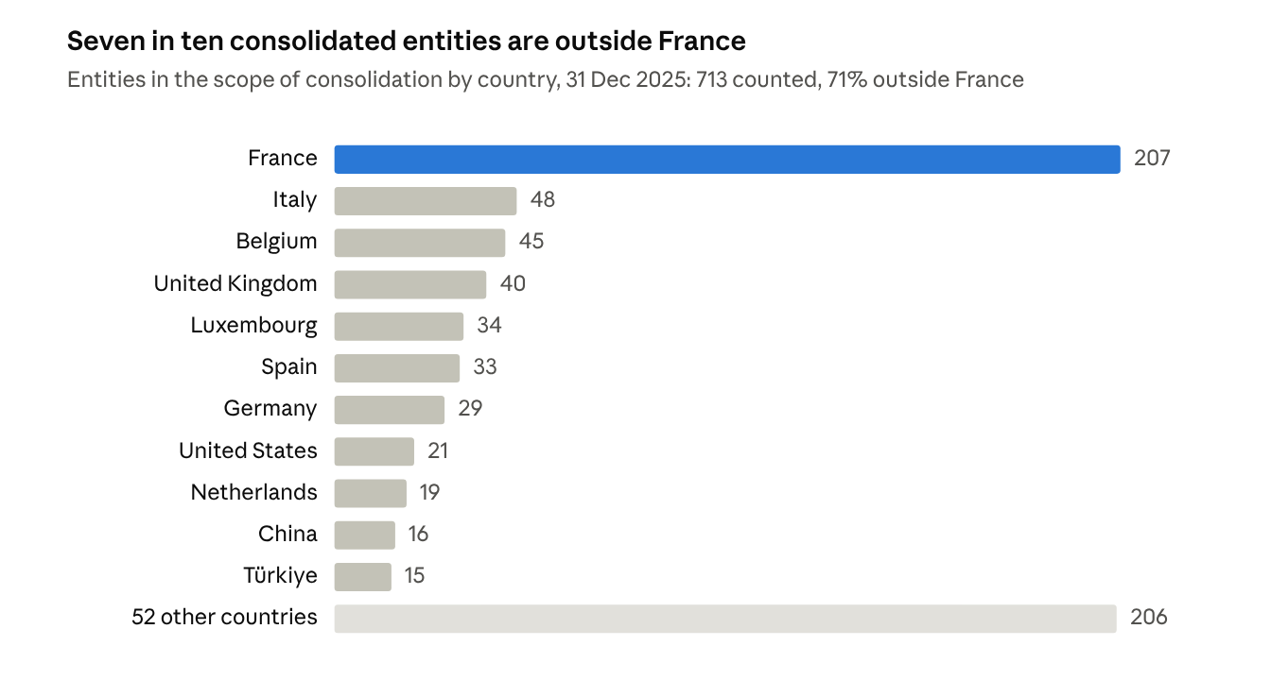
Our count of fully consolidated and equity-method entities and branches listed in Note 8.f Scope of consolidation, pp. 140 onwards
France hosts the largest number of entities, followed by the other domestic markets (Italy, Belgium, Luxembourg), the main European financial centres (United Kingdom, Germany, Netherlands) and the large international markets (United States, China). The long tail of 52 other countries, often with one to three entities each, includes many branches of BNP Paribas SA that serve corporate and institutional clients locally.

3.6 Risks linked to international activities
Operating in more than 60 countries exposes the bank to local economic, legal and currency risks. The report quantifies several of them:
Country | Issue | Impact reported for 2025
Türkiye | Hyperinflation: IAS 29 applied to Turkish subsidiaries since 2022 | −€329m on the net monetary position (−€487m revaluation, +€158m on inflation-indexed bonds); −€118m extra tax
Poland | Swiss franc mortgage loans of BNP Paribas Bank Polska | €118m expense (2024: €186m); 5,865 pending court cases; €399m of provisions
Spain | Supreme Court rulings on revolving consumer credit | €100m expense
United States | Class action linked to past transactions with Sudan under US sanctions | Jury verdict of USD 20.75m against BNP Paribas SA (October 2025), under appeal
United Kingdom | Proposed FCA redress scheme for motor finance customers | Not quantified; final rules expected in February–March 2026
Russia | Ratings downgraded since 2022 | Exposure described as limited; no significant effect on cost of risk
Source: Notes 1.d, 2.g, 2.i, 2.j, 4.n and 8.c.
Currency risk is visible over ten years in the export. Subsidiaries outside the eurozone are converted into euros at closing rates, and the difference is booked in equity (other comprehensive income), not in profit:
€m | 2017 | 2018 | 2019 | 2020 | 2021 | 2022 | 2023 | 2024 | 2025
Foreign-currency translation (OCI) | −2,589 | −159 | +530 | −2,358 | +481 | +1,041 | −109 | +1,177 | −2,212
Source: Company Fundamentals (CF) export, BNP Paribas SA (BNPP.PA), 7 Oct 2026, sheet "Income Statement" (Other Comprehensive Income – Foreign Currency); "Balance Sheet" (Foreign Currency Translation Adjustment – Accumulated).
- 2025 was one of the worst years of the decade: −€2.2bn, equal to 17% of net income, as the US dollar and other currencies weakened against the euro. It explains most of the small fall in equity noted in Part 1.
- Losses accumulate over time. Cumulated translation differences reached −€4.9bn at end-2025 (−€2.2bn a year earlier), about 3.9% of common equity. Over 2017–2025 the net effect is −€4.2bn.
- FX also hits liquidity: exchange-rate movements reduced the euro value of the group's cash by €7.1bn in 2025 (cash-flow statement).

3.7 Assessment
International diversification cuts both ways. It spreads the bank across economies that do not move together: revenues in the Americas grew by 12.6% in 2025 (export comparatives) while the group's customer loans were flat, and Asia-Pacific raised its profitability while shrinking its balance sheet. But the international business is concentrated in CIB and therefore in market-sensitive revenues, it uses balance sheet less efficiently in the Americas, and it brings costs that a purely domestic bank would not bear, from Turkish inflation and Polish or American litigation to currency losses booked directly in equity. In short, BNP Paribas is international by its people and its corporate clients, but its earnings remain anchored in Europe.

Conclusion
With €2.79 trillion of total assets (+3.3% in 2025), BNP Paribas is a balance sheet comparable in size to the French economy, financed mainly by €1.08 trillion of customer deposits and supported by €132bn of equity (leverage of 21x). Only a third of these assets are customer loans; nearly another third is the trading book, and a tenth backs insurance contracts.
The segment data confirm that BNP Paribas is a diversified universal bank, with three divisions of very different weight depending on the measure:
- CPBS (retail and commercial banking, consumer credit, leasing) is the core earner: 52% of revenues and 46% of pre-tax income, with only 29% of assets, but it carries most of the credit risk.
- CIB (Global Banking, Global Markets, Securities Services) is the heaviest user of the balance sheet with 46% of assets, for 37% of revenues and 44% of pre-tax income. Global Markets alone accounts for 37% of group assets.
- IPS (insurance, wealth and asset management) is small (13.5% of revenues) but the fastest growing (+19.6%, helped by AXA IM) and very profitable, especially Insurance.
Internationally, about one-fifth of revenues and assets is booked outside Europe, a share that has barely moved in ten years. Since the sale of Bank of the West, the Americas have been rebuilt as a CIB platform and are the fastest-growing region (+13% a year since 2022), while Asia-Pacific is the most asset-efficient. Half of the staff works outside the four domestic markets, and currency movements cost €2.2bn of equity in 2025.
This balance is the main strength of the model: when one activity weakens (Arval and Global Banking in 2025), others compensate (Global Markets, French retail banking, IPS), and group pre-tax income still rose by 5.4% to €17.1bn. The flip side is size and complexity: a market-heavy balance sheet of this scale is why BNP Paribas is treated as systemically important and held to stricter capital rules.

