Title page

Multimedia University

CCP6124 Object Oriented Programming and Data Structures 2510

Lecture section: TC2L
Tutorial section: TT5L
Group number: G11
Group leader student name: Chong Meng Hang

Num | Student  ID | Student Name by  alphabetical order | Task Descriptions | Percentage (100%)
1 | 242UC244JT | Chong Meng Hang | FUNCTIONS : starting base struture, printing battlefield, print only current robot, get set and clear cells, getter and setter fucntions  code logic : upgrade class, pointer related, turn-based  class : scoutbot, trackbot, longshotbot  Extra task: debugging | 25
2 | 242UC244PF | Tan Yong Xin | FUNCTIONS: actionLook  Code logic: let robot check 3x3 area around itself, show [R] for itself, [ ] for empty, [E] for enemy, log everything to file  Class: HealthBot, GodBot  Extra task: UML design | 25
3 | 242UC244S6 | Tham Mei Ting | FUNCTIONS: actionMove, handle random jump coordinate  Code logic: jump limit check using jumpCount and MAXjump, turnCounter to control when JukeBot teleport  Class: JumpBot, JukeBot  Extra task: UML design | 25
4 | 242UC244KX | Yap Chi Yi | FUNCTIONS : readfile, placeRobots, updateWaitingRobots, returnbattlefield_, waitingrobots, destroyedrobots, returnrobots,  code logic : actionShoot 's general shooting logic( not upgrading ) , outputting to a txt file , game ending requirements  class : thirtyshotbot, semiautobot, hidebot  extra task : change code to non user input, debugging upgrade class | 25

Assignment Evaluation Criteria

Assignment Programming, Assignment Report (40m)
You are required to present your assignment in group to your respective tutor.
Also report and document all your assignment tasks with this marking table that contain cover page, table of contents, page numbering, inputs, outputs, figures, screenshots, explanations, descriptions, classes design, and others.

Criteria | Mark | Max
Q1. Design documentation or -40  [] UML classes diagram, explanations  [] screenshots, screen OUTPUT, figures, explanations  [] two sample input files, two sample txt log output files, correct, explanations  [] code segments, pseudocodes, explanations  [] great | ? | 5
Q2. Initialization of a simulation, explanations  [] read input files  [] screen outputs initial battlefield of all robots  [] fixed seed integer for random functions | ? | 3
Q3. OUTPUT and logging of the status of the battlefield of robots at each turn, explanations  [] OUTPUT battlefields to screen  [] battlefields in txt log output files  battlefield two end games  [] fileInput2a.txt: left one robot  [] fileInput2b.txt: reached max number of turns  [] great  Q4. OUTPUT and logging of the actions and the status of each robot at each turn, explanations  ()()() accept status of robots & screen OUTPUT & has txt log output files, good, great | ?  ? | 5  3
Q5. Implementation of the 7 additional required robot classes with OOP concepts i.e. I&P&OO +3, explanations  Seeing: []ScoutBot []TrackBot  Shooting: []LongShotBot []SemiAutoBot []ThirtyShotBot  Moving: []HideBot []JumpBot  []inheritance []polymorphism []operator overloading | ? | 10
Q6. The algorithms used to optimize the actions of robots listed in the assignment document, explanations  () vector or queue  () vector and queue  ()()() accept algorithms & has explanations, good, great | ? | 5
Q7. Implementation of three new robot classes  (3 marks for each robot), explanations  New robot name 1: GodBot  New robot name 2: JukeBot  New robot name 3: HealthBot  ()()() accept & has explanations, good, great | ? | 9
Total |  | 40

Additional comments

You are required to fill in your task percentage and task descriptions.
Every student is responsible for 100% (task percentage) of this group assignment work.

Student 1
Student ID | 242UC244JT
Student name | CHONG MENG HANG
Task percentage | 25
Task descriptions | FUNCTIONS : starting base struture, printing battlefield, print only current robot, get set and clear cells, getter and setter fucntions  code logic : upgrade class, pointer related, turn-based  class : scoutbot, trackbot, longshotbot
Total score (40m) | ?

Student 2
Student ID | 242UC244PF
Student name | TAN YONG XIN
Task percentage | 25
Task descriptions | FUNCTIONS: actionLook  Code logic: let robot check 3x3 area around itself, show [R] for itself, [ ] for empty, [E] for enemy, log everything to file  Class: HealthBot, GodBot  Extra task: UML design
Total score (40m) | ?

Student 3
Student ID | 242UC244S6
Student name | THAM MEI TING
Task percentage | 25
Task descriptions | FUNCTIONS: actionMove, handle random jump coordinate  Code logic: jump limit check using jumpCount and MAXjump, turnCounter to control when JukeBot teleport  Class: JumpBot, JukeBot
Total score (40m) | ?

Student 4
Student ID | 242UC244KX
Student name | YAP CHI YI
Task percentage | 25
Task descriptions | FUNCTIONS : readfile, placeRobots, updateWaitingRobots, returnbattlefield_, waitingrobots, destroyedrobots, returnrobots,  code logic : actionShoot 's general shooting logic( not upgrading ) , outputting to a txt file , game ending requirements  class : thirtyshotbot, semiautobot, hidebot  extra task : change code to non user input, debugging upgrade class
Total score (40m) | ?

Each feature will be evaluated based on fulfilment of requirements, correctness, compilation without warnings and errors, error free during runtime, basic error handling, quality of comments, user friendliness, good coding format and style.

Table of contents with page numbers and links

Title page 1
Assignment Programming, Assignment Report (40m) 2
Delete this information section 6
Questions Section 7
Q1. [5] Design documentation or -40, UML classes diagram, explanations, screenshots, screen display, figures, explanations, two sample input files, two sample txt log output files, correct, explanations, code segments, pseudocodes, explanations 7
Q2. [3] Initialization of a simulation, read input file, screen output initial battlefield of all robots, fixed seed integer for random functions 10
Q3. [5] Display and logging of the status of the battlefield of robots at each turn 11
Q4. [3] Display and logging of the robot actions and the status of each robot at each turn 11
Q5. [10] Implementation of the 7 additional required robot classes with OOP concepts i.e. I&P&OO +3 14
Q6. [5] The algorithms used to optimize the actions of robots, vector, queue 23
Q7. [9] Implementation of three new robot classes 25
Question: How to compile, how to run the program 28

Delete this information section

Insert the comment below at the beginning of your source code files:
//*********************************************************
// Program: YOUR_FILENAME.cpp
// Course: CCP6124 OOPDS
// Lecture Class: TC2L
// Tutorial Class: ?TT5L
// Trimester: 2510
// Member_1: ID | NAME | EMAIL | PHONE
// Member_2: ID | NAME | EMAIL | PHONE
// Member_3: ID | NAME | EMAIL | PHONE
// Member_4: ID | NAME | EMAIL | PHONE
//*********************************************************
// Task Distribution
// Member_1:
// Member_2:
// Member_3:
// Member_4:
// ********************************************************

Filename examples
{
TC2L_G04_main.cpp
fileInput1.txt, fileInput2.txt, fileOutput1.txt, fileOutput2.txt
TC2L_G04_report.docx
}

Questions Section

Q1. [5] Design documentation or -40, UML classes diagram, explanations, screenshots, screen OUTPUT, figures, explanations, two sample input files, two sample txt log output files, correct, explanations, code segments, pseudocodes, explanations

UML classes diagram, explanations
Screenshots (inputs, outputs), text screen OUTPUT, figures, explanations

UML Class Diagram
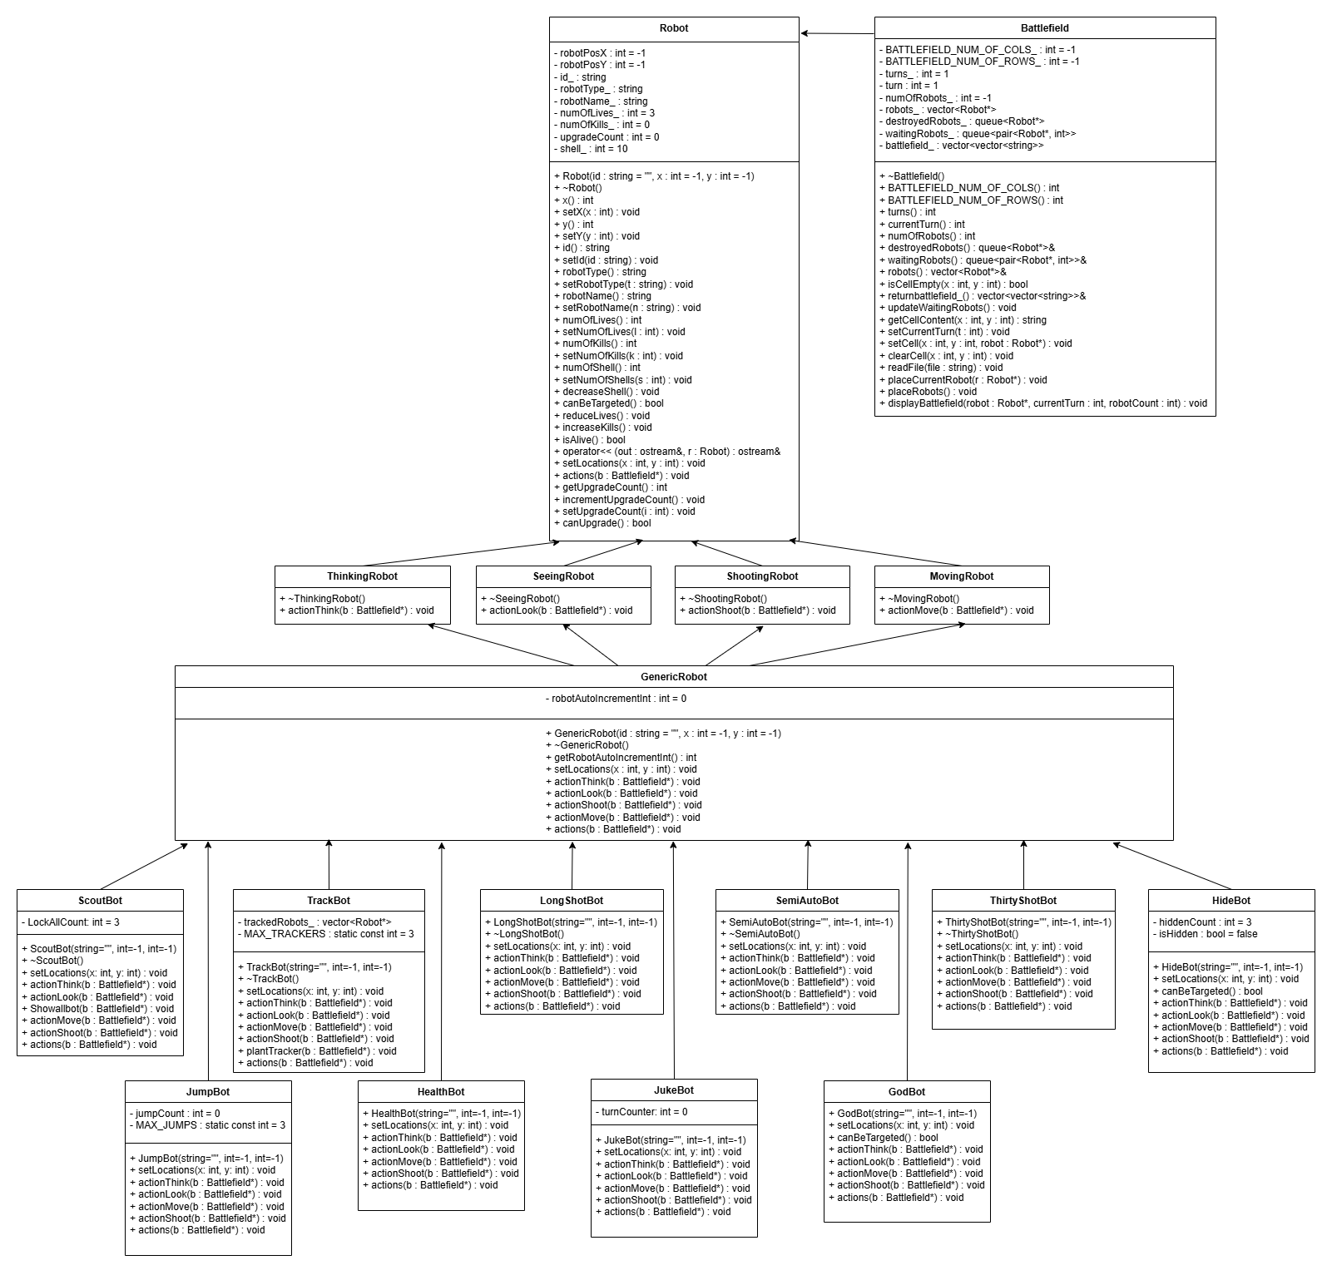
Class Explanations
- Robot (Base Class)
Attributes:
- robotPosX, robotPosY (position)
- id_, robotType_, robotName_ (identification)
- numofLives_, numOfKills_, shell_ (combat stats)
- UpgradeCount (upgrade tracking)
Methods:
- setLocations(), actions() (pure virtual)
- reduceLives(), increaseKills(), isAlive()

- ThinkingRobot, SeeingRobot, ShootingRobot, MovingRobot (Interfaces)
- Define role-specific actions (actionThink(), actionLook(), etc.)
- Inherited by concrete robot types.

- GenericRobot (Basic Robot)
- Default implementation of all actions.
- Can be upgraded into specialized robots.

- Can be upgraded into specialized robots.
- Each has unique abilities:
- ScoutBot: Can reveal the entire battlefield.
- TrackBot: Can track enemy movements.
- LongShotBot: Can shoot at long range.
- HideBot: Can temporarily become invisible.

UML Code segments, pseudocode parts, explanations

Two sample input files, two sample txt log output files, correct, explanations

Sample 1 file input
file input name: fileInput1.txt
/////
M by N: 10 15
turns: 300
robots: 5
GenericRobot GR01_Kidd 3 6
GenericRobot GR02_Jet 1 1
GenericRobot GR03_Alpha 5 2
GenericRobot GR04_Beta 2 7
GenericRobot GR05_Star random random
/////

Sample 1 file output
filename: fileOutput1.txt
step by step screenshot outputs, output file, explanations
/////

///

Sample 2 file input
file input name: fileInput2.txt
/////
M by N: 5 5
turns: 300
robots: 5
GenericRobot GR01_Kidd 3 4
GenericRobot GR02_Jet 1 1
GenericRobot GR03_Alpha 4 2
GenericRobot GR04_Beta 3 3
GenericRobot GR05_Star random random
/////

Sample 2 file output
filename: fileOutput2.txt
step by step screenshot outputs, output file, explanations
/////
?
/////

Q2. [3] Initialization of a simulation, read input file, screen output initial battlefield of all robots, fixed seed integer for random functions

Screenshots (inputs, outputs), text screen OUTPUT, figures, explanations
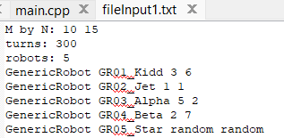
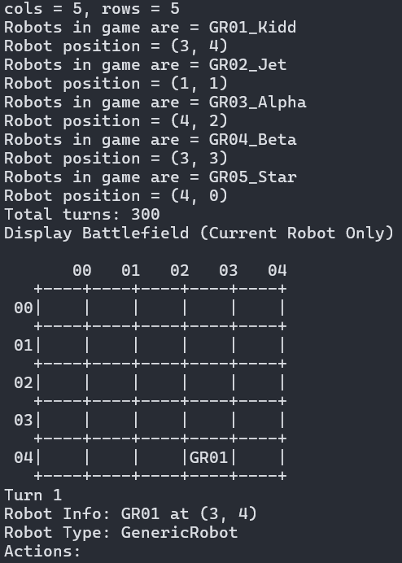

Code segments, initial of a simulation, read input file, fixed seed integer right at first line in the main function, pseudocode parts, explanations
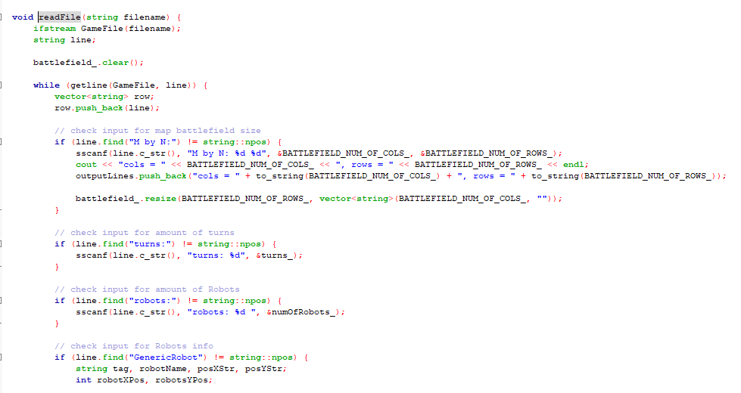
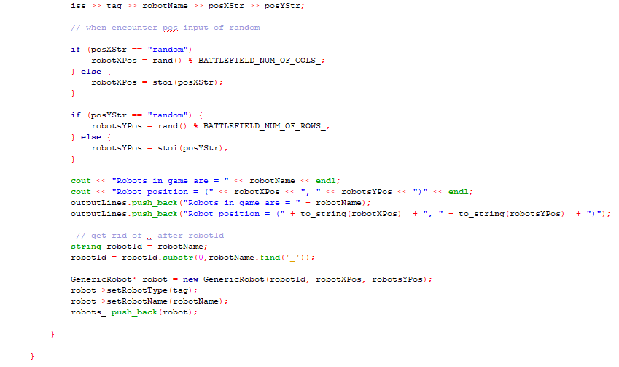
- Read in file, and check line using .find() to find string that correlates to their assigning value, and c string style function sscanf to extract data and push into their assigned data

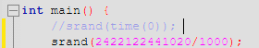
- Srand(id/1000) for fixed seed integer

Q3. [5] OUTPUT and logging of the status of the battlefield of robots at each turn

Q4. [3] OUTPUT and logging of the robot actions and the status of each robot at each turn

a. OUTPUT battlefields of robots at each turn to screen

Screenshots (inputs, outputs), text screen OUTPUT, figures, explanations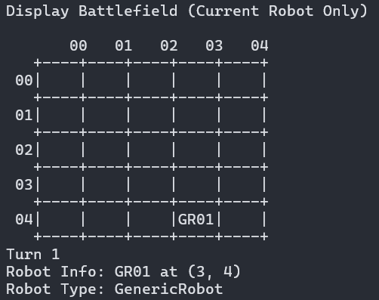

Code segments, fixed seed integer right at first line in the main function, pseudocode parts, explanations
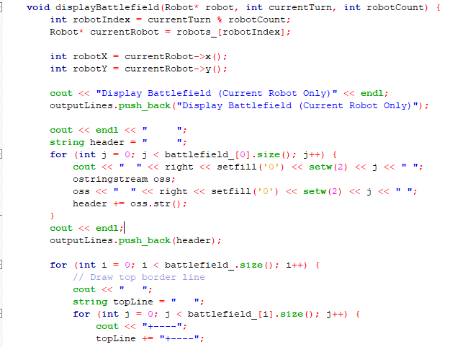
DisplayBattlefield first takes in the a pointer to robots, the currentTurn and how many robots are there. It find the X and Y positions of said robots and then prints out the battlefield for that current robot only, all the rrobots are actually on the same grid and some bots later down the upgrades path can see all the robots on the battlefield, they are just hidden as default.

PSUEDOCODE:
FUNCTION displayBattlefield(robot, currentTurn, robotCount):
robotIndex = currentTurn MOD robotCount
currentRobot = robots_[robotIndex]
robotX = currentRobot's X position
robotY = currentRobot's Y position
PRINT "Display Battlefield (Current Robot Only)"
ADD message to outputLines
PRINT " " (5 spaces for row labels)
header = " "
FOR each column j in battlefield:
PRINT formatted column number (e.g., " 02 ")
ADD to header string
PRINT newline
ADD header to outputLines
FOR each row i in battlefield:
// Draw top border (+----+----+...)
PRINT " " (3 spaces for alignment)
topLine = " "
FOR each column in battlefield:
PRINT "+----"
ADD "+----" to topLine
PRINT "+"
ADD "+" to topLine
ADD topLine to outputLines
PRINT formatted row number (e.g., " 02")
rowLine = formatted row number
FOR each column j in battlefield:
IF current cell (i,j) is robot's position:
PRINT "|" + robot's ID (left-aligned, 4 chars)
ADD "|" + ID to rowLine
ELSE:
PRINT "| " (empty cell)
ADD "| " to rowLine
PRINT "|"
ADD "|" to rowLine
ADD rowLine to outputLines
PRINT " " (3 spaces for alignment)
bottomLine = " "
FOR each column in battlefield:
PRINT "+----"
ADD "+----" to bottomLine
PRINT "+"
ADD "+" to bottomLine
ADD bottomLine to outputLines

b. Battlefields of robots at each turn in txt log output file

Screenshots (inputs, outputs), text screen OUTPUT, figures, explanations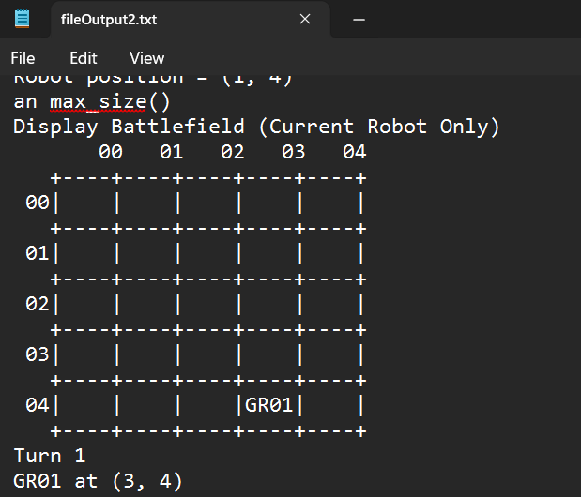

Code segments, fixed seed integer right at first line in the main function, pseudocode parts, explanations
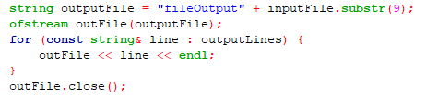

PSUEDOCODE:
FUNCTION WriteOutputToFile(inputFile, outputLines):
// Generate output filename by replacing "fileInput" with "fileOutput"
outputFile = "fileOutput" + inputFile.substring(starting from index 9)
// Open the output file for writing
outFile = open outputFile for writing
// Write all accumulated output lines
FOR EACH line IN outputLines:
WRITE line to outFile
WRITE newline to outFile
// Close the file
CLOSE outFile

c. OUTPUT and logging of the actions and the status of each robot at each turn

Screenshots (inputs, outputs), text screen OUTPUT, figures, explanations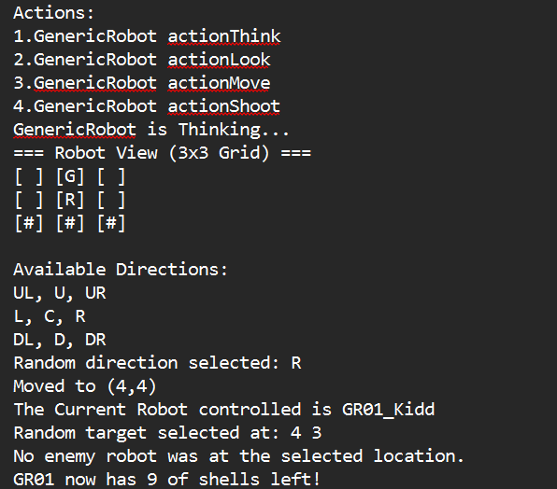

Code segments, fixed seed integer right at first line in the main function, pseudocode parts, explanations

PSUEDOCODE:
FUNCTION WriteOutputToFile(inputFile, outputLines):
// Generate output filename by replacing "fileInput" with "fileOutput"
outputFile = "fileOutput" + inputFile.substring(starting from index 9)
// Open the output file for writing
outFile = open outputFile for writing
// Write all accumulated output lines
FOR EACH line IN outputLines:
WRITE line to outFile
WRITE newline to outFile
// Close the file
CLOSE outFile

d. Battlefield two end games
fileInput2a.txt: left one robot
{
Screenshots (inputs, outputs), text screen OUTPUT, figures, explanations
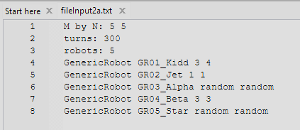
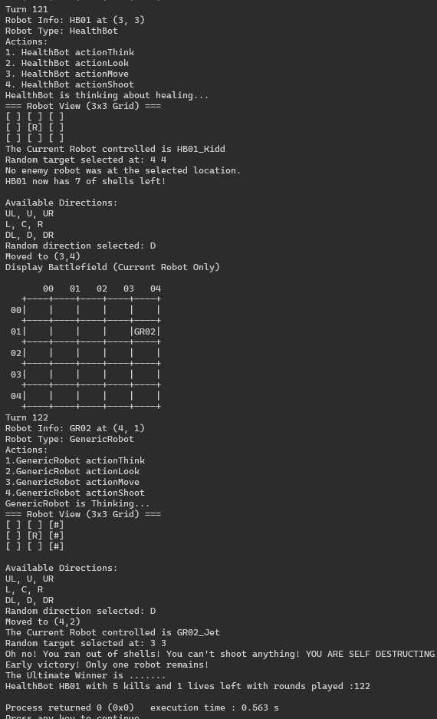
- HB01 only has 1 life and won after GR02 tried to shoot but ran out of shells and exploded thus ending the game

Code segments, fixed seed integer right at first line in the main function, pseudocode parts, explanations
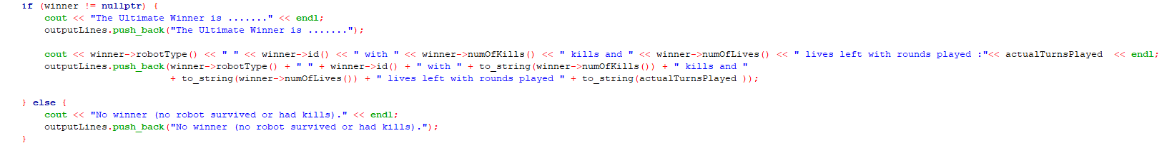
PSUEDOCOEDE:
FUNCTION AnnounceWinner(winner, actualTurnsPlayed, outputLines):
IF winner is not null:
PRINT "The Ultimate Winner is ......."
ADD "The Ultimate Winner is ......." to outputLines
winnerStats = winner's type + " " + winner's ID +
" with " + winner's kill count + " kills and " +
winner's remaining lives + " lives left" +
" with rounds played: " + actualTurnsPlayed
PRINT winnerStats
ADD winnerStats to outputLines
ELSE:
PRINT "No winner (no robot survived or had kills)"
ADD "No winner (no robot survived or had kills)" to outputLines

e. Battlefield two end games
fileInput2b.txt: reached max number of turns
{
Screenshots (inputs, outputs), text screen OUTPUT, figures, explanations
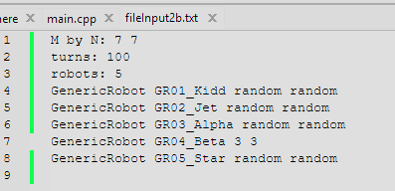
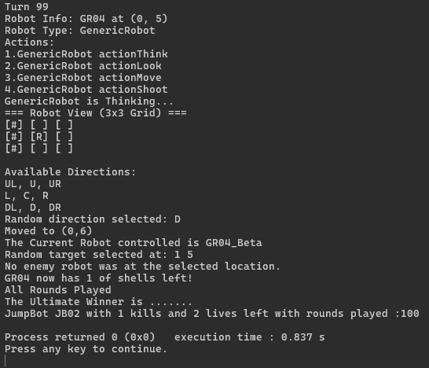

Code segments, fixed seed integer right at first line in the main function, pseudocode parts, explanations

PSUEDOCODE:
FUNCTION AnnounceWinner(winner, actualTurnsPlayed, outputLines):
IF winner is not null:
PRINT "The Ultimate Winner is ......."
ADD "The Ultimate Winner is ......." to outputLines
winnerStats = winner's type + " " + winner's ID +
" with " + winner's kill count + " kills and " +
winner's remaining lives + " lives left" +
" with rounds played: " + actualTurnsPlayed
PRINT winnerStats
ADD winnerStats to outputLines
ELSE:
PRINT "No winner (no robot survived or had kills)"
ADD "No winner (no robot survived or had kills)" to outputLines

Q5. [10] Implementation of the 7 additional required robot classes with OOP concepts i.e. I&P&OO +3

GenericRobot
- actionThink(): random order either actionFire() actionMove() or actionMove() actionFire()
- actionLook(): looks 8 neighbors from its current position
- actionFire(): fires at one random of its 8 neighboring locations, it has only 10 shells to fire in a match, if a robot uses up all its shells then it will self-destruct
- actionMove(): moves to one of its 8 neighboring locations or remain in place

A robot can change only to one robot upgrade after killed an enemy robot.

Screenshots (inputs, outputs), figures, explanations
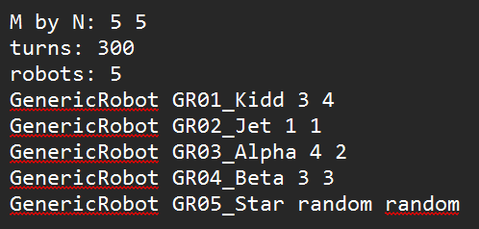

Code segments, pseudocode parts, explanations
ActionThink was suppose to be where the sequence of actions is dertermined, but the reason ours just prints 1 line is because
- We have a separate function that already does it
- Only 1 sequence is allowed (think look move shoot), the reason (think look shoot move) wouldn't work is because the bot would change classes by the time it moves and its hard to keep track for that bot to move while its changing classes
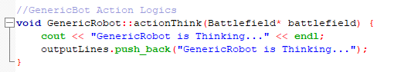

PSEUDOCODE:
FUNCTION actionThink
PRINT generic robot is thinking...
ADD “generic robot is thinking...” to outputLines

ActionLook allows the bot to look at the neighbouring 8 squares by printing the 3 x 3 grid, if there is a bot it will print the first initial of that bot, if its out of bound it will print a #.

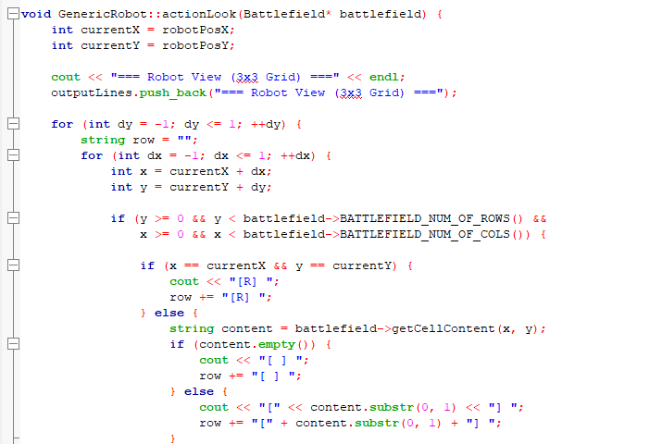
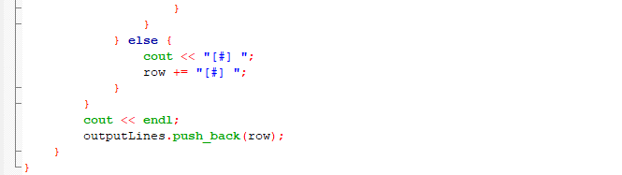

PSEUDOCODE :
FUNCTION actionLook(battlefield)
currentX = robot's X position
currentY = robot's Y position
PRINT "=== Robot View (3x3 Grid) ==="
ADD "=== Robot View (3x3 Grid) ===" to outputLines
FOR (int dy = -1; dy <= 1; ++dy):
row = ""
FOR (int dx = -1; dx <= 1; ++dx):
x = currentX + dx
y = currentY + dy
IF position (x,y) is within battlefield boundaries:
IF position is robot's current position:
PRINT "[R] "
ADD "[R] " to row
ELSE:
content = get cell content at (x,y)
IF content is empty:
PRINT "[ ] "
ADD "[ ] " to row
ELSE:
PRINT first character of content in brackets
ADD first character of content in brackets to row
ELSE:
PRINT "[#] " (out of bounds)
ADD "[#] " to row
PRINT newline
ADD row to outputLines

ActionMove it records the current robots location and randomly choses a location to move to in the 8 neigbouring squares, if it picked a spot out of bounds or a robot is occupying it, it will not count.

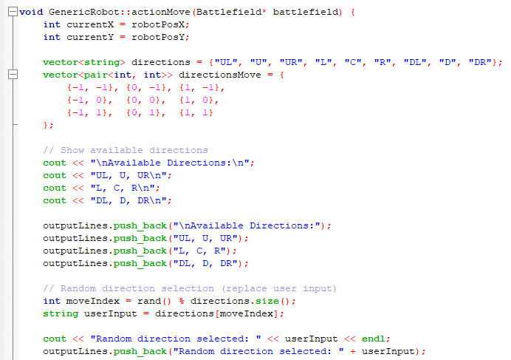
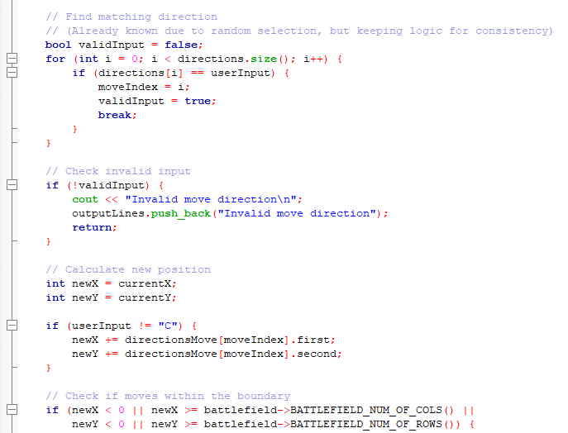
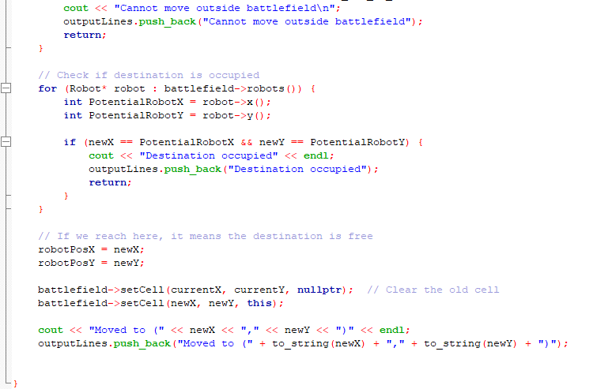

PSEUDOCODE :
FUNCTION actionLook
INT currentX = robotPosX;
INT currentY = robotPosY;

VECTOR directions = {"UL", "U", "UR", "L", "C", "R", "DL", "D", "DR"}
VECTOR PAIR directionsMove = {
{-1, -1}, {0, -1}, {1, -1},
{-1, 0}, {0, 0}, {1, 0},
{-1, 1}, {0, 1}, {1, 1}
PRINT "\nAvailable Directions:\n"
PRINT"UL, U, UR\n L, C, R\n DL, D, DR\n”
ADD ("\nAvailable Directions:") to outputLines
ADD ("UL, U, UR\n L, C, R\n DL, D, DR") to outputLines
INT moveIndex = rand() % directions.size();
STRING userInput = directions[moveIndex];
PRINT "Random direction selected: " << userInput << endl
ADD ("Random direction selected: " + userInput) to outputLines
BOOL validInput = false;
FOR (int i = 0; i < directions.size(); i++) {
IF (directions[i] == userInput) {
moveIndex = i;
validInput = true;
BREAK;
If (!validInput)
PRINT “nvalid move direction\n"
ADD("Invalid move direction") to outputLines
RETURN
INT newX = currentX
INT newY = currentY
IF (userInput != "C") {
newX += directionsMove[moveIndex].first
newY += directionsMove[moveIndex].second
IF (newX < 0 | | newX > battlefield columns
PRINT "Cannot move outside battlefield\n"
PRINT("Cannot move outside battlefield") to outputLines
RETURN
FOR (Robot* robot : battlefield->robots())
INT PotentialRobotX = robot->x();
INT PotentialRobotY = robot->y();
IF(newX == PotentialRobotX && newY == PotentialRobotY)
PRINT"Destination occupied"
ADD("Destination occupied") to outputLines
RETURN

robotPosX = newX;
robotPosY = newY;
set old cell to null pointer
set new cell with this robot and new X and Y
PRINT"Moved to (" << newX << "," << newY << ")"
ADD("Moved to (" + to_string(newX) + "," + to_string(newY) + ")") to outputLines

ActionShoot lets a robot randomly shoot a shot at a neighbouring 8 squares , if it hits a taget robot, it will be able to upgrade and randomly picks the upgrade. But if the robot runs out of shells it will self destruct.

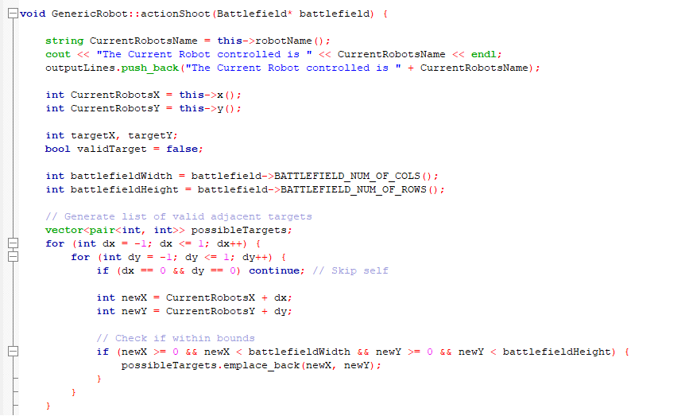
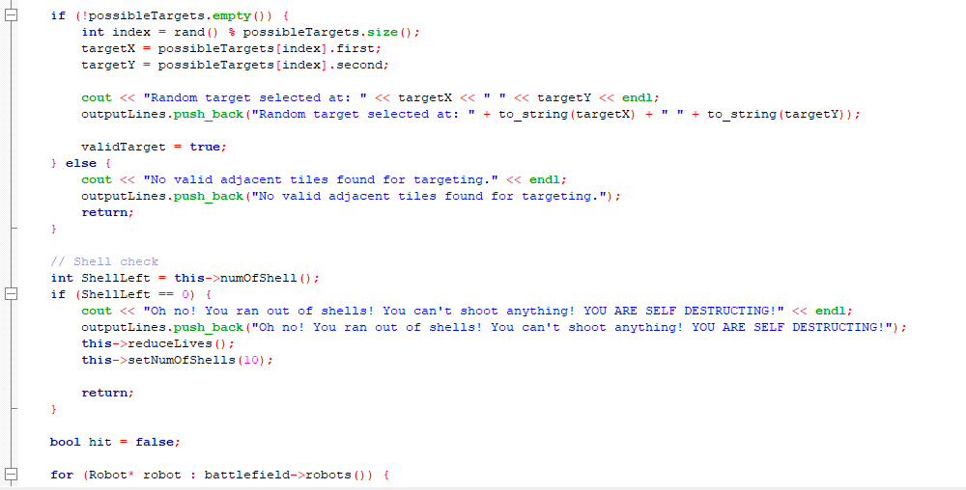
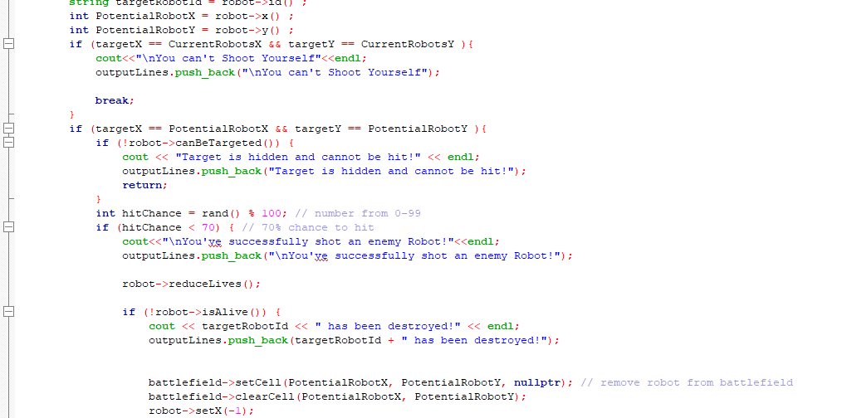
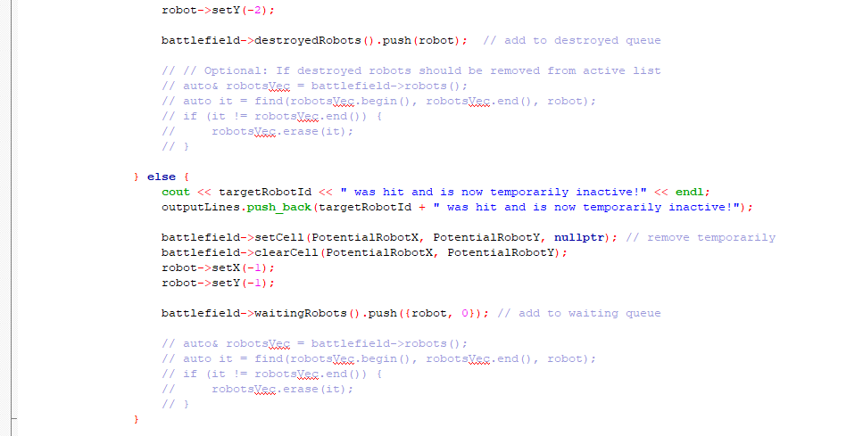
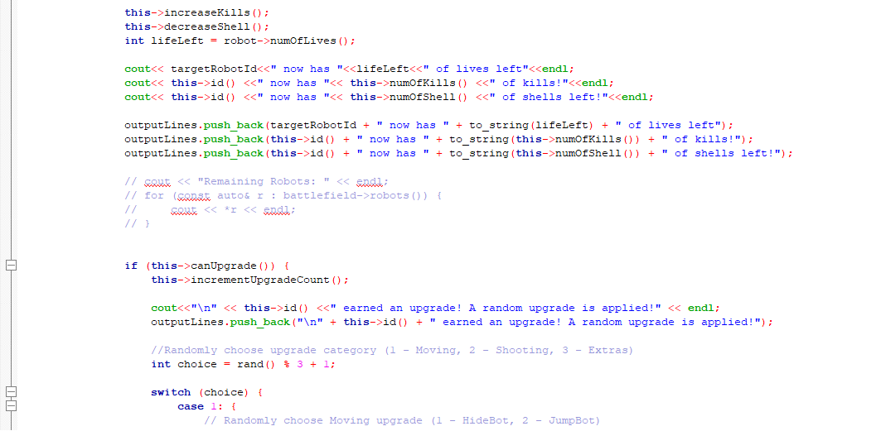
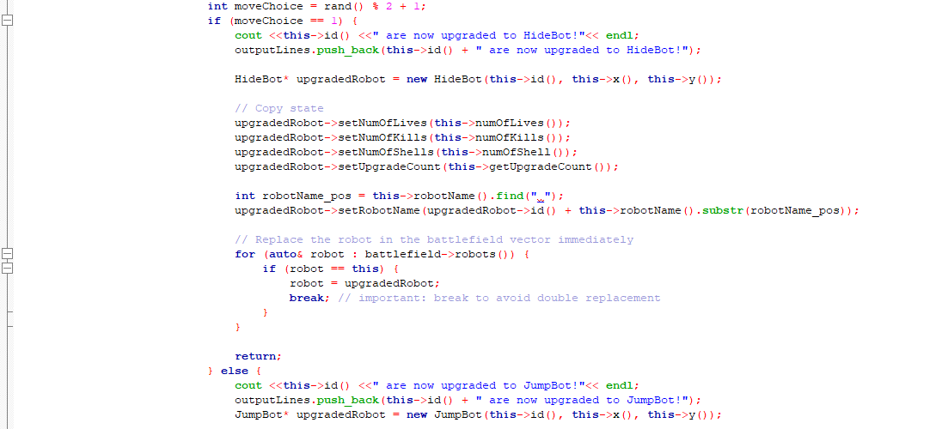
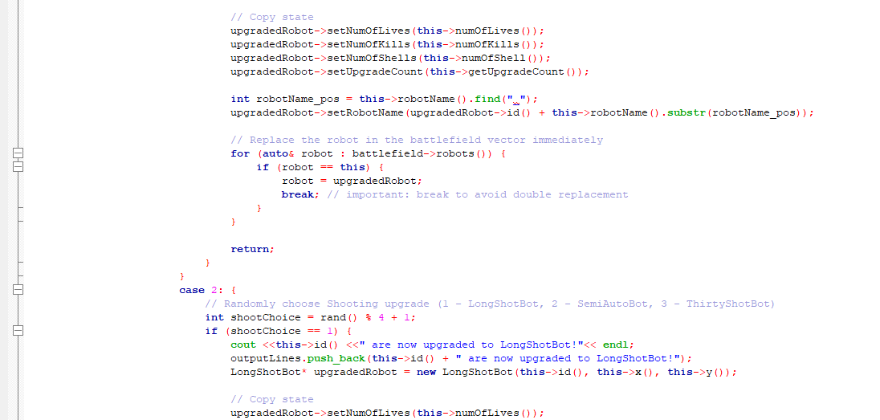
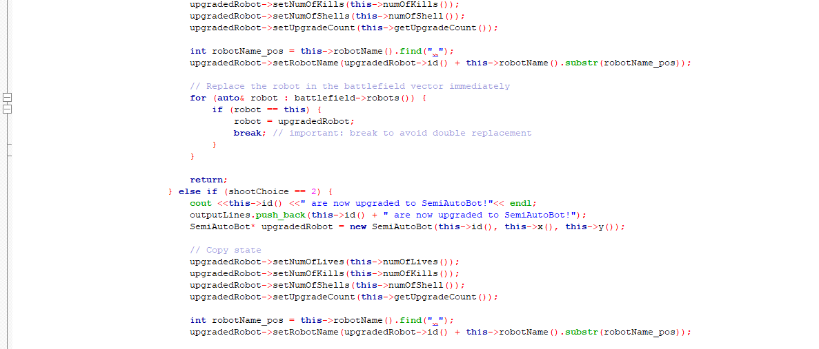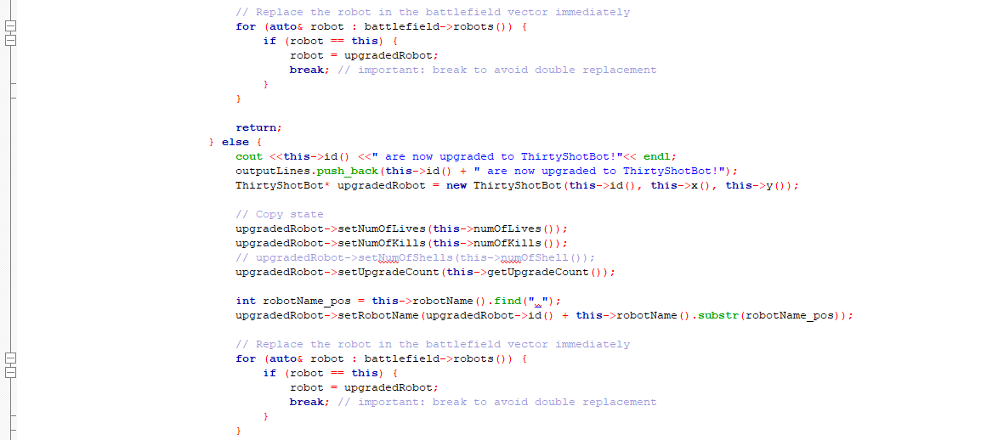
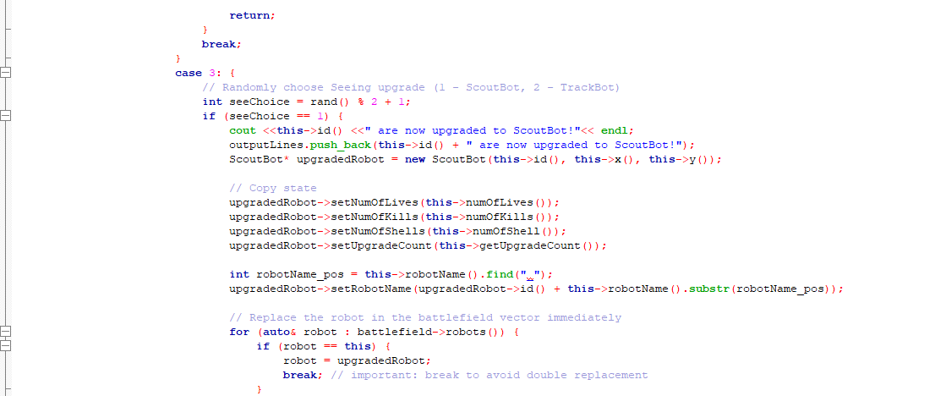
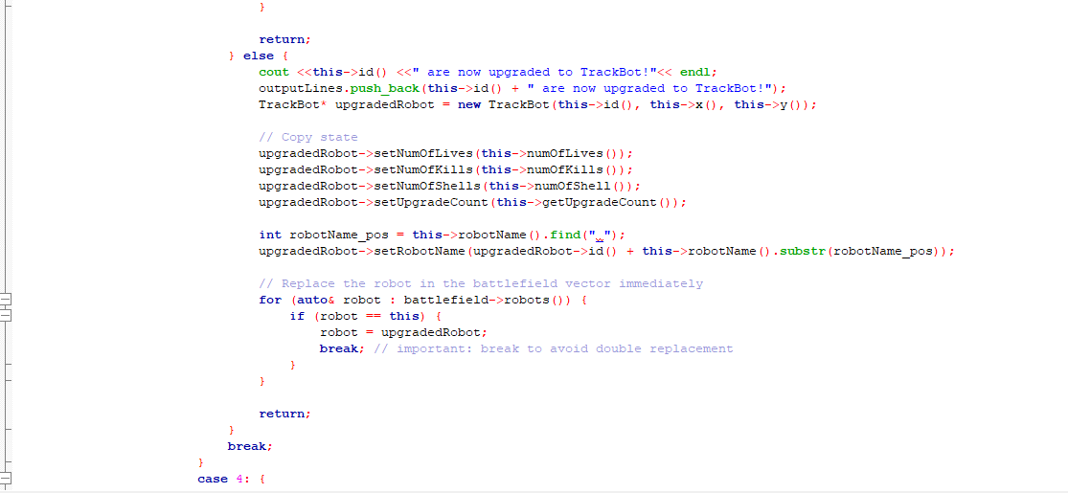
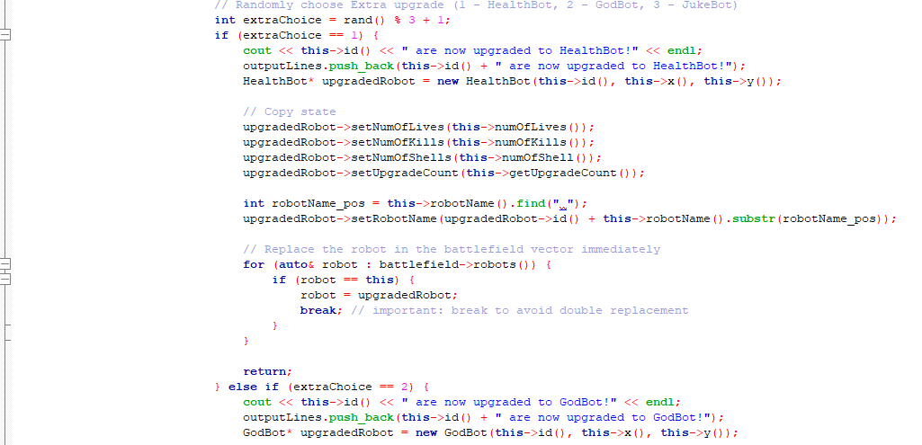
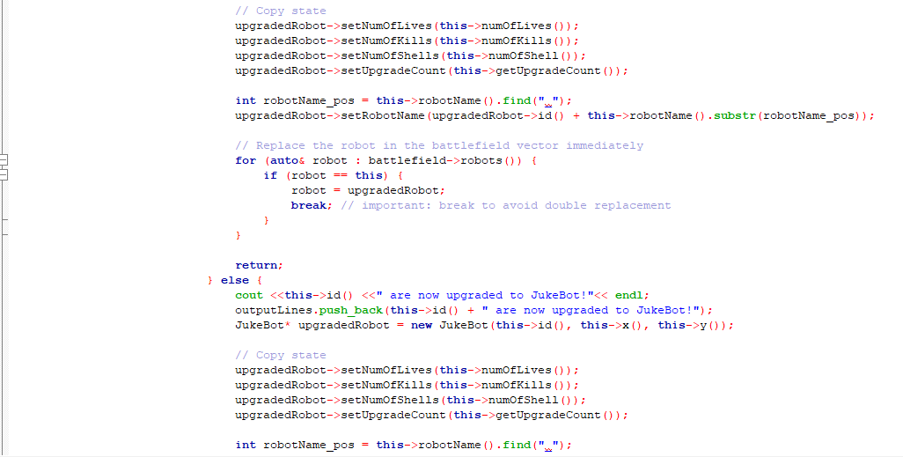
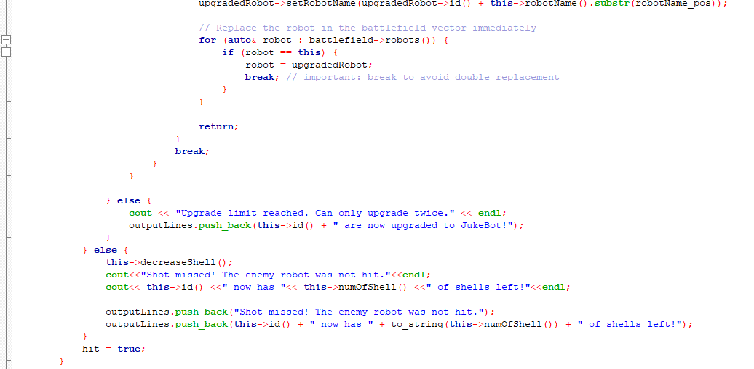
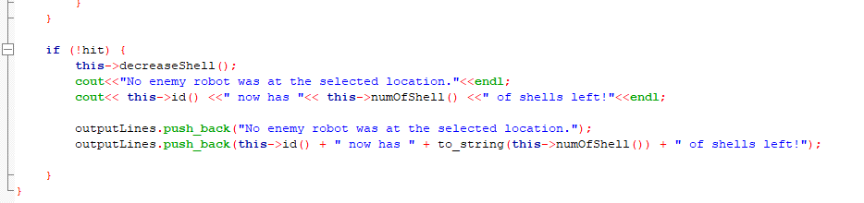

PSEUDOCODE:
FUNCTION actionShoot(battlefield)
PRINT current robot name
ADD current robot name to outputLines
currentX = robot's X position
currentY = robot's Y position
possibleTargets = empty list
FOR (int dx = -1; dx <= 1; dx++):
FOR (int dy = -1; dy <= 1; dy++):
IF dx = 0 AND dy = 0: CONTINUE (skip self)
newX = currentX + dx
newY = currentY + dy
IF (newX, newY) is within battlefield:
ADD (newX, newY) to possibleTargets
IF possibleTargets is not empty:
targetX, targetY = random target from possibleTargets
PRINT selected target
ADD target to outputLines
ELSE:
PRINT no targets message
ADD message to outputLines
RETURN
IF robot has no shells left:
PRINT out of shells message
ADD message to outputLines
reduce robot's lives
reset shells to 10
RETURN
hit = false
FOR EACH robot in battlefield:
IF target is current robot:
PRINT can't shoot self message
ADD message to outputLines
BREAK
IF target matches robot's position:
IF robot can't be targeted:
PRINT target hidden message
ADD message to outputLines
RETURN
hitChance = random number (0-99)
IF hitChance < 70: // 70% hit chance
PRINT hit success message
ADD message to outputLines
reduce target's lives
IF target is dead:
PRINT destroyed message
ADD message to outputLines
remove from battlefield
add to destroyed queue
ELSE:
PRINT hit but alive message
ADD message to outputLines
temporarily remove from battlefield
add to waiting queue
increase shooter's kill count
decrease shooter's shells
PRINT remaining lives, kills, shells
ADD stats to outputLines
IF shooter can upgrade:
increment upgrade count
PRINT upgrade message
ADD message to outputLines
choice = random upgrade category (1-4)
CASE choice:
1: // Moving upgrades (HideBot or JumpBot)
2: // Shooting upgrades (LongShotBot, SemiAutoBot, ThirtyShotBot)
3: // Seeing upgrades (ScoutBot or TrackBot)
4: // Extra upgrades (HealthBot, GodBot, JukeBot)
Create new upgraded robot
Copy all stats from current robot
Replace in battlefield
RETURN
ELSE:
PRINT upgrade limit message
ADD message to outputLines
ELSE:
decrease shells
PRINT miss message and shell count
ADD messages to outputLines
hit = true
IF no robot was hit:
decrease shells
PRINT no target message and shell count
ADD messages to outputLines

a. ScoutBot SBXX
- actionLook(): The robot can look the entire battlefield.

Screenshots (inputs, outputs), figures, explanations
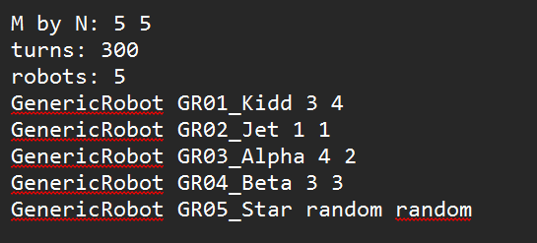
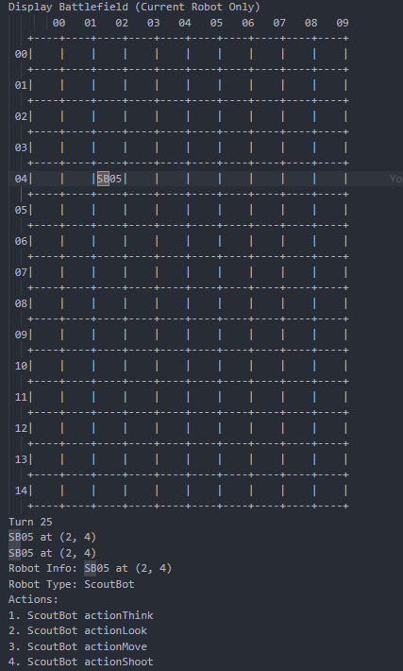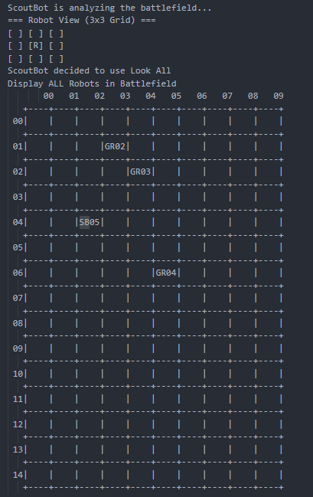

Code segments, pseudocode parts, explanations
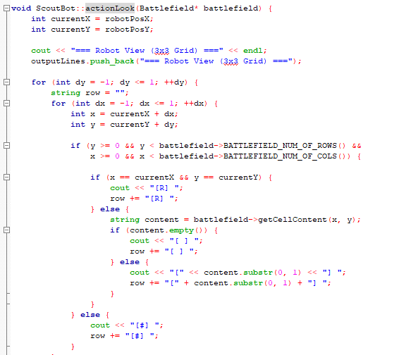

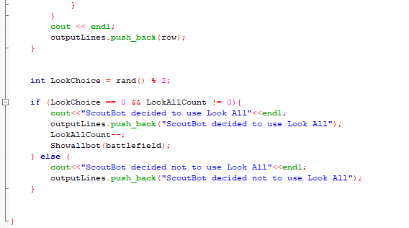

It has a function that is almost like LookAll that enables it to see the entire battlefield when executed, it is tied to a rand() variable of lookChoice, when actionLook is called it could look normally and then randomly choose between looking the entire battlefield or not.

PSEUDOCODE:
FUNCTION actionLook (Battlefield* Battlefield)
INT currentX = robotPosX;
INT currentY = robotPosY;
PRINT "=== Robot View (3x3 Grid) ==="
ADD "=== Robot View (3x3 Grid) ===" to outputLines
FOR (int dy = -1; dy <= 1; ++dy)
STRING row = "";
FOR (int dx = -1; dx <= 1; ++dx)
INT x = currentX + dx;
INT y = currentY + dy;
IF y > 0 & y < battlefield rows & x > 0 & x < battlefield coloumns
IF(x == currentX && y == currentY)
PRINT "[R] "
ADD "[R] " to rows
ELSE
STRING content = battlefield->getCellContent(x, y);
if (content.empty()) {
PRINT "[ ] "
ADD row "[ ] " to outputLines
ELSE
PRINT first letter of content
ADD first letter of content to rows
ELSE
PRINT"[#] "
ADD row "[#] "

b. TrackBot TBXX
- actionLook(): The robot can plant a tracker on another enemy robot so that it can look. The robot has maximum of three trackers to look on maximum of three enemy robots.

Screenshots (inputs, outputs), figures, explanations
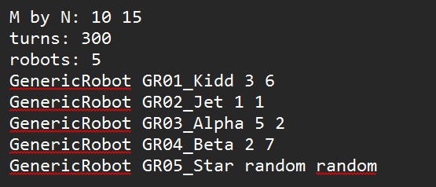
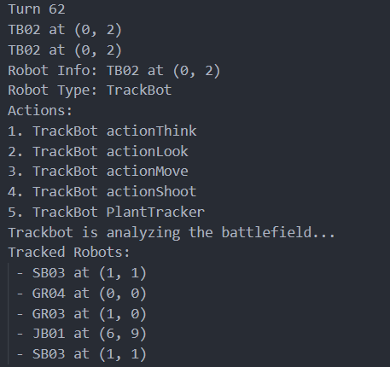

Code segments, pseudocode parts, explanations
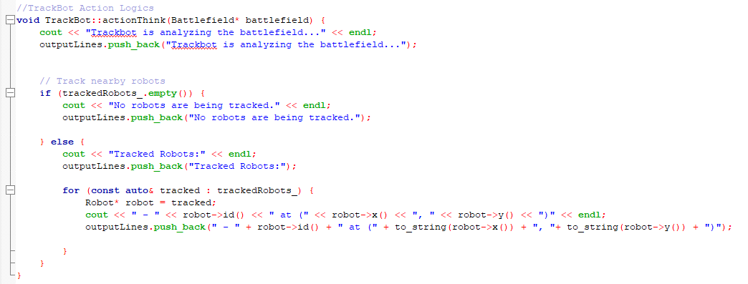
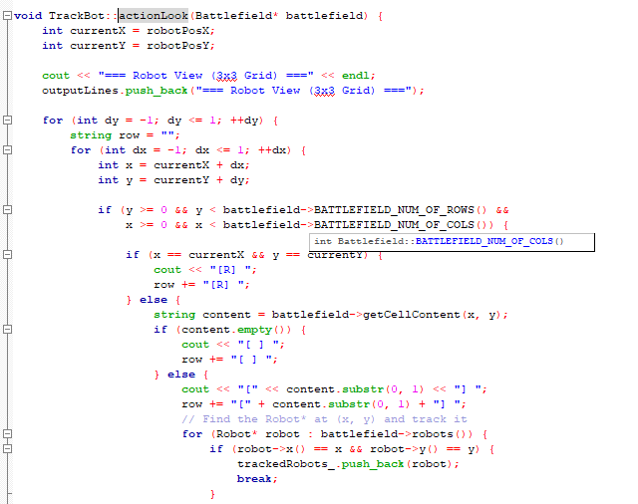

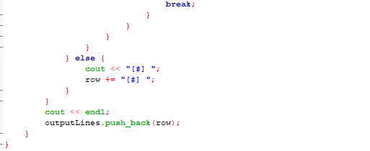

TrackBot when using actionThink can see currently tracking robots it has placed a tracker on. It places a tracker when it uses actionLook and sees a robot in its neighbouring 8 squares.

PSEUDOCODE:
ActionThink
FUNCTION actionThink(battlefield)
PRINT "Trackbot is analyzing the battlefield..."
ADD message to outputLines
IF trackedRobots_ list is empty:
PRINT "No robots are being tracked."
ADD message to outputLines
ELSE:
PRINT "Tracked Robots:"
ADD header to outputLines
FOR EACH robot in trackedRobots_:
PRINT robot's ID and position (x,y)
ADD robot info to outputLines

ActionLook
FUNCTION actionLook(battlefield)
currentX = robot's X position
currentY = robot's Y position
PRINT "=== Robot View (3x3 Grid) ==="
ADD grid header to outputLines
FOR dy FROM -1 TO 1:
row = empty string
FOR dx FROM -1 TO 1:
x = currentX + dx
y = currentY + dy
IF (x,y) is within battlefield boundaries:
IF position is robot's current position:
PRINT "[R] "
ADD "[R] " to row
ELSE:
content = get cell content at (x,y)
IF content is empty:
PRINT "[ ] "
ADD "[ ] " to row
ELSE:
PRINT first character of content in brackets
ADD first character in brackets to row
FOR EACH robot in battlefield:
IF robot is at (x,y):
ADD robot to trackedRobots_ list
BREAK
ELSE: // Out of bounds
PRINT "[#] "
ADD "[#] " to row
PRINT newline
ADD row to outputLines

c. LongShotBot LBXX
- actionFire(): The robot can fire up to three units distance away from its location. It means the robot can fire(x, y) where dx + dy <= 3.

Screenshots (inputs, outputs), figures, explanations
Input
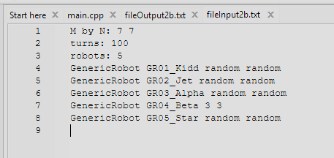
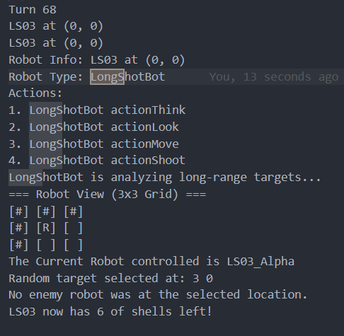

Code segments, pseudocode parts, explanations
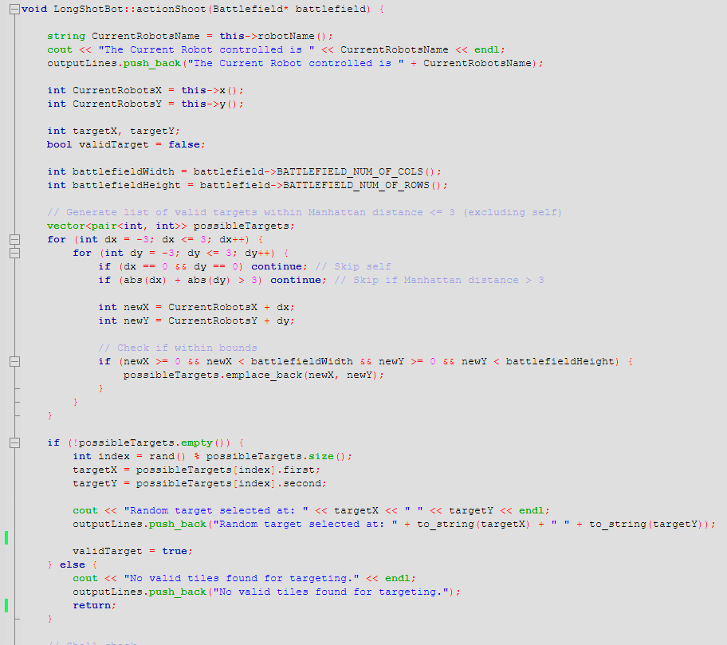

- Create all possible target that maximum 3 units away and emplace into vector<pair<int,int>> possibleTargets;
- If possibleTargets is not empty than it use rand() to get randomise targetX and targetY
- Then actionShoot is the same as GenericRobot where it check if the targetX and targetY contain another robot.

PSEUDOCODE:
FUNCTION actionShoot(battlefield):
PRINT "The Current Robot controlled is [robotName]"
ADD message to outputLines
currentX = robot's X position
currentY = robot's Y position
// Initialize target variables
targetX, targetY = 0
validTarget = false
battlefieldWidth = battlefield's width
battlefieldHeight = battlefield's height
// Generate possible targets (Manhattan distance ≤ 3)
possibleTargets = empty list
FOR dx FROM -3 TO 3:
FOR dy FROM -3 TO 3:
IF dx = 0 AND dy = 0:
CONTINUE // Skip self
IF |dx| + |dy| > 3:
CONTINUE // Skip if beyond range
newX = currentX + dx
newY = currentY + dy
IF (newX, newY) is within battlefield bounds:
ADD (newX, newY) to possibleTargets
// Select a random target
IF possibleTargets is not empty:
index = random index in possibleTargets
targetX, targetY = possibleTargets[index]
PRINT "Random target selected at: (targetX, targetY)"
ADD message to outputLines
validTarget = true
ELSE:
PRINT "No valid tiles found for targeting."
ADD message to outputLines
RETURN
// (Rest of the shooting logic would go here...)

d. SemiAutoBot SAXX
- actionFire(): Each shot the robot fires is now considered as three consecutive shells into one location and each fire of three shells to destroy another robot if any.

Screenshots (inputs, outputs), figures, explanations
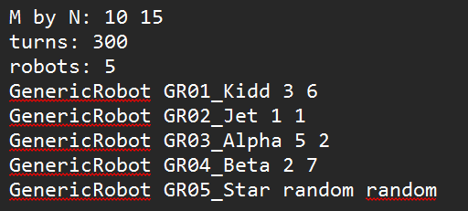
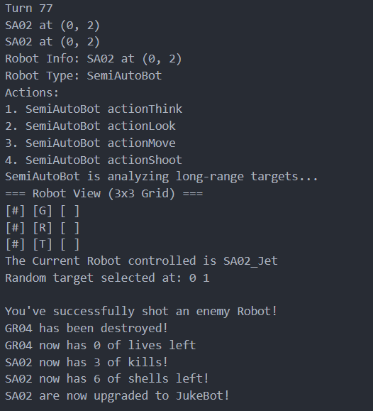

Code segments, pseudocode parts, explanations
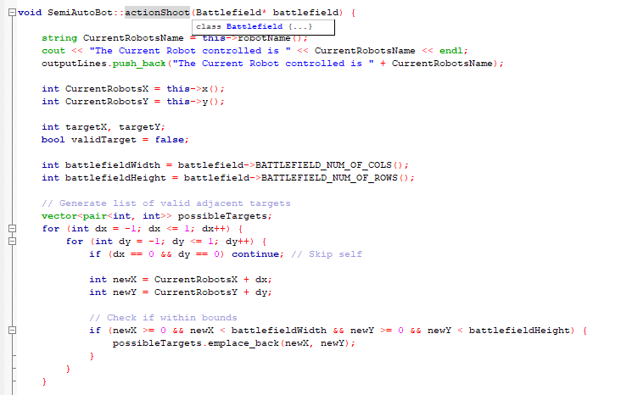
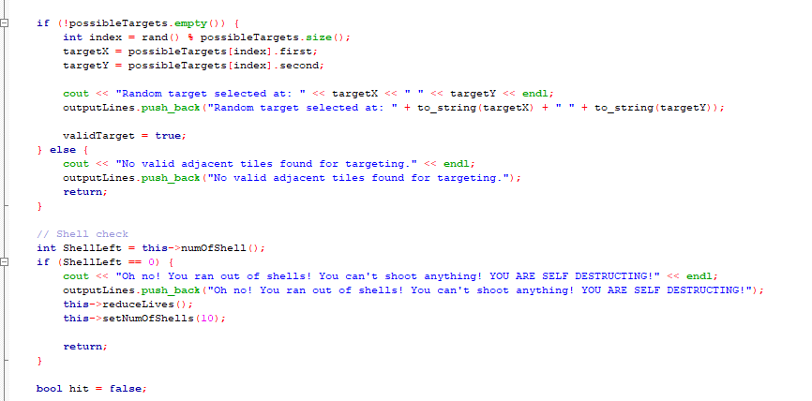

PSEUDOCODE:
IF targetX is equal to PotentialRobotX AND targetY is equal to PotentialRobotY THEN
IF robot cannot be targeted THEN
OUTPUT "Target is hidden and cannot be hit!"
ADD "Target is hidden and cannot be hit!" TO outputLines
RETURN from the function
ENDIF

SET threeShotSuccess TO FALSE
INITIALIZE hitChance as INTEGER

FOR i FROM 0 TO 2 DO
SET chance TO random number between 0 and 99
IF chance < 70 THEN
SET threeShotSuccess TO TRUE
BREAK the loop
ENDIF
ENDFOR

IF threeShotSuccess IS TRUE THEN
SET hitChance TO 69 // make it successful
ELSE
SET hitChance TO 80 // make it unsuccessful
ENDIF

IF hitChance < 70
OUTPUT "You’ve successfully shot an enemy Robot!"
ADD " You’ve successfully shot an enemy Robot! " TO outputLines

CONTINUE ON SHOOTACTION SAME AS GENERICROBOT • • •
END

EXPLAIN
- SemiAutoBot instead of doing 1 random hit chance after aiming at a target with robot, it has 3 tries to be successful
- If any turn is successful, it sets threeShotSuccess to true and break the loop
- Then as threeShotSuccess is true hitChance is set to 69, if false it is set to 80 which is unsuccessful and won’t hit the enemy

e. ThirtyShotBot TSXX
- actionFire(): The robot now has a fresh load of 30 shells replacing its current load of shells.

Screenshots (inputs, outputs), figures, explanations
Input:
Output:
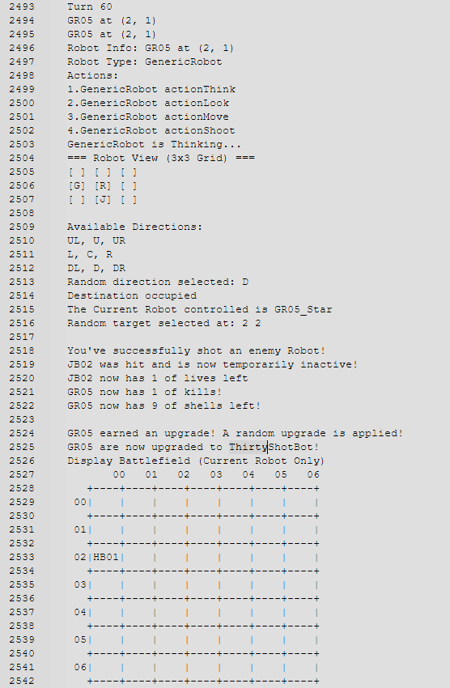
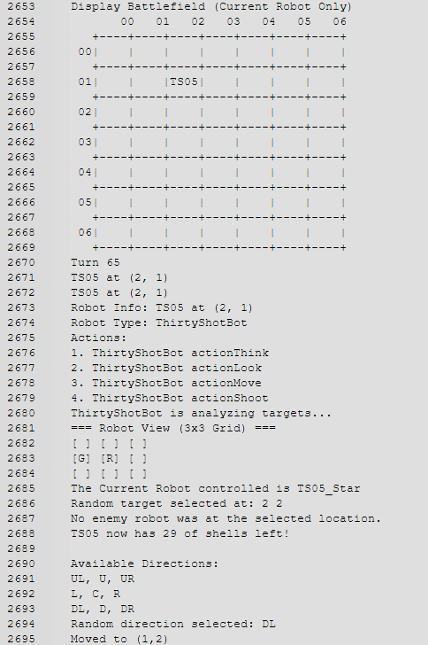

- After turning into ThirtyShotBot, its shells is set to for 30 next round

Code segments, pseudocode parts, explanations
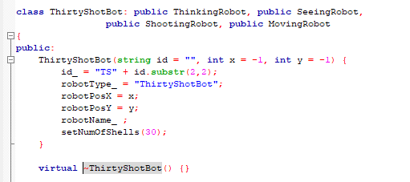

PSEUDOCODE:
FUNCTION Constructor ThirtyShotBot(id = "", x = -1, y = -1)

SET id_ TO "TS" + substring of id from position 2 to 3

SET robotType_ TO "ThirtyShotBot"

SET robotPosX TO x
SET robotPosY TO y

CALL setNumOfShells WITH argument 30
END FUNCTION

EXPLAIN
-We didn’t do it actionFire() instead after upgrading into ThrityShotBot, its shell is set to 30 instantly.

f. HideBot HBXX- actionMove(): The robot can hide three turns in a match. When the robot hides, it cannot be hit by other enemy robots.

Screenshots (inputs, outputs), figures, explanations
Input :
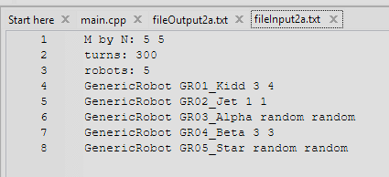
Output:
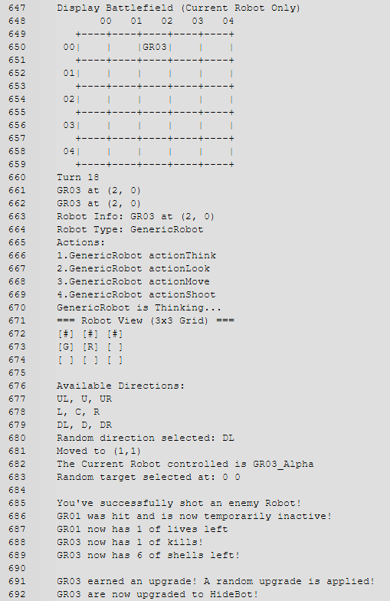
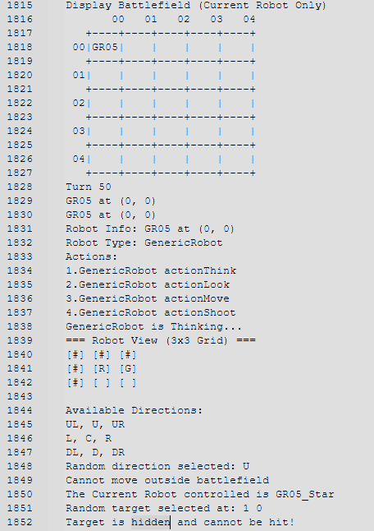

Code segments, pseudocode parts, explanations
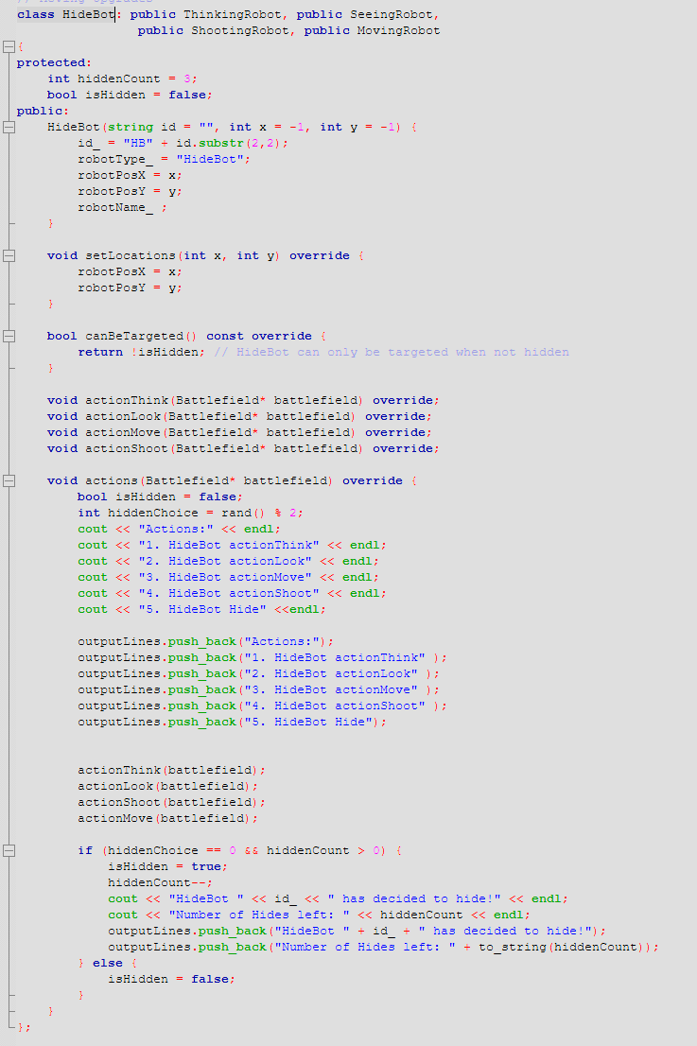
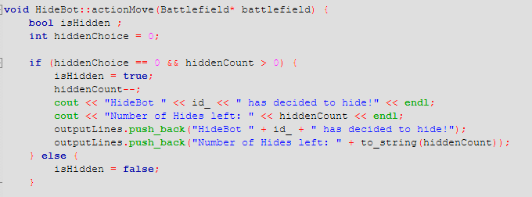

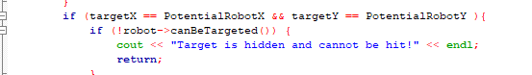

Pseudocode 1
FUNCTION actionMove(battlefield):
INITIALIZE variable isHidden
SET hiddenChoice to 0

IF hiddenChoice is 0 AND hiddenCount is greater than 0:
SETi sHidden to true
DECREASEhiddenCount by 1
OUTPUT "HideBot [id] has decided to hide!"
OUTPUT "Number of Hides left: [hiddenCount]"
ADD message "HideBot [id] has decided to hide!" TO output log
ADD message "Number of Hides left: [hiddenCount]" TO output log
ELSE
SET isHidden TO FASLE

CONTINUE ON actionMove that is same as GENEREICBOT • • • • •
Pseudocode 2

IF targetX equals PotentialRobotX AND targetY equals PotentialRobotY:
IF robot cannot be targeted:
OUTPUT "Target is hidden and cannot be hit!"
ADD "Target is hidden and cannot be hit!" to output log
EXIT

CONTINUE ON actionShoot that is same as GENEREICBOT • • • • •

Explanation
- Implement a bool function in HideBot class called canBeTargeted() which returns !isHidden
- In ActionMove, create boolean isHidden and hiddenChoice is selected with rand()
- If hiddenChoice is 0 then it hides and isHidden is True ELSe isHidden is False

- In all ActionShoot of all robots , after checking the pos contain a robot, it thens check if (!robot->canTargeted()) , when hidden is true it runs as (!(!(hidden)) == (hidden).
- If true it can’t be shot.

g. JumpBot JBXX
- actionMove(): The robot can jump to a new location anywhere in the battlefield. It can jump three times in a match.

Screenshots (inputs, outputs), figures, explanations
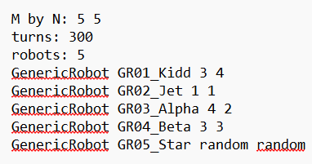

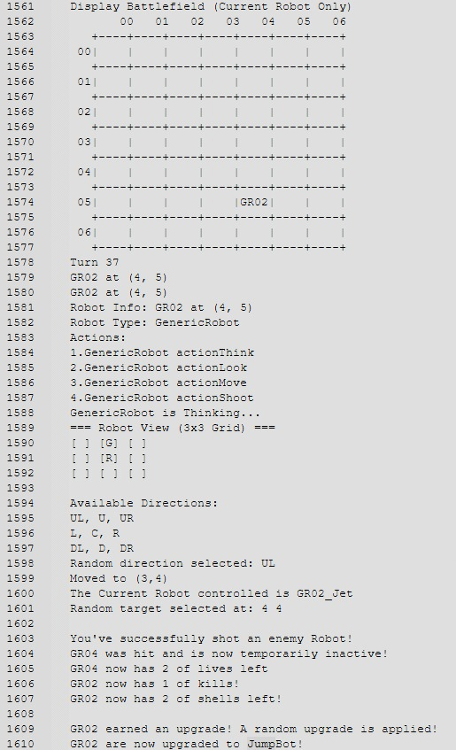

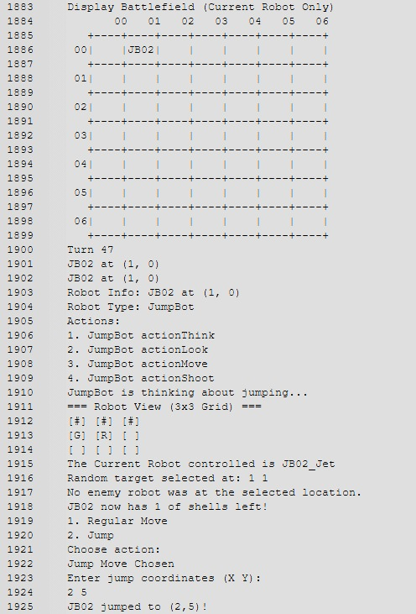

- All robots are taking turns during each game round.
- When its JumpBot’s turn it automatically run its own action methods
- JumpBot is not manually selected
- During its move, it randomly chosen 0=regular move while 1 =jump
- If 1=jump is chosen
- Random jump coordinate will generated
- Position will be checked for validility
- If valid then jump will perform
- Jump count will increased by 1
- A GenericRobot can be upgraded to JumpBot after earning a kill
- Once upgrade it will behave like a JumpBot in future turn

Code segments, pseudocode parts, explanations
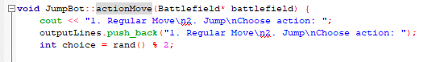

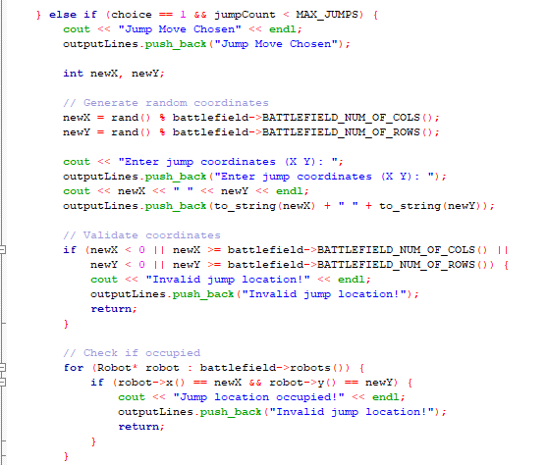

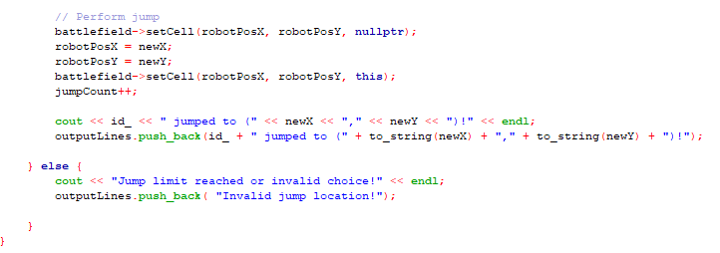

Pseudocode
Part 1
DISPLAY "1. Regular Move\n2. Jump\nChoose action:"
ADD message to outputLines

SET choice to a random number between 0 and 1

Part 2
IF choice is 1 AND jumpCount is less than MAX_JUMPS THEN
DISPLAY "Jump Move Chosen"
ADD message to outputLines

GENERATE random coordinates newX and newY within battlefield bounds

DISPLAY "Enter jump coordinates (X Y):"
DISPLAY newX and newY
ADD messages to outputLines

IF newX or newY is out of battlefield bounds THEN
DISPLAY "Invalid jump location!"
ADD message to outputLines
EXIT the function
ENDIF

FOR each robot on battlefield
IF another robot exists at (newX, newY) THEN
DISPLAY "Jump location occupied!"
ADD message to outputLines
EXIT the function
ENDIF
END FOR

Part 3
SET current cell (robotPosX, robotPosY) to empty
UPDATE robotPosX to newX
UPDATE robotPosY to newY
SET new cell (robotPosX, robotPosY) to this robot
INCREMENT jumpCount by 1

DISPLAY "[id_] jumped to (newX, newY)!"
ADD message to outputLines

ELSE
DISPLAY "Jump limit reached or invalid choice!"
ADD message to outputLines

Explanation
- The robot shows 2 option Regular Move or Jump and randomly choose 1 action.
- If Jump is chosen and the robot have jumps left:
- I t picks random position on the battlefield
- It checks iof the position is valid
- If is valid and free, the robot jumps to the new position and the jump count increases
- A success message is printed
- If the jump limit is reached:
- An error message is printed adn the robot stays in places

Inheritance, figures, explanations
code segments, pseudocode parts, explanations
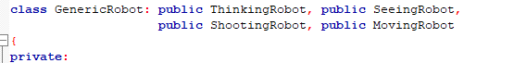
GenericRobot including the other upgrade bots all inherit the base class of Thinking, Seeing, Shooting, Moving Robot

Polymorphism, figures, explanations
code segments, pseudocode parts, explanations
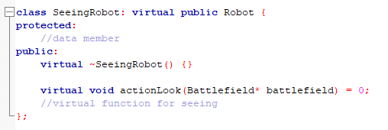
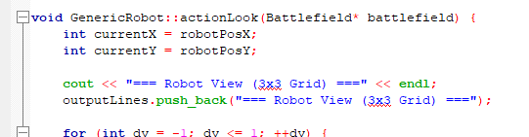
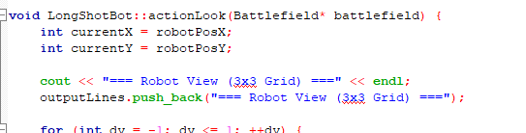

ThinkingRobot is a base abstract class that only has a Pure Virtual Function that all other classes inherit and redefine differently

Operator overloading, figures, explanations
code segments, pseudocode parts, explanations
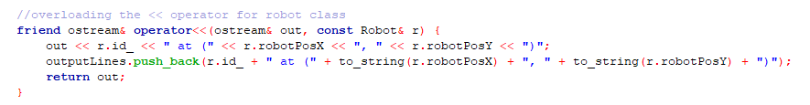
Here we overload the << function as a friend with the robot class, so the cout is able to access private members of the class.

Q6. [5] The algorithms used to optimize the actions of robots, vector, queue

Algorithm 1 using optimize the action, figures, explanations
Vector: keep track robot actions during the simulation
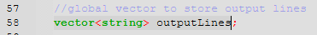

Algorithm 1 screenshots (inputs, outputs), explanations
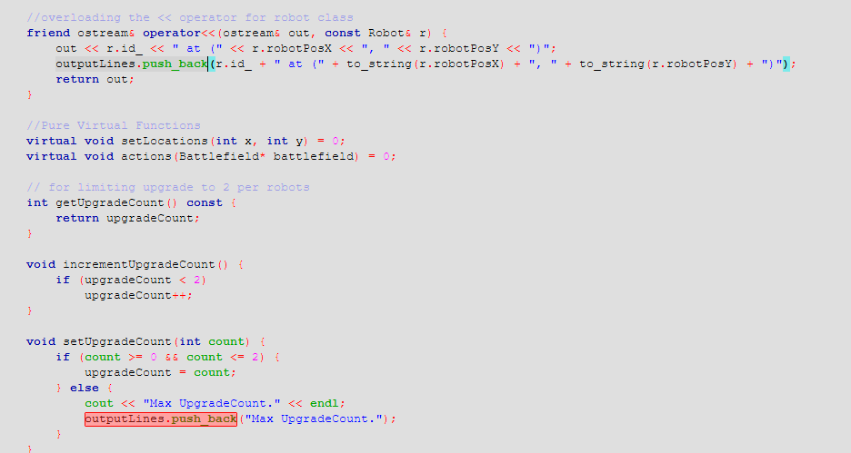
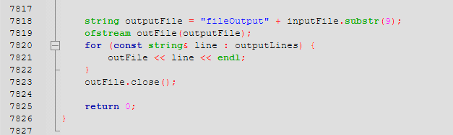

Algorithm 1 code segments, pseudocode parts, explanations

PSEUDOCODE
Part1
INITIALIZE GLOBALLY vector<string> outputLines;

Part2
SET outputFile TO "fileOutput" + SUBSTRING OF inputFile STARTING FROM index 9
OPEN outputFile FOR writing AS outFile

FOR EACH line IN outputLines:
WRITE line TO outFile WITH newline

CLOSE outFile
END

Explaination
- Every line of code that contain cout is followed by outputLines.push_back() that push string into the vector to be output to a txt file at the end of the program.

Algorithm 2 optimize the action, figures, explanations
Two queues: keep track of the respective destroyed and waiting robots
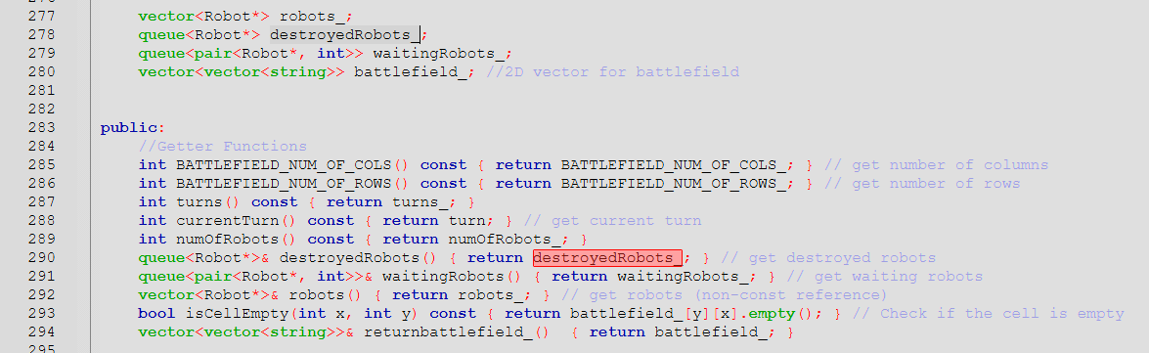

Algorithm 2 screenshots (inputs, outputs), explanations
Updatewaitingrobots() uses waitingrobots_, it let them wait for a certain round before letting them return to battlefield
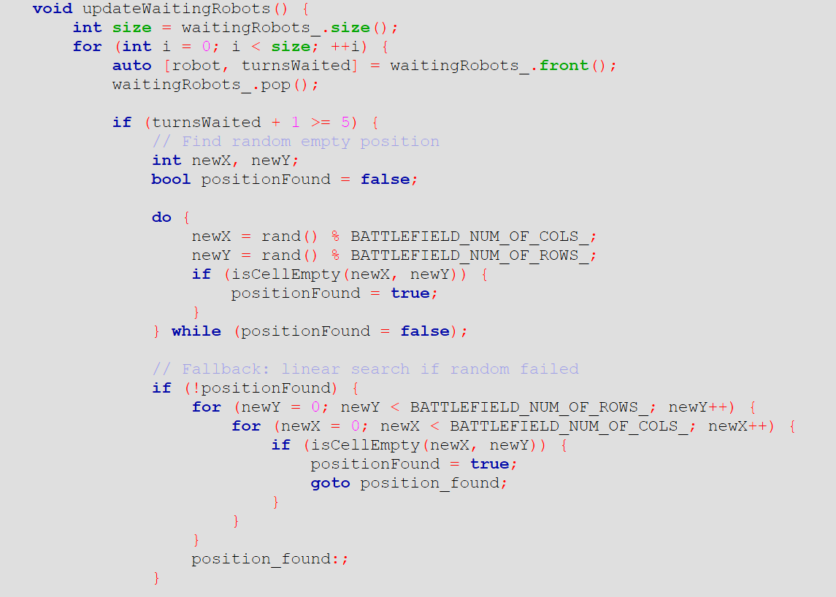
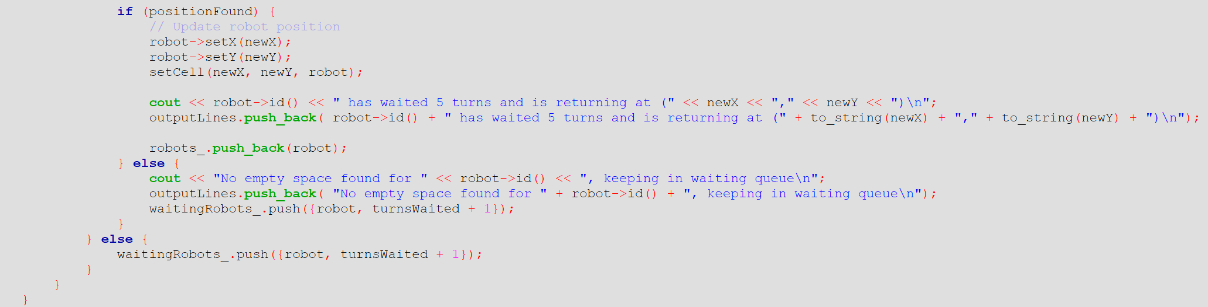

PlaceRobots() check for whether a robot is in waitingRobots_ or destroyedRobots_ before placing
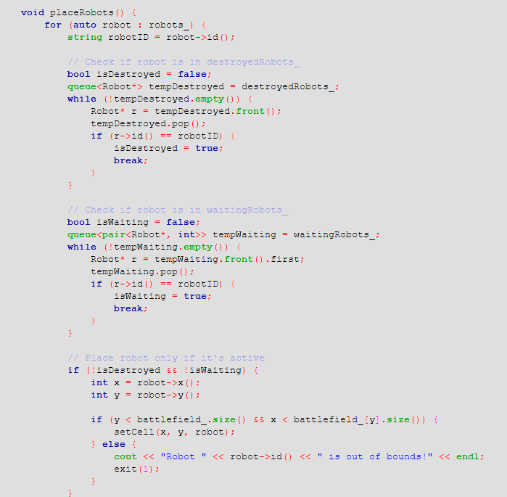

In actionShoot() of every class we set pos to –1 , -1 to for waiting robots, then push into waitingRobots() and –1 , -2 for destroyed robots and push into waitingRobots()
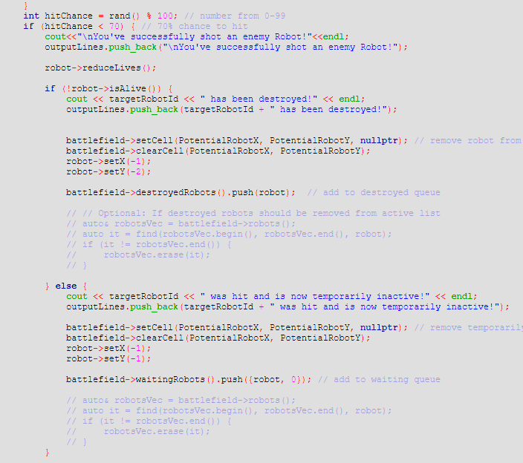
In main we used the pos for destroyed and waiting robot to skip turns
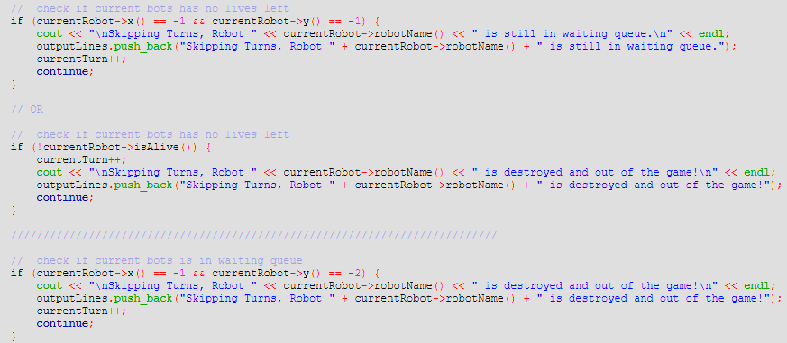

Algorithm 2 code segments, pseudocode parts, explanations

PSEUDOCODE

FUNCTION updateWaitingRobots: SET size TO SIZE OF waitingRobots_
FOR i FROM 0 TO size - 1:
REMOVE the front ELEMENT OF waitingRobots_ AND UNPACK INTO robot AND turnsWaited
IF turnsWaited + 1 IS GREATER THAN OR EQUAL TO 5 THEN:
SET positionFound TO FALSE
DO:
SET newX TO RANDOM INTEGER MODULO BATTLEFIELD_NUM_OF_COLS_
SET newY TO RANDOM INTEGER MODULO BATTLEFIELD_NUM_OF_ROWS_
IF cell AT (newX, newY) IS empty THEN:
SET positionFound TO TRUE
WHILE positionFound = FALSE
IF positionFound IS FALSE THEN:
FOR newY FROM 0 TO BATTLEFIELD_NUM_OF_ROWS_ - 1:
FOR newX FROM 0 TO BATTLEFIELD_NUM_OF_COLS_ - 1:
IF cell AT (newX, newY) IS empty THEN:
SET positionFound TO TRUE
GOTO position_found
LABEL position_found
IF positionFound IS TRUE THEN:
SET robot X coordinate TO newX
SET robot Y coordinate TO newY
PLACE robot ON battlefield cell AT (newX, newY)
OUTPUT message: robot has waited 5 turns and is returning
ADD message TO outputLines
ADD robot TO robots_ list
ELSE:
OUTPUT message: no empty space found
ADD message TO outputLines
ADD (robot, turnsWaited + 1) BACK TO waitingRobots_
ELSE:
ADD (robot, turnsWaited + 1) BACK TO waitingRobots_
END FOR
END FUNCTION

2. FUNCTION updateWaitingRobots: SET size TO SIZE OF waitingRobots_
FOR i FROM 0 TO size - 1 DO:
EXTRACT robot AND turnsWaited FROM FRONT OF waitingRobots_
REMOVE FRONT OF waitingRobots_
IF turnsWaited + 1 IS GREATER THAN OR EQUAL TO 5 THEN:
SET positionFound TO FALSE
DO:
SET newX TO RANDOM NUMBER MODULO BATTLEFIELD_NUM_OF_COLS_
SET newY TO RANDOM NUMBER MODULO BATTLEFIELD_NUM_OF_ROWS_
IF isCellEmpty(newX, newY) IS TRUE THEN:
SET positionFound TO TRUE
WHILE positionFound IS EQUAL TO FALSE
IF positionFound IS FALSE THEN:
FOR newY FROM 0 TO BATTLEFIELD_NUM_OF_ROWS_ - 1 DO:
FOR newX FROM 0 TO BATTLEFIELD_NUM_OF_COLS_ - 1 DO:
IF isCellEmpty(newX, newY) IS TRUE THEN:
SET positionFound TO TRUE
GOTO position_found
END FOR
END FOR
LABEL position_found:
END IF
IF positionFound IS TRUE THEN:
CALL robot->setX(newX)
CALL robot->setY(newY)
CALL setCell(newX, newY, robot)
OUTPUT robot ID AND RETURN POSITION MESSAGE
ADD MESSAGE TO outputLines
ADD robot TO robots_
ELSE:
OUTPUT "No empty space found" MESSAGE
ADD MESSAGE TO outputLines
ADD {robot, turnsWaited + 1} TO waitingRobots_
END IF
ELSE:
ADD {robot, turnsWaited + 1} TO waitingRobots_
END IF
END FOR
END FUNCTION

3. FUNCTION placeRobots: FOR EACH robot IN robots_ DO: SET robotID TO robot's ID
SET isDestroyed TO FALSE
COPY destroyedRobots_ TO tempDestroyed
WHILE tempDestroyed IS NOT EMPTY DO:
SET r TO FRONT OF tempDestroyed
REMOVE FRONT FROM tempDestroyed
IF r's ID EQUALS robotID THEN:
SET isDestroyed TO TRUE
BREAK
END WHILE
SET isWaiting TO FALSE
COPY waitingRobots_ TO tempWaiting
WHILE tempWaiting IS NOT EMPTY DO:
SET r TO FIRST ELEMENT’S ROBOT IN tempWaiting
REMOVE FRONT FROM tempWaiting
IF r's ID EQUALS robotID THEN:
SET isWaiting TO TRUE
BREAK
END WHILE
IF isDestroyed IS FALSE AND isWaiting IS FALSE THEN:
SET x TO robot's X position
SET y TO robot's Y position
IF y < battlefield_ SIZE AND x < battlefield_[y] SIZE THEN:
CALL setCell(x, y, robot)
ELSE:
OUTPUT "Robot " + robotID + " is out OF bounds!"
TERMINATE PROGRAM
END IF
END FOR
END FUNCTION

4.
IF robot IS NOT alive THEN
DISPLAY targetRobotId + " has been destroyed!"
ADD targetRobotId + " has been destroyed!" TO outputLines

SET cell at (PotentialRobotX, PotentialRobotY) TO NULL IN battlefield
CLEAR cell at (PotentialRobotX, PotentialRobotY) IN battlefield

SET robot X TO -1
SET robot Y TO -2

PUSH robot TO destroyedRobots QUEUE IN battlefield

ELSE
DISPLAY targetRobotId + " was hit and is now temporarily inactive!"
ADD targetRobotId + " was hit and is now temporarily inactive!" TO outputLines

SET cell at (PotentialRobotX, PotentialRobotY) TO NULL IN battlefield
CLEAR cell at (PotentialRobotX, PotentialRobotY) IN battlefield

SET robot X TO -1
SET robot Y TO -1

PUSH (robot, 0) TO waitingRobots QUEUE IN battlefield
END IF

5.
WHILE (currentTurn < totalTurns)
• • • •
IF robot's position is (-1, -1) THEN
PRINT "Skipping Turns, Robot [robotName] is still in waiting queue."
ADD to outputLines "Skipping Turns, Robot [robotName] is still in waiting queue."
INCREMENT currentTurn
CONTINUE to next robot

IF robot is not alive (isAlive() == false) THEN
PRINT "Skipping Turns, Robot [robotName] is destroyed and out of the game!"
ADD to outputLines "Skipping Turns, Robot [robotName] is destroyed and out of the game!"
INCREMENT currentTurn
CONTINUE to next robot

IF robot's position is (-1, -2) THEN
PRINT "Skipping Turns, Robot [robotName] is destroyed and out of the game!"
ADD to outputLines "Skipping Turns, Robot [robotName] is destroyed and out of the game!"
INCREMENT currentTurn
CONTINUE to next robot

CONTINUITAION OF WHILE LOOP CODE• • • •

EXPLANATION
- Updatewaitingrobots() can be called using battlefield->waitingRobots().push({robot, 0});
  - It push in robots and at the same time and an int 0 which mean it start to count down from 0
  - Updatewaitingrobots() accept an int to count down from it to 5.
  - After 5, it randomise an unoccupied location for the robot to be respawned at.
  - The robot is then .pop out of the queue waitingRobots_ and respawned at random location.
  - **** Updatewaitingrobots() **** is called every turn in main to update the reamaing turn the robots is stunned for.

- PlaceRobots() check first if current robot about to be placed is in waitingRobots_ or is in destroyedRobots_
- After a robot is pushed into destroyedRobots() it wont be able to respawn again and thus out of this game
- A robot that is destroyed is setX to –1 and setY to –2 then pushed intoqueue<Robot*> destroyedRobots_, while a robot that is killed and pushed into waitingRobots is setX to –1 and setY to –1 then push into queue<pair<Robot*, int>> waitingRobots_
- In main, we cheked if x() == -1 && y() == -1 which is the condition for waitingRobots_ where it will skip to next turn
  - We also cheked if x() == -1 && y() == -2 which is the condition for destroyedRobots_ where it will skip to next turn
  - OR check if isAlive() if return false then it also means its a destroyedRobots_ thus skipping turn

Q7. [9] Implementation of three new robot classes

New robot name 1: HealthBot HBXX
- The robot starts with 5 lives, making it harder to destroy than a normal robot.

Screenshots (inputs, outputs), figures, explanations
Input:
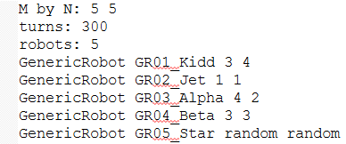
Output:
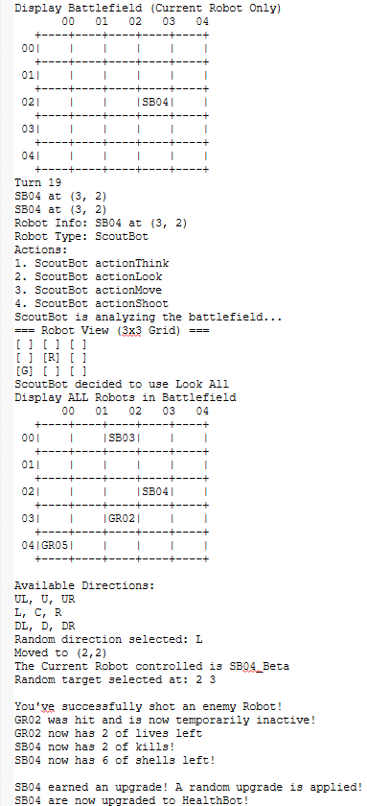
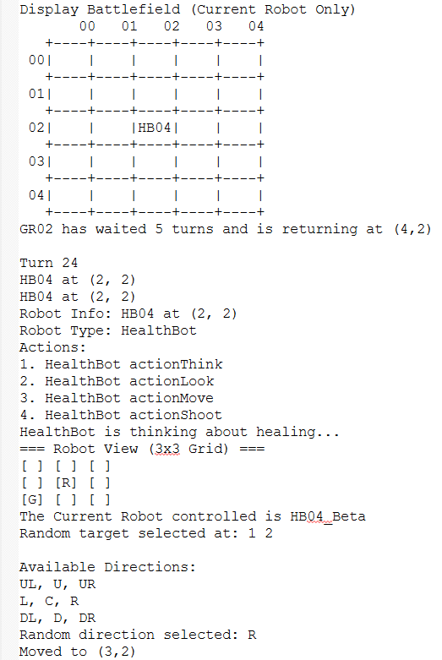
- SB04 has been upgraded to a HealthBot, now identified as HB04, and is currently located at position (2,2).
- HealthBot functions like a GenericRobot but starts with 5 lives instead of 3, making it more durable in battle.
- The robot’s name format changes to "HBxx" to reflect the upgraded type. For example, HB04 refers to the upgraded version of SB04.

Code segments, pseudocode parts, explanations
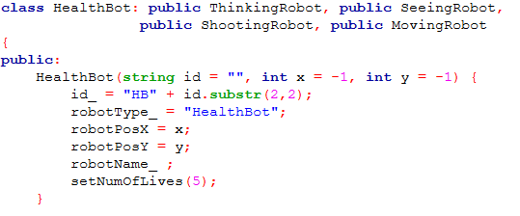

Pseudocode
FUNCTION Constructor HealthBot(id = "", x = -1, y = -1)
SET id_ TO "HB" + substring of id from position 2 to 2
SET robotType_ TO "HealthBot"
SET robotPosX TO x
SET robotPosY TO y
CALL setNumOfLives WITH argument 5
END FUNCTION

Explanation
The HealthBot constructor initializes a robot with the given ID and position, then sets its robot type and gives it 5 lives using setNumOfLives(5). This is more than the default 3 lives of a GenericRobot, allowing it to survive longer in battle. The ID is prefixed with "HB" to distinguish it from other robot types.

New robot name 2: GodBot GBXX
- canBeTargeted(): The robot cannot be targeted or destroyed by other robots (invincible).

Screenshots (inputs, outputs), figures, explanations
Input:
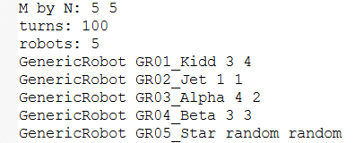
Output:
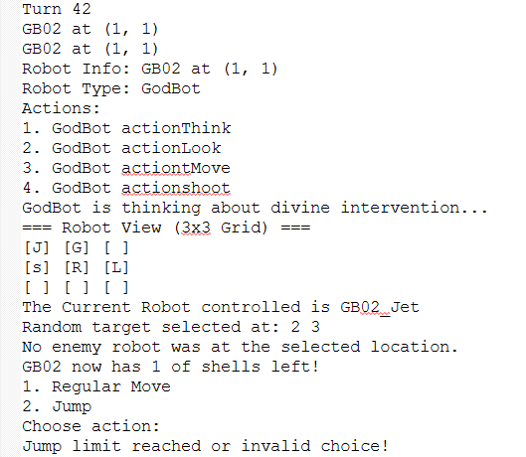
- GR02_Jet has been upgraded to a GodBot, now identified as GB02, and is currently located at position (1,1).
- GodBot behaves like a normal robot but is invincible, as its canBeTargeted() function always returns false.
- In Turn 42, GB02 executed its standard actions: think, look, move, and shoot. It fired at (2,3) but missed. The jump action failed due to a limit or invalid choice.

Code segments, pseudocode parts, explanations
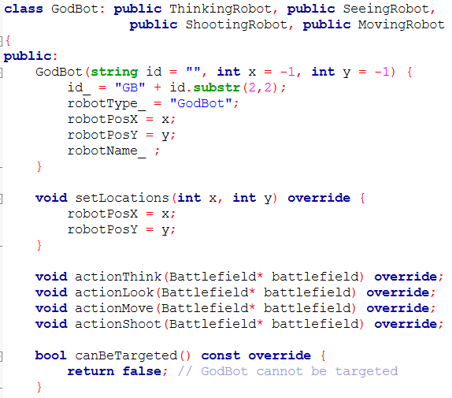

Pseudocode
FUNCTION Constructor GodBot(id = "", x = -1, y = -1)
SET id_ TO "GB" + substring of id from 2 to 2
SET robotType_ TO "GodBot"
SET robotPosX TO x
SET robotPosY TO y
END FUNCTION

FUNCTION canBeTargeted() RETURNS bool
RETURN false
END FUNCTION

Explanation
The GodBot constructor sets a unique robot ID starting with "GB" and initializes its position. While it behaves like a normal robot in movement and attack, it becomes invincible by overriding canBeTargeted() to always return false, meaning it cannot be hit or destroyed. This makes it ideal for testing or acting as a powerful boss character in the battlefield.

New robot name 3: JukeBot
Explanations, choose one.
Instaed of putting it at actionMove() we decided to put it at actions()

- actions(): Every 5 turns, the JukeBot will instantly teleport to a random empty spot on the batterfield, and this happens automatically, no player input needed.

Screenshots (inputs, outputs), figures, explanations
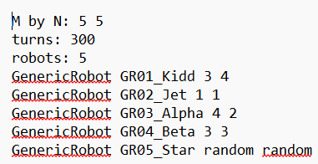

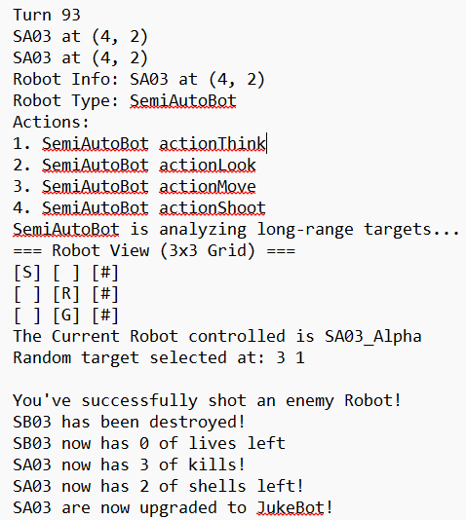

- Each time it takes turn the turnCounter increases
- Every 5 turn, it attempts to “juke” (teleport) to a random empty position
- It tries up to 100 random position to find an empty one
- It will print out successful message when success
- It will also print unsuccessful message when not success
- A robot gets an upgrade after earning a kill
- The upgrade type is chosen randomly
- If JukeBot selected, the robot will become JukeBot immediately

Code segments, pseudocode parts, explanations
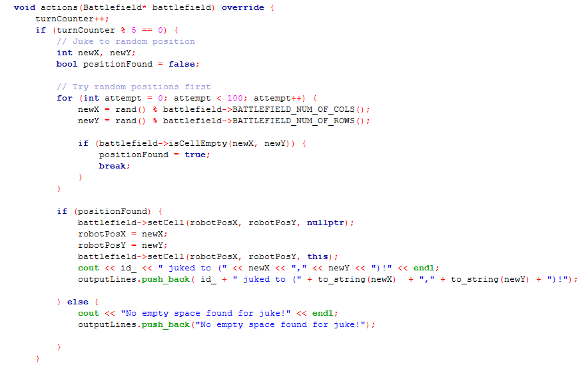

Pseudocode
INCREMENT turnCounter by 1

IF turnCounter is divisible by 5 THEN
SET positionFound to FALSE

REPEAT up to 100 times
SET newX to a random column within battlefield bounds
SET newY to a random row within battlefield bounds

IF the cell at (newX, newY) is empty THEN
SET positionFound to TRUE
BREAK the loop
ENDIF
END REPEAT

IF positionFound is TRUE THEN
// Move the robot to the new position
SET current cell (robotPosX, robotPosY) to null in battlefield
UPDATE robotPosX to newX
UPDATE robotPosY to newY
SET new cell (robotPosX, robotPosY) to this robot in battlefield

PRINT message: "[robot ID] juked to (newX, newY)!"
ADD message to outputLines list
ELSE
PRINT message: "No empty space found for juke!"
ADD message to outputLines list
ENDIF
ENDIF

Explanation
- Every 5 turns, the robot tries to perfor, a ‘juke’ (sudden move)
- It randomly searches for an empty position on the batterfield (up to 100 tries)
- If an empty spot was found:
- The robot will move to the new postition
- A message is printed
- If no empty spot is found:
A failure message is printed

Question: How to compile, how to run the program

Go to int main() , write ur prefered inputfile to be ran, and run main.cpp

