# Projects

## Employee Time Clock*

The employee time clock is essentially a sign in station for employees to clock in when they arrive and clock out when leaving.

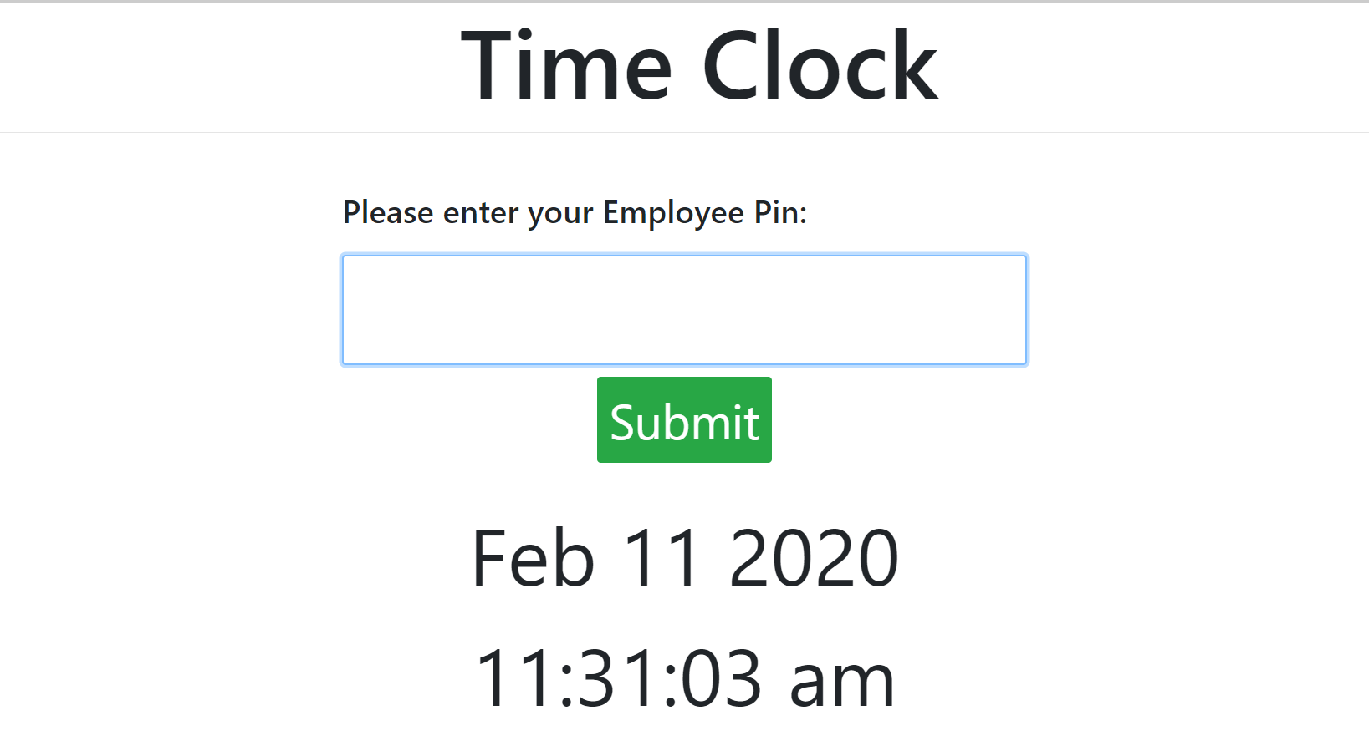

### Goals

The old system was a 3rd party program that relies on the employee to remember to clock out. If an employee forgot to clock out on Friday, then they still stayed clocked in for the whole weekend and on Monday, when they attempt to clock in, they end up clocking out instead. This created a huge confusion for the admins to edit.

The goal of this new system is that not only can it be changed easily, it will automatically sign out the employee at 11:00 PM which makes it easier for the admins to edit the time to the correct sign out time.

### Implemented Features

* The entire sign in and sign out functionality.
* Auto Sign Out at 11:00 PM if employee still clocked in.
* If the employee was supposed to work on that day, it will automatically count it as a sick day.
* Automatically add entries where an employee didn’t sign in on this day which makes it easier to add times should an employee forget to sign in.
* The web application is strictly on Google Chrome on --kiosk mode where employees cannot click X to close the browser or change the URL. Any redirects done on this page is also restricted.
* Restricted the sign in station to only be used by a default user so that employees can’t sign in and access this page.
* When admins are giving a staff member a unique pin, it would check to see if the pin is not already in use.

### Done With

* PHP
* MySQL
* JavaScript & JQuery & AJAX
* HTML5
* CSS3

## Snow Removal

The snow removal is essentially used for employees to record for what and when they did a task that helps with removing snow from the housing complex.

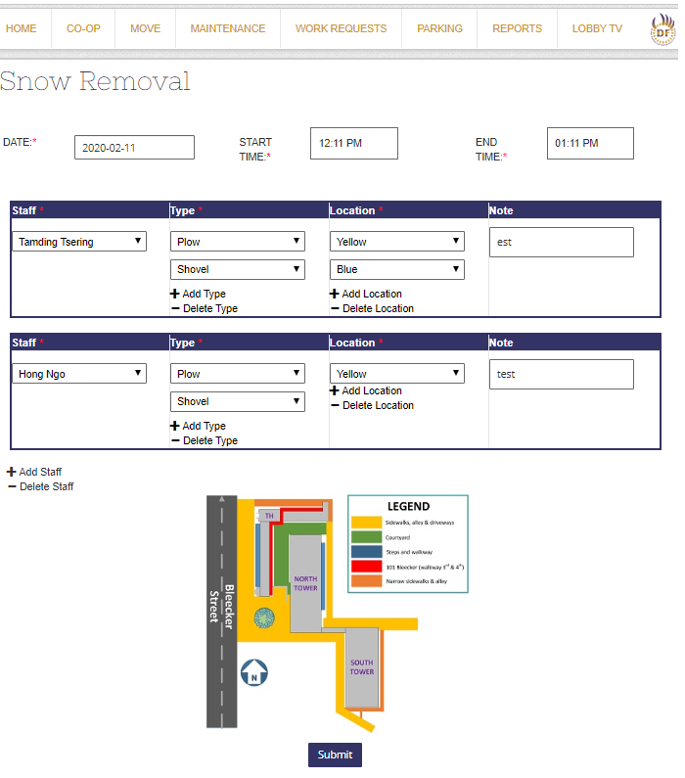

### Goals

The entire point of recording the records is not only to keep track whether or not an employee shovelled, added salt, used blowers, or plowed but in case there was an injury, a record is there should there be any legal issues.

### Implemented Features

* Ability to select a date, start time, end time, a staff, type, and location based on a map and a note option.
* Ability to add another staff member to enter more than one entries at once.
* Attempting to add the same staff member per box will cause the previous box to empty.
* Ability to delete an entry.
* Ability to add more than what type and location.
* Indicates to the user that all required data must be filled in or it will refuse to submit

### Done With

* PHP
* MySQL
* JavaScript & JQuery & AJAX
* HTML5
* CSS3

## Winter Schedule

The Winter Schedule is a specific calendar where employees have different types of shifts on a certain day. Those in the light colour are exceptional days where employees not on that shift must attend.

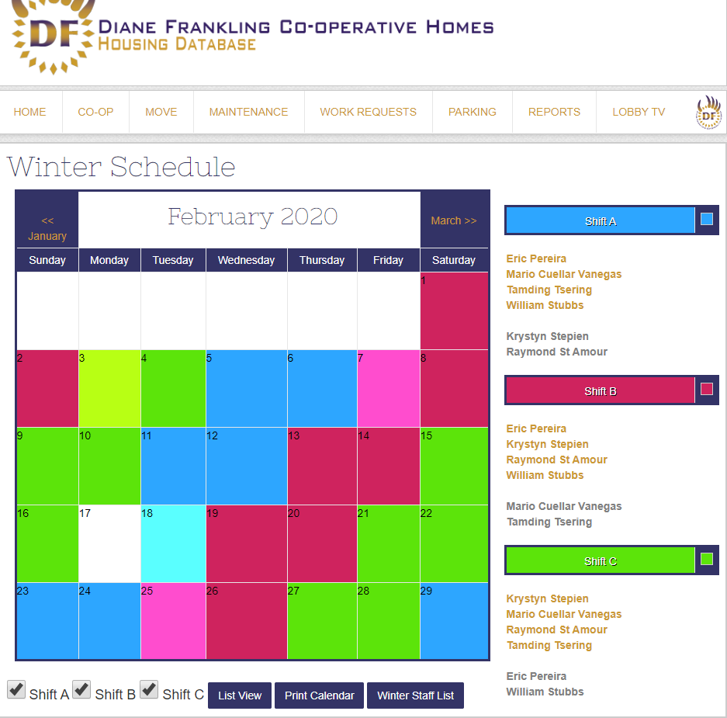

### Goals

The goal is to keep track of the calendar, be able to print it, accessible online, and that the admins can easily update the calendar.

### Implemented Features

* Ability to modify the colours of the shifts by clicking on the small square box beside the Shift box list.(marked as either Shift A, Shift B, or Shift C)
* Ability for admins to edit the shifts by clicking on the shift boxes.
* Ability to view a specific employee on what days do they have shifts by clicking a hyperlink on their name.
* Ability to filter the viewing of the calendar by checking off Shift A, Shift B, or Shift C.
* Ability to print the calendar.
* Ability to view the calendar in list format instead.
* Ability to modify what shifts are a staff in by clicking on Winter Staff List.

### Done With

* PHP
* MySQL
* JavaScript & JQuery & AJAX
* HTML5
* CSS3

## Unit Turnover*

Complete but not approved. No comment until further notice.

## Fire Inspection

The fire inspection is an online system for maintenance staff with the fire department to go through each unit in the housing complex to check if smoke detectors are working as intended. Then they record as they go.

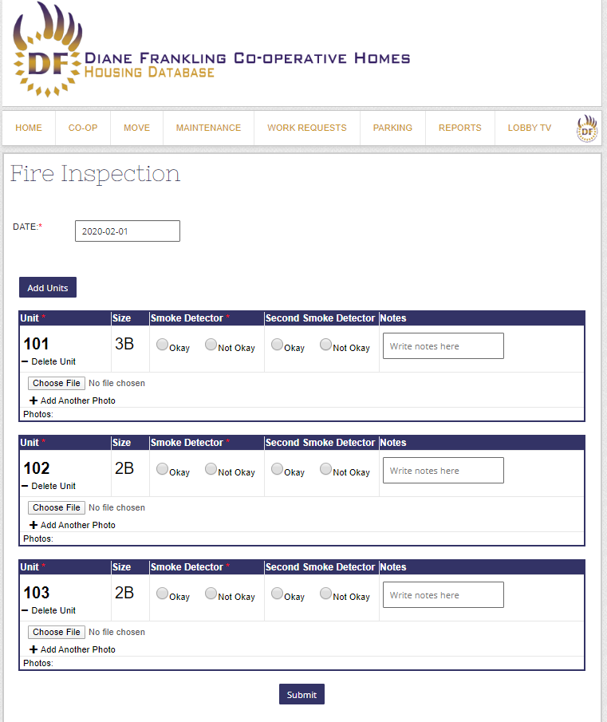

### Goals

Instead of doing it on paper, it was better to record it online through IPAD so that it’s easily accessible from anywhere. One of the major issues is that because they are going through each unit, most likely the internet can disconnect and data being sent can be lost.

Therefore, the fire inspection was built in a way to prevent this disconnection problem from being a nuisance.

### Implemented Features

* Ability to select multiple units and record data for each and one of the unit.
* Indicates to the user that all required data must be filled in or it will refuse to submit
* When editing the fire inspection reports, ability to install a new smoke detector if “Not Okay” is selected. This would add to the housing complex’s online asset data via SQL.
* If the internet disconnects, it would attempt to reconnect while remaking AJAX functions.
* When submitted, a popup will count to 30 seconds to ensure all data is submitted before redirecting.
* When uploading files, prevent the user from doing anything else until the fire is uploaded.
* Uses SQL and PHP to grab the unit size data once a unit is selected.
* Ability to delete a unit entry in case it was mistakenly added.
* Ability to select a date.

### Done With

* PHP
* MySQL
* JavaScript & JQuery & AJAX & offline.js
* HTML5
* CSS3

## Bike Parking & Map

The Bike Parking is a record of residents or guests that have a specific bike parking spot.

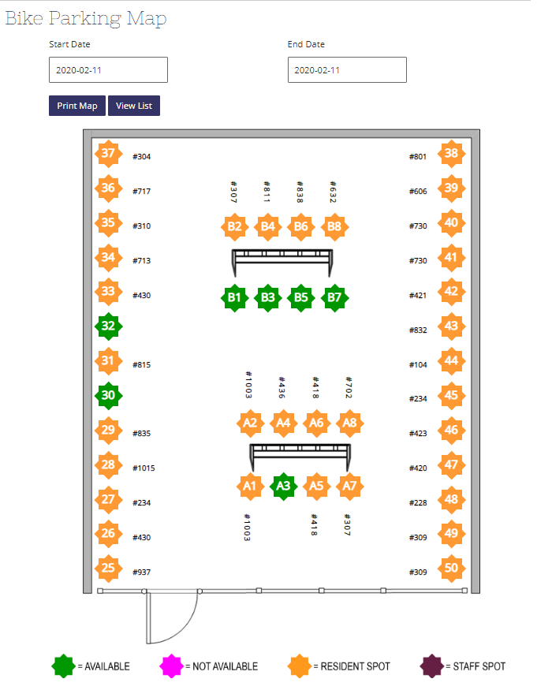

### Goals

To be able to determine which bike spots are available or unavailable based on the dates.

### Implemented Features

* Not being able to assign a spot to someone on a date where it’s occupied by a guest or resident.
* Ability to assign a spot to an available spot.
* Ability to assign a guest spot to a staff spot.
* Ability to print the map or view by list.
* Gradient coloured bike parking icons is used depending on start date and end date range.

### Done With

* PHP
* MySQL
* JavaScript & JQuery & AJAX
* HTML5
* CSS3

## Maintenance Tasks

## Lobby Signage TV

The Lobby Signage TV is the TV screen displayed for residents in lobby for main building and townhouses. Data such as weather, time, date, events, and .etc can be shown.

### Goals

The goal is to update the old 3rd party Lobby Signage TV to improve the layout of the design, have the freedom to modify it, and have it continuously reconnect to external RSS feeds should it fail to connect.

### Implemented Features

* Ability to keep trying to reconnect to external RSS feeds should it fail to connect.
* Displays Weather of Toronto and CTV news which is obtained from external RSS feeds.
* Displays Housing Complex’s events, facts, and maintenance tasks built with Housing Complex’s own XML files.
* A dashboard that allows the user to select which building’s signage TV to display.
* A Manual on how to setup the Lobby TV for users and programmers.
* Restricted the lobby tv to a specific user so that employees can’t access it from their own account.
* Ability to upload videos to events and maintenance tasks which smartly plays the video without JavaScript errors due to google chrome loading problems
* Uses --kiosk to keep the lobby tv in full screen mode and prevent users from closing the lobby tv by hitting X.
* Added an ability to add videos to maintenance tasks.

### Done With

* PHP
* JavaScript & JQuery
* HTML5
* CSS3
* XML

## Sick Calendar*

The Sick Calendar is a calendar that displays on what days are the staff members are

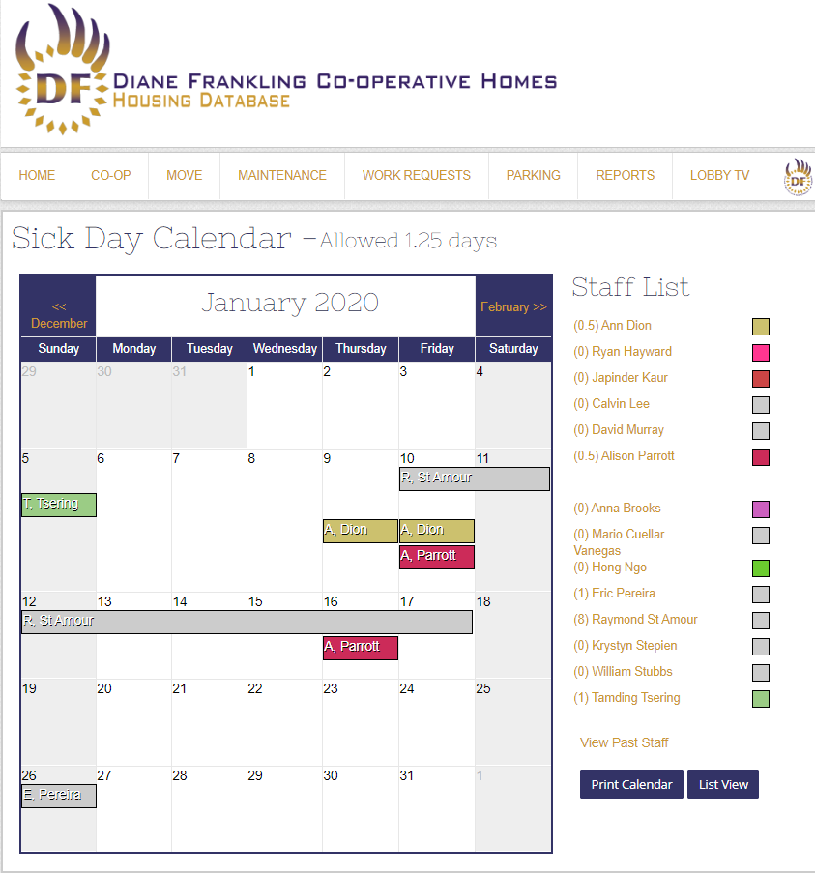

### Goals

Originally, an existing calendar already existed but the design was built in not consider weekends. With the creation of winter schedule, this had to change but the design was too complicated so it was simplified to not even include the weekend-exclusion algorithm at all.

### Implemented Features

* Attempting to add a sick day for a maintenance task that do not have shift on that day would refuse to add at all. If it’s a range of date, it will only add the dates that are in the winter schedule and break it into different ranges.
* Height of a week is adjusted based on number of sick staff on the week.

### Done With

* PHP
* JavaScript & JQuery
* HTML5
* CSS3
* MySQL

## Incident Reports from External Site Links with Database

Incident reports are when residents report a suspicious incident that occurred at the housing complex.

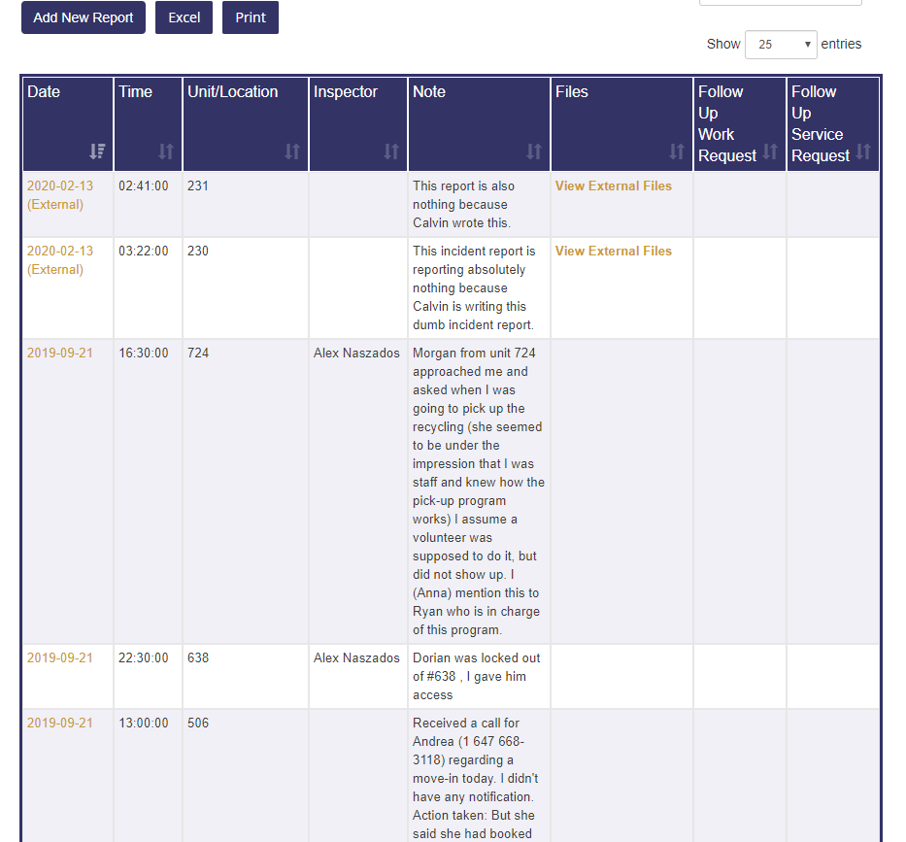

### Goals

The incident reports before can only be emailed to a staff member and then a staff member has to manually write an incident report on the database. This is too inconvenient. Instead, residents can now login onto the public external site and add an incident report. Once an incident report is added, it automatically adds to this database.

### Implemented Features

* External SQL database connection is established where an ID on the external SQL database is used to track whether or not it’s been transferred.
* Automatically transfers external incident reports to database reports and adds it onto the database with only relevant information (date, time, notes unit number, and files). The staff will manually assign an inspector, work request, and service request when they start looking into the incident.
* Files that are uploaded to the external site will have a link to it so that it can be viewed from the database.

### Done With

* PHP
* JavaScript & JQuery
* HTML5
* CSS3
* MySQL

# Updates to Existing Code

## Parking History (Bike, Motorcycle, Resident, Guest)

The parking history was outdated and did not contain much information such as whether or not the resident/guest had paid for the parking spot.

## Weekly Staff Calendar*

The weekly staff calendar originally only permitted admins to add tasks to maintenance staff on weekdays only. Updated to include weekends and allow printing of all the available duties for reference.

Also shows past staff in the past up until they are not longer staff members.

## Automated Gym Membership Emails

Automatically implemented a feature where if the homepage of the site is visited, it will automatically send emails to a staff member of new gym members that are over the age of 65. This is because those over the age of 65 get free gym memberships.

## Motorcycle Parking

Added an ability to view past motorcycle parking.

## Unit Moves*

Updated the moves to create only one unit inspection report if someone moves out. Does not delete the resident from the unit until a new resident takes over the unit. When someone moves out, automatically removes them from resident data such as gym membership, access cards, parking spots, and .etc.

## Incident Reports

By default, orders the date by descending order instead of ascending.

## Excel & Print Options

Added options to download an excel version of the report and printable versions for many reports and assets.

## Renaming Menu Names

Renamed some menu names to be more accurate.

## Paint Requests

Modified paint requests to automatically create a new paint request whenever a new unit is renovated with paint.

## Administrative Reports Reorganization and Search Bar

Reorganized the administrative reports to be clearer on what each report means and added new features in the search filter such as adding a filter to search by members.

## Menu Reorganization (?)

Reorganized menus to avoid one menu having too many content.

## Reorganizing Buttons

Renamed, removed, and replaced links with buttons on some pages.

## History Tracking of SQL Queries

Some SQL queries do not track such as name of employee that did an action, the old values and new values and .etc. Modified some old code to include this tracking,

## Applicants

Added delete option for applicants that apply as residents at the Housing Complex.

# Bug Fixes

## Weekly Staff Calendar*

Weekly Staff Calendar had multiple JavaScript errors if an employee was to do something such as removing duties or when a staff member is no longer active.

Many extreme cases were tackled and perfected to ensure it does not happen again.

## Parking

Parking contained multiple issues where a specific parking spot doesn’t show up as an option despite it being available. This was tackled and fixed,

## Lobby TV Signage Menus

Some of the options to edit the XML files were not working and thus was fixed.

## Sick Calendar Count

The Sick Calendar wasn’t counting the number of sick days that an employee was sick for during the year. This was fixed.

## Unit Moves*

When a resident moved out, sometimes it caused a SQL issue due to the resident data being deleted. This was updated to stop that from happening.

## External Site Connection Issues

The Housing Complex had another external site for the public to view. Due to a domain renewal, the SQL database was lost and external site had connection problems on top of missing data. After contacting the domain providers and recreating old SQL databases, the old data has been reinstalled and more up to date.

## Xibo Connection Issues

This was the 3rd party Lobby TV Signage Screen. Xibo had many issues where it suddenly stopped working. Sometimes I had to do a full reset to fix the screens. However, when the external site connection issues popped up, Xibo also had issues connecting to the RSS feeds. This soon became less relevant when the Lobby TV Project was completed and Xibo was abandoned.

## Elevators

Elevators had an issue where sometimes it didn’t delete if it was a certain case which was a bug. I added a check on those cases to ensure elevator schedules delete if a unit move was cancelled.

## Move Calendar

Following the elevator issue, some of the unit data in the calendar full of moves is incorrect and inconsistent. I made it so that it’s more consistent and the data is displayed correctly.

## Email Connection Issues

Due to the external site connection issues, the email also had some issues. After gathering SMTP data, I was able to update the port numbers, passwords, and .etc. to fix this problem.

## Staff List*

Viewing past staff and then present staff added unneeded characters to the URL. I changed it to remove those unneeded characters.