Calvin Makelky

A01872013

HW1

1.

a) Aminophylline ~ N(44, 20) n=9, Salbutamol ~ N(86, 15) n=11

i. 2 sample T-test

ii. Ho: mean spirometric increase between the treatments is the same

Ha: mean spirometric increase between the treatments are not the same

iii. t statistic = -5.21

iv. p-value = 0.0001

v. We reject the null hypothesis that the two treatments have the same spirometric increase, and we conclude that two treatments are significantly different. The salbutamol treatment group had a much higher mean increase in spirometric levels than the aminophylline group.

b)

The p-value of 0.0001 means that if the null hypothesis was true that there is no difference in spirometric increase between the two treatments, we would see an outcome like this or more extreme in 0.0001 percent of the time. Or the probability we would observe a test statistic this extreme given that the null is true.

c)

0.677

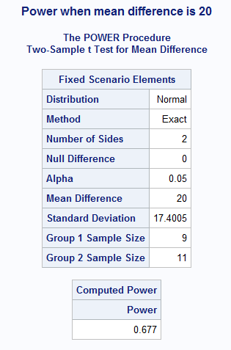

d)

The probability that we reject the Ho ( treatments are different) given that Ho is false because aminophylline effect is 20 liters per minute more than salbutamol.

e)

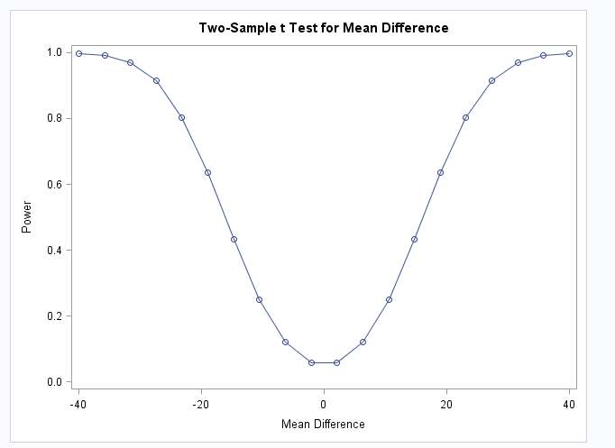

2.

a)

Because if let alpha = 0.05 for each test the probability of making a Type I error becomes very likely.

b)

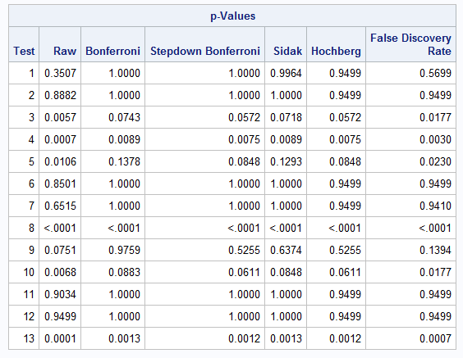

c)

Sidak correction, because we care more about controlling the Family-Wise error Rate than the False Discovery Rate because we really want to limit the chance we make a Type I error. And the Sidak over Bonferroni because it's more powerful and the we know the 13 test were independently assessed. The Sidak correction assumes statistical independence while Bonferroni does not.

d)

Using the Sidak correction we see that three of the 13 tests had significant p-values (below .05) and seven tests had almost no evidence at all of significance. Because we had adjusted p-values less than the alpha level of .05, we reject the null hypothesis that there is no difference in mean spirometric increase between aminophylline and other treatments. There is significant evidence to reject the null just like in problem 1, but not as strongly as in problem 1 due it's extremely low p-value and the conclusion is different in that this was compared to various other treatments, not just salbutamol.

**Problem 1 code:**

data lung;

input group $ _STAT_ $ CONTINOUS_VAR;

datalines;

1 N 9

1 MEAN 44

1 STD 20

2 N 11

2 MEAN 86

2 STD 15

;

run;

PROC PRINT data=lung;

RUN;

proc ttest data=lung;

class group;

var CONTINOUS_VAR;

title1 '2 samp t-test';

run;

proc power;

twosamplemeans test=diff

meandiff = -40 to 40 by .5

alpha = 0.05

dist = normal

stddev = 17.4005

ntotal = 20

power = .;

;

plot x=effect min=-40 max=40;

title2 'Power Calculation for Lung Example';

run;

proc power;

twosamplemeans test=diff

nulldiff = 0

sides=2

alpha =.05

meandiff = 20

stddev = 17.4005

groupns = (9 11)

power = .;

title3 'Power when mean difference is 20';

run;

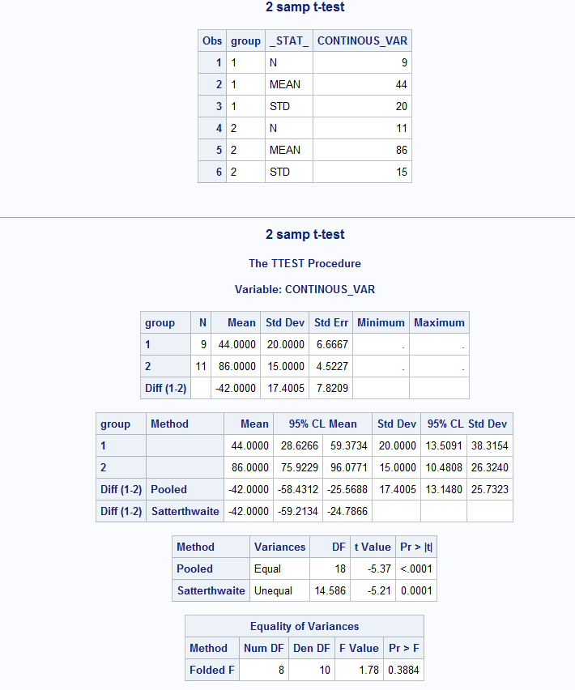

**Problem 2 code:**

data pvals;

input pval @@;

cards;

0.350697 0.88816 0.005715 0.000684 0.010598 0.850057

0.651455 0.000005 0.075073 0.006792 0.9034 0.949922 0.0001

;

run;

proc multtest inpvalues=pvals bonferroni sidak holm hochberg fdr;

title1 'Adjusted P-values II';

run;