Calvin Makelky

A01872013

HW4

**1.**

1. Treatment must not be known to be inferior – The current treatment is often available, so you must use this instead of a placebo for the control because else you are depriving them access to something you know is better for them. You must stop the procedures once you find a significant result, else you are knowingly hurting some patients over others.
2. Subject can withdraw – Statistically you still want the sample to be representative of the population in order to make inferences.
3. Sample size is appropriate – If the sample size is not big enough, wasted everyone's resources because you can't make a conclusion on the RCT. Too big of a sample size results in more risk than is necessary. Want use the smallest sample size necessary to achieve desired power. That way you have enough data to make a conclusion with the specified power, but you don't waste more resources than you need to do this.

**2.**

1. Assessment bias: assessment of the proportion of body covered by scales could be somewhat subjective, and because each person has it measured by their dermatologist, the assessment by one dermatologist from another could vary.

b.

Have the same dermatologist examine everyone with rules of how to calculate the proportion so that the procedure is exactly the same for everyone. This dermatologist must not know who had what treatment.

**3.**

a. The distribution of scorechange is approximately normal based on the histogram below. The mean difference between the two treatments equals -2.635 minus -0.489 which equals 2.146. The standard deviation of the entire group together is 6.528. Using proc power we find that **we need a total of 147 patients in each group in order to have 80% power with an alpha level of 0.05.**

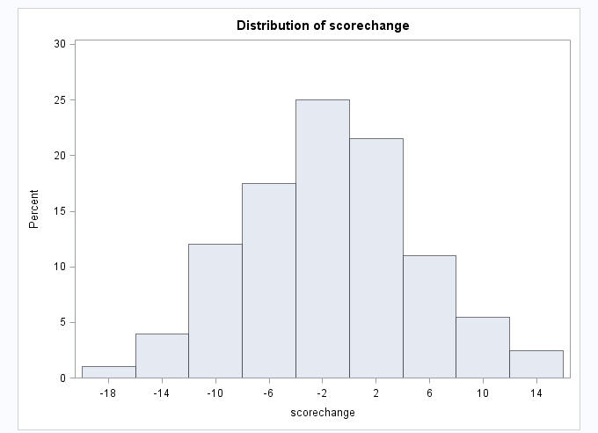

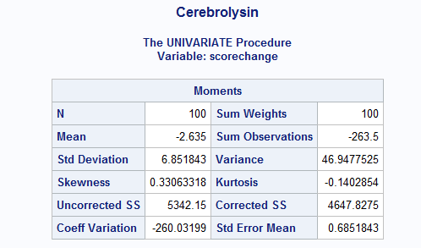

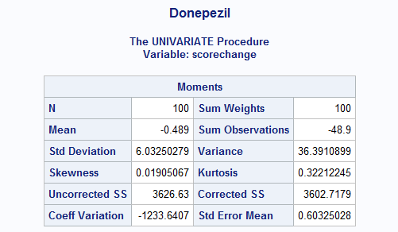

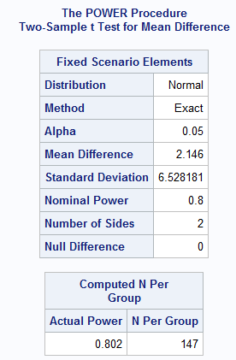

b.

To protect the overall Type I error rate at alpha. In this scenario patients will be taking the treatment regularly for 28 weeks, so we might want to measure before this in case we find significant differences, that way we don’t expose patients to the inferior treatment.

c.

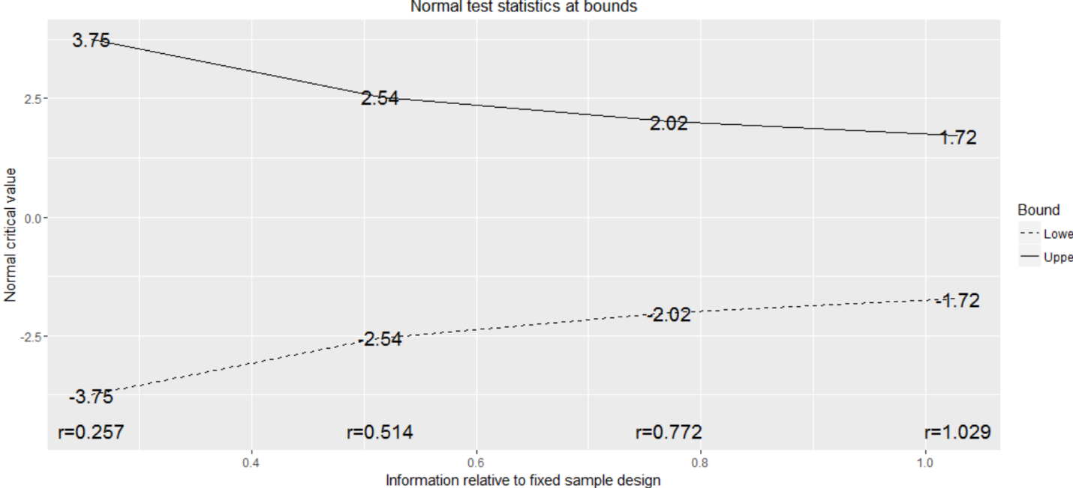

The graph above show the boundaries at each interim analysis, in that if the test statistic is not within the bounds at that interim analysis there is significance and we would ethically stop the test. The numbers at the bounds are the normal critical values to compare the test statistic to, and the numbers at the bottom is the information fraction.

d.

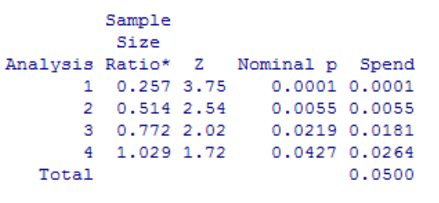

The significance threshold for each interim analysis is found by multiplying the Nominal p by 2. So at analysis 1 it equals: .0002, analysis 2: 0.0110, analysis 3: 0.0438, analysis 4: 0.0854.

To find the per=group sample size at each interim analysis we multiply the Information Fraction(Sample Size Ratio) by 147 because that was found earlier to be the n per group needed to achieve 80% power at alpha=0.05.

So the per-group sample size at Analysis 1: 38, Analysis 2: 76, Analysis 3: 114, Analysis 4: 152.

T-test at interim analysis 1: 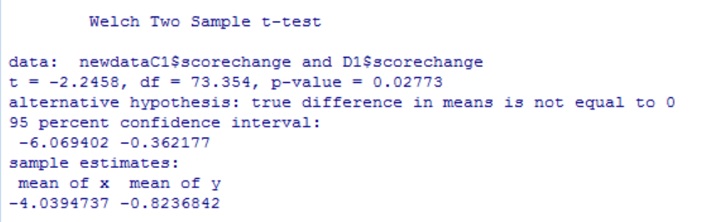

P-value of 0.02773 is not below the threshold at interim analysis 1 so we continue.

T-test at interim analysis 2:

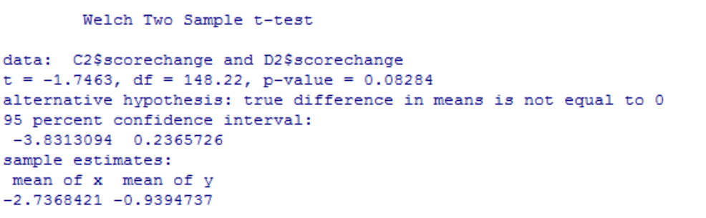

P-value of 0.08284 is below the threshold at interim analysis 2 so we continue.

T-test at interim analysis 3:

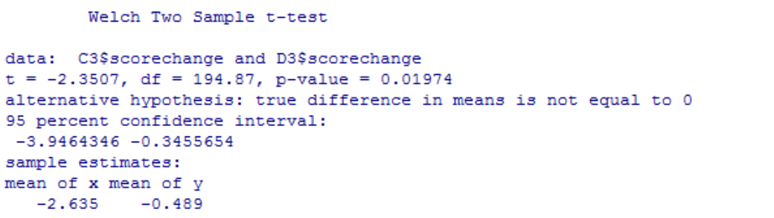

The p-value of 0.01974 is below the significance threshold of 0.0438 at interim analysis 3. So we conclude there is a significant difference between the two treatments at this time, and we stop the study.

Because the data provided only had a 100 observations for each group, the third interim analysis was done with 100 subjects per group instead of 114, and we couldn’t do the 4th interim analysis since we already tested all the subjects we had available.

|  |  |  |  |
| --- | --- | --- | --- |
| Analysis | Sample Sizer (per group) | Observed P-value | Significance Threshold |
| 1 | 38 | 0.02773 | 0.00020 |
| 2 | 76 | 0.08284 | 0.0110 |
| 3 | 114 | 0.01974 | 0.0438 |
| 4 | 152 | N/A | 0.0854 |

We would stop the RCT after analysis 3.

Problem 3 code:

**proc** **import**

datafile="C:\Users\itcl\Desktop\RCT.csv"

dbms=csv out=rct replace;

getnames=yes;

datarow=**2**;

**run**;

**proc** **print** data=rct;

**run**;

**proc** **univariate** data=rct;

histogram scorechange;

**run**;

**proc** **univariate** data=rct;

var scorechange;

where trt="Cerebrolysin";

title 'Cerebrolysin';

**run**;

**proc** **univariate** data=rct;

var scorechange;

where trt="Donepezil";

title 'Donepezil';

**run**;

**proc** **power**;

twosamplemeans test=diff

meandiff = **2.146**

alpha = **0.05**

dist = normal

stddev = **6.52818058**

ntotal =**.**

power = **.80**;

**run**;

d <- gsDesign(k=4, test.type=2, alpha=0.05, beta=.2, sfu=sfLDOF)

plot(d)

print(d)

newdataC1 <- data[which(data$trt=="Cerebrolysin" & data$subject < 39),]

D1 <- data[which(data$trt=="Donepezil" & data$trtID < 39),]

t.test(newdataC1$scorechange,D1$scorechange,var.equal=FALSE)

D2 <- data[which(data$trt=="Donepezil" & data$trtID < 77),]

C2 <- data[which(data$trt=="Cerebrolysin" & data$trtID < 77),]

t.test(C2$scorechange,D2$scorechange,var.equal=FALSE)

D3 <- data[which(data$trt=="Donepezil" & data$trtID < 115),]

C3 <- data[which(data$trt=="Cerebrolysin" & data$trtID < 115),]

t.test(C3$scorechange,D3$scorechange,var.equal=FALSE)