Calvin Makelky

A01872013

HW5

1.

To see if the drug Rosiglitazone has significant effect on the rate of heart attacks and death in human patients.

2.

Meta-analysis is useful because it determines a clearer picture of the treatment effect being studied by combining results of similar studies, essentially increasing the power of the test. It also determines whether the research question is clearly settled, so if it is settled, it may be known that it’s unethical to have more RCTs.

3.

Publication bias is when significant results are more likely to get published. Thus, resulting in an increase in type-I errors.

4.

a. $\hat{OR }$ = bc / ad

bc = odds of not getting Heart Attack when given Rosiglitazone treatment

ad = odds of not getting Heart Attack when given control treatment

b.

The forest plot below shows the estimated treatment effect shift over time; the confidence intervals for the odds ratio in each of the 42 studies. There is no discernable pattern as far as the estimated treatment effect increasing or decreasing over time. Every one of the 42 studies’ confidence intervals contained the logs odd ratio of 1 (null hypothesis), so it shows there is no evidence to suggest a significant treatment effect. The combined estimated treatment effect confidence interval also contains the log odds ratio of 1, and has very high precision due to small length.

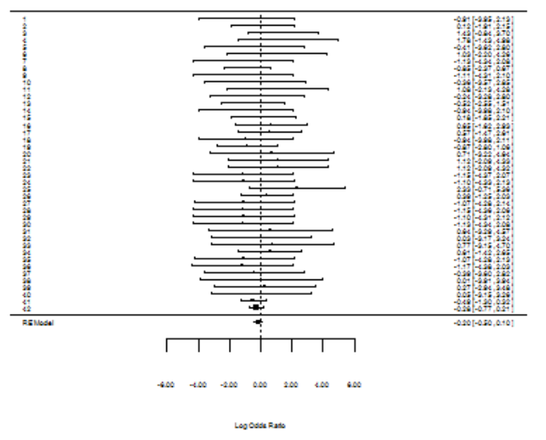

c.

The point estimate is 0.81799, and the 95% confidence interval is (.607, 1.102). This means the odds of not getting a heart attack when receiving the Rosiglitazone treatment is about 18% less than the odds of not having a heart attack when receiving the control treatment. But the p-value is 0.1864, which is not less than 0.05 so it is not significant. The odds ratio contains one, so that also points to the treatment effect on having a heart attack not significantly different than the control treatment.

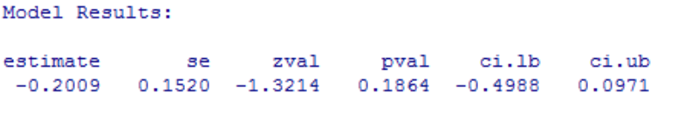 

d.

Funnel plot: asymmetrical, which indicates the presence of publishing bias. More points to the right of the line, and most of those were the ones with lower amounts of precision. This might indicate a systematic difference between smaller and larger studies (“small study effects”).

Normal QQ plot: About two of the points were outside the 95% confidence interval, and the points as a whole are long tailed and not very straight like a line. This also indicates publication bias and that the normality assumption is likely false.

Numerical Test – Galbraith Test: p-value of the intercept is not significant, so no evidence of publication bias.

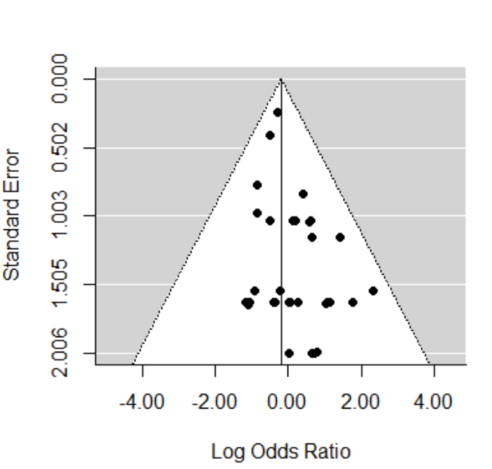

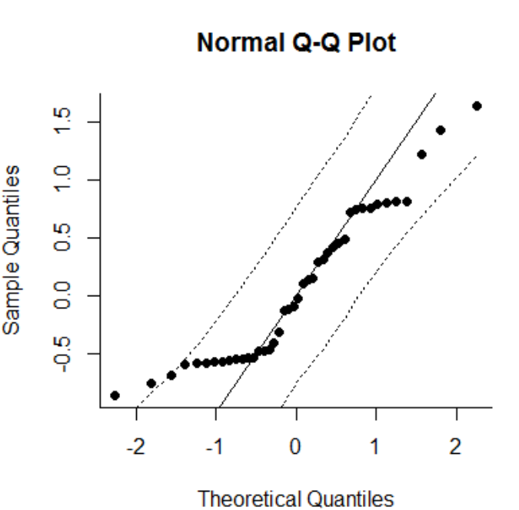

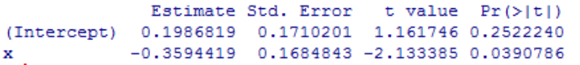

5.

a.

$\hat{OR }= e^{\hat{B1}}$ Where B1 is the log of the odds ratio: log( bc/ad)

b.

The forest plot below shows the estimated treatment effect shift over time; the confidence intervals for the odds ratio in each of the 42 studies. There is no discernable pattern as far as the estimated treatment effect increasing or decreasing over time. It is very symmetrical on each side of the null effect line. Every one of the 42 studies’ confidence intervals contained the logs odd ratio of 1 (null hypothesis), so it shows there is no evidence to suggest a significant treatment effect. The combined estimated treatment effect confidence interval also contains the log odds ratio of 1, and has very high precision due to small length.

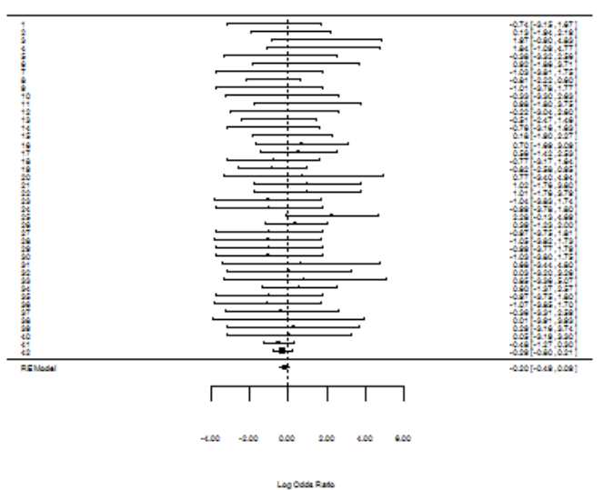

c.

The point estimate is .70, and the 95% confidence interval is (.505, .97). This means the odds of not getting a heart attack when receiving the Rosiglitazone treatment is about 30% less than the odds of not having a heart attack when receiving the control treatment. The p-value is 0.321, which is less than 0.05 so it is significant. The odds ratio contains does not contain one, so that also points to the treatment effect on having a heart attack being significantly different than the control treatment.

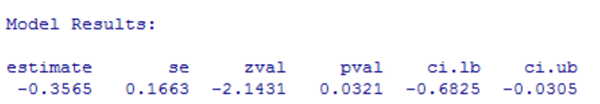 

d.

My results in 5c are exactly the same as the NEJM article. Both found a significant effect by the treatment drug Rosiglitazone on the rate of heart attacks, and both had a p-value of 0.3.

6.

a.

That study is dropped from the group automatically. Because both ad and bc in the odds ratio estimate would equal zero, and 0/0 is indeterminate. And you can’t make any calculations with an indeterminate.

b.

The point estimate is 0.7916784, and the 95% confidence interval of the estimate is (.565, 1.11). This means the odds of not getting a heart attack when receiving the Rosiglitazone treatment is about 21% less than the odds of not having a heart attack when receiving the control treatment. But the p-value is 0.1755, which is not less than 0.05 so it is not significant. The odds ratio contains one, so that also points to the treatment effect on having a heart attack not being significantly different than the control treatment.

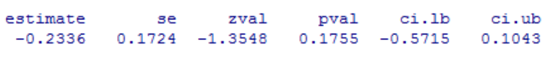 

**Problem 4 code**

data <- read.csv("http://www.stat.usu.edu/jrstevens/biostat/data/rosiglitazone.csv"

data$RosNO <- data$RosNum - data$RosMI

data$CtlNO <- data$CtlNum - data$CtlMI

data$RosNum = NULL

data$CtlNum=NULL

data$RosDeath = NULL

data$CtlDeath = NULL

*********

Fishers.p <- rep(NA,nrow(data))

for(i in 1:nrow(data))

{

mat <- matrix(as.numeric(data[i,]),ncol=2)

Fishers.p[i] <- fisher.test(mat)$p.value

}

round(cbind(data,Fishers.p),5)

*****

library(metaphor)

*****

result <- rma.uni(

ai = RosNO,

bi = RosMI,

ci = CtlNO,

di = CtlMI,

measure = 'OR', # report LOG odds ratio scale

add = 0.5, to='all',

method = 'DL', # Dersimonian-Laird

slab = 1:42, # study labels

data=data # dataset containing named variables

)

summary(result)

****************

exp(c(-.2009,-.4988,.0971))

forest(result)

funnel(result)

qqnorm(result)

z <- result$yi/sqrt(result$vi + result$tau2)

x <- 1/sqrt(result$vi + result$tau2)

fit <- lm(z~x)

summary(fit)$coeff

**Problem 5 code**

result <- rma.uni(

ai = RosNO,

bi = RosMI,

ci = CtlNO,

di = CtlMI,

measure = 'PETO', # report LOG odds ratio scale

add = 0, to='all',

method = 'DL', # Dersimonian-Laird

slab = 1:42, # study labels

data=data # dataset containing named variables

)

summary(result)

*****************

exp(c(-0.3565, -.6825, -.0305))

**Problem 6 code**

ids.drop <- c("49653/127","49653/128","49653/136","49653/143","49653/145",

"49653/147","49653/162","49653/284","SB-712753/002","SB-712753/003")

data6 <- data[!is.element(data$StudyID,ids.drop),]

result <- rma.uni(

ai = RosNO,

bi = RosMI,

ci = CtlNO,

di = CtlMI,

measure = 'PETO', # report LOG odds ratio scale

add = 0, to='all',

method = 'DL', # Dersimonian-Laird

slab = 1:32, # study labels

data=data6 # dataset containing named variables

)

summary(result)

exp(c(-.2336, -.5715, .1043))