# User documentation

## Opening Hire Cars

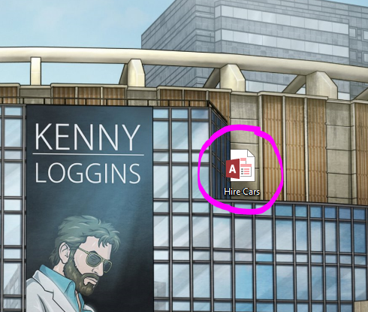

Double click **Hire Cars** to start the application.

## Using the program

### Starting up

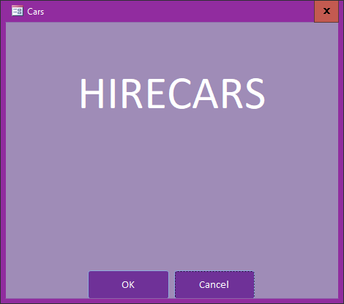

The start-up form has only two options, “OKAY” which gives access to the switchboard and “CANCEL” which will close the program

### Navigating the Menu



Along the top of the Switchboard is the **Menu**, clicking one of these will open a different form. The booking form is the default, so you must click another to change forms.

### Using the Customer Form

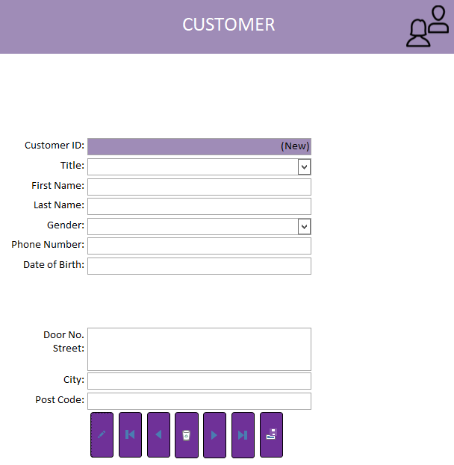 The customer form has some required information, **First Name** and **Phone Number**. These are the minimum things needed to create a new customer. Without this information a booking cannot be created.

### Using the Staff form

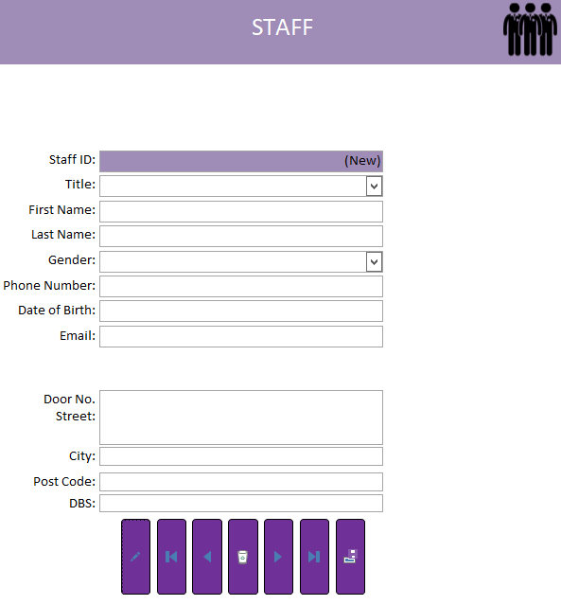 All the fields on the staff form are required and must be filled in.

### Using the Driver Form

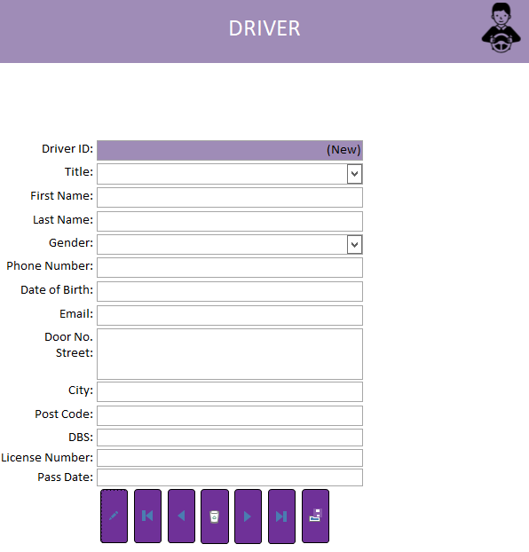 The Driver Form much like the staff form requires all fields to be filled out.

### Using the Vehicle Model Form

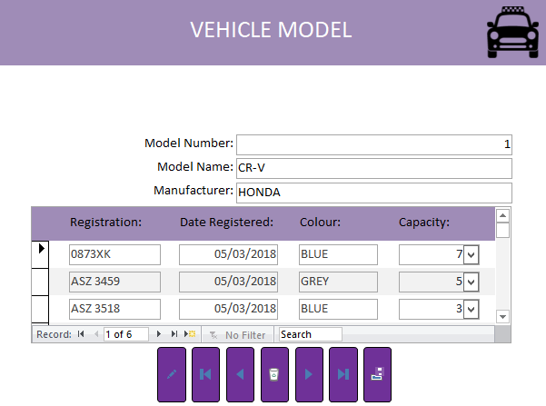 The Vehicle Model is different to any other form as it consists of a main form and a sub form. The main form is like the others and requires all fields to be filled but the sub form is different, it has rows that correspond to the information on the main form which also need to be filled.

### Using Locations

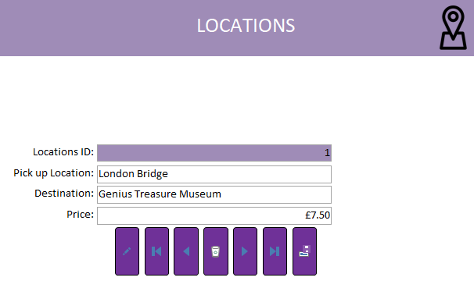 The location form requires each form to be filled. The pick-up location is the starting point of any journey and the destination is the end, each one is unique and served by all drivers.

## Reports

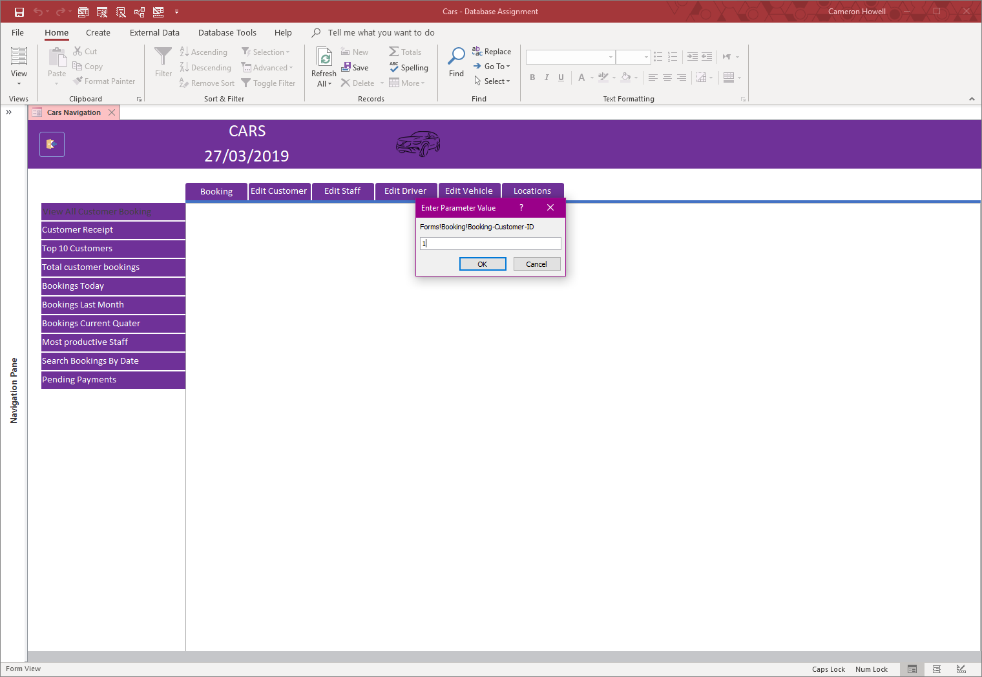Reports are on the Left of the Switchboard, each Menu option has their own Reports. Some may require input from a user and others will automatically gather the information needed.

## Reports - Booking

### View booking by customer id



View all customer booking will ask for the customer ID.

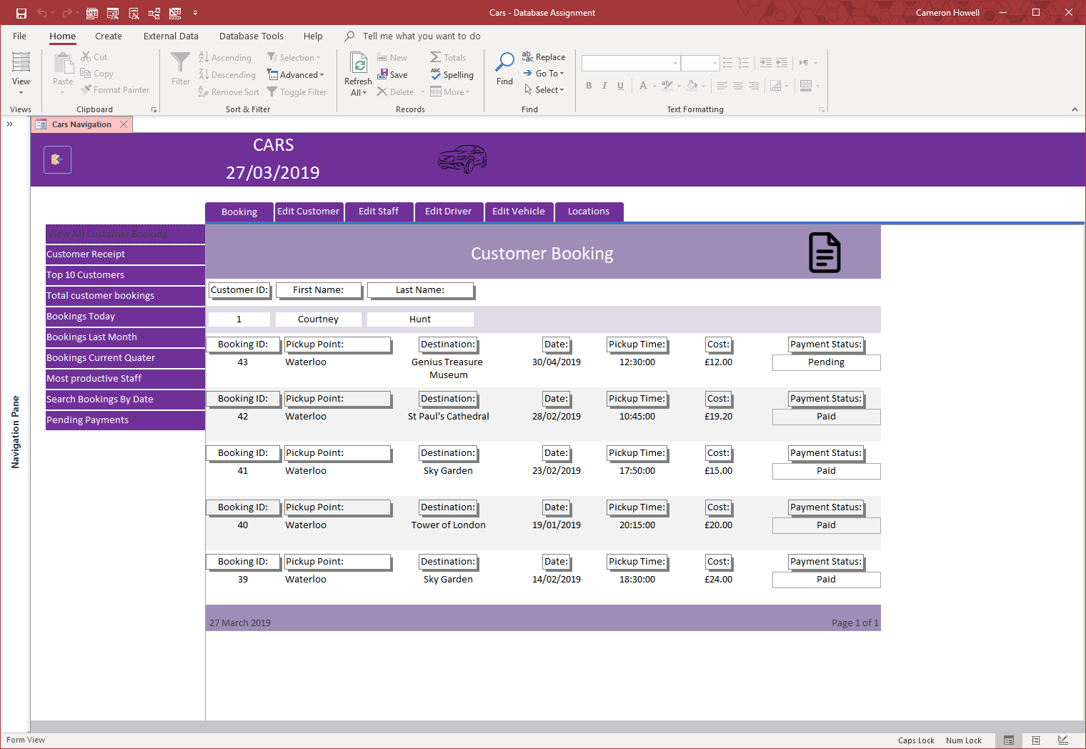

Once a customer ID is given, all the bookings made by that customer will be shown.

### View booking by booking id

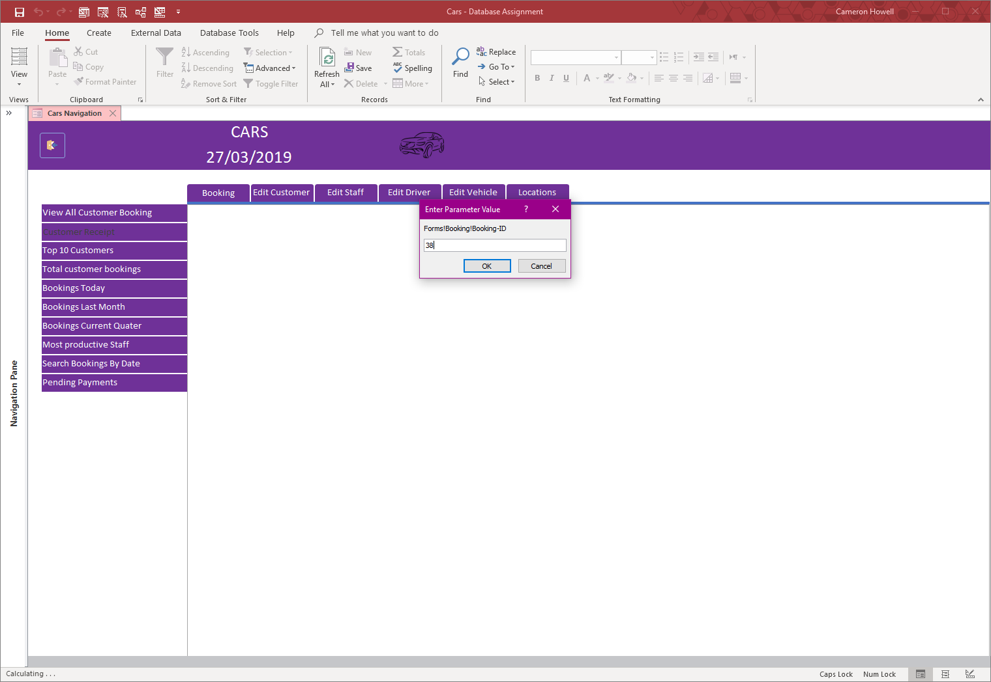

Entering booking ID to get Specific booking

Customer receipt report will ask for the booking ID number.

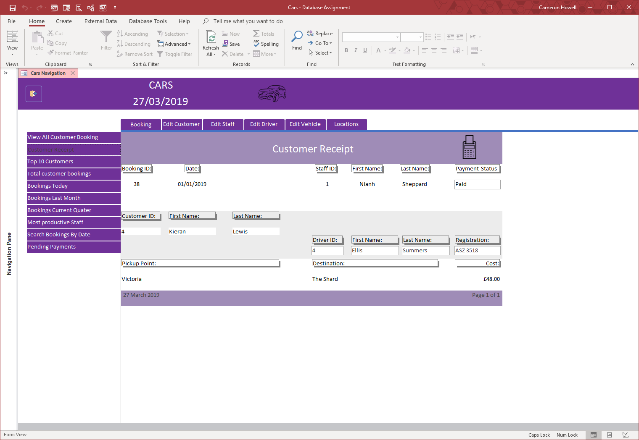

Viewing booking specified

Once the booking ID number is given the details of that booking is displayed in a receipt style/format.

### View most loyal customers

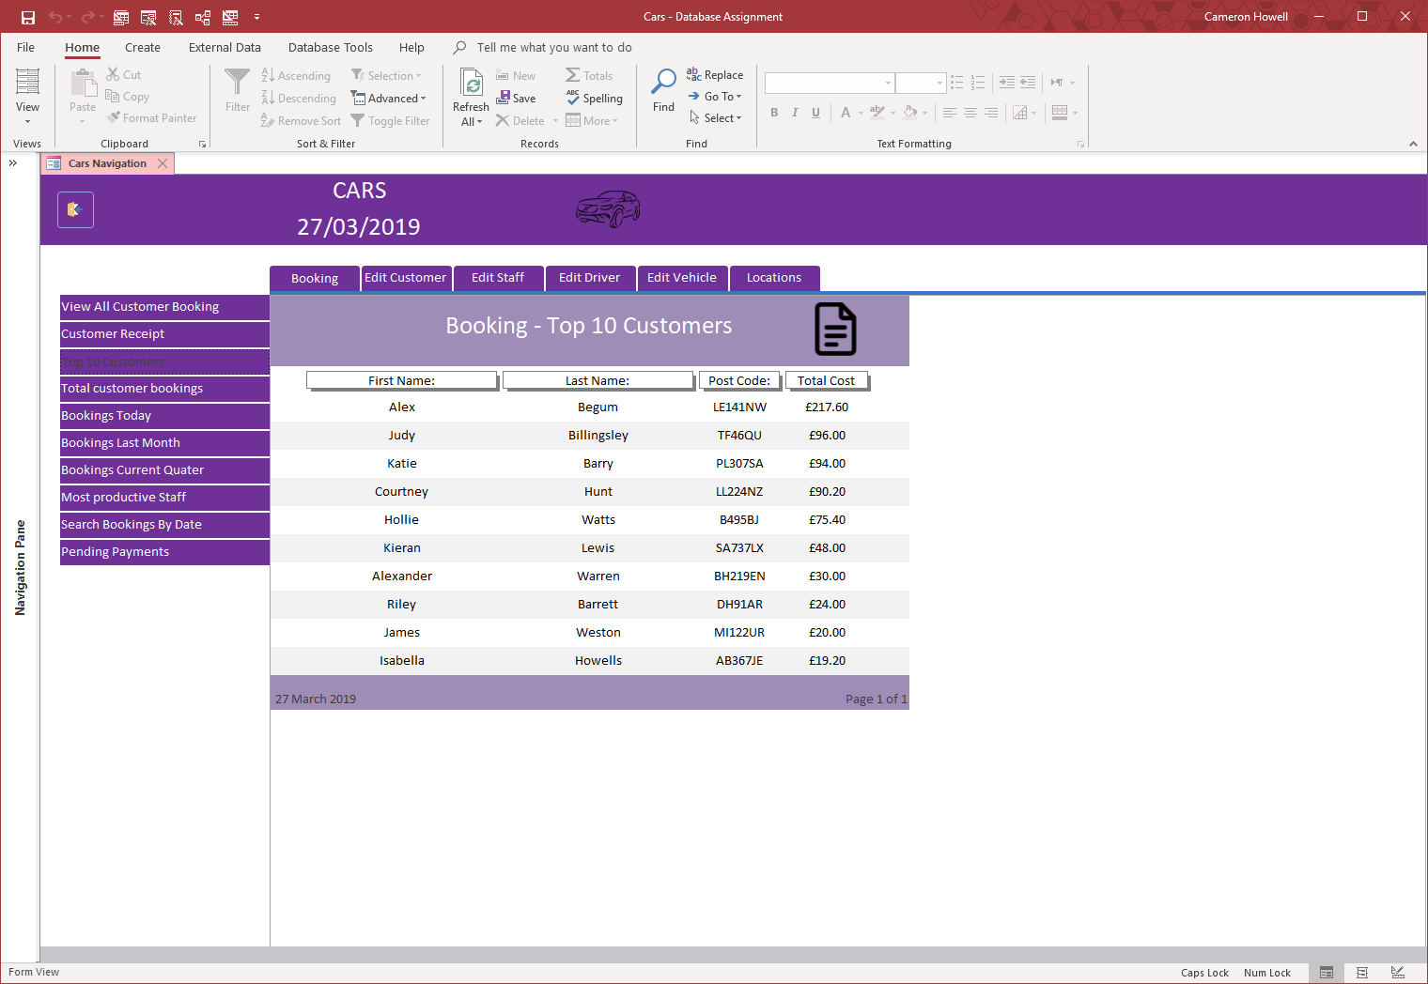

View top 10 customers

This displays the most loyal customers, by using the sum of all their bookings a top 10 is then shown.

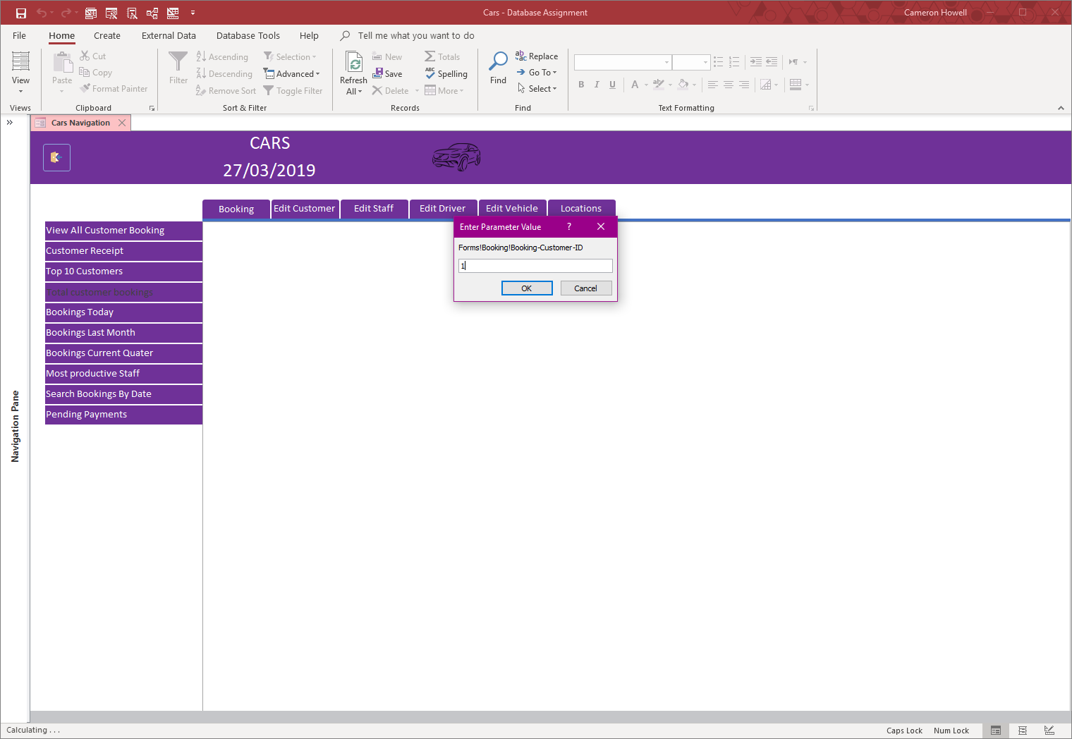

Using customer ID to see how many bookings they have

Using a customer ID to display their total number of bookings.

### View customers total number of booking

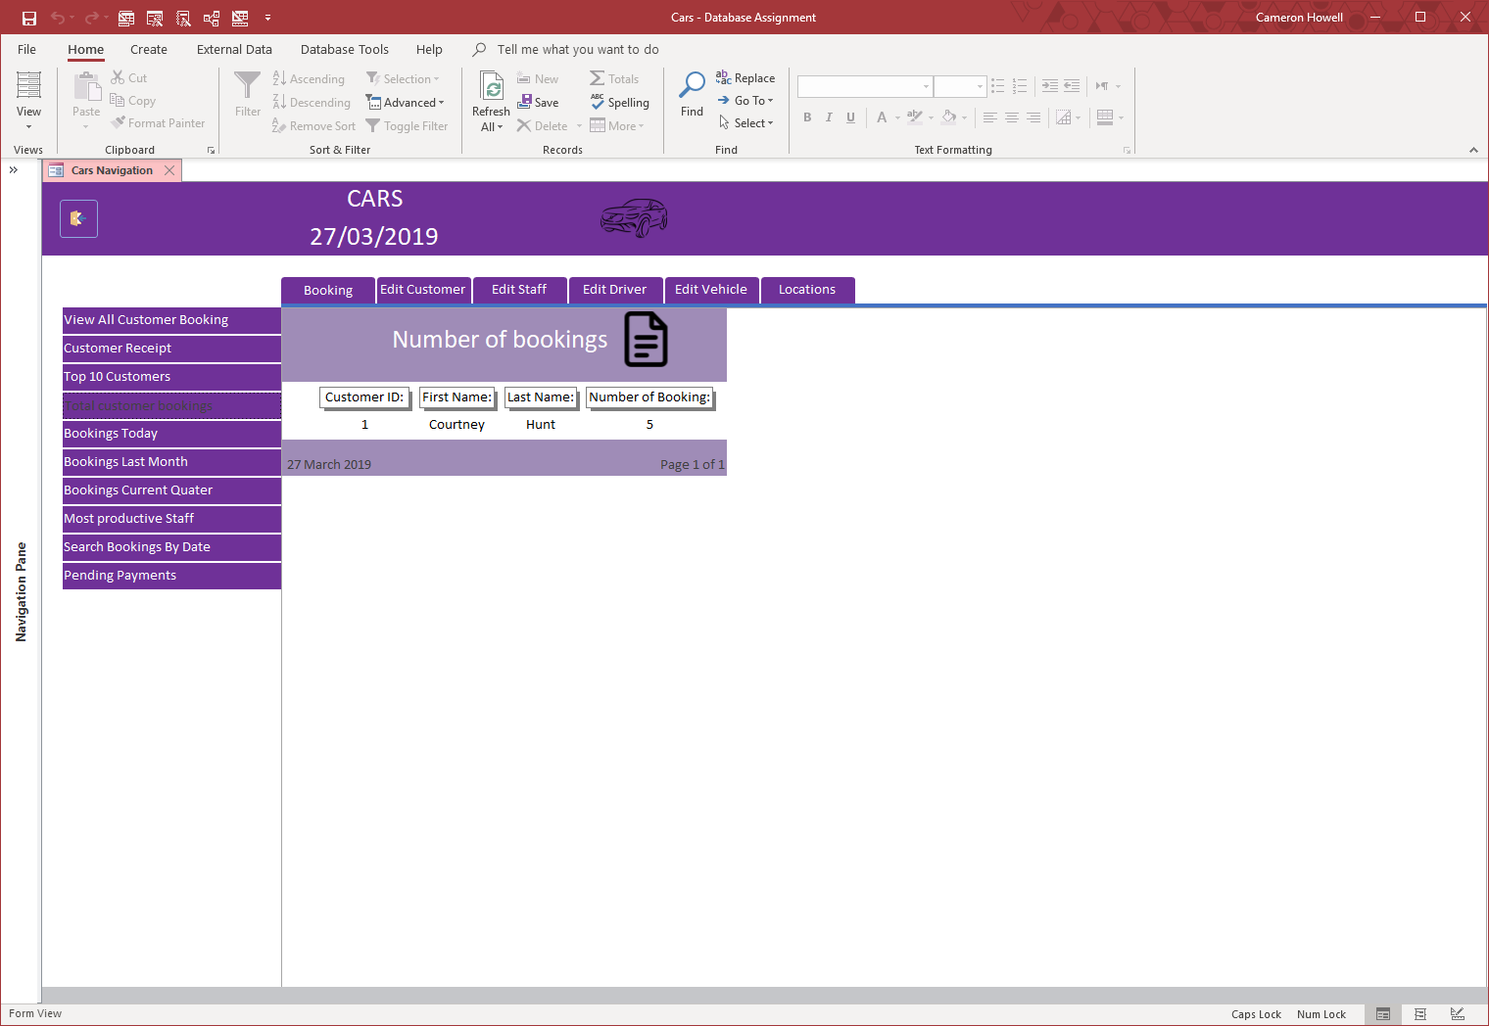

Viewing a customer’s total number of bookings

After using a customer ID, the ID number, name and number of bookings is displayed.

### Bookings today

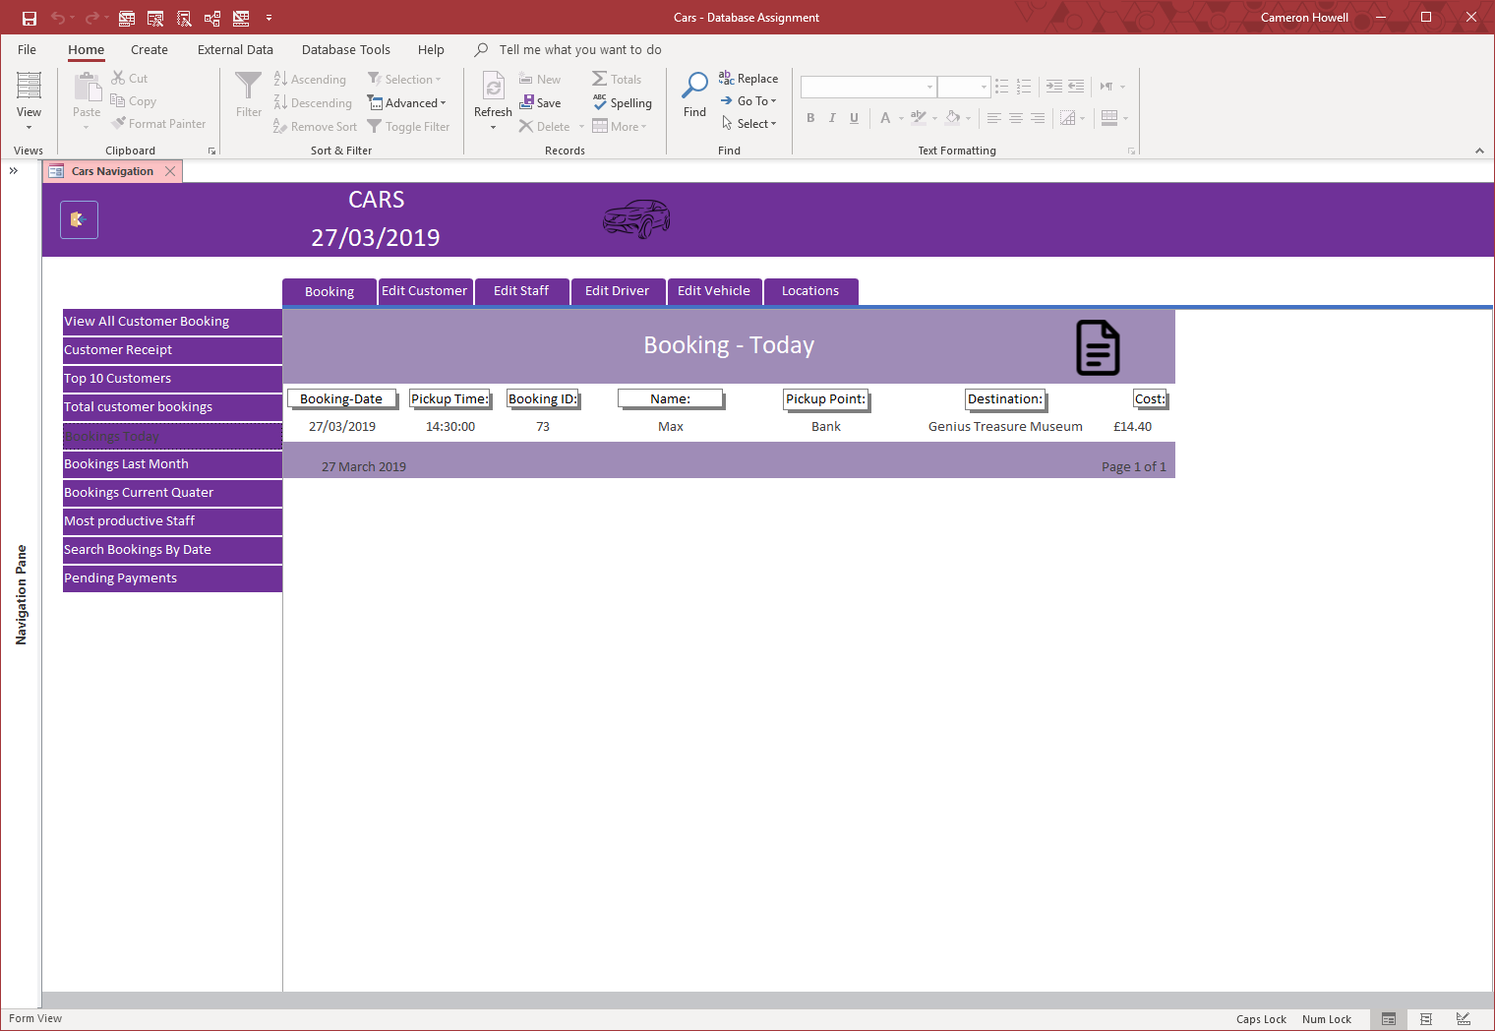

View bookings for today

This report displays every booking made for today.

### Bookings for the last month

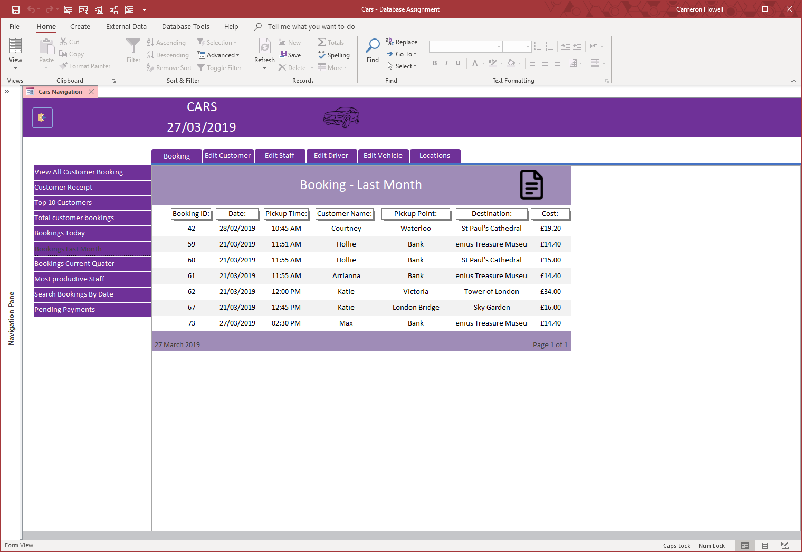

View bookings for the last month

This report shows all the bookings made over the past month, starting at the present day.

### Bookings for the current quarter

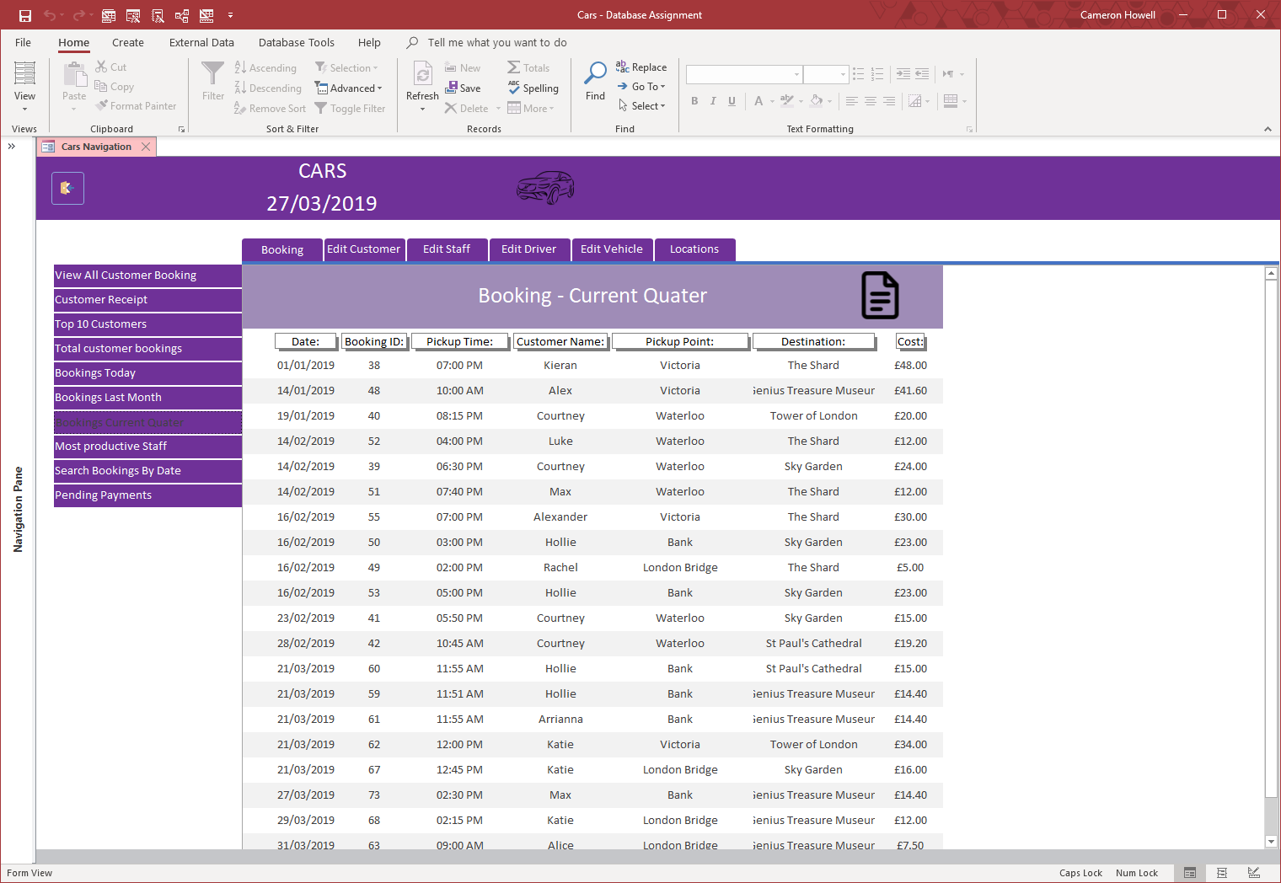

View bookings over the current quarter

This report shows all bookings made during the current quarter of the year.

### most productive staff

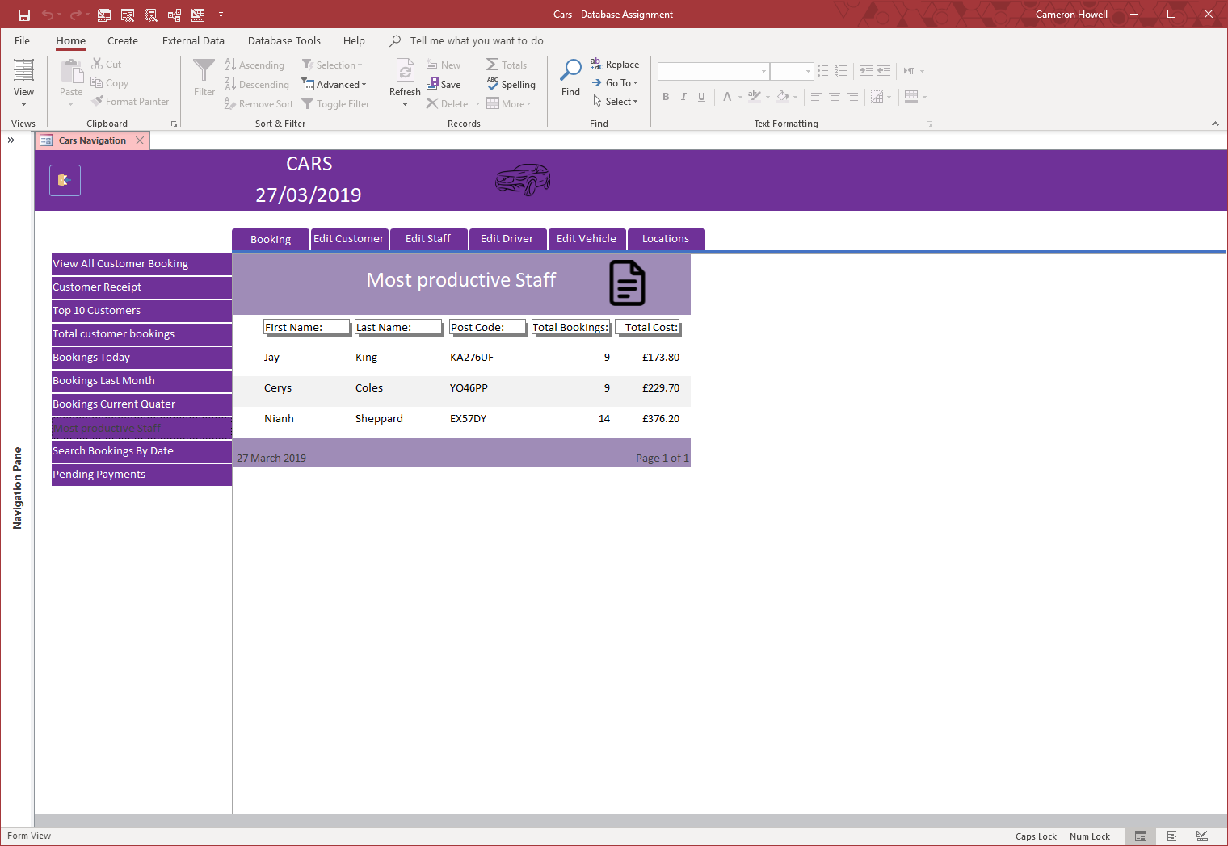

Most productive staff

This report displays the staff, the number of bookings they have made and the sum of money they have made to easily see who is most productive.

### Search booking by date

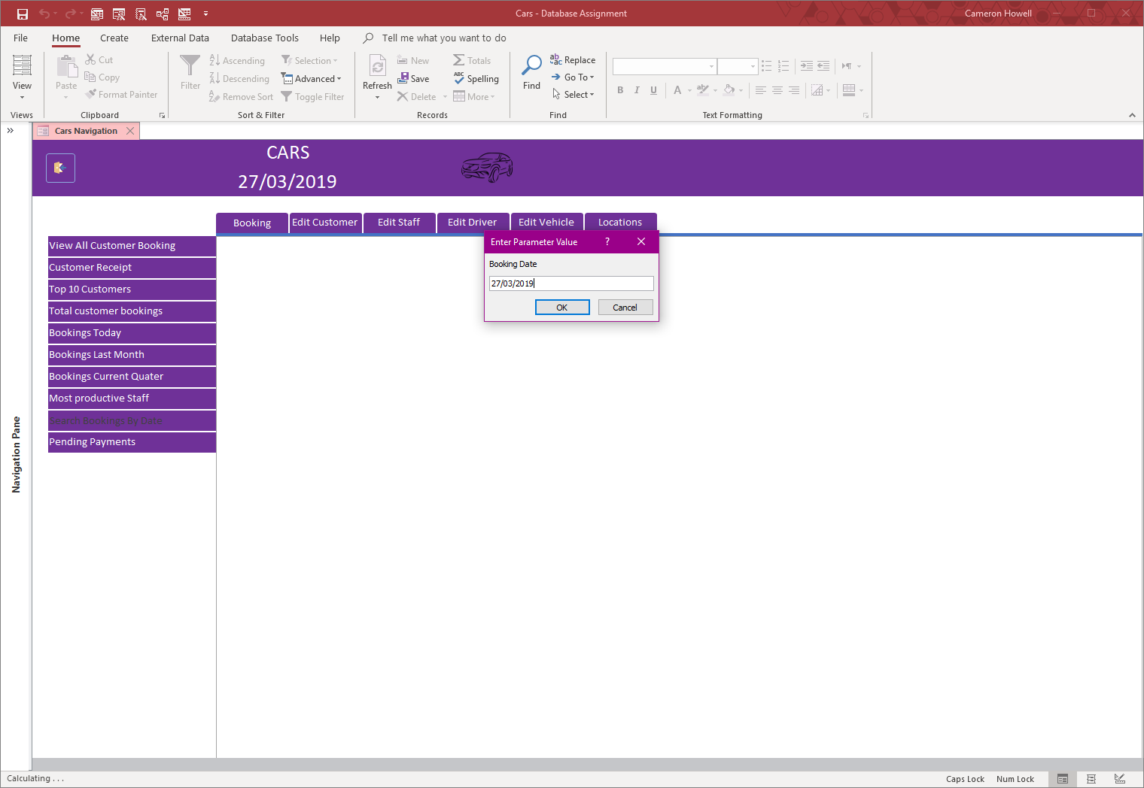

Search booking by date

This report asks for the input of a date.

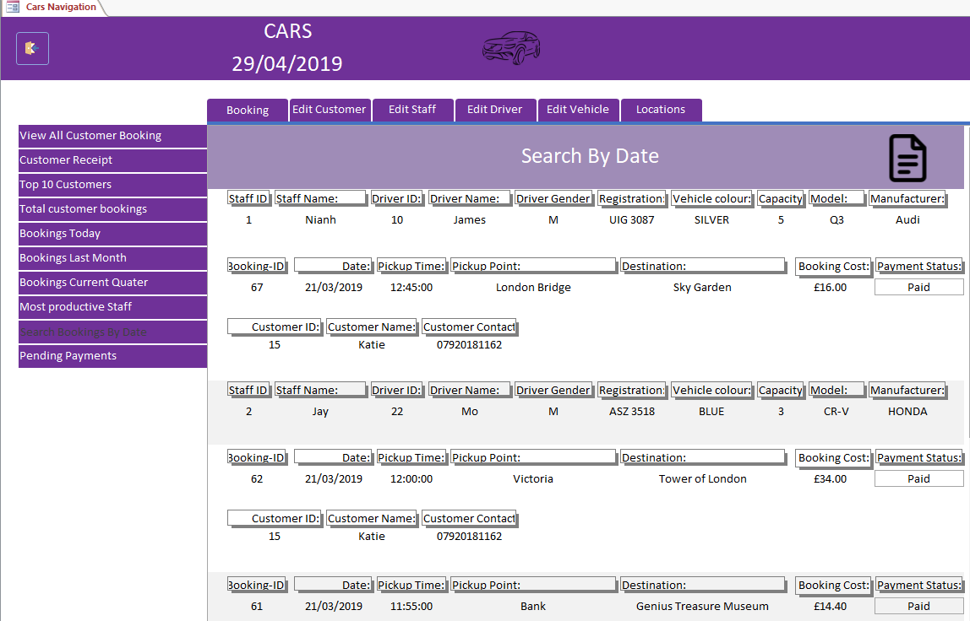

Once a date is entered, all bookings made for this date is then displayed.

### Bookings with payments pending

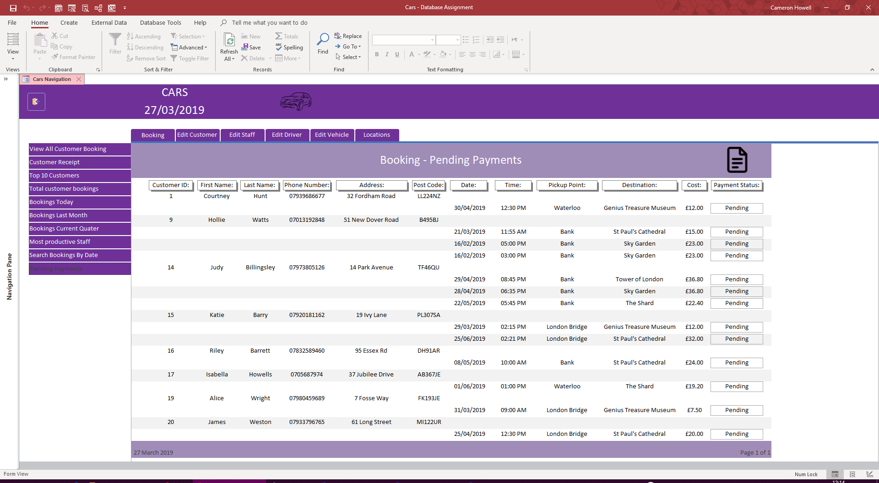

Bookings with payment pending

This report shows all bookings where a payment has not been made yet and is outstanding, it includes the journey date, cost, time and customer contact information.

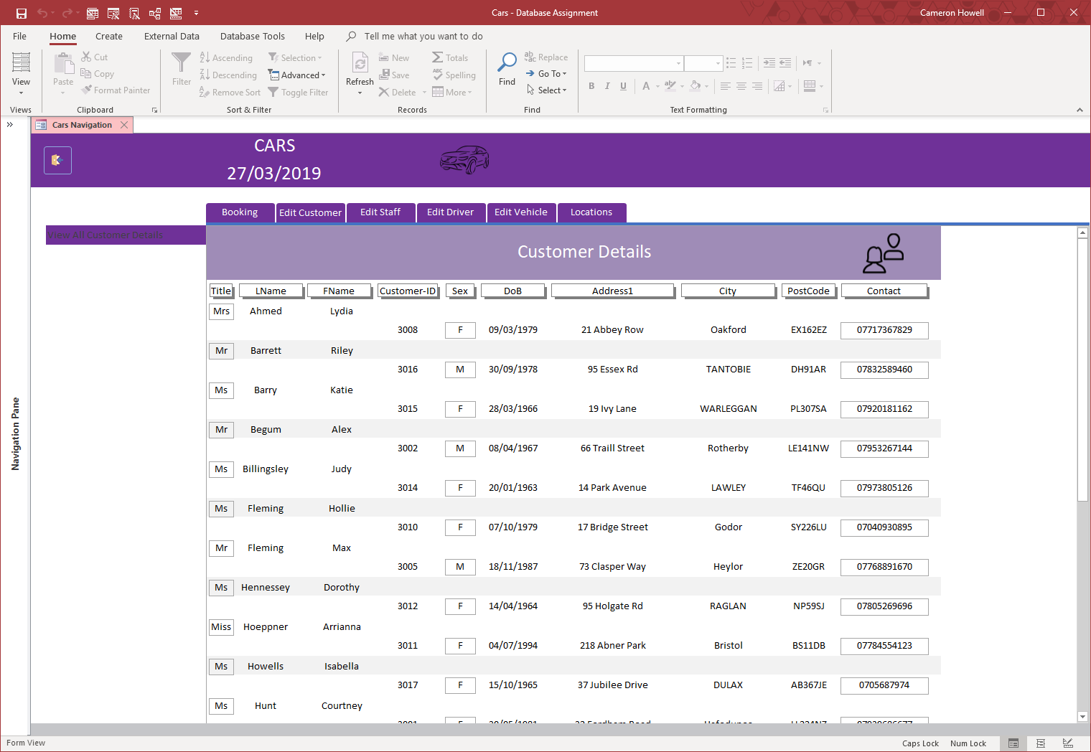

View all customer information

The “View All Customer Details” tab will show the details of all current customers.

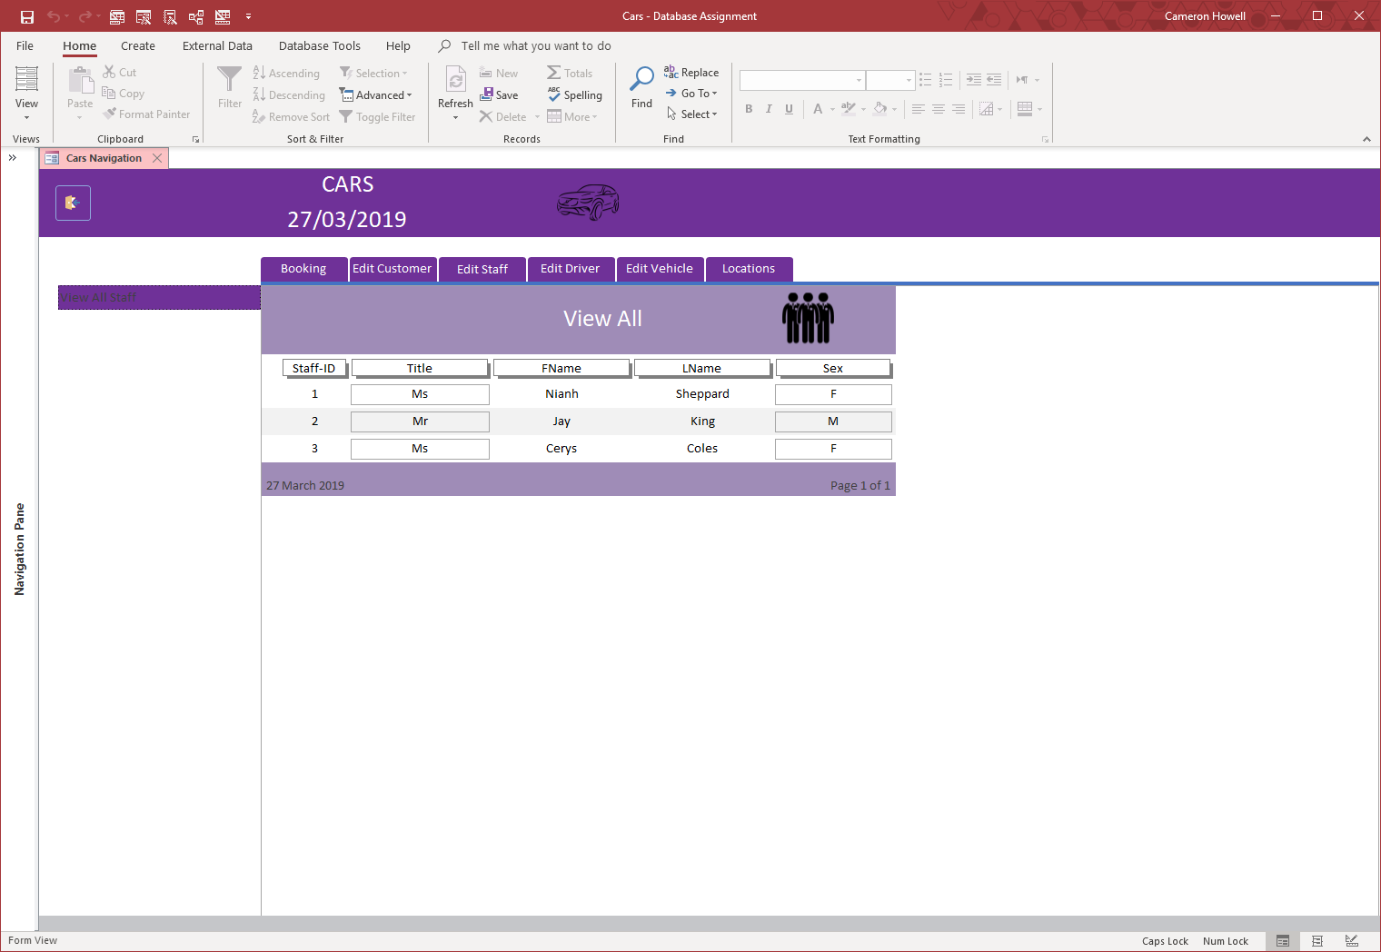

View staff details

Clicking the “View All Staff” tab shows some details of the staff employed.

## Reports – Staff

### View All Staff Details



View staff details

Clicking the “View All Staff” tab shows some details of the staff employed.

## Reports – Customer

### View All Customer Details



View all customer information

The “View All Customer Details” tab will show the details of all current customers.

## Reports - Driver

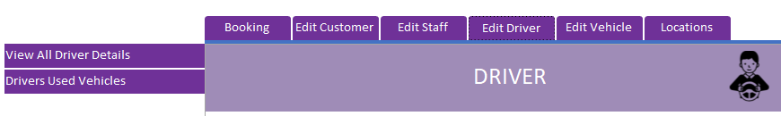

### View all drivers

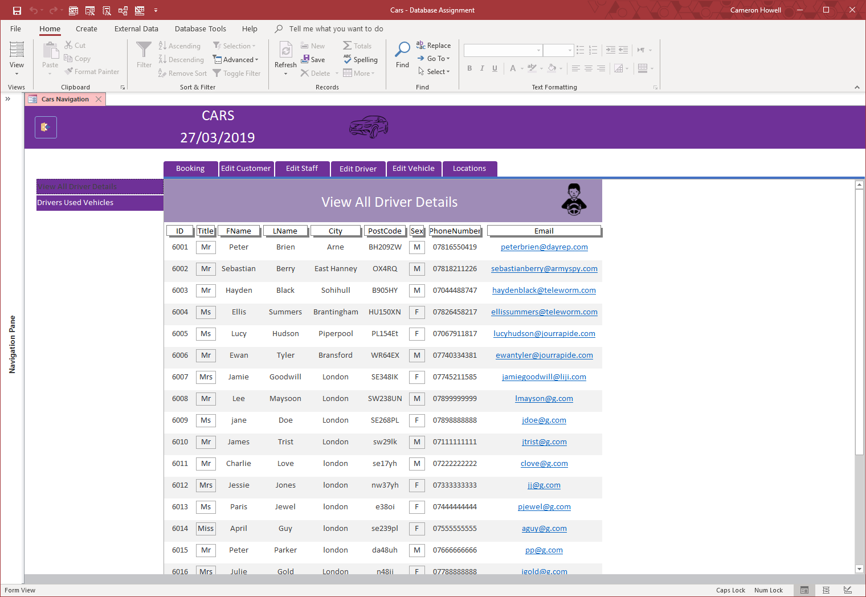

View all drivers

Clicking the tab “View All Drivers” shows all the drivers currently employed.

### View drivers and cars driven

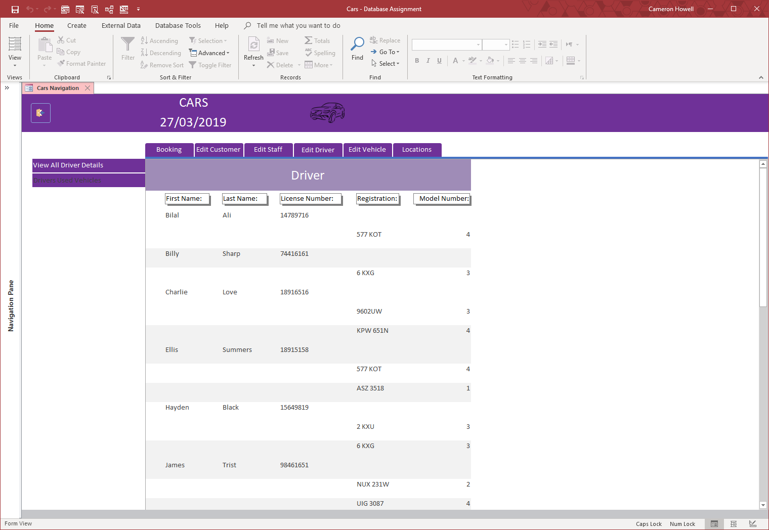

View cars driven

Driver and their cars are selected by both staff and customers preference, so any driver can drive any number of cars.

### View vehicle by capacity

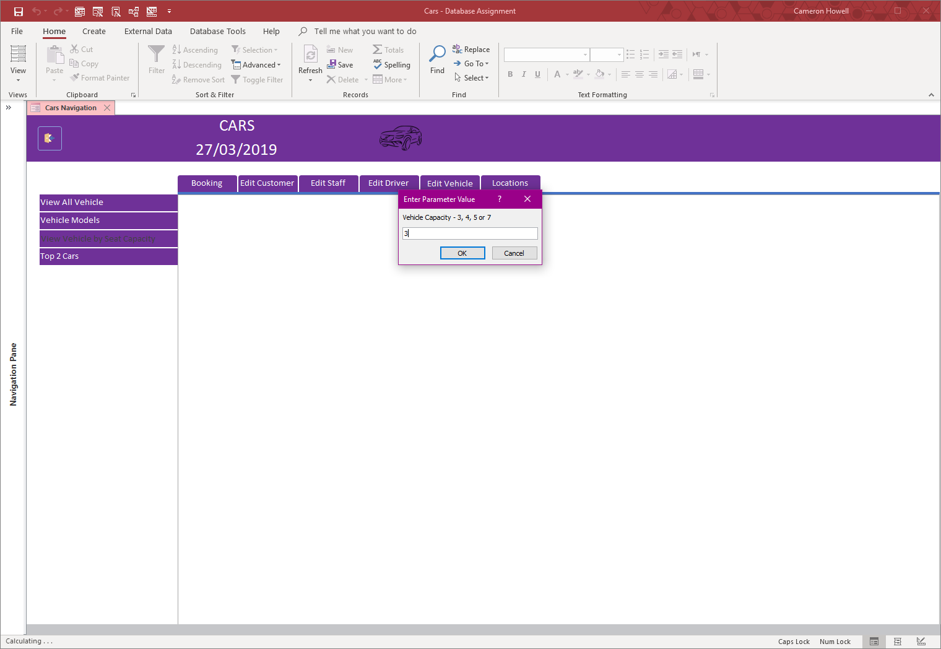

View vehicle by Capacity

This report asks for the capacity of the vehicle whose details you want to view.

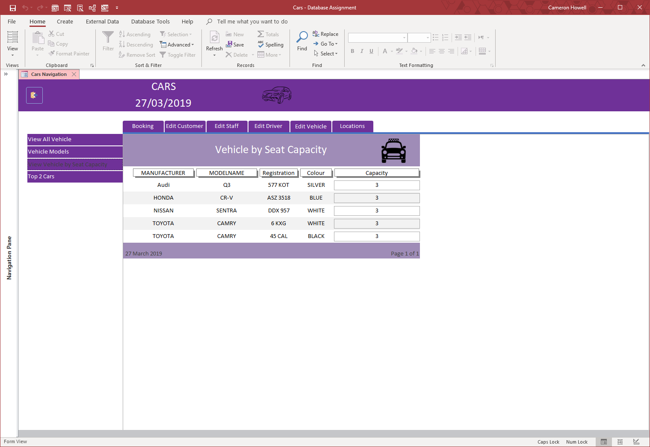

View vehicle with 3 seats

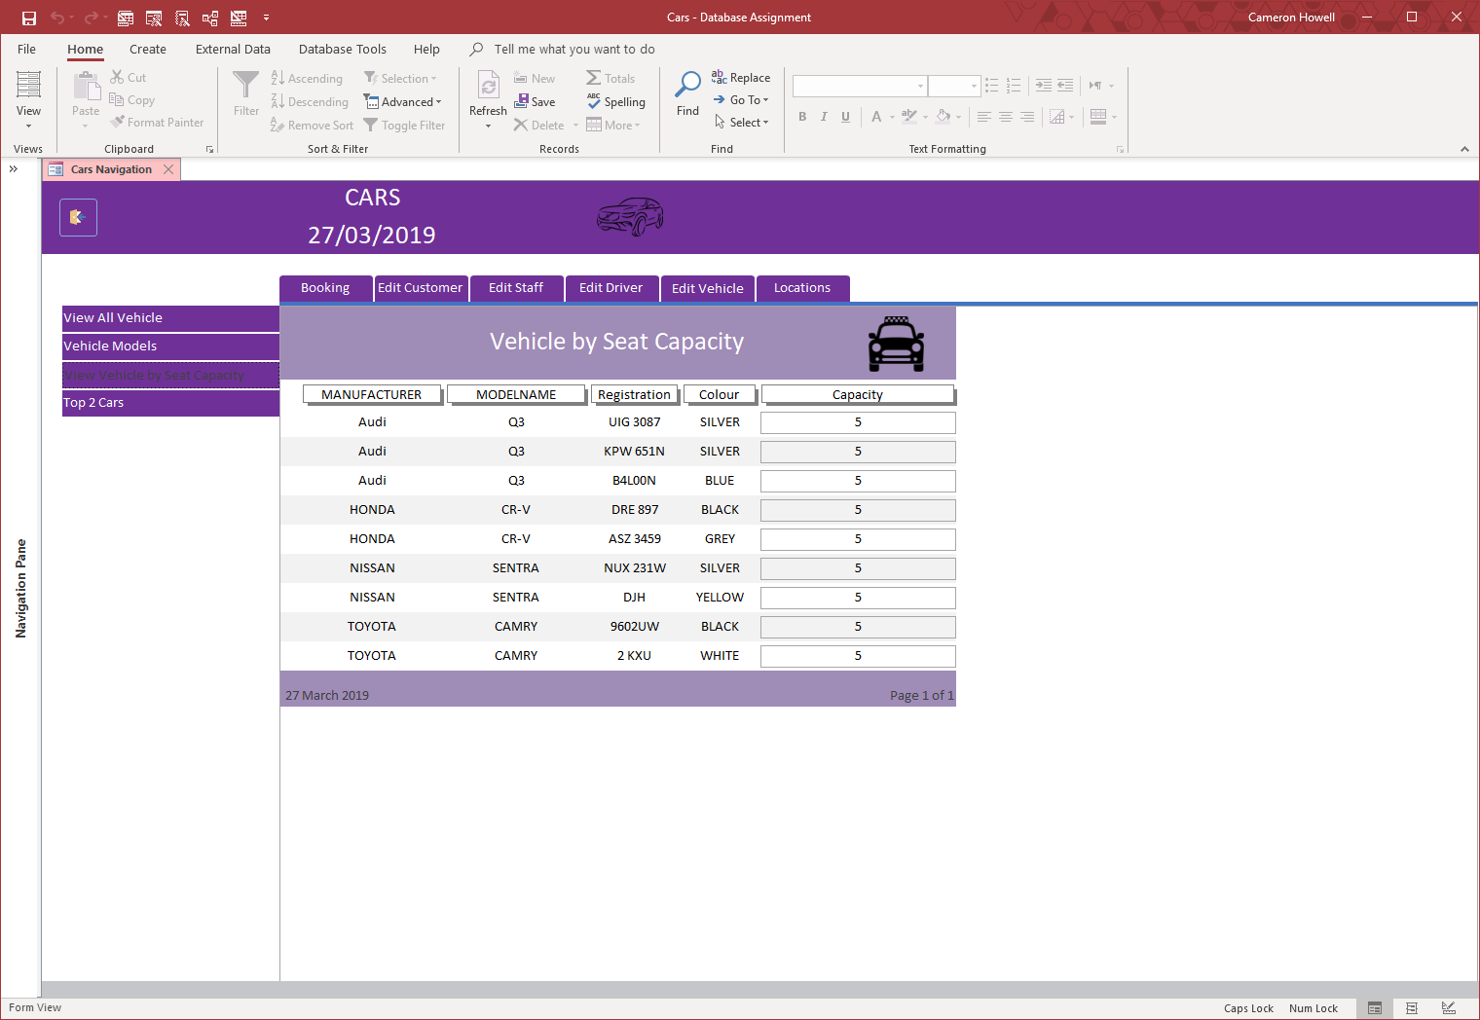

View vehicles with 5 seats

The report shows the results of the search of vehicles by capacity, displaying two different searched.

## Reports – Vehicles

### View vehicle by capacity



View vehicle by Capacity

This report asks for the capacity of the vehicle whose details you want to view.



View vehicle with 3 seats



View vehicles with 5 seats

The report shows the results of the search of vehicles by capacity, displaying two different searched.

## Reports - Locations

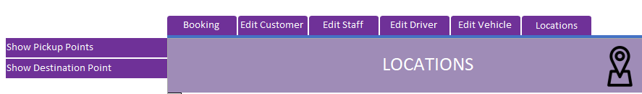

The left menu holds the reports.

### Pickup points

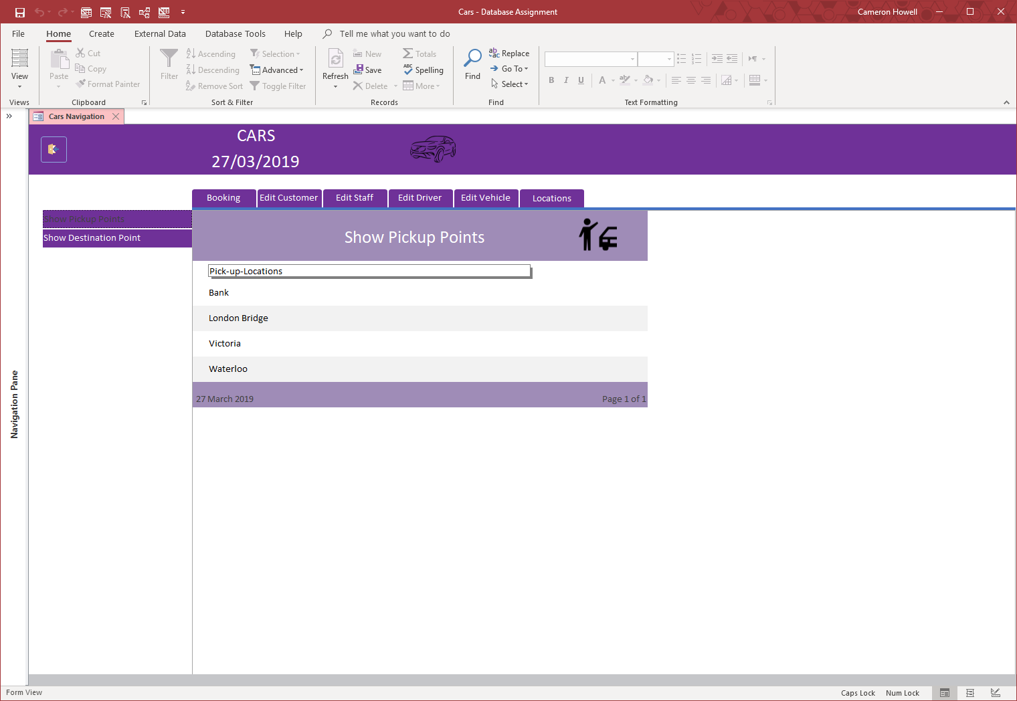

View pick up locations

The company has specific points where they pick up customers.

### Destination points

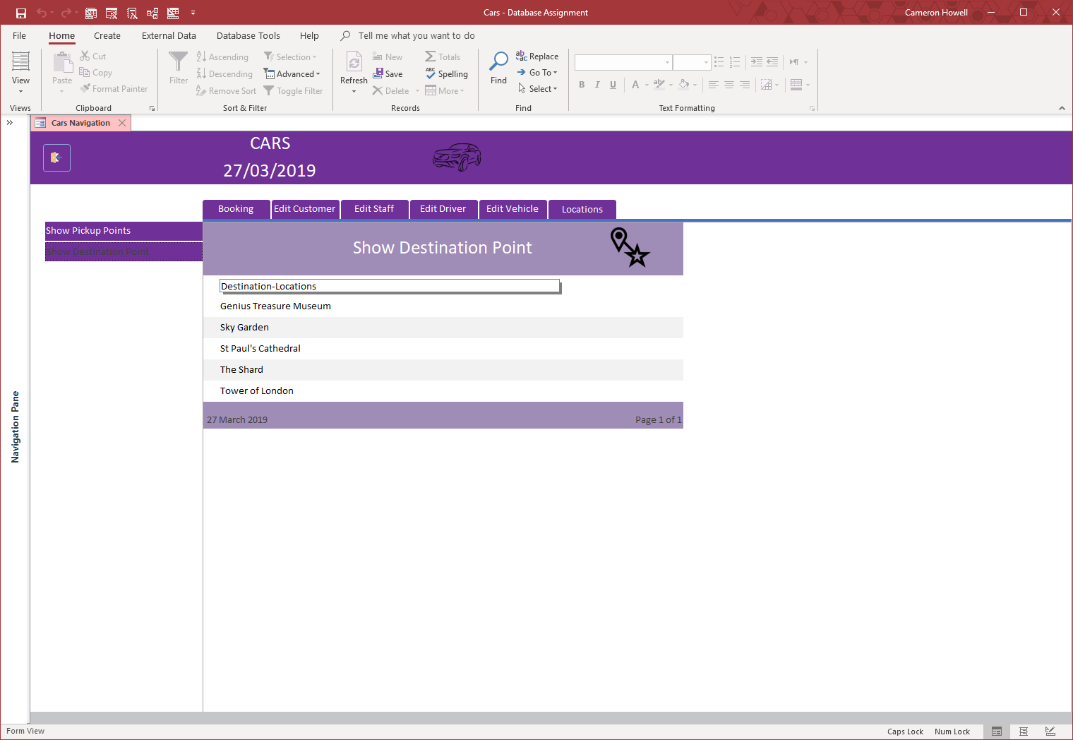

View destinations

The company also has specific tourist attraction destinations

## Using buttons

To create a new booking, click the Add Record button and begin filling in the required information.



To delete a record, click the Delete Record button.

To navigate to the first and last record, click the First Record or the Last Record button.



 To navigate to the previous or the next record, click the Previous Record or the Next Record button.



To save a record, click the Save Record button.



To view a booking receipt, click the Receipt button. **Unique to Booking table.**

To make a journey a return, click the Return Journey radio button. **Unique to Booking table.**

References

# References

Microsoft, 2019. *Examples of using dates as criteria in Access queries.* [Online]   
Available at: https://support.office.com/en-us/article/examples-of-using-dates-as-criteria-in-access-queries-aea83b3b-46eb-43dd-8689-5fc961f21762  
[Accessed 23 02 2019].

W3SCHOOLS, 2019. *SQL TOP, LIMIT or ROWNUM Clause.* [Online]   
Available at: https://www.w3schools.com/sql/sql_top.asp  
[Accessed 23 02 2019].