Calvin Suratos

CPE301 – SPRING 2016

Design Assignment 2

**DO NOT REMOVE THIS PAGE DURING SUBMISSION:**

The student understands that all required components should be submitted in complete for grading of this assignment.

|  |  |  |  |
| --- | --- | --- | --- |
| **NO** | **SUBMISSION ITEM** | **COMPLETED (Y/N)** | **MARKS**  **(/MAX)** |
| 0. | COMPONENTS LIST AND CONNECTION BLOCK DIAGRAM w/ PINS |  |  |
| 1. | INITIAL CODE OF TASK 1/A 2/B 3/C 4/D WITH ASSEMBLY |  |  |
| 2. | INITIAL CODE OF TASK 1/A 2/B 3/C 4/D WITH C LANGUAGE |  |  |
| 3. | SCHEMATICS |  |  |
| 4. | SCREENSHOTS OF EACH TASK OUTPUT |  |  |
| 5. | SCREENSHOT OF EACH DEMO |  |  |
| 6. | VIDEO LINKS OF EACH DEMO |  |  |
| 7. | GOOGLECODE LINK OF THE DA |  |  |
|  |  |  |  |
|  |  |  |  |

|  |  |  |  |
| --- | --- | --- | --- |
| 0. | COMPONENTS LIST AND CONNECTION BLOCK DIAGRAM w/ PINS |  |  |

Breadboard

Jumper Wires

Atmega328P

Pololu USB AVR programmer

10-Bit LED Bar

1 Red LED

11 4.7K Resistors

|  |  |  |  |
| --- | --- | --- | --- |
| 1. | INITIAL CODE OF TASK 1/A 2/B 3/C 4/D WITH ASSEMBLY |  |  |

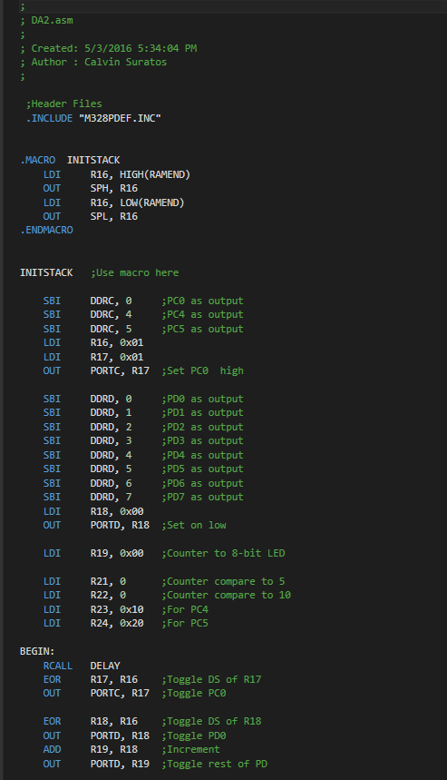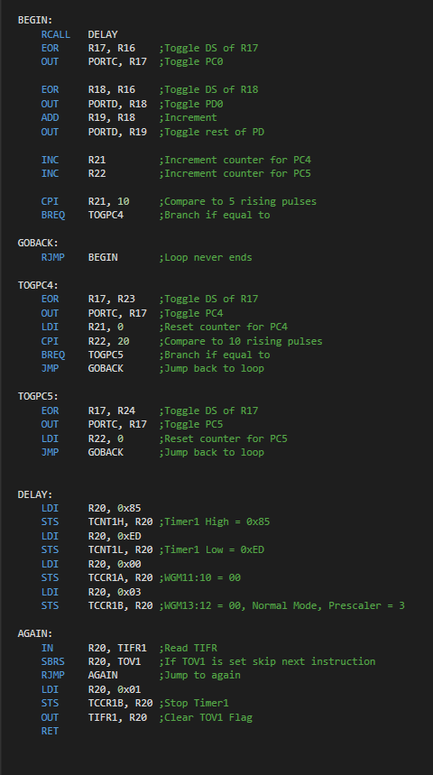

|  |  |  |  |
| --- | --- | --- | --- |
| 2. | INITIAL CODE OF TASK 1/A 2/B 3/C 4/D WITH C LANGUAGE |  |  |

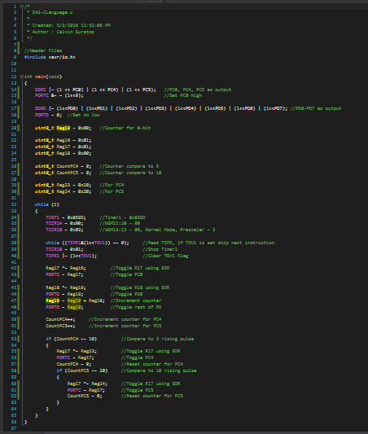

|  |  |  |  |
| --- | --- | --- | --- |
| 3. | SCHEMATICS |  |  |

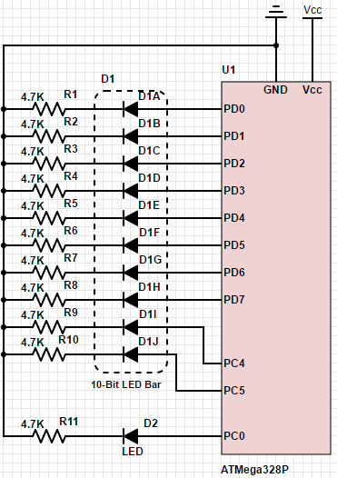

|  |  |  |  |
| --- | --- | --- | --- |
| 4. | SCREENSHOTS OF EACH TASK OUTPUT |  |  |

TASK 1/A: Generate a 50% duty cycle waveform with 0.5 sec period in PORTC.0

TASK 2/B: Implement 8-bit counter on a 10-bit LED bar in PORTD

TASK 3/C: Toggle 9th Bit of bar in PORTC.4 every 5 pulses, and 10th Bit of bar in PORTC.5 every 10 pulses

TASK 4/D: Use interrupts to update status/toggle of 9th and 10th LED bar

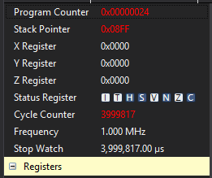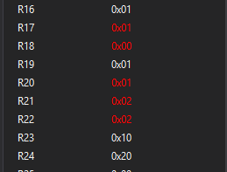

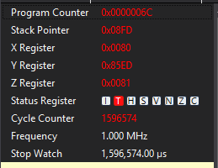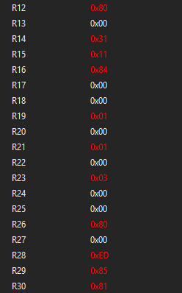

|  |  |  |  |
| --- | --- | --- | --- |
| 5. | SCREENSHOT OF EACH DEMO |  |  |

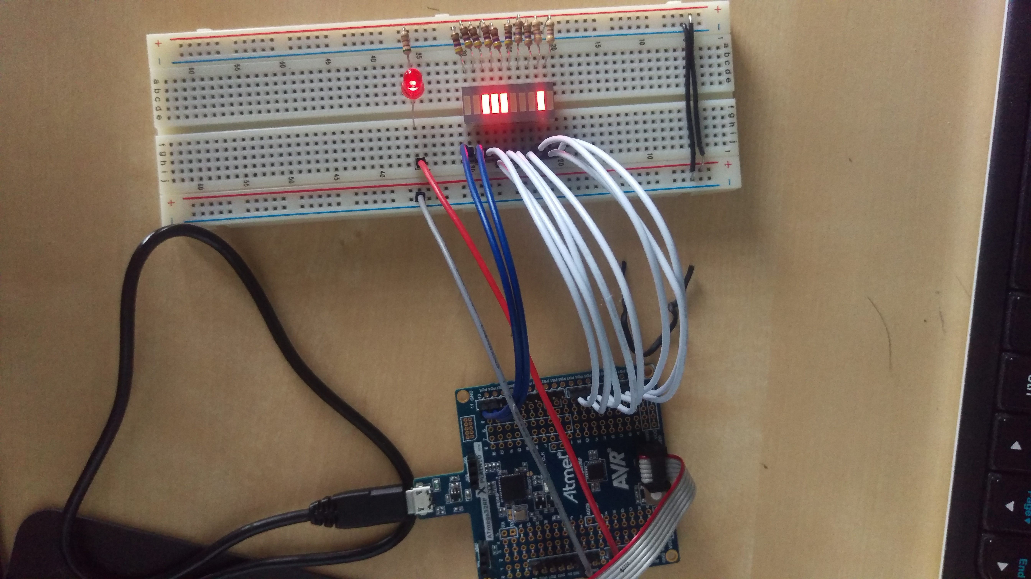

|  |  |  |  |
| --- | --- | --- | --- |
| 6. | VIDEO LINKS OF EACH DEMO |  |  |
| <https://drive.google.com/a/unlv.nevada.edu/folderview?id=0B5Kz0gdhFCkDVkc4a09SdlB6bXc&usp=sharing> | | | |
| 7. | GOOGLECODE LINK OF THE DA |  |  |
| <https://github.com/CalvinSuratos/DesignAssignments.git> | | | |

**Student Academic Misconduct Policy**

<http://studentconduct.unlv.edu/misconduct/policy.html>

“This assignment submission is my own, original work”.

Calvin Suratos