Practical Gaming 2025

Name of Student: Calvin Wong

T Number: T00247209

Name of Project: Minecraft_BO_Survival

Gameplay
Describe how to play the game here, specify keys/mouse etc. what needs to be done to unlock further features etc.., i.e. a walkthrough which covers all of what is to be seen to be marked.
This game is made in reference to both Minecraft and Black Ops Zombie Apocalypse. In all 4 levels, the player is spawned in the city with a certain weapon which he/she had to survive for the longest amount of time. In all 4 levels, there are multiple numbers of enemy spawn points that spawn zombies for every 3 seconds and their only target is to kill the player. To accumulate points in the score system, the player must kill the zombies by shooting the weapon, they were spawned with. For every kill the player gets from the enemy, the score text value at the top right corner increases by 20. If the player were to take damage from the zombies, the armour bar takes damage before the health bar, updating the Blue Image bar and Green Image Bar. Every zombie that spawns into the game has exactly 100 health while the player has only 100 armour and 100 health. The zombies are given a component called ‘Nav Mesh agent’ which directs the zombie around any obstacle it encounters while chasing towards the player.
The keys for moving the player in this game are W, A, S, D. Pressing W will move the player forward, S will move the player backwards, A will move the player to the left, and D will move the player to the right. The mouse itself is the rotation of the player to look around the scene but has a 90-degree restraint when moving the mouse up and down. The player speed is to 5 and mouse sensitivity is set to 50. The Player and Enemy speed must be near the same, the mouse sensitivity can’t be too dramatic when looking around.
In the inventory bar, there are 5 slots, each containing an item that will help the player survive longer in the game. The 5 items are the main weapon (slot 1), Iron sword (slot 2), Armour plate (slot 3), Med Kit (slot 4), and Hand Grenade (slot 5). The player must press from key 1 – 5 to select a slot. Upon selecting the desired slot, the player must left click the mouse to use the weapon/item. This also enables and disables the player’s selected item, making any weapon or item invisible during the game.
The main weapon which the player spawns with at the start of any level, has a limited number of bullets (sphere projectile) in the gun capacity to shoot with. The player must left click the mouse to fire the gun. If the gun were to run out of bullets, there is a cooldown for reloading the weapon until the weapon has been fully reloaded. Each bullet in different weapons has different damage points i.e. AK47 does 35 damage per bullet, sniper does 100 damage per bullet, etc…
The Iron sword is also a weapon that spawns with the player at any level and has unlimited durability with 25 attack damage. The player must also left click to swing the sword at the zombies. But for each swing of the sword, it has an attack cooldown of 2.5 seconds, before the player can swing his sword again.
The Armour Plate (slot 3) and Med Kit (slot 4) has a limited number of uses which can be used to heal the Player’s armour bar and health bar. Each of these items are set to 2 uses only at the beginning of any level, and if they want more armour plates or med kits, they must find one of many spawn points located around the level. Upon picking up the item, a 60 second timer will start and will respawn another one until 60 seconds are over. Both the armour plates and med kits restore about 25% of the player’s armour bar and health bar when the player left clicks the selected item.
The hand grenade (slot 5) has 100 attack damage with a blast radius of 5 blocks. The grenade is thrown upon left clicking the mouse in the direction the player is looking at. This is also applied to the main weapon and iron sword.

Coding
Under each of the following headings, please describe the concept, why is it or isn’t it useful/needed, where do you implement in your project, you may provide screenshots or cut and past code segments etc..
- Frame Rate Independence – ensures that a game’s movement and logic run consistently regardless of the player’s frame rate.
  - Time.deltaTime – this code is used to initiate the timer variable whenever the gun or sword is on its cooldown rate. This is also applied to the iron sword attack cooldown and the Enemy attack cooldown.
- Interfaces
  - IUsable – this interface is used globally and is used to all five item scripts, each assigned to its individual slot of the inventory bar. The interface only has one method called ‘use()’.
  - IHealth – this interface is used to detect enemies (zombies) when the player swings his sword or throws a grenade upon exploding when it’s within attack range or blast radius by calling the method ‘takeDamage()’.
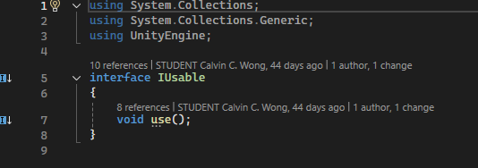
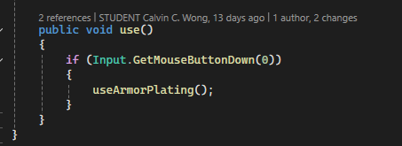
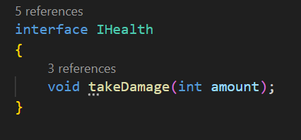
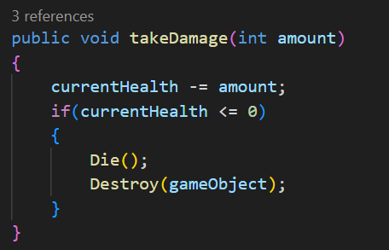

- Inheritance
  - Bullet – the bullet script becomes an inheritance script to the Revolver bullet, sniper bullet and Shotgun bullets scripts. The Start() and Update() including the OnCollisionEnter() method are all inherited by calling the base.Start()/Update()/OnCollisionEnter() method in all bullet scripts.
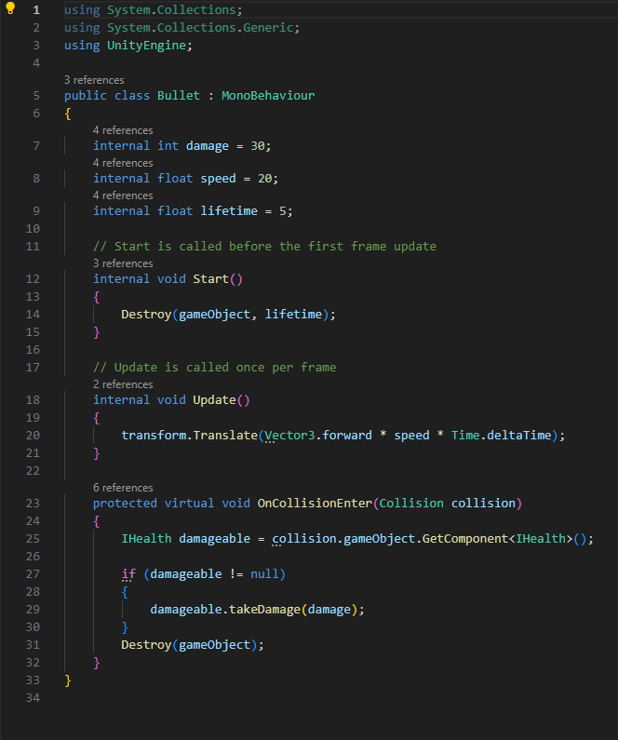
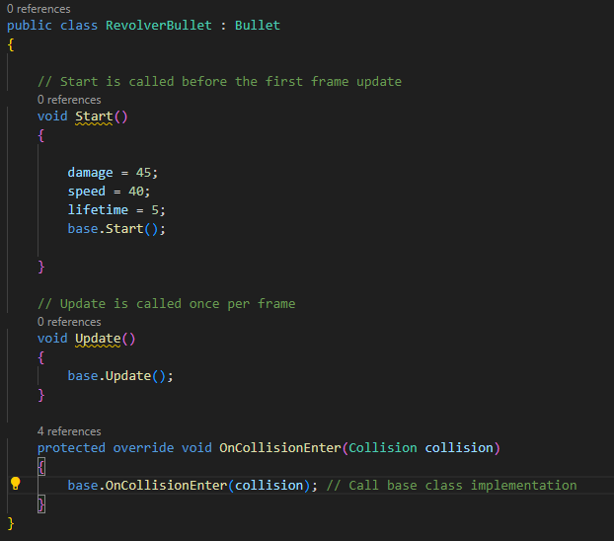
- Observer Pattern – a design pattern in which an object maintains a list of its dependents (zombies, med kits, armour plate), and automatically notifies them of any state changes.
  - GameController Script – this is an observer that instantiates zombies from various spawn points including med kits and armor plates at a controlled time.
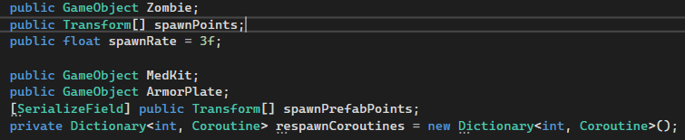
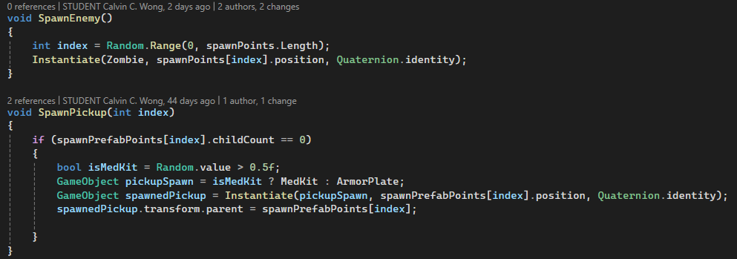
- Communication between scripts/game objects
  - Med kit/Armour plate – Upon colliding with the spawned prefab from different spawn points, the prefab will be destroyed and increase the med kit/armour plate use by 1.
  - Game Script – this Game Object has an attached script called ‘Game Controller’ which controls the number of spawns for the enemy, med kit and armour plate. This also updates the score for the player when killing the enemies (zombies) and the timer.
  - Game Over Scene – this Game Over scene only appears when the player dies in the game when player health reaches below 0. This UI contains a message saying, ‘Player has died, Game Over!!!’, and three buttons each saying, ‘Retry’ to retry the level again, ‘Level Selection’ to go into the Level Selection scene, and ‘Quit’ to quit/exit the game completely.
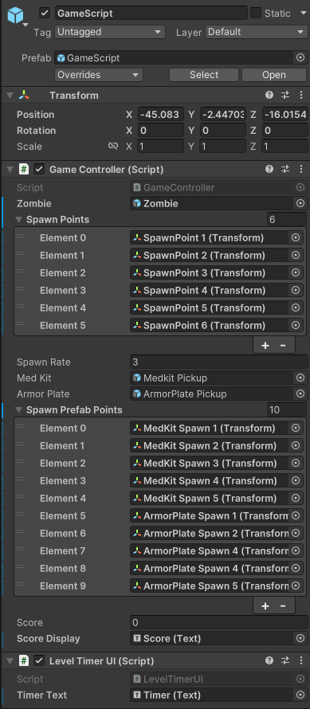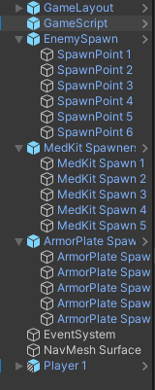
- Polymorphism – a feature of inheritance where you can treat class instances as any class that they can inherit from.
- Inside the CharacterController script, I have a list of IUsable items for all objects that the player has in each level, if the player selects an inventory slot, all other items except the selected item are invisible and scripts are enabled/disabled.
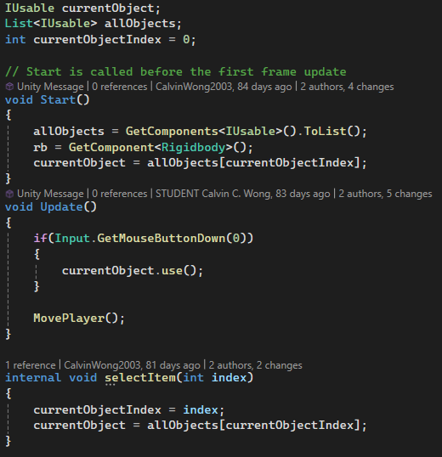
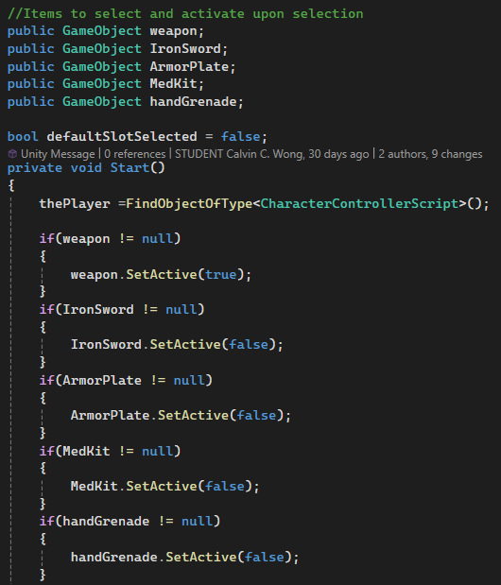

- Instantiation and Prefabs
  - Zombies – The zombie prefabs are instantiated every 3 seconds at different spawn points in the game in each level.
  - Bullets (bullet, sniper bullet, etc…) – the bullet prefab are instantiated at the player’s attack point when left clicking the mouse to fire the gun.
  - Player – In different levels, the player has a different weapon with a different damage output.
  - Med kit – med kit prefabs are instantiated at different spawn points in the game.
  - Armour plate – armour plate prefabs are instantiated at different spawn points in the game.
  - Iron sword – iron sword prefabs are used by the player for attacking the zombies that approaches in close range.
- Self-made models and or animations
  - Zombie – this self-made model is made using the application of Maya to create the limbs and body of the zombie.
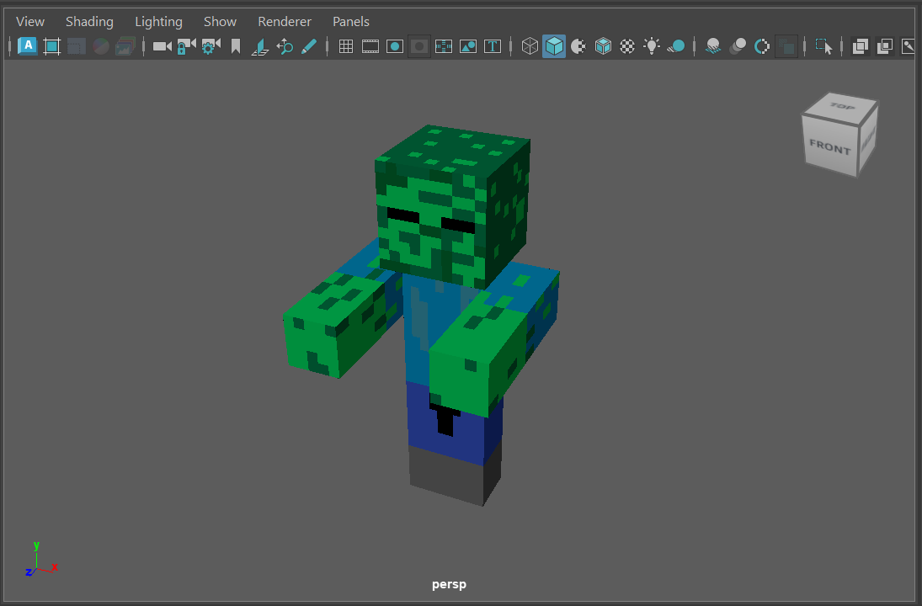
  - Player – this is also made by Maya to create the limbs and body of the character when playing.
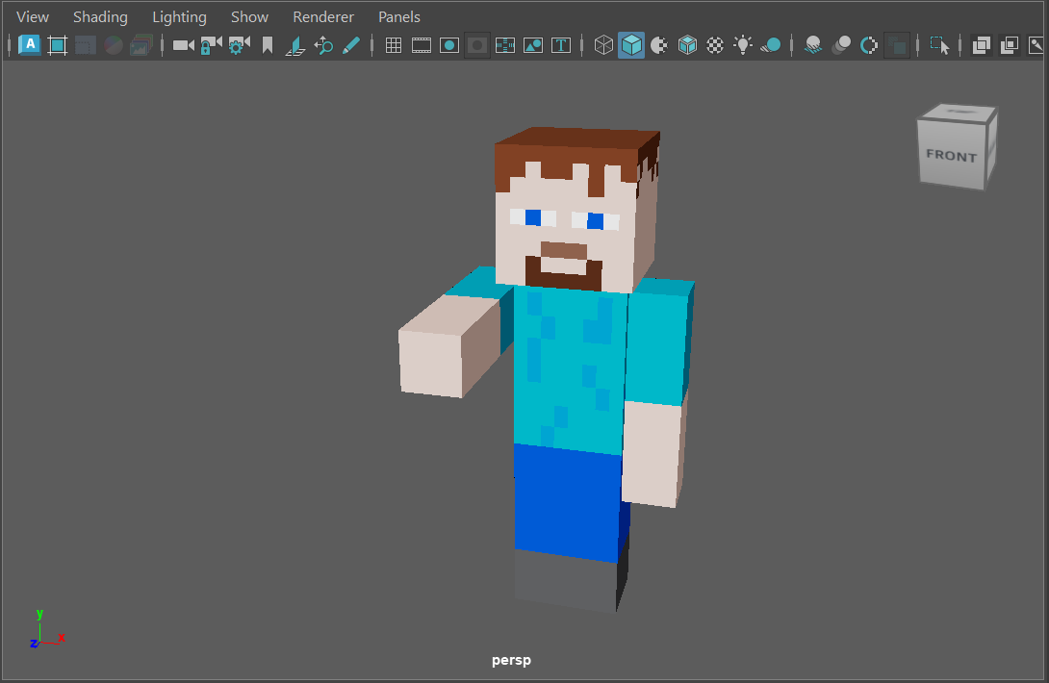
- Interactions between objects/scripts
  - When a player interacts with either a spawned med kit or armour plate in any level of the game by going through the game object, the OnTriggerEnter method will immediately interact with another script(s) called ‘CW_MedKit’ and ‘CW_ArmorPlate’ and access the method ‘AddUse()’ to increase the number of uses.
  - When an enemy attacks the player within its attack range, it accesses the player’s PlayerHealthArmor script and the method ‘TakeDamage()’ is initiated.
- Proper code placement – uses different C# classes to manage various aspects of the game
  - The GameController script is used to spawn Zombies in a list of spawn points as well as med kits and armour plates.
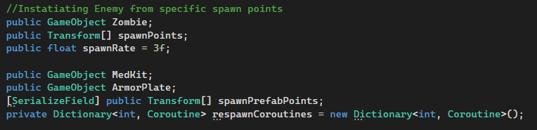
  - The LevelTimerUI script is used to control the timer on how long the player has survived in the selected level.
- Code repetition
  - StartCoroutine(Reload()) – this code is used when the gun is currently empty and reloading after a certain time.
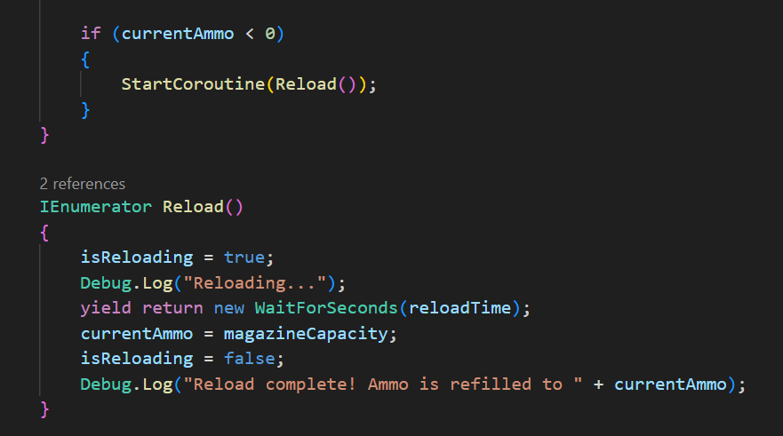
  - StartCoroutine(RespawnPickUp(index)) – this code is used when a respawned item like a med kit or armor plate has respawned after the player has picked the item and a timer starts to respawn another in its place.
- Magic Numbers – a piece of code that replaces any number with a variable instead.
- currentArmor/Health – this part of the code is in takeDamage() method when the damage output is based on the zombie’s attack damage i.e. if(current >= damage) {currentArmor -= damage}
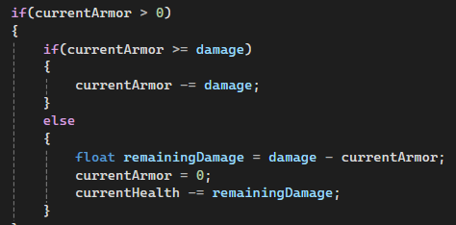

- Feature 1
  - SimplePoly city – this is the main that I have used as the layout of the game which includes city buildings, houses, terrain, etc…, to make the scene somewhat like Minecraft.
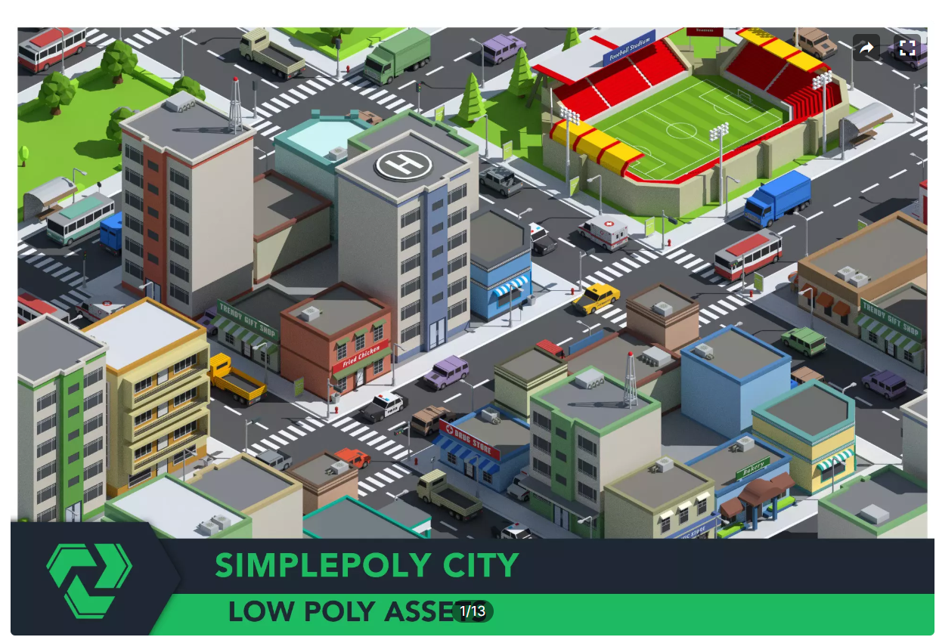
- Feature 2
  - Weapons Free Low Poly 3D model pack – this is a weapons feature where I used the guns to shoot the projectile out of.
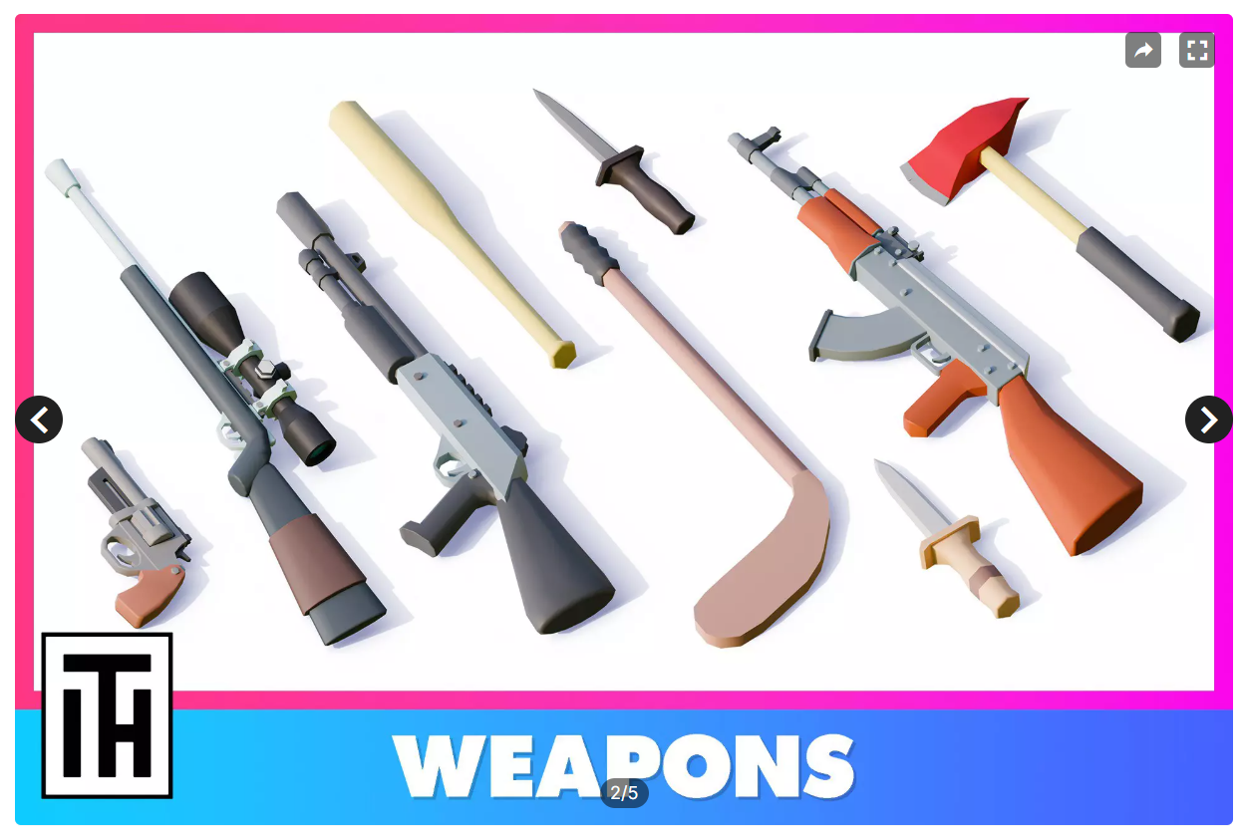
  - Low Poly Swords – this is another weapons feature where I used an Iron Sword to swing and attack the zombies in close range.
  - Low Poly Hand Grenades – a weapons feature where I used both low- and high-quality hand grenade prefabs for the player to throw and deal explosive damage.
- Feature 3
  - Low Poly Military med kits – this is a feature where I used 4 types of prefabs and renamed with 2 names only as: 1. Med Kit, 2. Armor Plate. This is used to apply restoration of health and armor as well as pick up items.
  - Nav Mesh Surface – a component that represents the walkable area for a specific NavMesh Agent type, and defines a part of the scene.

