**Instructions on How to Run Code (on Linux terminal)**

**Running part2.py, part3.py and part4.py:**

1. **Using IDE**

When using IDE, simply unzip the file, open the python script (e.g. part2.py) and run it. It will run using default values, for example: smoothing_k = 3 and viterbi_k = 3. Output is written into the corresponding folder. For example: EN/dev.p2.out when running part2.py for EN question 2. All 4 languages are processed in one run.

1. **From Command Line**

When using command line:

* Unzip the file
* cd into the **ML Project** folder
* Run the python file, e.g: “python part2.py”

Same as above, it will run with default values. After writing the output file, it will automatically run the evalResult.py script. Expected result when running from command line:

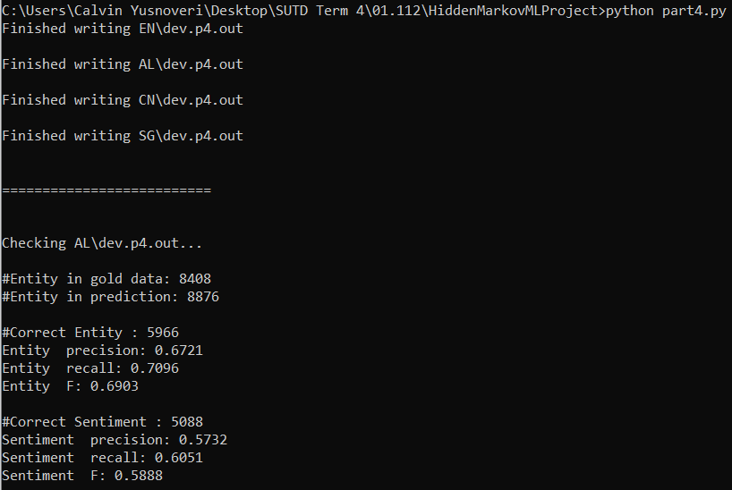

**Running the evalResult.py only:**

Question 2

1. Unzip folder **ML Project**
2. Cd the terminal to **ML Project**’s directory
3. Once inside **ML Project**’s directory, enter the command:

**python3 evalResult.py AL/dev.out AL/dev.p2.out**

1. Continue to perform testing on the other files by entering the commands

**python3 evalResult.py CN/dev.out CN/dev.p2.out**

**python3 evalResult.py EN/dev.out EN/dev.p2.out**

**python3 evalResult.py SG/dev.out SG/dev.p2.out**

Question 3

1. Inside **ML Project**’s directory, enter the command:

**python3 evalResult.py AL/dev.out AL/dev.p3.out**

1. Continue to perform testing on the other files by entering the commands

**python3 evalResult.py CN/dev.out CN/dev.p3.out**

**python3 evalResult.py EN/dev.out EN/dev.p3.out**

**python3 evalResult.py SG/dev.out SG/dev.p3.out**

Question 4

1. Inside **ML Project**’s directory, enter the command:

**python3 evalResult.py AL/dev.out AL/dev.p4.out**

1. Continue to perform testing on the other files by entering the commands

**python3 evalResult.py CN/dev.out CN/dev.p4.out**

**python3 evalResult.py EN/dev.out EN/dev.p4.out**

**python3 evalResult.py SG/dev.out SG/dev.p4.out**

Question 5

1. Inside **ML Project**’s directory, enter the command:

**python3 evalResult.py AL/dev.out AL/dev.p5.out**

1. Continue to perform testing on the other files by entering the commands

**python3 evalResult.py CN/dev.out CN/dev.p5.out**

**python3 evalResult.py EN/dev.out EN/dev.p5.out**

**python3 evalResult.py SG/dev.out SG/dev.p5.out**

Example:

