11/4/2024

OPSC Final POE

• Mohlao Makhale - St10082707

• Calvin Fourie - ST10121193

• Naeem Brown - ST10231877

• Ben Rush - ST10132792

• Jaiden Charles - ST10145509

Contents

Overview 2

Screenshots 5

Integration Test 16

# Overview

**BudgetApp**

**Team Members**

* **Mohlao Makhale** - St10082707
* **Calvin Fourie** - ST10121193
* **Naeem Brown** - ST10231877
* **Ben Rush** - ST10132792
* **Jaiden Charles** - ST10145509

**Purpose of the App**

The **BudgetApp** is a financial management tool designed to help users efficiently track their expenses, set budgets, and visualize spending patterns. This app targets individuals seeking better control over their finances, offering features that allow for expense categorization, cash flow monitoring, and informed financial decision-making.

**Design Considerations**

The development of the BudgetApp emphasized simplicity, performance, and scalability. Key design decisions include:

* **Architecture**: Utilization of **MVVM (Model-View-ViewModel)** architecture to ensure a clear separation of concerns. This structure promotes modularity and maintainability within the codebase.
* **Libraries and Dependencies**:
  + **Retrofit** for handling network requests.
  + **OkHttp** for HTTP operations.
  + **Filament** for advanced graphics rendering, which collectively provides a smooth and responsive user experience.
* **Dependency Management**:
  + **Android Gradle Plugin (AGP)**: Version 8.4.0.
  + **Kotlin**: Version 1.9.0.

Core libraries such as coreKtx, lifecycleRuntimeKtx, and activityCompose are included at their latest stable versions, ensuring compatibility, stability, and security.

* **UI Framework**: The app leverages **Jetpack Compose** for creating modern, declarative UI elements, offering users a smooth and interactive experience.

**GitHub and GitHub Actions Usage**

The project employs **GitHub** for version control, facilitating collaborative development and tracking of changes. Additionally, **GitHub Actions** are configured to automate various tasks, including:

* **Continuous Integration (CI)**: Automated builds and tests triggered on each commit, helping maintain a stable codebase and ensuring new changes are free of bugs.
* **Deployment Pipeline**: GitHub Actions workflows streamline the deployment process by automatically deploying the latest app version to designated environments.

This setup enhances efficiency and maintains a consistent, high-quality codebase.

**Release Notes**

**Latest Version**

* **New Features**:
  + **Expense Categorization**: Users can categorize expenses for improved tracking and reporting.
  + **Budget Alerts**: A new feature to alert users when they are nearing their budget limits.
  + **Data Sync**: Enables data synchronization, allowing seamless access across multiple devices.
  + **Multi-Language Support**: Added support for two additional languages to enhance accessibility for a global audience.
  + **Offline Capabilities**: Users can now manage budget information without requiring an internet connection.
  + **Notification System**: Notifications remind users of upcoming bills, budget limits, and other key events.
* **Improvements**:
  + **UI Enhancements**: Updated layout and visual design for improved usability and aesthetic appeal.
  + **Performance Optimization**: Reduced load times and optimized background processes.
  + **Bug Fixes**: Addressed issues reported in the prototype, including app crashes under certain conditions.

**Previous Versions**

* **Prototype Version**:
  + Basic functionalities included for adding expenses, viewing lists, and calculating totals.

**YouTube Demo**

For a detailed walkthrough of the app, [watch the demo on YouTube](https://youtu.be/wUlehHYR9s8?si=yYJ3hzmB2Vx2xBHZ).

**Images and Visuals**

This document includes screenshots and diagrams illustrating key features, user flows, and the overall structure of the application. These visuals aim to provide clarity and showcase the app’s functionality.

**Additional Documentation**

Further details on design considerations, code structure, and future development goals are available in the additional documentation within the GitHub repository.

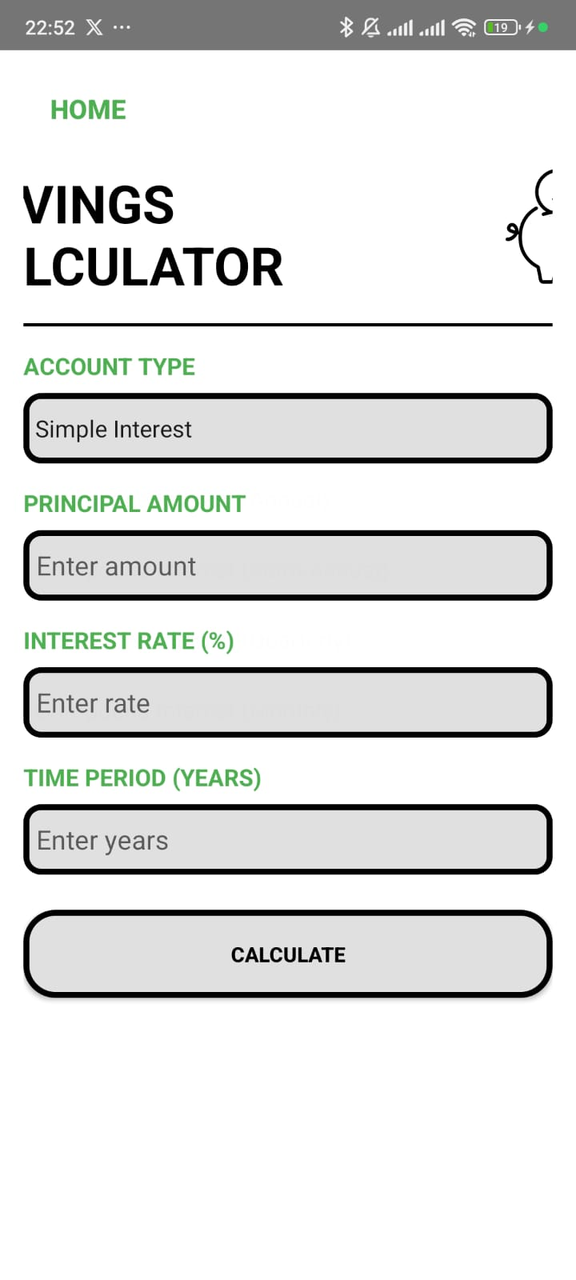Screenshots:

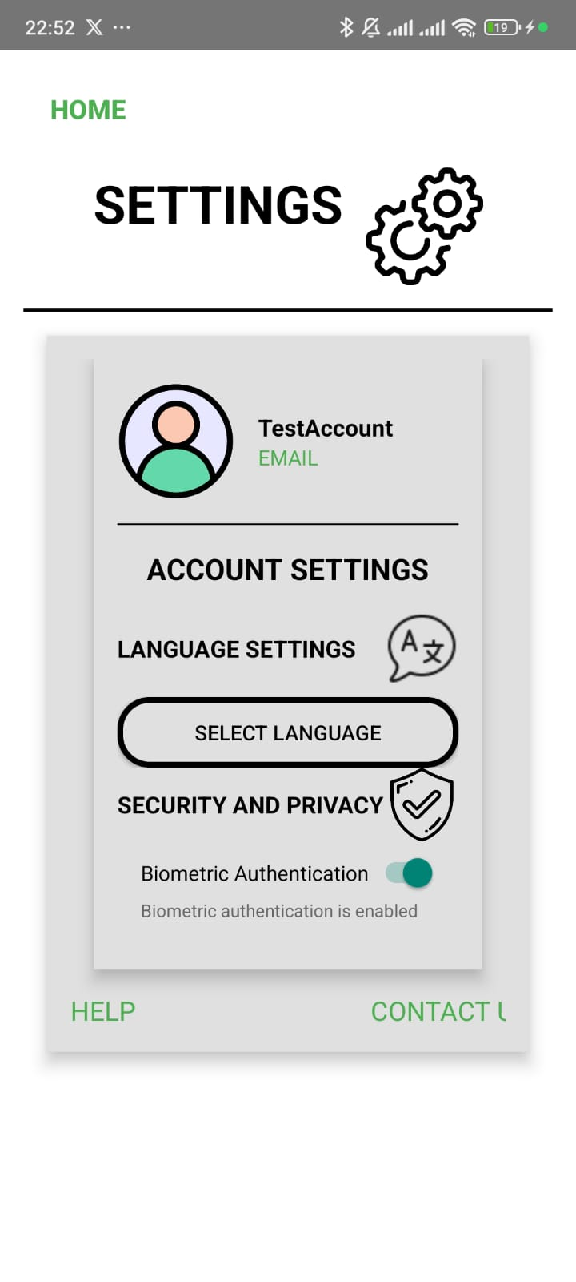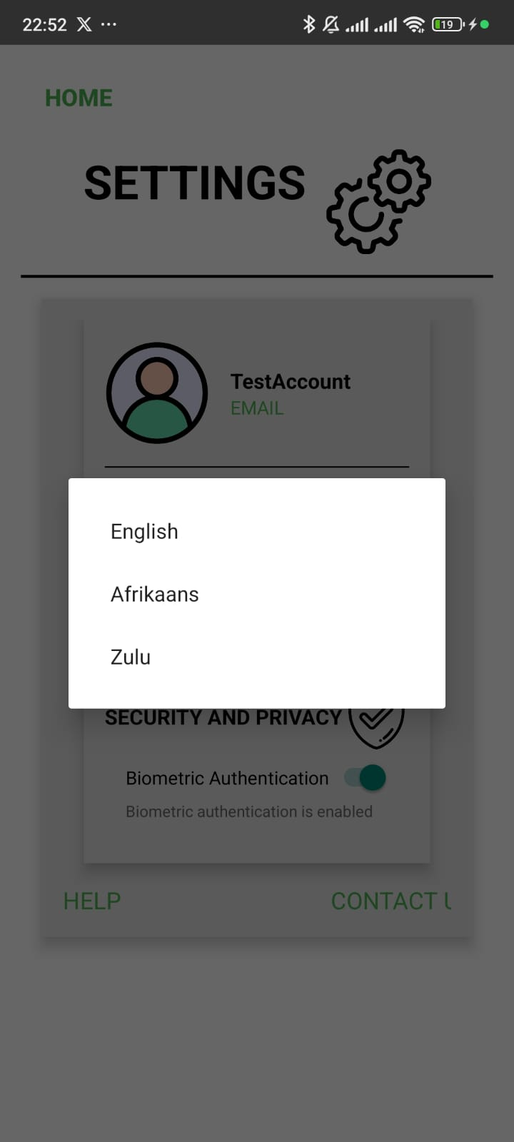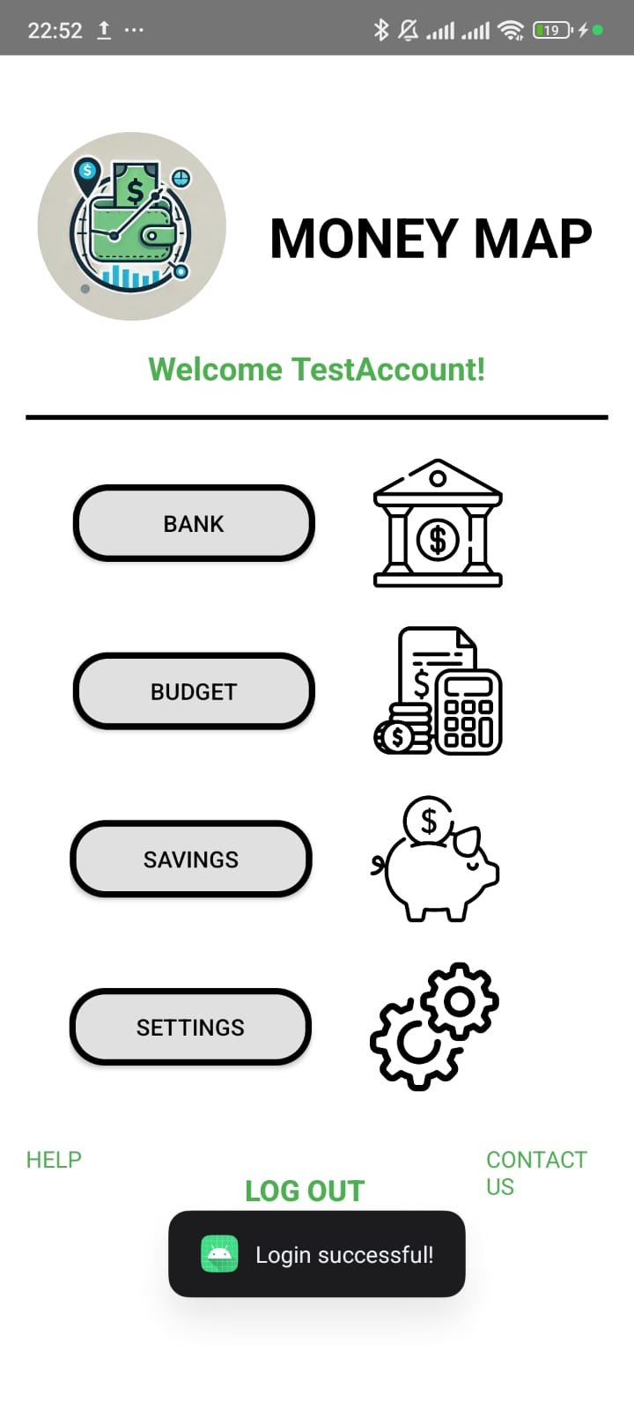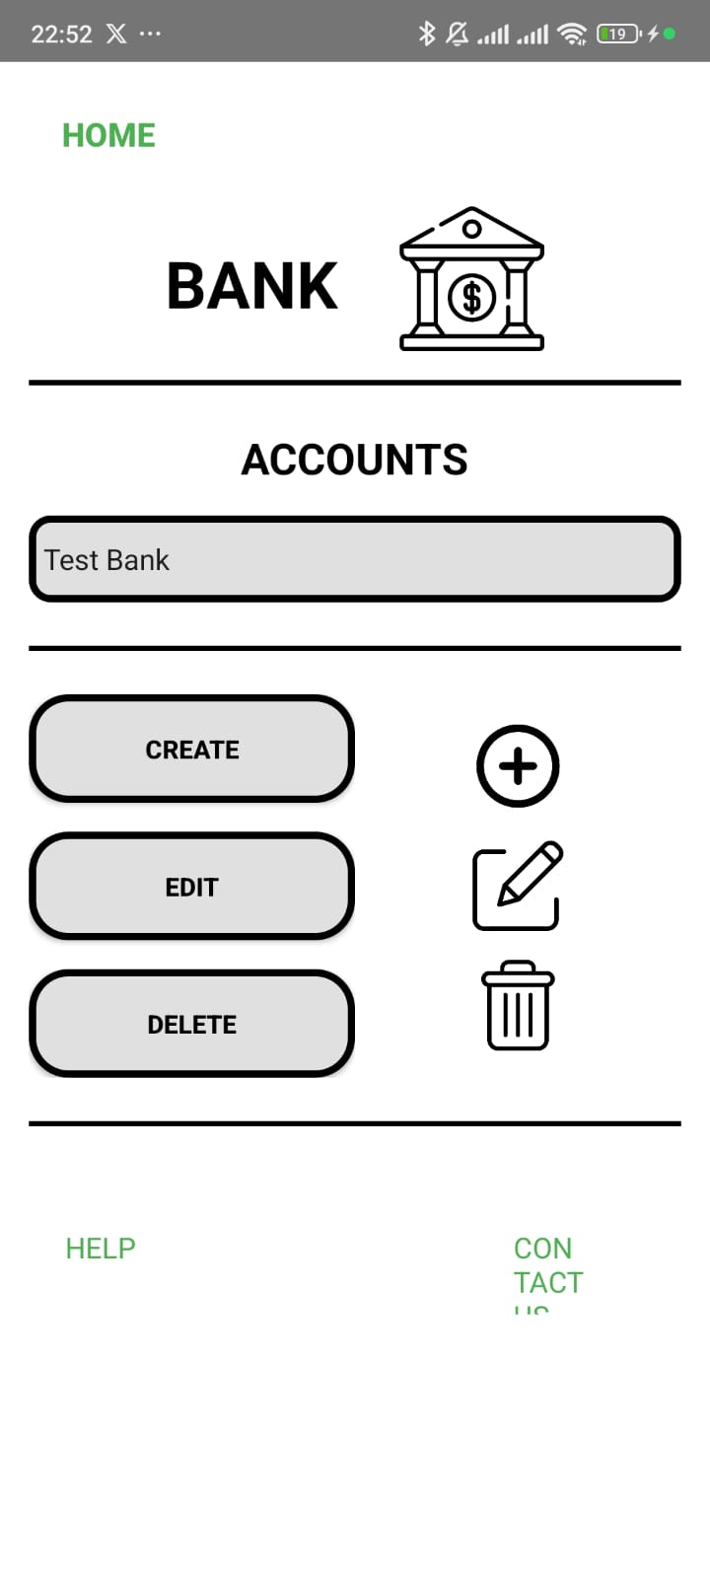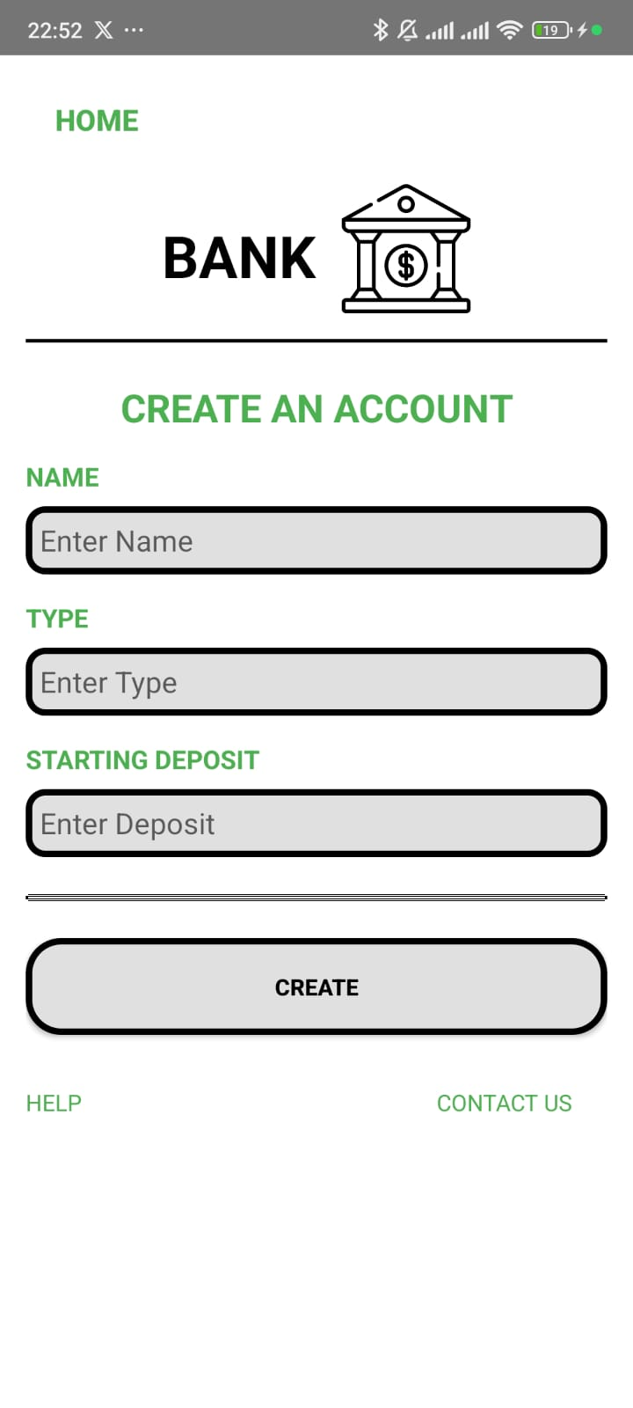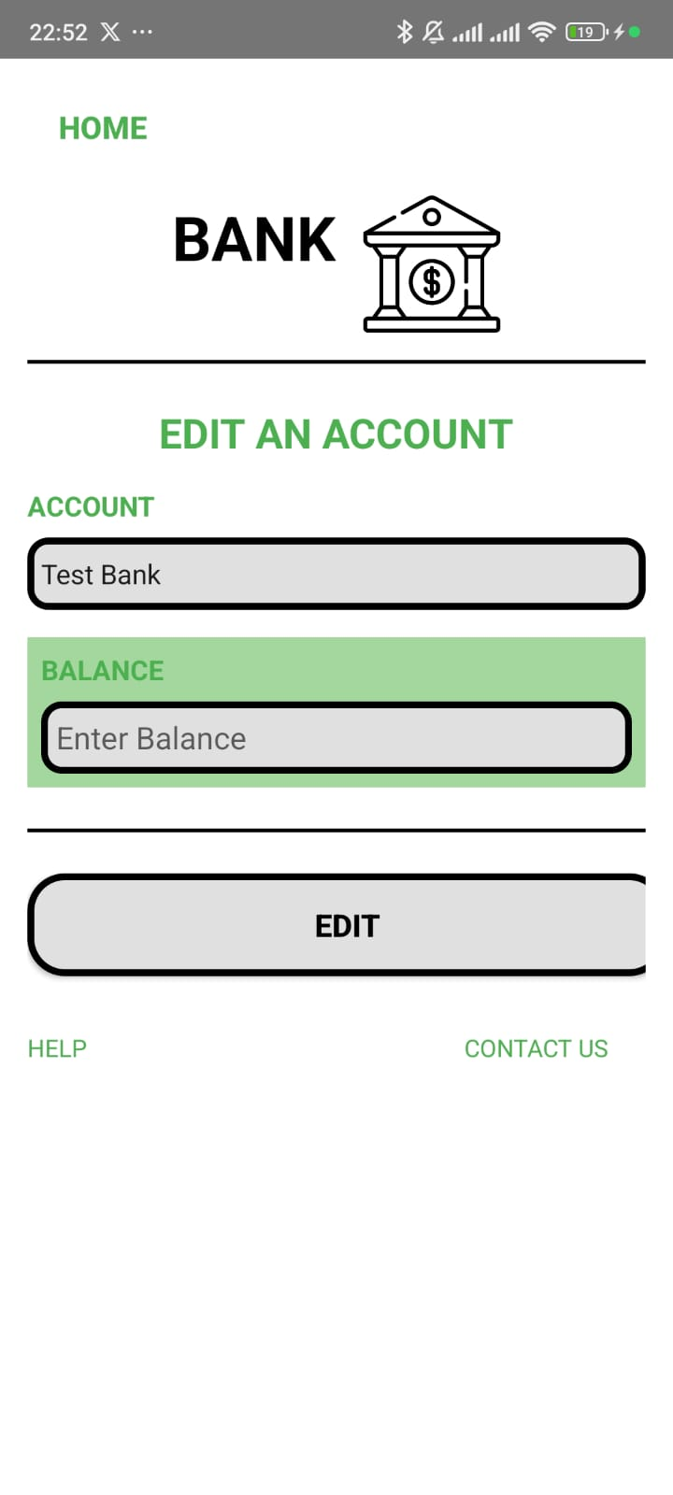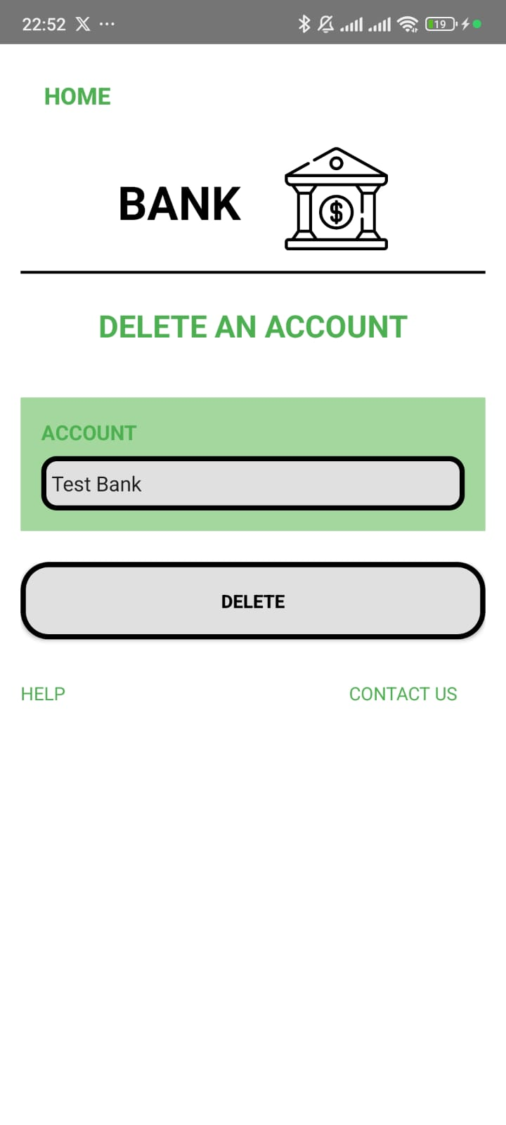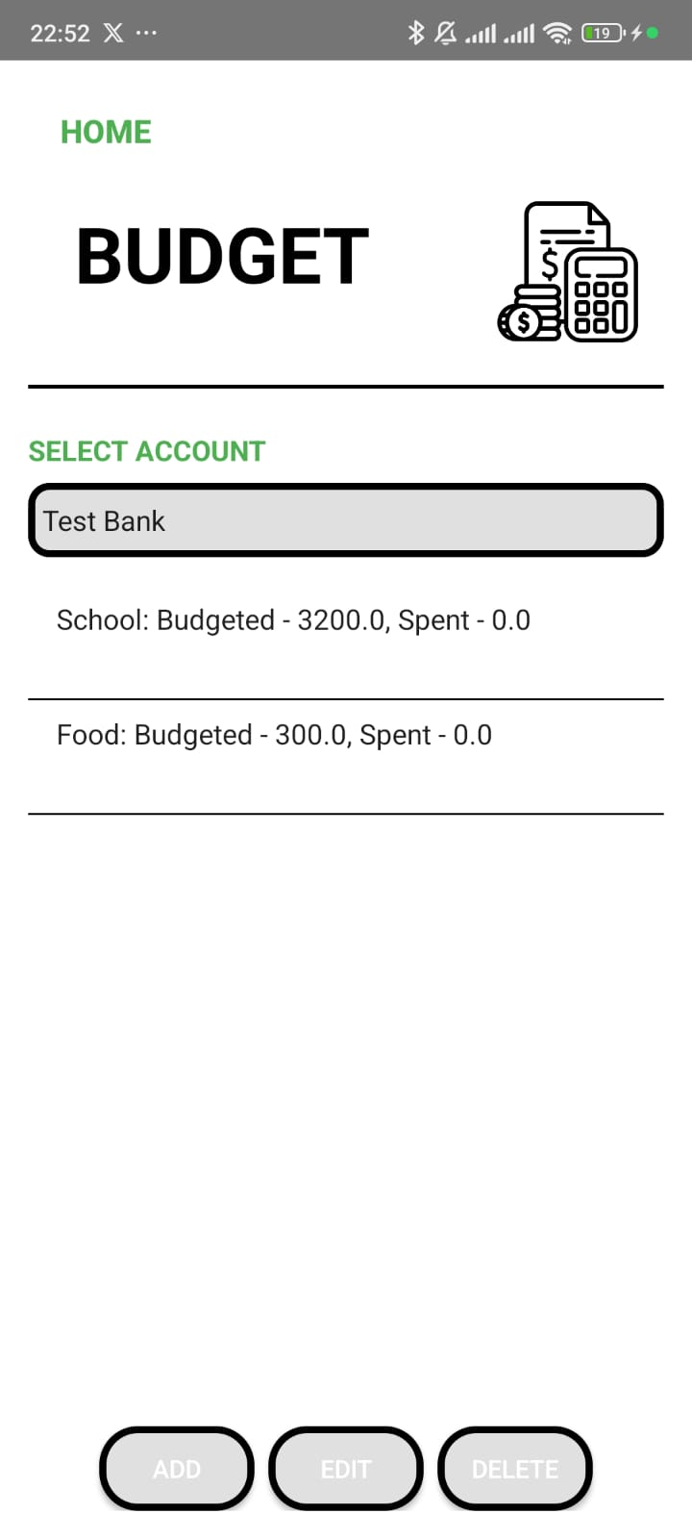

# Integration Test

