
Pokhara, Gandaki Province, Nepal

A
Project Proposal
On
Earthquake Building Damage Prediction
Using Machine Learning Algorithms

For the partial fulfillment of the requirements for Micro-degree of AI/ML
Under Gandaki University

Submitted to:
AI Community in Nepal(AICN)

Under the supervision of
Mr. Diwash Sapkota
Lecturer, Artificial Intelligence and Machine Learning Micro-degree
Submitted by
Rohit Poudel
Keshav KC

Submission Date: 29/04/2026
ACKNOWLEDGEMENT
We would like to express our sincere gratitude to our supervisor, Mr. Diwash Sapkota, for his guidance and support throughout the development of this project proposal. His feedback and suggestions helped us shape our ideas into a proper plan.
We are grateful to Code for Change, Pokhara for organizing the AI/ML Micro degree Program and giving us the platform to learn and work on real projects. We would also like to thank Gandaki University and National Innovation Centre ICT Lab for their academic support and for making this program possible. Our thanks also go to AI Community Nepal (AICN) for their collaboration in this initiative.
We appreciate the open-source community and platforms like DrivenData for making the Nepal earthquake dataset publicly available, which forms the foundation of this project. Finally, we would like to thank our families and friends for their constant motivation.

STUDENT’S DECLARATION
We hereby declare that we are the sole authors of this project proposal and that no sources other than those referenced herein have been used. The work presented is original and any resemblance to existing projects is purely coincidental. We acknowledge that academic dishonesty will result in disqualification.

Name: Rohit Poudel Name: Keshav KC
Date: 23/04/2026 Date: 23/04/2026

ABSTRACT
Nepal is located in a highly seismically active area, which was demonstrated by the Gorkha earthquake that occurred in 2015 when over 600,000 structures either collapsed or were extensively damaged, leading to the loss of many lives. Although it is well known that such elements as building age, materials, and foundation type play a direct role in determining the amount of damage that a structure sustains during an earthquake, no viable method has been developed for assessing building vulnerabilities in large numbers. Manual inspections by engineers would be impossible to conduct on millions of buildings within Nepal. Therefore, this project seeks to create an automated prediction tool using machine learning that estimates the damage grade of a building after an earthquake. The dataset used for training purposes is available on the DrivenData website and comprises more than 260,000 observations with 38 features relating to their structural characteristics and location during the earthquake of 2015. The target variable is the damage grade divided into three classes – low, medium, and high. Four classification techniques are implemented and contrasted, including Decision Tree, K-Nearest Neighbors, Random Forest, and XGBoost by making use of such programming tools as Python, scikit-learn, and XGBoost libraries. Models’ performance is analyzed according to macro-averaged F1-score, accuracy, precision, recall, and through confusion matrices. The best algorithm developed will be integrated into an app that can be run via FastAPI framework, which allows one to input some building information and receive a predicted damage grade without being a developer. The aim is to reach a macro-averaged F1-score of not less than 0.70 and prove that ML algorithms can be used as a fast and evidence-based solution for earthquakes preparedness in Nepal.
Keywords: Earthquake Damage Prediction, Machine Learning, Classification, Random Forest, XGBoost, Nepal

TABLE OF CONTENTS
ACKNOWLEDGEMENT……………………………………………………………i
STUDENT’S DECLARATION……………………………………………………………….ii
ABSTRACT………………………………………………………………………….iii
LIST OF FIGURES………………………………………………………………......v
LIST OF TABLES…………………………………………………………………....v
ABBREVIATIONS……………………………………………………………….….vi
CHAPTER 1……………………………………………………………………….....1
INTRODUCTION………………………………………………………………..…..1
1.1 Background……………………………………………………………..…...1
1.2 Problem Statement………………………………………………………......2
1.3 Objective………………………………………………………………….....2
1.4 Literature Review…………………………………………………………....3
CHAPTER 2……………………………………………………………………….....5
METHODOLOGY……………………………………………………………….…..5
2.1 Tools and Technologies……………………………………………………...5
2.2 Dataset…………………………………………………………………….....5
2.3 Model Selection Rationale…………………………………………………..5
2.4 Training Approach……………………………………………………….…..6
2.5 Model Pipeline Diagram…………………………………………………….6
CHAPTER 3 ………………………………………………………………………….7
REQUIREMENT DOCUMENT …………………………………………………….7
3.1 Functional Requirements …………………………………………7
3.2 Non-Functional Requirements 8
3.3 Technology Stack 8
CHAPTER 4 9
SYSTEM ANALYSIS AND DESIGN 9
4.1 System Architecture Diagram 9
4.2 Data Flow Diagram 10
CHAPTER 5 11
DEVELOPMENT PLAN 11
CHAPTER 6 13
TESTING STRATEGY 13
6.1 Test Types 13
6.2 Validation Plan 13
EXPECTED RESULTS 14
CONCLUSION…...…………………………………………………………………15
BIBLIOGRAPHY 17
LIST OF FIGURES
Figure 2.5 End-to-End Machine Learning Pipeline for Earthquake Building Damage Prediction…………………………………………..6 Figure 4.1 System Architecture Diagram…………………………………………9
Figure 4.2 Data Flow Diagram — Level 0 (Context) and Level 1………………10

LIST OF TABLES
Table 4.1 System Architecture Diagram…………………………………………9
Table 5.1 Development Plan……………………………………….……………11
Table A.1 Dataset Information…………………………………………………..16
Table A.2 Libraries with Versions……………………………………………….16

ABBREVIATIONS
AI | Artificial Intelligence
ANN | Artificial Neural Network
APA | American Psychological Association
API | Application Programming Interface
CSV | Comma-Separated Values
DFD | Data Flow Diagram
DT | Decision Tree
EDA | Exploratory Data Analysis
ER | Entity-Relationship
F1 | F1-Score (Harmonic Mean of Precision and Recall)
KNN | K-Nearest Neighbors
ML | Machine Learning
Mw | Moment Magnitude
NBDP | Nepal Building Damage Portfolio
RC | Reinforced Concrete
RCC | Reinforced Cement Concrete
REST | Representational State Transfer
RF | Random Forest
ROC-AUC | Receiver Operating Characteristic – Area Under Curve
SMOTE | Synthetic Minority Over-sampling Technique
SVM | Support Vector Machine
USGS | United States Geological Survey
VS30 | Average Shear Wave Velocity in Top 30 Meters
XGBoost | Extreme Gradient Boosting

CHAPTER 1
INTRODUCTION
1.1 Background
Nepal lies in a highly seismically active zone where the Indian and Eurasian tectonic plates collide. On 25 April 2015, a 7.8 magnitude earthquake struck the Gorkha region, killing nearly 9,000 people, injuring over 22,000, and displacing more than 3.5 million [1]. Around 600,000 buildings collapsed or were severely damaged across 14 districts [1]. A clear pattern emerged from the destruction. Older structures built with mud mortar, stone, or bamboo suffered the most, while buildings with cement foundations performed significantly better.
Despite this knowledge, there is still no automated system to assess building vulnerability at scale. Manually inspecting millions of buildings spread across difficult terrain is neither practical nor affordable. Machine learning offers an alternative approach. Given enough data on building characteristics such as age, floor count, materials, and location, along with the damage they sustained, a model can learn the relationship between these features and damage outcomes. It can then predict the expected damage grade of any other building based on its features.
This project uses a publicly available dataset from DrivenData [2] containing 260,601 building records with 38 structural and geographic features. The damage is classified into three grades: Grade 1 (low), Grade 2 (medium), and Grade 3 (high). Four classification models, namely Decision Tree, KNN, Random Forest, and XGBoost, are trained and compared, and the best performing one is deployed as a web application.

1.2 Problem Statement
Nepal has millions of buildings spread across 77 districts, many in areas with high seismic risk. The 2015 earthquake showed that building age, materials, floor count, and foundation type all play a direct role in how much damage a structure takes. Yet there is still no automated system that can assess building vulnerability across the country. Manual inspection by trained engineers is the traditional approach but given that many buildings are in hard-to-reach rural areas, doing this at a national scale would take years, require thousands of personnel, and cost far more than what the disaster preparedness budget allows. At the same time, survey data from the 2015 earthquake covering over 260,000 buildings with detailed structural and damage records is publicly available, but it has not been turned into a usable tool for local authorities or planners. The core question this project tries to answer is: can machine learning algorithms accurately predict the damage grade of a building based on its structural and geographical features, and can this prediction be made accessible through a simple web-based tool?

1.3 Objective
The main objectives of this project are as follows:
- Train and evaluate four classification models (Decision Tree, KNN, Random Forest, and XGBoost) on the DrivenData earthquake dataset to predict building damage grades.
- Compare model performance using accuracy, macro-averaged F1-score, precision, recall, and confusion matrix to select the best algorithm.
- Deploy the best model as a web application using FastAPI, allowing users to input building details and receive damage predictions.

1.4 Literature Review
It is not new to predict the damage caused by earthquakes using machine learning. However, the topic has gained increased popularity in the last few years mainly because there have been large datasets released into the public domain containing information about real-life earthquakes. Before such datasets were available, the only way to estimate the vulnerability of buildings to earthquakes was sending engineers to inspect them physically. That works for a handful of buildings, but when you are dealing with hundreds of thousands of them, it just does not scale. This section looks at five studies that are closely related to what we are trying to do in this project.
Ghimire, Guéguen, Giffard-Roisin, and Schorlemmer [3] worked with a really large dataset of 762,106 buildings from the Nepal Building Damage Portfolio, covering 11 districts. They combined the building data with seismic intensity values from the USGS ShakeMap and tested six different models. Out of all of them, Random Forest Regression came out on top with an accuracy of 0.68 for three-class damage prediction. What was interesting in their study was the feature importance result — mud-mortar stone as a construction material accounted for 32% of the prediction power, and macro-seismic intensity came close at 31%. They also showed that even with just four basic features, the model could still manage 0.64 accuracy, which is decent.
Bhatta and Dang [4] took a slightly different approach. They trained five models including KNN, Random Forest, Decision Tree, SVM, and ANN on simulation data from 35 RC buildings and then validated those models on 67 actual RC buildings that were damaged in the 2015 Nepal earthquake. Random Forest again gave the best results with 74.62% accuracy. ANN came second at 70.14%, then SVM at 68.65%, Decision Tree at 64.17%, and KNN at the bottom with 62.68%. The features that mattered most in their case were construction year, plinth area, and peak ground acceleration.
The study by Adi, Adishesha, Bharadwaj, and Narayan [5] is probably the most directly relevant to our project because they used the exact same DrivenData dataset that we are using. The F1-Score for their Random Forest model stood at 72.95%. However, when switching to Gradient Boosting along with proper hyper-parameter optimization, it went up to 74.42%. Since they used the same dataset and target variable as ours, their results give us a good benchmark to compare against.
According to Poudyal and Shakya [6], the DrivenData dataset was used, but they focused more on the class imbalance. They tried different resampling methods and found that the use of Random Forest and SMOTE provided a macro F1-score equal to 0.67 and accuracy of 82.1%. The best result for ROC-AUC criterion was obtained when using Random Forest and Gradient Boosting with value equal to 0.89. They also noticed, like other studies, that Grade 2 buildings are the hardest to classify due to their similarity with both Grade 1 and Grade 3.
Ulku, Atici, Yesilirmak, and Hancilar [7] looked at a completely different earthquake — the 2020 Elazığ earthquake in Turkey, which was a magnitude 6.8 event. Their dataset was much smaller at 8,071 buildings, but the results were still useful. Random Forest again performed best with 85% accuracy and 68% F1-score after they applied Tomek's link under-sampling. The fact that Random Forest works well not just on Nepal data but also on Turkish earthquake data suggests it generalizes across different seismic contexts.
Looking at all five studies together, a pretty clear pattern shows up. The use of ensemble algorithms tends to outperform simple algorithms. In particular, for the Nepal dataset, the F1-scores always range between roughly 0.67 and 0.74. And class imbalance is a problem that every study has to deal with. But one thing none of these studies actually do is turn their model into something usable. That is the gap this project is trying to fill by combining model training and evaluation with a web application built on FastAPI.

CHAPTER 2
METHODOLOGY
2.1 Tools and Technologies
The project is built using Python 3.x with scikit-learn and XGBoost for model training, pandas and NumPy for data processing, and matplotlib and seaborn for visualization. The trained model is saved as a .joblib file and served through a FastAPI backend. The frontend is built with HTML, CSS, and JavaScript. All development and experimentation is done in Jupyter Notebook.
2.2 Dataset
The dataset is taken from the DrivenData competition "Richter's Predictor: Modeling Earthquake Damage" [2], originally collected by the Central Bureau of Statistics and Kathmandu Living Labs after the 2015 Gorkha earthquake. It contains 260,601 building records with 38 input features covering floor count, age, area, height, foundation type, roof type, land surface condition, and building materials. The target variable is damage_grade with three classes: Grade 1 (low), Grade 2 (medium), and Grade 3 (high).
2.3 Model Selection Rationale
Four classifiers are used: Decision Tree and KNN as baselines, Random Forest due to its strong performance in previous studies [3], [4], [7], and XGBoost as an advanced gradient boosting method with built-in regularization.
2.4 Training Approach
The dataset is preprocessed by encoding categorical features and applying feature scaling for KNN. It is then split 80:20 using stratified sampling. Feature selection is performed using Random Forest importance scores. All four models are trained with hyperparameter tuning via GridSearchCV with 5-fold cross-validation. Models are evaluated using macro-averaged F1-score, accuracy, precision, recall, and confusion matrices. The best model is saved and deployed through the FastAPI web application.

2.5 Model Pipeline Diagram
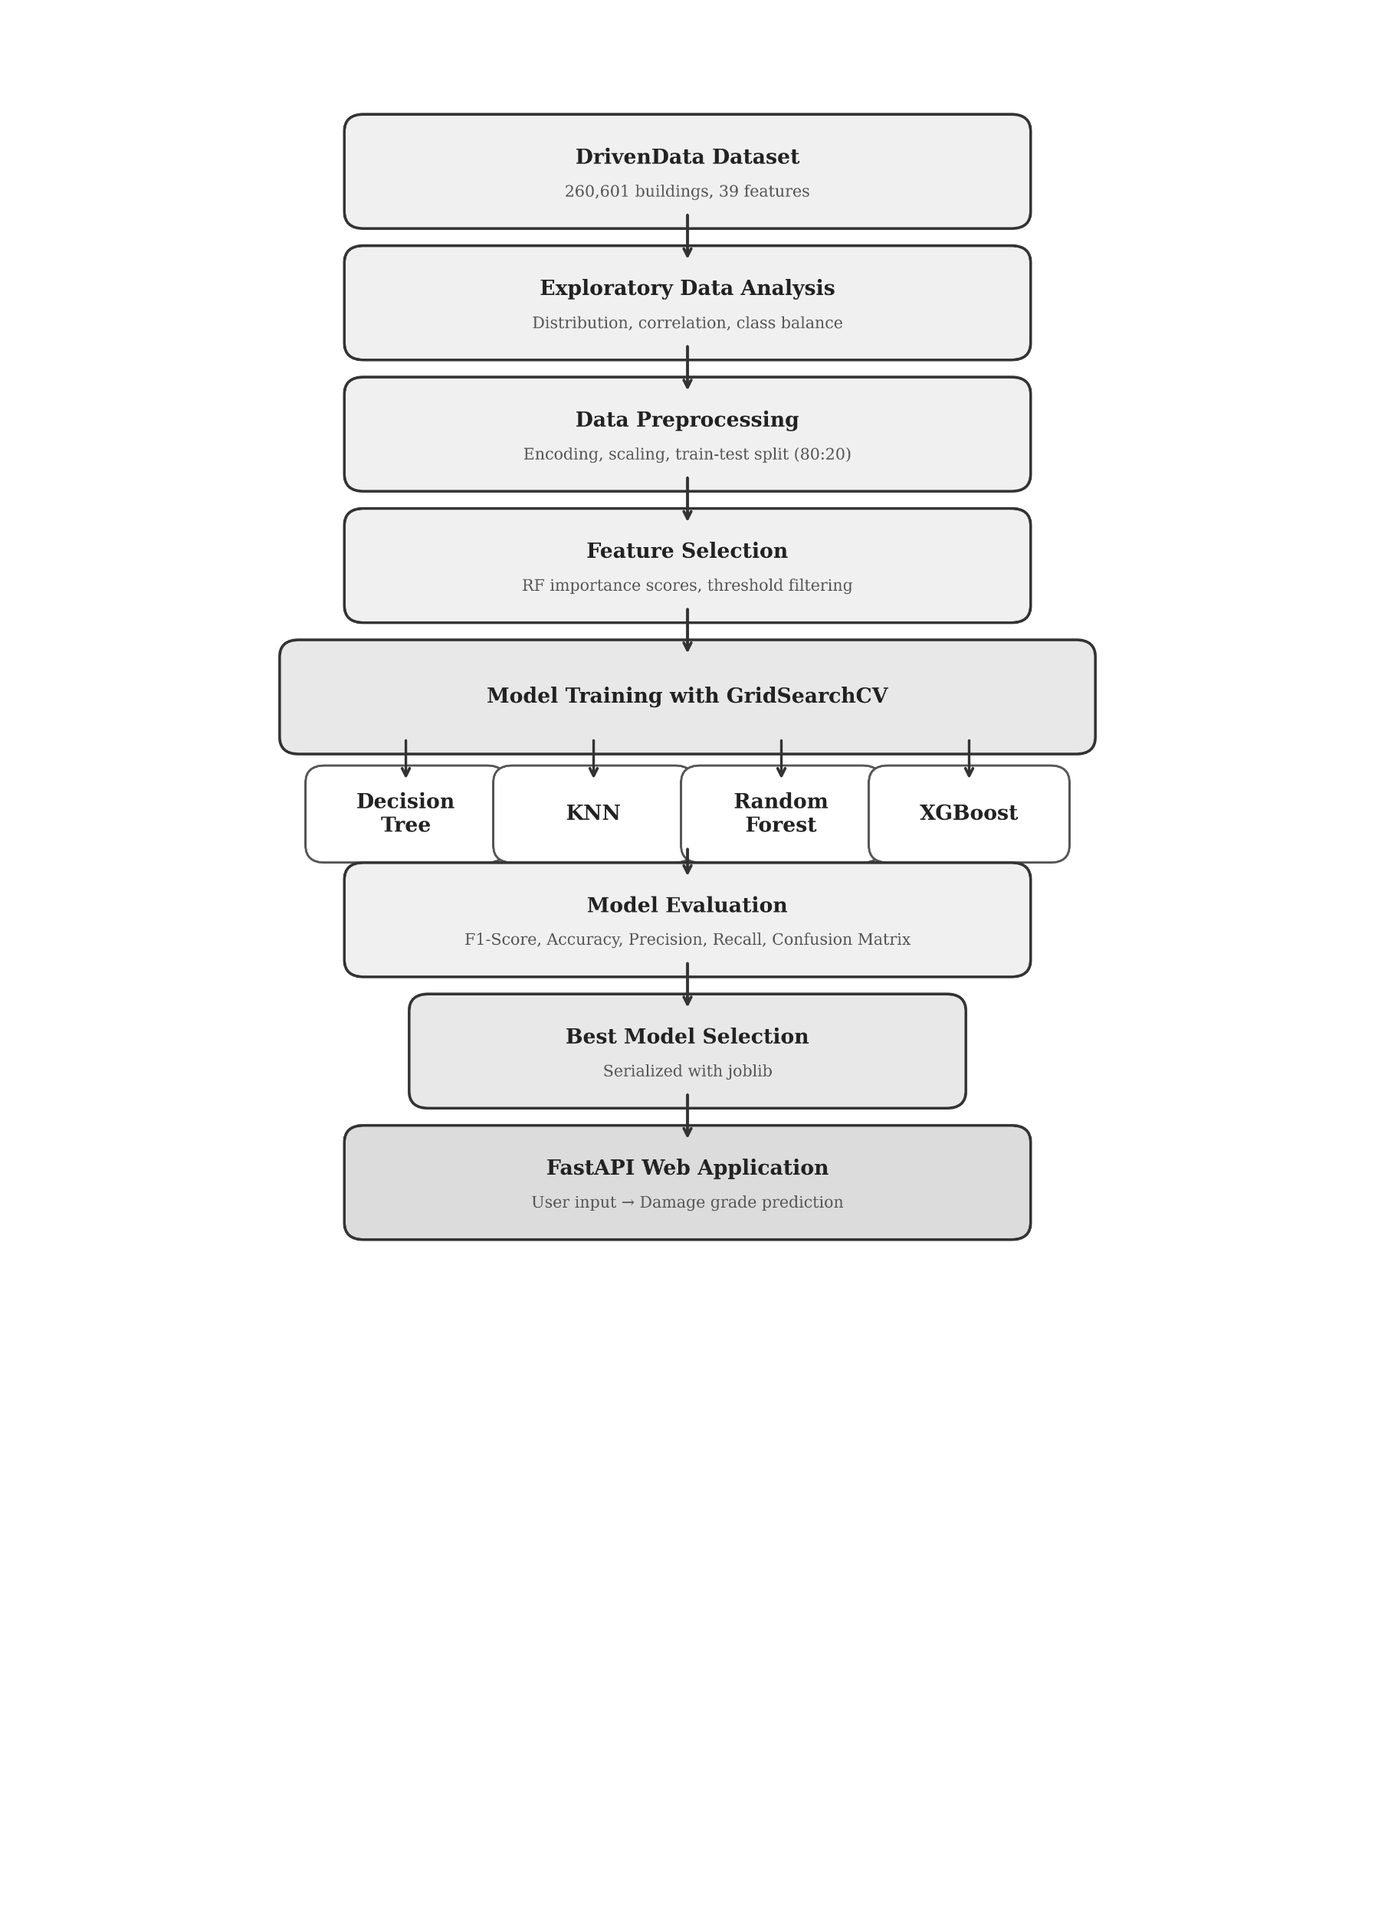
This figure represents the entire ML pipeline that is employed in the current study.

Figure 2.5: End-to-End Machine Learning Pipeline for Earthquake Building Damage Prediction

CHAPTER 3
REQUIREMENT DOCUMENT
3.1 Functional Requirements
The following functional requirements specify the operational requirements of the system:
• FR-01: The system should be able to load and process the DrivenData Earthquake dataset which includes features of buildings along with the respective labels for damage grades.
• FR-02: The system is supposed to preprocess the data by handling any missing value that is found in the data, encoding the categories appropriately, performing feature scaling when necessary, and dividing the data into training and test datasets through stratified sampling.
• FR-03: The system will carry out four machine learning algorithms, which include Decision Tree, K-Nearest Neighbor, Random Forest, and XGBoost.
• FR-04: The results for each of the models developed by the system will be compared in terms of their F1 score, accuracy, precision, recall, and confusion matrix.
• FR-05: The system shall provide a web-based input form where users can enter building characteristics such as count_floors_pre_eq, age, area_percentage, height_percentage, foundation_type, roof_type, and land_surface_condition.

• FR-06: The system should predict the damage grade (Grade 1, 2, or 3) of the building provided in the input form based on the best performing model selected.
• FR-07: The system shall generate feature importance rankings during the training phase in Jupyter Notebook to identify which building attributes contribute most to the prediction.
• FR-08: The system shall save the trained model along with any preprocessing steps to a file so that the prediction module can reuse them without retraining.
3.2 Non-Functional Requirements
The following list of requirements defines the quality attributes that the system should meet:
• NFR-01 (Performance): The system shall return a prediction within two seconds after receiving the input information from the input form.
• NFR-02 (Accuracy): The chosen model should have a macro-averaged F1-score of at least 0.70 on the unseen test data set.
• NFR-03 (Usability): The web interface should be easy enough to use so that the user could fill in the information about their building and get the prediction within one minute without getting help from anyone else.
• NFR-04 (Compatibility): The web application should work correctly in the modern browsers, like Google Chrome, Mozilla Firefox, Microsoft Edge, or Apple Safari.
• NFR-05 (Portability): The whole system could be run locally without using cloud services or any paid resources.
• NFR-06 (Maintainability): The codebase shall be organized into separate modules for preprocessing, training, evaluation, and deployment so that each part can be updated independently.
3.3 Technology Stack
Table 3.3: Technology Stack
Component | Technology
Programming Language | Python 3.x
ML Libraries | scikit-learn, XGBoost
Data Processing | pandas, NumPy
Visualization | matplotlib, seaborn
Backend Framework | FastAPI, uvicorn
Frontend | HTML, CSS, JavaScript
Model Serialization | joblib
Development Environment | Jupyter Notebook
Version Control | Git

CHAPTER 4
SYSTEM ANALYSIS AND DESIGN
4.1 System Architecture Diagram
The system uses a three-layer architecture design. The frontend layer handles user interaction by receiving the input through a web form with information about the buildings. The backend layer, built with FastAPI, takes the input data, checks its validity, and then sends the input data to the ML model engine. This ML engine holds the model file created from the machine learning model training process using the joblib module. The model training stage of this system is separate from the other parts and only needs to be executed once to produce the model file.
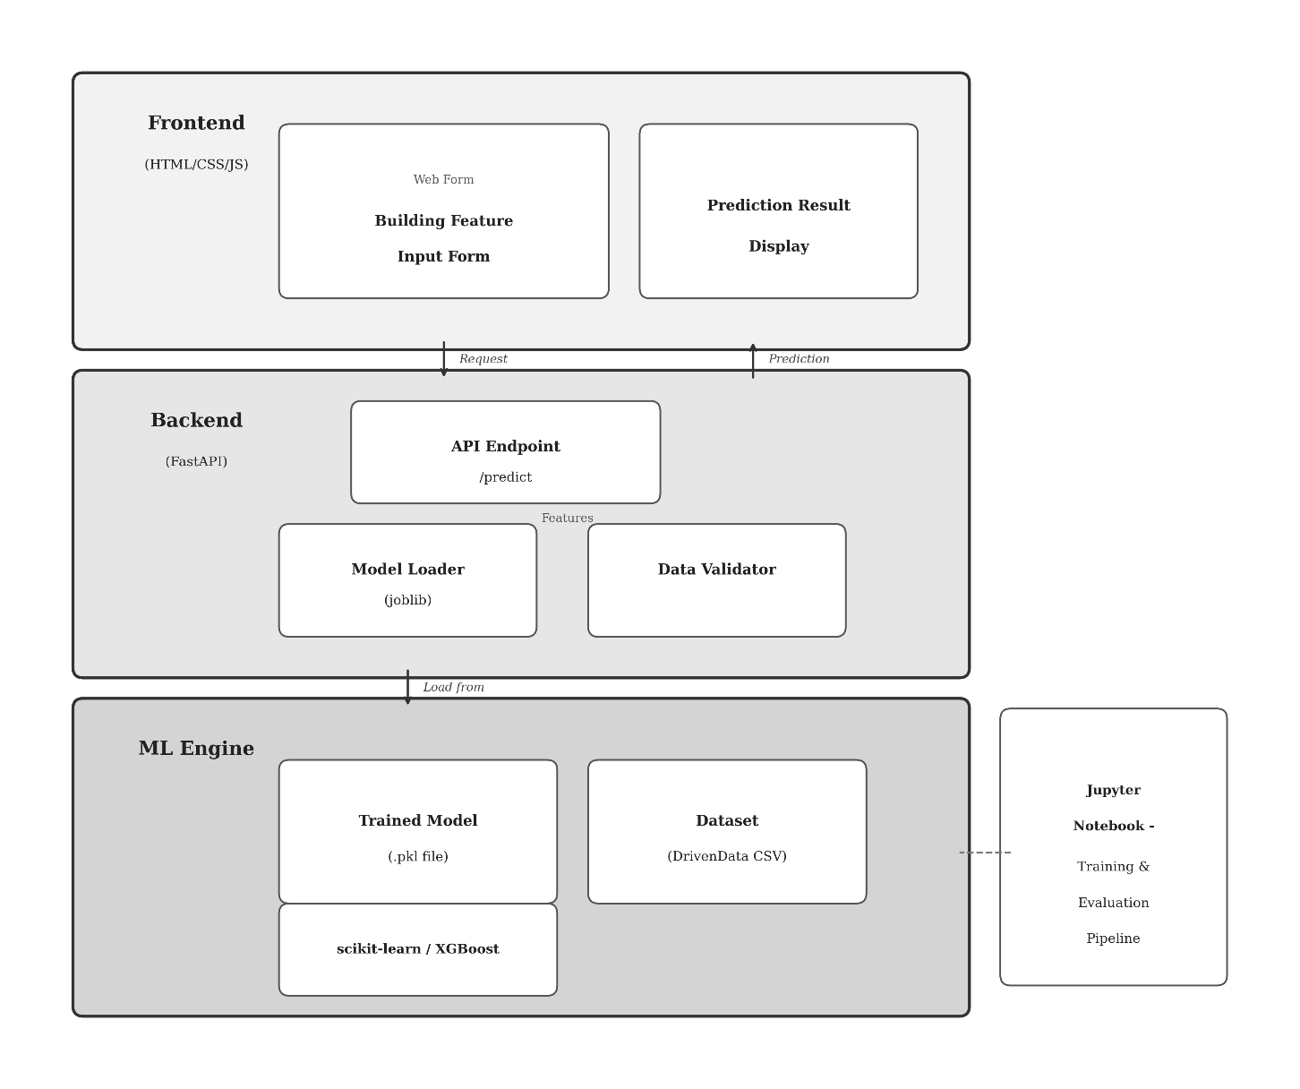

Figure 4.1: System Architecture Diagram
4.2 Data Flow Diagram
The Data Flow Diagram shows how data moves through the system. At Level 0 (context level), the system interacts with two external entities: the User who provides building features and receives predictions, and the DrivenData platform which supplies the training dataset. At Level 1, the system is broken down into three main processes: data preprocessing, model training and evaluation, and the prediction engine. The trained model is stored as a data store that connects the training phase to the prediction phase. Figure 3 shows both DFD Level 0 and Level 1.
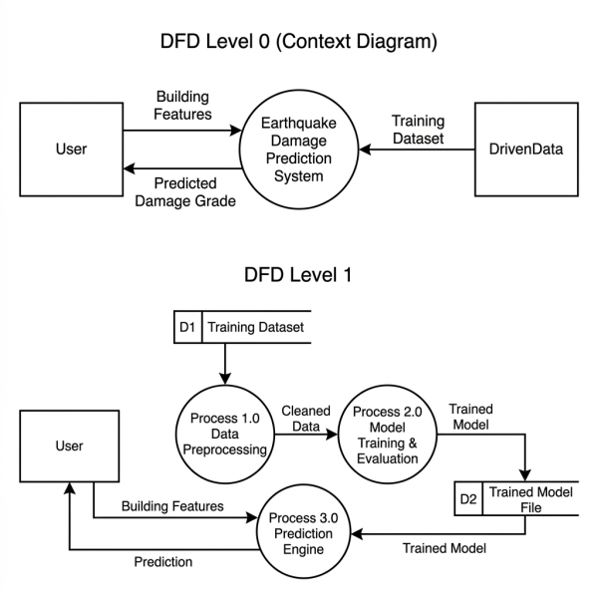
Figure 4.2: Data Flow Diagram — Level 0 (Context) and Level 1

CHAPTER 5
DEVELOPMENT PLAN
The project is planned for 4 weeks and split into five phases. Both team members work on the tasks together with guidance from the project supervisor. The table below shows what each phase covers, the main milestones, and when everything is expected to be done.
Table 5.1: Development Plan
Phase | Activities | Milestone | Timeline
Phase 1:  Research &  Planning | Literature review, proposal writing, dataset study, tool setup | Proposal approved, environment ready | Week 1
Phase 2:  Data Analysis &  Preprocessing | Download dataset, perform EDA, handle missing values, encode features, split data | Clean dataset ready for training | Week 1–2
Phase 3:  Model  Development | Train DT, KNN, RF, and XGBoost. Hyperparameter tuning with GridSearchCV. Feature importance analysis | All four models trained and evaluated | Week 2–3
Phase 4:  Deployment | Save best model with joblib, build FastAPI backend, develop web form frontend | Working web application | Week 3–4
Phase 5:  Testing &  Documentation | Test web app, verify accuracy, write final report, prepare presentation | Final report submitted, project demonstrated | Week 4

Responsibilities
This work is carried out by two students under the guidance of Mr. Diwash Sapkota. Data pre-processing, EDA, and development of the web application are taken care mainly by Keshav KC. On the other hand, the task of model training, fine-tuning of hyperparameters, and evaluation is handled mainly by Rohit Poudel. Both the team members participate equally in the research and documentation processes.
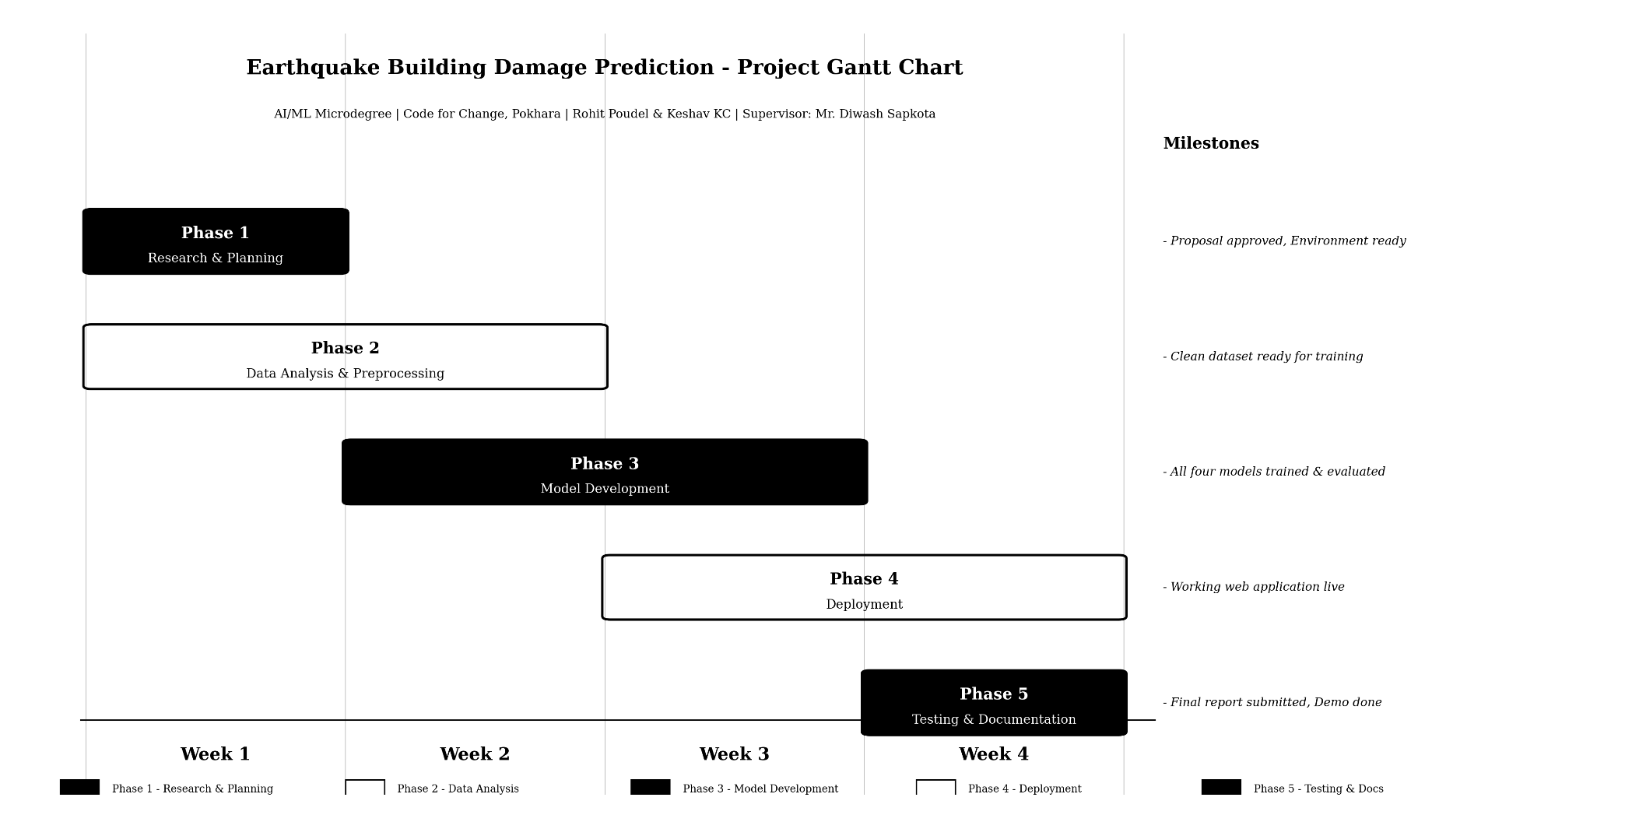
Gantt Chart

CHAPTER 6
TESTING STRATEGY
6.1 Test Types
Three types of testing are planned for this project:
Model Testing: Each developed model will undergo testing with datasets that have not been used for training. The dataset will be divided with a ratio of 80:20 (train:test), applying stratified sampling. The following evaluation criteria will be applied: accuracy, macro-averaged F1-score, precision, recall, and confusion matrices. In hyperparameter tuning, a 5-fold cross-validation method will be used to guarantee that test outcomes are independent of a particular random splitting of the dataset.
Functional Testing: This applies to the web application. Functional tests will validate the correct operation of the form, the API, and the presentation of the output prediction. Valid as well as invalid inputs will be provided for each attribute to make sure that the application is able to handle the extreme scenarios without crashing.
Integration Testing: This type of testing will assure that the file of the trained model is successfully loaded on the FastAPI application and the same preprocessing procedures are used for prediction. When the model expects feature encoding in a certain order, the API should provide it precisely in this order.
6.2 Validation Plan
The key metric used is the macro-averaged F1-score calculated on the test data set. Considering the imbalance in the data set where the class “Grade 2” dominates, precision and recall values are also calculated on each of the classes so that the classifier does not end up predicting the dominant class alone. The confusion matrix is generated for all four models to help visually compare the correct and erroneous predictions made by the four classifiers. An acceptable model for implementation is achieved only if it has an F1-score greater than 0.70. In case no model fulfills this criteria even after optimization, other approaches like SMOTE will be considered.

CHAPTER 7
EXPECTED RESULTS
Random Forest is expected to achieve the best performance among the four models, with a macro-averaged F1-score in the range of 0.70 to 0.74. XGBoost is expected to perform close to Random Forest, while Decision Tree and KNN are expected to show lower scores due to their simpler learning mechanisms.
Grade 2 (medium damage) is expected to be the hardest class to predict accurately, as buildings in this category often share features with both Grade 1 and Grade 3 buildings. Models will likely perform best on Grade 1 and Grade 3, with Grade 2 pulling down the overall F1-score.
The FastAPI web application is expected to return predictions within two seconds for any valid input. The web form should correctly accept building feature inputs and display the predicted damage grade clearly. The overall goal is to deliver a working prototype that demonstrates how machine learning can be applied to earthquake preparedness in Nepal.

CHAPTER 8
CONCLUSION
This project proposes a machine learning-based system for predicting earthquake building damage grades using data from the 2015 Gorkha earthquake. By training and comparing four classification models on a dataset of over 260,000 buildings, the project aims to identify the most accurate algorithm and deploy it as a web application through FastAPI. If successful, this tool can serve as a practical and cost-effective alternative to manual building inspections, helping local authorities and disaster preparedness planners assess building vulnerability at scale. The project also demonstrates how publicly available earthquake data can be turned into a usable, real-world application that contributes to making Nepal more resilient against future earthquakes.

ANNEX / APPENDIX
- Dataset Information
Table A.1: Dataset Information
Dataset Name | Richter’s Predictor: Modeling Earthquake Damage
Source | DrivenData (https://www.drivendata.org/competitions/57/nepal-earthquake/)
Collected By | Central Bureau of Statistics, Nepal & Kathmandu Living Labs
Total Records | 260,601 buildings
Features | 38 input features + 1 target variable (39 total columns)
Target Variable | damage_grade (Grade 1, Grade 2, Grade 3)

- Key Python Libraries and Versions
Table A.2: Libraries with Versions
Library | Version | Purpose
Python | 3.11+ | Programming language
scikit-learn | 1.3+ | ML model training, evaluation, GridSearchCV
xgboost | 2.0+ | XGBoost classifier implementation
pandas | 2.0+ | Data loading and manipulation
numpy | 1.24+ | Numerical computation
matplotlib | 3.7+ | Data visualization and charts
seaborn | 0.12+ | Statistical plots and heatmaps
fastapi | 0.100+ | REST API backend for web deployment

C. Code Repository
All source code for this project will be hosted on a public GitHub repository. The repository will include a README.md file with setup instructions, a requirements.txt listing all dependencies, the Jupyter Notebook used for training and evaluation, and the FastAPI application code for the web deployment.
GitHub URL: https://github.com/Code4Sake/earthquake-damage-prediction

BIBLIOGRAPHY
[1] National Planning Commission, "Nepal Earthquake 2015: Post Disaster Needs Assessment," Kathmandu, Nepal, 2015. [Online]. Available: https://www.dpnet.org.np/uploads/files/PDNA_volume_BFinalVersion%202024-07-03%2004-50-19.pdf
[2] DrivenData, "Richter's Predictor: Modeling Earthquake Damage." [Online]. Available: https://www.drivendata.org/competitions/57/nepal-earthquake/
[3] S. Ghimire, P. Guéguen, S. Giffard-Roisin, and D. Schorlemmer, "Testing machine learning models for seismic damage prediction at a regional scale using building-damage dataset compiled after the 2015 Gorkha Nepal earthquake," Earthquake Spectra, vol. 38, no. 4, pp. 2970–2993, 2022.
[4] S. Bhatta and J. Dang, "Seismic damage prediction of RC buildings using machine learning," Earthquake Eng. Struct. Dyn., vol. 52, no. 11, pp. 3504–3527, 2023.
[5] S. P. Adi, V. B. Adishesha, K. V. Bharadwaj, and A. Narayan, "Earthquake damage prediction using Random Forest and Gradient Boosting Classifier," Amer. J. Biol. Environ. Stat., vol. 6, no. 3, pp. 58–63, 2020.
[6] B. Poudyal and M. Shakya, "Enhancing earthquake preparedness in Nepal through machine learning-based damage prediction models," J. Future Artif. Intell. Technol., vol. 2, no. 3, pp. 479–492, 2025.
[7] O. Ulku, A. T. Atici, F. C. Yesilirmak, and U. Hancilar, "Classifying and predicting earthquake damage by using machine learning after the 2020 Elazığ, Turkey, earthquake," in Proc. 3rd European Conf. Earthquake Eng. Seismol. (3ECEES), Bucharest, Romania, 2022.

