5. METHODOLOGY
5.1 Tools and Technologies
This project is developed entirely in Python 3.x using open-source libraries. The core machine learning workflow uses scikit-learn for model training, evaluation, and hyperparameter tuning, along with XGBoost for the gradient boosting implementation. Data manipulation and preprocessing are handled using pandas and NumPy. Exploratory data analysis and visualization use matplotlib and seaborn. For the deployment component, FastAPI is used to build a lightweight REST API that serves predictions through a web interface. The frontend is built using HTML, CSS, and JavaScript. Jupyter Notebook is used for the experimentation and model development phase, while the final trained model is serialized using joblib for integration with the web application.
5.2 Dataset
The dataset used in this project is sourced from the “Richter’s Predictor: Modeling Earthquake Damage” competition hosted by DrivenData (https://www.drivendata.org/competitions/57/nepal-earthquake/). The data was originally collected by the Central Bureau of Statistics of Nepal and Kathmandu Living Labs through household surveys conducted after the 7.8 Mw Gorkha earthquake on April 25, 2015. The dataset contains 260,601 building records with 39 features describing structural properties such as number of floors, age of building, floor area, height, foundation type, roof type, ground floor type, land surface condition, and construction material. The target variable is damage_grade, which classifies each building into one of three ordinal levels: Grade 1 (low damage), Grade 2 (medium damage), and Grade 3 (high damage). The dataset is publicly available and does not require any ethical clearance for academic use.
5.3 Model Selection Rationale
Four supervised classification algorithms are selected for comparative evaluation:
1. Decision Tree Classifier — selected as a baseline model due to its interpretability and ability to handle both categorical and numerical features without scaling.
2. K-Nearest Neighbor (KNN) — selected as a distance-based, non-parametric classifier to evaluate how spatial similarity among building features contributes to damage prediction.
3. Random Forest Classifier — selected because the literature consistently identifies it as the best-performing model for this type of task (Ghimire et al., 2022; Bhatta & Dang, 2023; Onur et al., 2022).
4. XGBoost Classifier — selected as an advanced gradient boosting method that includes built-in regularization to reduce overfitting, and has shown strong performance on structured tabular data.
These four models represent a progression from simple to complex, allowing a meaningful comparison of accuracy, training time, and generalization ability.
5.4 Training Approach
The end-to-end machine learning pipeline follows these steps:
Step 1 — Data Collection: Download the dataset from DrivenData and merge the feature and target files.
Step 2 — Exploratory Data Analysis: Analyze feature distributions, class balance, correlations, and missing values. Visualize damage grade distribution across building types and geographic regions.
Step 3 — Data Preprocessing: Encode categorical variables using one-hot encoding or label encoding. Handle missing values where applicable. Apply feature scaling for KNN. Address class imbalance using stratified train-test splitting with an 80:20 ratio.
Step 4 — Feature Selection: Evaluate feature importance using Random Forest-based importance scores. Remove low-contribution features to reduce noise and improve model efficiency.
Step 5 — Model Training: Train all four models on the training set. Perform hyperparameter tuning using GridSearchCV with 5-fold cross-validation.
Step 6 — Model Evaluation: Compare models using micro-averaged F1-score (primary metric), accuracy, precision, recall, and confusion matrices. Select the best-performing model.
Step 7 — Deployment: Serialize the best model using joblib. Build a FastAPI backend that accepts building features as input and returns the predicted damage grade. Connect the API to a simple web interface for user interaction.
5.5 Model Pipeline Diagram
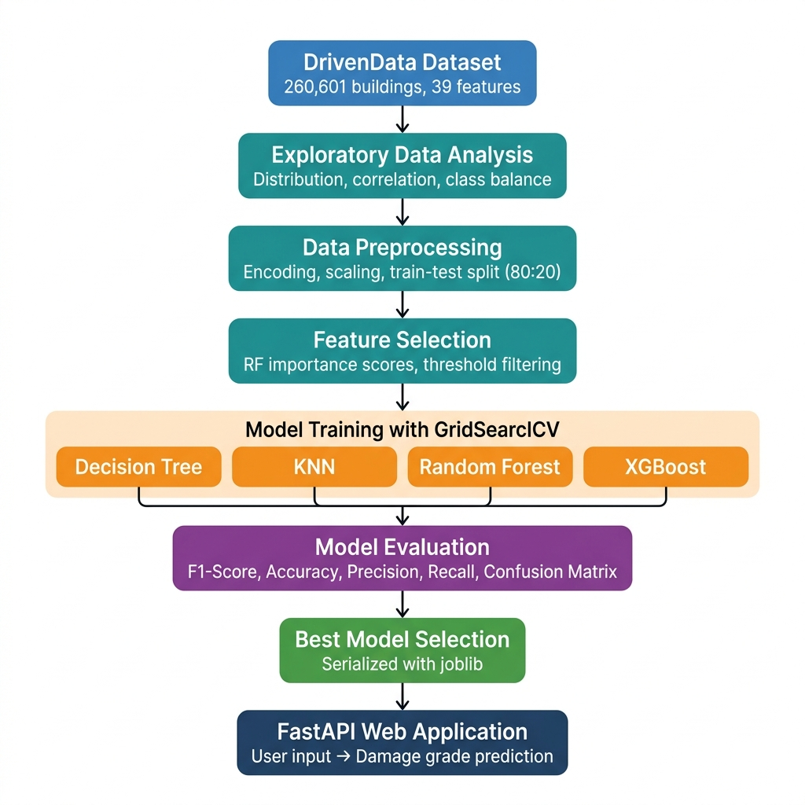
Figure 1: End-to-End Machine Learning Pipeline for Earthquake Building Damage Prediction

