Earthquake Building Damage Prediction
Using Machine Learning Algorithms

A Project Proposal

Submitted in partial fulfillment of the requirements
for the completion of the
Artificial Intelligence & Machine Learning Microdegree

Submitted by:
Rohit Poudel
Enrollment No.: _______________

Keshav KC
Enrollment No.: _______________

Supervised by:
Mr. Diwash Sapkota

Code for Change, Pokhara

Submission Date: 23/04/2026

ACKNOWLEDGEMENT
We would like to express our sincere gratitude to our supervisor, Mr. Diwash Sapkota, for his guidance and support throughout the development of this project proposal. His feedback and suggestions helped us shape our ideas into a proper plan.

We are grateful to Code for Change, Pokhara for organizing the AI/ML Micro degree Program and giving us the platform to learn and work on real projects. We would also like to thank Gandaki University and National Innovation Centre ICT Lab for their academic support and for making this program possible. Our thanks also go to AI Community Nepal (AICN) for their collaboration in this initiative.

We appreciate the open-source community and platforms like DrivenData for making the Nepal earthquake dataset publicly available, which forms the foundation of this project. Finally, we would like to thank our families and friends for their constant motivation.

Student’s Declaration
We hereby declare that we are the sole authors of this project proposal and that no sources other than those referenced herein have been used. The work presented is original and any resemblance to existing projects is purely coincidental. We acknowledge that academic dishonesty will result in disqualification.

Rohit Poudel
Keshav KC

Abstract
Nepal lies within one of the seismically most active zones on earth. The 2015 Gorkha earthquake caused massive damage, about 600 thousand buildings suffered losses, while thousands of people were killed. Most Nepalese buildings are prone to such natural disasters, and yet there exists no efficient way to determine those structures that will face serious damage due to earthquakes.
This project aims to build a machine learning-based system capable of predicting the damage grade of a building following the occurrence of an earthquake. For training purposes, a public dataset available from the DrivenData platform containing information on 260,000+ structures damaged during the 2015 Nepal earthquake is utilized. Features such as Building age, number of floors, foundation material, roof type, and geographic location are used as input data. Damage grade is the target variable (low, moderate, or high).
Various classification algorithms are implemented using Python libraries such as scikit-learn and XGBoost and evaluated based on accuracy and F1 score. Finally, the most efficient classification model is then deployed via a user-friendly web application developed using Python programming language and FastAPI framework. The goal is to produce an efficient prediction model with a classification accuracy of 70% or more to prepare for earthquakes in Nepal.
Keywords: Earthquake Damage Prediction, Machine Learning, Classification, Random Forest, XGBoost, Nepal

ABBREVIATIONS
[Right-click here and select "Update Field" to generate Table of Contents]
AI | Artificial Intelligence
ANN | Artificial Neural Network
APA | American Psychological Association
API | Application Programming Interface
CSV | Comma-Separated Values
DFD | Data Flow Diagram
DT | Decision Tree
EDA | Exploratory Data Analysis
ER | Entity-Relationship
F1 | F1-Score (Harmonic Mean of Precision and Recall)
KNN | K-Nearest Neighbors
ML | Machine Learning
Mw | Moment Magnitude
NBDP | Nepal Building Damage Portfolio
RC | Reinforced Concrete
RCC | Reinforced Cement Concrete
REST | Representational State Transfer
RF | Random Forest
ROC-AUC | Receiver Operating Characteristic – Area Under Curve
SMOTE | Synthetic Minority Over-sampling Technique
SVM | Support Vector Machine
USGS | United States Geological Survey
VS30 | Average Shear Wave Velocity in Top 30 Meters
XGBoost | Extreme Gradient Boosting

Introduction
Nepal is found within an area that experiences a lot of geological activity, with the Indian and Eurasian plates colliding and resulting in numerous earthquakes. Nepal has experienced some terrible earthquakes before, for example, in 1934 when an earthquake destroyed a large part of the Kathmandu Valley. However, none can compare to the 25 April 2015 earthquake, a 7.8 magnitude quake, which occurred in the region of Gorkha and resulted in close to 9,000 deaths, over 22,000 injuries, and left more than 3.5 million people homeless.
Physically, the destruction caused by the earthquake was equally horrific. About 600,000 buildings had either collapsed or been destroyed in 14 districts. When people looked at which buildings fell and which survived, a clear pattern started to emerge. Most of the buildings that collapsed were older structures made with mud mortar, stone, or bamboo. Buildings with cement foundations and engineered structures handled the shaking much better. Before the 2015 earthquake, there were no methods of assessing vulnerability. There were no processes, no systems, or no databases to determine whether a building might be vulnerable.
Unfortunately, a manual inspection and evaluation of all buildings in Nepal cannot become a realistic option as there are millions of them situated in difficult terrains and remote locations. It would require enormous efforts and time to send engineers for evaluation and cost an exorbitant amount of money. Machine learning techniques offer an alternative approach to solving this problem.
Machine learning relies heavily on data that can be used to reveal patterns behind specific results. If there is enough information about building features, such as year of construction, number of floors, roof and wall materials, geographic location, and the degree of damage, then it is possible to teach the machine to detect relationships between those features and damage. Based on the discovered associations, a computer can evaluate the expected damage grade of any other building by its features.

For this project, we use a dataset from DrivenData that has data on 260,601 buildings from the 2015 earthquake. The dataset contains 38 attributes such as age, number of floors, foundation type, roof type, wall material, land surface condition, and geographic location. There are three different damage grades: Grade 1 for light damage, Grade 2 for moderate damage, and Grade 3 for severe destruction. The goal is to train four machine learning models, Decision Tree, KNN, Random Forest, and XGBoost on this data, compare their accuracy, and deploy the best one as a web application.

Problem Statement
Nepal has millions of residential and commercial buildings spread across 77 districts, many of them located in areas with high seismic risk. The 2015 earthquake showed that the type of materials used in a building, its age, the number of floors, and the kind of foundation it sits on all play a direct role in how much damage it takes during an earthquake. Yet even after learning this, there is still no automated or data-driven system that can assess building vulnerability across the country.
The traditional way to evaluate a building's structural safety is through manual inspection by trained engineers. But given the number of buildings in Nepal and the fact that many of them are in hard-to-reach rural areas, doing this at a national scale is simply not practical. It would take years, require thousands of trained personnel, and cost far more than what is currently available in the disaster preparedness budget.
At the same time, there is now a large amount of data available from the 2015 earthquake. The survey covers over 260,000 buildings with detailed records of their structural features and the damage they sustained. This data has the potential to be used for building a prediction model, but it has not yet been turned into a usable tool that local authorities or planners can actually work with.
The core question this project tries to answer is: can machine learning algorithms accurately predict the damage grade of a building based on its structural and geographical features, and can this prediction be made accessible through a simple web-based tool?

Objectives
- Analyze the DrivenData earthquake dataset containing 260,601 building records through exploratory data analysis to understand feature distributions, class imbalance, and correlations between building attributes and damage grades.

- Develop and train four classification models to predict building damage grades (low, medium, severe) using 38 features of building structures and geography.

- Compare the performance of all four models using standard evaluation metrics including accuracy, F1-score, precision, recall, and confusion matrix to identify the best-performing algorithm.

- Identify the most important building features that contribute to earthquake damage through feature importance analysis and rank them by their impact on prediction accuracy.

- Deploy the best performing model onto a web application using Python and FastAPI, enabling the user to input data about the building and obtain predictions for the damage grade.

Literature Review
Earthquake damage prediction has become an active research area, especially after large-scale post-earthquake datasets became publicly available. Traditional vulnerability assessment relies on manual inspection, which is slow, expensive, and difficult to scale. This section reviews five studies that directly relate to the machine learning approach taken in this project.
Ghimire, Guéguen, Giffard-Roisin, and Schorlemmer (2022) analyzed 762,106 buildings from the Nepal Building Damage Portfolio across 11 districts, combined with macro-seismic intensity values from the USGS ShakeMap. They tested six models and found that Random Forest Regression performed best, achieving an accuracy of 0.68 for three-class damage classification and 0.49 for the full five-grade scale. Their feature importance analysis showed mud-mortar stone construction material (32%) and macro-seismic intensity (31%) as the most significant predictors. Even with only four basic building features, the model maintained a reasonable accuracy of 0.64.
Bhatta and Dang (2023) trained five models — KNN, Random Forest, Decision Tree, SVM, and ANN — on simulation data from 35 RC buildings and validated them on 67 real RC buildings damaged during the 2015 Nepal earthquake. Random Forest achieved the highest testing accuracy of 74.62%, followed by ANN (70.14%), SVM (68.65%), Decision Tree (64.17%), and KNN (62.68%). Construction years, plinth area, and peak ground acceleration were identified as the most important features.
Adi, Adishesha, Bharadwaj, and Narayan (2020) worked with the same DrivenData Nepal earthquake dataset used in this project. Their Random Forest Classifier achieved an F1-score of 72.95%, which improved to 74.42% using Gradient Boosting with hyperparameter tuning. This study serves as a direct benchmark since we use the same dataset and target variable.

Poudyal and Shakya (2025) also used the DrivenData dataset and compared resampling techniques for class imbalance. Random Forest with SMOTE achieved a macro F1-score of 0.67 and accuracy of 82.1%. Both Random Forest and Gradient Boosting achieved the highest ROC-AUC of 0.89. They found Grade 2 (medium damage) was the hardest class to predict across all models due to overlapping features.
Onur, Atici, Yeşilırmak, and Hancılar (2022) studied 8,071 buildings damaged during the 2020 Elazığ earthquake (Mw 6.8) in Turkey. Random Forest achieved the best accuracy of 85% and F1-score of 68% after applying Tomek’s link under-sampling, confirming that Random Forest generalizes well across different seismic contexts.
These studies consistently show that ensemble methods like Random Forest and Gradient Boosting outperform simpler models, with F1-scores ranging from 0.67 to 0.74 on the Nepal dataset. Class imbalance remains a shared challenge. However, none of these studies produce a deployable tool for local authorities. This project addresses that gap by combining model evaluation with a FastAPI web application for practical earthquake preparedness planning.

5. METHODOLOGY

5.1 Tools and Technologies
This project was made with Python 3.x along with several other open-source packages. The machine learning pipeline is focused on scikit-learn for model training, validation, and optimization, while the algorithm itself is implemented via XGBoost library as the base for gradient boosting. Data manipulation and preprocessing are done by using pandas and NumPy. Matplotlib and seaborn packages provide tools for exploratory analysis and visualization. Once the best model is identified, the next step is making it available for actual use. For this, FastAPI serves as the backend framework , it takes in building details from a simple web form and returns the predicted damage grade. The website is built using basic HTML, CSS, and JavaScript.All the training and testing are done inside Jupyter Notebook. After the final model is ready, it will be saved as a .joblib file and loaded into the web application.

5.2 Dataset
The data set for this project comes from DrivenData’s challenge called “Richter’s Predictor: Modeling Earthquake Damage” (https://www.drivendata.org/competitions/57/nepal-earthquake/). The Central Bureau of Statistics of Nepal and Kathmandu Living Labs collected the data through household surveys after the Gorkha Earthquake. This earthquake hit Nepal on April 25, 2015, and registered 7.8 on the Richter scale. This data set comprises of 260,601 records for buildings and 39 variables that describe the structure of the building. Variables include number of floors, building age, total floor area, height, foundation type, roof type, ground floor type, land surface condition, and construction material. The target variable in this project is the damage_grade, classified in three ordinal categories – Grade 1, Grade 2, and Grade 3 representing low, medium, and high damage respectively. The dataset is publicly available and does not require any ethical clearance for academic use.

5.3 Model Selection Rationale
The following supervised classification methods have been selected in order to conduct their comparative performance evaluation:
1. Decision Tree Classifier : selected as a baseline model due to its ease of interpretation and ability to work equally well with categorical and numerical variables without scaling.
2. K-Nearest Neighbor (KNN) : used as a baseline due to its distance-based, non-parametric nature in order to examine how building feature similarities impact predictions of damage.
3. Random Forest Classifier included due to being ranked highest among all machine learning classifiers by the majority of recent research studies (Ghimire et al., 2022; Bhatta & Dang, 2023; Onur et al., 2022).
4. XGBoost Classifier — selected as an advanced gradient boosting method that includes regularization mechanisms in order to avoid overfitting problems.
These four models represent a progression from simple to complex, allowing a meaningful comparison of accuracy, training time, and generalization ability.

5.4 Training Approach
The machine learning pipeline for this project is carried out in the following steps:
Step 1 Data Collection: The dataset is downloaded from the DrivenData competition page. The building features and their damage grades come in separate files, so they are merged together into one working dataset before anything else.
Step 2 Exploratory Data Analysis: Before training any model, the data needs to be understood first. We look at how the three damage grades are distributed, check for missing or inconsistent entries, and study how features like building age, number of floors, and construction material relate to the level of damage.
Step 3 Data Preprocessing: Categorical features like foundation type, roof type, and land surface condition are converted to numerical form using label encoding. Since KNN depends on distance between data points, feature scaling is applied for that model. The dataset is split into training (80%) and testing (20%) sets using stratified sampling so that all three damage grades appear proportionally in both sets.
Step 4 Feature Selection: The dataset has 39 features, but not all of them are equally useful. We use Random Forest importance scores to figure out which features actually help with prediction and remove the ones that mostly add noise.
Step 5 Model Training: All four models — Decision Tree, KNN, Random Forest, and XGBoost — are trained on the same training set. For each model, we use GridSearchCV with 5-fold cross-validation to find the best hyperparameter settings.
Step 6 Model Evaluation: After training, we compare all four models using micro-averaged F1-score as the main metric. We also look at accuracy, precision, recall, and confusion matrices to understand where each model does well and where it struggles. The model with the best overall performance is selected.
Step 7 Deployment: The selected model is saved to a file using joblib. A FastAPI backend is set up to load this model and accept building details from a web form. When a user fills in the form and submits it, the system returns the predicted damage grade for that building.

Model Pipeline Diagram
The diagram below shows the complete machine learning pipeline used in this project. It starts with loading the dataset from DrivenData, followed by exploratory analysis and preprocessing. After feature selection, all four candidate models are trained in parallel and evaluated using F1-score and other metrics. The best-performing model is then saved using joblib and deployed through a FastAPI web application that accepts building details and returns the predicted damage grade.
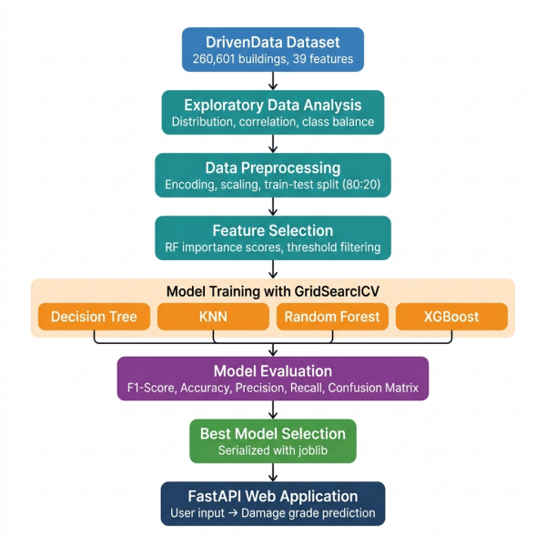
Figure 1: End-to-End Machine Learning Pipeline for Earthquake Building Damage Prediction

6. REQUIREMENT DOCUMENT

6.1 Functional Requirements
The following functional requirements describe what the system needs to do:
• FR-01: The system shall load and prepare the DrivenData earthquake dataset consisting of building features and their corresponding damage grade labels.
• FR-02: The system shall perform data preprocessing including handling missing values if present, encoding categorical variables, applying feature scaling where needed, and splitting the dataset into training and testing sets using stratified sampling.
• FR-03: The system shall train and evaluate four machine learning models: Decision Tree, K-Nearest Neighbors (KNN), Random Forest, and XGBoost.
• FR-04: The system shall display model comparison results including F1-score, accuracy, precision, recall, and confusion matrices for each trained model.

• FR-05: The system shall provide a web-based input form where users can enter building characteristics such as count_floors_pre_eq, age, area_percentage, height_percentage, foundation_type, roof_type, and land_surface_condition.

• FR-06: The system shall predict and display the damage grade (Grade 1, 2, or 3) for the submitted building based on the selected best-performing model.

• FR-07: The system shall generate feature importance rankings during the training phase in Jupyter Notebook to identify which building attributes contribute most to the prediction.

• FR-08: The system shall save the trained model along with any preprocessing steps to a file so that the prediction module can reuse them without retraining.

6.2 Non-Functional Requirements
These requirements define the quality and constraints the system should meet:
• NFR-01 (Performance): The system shall return a prediction within 2 seconds after the user submits the input form.
• NFR-02 (Accuracy): The selected model shall achieve a macro-averaged F1-score of at least 0.70 on the held-out test dataset.
• NFR-03 (Usability): The web interface shall be intuitive enough that a user can fill in building details and receive a prediction within one minute without needing technical assistance.
• NFR-04 (Compatibility): The web application shall work on modern browsers including Chrome, Firefox, Edge, and Safari.
• NFR-05 (Portability): The entire system shall be deployable on a local machine without requiring any cloud infrastructure or paid services.
• NFR-06 (Maintainability): The codebase shall be organized into separate modules for preprocessing, training, evaluation, and deployment so that each part can be updated independently.

6.3 Technology Stack
Component | Technology
Programming Language | Python 3.x
ML Libraries | scikit-learn, XGBoost
Data Processing | pandas, NumPy
Visualization | matplotlib, seaborn
Backend Framework | FastAPI, uvicorn
Frontend | HTML, CSS, JavaScript
Model Serialization | joblib
Development Environment | Jupyter Notebook
Version Control | Git

7. SYSTEM ANALYSIS AND DESIGN

7.1 System Architecture Diagram
The system follows a three-layer architecture. The frontend layer handles user interaction through a web form where building details are entered. The backend layer, built with FastAPI, receives these inputs, validates them, and passes them to the prediction engine. The ML engine layer contains the trained model file which was saved during the training phase using joblib. The training pipeline itself runs separately in Jupyter Notebook and only needs to be executed once to produce the model file. Figure 1 shows the overall system architecture.
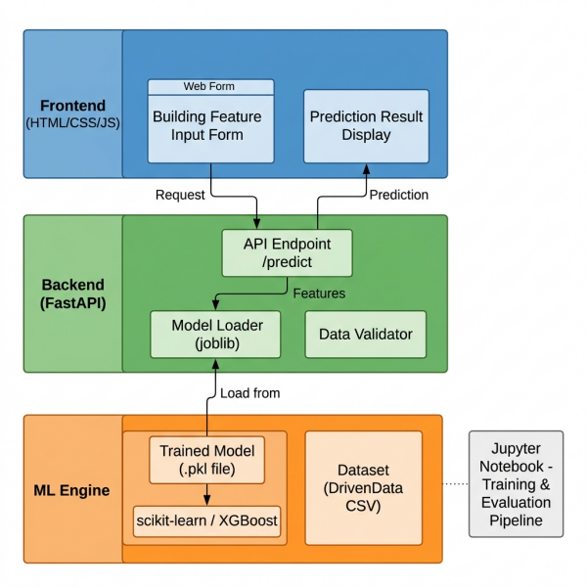
Figure 1: System Architecture Diagram

7.2 Data Flow Diagram
The Data Flow Diagram shows how data moves through the system. At Level 0 (context level), the system interacts with two external entities: the User who provides building features and receives predictions, and the DrivenData platform which supplies the training dataset. At Level 1, the system is broken down into three main processes: data preprocessing, model training and evaluation, and the prediction engine. The trained model is stored as a data store that connects the training phase to the prediction phase. Figure 2 shows both DFD Level 0 and Level 1.
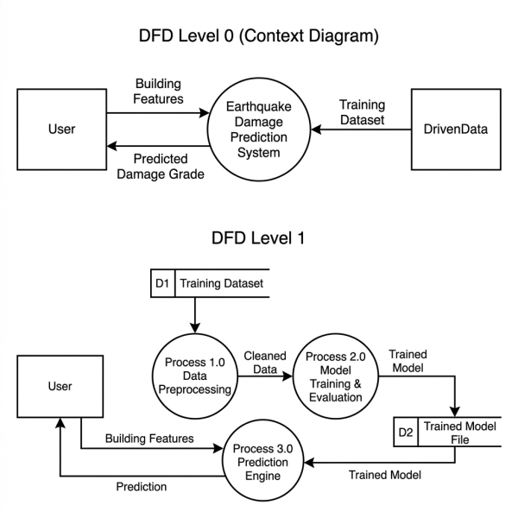
Figure 2: Data Flow Diagram — Level 0 (Context) and Level 1

7.3 Process Flowchart
The flowchart in Figure 3 shows the step-by-step logic of the system, starting from loading the dataset to returning the final prediction. After training and evaluating all four models, the system checks whether a satisfactory model has been found. If not, hyperparameters are tuned and the models are retrained. Once the best model is identified, it is saved and deployed through the FastAPI web application.
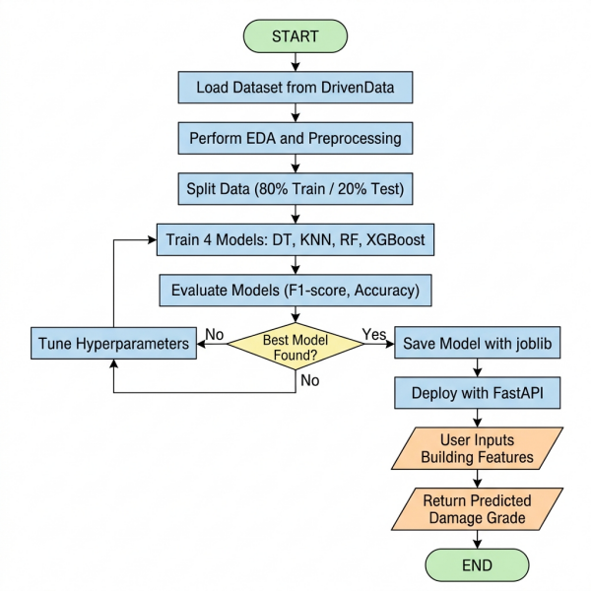
Figure 3: Process Flowchart for Earthquake Damage Prediction System

7.4 Model Pipeline Diagram
The end-to-end model pipeline covering data ingestion through to the prediction output has already been presented in Section 5.5 (see Figure 1). It covers all stages from dataset loading, preprocessing, and model training to the final deployment through the web interface.

7.5 Note on ER Diagram
This project does not use a traditional relational database. The dataset is loaded directly from CSV files during training, and the trained model is stored as a serialized file. The web application processes each prediction request independently without storing user data in a database. Therefore, an Entity-Relationship diagram is not applicable to this project.

8. DEVELOPMENT PLAN
The project is planned over a 4-week period divided into five phases. Since this is an individual project, all tasks are carried out by the student under the guidance of the project supervisor. The table below outlines the phases, their key activities, expected milestones, and timeline.
Phase | Activities | Milestone | Timeline
Phase 1:  Research &  Planning | Literature review, proposal writing, dataset study, tool setup | Proposal approved, environment ready | Week 1
Phase 2:  Data Analysis &  Preprocessing | Download dataset, perform EDA, handle missing values, encode features, split data | Clean dataset ready for training | Week 1–2
Phase 3:  Model  Development | Train DT, KNN, RF, and XGBoost. Hyperparameter tuning with GridSearchCV. Feature importance analysis | All four models trained and evaluated | Week 2–3
Phase 4:  Deployment | Save best model with joblib, build FastAPI backend, develop web form frontend | Working web application | Week 3–4
Phase 5:  Testing &  Documentation | Test web app, verify accuracy, write final report, prepare presentation | Final report submitted, project demonstrated | Week 4

Responsibilities
This project is carried out by two team members under the supervision of Mr. Diwash Sapkota. Keshav KC is primarily responsible for data preprocessing, EDA, and the web application development. Rohit Poudel handles model training, hyperparameter tuning, and evaluation. Both members contribute to the research, documentation, and testing phases. The supervisor provides guidance during design review and final evaluation.

9. TESTING STRATEGY

9.1 Test Types
Three types of testing are planned for this project:
Model Testing: This involves evaluating how well each trained model performs on data it has not seen during training. The dataset is split into 80% training and 20% testing using stratified sampling. Each model is evaluated using accuracy, macro-averaged F1-score, precision, recall, and confusion matrices. 5-fold cross-validation is used during hyperparameter tuning to make sure the results are not dependent on a single random split.
Functional Testing: This covers the web application. We check whether the input form correctly accepts building details, whether the API properly processes the request, and whether the predicted damage grade is displayed back to the user. Each input field is tested with valid and invalid values to make sure the system handles edge cases without crashing.
Integration Testing: This verifies that the saved model file loads correctly inside the FastAPI application and that the preprocessing steps applied during training are also applied consistently during prediction. If the model expects encoded features in a certain order, the API must send them in that exact format.

9.2 Sample Test Cases
Test ID | Description | Input | Expected Output | Status
TC-01 | Predict damage for a low-risk building | 2 floors, age 5, cement foundation, RCC roof, flat land | Grade 1 (Low) | —
TC-02 | Predict damage for a high-risk building | 1 floor, age 45, mud mortar stone, bamboo roof, steep slope | Grade 3 (High) | —
TC-03 | Submit form with missing fields | Empty age field | Error message displayed | —
TC-04 | Submit form with invalid values | Negative floor count | Error message displayed | —
TC-05 | API response time | Valid building input | Response within 2 seconds | —
TC-06 | Model accuracy check | Full test dataset (20%) | F1-score ≥ 0.70 | —

9.3 Validation Plan
The primary validation metric is the macro-averaged F1-score on the held-out test set. Since the dataset has class imbalance (Grade 2 dominates), we also examine per-class precision and recall to make sure the model is not just predicting the majority class. Confusion matrices are generated for all four models to visually compare where each model makes correct and incorrect predictions. The final selected model must achieve an F1-score of at least 0.70 to be considered acceptable for deployment. If none of the models meet this threshold after tuning, additional preprocessing steps like SMOTE oversampling will be explored as a fallback.

10. EXPECTED RESULTS
Based on the literature reviewed and the nature of the dataset, we expect the following outcomes from this project:
Random Forest is expected to deliver the best overall performance among the four models. Previous studies on the same DrivenData dataset have reported F1-scores between 0.67 and 0.74 for similar classification tasks (Adi et al., 2020; Poudyal & Shakya, 2025). We anticipate our Random Forest model to achieve a macro-averaged F1-score in the range of 0.70 to 0.74 after hyperparameter tuning. XGBoost is expected to perform close to Random Forest, while Decision Tree and KNN are likely to fall behind due to their simpler learning mechanisms.
Grade 2 (medium damage) is expected to be the hardest class to predict accurately. This has been a consistent finding across all reviewed studies because Grade 2 buildings share overlapping features with both Grade 1 and Grade 3. We expect the models to perform best on Grade 1 and Grade 3, with Grade 2 pulling down the overall macro F1-score.
The table below summarizes the anticipated performance range for each model:
Model | Expected F1-Score | Expected Accuracy
Decision Tree | 0.60 – 0.65 | 65% – 70%
K-Nearest Neighbors | 0.58 – 0.63 | 62% – 68%
Random Forest | 0.70 – 0.74 | 72% – 78%
XGBoost | 0.68 – 0.73 | 70% – 76%

On the deployment side, we expect the FastAPI web application to return predictions within 2 seconds for any valid input. The web form should correctly handle all building feature inputs and display the predicted damage grade in a clear and understandable format. The overall goal is to produce a working prototype that demonstrates how machine learning can be used for practical earthquake preparedness in Nepal.

11. FUTURE ENHANCEMENTS
While this project covers the core objective of predicting earthquake damage using machine learning, there are a number of things that could be added or improved if more time and resources were available.
One obvious next step would be to include geographic and soil data as additional features. Right now, the model only looks at building characteristics like age, floor count, and construction material. But the type of soil a building sits on and how close it is to a fault line also play a big role in how much damage it takes. Adding features like VS30 (soil shear wave velocity) or distance from the epicenter could help the model make better predictions, especially for buildings in areas where soil conditions vary a lot.
Another improvement would be to try deep learning models like Multilayer Perceptron or even more advanced architectures. The current project sticks to traditional machine learning algorithms because they are easier to interpret and faster to train, but deep learning might pick up on patterns that simpler models miss, particularly for Grade 2 buildings which are the hardest to classify correctly.
The web application itself could also be expanded. Right now it takes in details for one building at a time. A useful addition would be to allow batch predictions, where someone could upload a CSV file of hundreds of buildings and get damage predictions for all of them at once. This would be much more practical for local government offices or disaster management agencies that need to assess entire districts.
Finally, the system could be extended to include a mapping component. If geographic coordinates are available for each building, the predictions could be plotted on an interactive map showing which areas have the highest concentration of vulnerable buildings. This kind of visual output would be far more useful for planning and resource allocation than a simple table of numbers.

12. CONCLUSION
Nepal sits in one of the most earthquake-prone regions in the world, and the 2015 Gorkha earthquake made it painfully clear how vulnerable a large portion of the country’s buildings really are. Manually inspecting millions of structures across 77 districts is simply not feasible with the resources currently available. This project proposes a machine learning-based approach as a practical alternative.
Using the publicly available DrivenData dataset of over 260,000 buildings, we plan to train and compare four classification models — Decision Tree, K-Nearest Neighbors, Random Forest, and XGBoost — to predict building damage grades. Based on what previous studies have shown, we expect Random Forest to perform best with an F1-score around 0.70 to 0.74. The best model will then be deployed through a simple web application built with FastAPI, allowing anyone to input building details and get a damage prediction without needing any technical background.
This is not meant to replace proper engineering assessments. What it can do is provide a quick, data-driven first screening that helps prioritize which buildings need urgent attention. If a local authority has limited engineers and a large number of buildings to check, a tool like this could help them decide where to start. That is the practical value this project aims to deliver.

13. ANNEX / APPENDIX

A. Dataset Information
Dataset Name | Richter’s Predictor: Modeling Earthquake Damage
Source | DrivenData (https://www.drivendata.org/competitions/57/nepal-earthquake/)
Collected By | Central Bureau of Statistics, Nepal & Kathmandu Living Labs
Total Records | 260,601 buildings
Features | 39 (structural, geographic, categorical, and binary)
Target Variable | damage_grade (Grade 1, Grade 2, Grade 3)

B. Key Python Libraries and Versions
Library | Version | Purpose
Python | 3.11+ | Programming language
scikit-learn | 1.3+ | ML model training, evaluation, GridSearchCV
xgboost | 2.0+ | XGBoost classifier implementation
pandas | 2.0+ | Data loading and manipulation
numpy | 1.24+ | Numerical computation
matplotlib | 3.7+ | Data visualization and charts
seaborn | 0.12+ | Statistical plots and heatmaps
fastapi | 0.100+ | REST API backend for web deployment

C. Code Repository
All source code for this project will be hosted on a public GitHub repository. The repository will include a README.md file with setup instructions, a requirements.txt listing all dependencies, the Jupyter Notebook used for training and evaluation, and the FastAPI application code for the web deployment.
GitHub URL: [To be added after repository creation]

D. Sample Features from Dataset
Feature Name | Type | Description
geo_level_1_id | Integer | Geographic region identifier (level 1)
count_floors_pre_eq | Integer | Number of floors before the earthquake
age | Integer | Age of the building in years
area_percentage | Integer | Normalized area of the building footprint
height_percentage | Integer | Normalized height of the building
foundation_type | Categorical | Type of foundation (h, i, r, u, w)
roof_type | Categorical | Type of roof (n, q, x)
ground_floor_type | Categorical | Type of ground floor (f, m, v, x, z)
land_surface_condition | Categorical | Surface condition (n, o, t)
has_superstructure_mud_mortar_stone | Binary | Whether walls use mud mortar stone

14. GANTT CHART
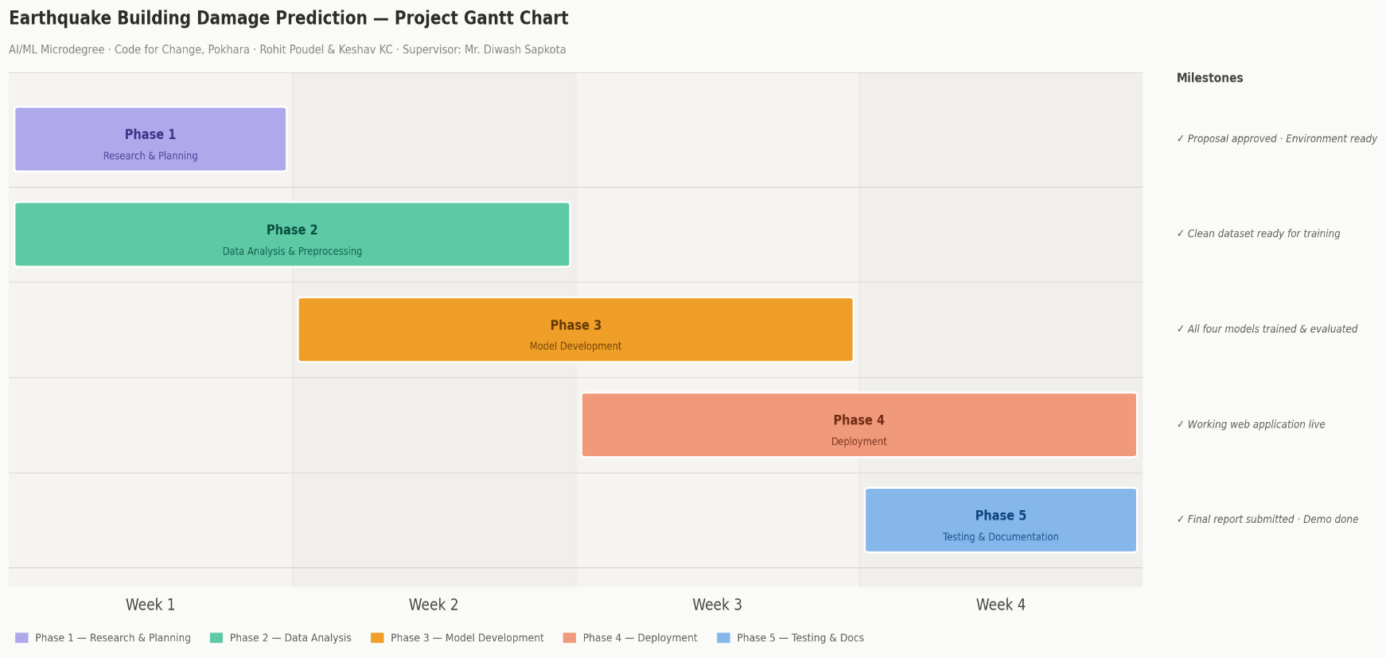
The Gantt chart below shows the project timeline across four weeks. The five phases overlap where needed to fit the compressed schedule. Research and planning start in Week 1, data work runs from Week 1 to 2, model development takes place in Weeks 2 and 3, deployment happens in Weeks 3 and 4, and the final week is used for testing and documentation. Key milestones are marked on the right side of the chart.
Figure 5: Project Gantt Chart — Earthquake Building Damage Prediction

References
Adi, S. P., Adishesha, V. B., Bharadwaj, K. V., & Narayan, A. (2020). Earthquake damage prediction using Random Forest and Gradient Boosting Classifier. American Journal of Biological and Environmental Statistics, 6(3), 58–63. https://doi.org/10.11648/j.ajbes.20200603.14
Bhatta, S., & Dang, J. (2023). Seismic damage prediction of RC buildings using machine learning. Earthquake Engineering & Structural Dynamics, 52(11), 3504–3527. https://doi.org/10.1002/eqe.3907
Ghimire, S., Guéguen, P., Giffard-Roisin, S., & Schorlemmer, D. (2022). Testing machine learning models for seismic damage prediction at a regional scale using building-damage dataset compiled after the 2015 Gorkha Nepal earthquake. Earthquake Spectra, 38(4), 2970–2993. https://doi.org/10.1177/87552930221106495
Onur, U., Atici, A. T., Yeşilırmak, F. C., & Hancılar, U. (2022). Classifying and predicting earthquake damage by using machine learning after the 2020 Elazığ, Turkey, earthquake. In Proceedings of the 3rd European Conference on Earthquake Engineering & Seismology (3ECEES), Bucharest, Romania.
Poudyal, B., & Shakya, M. (2025). Enhancing earthquake preparedness in Nepal through machine learning-based damage prediction models. Journal of Future Artificial Intelligence and Technologies, 2(3), 479–492.

