6. REQUIREMENT DOCUMENT
6.1 Functional Requirements
The following functional requirements describe what the system should be able to do:
• FR-01: The system shall load and merge the DrivenData earthquake dataset consisting of building features and damage grade labels.
• FR-02: The system shall perform data preprocessing including encoding categorical variables, handling missing values, and splitting data into training and testing sets.
• FR-03: The system shall train and evaluate four machine learning models: Decision Tree, K-Nearest Neighbor, Random Forest, and XGBoost.
• FR-04: The system shall display model comparison results including F1-score, accuracy, precision, recall, and confusion matrices.
• FR-05: The system shall provide a web-based form where users can input building characteristics such as number of floors, age, construction material, foundation type, and roof type.
• FR-06: The system shall predict and display the damage grade (Grade 1, 2, or 3) for the submitted building based on the best-performing trained model.
• FR-07: The system shall visualize feature importance rankings to show which building attributes contribute most to the prediction.
6.2 Non-Functional Requirements
The non-functional requirements define the quality attributes and constraints of the system:
• NFR-01 (Performance): The prediction response time shall be under 2 seconds after the user submits the form.
• NFR-02 (Accuracy): The selected model shall achieve a micro-averaged F1-score of at least 0.70 on the test dataset.
• NFR-03 (Usability): The web interface shall be simple enough for a non-technical user to fill in building details and understand the prediction result.
• NFR-04 (Compatibility): The web application shall run on modern browsers including Chrome, Firefox, and Edge.
• NFR-05 (Portability): The system shall be deployable on a local machine without requiring cloud infrastructure.
• NFR-06 (Maintainability): The codebase shall be modular and documented so that individual components can be updated independently.
6.3 Technology Stack
Component | Technology
Programming Language | Python 3.x
ML Libraries | scikit-learn, XGBoost
Data Processing | pandas, NumPy
Visualization | matplotlib, seaborn
Backend Framework | FastAPI, uvicorn
Frontend | HTML, CSS, JavaScript
Model Serialization | joblib
Development Environment | Jupyter Notebook
Version Control | Git

7. SYSTEM ANALYSIS AND DESIGN
7.1 System Architecture Diagram
The system follows a three-layer architecture. The frontend layer handles user interaction through a web form where building details are entered. The backend layer, built with FastAPI, receives these inputs, validates them, and passes them to the prediction engine. The ML engine layer contains the trained model file which was saved during the training phase using joblib. The training pipeline itself runs separately in Jupyter Notebook and only needs to be executed once to produce the model file. Figure 1 shows the overall system architecture.
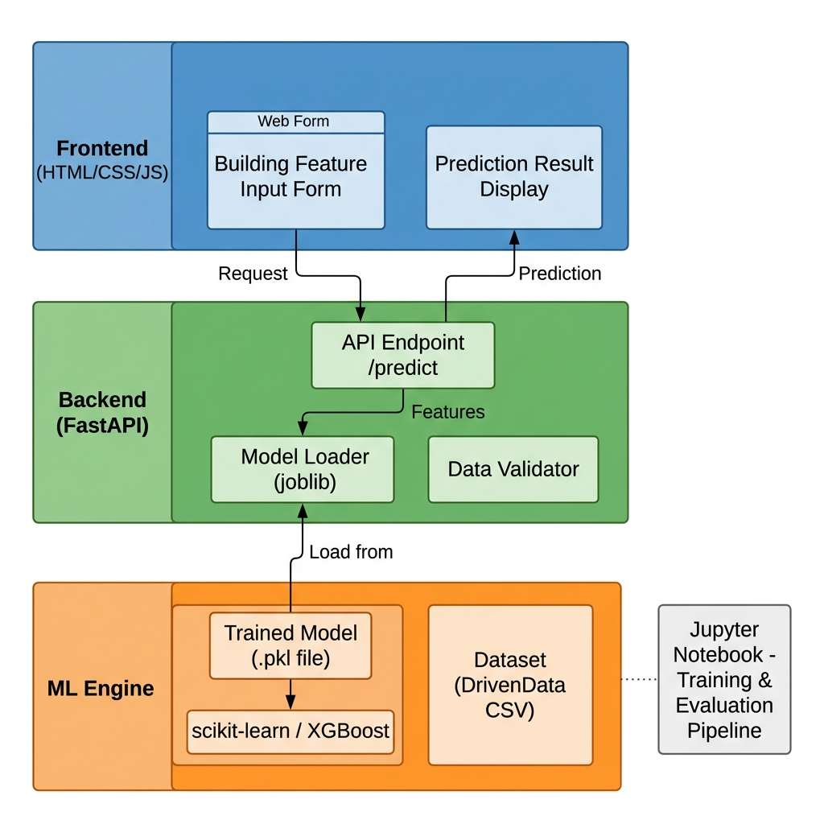
Figure 1: System Architecture Diagram
7.2 Data Flow Diagram
The Data Flow Diagram shows how data moves through the system. At Level 0 (context level), the system interacts with two external entities: the User who provides building features and receives predictions, and the DrivenData platform which supplies the training dataset. At Level 1, the system is broken down into three main processes: data preprocessing, model training and evaluation, and the prediction engine. The trained model is stored as a data store that connects the training phase to the prediction phase. Figure 2 shows both DFD Level 0 and Level 1.
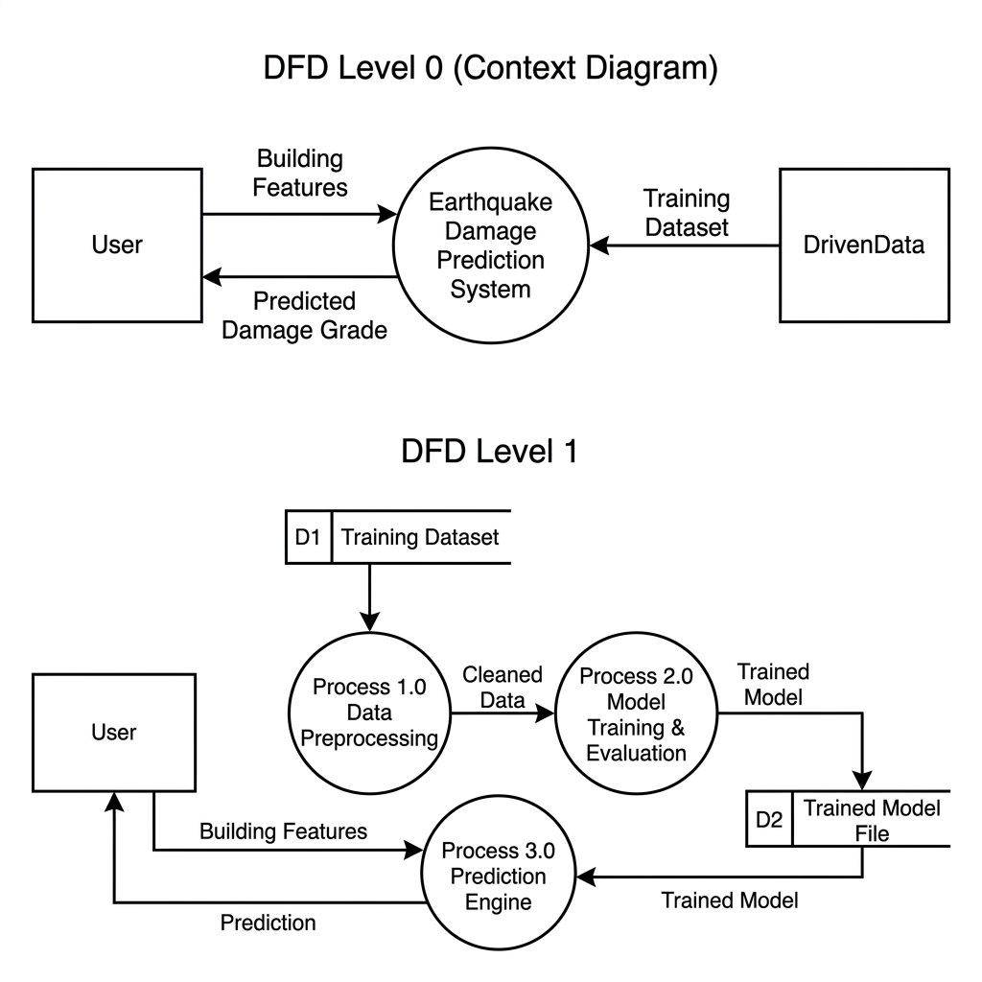
Figure 2: Data Flow Diagram — Level 0 (Context) and Level 1
7.3 Process Flowchart
The flowchart in Figure 3 shows the step-by-step logic of the system, starting from loading the dataset to returning the final prediction. After training and evaluating all four models, the system checks whether a satisfactory model has been found. If not, hyperparameters are tuned and the models are retrained. Once the best model is identified, it is saved and deployed through the FastAPI web application.
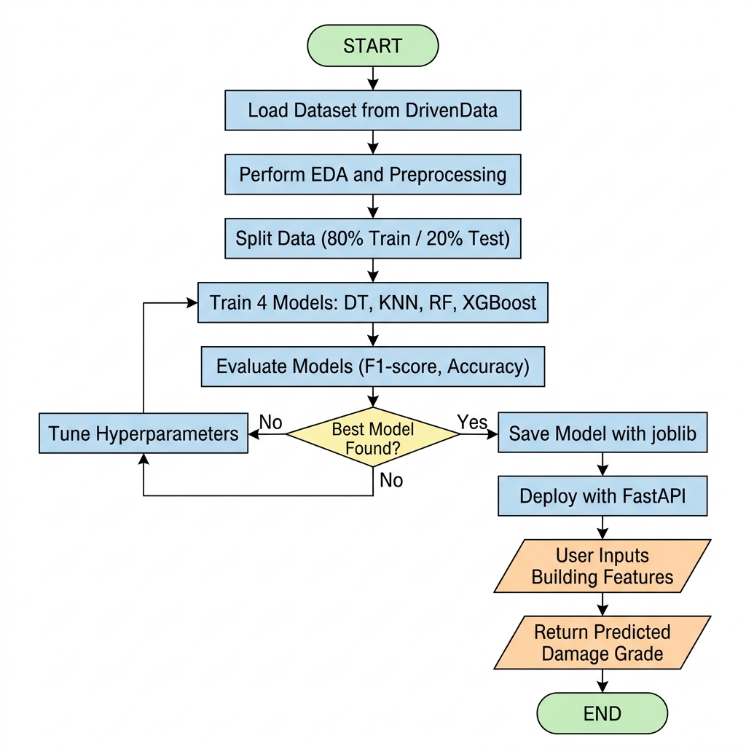
Figure 3: Process Flowchart for Earthquake Damage Prediction System
7.4 Model Pipeline Diagram
Figure 4 illustrates the end-to-end machine learning pipeline, from data ingestion through the DrivenData dataset to the final prediction output served via the web application. The pipeline covers data collection, exploratory analysis, preprocessing, feature selection, parallel training of four candidate models, evaluation, and deployment.
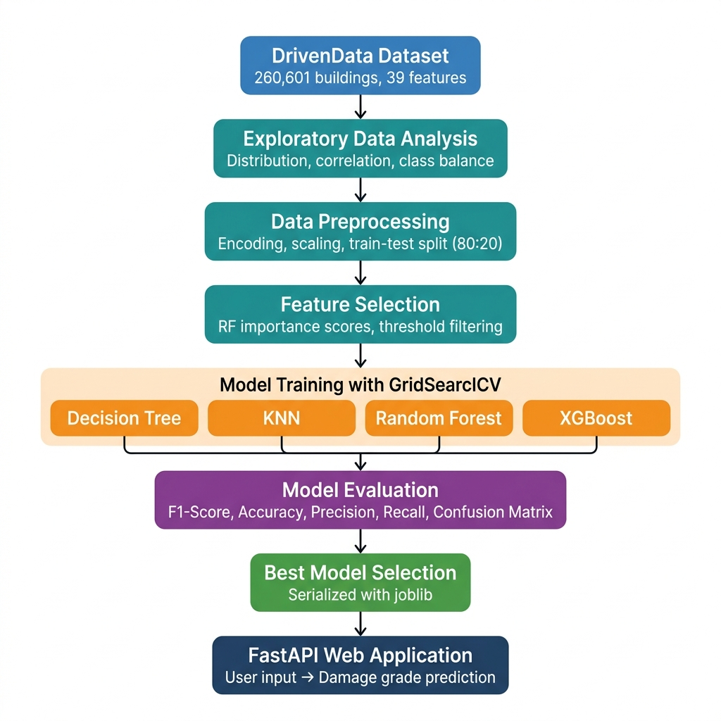
Figure 4: End-to-End Machine Learning Pipeline
7.5 Note on ER Diagram
This project does not use a traditional relational database. The dataset is loaded directly from CSV files during training, and the trained model is stored as a serialized file. The web application processes each prediction request independently without storing user data in a database. Therefore, an Entity-Relationship diagram is not applicable to this project.

