Control Implementation assignment 2: Helicopter

Supporting documentation

Lachlan Arundell

Arnav Joshi

Callum Rohweder

Harry Veivers

# Introduction

## System overview

We have been tasked with developing a controller for a 3-DOF helicopter. The helicopter is made up of several main parts:

* Base
* Long travel arm
* Helicopter body
* Counterweight

The long travel arm is mounted on the helicopter base, and allows the helicopter to move in both the pitch and the travel direction. Quadrature optical encoders are mounted on these axes to measure the elevation and travel of the arm.

The helicopter counterweight and body are positioned on opposite ends of the travel arm. The counterweight has been designed such that the effective mass of the body is approximately 70g. The helicopter body itself is designed such that it can freely pitch about the pitch axis. The pitch angle is measured by a third encoder (of the same type as the other two encoders) located on the helicopter body. The helicopter body consists of two motor driven propellers mounted equidistant from the pitch axis and connected by a rigid beam. The propellers are designed such that they will generate a force proportional to the applied voltage. The force provided by the propellers allows the helicopter to hover and rotate about the respective axes.

In addition to the helicopter system itself, a joystick has been provided with which the desired pitch (, elevation and travel of the helicopter may be set.

## Objective

The overall objective of this assignment is to:

“*Develop and implement a Linear Quadratic Gaussion (LQG) controller that enables the helicopter to be manoeuvred using the provided joystick input device which exhibits zero steady state error to commanded positions. “*

An LQG controller is comprised of two main components:

* a Linear Quadratic Regulator (LQR) state feedback controller
* A Kalman filter based Linear Quadratic Estimator (LQE) state observer

It is expected that this controller will incorporate integral control with a DC feedforward gain model based on the desired reference provided by the joystick. This requires the design of a reference gain kr and integral feedback gain ki for use with the joystick.

# The helicopter model

The system dynamics of the model have been designed using a linearized model about the neutral hovering position of the helicopter body, where the helicopter is stationary and level.

The lumped parameter model depicted in Figure 1 was used to develop the equations of motion.

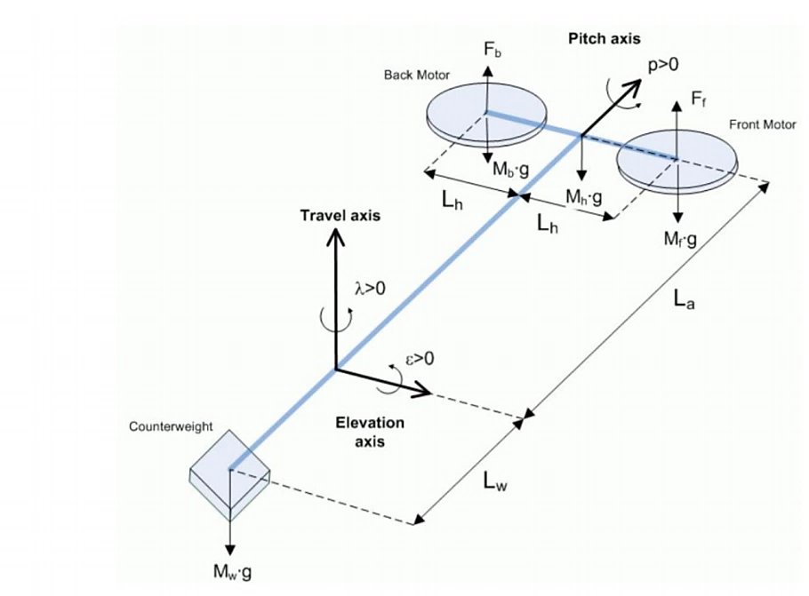

Figure : Lumped Parameter Free Body Diagram

The system parameter values are presented in Appendix A.

The state variables for the system model are the configuration variables and their respective derivatives:

The linearized equations of motion for this system were provided in order to speed the control design process. The equations of motion may be expressed as:

Where A is the dynamics matrix of the system, B is the control matrix of the system, C is the sensor matrix for the system and u is the system input vector.

The system input vector is a 2x1 column vector:

Vf  is the input voltage for the front propeller and Vb is the input voltage for the back propeller.

As stated earlier the system dynamics of the model have been designed using a linearized model about the neutral hovering position of the helicopter body. The state values of the operating point are:

However, in order for the helicopter to hover about this neutral operating point, the input voltage must be nonzero.

V0 is the required bias voltage to have the helicopter hover at the operating point with an input reference of 0. The required bias voltage may be calculated as:

The linearized system matrices are presented below in algebraic form.

By substituting the relevant parameter values for the system, the A and B matrices may be expressed as:

# Controllability

The system is controllable when the controllability gramian is full rank i.e.

The rank of the controllability gramian was found to be:

A rank of six for the controllability gramian is full rank, therefore the system is fully controllable. If this matrix was found not to be full rank (i.e. this system is not fully controllable) the eigenvalues corresponding to uncontrollable modes would need to be found. If the eigenvalues of the uncontrollable modes are stable then the system may still be stabilized. In this case when designing the state feedback controller the diagonal corresponding to the uncontrollable mode may be set to zero. If the mode is uncontrollable and unstable then further action must be taken (e.g. implementation of eigenstructure assignment) to reduce the effect of the unstable mode.

# Observability

The system is observable when the observability gramian is full rank i.e.

The rank of the observability gramian was found to be:

A rank of six for the observability gramian is full rank, therefore the system is fully observable. If the system was not fully observable one of its modes would not be present in the output.

# Linear Quadratic Regulation (LQR)

It was stated previously that LQR state feedback control is required for the helicopter system.

Where for state feedback control u = -kx

Linear Quadratic regulation in state feedback minimizes the cost function:

Where Qx is the state cost matrix and Qu is the input cost matrix.

A common tuning rule used in linear quadratic regulation is:

Where:

* tsi is the desired settling time
* xi,max is the maximum value range of the ith state
* uimax is the maximum value of the ith input
* ρ is selected through trial and error as a trade-off between regulation and control effort.

## Problems with control using encoder outputs

Optical encoders are used to measure the position states (elevation, pitch and travel) of the helicopter body. A simple method for determining the velocity states is to perform a differential operation on the position states. However, the position encoders operate by measuring the number of times a hole in a rotating disk passes the encoder laser. A result of this is that the encoder reading is a series of small step changes. When differentiating this reading the output is unusable as it is filled with noise; a compilation of spikes generated when a change in reading is found.

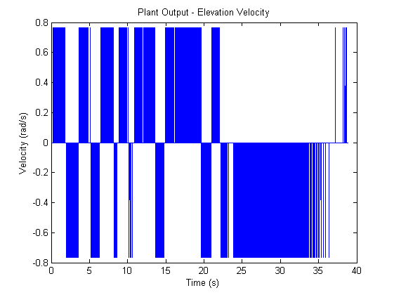

Instead of continuous differentiation a low pass filter can be used on the encoder position prior to differentiation to smooth out the position measurement and severely reduce noise present in the velocity measurement.

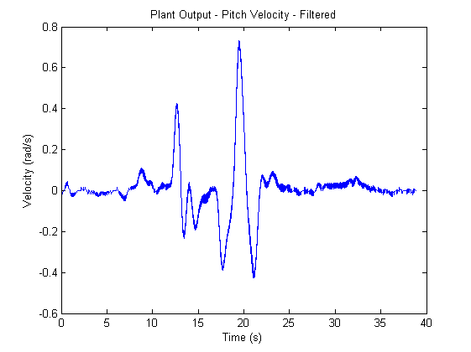

An alternative method to low pass filtering and differentiating the encoder position is to develop an observer (state estimator). From the below figure it can be seen that any noise in the velocity measurement has been eliminated.

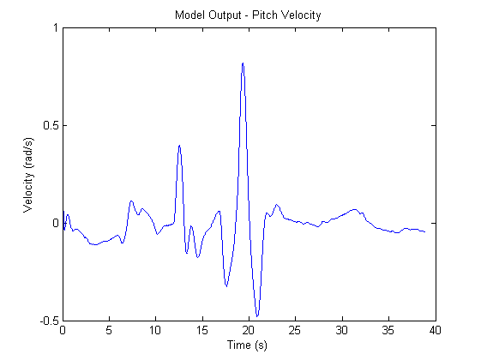

## Control using estimated states

By using the linearized model of the system an estimate for the state output can be developed.

In equation form this may be written as:

Th error between the state and the state estimate may be expressed as

The system difference between the state and the model is:

From the above equation it may be inferred that if the eigenvalues of A are stable, then the error between the actual and estimated states will converge to zero. However, if there is any modelling error in the linearized system dynamics used to determine the state estimate, or if there are any system disturbances the error will instead increase.

The observer system can be modified to reduce the steady state error in the system:

In the above system, the matrix L is known as the Luenberger observer.

The system difference between the state and the model is:

The poles of the system (A-LC) can be designed such that the error will go to zero.

The closed loop poles of the system under state estimate control are:

Through use of the separation principle the eigenvalues of the state feedback controller and the observer can be designed separately.

## LQR Design Procedure

Implementation of state feedback is required in-order to effectively control the system such that it can be driven to and regulated about arbitrary operational states. For the helicopter system, an operational state is represented by the position of the device within 3-D space. Furthermore, the application of system control also extends to address the requirement of operational trajectories that may have to be performed by the system e.g. the helicopter may be required to follow randomised/cyclic/systematic paths in 3-D space to achieve a desired result. Each system will have its own unique dynamic (behavioural) characteristics that are impacted by various factors associated with the system design. Due to the broadness of this aspect and flexibility in the requirements from a system, a generalised solution for state feedback controller design does not exist.

In-order to design an effective state feedback controller for the helicopter system, the desired behavioural characteristics required from the system during its operation can be considered. Designing the controller gains for state feedback through direct variation of the systems closed loop poles greatly limits the designer’s ability to gauge the influence of pole placement on individual state responses. Furthermore, the order of magnitudes and spacing required for individual pole placement is unknown and depends greatly on the system. LQR addresses these issues and provides more insight into the resulting controller dynamics by allowing direct selection of the state variable response weightings. The weightings themselves are chosen based on desired physical characteristics of the state variable responses such as settling time and expected range.

The following requirements describe the desired behavioural characteristics of the helicopter system,

* The strongest gain required should be on travel velocity, as this arm is the longest, it is most sensitive to variations in motor noise and acceleration, and has the greatest inertia and is thus sensitive to overshoot. For this reason, the travel’s velocity should be highly gained.
* Elevation is a system input, and thus it is required that the gain of this state is larger than others, behind travel travel velocity, for the aforementioned reasons.
* As the inputs set the reference of elevation and travel positions, these are weighed more than the pitch angle; more freedom in pitch is required to move the helicopter to the desired position.
* Due to direct coupling between elevation and travel, a strong elevation control may simultaneously correspond to strong travel position control, and robustness in eliminating movement in travel. However, this effect should be appropriately controlled to ensure it does not limit the helicopter’s range of pitching motion, by ensuring pitch is weighed less than travel and elevation position.
* To limit the rate of twist of the motors, the pitch velocity, this state is weighed more than the velocity of the elevation, as to minimise the effects of disturbances.

When implementing the joystick reference, both elevation and travel will be used as the reference parameters. Hence, when calculating the reference gain, gain values associated with these state variables will be extracted from the primary state feedback gain matrix, K and used for Kr. As a result, by addressing the first requirement stated above, the joystick responsiveness should automatically be enhanced for effective manoeuvring of the helicopter.

Now that the requirements have been defined clearly, the state feedback design can be commenced using LQR. Six state variables are being considered and hence from LQR theory, the construction of the regulation cost matrix, Qx requires the selection of six q values. These values will be of primary importance during the tuning process for state feedback design. The selection of Qu will be determined based on the trade-off required between regulation and control effort in-order to achieve the desired system behaviour.

With the desired requirements in mind, the following conditions for qi were initially expected to replicate the desired controller behaviour,

*Elevation*

Rapid response with relaxed freedom of motion.

*Pitch*

Rapid response with significant freedom of motion.

*Travel*

Rapid response with significant freedom of motion.

*Elevation Rate*

Rapid response with some freedom of motion.

*Pitch Rate*

Relaxed response with significant freedom of motion.

*Travel Rate*

Rapid response with significant freedom of motion.

Note, these constraints were not expected to be quantitatively reflected in the system response, but instead were used to gauge and contrast between the different state variable behaviours. This method of design provided an effective justification platform through which a realistic thought process could be implemented, the influences of which could be physically well understood and reasonably predicted. Although the above constraints were aimed at achieving the required state behaviours, the numerical solution to the K matrix failed to reflect this. Gains associated with elevation and travel were found to be too weak and stronger pitch rate control was observed to be a hindrance on the helicopter’s ability to travel. From a mathematical standpoint, the elemental gains within K were found to have varying sensitivities and cross couplings associated with the state variables.

* Changing qi for any of the pitch/travel position/rate states directly affected the gains associated with all remaining state variables.
* Depending on the qi changed above, the associated position or rate state was influenced more compared to the other impacted state gains.
* In-order to truly replicate the desired requirements, extreme qi values were found to be required for particular state variables in-order to address the issues associated with its sensitivity.
* For the reasonably well performing state variable controls, a standard fine tuning was required in-order to refine the helicopter response.
* The selection of ri is not crucial to controller design in this context as both input behaviours for both identical motors are expected to be within the same range.
* The choice of ρ was (as mentioned) simply based on the desired strength of the controller and essentially acted as an indirect scaling factor for K (increasing ρ resulted in almost equally distributed gain reduction within the K matrix).

Taking these observations into consideration, the following LQR design was eventually developed,

Both elevation position and travel velocity were required to be strongly controlled, however as both associated q values were found to have minimal influence on K using the desired constraints for settling time and range, they were significantly amplified through severe reduction of the settling time. Although this was not realistically replicable, it produced the required control strength for these state behaviours. The state controls for both pitch and travel rates also had to be rectified, however the variations in settling time and range were not as prominent.

Due to the expectation of severe variation in control inputs throughout the manoeuvring of the helicopter, the selection of ri was mainly based upon the expected variation around the reference/equilibrium position. However this selection process does not greatly affect the controller design as explained. The choice of ρ was of greater importance and was selected based on how strong the overall state feedback was required to be in-order to achieve a comfortable joystick sensitivity during helicopter operation. Alternating signs (row-wise) associated with the pitch and travel related state columns are a direct consequence of the coupling between the two variables. Manoeuvres involving variation in these states require non-equal motor inputs.

Looking at the closed loop system poles (including state feedback only), it is observed that two complex conjugate pole pairs exist. One of which is significantly more underdamped. Looking at the two extremities, it is likely that the pole furthest to the left corresponds to either the travel rate control mode. The weakest control being pitch position makes it the most viable control mode that corresponds to the underdamped pole pair.

The decided gains have produced the following response, where steady state error has been seen to be of an acceptable standard:

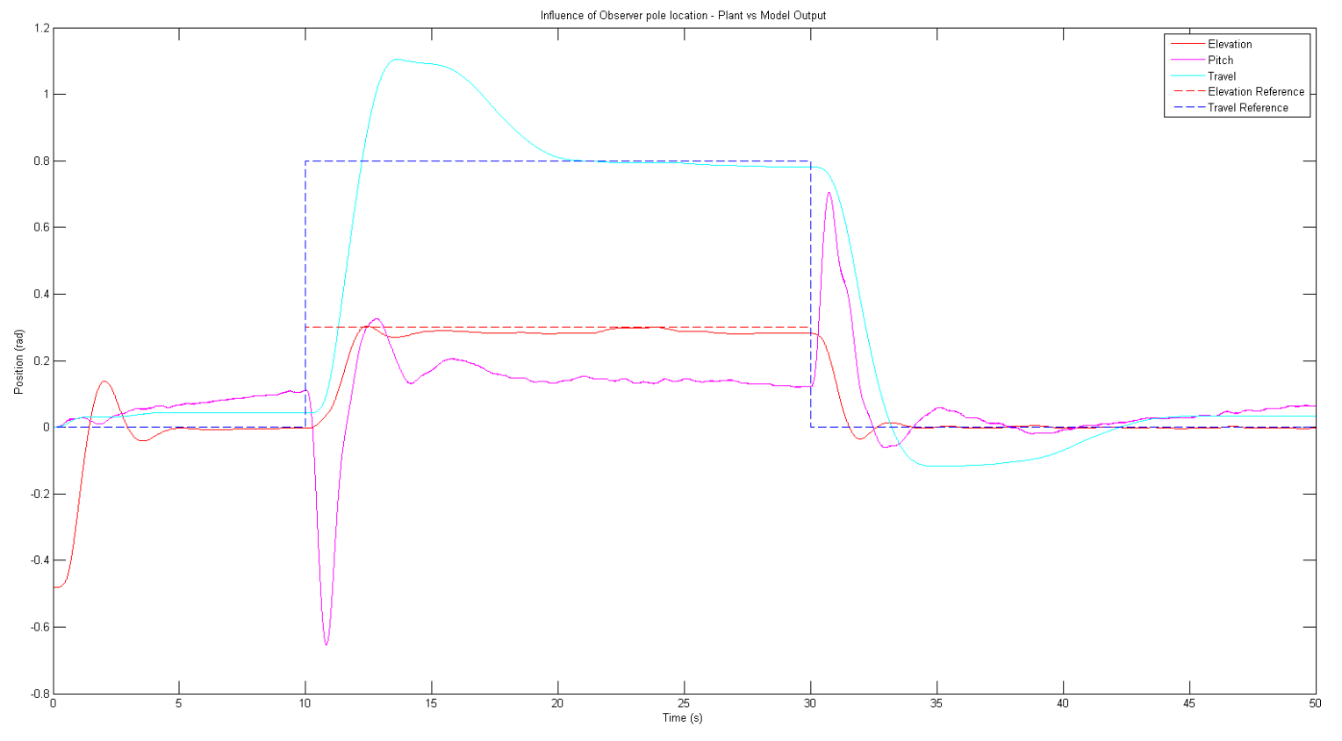

Where previously the following was used, where it can be seen that travel velocity has been weighted higher along with a decrease in pitch position:

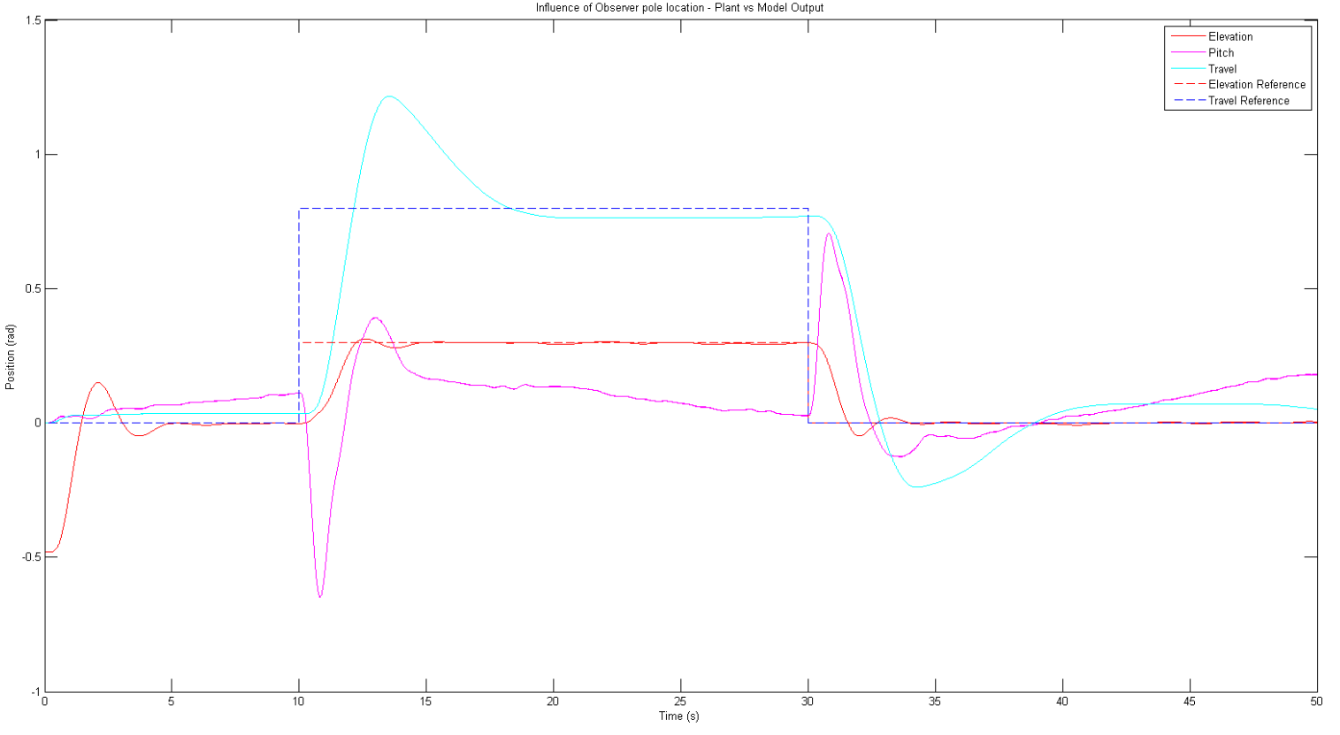

# Kalman Filter

## Theory

It was shown earlier that when implementing control using a state estimator there will be an error between the state and state estimate. In order to drive this error to zero a Luenberger observer can be designed to effectively place the poles required to achieve this.

There are two main causes for the error between the state and the state estimator:

* Process noise
* Measurement noise

Process noise is sued to model any error in the system model as well as any system disturbances whereas measurement noise is used to model errors in the sensors and measurement apparatus.

The process and measurement noise are modelled as white-noise stationary gaussian processes and .

The system model with included uncertainties may be expressed as:

For the multi input system under consideration and will be vector random variables. Where Q and R are the covariance of and respectively. The covariance of the vector random variables may be calculated as:

The new L matrix is the steady state Kalman filter gain.

## Design procedure

### Noise determination

To evaluate the values of Q and R, as specified above, the process and sensor noise for each state needed to be determined. Sensor noise was defined as the uncertainty in position readings from the encoder, and process noise as the difference between the physical system and system model to a change in reference position. The variance in each state to sensor noise was determined in the following procedure:

1. Apply a bias voltage to the plant, such that it is in balance with the counter weight and all axes are zerod.
2. Once a steady state has been reached, the positions of pitch, elevation and travel were recorded for approximately 1405 samples (approximately 3 seconds).
3. Evaluate the variance in the readings (data) obtained for each axis
4. Repeat from step 1 to obtain an understanding of the average variance in each state due to sensor noise

It was found that elevation had the greatest variance, in both position and velocity, whereas the other axes showed no deviation in reading for all tests, as shown below.

|  |  |  |  |  |  |  |
| --- | --- | --- | --- | --- | --- | --- |
| Test Number | Elevation Variance | Pitch Variance | Travel Variance | Elevation Velocity Variance | Pitch Velocity Variance | Travel Velocity Variance |
|  | 7.5783e-06 | 0 | 0 | 0.0024 | 0 | 0 |
|  | 4.1876e-05 | 0 | 0 | 0.0061 | 0 | 0 |
|  | 8.1846e-06 | 0 | 0 | 0.0018 | 0 | 0 |
|  | 6.5153e-06 | 0 | 0 | 0.0020 | 0 | 0 |

Having no variance on the pitch and travel axes is a surprising result, however the difference in variance between axes can be explained. The helicopter motors were positioned to oppose gravity, facing out of plane to the pitch and travel axis, but aligned with the elevation. Thus, elevation was sensitive to slight variances between motor velocities (as a result of input noise) and motor noise. Due to the position of the motors relative to the travel axis, and the large inertia of the helicopter on this axis, it was expected that this would have the least variance in the tests.

The procedure for determining the variance between the plant and system model is similar to that of noise, however it looks at the difference between the plant and observer states, for a given response:

1. Using a bias voltage, bring the helicopter into its initial position, horizontal with the counter-mass; the system is set up with state-feedback connected and output feedback disconnected.
2. Once in steady state, mimic a rapid change in reference in position, provided by the joystick (found to have a slope of 0.125 maximum, to a position of 0.4995 in elevation).
3. Collect data for each state from the plant and observer
4. Subtract the plant and model states for each data-collection, and calculate the variance for the Q matrix

It was found that without output feedback, the observer would respond in a similar manner to the plant for the first second after the change in reference in applied. During the rapid change in input, the helicopter began to decrease in position, however the observer continued to increase with the input. The difference in models is due to the observer not having reference to the position of the plant as time continued; hence the need for output feedback to correct for this error. For the process noise, the variance between the plant and observer for the first second was used, as the transient responses were most similar here (having an effect on the output feedback pole locations), as shown in the figure below.

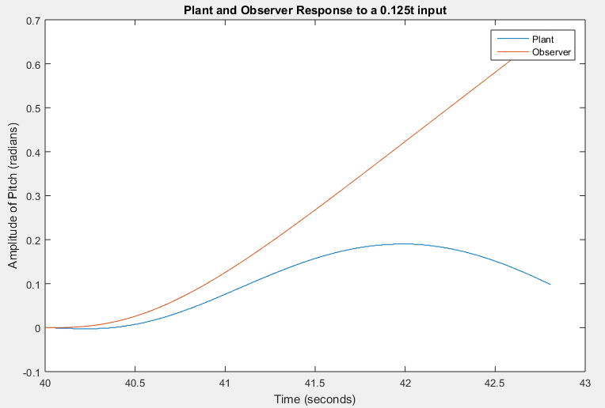

The variance in the positions were found to be:

|  |  |  |  |
| --- | --- | --- | --- |
| Test Iteration | Elevation Variance | Pitch Variance | Travel Variance |
|  | 0.0015 | 5.4207e-31 | 3.0264e-07 |
|  | 0.0014 | 1.6229e-31 | 3.7599e-07 |

The aforementioned variances were averaged and placed along the diagonals of the R and Q matrices. The Kalman function in MATLAB was then used to compute the L matrix required for output feedback, leading to observer eigenvalues below that of the state-feedback.

An additional method for determining Q was used, however also came to undesirable results, as the observer poles should be around 5 times those of the state-feedback.

### Pole placement

An alternative approach to determining the desired L matrix gain values is through implementation of pole placement. From best engineering practises it is known that observer pole locations provide optimal response when located 5 to 10 times further away from the origin than the state feedback poles. In addition to this, one conjugate pair was selected to be closer to the origin to the others in order to mimic a second order response; creating a response understandable to us. Variations of the pole locations were simulated to achieve the minimum transient and steady state-error between the observer and plant, with sensitivity to noise included.

The poles were grouped in complex conjugate pairs. The damping present in the observer response can also be designed through careful selection of the imaginary component of the pole location with the regards to the corresponding real component.

|  |  |
| --- | --- |
| Pole Location Scaling From Chosen | Elevation and Travel State Response to Step Disturbances |
| 2 |  |
| 0.5 |  |
| 0.25 |  |
| 0.1 |  |

In order to confirm the optimal damping ratio, the system response was plotted for various damping ratios including

It was found that a damping ratio of provides an optimal system response.

This is unsurprising as this value is documented as corresponding to a minimum settling time with no oscillation. There is however some overshoot but this was found to be preferable over the reduced rise time.

This corresponded to an observer pole placement of:

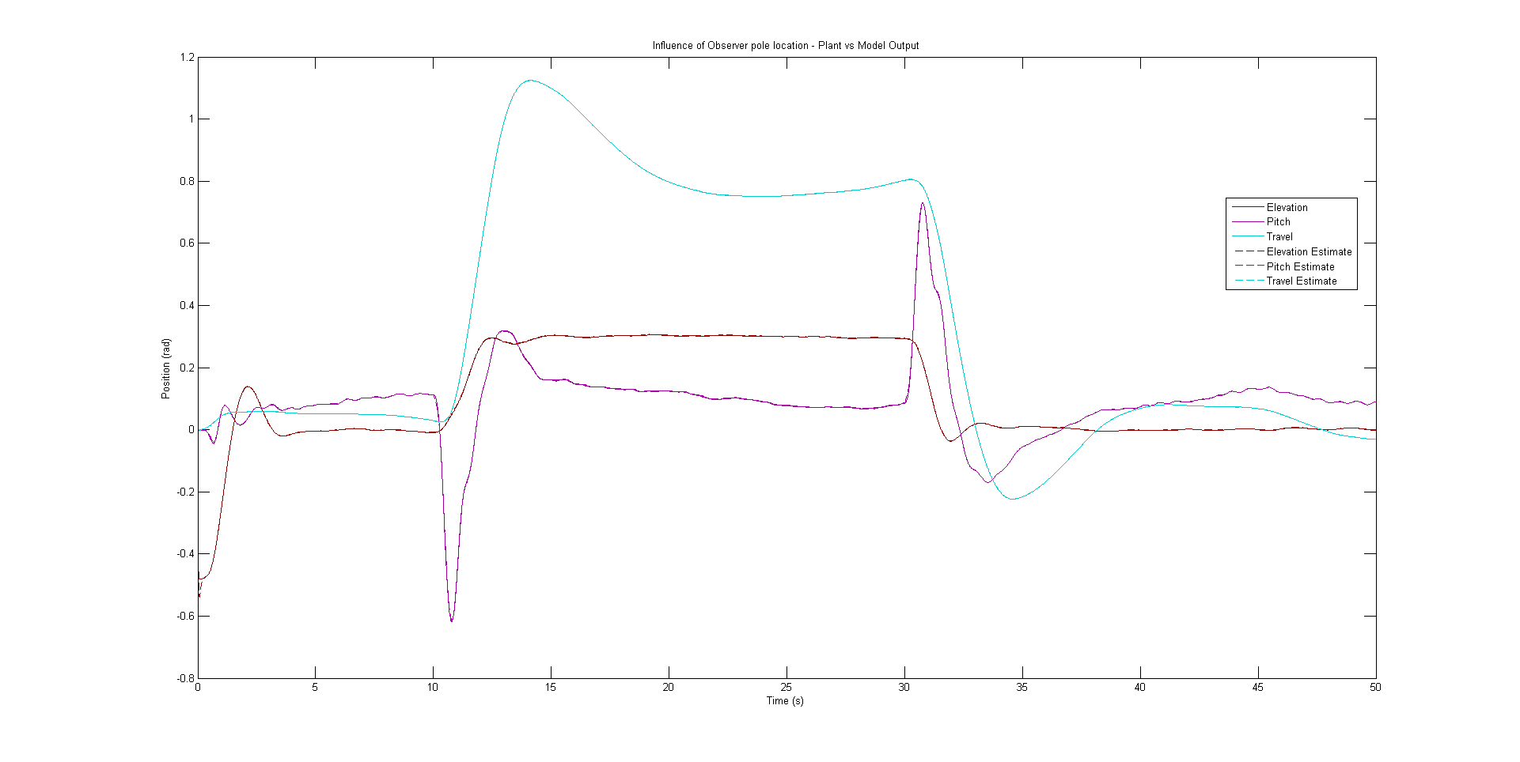

Response with the above observer poles

# Reference gain kr

It is desired that the system be desired such that the output, y, matches the reference state, r. In order to achieve this a reference kr must be effectively designed.

When the output matches the reference the rate of change of state should be zero:

The system equations of motion can thus be solved for the state values explicitly:

The output of the system may be calculated as:

By substituting in the previous expression for this becomes:

By keeping in mind that we are trying to make the output equal to the reference state and the above expression may be solved explicitly for the desired reference gain

The end result of this is that the pitch reference cannot be set to a reference value other than zero and the pitch will only vary due to a change in the travel axis position reference.

# State variable feedback controller with integral action

It was shown previously that the reference gain kr may be solved for explicitly by using the linearized system model equations of motion. The main problem with this derivation is that it will only work for instances where the linearized system model exactly matches the physical system because it depends on the values of the A and B matrices.

Although the system model closely matches the physical model, there will be discrepancies between them. This is a problem as we desire the system output y to exactly match the reference state. In order to simply remove the steady state error integral action may be implemented.

Integral action may be simply implemented through the addition of a new state z, where:

The control law for the system is:

This gives the system dynamics as:

For our helicopter system, C is designed such that only the elevation and travel are fed back.

An initial approach used a single ki gain that both input states (elevation and travel) error was gained by, resulting in the following response to a joystick step disturbance:

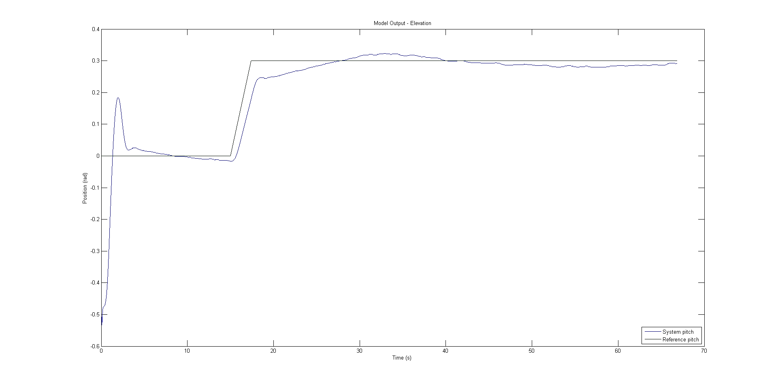

Although with enough time this method had sufficiently eliminated steady-state error, this approach was abandoned for more control over both input states’ settling time.

The final approach taken involved using the Matlab lqi function to use linear quadratic regulation to determine the required integral gains along with the state feedback gains.

By focusing on the state feedback gain designs lqi develops an answer to matrix K where:

Where Ksf are the state feedback gains.

The solution process for determining K is then the same as LQR except the state regulation cost matrix Qx contains and extra two dimensions corresponding to the weighting of the integral action.

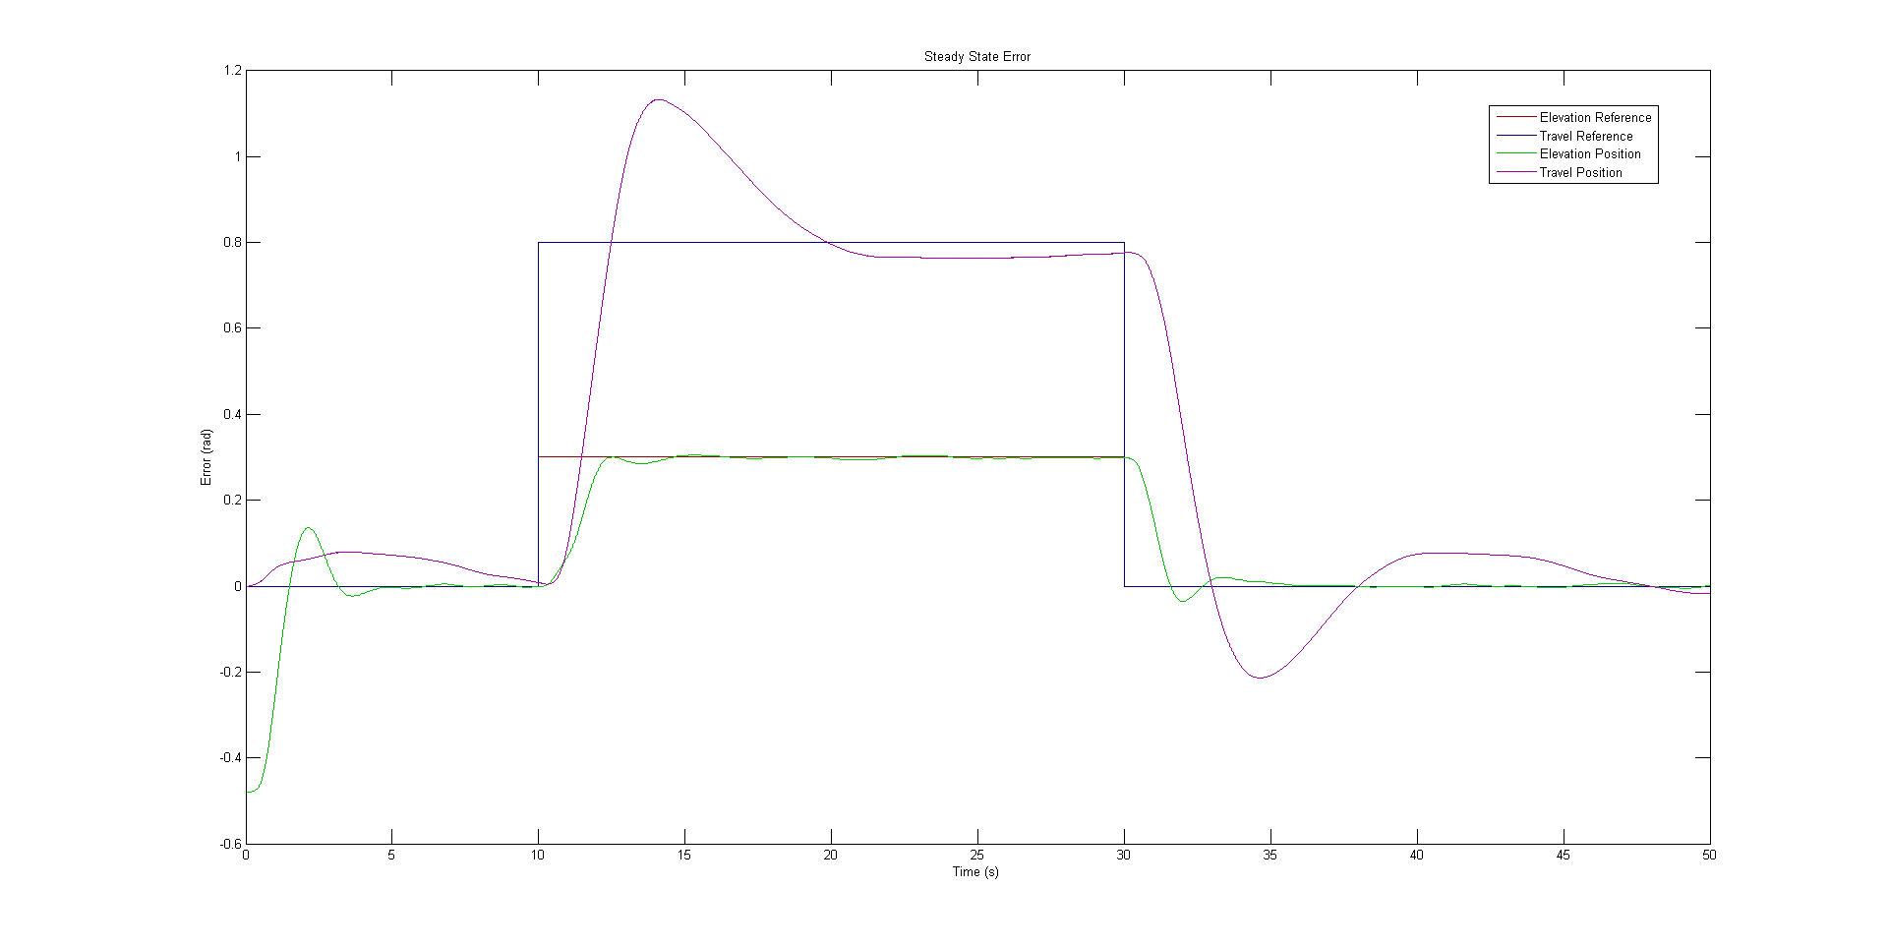

Test 3 (optimal; elevation reached a steady state within 10 seconds, and the overshoot and oscillation in travel position is minimised)

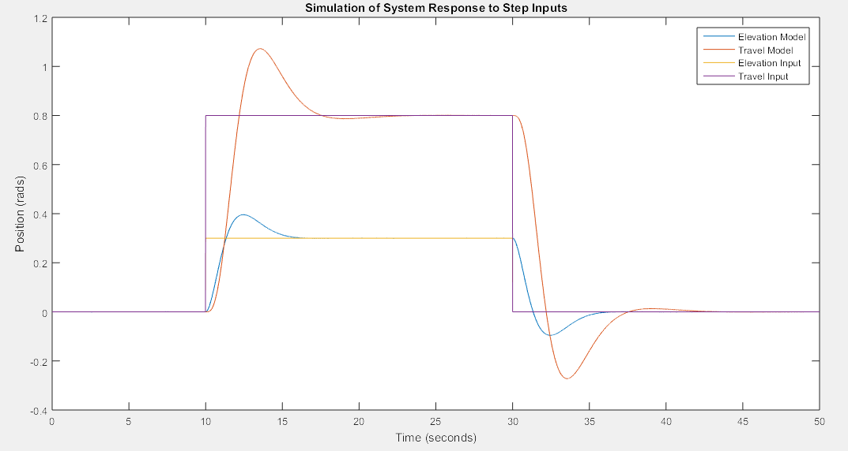

Simulation comparison to optimal

When comparing the optimised response to a purely theoretical Simulink model it can be seen that there is a close agreement in terms of rise time and settling time. Additional tests of Ki are shown below, where the setting time was varied to smaller and greater than the optimal values (shown above). It can be seen that they result in higher overshoot or increased oscillation, where the optimal was chosen as it minimised these.

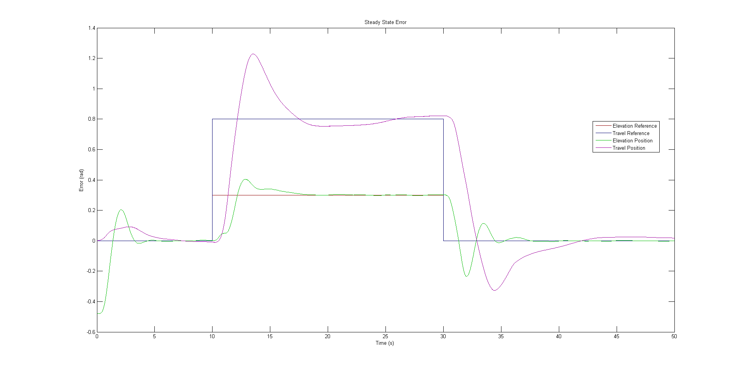

Test 1 (ki too big; note that the overshoot and amount of oscillation has increased)

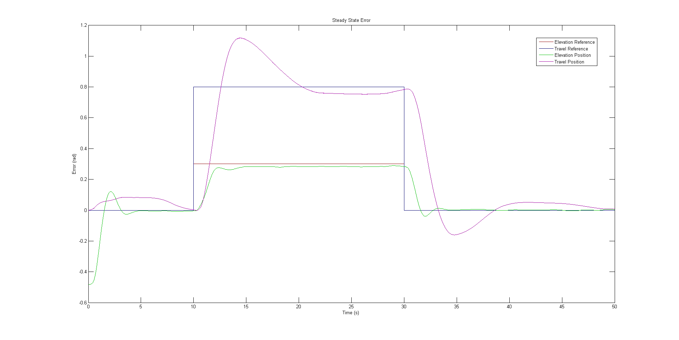

Test 2 (ki too small; note that it does not converge to the reference position within the 20 second pause between disturbances)

# Appendix

## Appendix A

