Login:

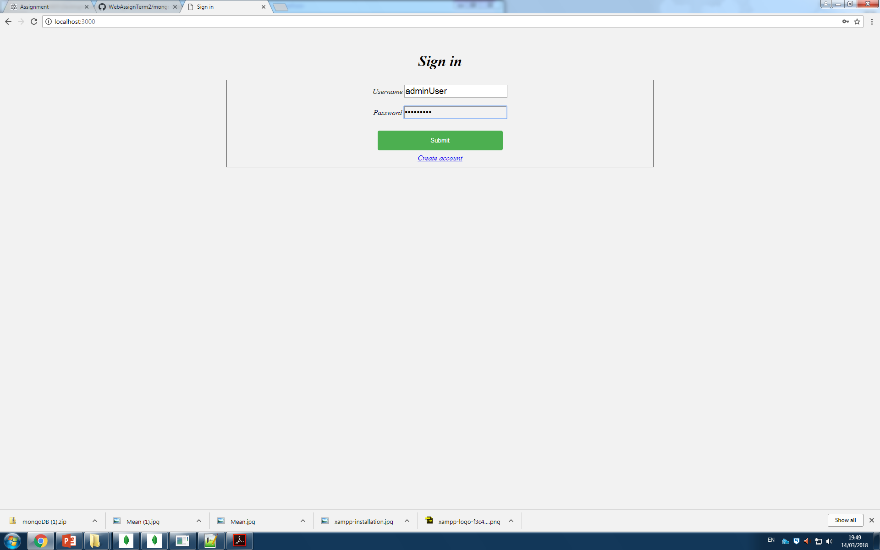

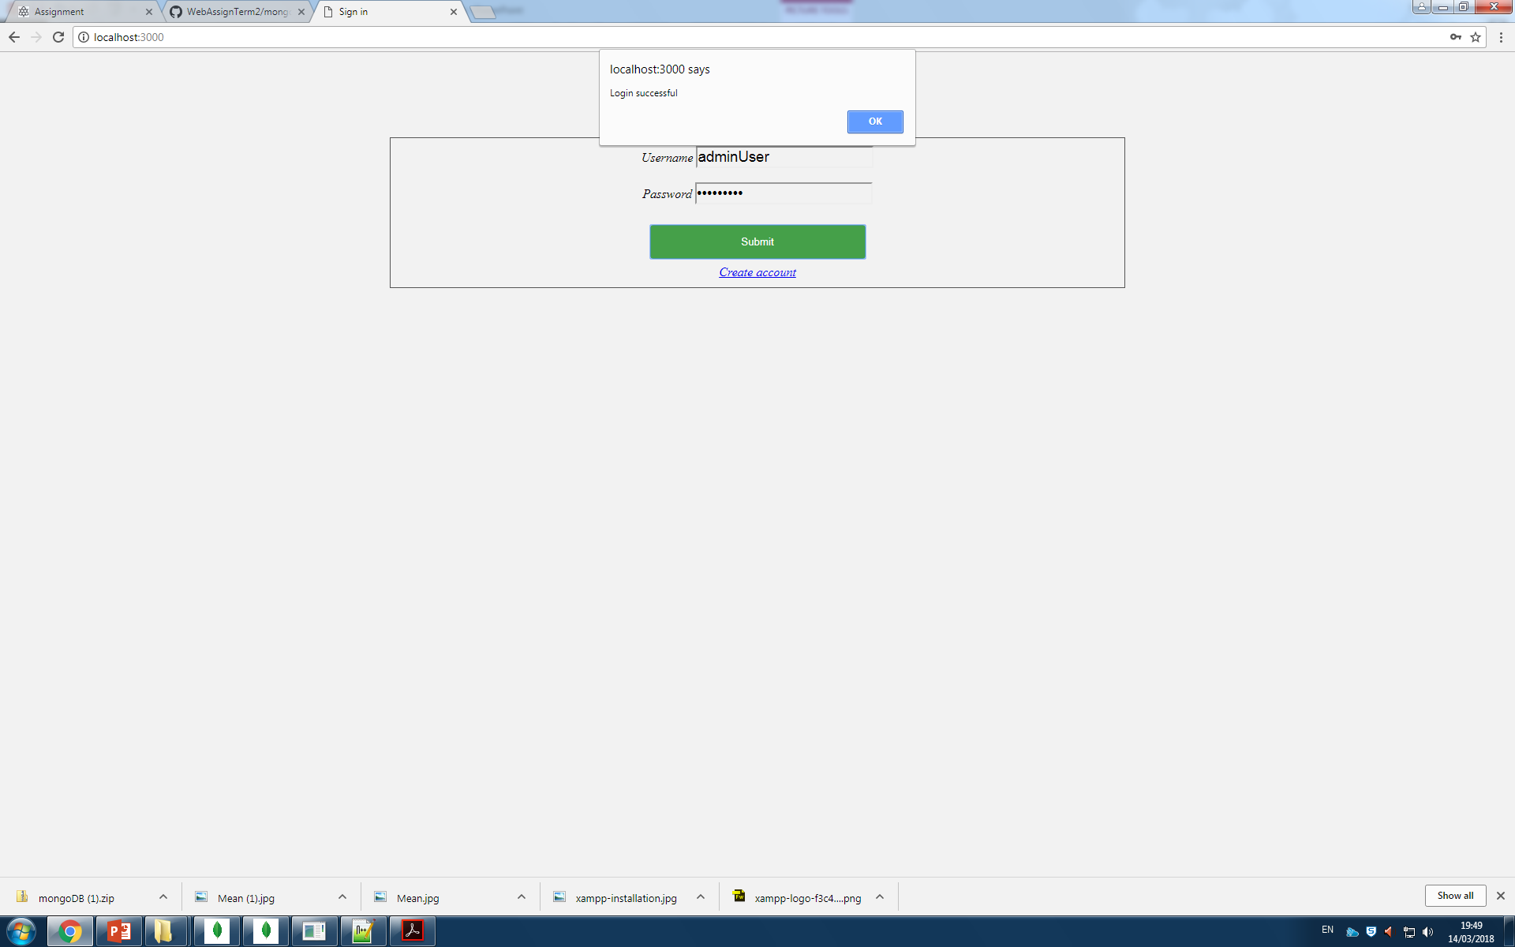

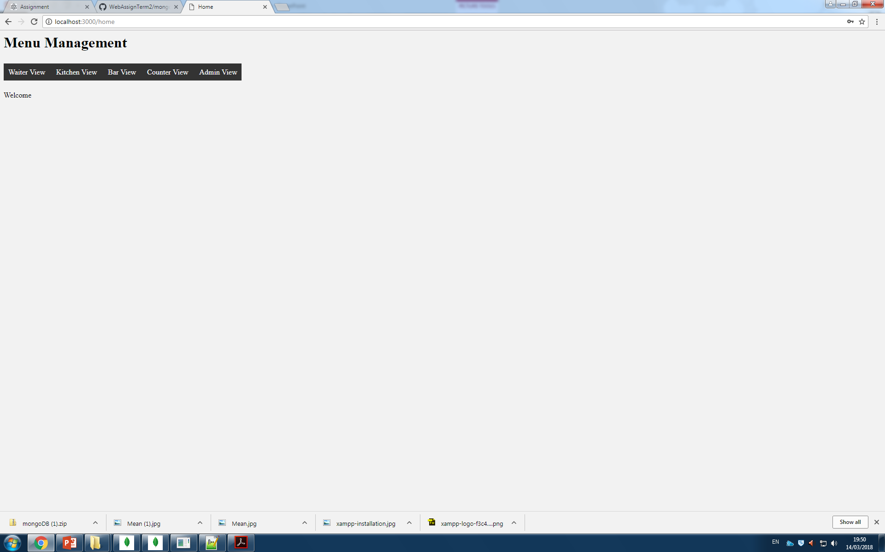

User is able to login to either a customer, staff of admin account. Each position has its own cusom navigation-bar

Kitchen View

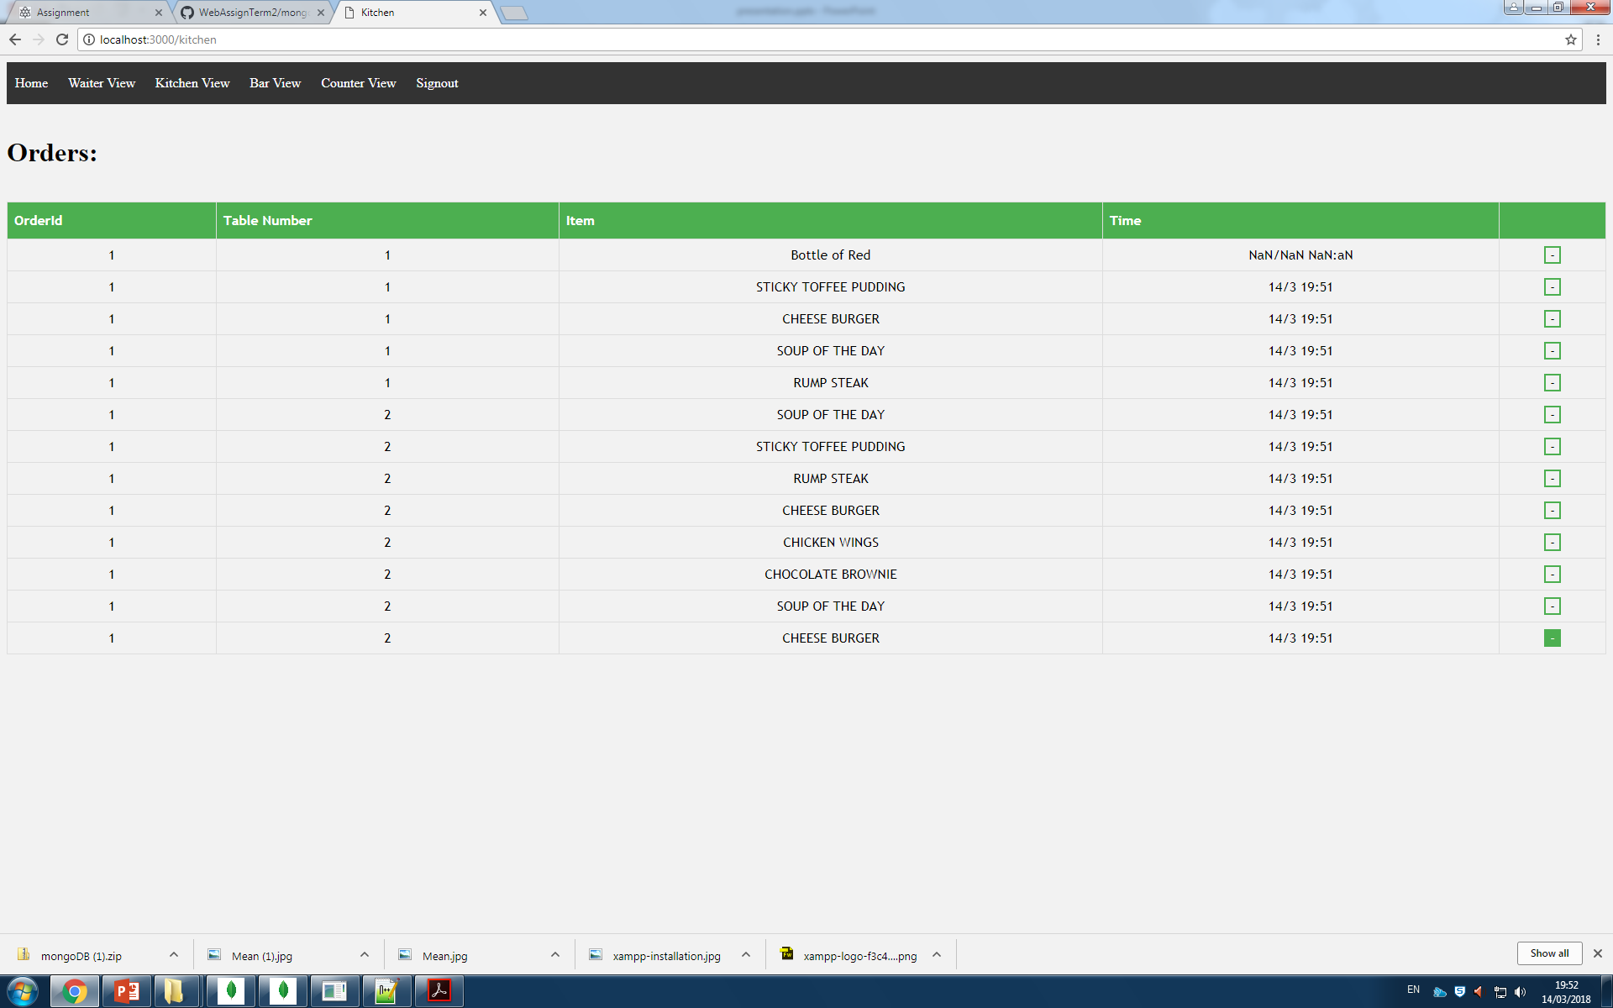

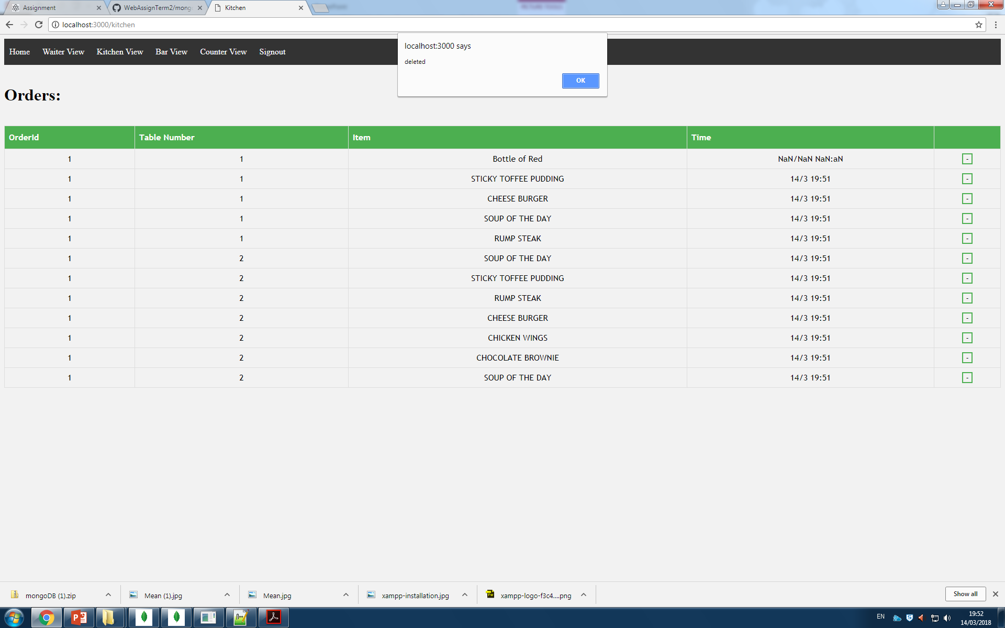

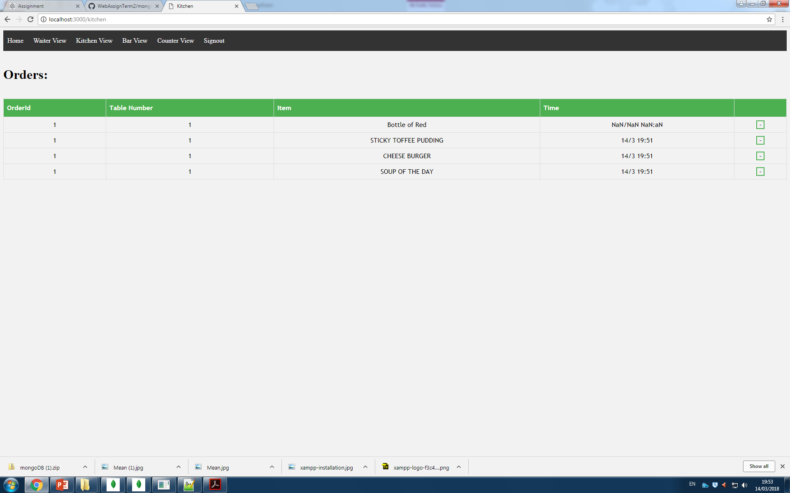

The kitchen view provides the kitchen staff a up–to-date record of the food items that need making. The view also has the ability to hold orders from online. These are saved with a table id of 0 to indicate that they are not for the people in the restaurant.

Bar View

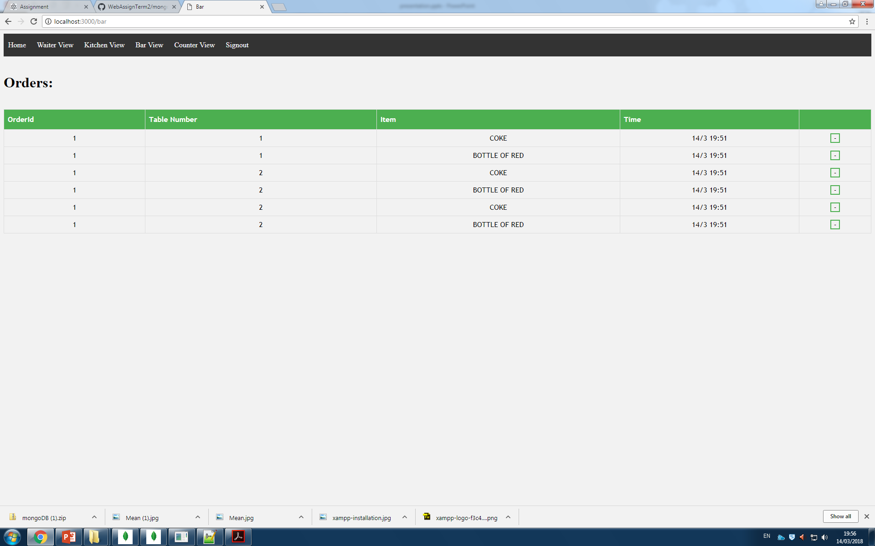

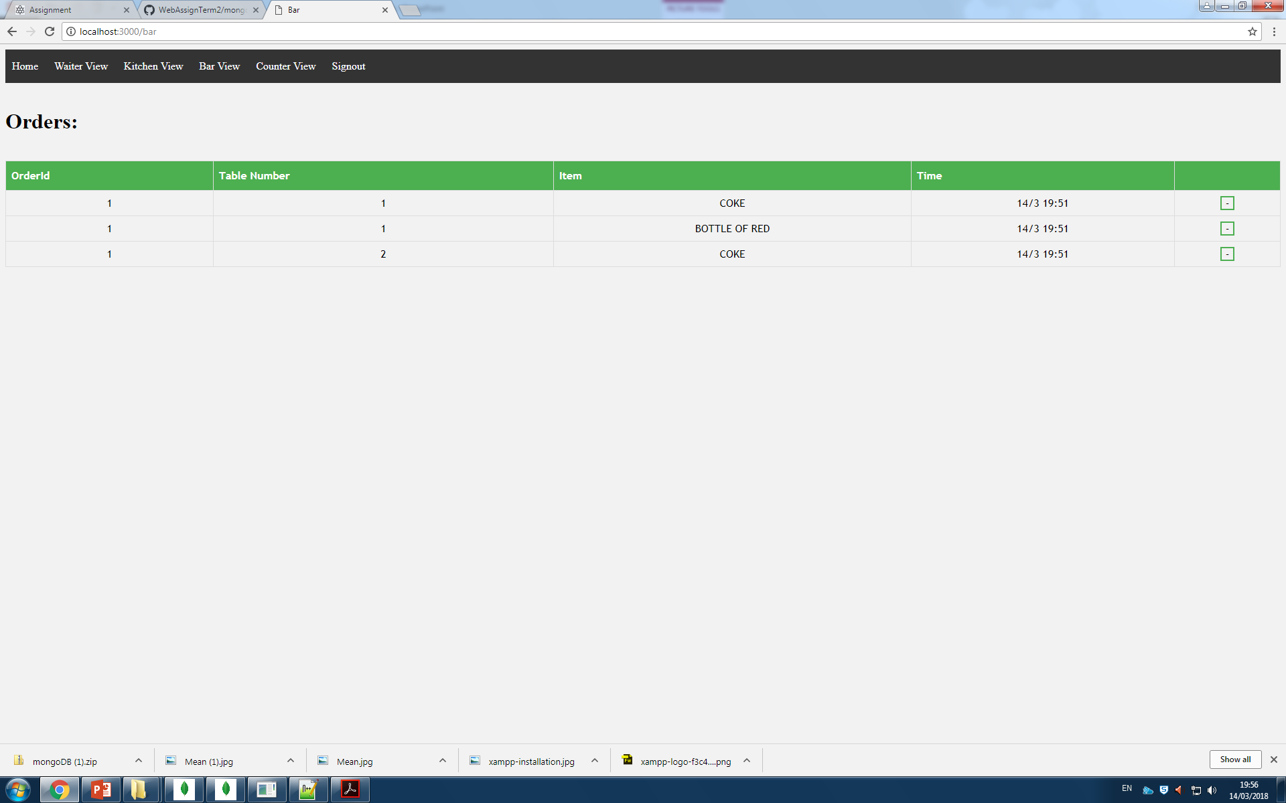

The bar view, like the kitchen view shows all current orders, however the bar view is limited to drinks. It also shows the online orders, indicated with a 0 as their table id.

Responsive Design

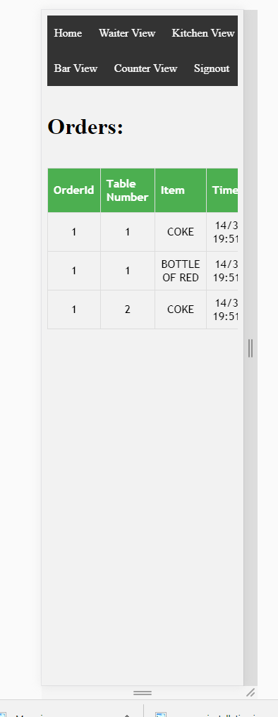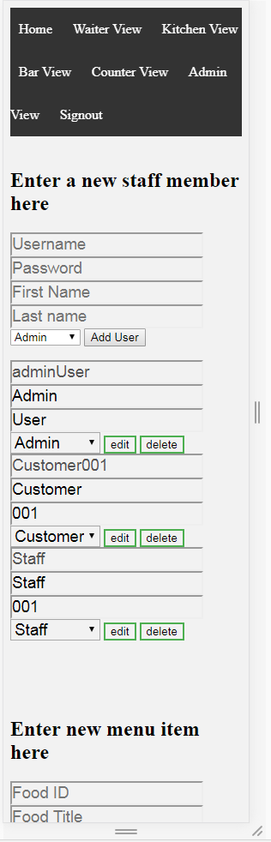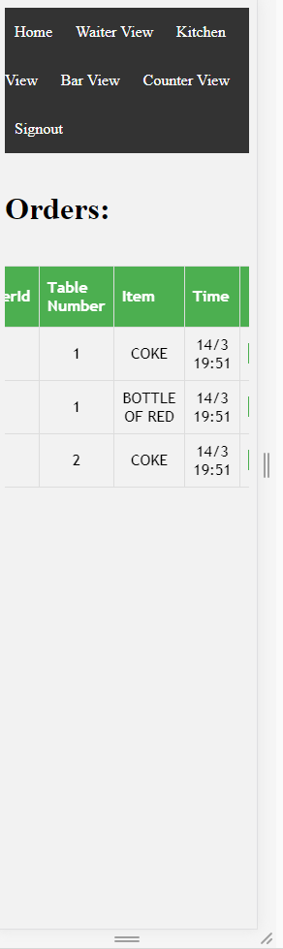

The site has been specially built to provide a responsive design for the user. This means that the page will remain functional no matter how small or large their display is. The tables even have scroll bars in order to better view them on a thin display.

Admin page

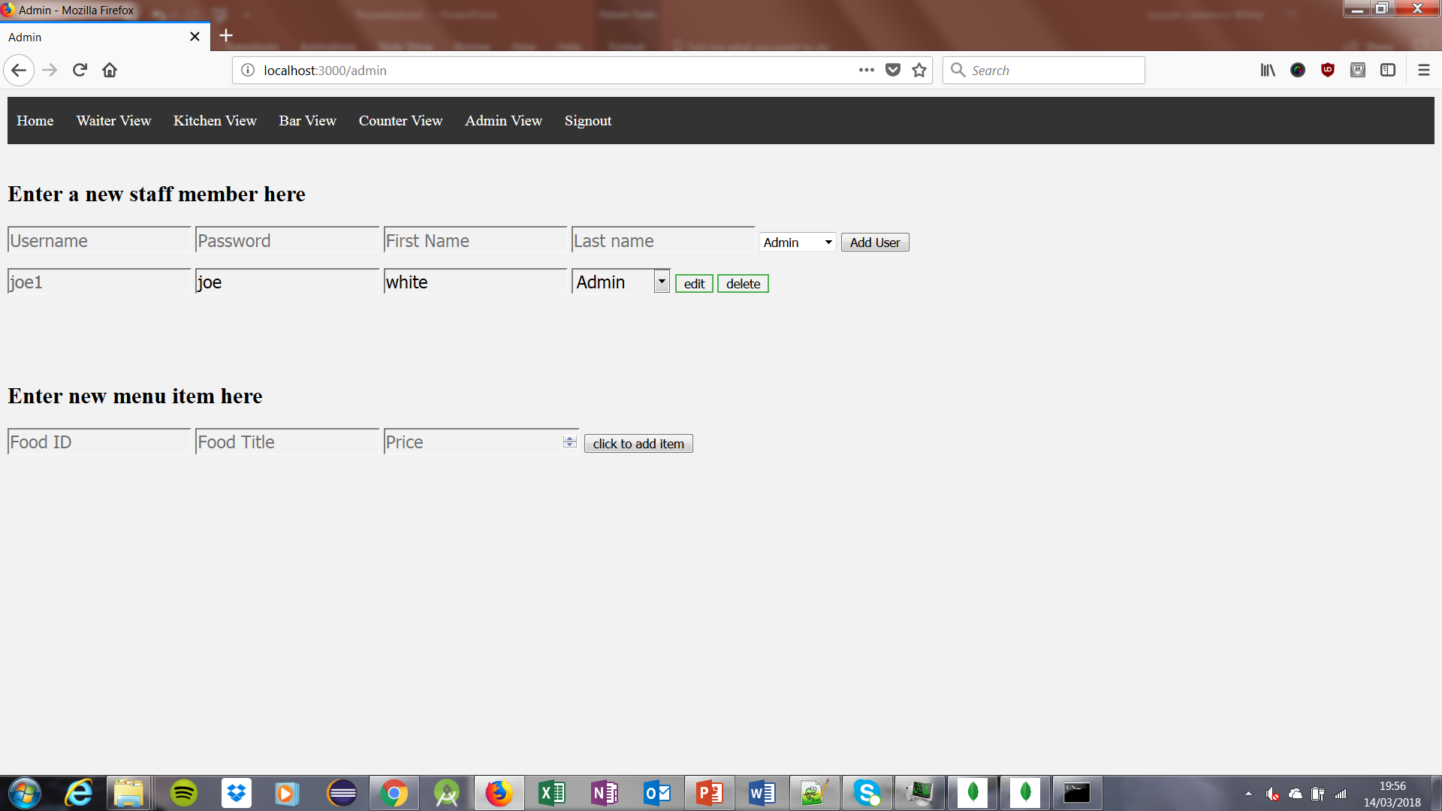

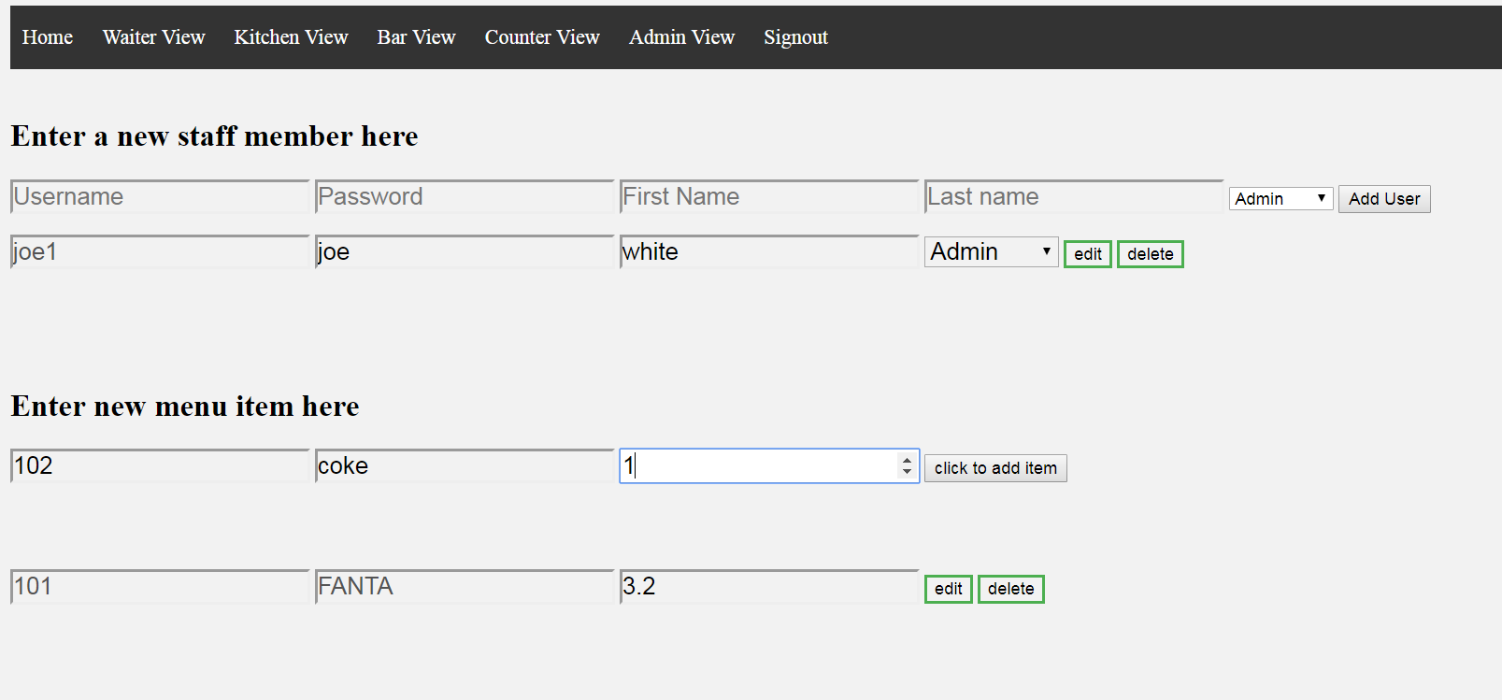

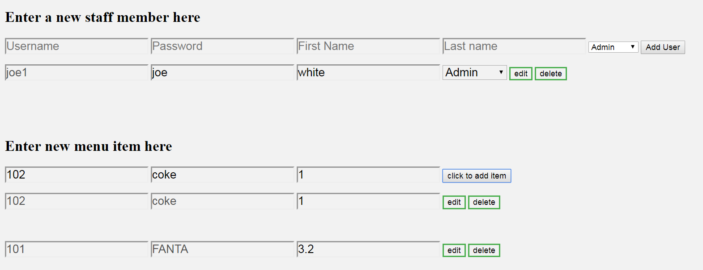

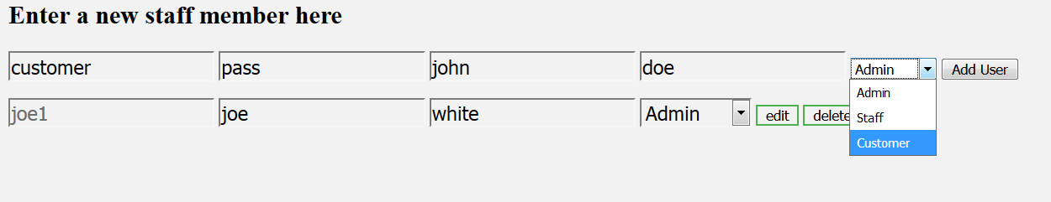

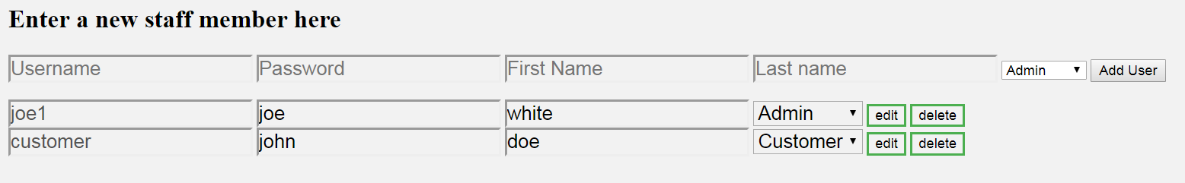

The add staff function of the admin page allows an admin to create a new user. Despite the name, this page actually allows the admin to create a new customer, staff member or another admin. The page will also display all current users and permits the admin to edit the user or even remove them from the system entirely.

The page also permits the admin to modify, add and remove items from the menu.

Counter

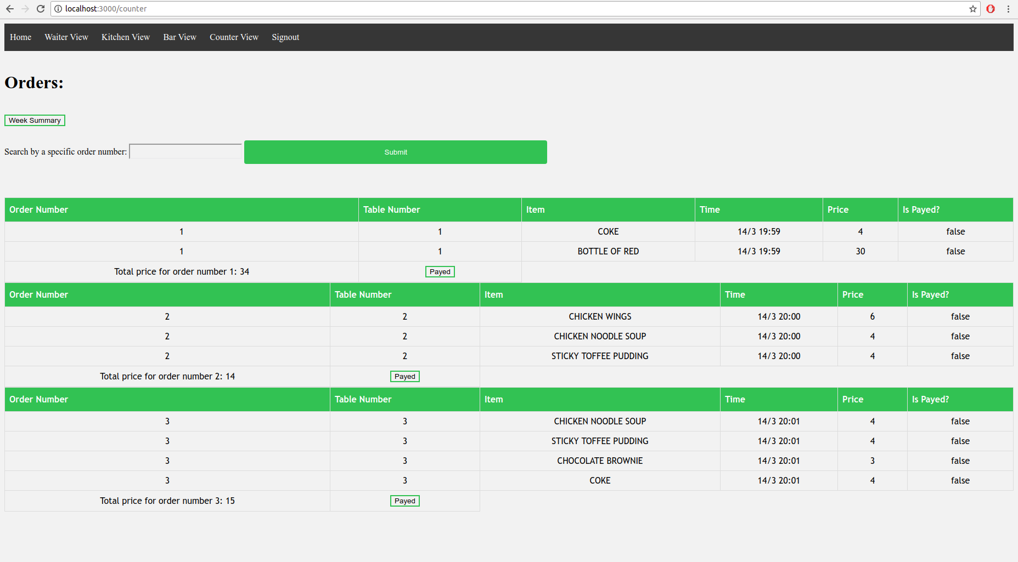

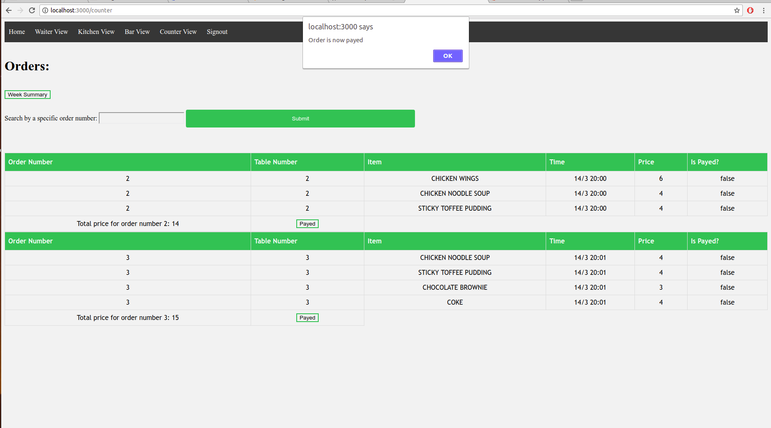

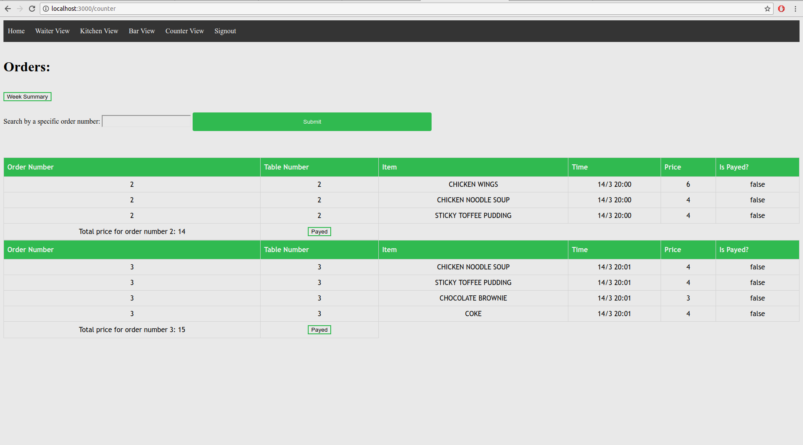

Redirecting to the page with its own router, the counter page will display all of the unpaid bills that the restaurant currently has. Each order also has its own pay button which will clear the bill from the page while still keeping a record of the bill for further use.

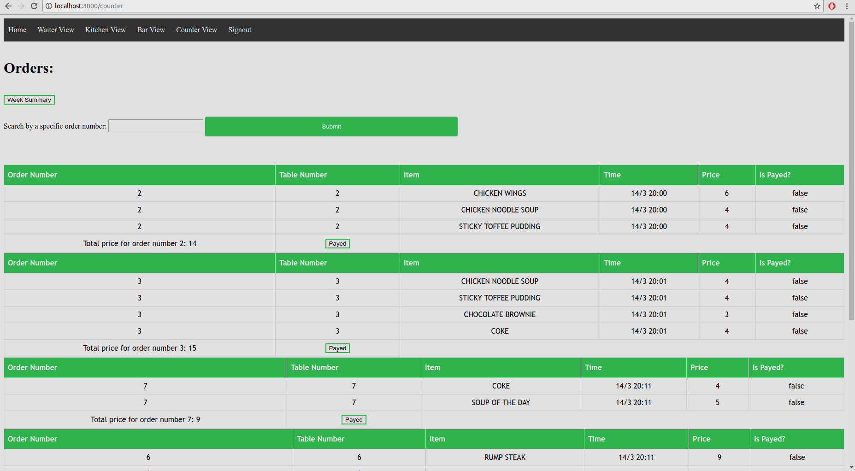

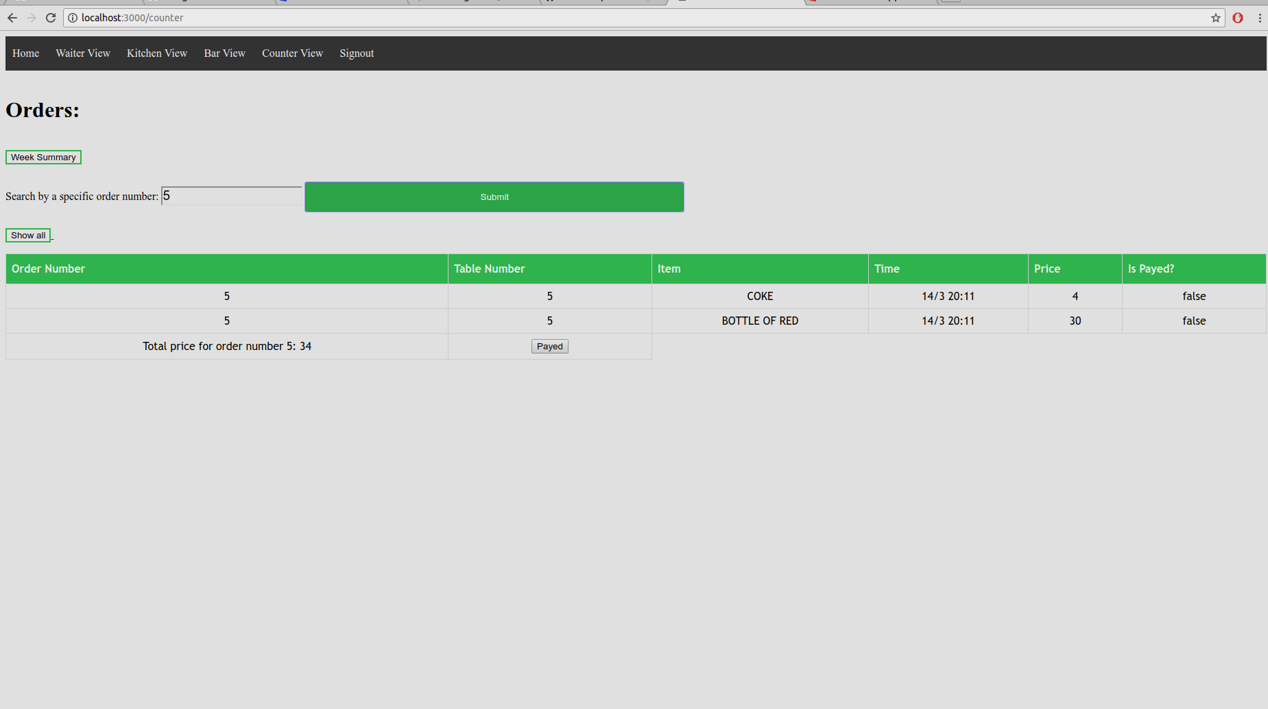

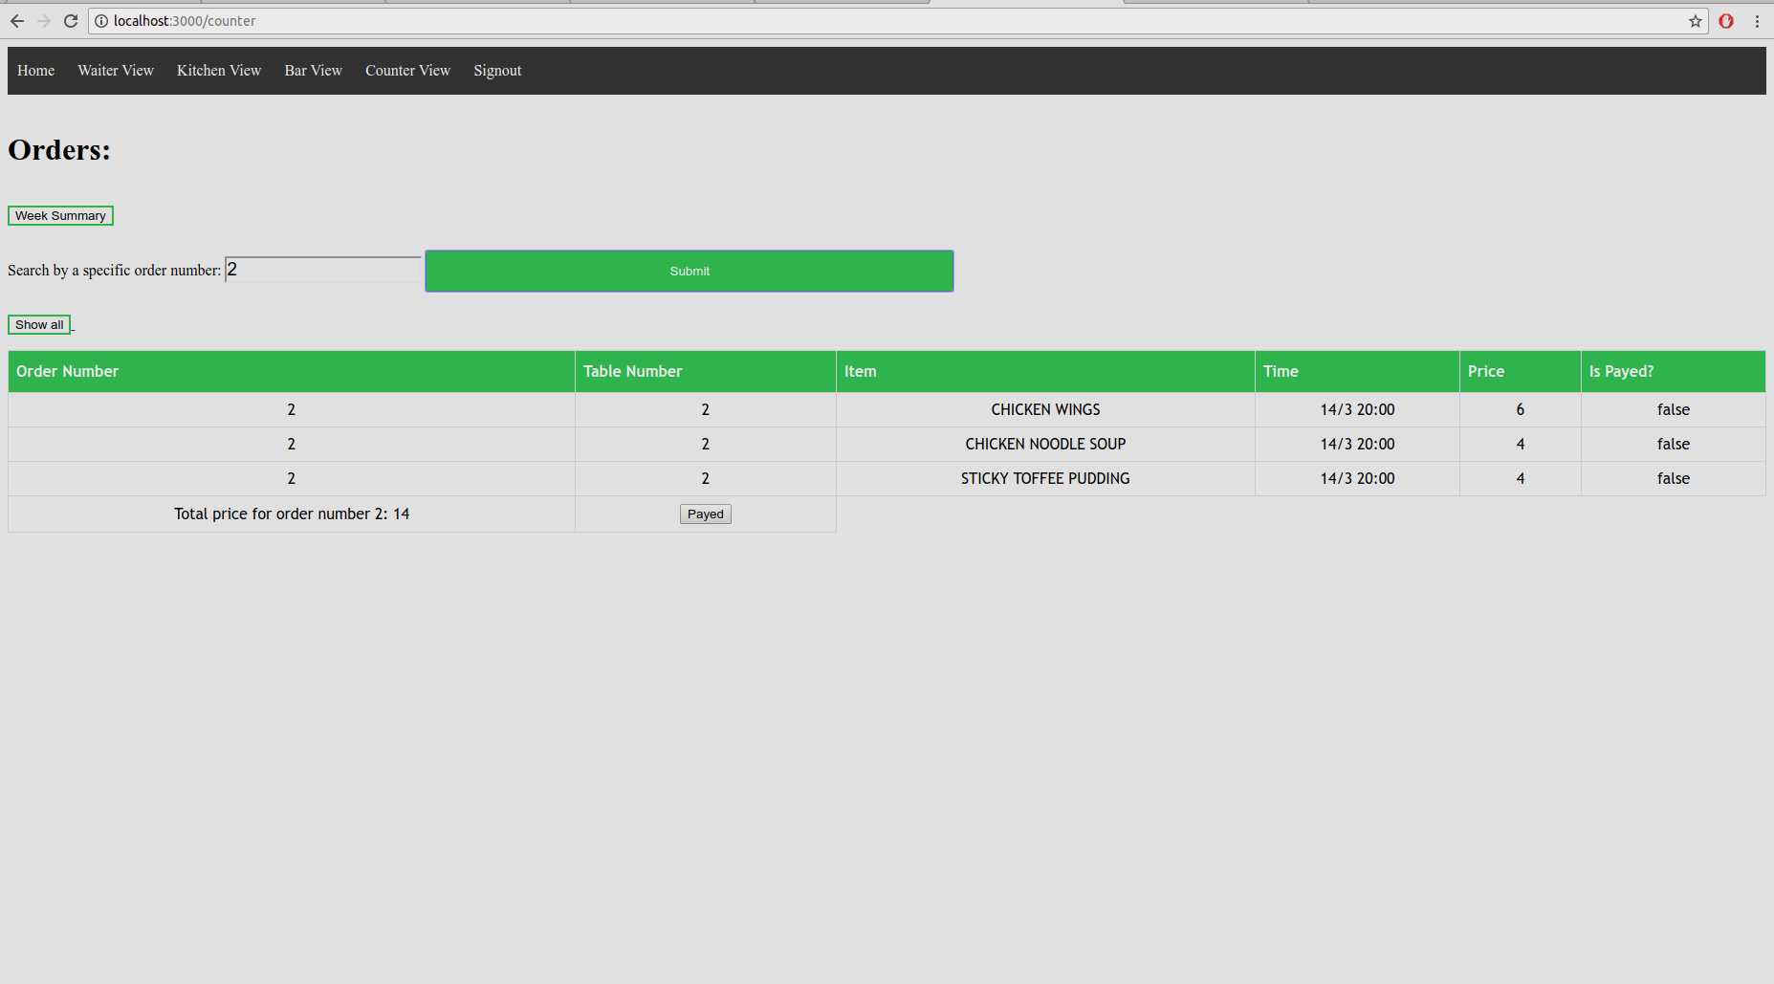

Another valuable feature for the counter view is the ability to filter through the orders. After entering an order id into the textbox and clicking submit, the page will limit the orders show to only that specific order.

Week Summary

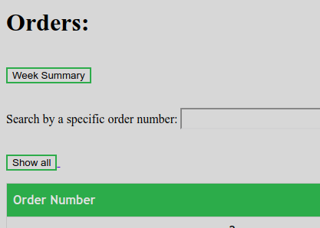

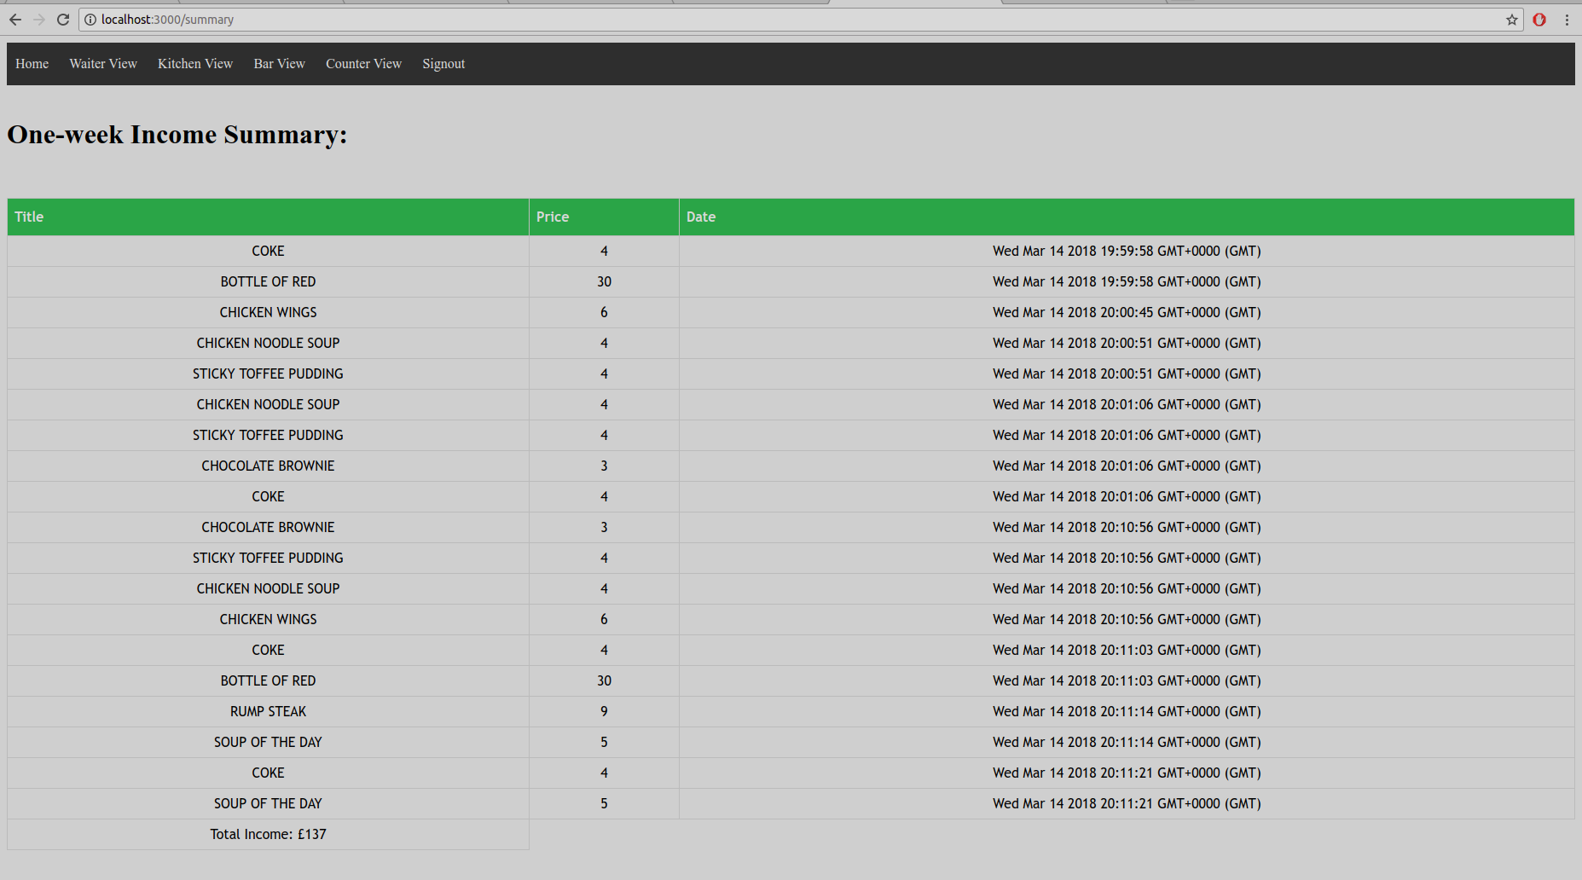

The last significant feature of the counter system is the 1 week summary option. This button redirects to another page which then finds all of the orders that have been made in the last week. It then adds up the total income for the company.

Permissions

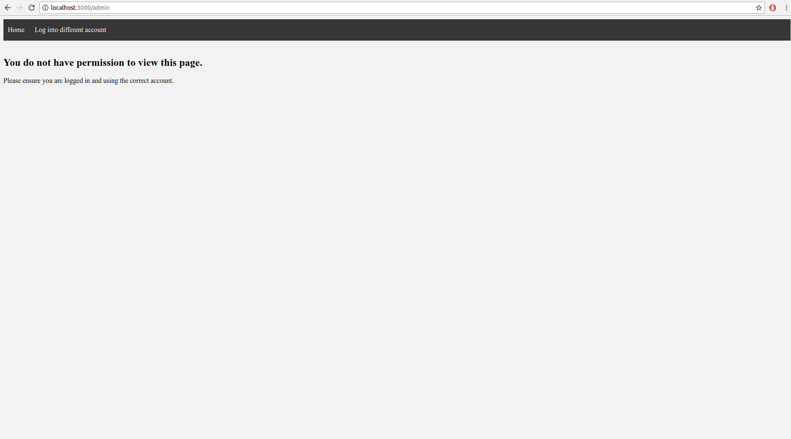

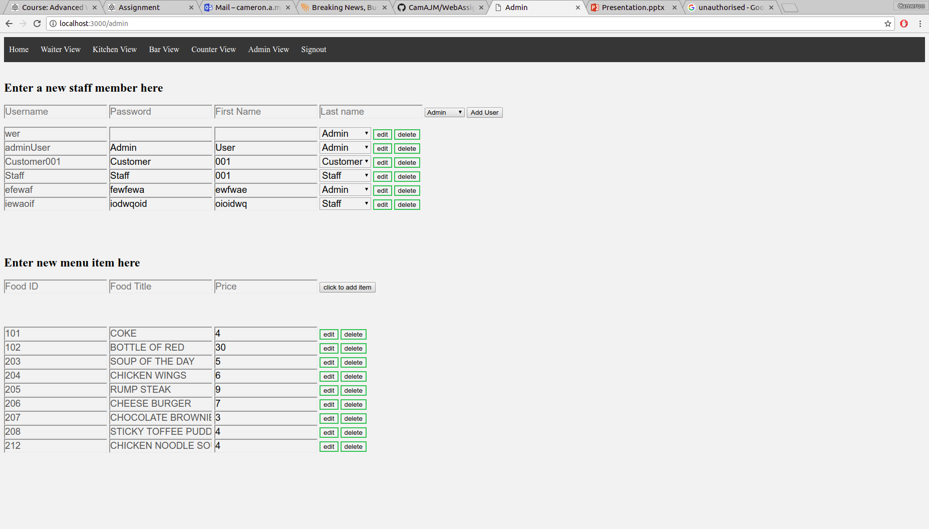

One of the major functions that features in most of the pages in the site is the permissions system. Each page is set with either the customer, the staff or the admin in mind. In order to avoid unauthorised access, the site confirms that the user's position meets the require access level before permitting access.

Waiter View

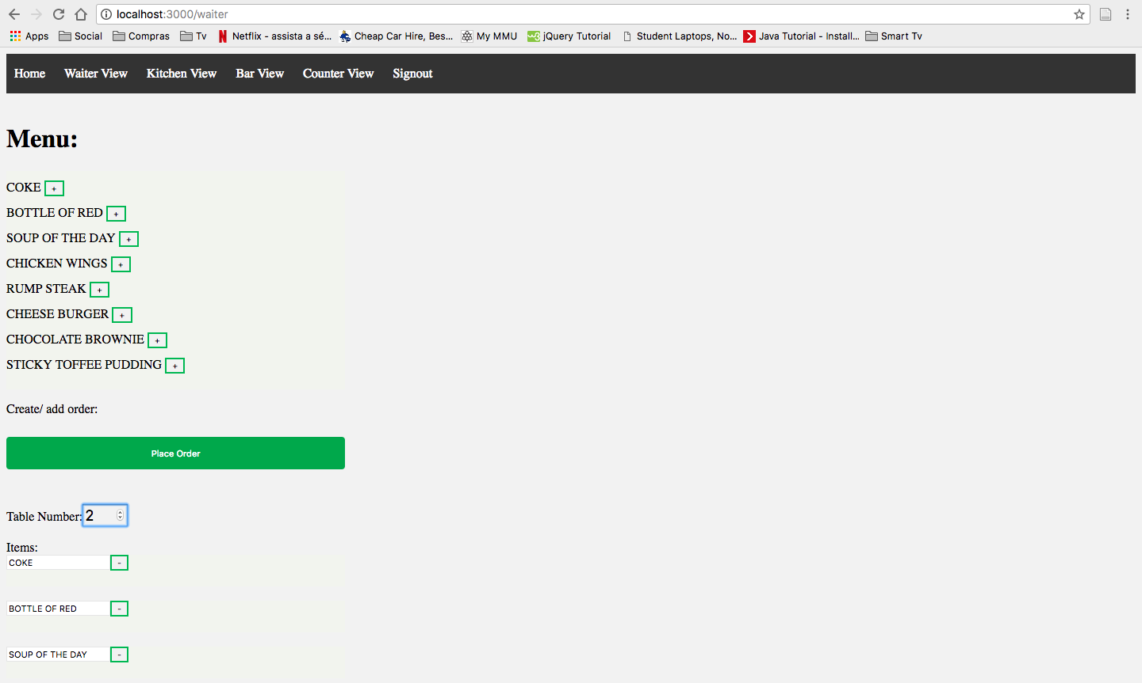

The waiter view provides a quick and easy way to add new orders. Simply select the items you want, choose a table and hit "Place Order".

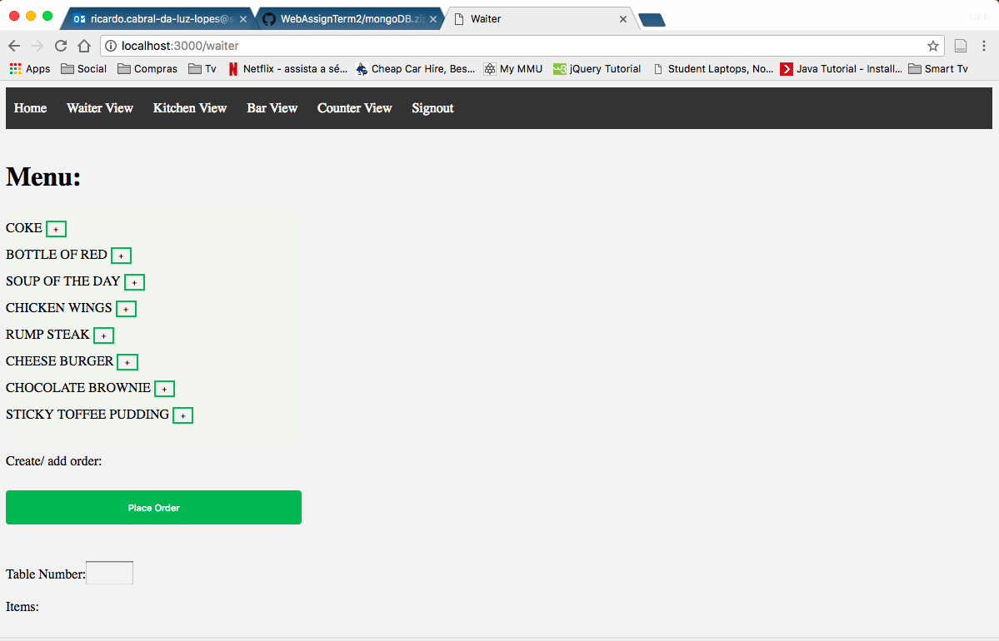

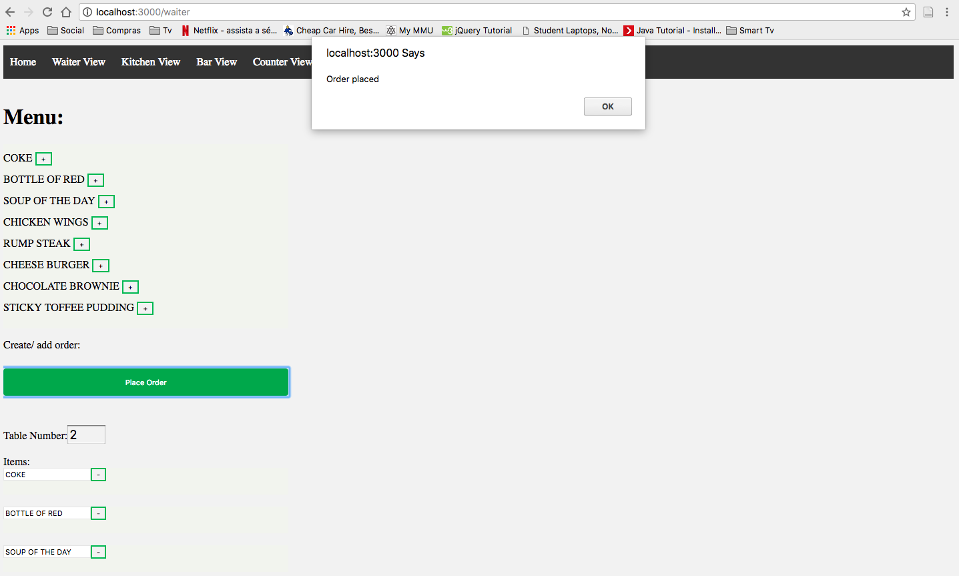

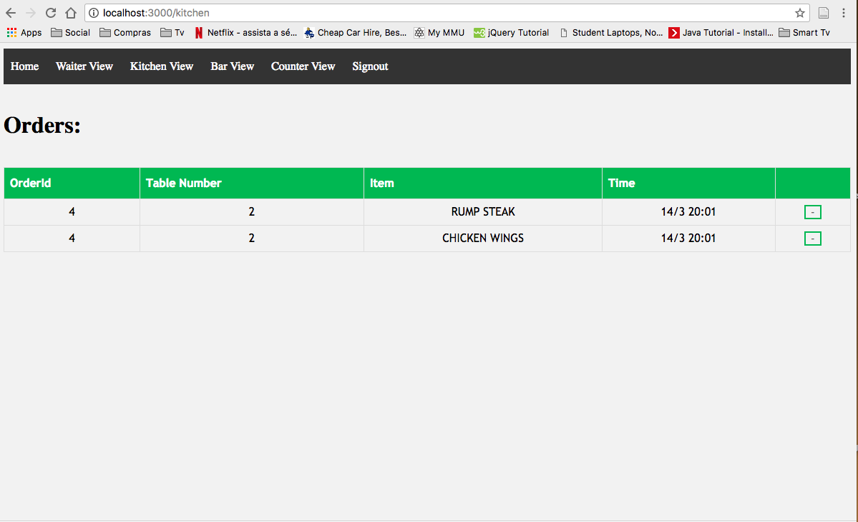

Once submit, the menu will automatically split the data. Food will be sent to the kitchen view, drinks to the bar view and both to the counter view. The waiter view also has a system to detect if that table already has an active order. If so, data is added to that order. Otherwise, it creates a new order.

Online orders

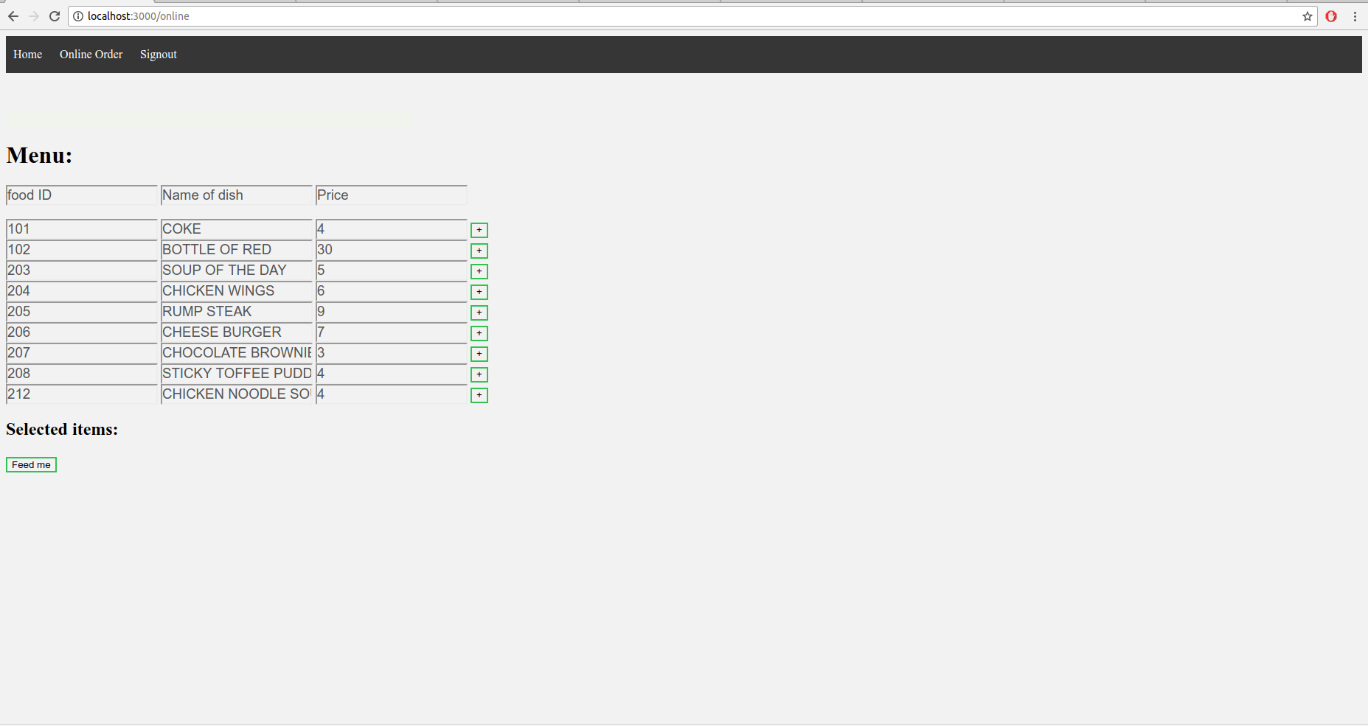

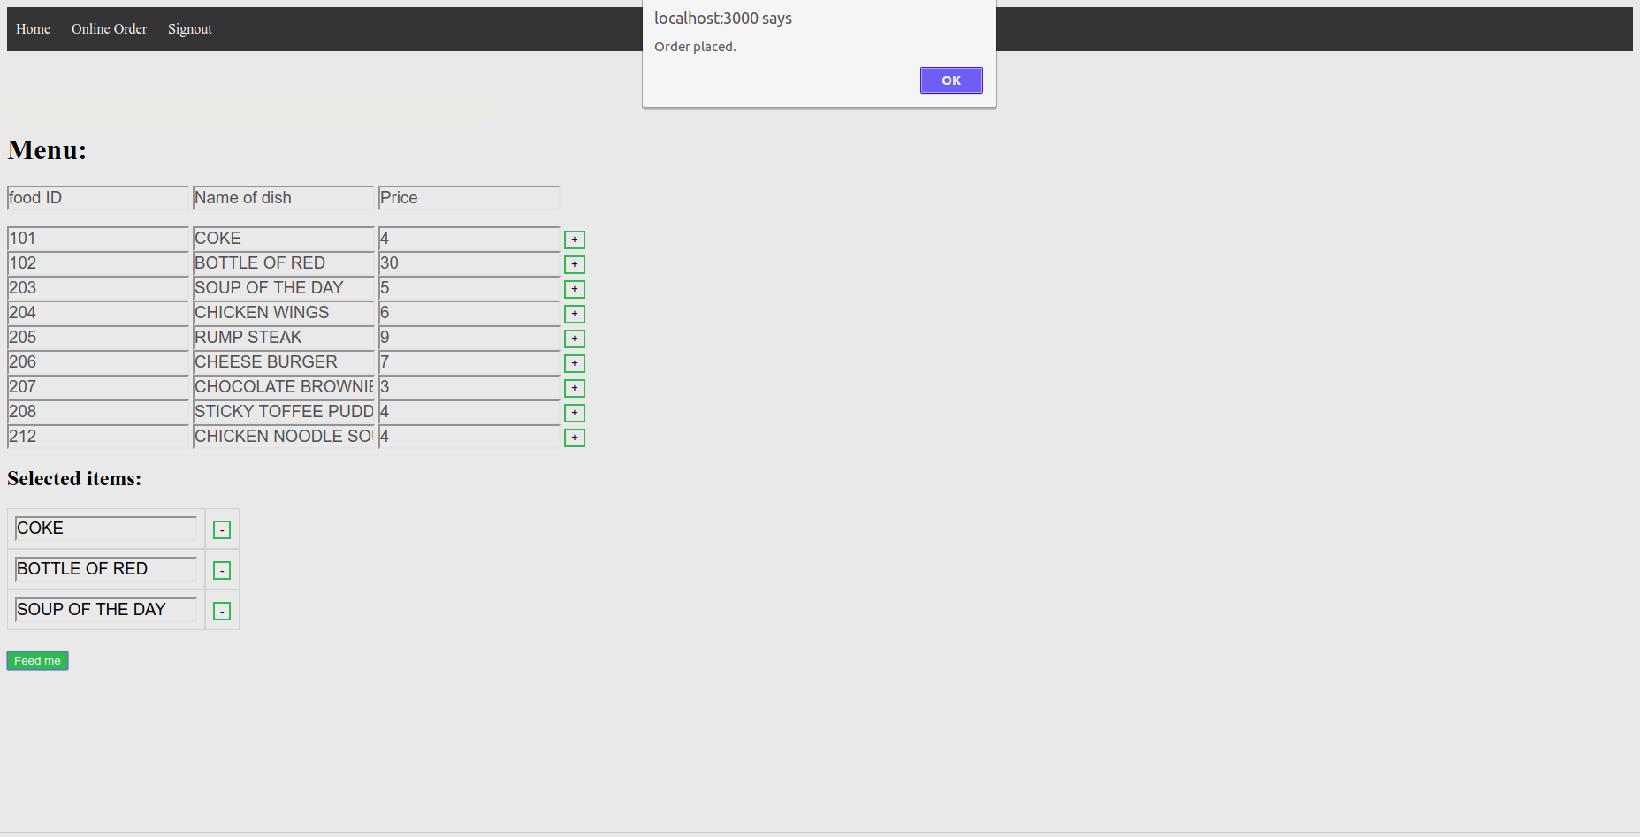

The online orders view provides a unique page which allows the customer to place an order for a takeaway or delivery meal.