3-Methyl-1H-quinoxalin-2-one (S3)
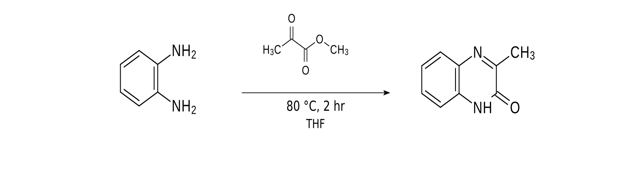
Name {S3}: 3-methyl-1H-quinoxalin-2-one; Formula: C₉H₈N₂O; Molecular Mass: 160.1726; Exact Mass: 160.0637; EA: C, 67.49; H, 5.03; N, 17.49; O, 9.99; Smiles: O=c1[nH]c2ccccc2nc1C;InChIKey: BMIMNRPAEPIYDN-UHFFFAOYSA-N

To a solution of 1,2-phenylenediamine (934 mg, 8.64 mmol, 1.00 equiv) in THF (20.0 mL) was added methyl-2-oxopropanoate (1.06 g, 942 μL, 10.4 mmol, 1.20 equiv). The solution was stirred at reflux for 2 h. The solution was then allowed to reach 21 °C. The formed precipitate was filtered. The remaining solution was reduced by half and filtered again (3x). The solid was then washed with DCM. The product 3-methyl-1H-quinoxalin-2-one (1.32 g, 8.24 mmol, 95% yield) was obtained as a colorless solid.

R_{f} = 0.82 (Methylene Chloride/Methanol 30:1). ¹H NMR (400 MHz, DMSO-d₆, ppm) δ = 2.39 (s, 3H, CH₃), 7.14–7.35 (m, 2H, CH_{Ar}), 7.45 (ddd, J = 8.4 Hz, J = 7.1 Hz, J = 1.4 Hz, 1H, CHCHCN), 7.68 (dd, J = 8.0 Hz, J = 1.4 Hz, 1H, CHCN), 12.29 (s, 1H, NH); ¹³C NMR (100 MHz, DMSO-d₆, ppm) δ = 20.5 (CH₃), 115.2 (CH), 123.0 (CH), 127.8 (CH), 129.3 (CH), 131.6 (Cq), 131.9 (Cq), 154.9 (Cq), 159.2 (Cq); IR (ATR, ṽ) = 3301, 3166, 3094, 3006, 2951, 2890, 2834, 2810, 2769, 2708, 1949, 1914, 1798, 1659, 1601, 1567, 1500, 1485, 1432, 1422, 1380, 1353, 1344, 1276, 1204, 1188, 1156, 1123, 1030, 1007, 973, 945, 928, 888, 854, 781, 751, 727, 720, 693, 622, 599, 584, 561, 476, 469, 452, 418 cm^{–1}; EI (m/z, 70 eV, 90 °C): 161 (11) [M+H]⁺, 160 (100) [M]⁺, 132 (87), 131 (63), 90 (13), 64 (11), 63 (15). HRMS–EI (m/z): [M]⁺ calcd for C₉H₈O₁N₂, 160.0637; found 160.0636.

The analytical data correspond those reported in the literature^{[1]}.
Additional information on the chemical synthesis is available via Chemotion repository:
https://doi.org/10.14272/reaction/SA-FUHFF-UHFFFADPSC-BMIMNRPAEP-UHFFFADPSC-NUHFF-NUHFF-NUHFF-ZZZ.1
Additional information on the analysis of the target compound is available via Chemotion repository:
https://doi.org/10.14272/BMIMNRPAEPIYDN-UHFFFAOYSA-N.5

FHUcy018

- Testreaktion; Proof of principle
- Produkt isoliert H-NMR passt, ASAP-MS passt
- Methylgruppe aufgespalten; Vermutung: Rotamere / Atropisomere?

FHUcy024
- Fraktion A, 46% nicht fluoreszent, H-NMR passt, ASAP-MS passt
- Fraktion A: Substitution über Phenol; Phenol sollte geschützt werden
- Fraktion B: 6,5% leicht fluoreszent; H-NMR sehr unordentlich; ASAP-MS passt
- Phenol acider und vermutlich nucleophiler als Carbazol-N

2.2.4
(S)-2-(4-chlorophenyl)-2-((2,2,4,6,7-pentamethyl-2,3-dihydrobenzofuran)-5-sulfonamido)acetic acid 16a

Prepared according to GP4 from (4-chlorophenyl)boronic acid (156.4 mg, 1.00 mmol, 2.0 equiv). Purification by reverse phase column chromatography (H₂O/MeCN + 0.1 vol% TFA = 9:1 🡪 2:8) and freeze drying afterwards afforded product 16a as a colorless solid (145 mg, 66%).
[α]_{D}²⁰ = +81.7 (c 0.1, CHCl₃)
e.r = 87:13 [HPLC conditions: Chiralcel ® IA column, n-hexane/ethanol/TFA = 9:1:0.1, flow rate = 0.7 mL/min, t_{R} (minor) = 19.4 min and t_{R} (major) = 23.8 min].
R_{f} (n-hexane/acetone/AcOH = 2:1:0.1) 0.36
m.p. 165-168 °C
¹H NMR (400 MHz, CDCl₃) δ = 7.16 (d, J = 8 Hz, 2H), 7.09 (d, J = 8 Hz, 2H), 5.74 (d, J = 8 Hz, 1H), 4.99 (d, J = 8 Hz, 1H), 2.88 (s, 2H), 2.46 (s, 3H), 2.34 (s, 3H), 2.03 (s, 3H), 1.46 (d, J = 8 Hz, 6H).
¹³C NMR (101 MHz, CDCl₃) δ = 173.74, 160.11, 139.56, 134.79, 133.48, 128.74, 127.76, 125.24, 118.24, 87.11, 58.51, 43.15, 28.65, 28.61, 19.39, 17.81, 12.51.
MS (APCI) m/z calcd for C₂₁H₂₄ClNO₅S 438.1 [M+H]⁺, found 438.3 [M+H]⁺
HRMS (TOF MS EI+) m/z calcd for C₂₁H₂₄ClNO₅S [³⁵Cl] 437.1064 [M⁺], found 437.1062 [M⁺]; [³⁷Cl] 439.1034 [M⁺], found 439.1062 [M⁺]
IR (v in cm⁻¹): 3375, 2970, 2929, 1728, 1694, 1577, 1455, 1368, 1142, 1091, 989, 888, 850, 782, 636, 617, 562, 537.

