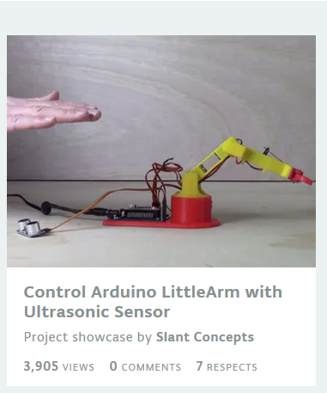
https://create.arduino.cc/projecthub/slantconcepts/control-arduino-littlearm-with-ultrasonic-sensor-8bb7fc?ref=tag&ref_id=robot&offset=127

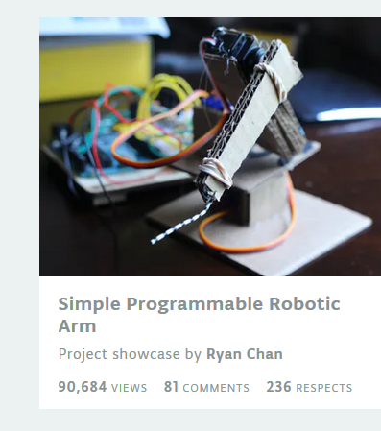

https://create.arduino.cc/projecthub/ChanR19/simple-programmable-robotic-arm-bd28a0?ref=tag&ref_id=robot&offset=3

https://create.arduino.cc/projecthub/benoitdr/max009-7888a4?ref=tag&ref_id=robot&offset=8
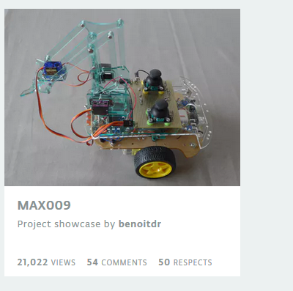

https://create.arduino.cc/projecthub/slantconcepts/waldo-motion-capture-with-littlearm-6c2089?ref=tag&ref_id=robot&offset=79

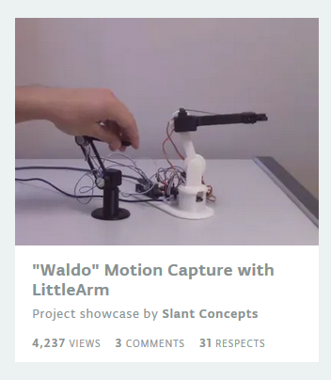
https://www.youtube.com/watch?v=wzyMk82zKng

https://www.academia.edu/39043483/COMMANDE_DUN_BRAS_ROBOTISE_AVEC_UNE_APPLICATION_ANDROIDv

