

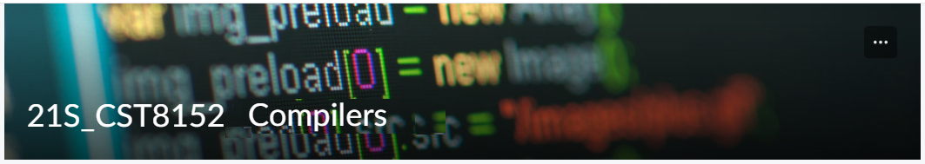

MODEL TASK FOR ASSIGNMENT 2.1 – Velvet

Language: Velvet
Team – Megan Clinch – Id: 041043369 / Cameron Ewing - Id: 041037946

- Note: This task is part of the Assignment 2 from Compilers Course. Any problem, contact your lab professor.

PART 1: RE – Regular Expression (1.5 mark)

Lexeme Classes: Define the classes to be used in your regular expression:

Answer:

* A = [+, -, *, /] (Arithmetic operators)

* D = [ , ] (Delimiter)

* E = [ \0 ] (End of file)

* L = [A-Za-z] (Letters)

* M = [method] (Method name prefix)
* N = [0-9] (Numbers)

* P = [ . ] (Decimal point)

* Q = [ “ ] (SL delimiter – double quotation)

* R = [==, !=, <, <=, >, >=] (Relational operators)
* U = [ _ ] (Underscore)

* Z = [^ADELMNPQRU] (Other characters)

Define the RE to be used for: variables, literals and keywords:

Answer:

* Comments:
SLC = [ // ] (Single line)
SLC [^Z | Z]

MLC = [ SLC [P], [P] SLC ] (Multi-line)
SLC[P] [^Z | Z] [P]SLC

* Variables:
Entero [ent, ENT]
Entero [ N ]

Decimal [decimal, DECIMAL]
Decimal N [ P ] N

Chain [chain, CHAIN]
Chain [ ^Z | Z ]

* Methods:
M [L | N | U]

* Literals:
Numbers
N = N
Strings
S = Q[^Q]*Q

* Keywords:
KEY = {if, elseif, else for, when, struct, close, true, false, send, print, cast, input}

s

PART 2: TD – Transition Diagram (1.5 marks)

Activity: Starting from the previous lexeme classes and obeying the RE, it is possible to define the automata for your language:

Answer (draw / copy image of the automata):

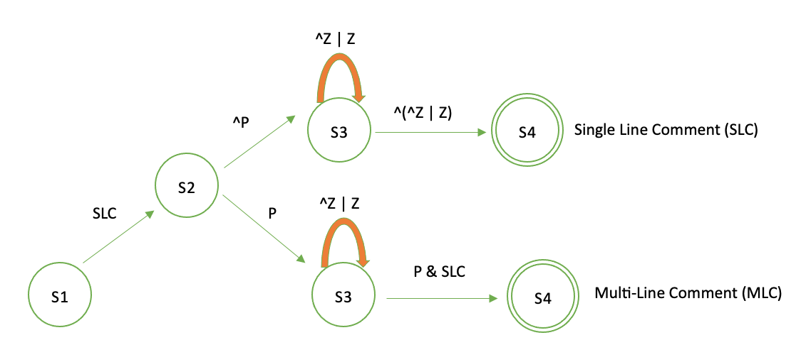

PART 3: TT – Transition Table (2 marks)

Activity: Now, it is possible to define the TT for these lexemes:

Answer (Transition Table):

Update: Feb 3rd 2023.

Adapted from resources developed by Prof. Svillen Ranev (Algonquin College, 2019)

