

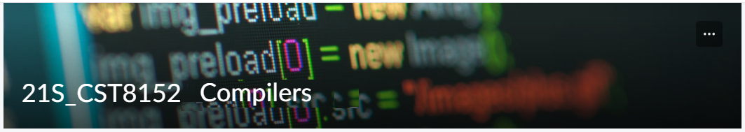

MODEL TASK FOR ASSIGNMENT 2.1 – Velvet

Language: Velvet
Team – Megan Clinch – Id: 041043369 / Cameron Ewing - Id: 041037946

PART 1: RE – Regular Expression (1.5 mark)

Lexeme Classes: Define the classes to be used in your regular expression:

Answer:

* BAR = / (Forward slash)

* HAS = # (Hashtag)

* AMP = & (Ampersand)

* UND = _ (Underscore)

* WHT = <SPACE><TAB> (Whitespace)

* NEW = <\n> (New line)

* ABC = [A-Za-z] (Letters)
* NUM = [0-9] (Numbers)

* POI = . (Decimal point)

* QUO = “ (SL delimiter – double quotation)

* OTH = [^BAR|HAS|AMP|UND|WHT|NEW|ABC|NUM|POI|QUO] (Other characters)

Define the RE to be used for: variables, literals, and keywords:

Answer:

* Single Line Comment:

BARBAR[^NEW]*NEW

Note! We decided not to include multi-line comments.

* Variables:

Numerical:
HAS[ABC|NUM]*^ABC|NUM

String:
AMP[ABC|NUM]*^ABC|NUM

* Methods:

UND[ABC|NUM]*^ABC|NUM

* Literals:

Numerical:
Ent: [NUM]*^NUM

Decimal: [NUM]*[POI][NUM]*^NUM

String:
Chain: QUO[ABC|NUM|WHT]*QUO

Note! Chains will only accept letters, numbers, and spaces.

* Keywords:

KEY = {method, ent, decimal, chain, if, elseif, else for, when, struct, close, true, false, send, print, cast, input}

Note! We decided to remove constants.

PART 2: TD – Transition Diagram (1.5 marks)

Activity: Starting from the previous lexeme classes and obeying the RE, it is possible to define the automata for your language:

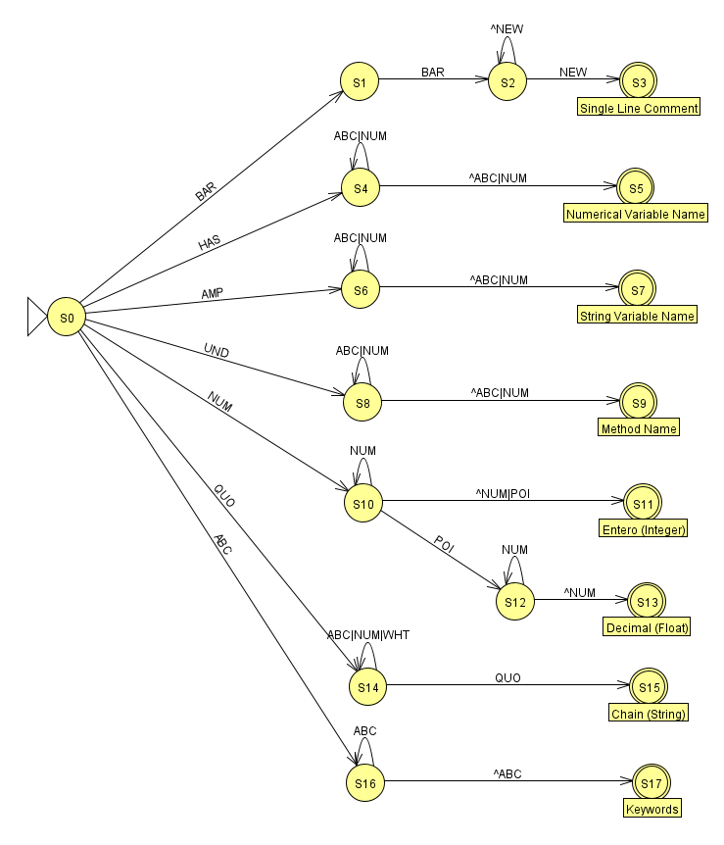

PART 3: TT – Transition Table (2 marks)

Activity: Now, it is possible to define the TT for these lexemes:

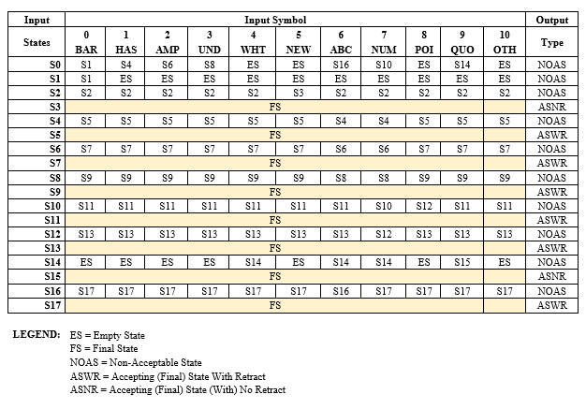

Update: Feb 3rd 2023.

Adapted from resources developed by Prof. Svillen Ranev (Algonquin College, 2019)

