**Introduction**

Ecological aggregates, such as metapopulations or communities, consist of components whose dynamics vary due to life history, unique environmental interactions, or simply chance. Asynchrony among components reduces temporal variability of the aggregate, often resulting in greater productivity and biomass, increased availability of ecosystem services, and improved resilience (Tilman, Isbell & Cowles 2014; Schindler, Armstrong & Reed 2015). These ecological relationships are broadly analogous to the stable returns of a diverse financial portfolio and, as a result, are commonly referred to as portfolio effects (Tilman 1999 REF; Schindler 2015 REF). The widespread recognition of ecological portfolio effects has coincided with a pivot towards systems-based approaches, which emphasize monitoring, managing, and conserving ecological aggregates, rather than component populations (Link 2018). Systems-based approaches are intended to simultaneously increase the stability of ecosystem services, while avoiding the difficulties associated with accurately forecasting the dynamics of single populations (Link 2018).

Systems-based approaches are particularly relevant to management-oriented disciplines such as biological conservation and fisheries science. However, there is still uncertainty as to how portfolio effects can be best-measured and incorporated into existing management strategies. The most common way to quantify a portfolio’s performance is via aggregate variability, the temporal coefficient of variation of multiple populations. An emergent property of ecological portfolios is that, due to statistical averaging alone, aggregate variability decreases as the number of components increases (Doak et al. 1998). For example, the Bristol Bay sockeye salmon (*Oncorhynchus nerka*) fishery encompasses an aggregate of nine major river systems, each containing multiple spawning populations (Schindler et al. 2010). This population diversity reduces aggregate variability in spawner returns and catches, as well as the probability of fishery closures, relative to a hypothetical fishery containing fewer stocks (Hilborn et al. 2003; Schindler et al. 2010). Thus maintaining biodiversity across ecological scales is a key prerequisite for maximizing portfolio effects.

Yet even when diversity remains stable and dramatic extirpations do not occur, ecological portfolios can exhibit changes in aggregate variability that compromise their performance. Aggregate variability is fundamentally driven by the variance-covariance of individual components. Thus it can be decomposed into two distinct metrics – the weighted mean coefficient of variation among components (CVc) and an index of synchrony (phi) (Loreau and de Mazancourt 2008; Thibaut and Connolly 2013). While increases in either CVC or phi will decrease an aggregate’s stability and weaken its portfolio effect, each process can produce unique challenges to systems-based approaches.

As component variability rises, the dynamics of individual populations become increasingly chaotic. Since greater interannual variability limits managers’ ability to predict future abundance, harvest rates for individual populations should be reduced following a precautionary approach. In a healthy portfolio with sufficient diversity and relatively low levels of synchrony, divergent dynamics among populations will reduce the impact of these changes at the aggregate level. However, as synchrony increases, otherwise localized boom-and-bust cycles will become more widespread. In highly variable and synchronized populations, harvesters will be less able to shift effort among component stocks, resulting in substantial socio-economic costs (Cline et al. 2017) and increasing the likelihood of overharvest if effort is not reduced at the aggregate level.

Of course the negative effects associated with greater component variability and synchrony are dependent on underlying trends in population abundance – synchronous increases in population size are unlikely to trigger management interventions. Unfortunately, declines in abundance and population productivity appear to be widespread, particularly among exploited fishes (Peterman and Dorner 2012; Britten et al. 2016), and are likely to become more common due to persistent stressors such as climate change (Oliver et al. 2015). Unsurprisingly the consequences of increased aggregate variability are likely to be most severe in systems where population abundance is reduced due to declines in productivity or carrying capacity.

California’s Central Valley provides one example in which aggregate variability and productivity have changed simultaneously. Though the absolute number of component Chinook salmon stocks within the region has not declined, aggregate returns of Chinook salmon have collapsed and become increasingly variable in recent decades (Carlson & Satterthwaite 2011; Satterthwaite & Carlson 2015). Increased interannual variability in the returns of individual stocks, greater synchrony, and reduced productivity have resulted in dramatic reductions in aggregate spawner abundance, as well as the ecosystem services they provide (Satterthwaite & Carlson 2015). While the region technically still exhibits a portfolio effect (i.e. aggregate variability is reduced relative to that of individual stocks), the buffering conferred by its diversity is substantially weaker than it was historically (Carlson & Satterthwaite 2011). Ultimately increased aggregate variability appears to have increased the probability of fishery closures by more than 10-fold (Yamane et al. 2018).

The decline of the Central Valley Chinook salmon fishery demonstrates that high levels of aggregate variability can be associated with substantial negative ecological and socio-economic outcomes. However, it is unclear to what extent declines in aggregate abundance are driven by increased component variability and synchrony as opposed to changes in underlying population productivity. Additionally previous analyses of portfolio effects have examined a relatively narrow suite of indicators of ecosystem functioning. The effects of aggregate variability on biological benchmarks commonly used to assess population status may differ from effects on absolute abundance.

In this study, we explore how increases in component variability and synchrony influence the probability of achieving conservation and management objectives using Fraser River sockeye salmon as a case study. Sockeye salmon are an anadromous, semelparous species and the Fraser River aggregate is composed of populations that spawn throughout southern British Columbia. Sockeye salmon have been harvested in the region by commercial fisheries for over a century and by indigenous communities for thousands of years (REF). Despite the historical abundance of Fraser River sockeye salmon, the aggregate’s productivity declined in the 1990s, resulting in frequent fishery closures and an emergency federal inquiry (REF). While there have been signs of recovery in recent years, recruitment continues to be variable and several populations within the aggregate have been assessed as at risk (State of the Pacific Ocean 2018; WSP status assessment; COSEWIC assessment). Since Fraser River sockeye salmon fisheries are predominantly mixed-stock, like most Pacific salmon fisheries, abundant and depleted populations are inevitably harvested simultaneously (REF). Thus managers must balance conservation goals with the desire to sustain economically and culturally significant fisheries, particularly during periodic years of high abundance. Changes in patterns of variability and synchrony may increase tension between these trade-offs if the fishery becomes increasingly concentrated on a smaller number of abundant years.

We first present a retrospective analysis that reveals aggregate temporal variability within the Fraser River has increased in recent years due to greater component variability, as well as greater synchrony among components. We then use stochastic, closed-loop simulations to evaluate how changes in component variability and synchrony influence the likelihood of meeting a suite of conservation- and catch-based performance metrics. Finally we repeat the simulations under a range of productivity scenarios to clarify how aggregate variability interacts with changes in productivity to shape dynamics. This multi-step approach allows us to assess changes in ecosystem functioning along a gradient of scenarios from historic levels of high asynchrony and productivity to heavily synchronized, unproductive dynamics consistent with degraded systems.

**Methods**

*Sockeye salmon biology, fisheries and data sources*

Sockeye salmon is an anadromous, semelparous fish distributed throughout the northern Pacific. Populations in southern British Columbia typically rear as juveniles in freshwater lakes for one-two years, mature in the Gulf of Alaska, and return to spawn as two-five year olds (Burgner 1991). In Canada, Pacific salmon status is assessed at the scale of conservation units (CUs) – groups of spawning populations with a common life history strategy, adult migration phenology, genetic history, and juvenile rearing habitat (Holtby & Ciruna 2007; Grant *et al.* 2011). Sockeye salmon CUs typically contain fewer spawning populations and are more spatially restricted than other Pacific salmon due to their dependence on nursery lakes (Holtby & Ciruna 2007). The Fraser River sockeye salmon aggregate is composed of 24 CUs, which are grouped into four management units (MUs) based on adult migration timing (Grant *et al.* 2011). Like many Pacific salmon, Fraser River sockeye salmon are only targeted by commercial fisheries as they move through nearshore areas on their return migration to their natal rivers for spawning. As a result, shifting marine fishery openings to coincide with a given migration phenology can be used to constrain effort at the MU, but not the CU, level. Fraser River sockeye salmon CUs vary in conservation status from abundant with stable or increasing population trends (i.e. healthy) to depleted with declining trends (critical). A recent assessment under Canada’s Wild Salmon Policy concluded that nine CUs were within the critical zone, 11 were within the cautious zone, and three were healthy (WSP 2017). The Fraser River sockeye salmon MUs included in this analysis, along with their component CUs, are listed in Table 1.

We used annual estimates of spawner abundance and recruit abundance (i.e. the number of spawning fish and catch produced by a spawners in a given brood year, minus an adjustment for en route mortality) for 19 CUs (Grant et al. 2011), with individual time series beginning between 1948 and 1973 (Table 1). Spawner abundance estimates were generated using a variety of techniques including fence counts, mark-recapture and visual surveys, and passive sonar methods (Grant et al. 2011). Catch is estimated in marine and freshwater fisheries for each CU and age class. Methods for estimating spawning abundance and catch are reviewed in detail in Grant et al. (2011).

Table 1. Relevant sockeye salmon management units and component conservation units within the Fraser River aggregate.

|  |  |  |  |  |  |  |  |
| --- | --- | --- | --- | --- | --- | --- | --- |
| **MU** | **CU** | **Stock** | **Time Series Start** | **SR Model** | **SR Model Parameters** | | |
|  |  |  |
| Early Stuart | Takla-Trembleur | Early Stuart | 1948 | Larkin | 1.80 | 1.49 | 0.77 |
| Early Summer | Bowron | Bowron | 1948 | Ricker | 1.60 | 25.96 | 0.81 |
| Shuswap-ES | Seymour | 1948 | Larkin | 1.98 | 3.58 | 0.82 |
| Scotch | 1980 | Ricker | 1.50 | 4.83 | 1.11 |
| North Barriere | Fennel | 1967 | Ricker | 2.14 | 97.82 | 0.96 |
| Anderson-Seton | Gates | 1968 | Ricker | 1.73 | 12.88 | 0.92 |
| Nadina-Francois | Nadina | 1973 | Ricker | 1.40 | 6.31 | 0.87 |
| Pitt | Upper Pitt River | 1948 | Ricker | 1.50 | 22.39 | 0.76 |
| Summer | Takla-Trembleur | Late Stuart | 1948 | Larkin | 2.03 | 1.01 | 1.28 |
| Francois-Fraser | Stellako | 1948 | Ricker | 1.84 | 3.96 | 0.83 |
| Kamloops-ES | Raft | 1948 | Ricker | 1.51 | 21.59 | 0.79 |
| Quesnel | Quesnel | 1948 | Larkin | 2.05 | 0.39 | 0.83 |
| Chilko | Chilko | 1948 | Ricker | 1.83 | 1.23 | 0.80 |
| Harrison (river-type) | Harrison | 1948 | Ricker | 1.49 | 2.79 | 1.39 |
| Late Summer | Shuswap-L | Late Shuswap | 1948 | Larkin | 2.17 | 0.30 | 0.95 |
| Lillooet-Harrison | Birkenhead | 1948 | Ricker | 1.90 | 6.75 | 0.98 |
| Cultus* | Cultus | 1948 | Ricker | 1.23 | 18.05 | 1.18 |
| Seton | Portage | 1965 | Ricker | 2.06 | 35.98 | 1.12 |
| Harrison (upstream) | Weaver Creek | 1966 | Ricker | 2.21 | 5.89 | 0.91 |

*Cultus spawner abundance and catch estimates extend to 2011, but the population has been heavily managed since 2000 using a captive breeding program. As a result, population parameters were estimated only using data collected prior to this change.

*Synchrony metrics and retrospective analysis*

We examined temporal changes in three metrics of metapopulation variability (Loreau & de Mazancourt 2008; Thibaut & Connolly 2013). The synchrony index reflects the relative degree of similarity in the dynamics of an ecological aggregate’s components. It is defined as the total temporal variance of the components (i.e. sum of all elements of the variance-covariance matrix **V**), divided by the variance of a hypothetical aggregate with the same component variances, but perfect covariance.

Equation 1

Here denotes covariance (over time) in productivity for populations *i* and *j* within the aggregate of *n* populations. Thus the simplified numerator represents the variance of aggregate abundance, consisting of *n* populations, and the denominator is the variance of a hypothetical, perfectly synchronized population (Loreau & de Mazancourt 2008; Thibaut & Connolly 2013). The synchrony index is analogous to comparing mean pairwise correlation coefficients, which have been used in similar analyses (e.g. Peterman and Dorner 2012), but makes no distributional assumptions, is normalized (i.e. ranges between 0 and 1 regardless of the number of components), and explicitly accounts for unequal variances among components (Thibaut & Connolly 2013).

The second metric is the mean of the component populations’ coefficients of variation (CVc), weighted by each component’s mean abundance.

Equation 2

where *mpop*(*i*) is the mean abundance (through time) of population *i* and *magg* is the mean abundance of the aggregate. Finally, we calculated the coefficient of variation for the aggregate (CVA) as a function of the first two metrics following Thibaut and Connolly (2013)

Equation 3

This metric defines CVA as linearly proportional to CVC, with a constant of proportionality related to synchrony. Thus as synchrony increases CVA becomes more similar to CVC, while CVA is dampened when components vary asynchronously.

To explore changes in aggregate variability of Fraser River sockeye salmon, we generated time series of , CVC, and CVA using 10-year moving windows of per capita productivity, log(recruits/spawner). Since Fraser River CUs vary in the length of their spawner-recruit time series, we generated trends in these metrics using two datasets. The primary dataset consisted of 11 CUs with data extending back to the 1948 brood year, while the second contained 18 CUs with data beginning in the 1973 brood year (Table 1). To place these changes in a broader management context, we also present temporal changes in observed productivity, aggregate spawner abundance, and aggregate catch.

*Forward simulation*

*Structure of biological and management submodels*

We used a stochastic, closed-loop simulation model of the Fraser River sockeye salmon management system to explore how differences in aggregate variability may influence conservation outcomes for Fraser River sockeye salmon. The model includes CU-specific population dynamics and harvesting, as well as process variance and deviations between target and realized catches (i.e. outcome uncertainty). The dynamics of each CU were simulated using age-structured, stock recruit models which typically took the form of the Ricker model (Ricker 1975)

Equation 3

where *i* represents a CU, *R* the number of recruits (number of offspring that return to spawn or are captured in the fishery), and *S* the number of spawners in year *y*. The parameter represents the number of recruits produced per spawner at low abundance and the density-dependent parameter, the reciprocal of the number of spawners that produce maximum recruits. This model is commonly arranged to account for normally distributed process error as

Equation 4

A subset of CUs exhibit persistent cycles in spawner abundance with highly abundant returns occurring every four years followed by one subdominant and two weak cycle lines. Although the specific mechanism that drives these cycles remains unclear, ecological interactions between cycle lines are likely responsible (e.g. predator abundance tracking juvenile sockeye salmon abundance at a one-two year lag (Ricker REF)). The productivity of CUs with cyclic dynamics is generally estimated with an extended version of the Ricker model (the Larkin model; REF), which accounts for interactions between brood years. In this case, we also used the Larkin model to forward simulate the dynamics of cyclic CUs (details of model structure and simulations in Appendix). Whether we estimated productivity for a given CU using a Ricker or Larkin model followed assignments made in the most recent Wild Salmon Policy assessment (DFO *in press*; Table 1).

To parameterize each CU’s stock-recruit relationship we used median estimates of , , and generated from an external, CU-specific Bayesian stock recruit analysis (ref to FRSSI). To account for autocorrelation and incorporate covariation among CUs we simulated deviations from the stock-recruitment relationship as

Equation 5

where represents the previous year’s recruitment deviation, represents an AR1 autocorrelation coefficient, and represents random error drawn from a multivariate normal distribution with mean 0 and standard deviation defined by the variance-covariance matrix **V** for *n* CUs. We assigned a value of 0.2 for CUs modeled with a Ricker relationship, consistent with evidence of weak autocorrelation in the residuals of these models (results not shown). Note that recruitment deviations in Larkin models did not include an autocorrelation component because AR1 processes have not been validated in these models and the inclusion of delayed density dependence parameters, to some extent, accounts for such effects.

We also incorporated a second productivity scenario in our analysis intended to represent an increased likelihood of poor recruitment events, which could magnify the relative effects of changes in CVC or synchrony. Decreases in productivity are commonly modeled by shrinking relative to reference values (e.g. Dorner et al. 2009, Holt & Folkes 2015), representing a change to a less favourable productivity regime. Rather than manipulate per capita productivity in this way, we chose to create a scenario where mean productivity remained the same, but the frequency of recruitment failures increased. These could represent, for example, intermittent periods of poor marine survival that are thought to regularly result in synchronous, poor returns of Pacific salmon (Mueter, Pyper & Peterman 2005; Peterman & Dorner 2012). To simulate this process we sampled recruitment deviations from a skewed, multivariate Student *t* distribution (heavy-tailed) in a subset of years (Anderson *et al.* 2018). Deviations were fit with the following distribution

Equation 6

where **V** is defined as in Equation 5, *v* represents the degrees of freedom parameter, and the skewness parameter. Lower values of *v* corresponding to heavier tails and as *v* approaches infinity, the *t* distribution approaches the normal distribution (Anderson *et al.* 2017). When is negative the distribution is left-skewed, when it is positive it is right-skewed. We assigned relatively moderate values to both parameters that are consistent with relatively weak evidence of heavy tails (Anderson *et al.* 2017) and a mean estimate of skewness from models fit to CU-specific stock-recruitment residuals. In the skewed productivity scenario we sampled from the Student *t* distribution with a mean frequency of 0.3 and a multivariate normal distribution in all other years, resulting in an increased likelihood of recruitment failures in approximately one third of the simulation period.

To compare the skewed productivity scenario to more commonly simulated low productivity regimes, we also incorporated an operating model where average productivity is directly reduced by using smaller values of . Specifically we used estimates from the 10th percentile of the posterior distribution of each CU’s estimates, rather than the median, to represent a transition to a persistently low productivity regime. This model generally produced declines in performance metrics that were more severe, relative to the reference productivity scenario, than the skewed scenario described above (results presented in Appendix).

The closed-loop simulation incorporated two sources of mortality. The first mortality mechanism simulated harvest in mixed stock fisheries. Total allowable catch (TAC) in this fishery was calculated each year using a harvest control rule (HCR) that approximates the Total Allowable Mortality framework currently used to manage the Fraser River sockeye salmon fishery (Pestal, Huang & Cass 2011). Broadly speaking, this HCR uses in-season estimates of recruitment derived from test fisheries to adjust TACs and meet escapement goals specific to each management unit (MU). If in-season recruitment estimates exceed escapement goals, the HCR switches to a fixed maximum target mortality rate. Escapement goals vary among years due to persistent cycles present in several CUs and are typically adjusted upwards (i.e. TACs reduced) to account for mortality during upstream migration and spatial overlap between abundant and depleted MUs. The second simulated source of mortality represented en route mortality that occurs after fish enter freshwater due to a combination of natural mortality (thermal stress, pathogen infection, predation) and unreported harvest (Grant *et al.* 2011). We modeled en-route mortality as a stochastic, CU-specific process because it appears to be correlated with migration phenology, in-river temperatures, and freshwater flow (Macdonald 2000; Cooke *et al.* 2004; Crossin *et al.* 2008). Details of the harvest control rule, mortality calculations, and parameter specifications are described in the Appendix.

We introduced additional stochasticity into the model via interannual variation in age at maturity, in-season abundance estimates error, en route mortality, and deviations between target and realized exploitation rates (implementation uncertainty). The results we present in the main text are based on simulations using the set of parameter inputs that we believe best represent the system and are consistent with similar studies simulating Pacific salmon dynamics (e.g. REFs); however, we tested the effect of alternative values in a series of sensitivity analyses to ensure that our results were robust to this assumption. Details of how each process was parameterized are described in the Appendix and results of sensitivity analyses are provided in an online supplement.

We used recent CU-specific time series of recruit and spawner abundance to initiate the simulation model (i.e. the same data that were used in the retrospective analysis). The length of the simulation period was set at 40 years (approximately 10 sockeye salmon generations) and each OM was simulated 1000 times (the number required to stabilize results).

*Component variability and synchrony “treatments”*

The principal drivers of variability in aggregate abundance within the model are deviations from CU-specific stock-recruitment relationships (i.e. *w* in Equation 5). To explore the consequences of greater aggregate variability on management objectives, we manipulated the strength of recruitment deviations to create nine operating models defined by unique variance-covariance matrices **V**, with each representing a distinct component variability and synchrony “treatment” (Table 2). We created component variance treatments by adjusting CU-specific estimates of process variance up or down by 25%. We selected these adjustments because they were sufficient to produce changes in CVC,but constrained to values that are plausible for sockeye salmon. Specifically, the maximum estimated mean value for sigma across three studies of Alaskan and BC sockeye salmon was 1.64 (Korman et al. 1995, Peterman et al. 2003, Holt and Peterman 2008) and the maximum here was 1.73 (i.e. 25% larger than the largest sigma value in Table 1). We parameterized synchrony treatments by adjusting the correlation coefficient to values consistent with 10-year moving window estimates of mean pairwise correlations in log(R/S) among CUs during periods of when productivity was weakly ( = 0.05; 1980s and 1990s) or moderately correlated ( = 0.50; 1950s, 1960s, and present). We specified a third high correlation treatment ( = 0.75) to represent a hypothetical scenario where synchrony increased even further.

Table 2. Parameterization of component variability (CVc) and synchrony () operating models.

|  |  |  |  |
| --- | --- | --- | --- |
|  | Low CVC | Moderate CVC | High CVC |
| Low |  |  |  |
| Moderate |  |  |  |
| High |  |  |  |

*Evaluating model performance*

We first confirmed that each operating model produced the predicted changes in CVC and. We then used a suite of performance measures (PMs) to assess how changes in each metric altered the likelihood of achieving conservation- and catch-based management objectives. Broadly conservation-based PMs are focused on absolute spawner abundance and the biological benchmarks associated with spawner abundance that are used to assess CU status. For example, consistent with Canada’s Wild Salmon Policy, we used the estimated spawner abundance necessary to produce maximum sustainable yield (*SMSY*, formula in Appendix) as the benchmark representing healthy status. Conversely, catch-based PMs are proxies DFO fishery managers may use to determine whether socio-economic objectives are met. For example, if the TAC for the Fraser River sockeye salmon aggregate exceeds 1,000,000 fish managers are able to allocate quota to each major stakeholder (i.e. First Nations, commercial, and recreational fisheries. A full list of performance measures and their definitions is in Table 3.

Although we focused our analyses on aggregate performance metrics because CVC and synchrony are calculated across groups of populations or species, it is likely that the consequences of increased aggregate variability will vary among components due to differences in productivity or abundance. An exhaustive analysis of CU-specific differences was beyond the scope of this paper, however to illustrate potential differences we present simulated changes in median spawner abundance across CVC and synchrony treatments for two CUs: Bowron (a low abundance CU that is considered at risk) and Chilko (an abundant CU that regularly makes up a considerable portion of commercial catch).

Instead of priming the simulation with initial population abundances sampled from random distributions, we used CU-specific time series of recruit and spawner abundance (i.e. the same data that were used in the retrospective analysis). We used these time series to ensure that each CU’s abundance reflected the best estimate of its current status and to seed cyclic CUs (i.e. those simulated with a Larkin model) with representative levels of variation among cycle lines. The length of the simulation period was set at 40 years (approximately 10 sockeye salmon generations) and each OM was simulated 1000 times (a supplementary analysis indicated variation in output metrics stabilized after 500-700 simulation runs). To evaluate differences in performance between OMs, we present median outputs among simulations, as well as 10th and 90th percentiles. We stress, however, that this study is not intended to accurately forecast the dynamics of Fraser River CUs or to predict the trajectory of the aggregate as a whole. Rather our goal is to demonstrate relative differences in projected performance associated with differences in component variability and synchrony.

Finally, we note that the goal of this study was to demonstrate relative differences in projected performance associated with trends in component variability and synchrony, not to accurately forecast the dynamics of Fraser River CUs or to predict the trajectory of the aggregate as a whole.

**Results**

*Retrospective analysis*

Mean Fraser River sockeye salmon productivity (log(recruits/spawner)) declined from the late 1980s through 2005, the brood year predominantly responsible for producing the poor return in 2009. Subsequently the aggregate exhibited several years of higher productivity, but productivity has recently declined again and remains variable (Figure 1a). Aggregate spawner abundance and aggregate catch increased until the early 1990s before declining (Figure 1b,c), coincident with declines in productivity and exploitation rate. However, there is substantial interannual variability in the patterns of both metrics due to highly abundant, cyclic CUs and particularly large returns were observed in 2010 and 2014 (catches for 2014 not shown).

Mean CVC (i.e. the temporal variability of the “average” CU’s productivity) was stable for most of the time series before showing a sharp increase in the 1990s that steepened over several years (Figure 1d). Productivity was relatively highly synchronized in the first decade of the time series, followed by a variable, but generally asynchronous period. In the early 2000s, approximately when CVC reached its unusually high levels, synchrony increased again (Figure 1e). As expected, changes in CVA mirror these patterns, showing a dramatic increase in the early 2000s (Figure 1f). Patterns in spawner abundance, catch, and variability metrics were robust to time series length and the number of CUs incorporated.

Figure 1. Observed trends in Fraser River sockeye salmon productivity (log (recruits per spawner)), aggregate spawner abundance, and aggregate catch (a-c). 10-year moving window estimates of the mean component coefficient of variation (CVC), synchrony index (), and aggregate variability (CVA) (d-f). Solid black lines represent trends for 11 CUs with time series extending back to 1948, lighter red lines represent trends for 18 CUs beginning in 1973.

*Forward simulation*

By specifying low, medium, and high values for and we were able to generate scenarios consistent with historically low, current, and moderately elevated trends in CVC and the synchrony index (Figure 2). As expected, increasing and resulted in increases in CVC and synchrony. These patterns were not strongly influenced by the productivity regime in the model (Figure 2). We use as a measure of CVC and as a measure of synchrony in subsequent results.

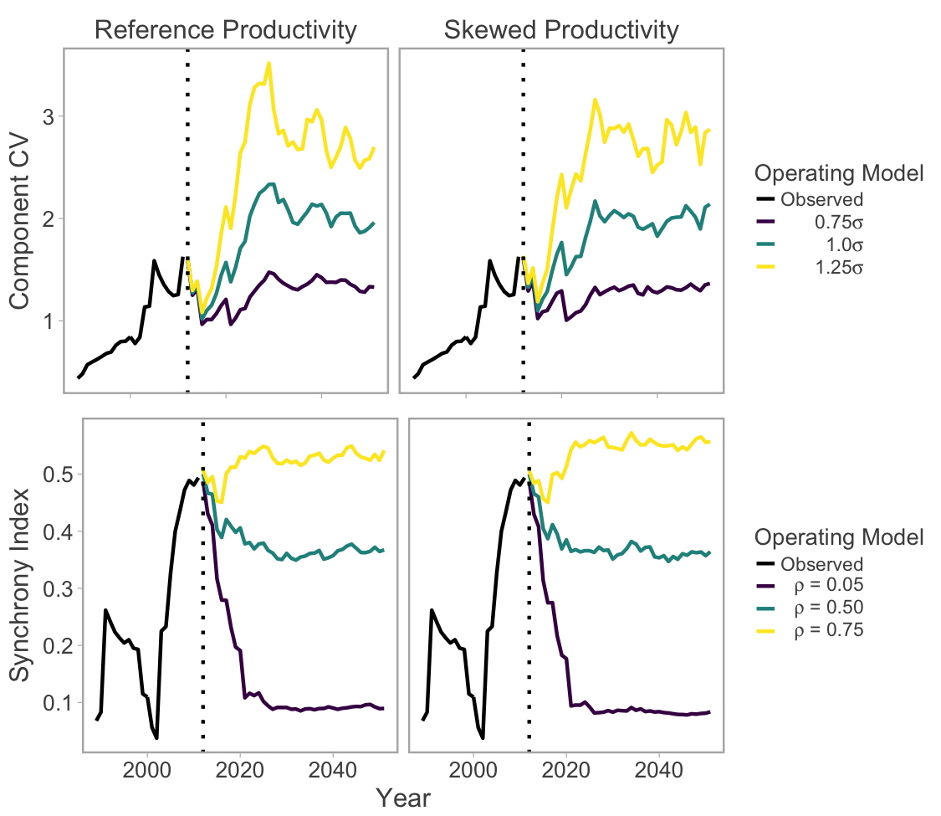

Figure 2. Changes in component variability and synchrony as a function of and , respectively. Trends in the observed stock-recruitment dataset are shown in black, the dashed line represents the beginning of the simulation period, and colored lines represent different CVC and synchrony operating models. Lines represent medians across 250 trials.

As CVC increased under a moderate synchrony scenario, the variance in recruitment increased, but the median remained stable, and the proportion of CUs above their lower benchmark decreased (Fig. 3a,b, green dots). As synchrony increased under a moderate CVC scenario, the opposite pattern emerged: median recruit abundance decreased (and its variance increased), while the median proportion of CUs above their lower benchmark remained stable (Fig. 3a,b, middle grouping). Interactions between CVC and synchrony also influenced certain performance metrics unexpectedly. For example, greater CVC increased median recruit abundance as long as synchrony remained low (purple points Figure 3a); however as synchrony increased, this pattern disappeared (yellow points Figure 3a).

The negative effects of high CVC and synchrony on conservation-based PMs were notably stronger when the model included skewed process variance, representing intermittent recruitment failures. For example, when CVC and synchrony were increased simultaneously in the skewed scenario, median aggregate recruit abundance declined from approximately eight million individuals to five million, while the median proportion of CUs above their lower and upper benchmarks declined by more than 10% (Figure 3e,f,g). The effects of greater synchrony were particularly magnified in the skewed productivity scenario and led to fewer CUs being above their biological benchmarks even when CVC was low (Figure 3f,g)

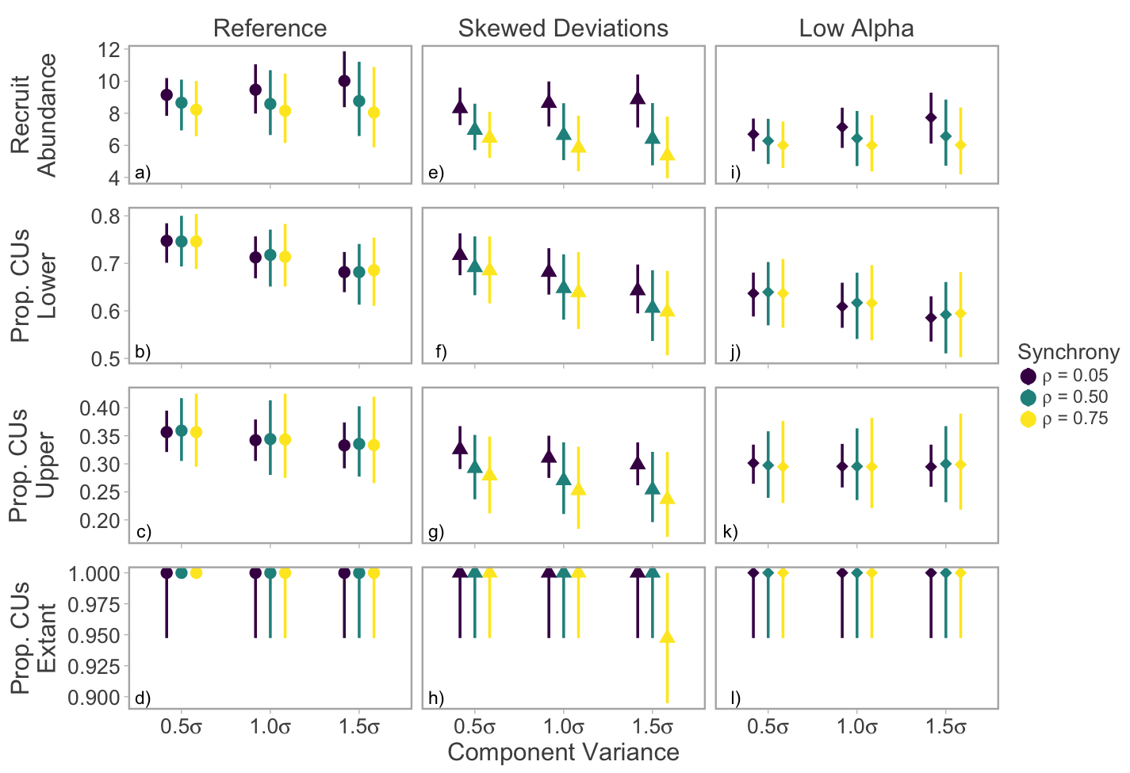

Figure 3. Effects of component variability and synchrony on conservation-based performance measures. Points represent medians and whiskers 90% posterior interval among 250 simulation runs.

The effects of greater component variability and synchrony also had large effects on several catch-based PMs. As CVC increased under a moderate synchrony scenario, the variance in median catches increased, but the median remained stable (Fig. 4a, green dots); however, median catch stability and the proportion of years the minimum catch threshold was met declined markedly (Fig. 4b,c). As synchrony increased under a moderate CVC scenario median catch abundance, catch stability and the proportion of the years threshold catches were met all declined (Fig. 4a,b,c, middle grouping).

Similarly to recruit abundance, median catches were positively correlated with component variability as long as synchrony remained low, but this relationship weakened or reversed as synchrony increased (Figure 4a). Interannual catch stability (i.e. the inverse of median interannual differences in catch) was strongly negatively correlated with both component variability and synchrony (Figure 4b). For example, median interannual fluctuations in aggregate catches increased from 45% (37-56% 90% PI) to 73% (59-83% 90% PI) when CVc and were increased to their highest levels. The median number of MUs with fisheries that were open was relatively less sensitive, but still declined at higher levels of component variability and synchrony (Figure 4c). Finally, the proportion of years where aggregate TAC was above a critical threshold (1,000,000) decreased by approximately 15% when component CV and synchrony were at high levels, suggesting managers would be less able to allocate some amount of TAC to all stakeholders (Figure 4d).

Interestingly the effects of switching from reference to skewed productivity deviations had weaker effects on catch PMs than conservation PMs. While median catches decreased considerably (Fig. 4e), the remaining PMs were relatively stable except when high CVC was coupled with moderate or high levels of synchrony (Fig 4g, 4h).

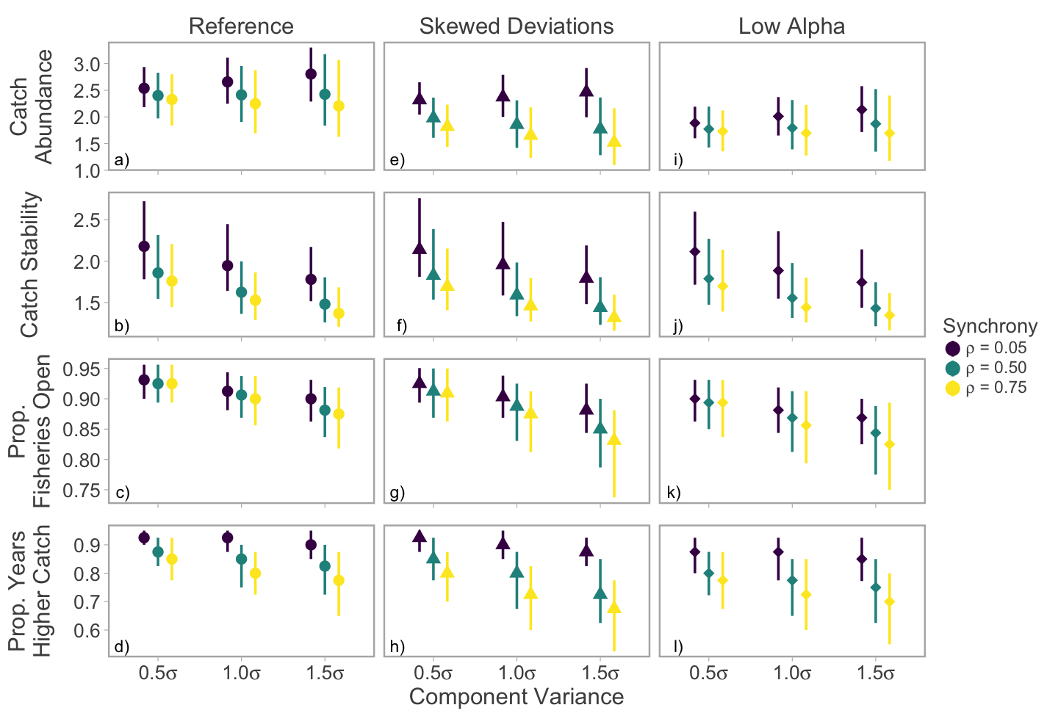

Figure 4. Effects of component variability and synchrony on catch-based performance measures. Points represent medians and whiskers 90% posterior interval among 250 simulation runs.

CU-specific median spawner abundances declined with greater component variability and when recruitment deviations were sampled from a skewed distribution. Shifts in median abundance relative to biological benchmarks were actually more severe in a relatively healthy CU (Chilko) because the depleted CU (Cultus) did not exhibit a high likelihood of recovery even when component variability was low and intermitted recruitment failures were not incorporated (Figure 5). Median spawner abundance within CUs did not exhibit strong declines when CVC was held constant and synchrony increased (Figure S1).

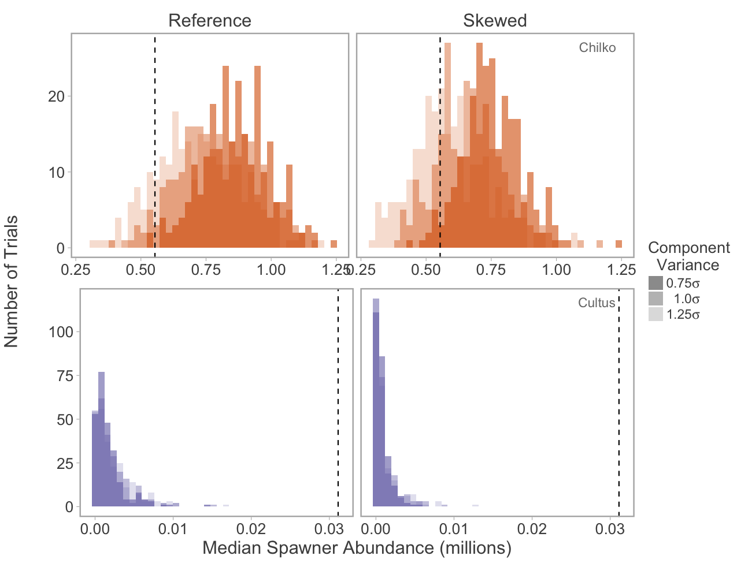

Figure 5. Distributions of CU-specific median spawner abundance (among 250 trials) across different levels of component variability (shading) and two productivity regimes for Chilko (top) and Cultus (bottom) CUs. The vertical dashed line represents each CU’s upper biological benchmark (Smsy). Simulations included moderate synchrony among CUs ( = 0.5). Note that x-axes differ between CUs.

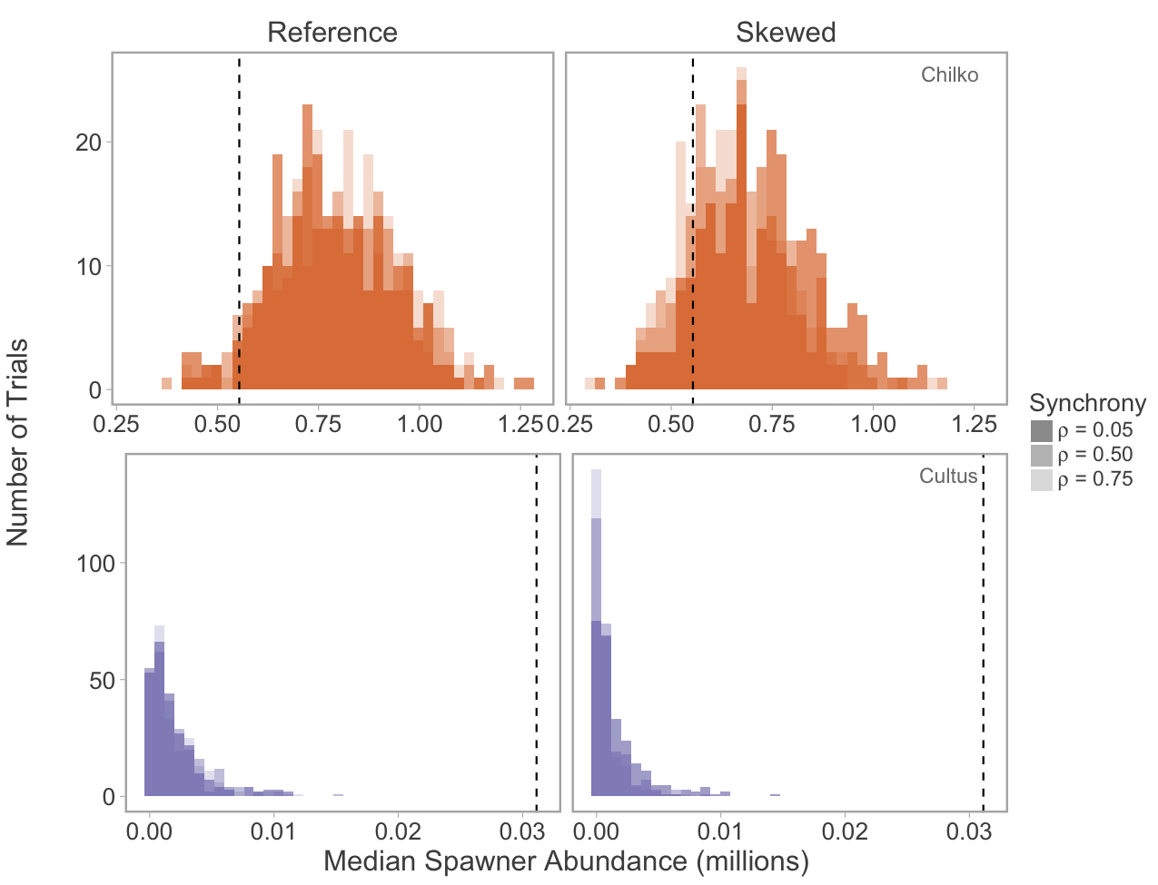

Figure S1. Distributions of CU-specific median spawner abundance (among 250 trials) across different levels of synchrony (shading) and two productivity regimes for Chilko (top) and Cultus (bottom) CUs. The vertical dashed line represents each CU’s upper biological benchmark (Smsy). Simulations included moderate synchrony among CUs (1.0). Note that x-axes differ between CUs.

**Discussion**

A range of ecological processes may underpin changes in variability and synchrony in Fraser River sockeye salmon. Component variability (i.e. within CU temporal variation) may increase due to changes in local environmental conditions, such as loss of spawning habitat (REF), high levels of mortality during incubation (e.g. scouring events (REF), high water temperatures (REF)), or changes in competition and predation during juvenile freshwater stages (REF). Synchrony among components within metapopulations is often associated with connectivity (i.e. dispersal). Although Fraser River sockeye salmon likely function as a metapopulation over evolutionary time scales, dispersal is assumed to be nil from a management perspective, with each CU representing a genetically distinct population assemblage (REF). In the absence of dispersal, synchronous dynamics may be driven by a common response to shared environmental drivers (i.e. Moran effect), competitors, or predators. In the case of Fraser River sockeye salmon, such mechanisms may be more likely to occur during marine residence, when populations from throughout North America migrate to the Gulf of Alaska.

Anderson, S.C., Branch, T.A., Cooper, A.B. & Dulvy, N.K. (2017) Black-swan events in animal populations. *Proceedings of the National Academy of Sciences*.

Burgner, R.L. (1991) Life history of Sockeye Salmon (*Oncorhynchus nerka*). *Pacific Salmon Life Histories* (eds C. Groot & L. Margolis).University of British Columbia Press, Vancouver, B.C.

Carlson, S.M. & Satterthwaite, W.H. (2011) Weakened portfolio effect in a collapsed salmon population complex. *Canadian Journal of Fisheries and Aquatic Sciences,* **68,** 1579-1589.

Cooke, S.J., Hinch, S.G., Farrell, A.P., Lapointe, M.F., Jones, S.R.M., Macdonald, J.S., Patterson, D.A., Healey, M.C. & van der Kraak, G. (2004) Abnormal migration timing and high en route mortality of sockeye salmon in the Fraser River, British Columbia. *Fisheries Research,* **29,** 22-33.

Crossin, G.T., Hinch, S.G., Cooke, S.J., Welch, D.W., Patterson, D.A., Jones, S.R.M., Lotto, A.G., Leggatt, R.A., Mathes, M.T., Shrimpton, J.M., Van Der Kraak, G. & Farrell, A.P. (2008) Exposure to high temperature influences the behaviour, physiology, and survival of sockeye salmon during spawning migration. *Canadian Journal of Zoology,* **86,** 127-140.

Doak, D.F., Bigger, D., Harding, E.K., Marvier, M.A., Malley, R.E.O. & Thomson, D. (1998) The statistical inevitability of stability-diversity relationships in community ecology. *American Naturalist,* **151,** 264-276.

Dorner, B., Peterman, R.M. & Su, Z. (2009) Evaluation of performance of alternative management models of Pacific salmon (*Oncorhynchus* spp.) in the presence of climatic change and outcome uncertainty using Monte Carlo simulations. *Canadian Journal of Fisheries and Aquatic Sciences,* **66,** 2199-2221.

Grant, S.C.H., MacDonald, B.L., Cone, T.E., Holt, C.A., Cass, A., Porszt, E.J., Hume, J.M.B. & Pon, L.B. (2011) Evaluation of uncertainty in Fraser Sockeye (*Oncorhynchus nerka*) wild salmon policy status using abundance and trends in abundance metrics. *Candian Science Advisory Secretariat Research Document,* **2011/087**.

Griffiths, J.R., Schindler, D.E., Armstrong, J.B., Scheuerell, M.D., Whited, D.C., Clark, R.A., Hilborn, R., Holt, C.A., Lindley, S.T., Stanford, J.A. & Volk, E.C. (2014) Performance of salmon fishery portfolios across western North America. *Journal of Applied Ecology,* **51,** 1554-1563.

Holt, C.A. (2009) Evaluation of benchmarks for conservation units in Canada's Wild Salmon Policy: Technical Documentation. *Canadian Science Advisory Secretariat Research Document 2009/059***,** 50 p.

Holt, C.A. & Folkes, M.J.P. (2015) Cautions on using percentile-based benchmarks of status for data-limited populations of Pacific salmon under persistent trends in productivity and uncertain outcomes from harvest management. *Fisheries Research,* **171,** 188-200.

Holtby, L.B. & Ciruna, K.A. (2007) Conservation units for Pacific salmon under the Wild Salmon Policy. *Canadian Service Advisory Secretariat Research Document,* **2007/070,** 358 p.

Larkin, P.A. (1971) Simulation studies of Adams River sockeye salmon (*Oncorhynchus nerka*). *Journal Fisheries Research Board of Canada,* **28,** 1493-1502.

Loreau, M. & de Mazancourt, C. (2008) Species synchrony and its drivers: neutral and nonneutral community dynamics in fluctuating environments *The American Naturalist,* **172,** E48-E66.

Macdonald, J.S. (2000) Mortality during the migration of Fraser River sockeye salmon (*Oncorhynchus nerka*): a study of the effect of ocean and river environmental conditions in 1997. *Canadian Technical Report of Fisheries and Aquatic Sciences,* **2315,** 120 p.

Mueter, F.J., Pyper, B.J. & Peterman, R.M. (2005) Relationships between Coastal Ocean Conditions and Survival Rates of Northeast Pacific Salmon at Multiple Lags. *Transactions of the American Fisheries Society,* **134,** 105-119.

Pestal, G., Huang, A.-M. & Cass, A. (2011) Updated methods for assessing harvest rules for Fraser River sockeye salmon (*Oncorhynchus nerka*). *Canadian Science Advisory Secretariat Research Document 2011/133***,** 175 p.

Peterman, Randall M. & Dorner, B. (2012) A widespread decrease in productivity of Sockeye Salmon (*Oncorhynchus nerka*) populations in western North America. *Canadian Journal of Fisheries and Aquatic Sciences,* **69,** 1255-1260.

Ricker, W.E. (1975) Computation and interpretation of biological statistics of fish populations. *Fisheries Research Board of Canada Bulletin,* **191**.

Satterthwaite, W.H. & Carlson, S.M. (2015) Weakening portfolio effect strength in a hatchery-supplemented Chinook salmon population complex. *Canadian Journal of Fisheries and Aquatic Sciences,* **72,** 1860-1875.

Schindler, D.E., Armstrong, J.B. & Reed, T.E. (2015) The portfolio concept in ecology and evolution. *Frontiers in Ecology and the Environment,* **13,** 257-263.

Schindler, D.E., Hilborn, R., Chasco, B., Boatright, C.P., Quinn, T.P., Rogers, L.A. & Webster, M.S. (2010) Population diversity and the portfolio effect in an exploited species. *Nature,* **465,** 609-612.

Thibaut, L.M. & Connolly, S.R. (2013) Understanding diversity-stability relationships: towards a unified model of portfolio effects. *Ecology Letters,* **16,** 140-150.

Tilman, D., Isbell, F. & Cowles, J.M. (2014) Biodiversity and ecosystem functioning. *Annual Review of Ecology, Evolution, and Systematics,* **45,** 471-493.

Yamane, L., Botsford, L.W. & Kilduff, D.P. (2018) Tracking restoration of population diversity via the portfolio effect. *Journal of Applied Ecology,* **55,** 472-481.