**Introduction**

Metapopulations, communities, and other ecological aggregates consist of components whose dynamics vary due to life history, unique environmental interactions, or simply chance. Asynchrony among components, commonly referred to as portfolio effects, reduces temporal variability of the aggregate resulting in greater productivity, increased availability of ecosystem services, and improved resilience (Tilman, Isbell & Cowles 2014; Schindler, Armstrong & Reed 2015). Portfolio effects have been identified as key stabilizing processes in a number of ecosystems and have been used as justification for systems-based approaches, which emphasize monitoring and conserving ecological aggregates, rather than individual components (Link 2018). The broad goal of systems-based approaches is to increase the stability of ecosystem services, while avoiding the difficulties associated with accurately forecasting the dynamics of single populations (Link 2018).

Systems-based approaches and portfolio effects are particularly relevant to management-oriented disciplines such as conservation biology and fisheries science. A common way to quantify a portfolio’s performance is via aggregate variability, the temporal coefficient of variation of multiple populations. An emergent property of ecological portfolios is that, due to statistical averaging alone, aggregate variability decreases as the number of components increases (Doak et al. 1998). For example, the Bristol Bay sockeye salmon (*Oncorhynchus nerka*) fishery encompasses an aggregate of nine major river systems, each containing tens to hundreds of spawning populations (Schindler et al. 2010). This population diversity reduces aggregate variability in spawner returns and catches, as well as the probability of fishery closures, relative to a hypothetical fishery containing fewer stocks (Hilborn et al. 2003; Schindler et al. 2010). Thus maintaining biodiversity across ecological scales is an effective, precautionary means of promoting resilience, particularly when future environmental conditions are uncertain (Anderson et al. 2015).

Yet even when population diversity is stable and extirpations do not occur, ecological portfolios can exhibit changes in aggregate variability that compromise their performance. Although the number of stocks within California’s Central Valley Chinook salmon (*O. tshawytscha*) aggregate has not declined, aggregate returns to the fishery have collapsed and become increasingly variable in recent decades (Carlson & Satterthwaite 2011; Satterthwaite & Carlson 2015). In this case, decreased stability appears to be associated with three distinct processes: greater variability in the returns of individual stocks, greater synchrony among stocks, and reduced productivity (Satterthwaite & Carlson 2015). While the region technically still exhibits a portfolio effect (i.e. aggregate variability is reduced relative to that of individual stocks), the buffering conferred by its diversity is substantially weaker than it was historically (Carlson & Satterthwaite 2011). Ultimately increased aggregate variability has resulted in substantial socio-economic costs with the probability of fishery closures increasing by more than 10-fold relative to historic levels (Yamane et al. 2018).

Aggregate variability is driven by the variance and covariance of component populations. Thus it can be decomposed into two metrics – the weighted mean coefficient of variation among components (CVc) and an index of synchrony (φ) (Loreau and de Mazancourt 2008; Thibaut and Connolly 2013). While increases in either CVC or φ will decrease an aggregate’s stability and weaken its portfolio effect, each process can produce unique challenges to systems-based management. For instance, the dynamics of individual populations become chaotic as CVC increases, raising the risk of overharvest if managers are unable to respond to rapid changes in abundance. In a healthy portfolio with sufficient diversity and relatively low levels of synchrony, divergent dynamics among populations will reduce the impact of these changes at the aggregate level. However, as synchrony increases, otherwise localized boom-and-bust cycles will become more widespread and harvesters will be less able to shift effort among component stocks, leading to reduced profits (Cline et al. 2017).

Aggregate variability can be associated with substantial negative ecological and socio-economic outcomes, as demonstrated by the decline of the Central Valley Chinook salmon fishery (Satterthwaite and Carlson 2015). However, it is unclear to what extent these outcomes are driven by increased component variability, increased synchrony, or reduced population productivity. The latter is particularly relevant because declines in abundance and productivity appear to be particularly widespread among exploited fishes (Peterman and Dorner 2012; Britten et al. 2016). Furthermore, the impacts of productivity declines on management strategies are likely to increase due to persistent stressors such as climate change (Oliver et al. 2015) and may be magnified by changes in aggregate variability.

An additional source of uncertainty is how changes in aggregate variability will influence various indicators of ecosystem health. Previous analyses of portfolio effects have typically examined changes in metrics such as abundance or catch (Moore et al. 2010; Schindler et al. 2010). Yet management actions often respond to a range of control points (e.g. whether abundance is above or below a value that provides maximum sustainable yield), which may vary in their sensitivity to changes in aggregate variability. The performance of systems-based approaches will be improved by a better understanding of how portfolio effects interact with various productivity regimes to influence different management objectives.

In this study, we explore how increased aggregate variability influences the probability of achieving a range of conservation and management objectives using Fraser River sockeye salmon as a case study. We first present a retrospective analysis that reveals aggregate temporal variability within the Fraser River has increased in recent years due to greater component variability, as well as greater synchrony among components. We then use stochastic, closed-loop simulations to evaluate how changes in component variability and synchrony influence the likelihood of meeting a suite of conservation- and catch-based performance metrics. Finally we repeat the simulations under a range of productivity scenarios to clarify how aggregate variability interacts with changes in productivity to shape dynamics. This multi-step approach allows us to assess changes in ecosystem functioning along a gradient of scenarios from historically observed levels of high asynchrony and productivity to heavily synchronized, unproductive dynamics consistent with degraded systems.

**Methods**

*Sockeye salmon biology, fisheries and data sources*

Sockeye salmon is an anadromous, semelparous fish distributed throughout the northern Pacific. Populations in southern British Columbia typically rear as juveniles in freshwater lakes for one-two years, mature in the Gulf of Alaska, and return to spawn as two-five year olds (Burgner 1991). In Canada, Pacific salmon status is assessed at the scale of conservation units (CUs) – groups of spawning populations with a common life history strategy, adult migration phenology, genetic history, and juvenile rearing habitat (Holtby & Ciruna 2007; Grant *et al.* 2011). Sockeye salmon CUs typically contain fewer spawning populations and are more spatially restricted than other Pacific salmon due to their dependence on nursery lakes (Holtby & Ciruna 2007). The Fraser River sockeye salmon aggregate is composed of 24 CUs, which are grouped into four management units (MUs) based on adult migration timing (Grant *et al.* 2011).

Fraser River sockeye salmon have been harvested in the region by commercial fisheries for over a century and by indigenous communities for thousands of years (Cohen 2012). Despite the historical abundance of Fraser River sockeye salmon, the aggregate’s productivity declined in the 1990s, resulting in frequent fishery closures and an emergency federal inquiry (Cohen 2012). While there have been signs of recovery in recent years, recruitment continues to be highly variable. Fraser River sockeye salmon are targeted by commercial fisheries as they move through nearshore areas on their return migration to their natal rivers for spawning. As a result, shifting marine fishery openings to coincide with a given migration phenology can be used to constrain effort at the MU, but not the CU, level and marine fisheries are considered mixed-stock. Fraser River sockeye salmon CUs vary in conservation status from abundant with stable or increasing population trends (i.e. healthy) to depleted with declining trends (critical). A recent assessment under Canada’s Wild Salmon Policy concluded that nine CUs were within the critical zone, 11 were within the cautious zone, and three were healthy (WSP 2017). The Fraser River sockeye salmon MUs included in this analysis, along with their component CUs, are listed in Table 1.

We used annual estimates of spawner abundance and recruit abundance (i.e. the number of spawning fish and catch produced by spawners in a given brood year, minus an adjustment for en route mortality) for 19 CUs (Grant et al. 2011), with individual time series beginning between 1948 and 1973 (Table 1). Spawner abundance estimates were generated using a variety of techniques including fence counts, mark-recapture and visual surveys, and passive sonar methods (Grant et al. 2011). Catch is estimated in marine and freshwater fisheries for each CU and age class. Methods for estimating spawning abundance and catch are reviewed in detail in Grant et al. (2011).

Table 1. Relevant sockeye salmon management units and component conservation units within the Fraser River aggregate.

|  |  |  |  |  |  |  |  |
| --- | --- | --- | --- | --- | --- | --- | --- |
| **MU** | **CU** | **Stock** | **Time Series Start** | **Stock Recruit Model & Parameters** | | | |
| Model |  |  |  |
| Early Stuart | Takla-Trembleur | Early Stuart | 1948 | Larkin | 1.80 | 1.49 | 0.77 |
| Early Summer | Bowron | Bowron | 1948 | Ricker | 1.60 | 25.96 | 0.81 |
| Shuswap-ES | Seymour | 1948 | Larkin | 1.98 | 3.58 | 0.82 |
| Scotch | 1980 | Ricker | 1.50 | 4.83 | 1.11 |
| North Barriere | Fennel | 1967 | Ricker | 2.14 | 97.82 | 0.96 |
| Anderson-Seton | Gates | 1968 | Ricker | 1.73 | 12.88 | 0.92 |
| Nadina-Francois | Nadina | 1973 | Ricker | 1.40 | 6.31 | 0.87 |
| Pitt | Upper Pitt River | 1948 | Ricker | 1.50 | 22.39 | 0.76 |
| Summer | Takla-Trembleur | Late Stuart | 1948 | Larkin | 2.03 | 1.01 | 1.28 |
| Francois-Fraser | Stellako | 1948 | Ricker | 1.84 | 3.96 | 0.83 |
| Kamloops-ES | Raft | 1948 | Ricker | 1.51 | 21.59 | 0.79 |
| Quesnel | Quesnel | 1948 | Larkin | 2.05 | 0.39 | 0.83 |
| Chilko | Chilko | 1948 | Ricker | 1.83 | 1.23 | 0.80 |
| Harrison (river-type) | Harrison | 1948 | Ricker | 1.49 | 2.79 | 1.39 |
| Late Summer | Shuswap-L | Late Shuswap | 1948 | Larkin | 2.17 | 0.30 | 0.95 |
| Lillooet-Harrison | Birkenhead | 1948 | Ricker | 1.90 | 6.75 | 0.98 |
| Cultus* | Cultus | 1948 | Ricker | 1.23 | 18.05 | 1.18 |
| Seton | Portage | 1965 | Ricker | 2.06 | 35.98 | 1.12 |
| Harrison (upstream) | Weaver Creek | 1966 | Ricker | 2.21 | 5.89 | 0.91 |

*Cultus spawner abundance and catch estimates extend to 2011, but the population has been heavily managed since 2000 using a captive breeding program. As a result, population parameters were estimated only using data collected prior to this change.

*Synchrony metrics and retrospective analysis*

We examined temporal changes in three metrics of metapopulation variability (Loreau & de Mazancourt 2008; Thibaut & Connolly 2013). The synchrony index reflects the relative degree of similarity in the dynamics of an ecological aggregate’s components. It is defined as the total temporal variance of the components (i.e. sum of all elements of the variance-covariance matrix **V**), divided by the variance of a hypothetical aggregate with the same component variances, but perfect covariance.

Equation 1

Here denotes temporal covariance in abundance for populations *i* and *j* within the aggregate of *n* populations. Thus the simplified numerator represents the variance of aggregate abundance, consisting of *n* populations, and the denominator is the variance of a hypothetical, perfectly synchronized population (Loreau & de Mazancourt 2008; Thibaut & Connolly 2013). The synchrony index is analogous to comparing mean pairwise correlation coefficients, which have been used in similar analyses (e.g. Peterman and Dorner 2012), but makes no distributional assumptions, is normalized (i.e. ranges between 0 and 1 regardless of the number of components), and explicitly accounts for unequal variances among components (Thibaut & Connolly 2013).

The second metric is the mean temporal coefficient of variation among components (CVc), weighted by each component’s mean abundance.

Equation 2

where *mpop*(*i*) is the mean abundance (through time) of population *i* and *magg* is the mean abundance of the aggregate. Finally, we calculated the coefficient of variation for the aggregate (CVA) as a function of the first two metrics following Thibaut and Connolly (2013)

Equation 3

This metric defines CVA as linearly proportional to CVC, with a constant of proportionality related to synchrony. Thus as synchrony increases CVA becomes more similar to CVC, while CVA is dampened when components vary asynchronously. Note, however, that CVA is identical to the temporal coefficient of variation of summed aggregate abundance.

To explore changes in aggregate variability of Fraser River sockeye salmon, we generated time series of , CVC, and CVA using 12-year moving windows of recruit abundance. **Insert blub on Bayesian sampling or TMB for intervals**. We used estimates of recruit, rather than spawner, abundance to account for large changes in exploitation rate over the past 70 years. Since Fraser River CUs vary in the length of their spawner-recruit time series, we generated trends in these metrics using a subset of CUs with data extending back to the 1948 brood year; however, a supplementary analysis analyzing a shorter time series that contained 18 CUs exhibited similar trends. To place these changes in a broader management context, we also present temporal changes in observed productivity (log(R/S)), aggregate spawner abundance, and aggregate catch.

*Forward simulation*

*Structure of biological and management submodels*

We used a stochastic, closed-loop simulation model of the Fraser River sockeye salmon management system to explore how differences in aggregate variability may influence conservation outcomes for Fraser River sockeye salmon. The model includes CU-specific population dynamics and harvesting, as well as process variance and deviations between target and realized catches (i.e. outcome uncertainty). The dynamics of each CU were simulated using age-structured, Ricker stock recruit models (Ricker 1975)

Equation 3

where *i* represents a CU, *R* the number of recruits, and *S* the number of spawners in year *y*. The parameter represents the number of recruits produced per spawner at low abundance and the density-dependent parameter, the reciprocal of the number of spawners that maximizes recruitment. This model is commonly arranged to account for normally distributed process error as

Equation 4

A subset of sockeye salmon CUs exhibit persistent cycles in spawner abundance with highly abundant returns occurring every four years. This dominant cycle line is followed by one subdominant and two weak return years. Although the specific mechanism that drives these cycles remains unclear, ecological interactions between cycle lines are likely responsible (e.g. predator abundance tracking juvenile sockeye salmon abundance at a one-two year lag (Ricker 1997)). The productivity of CUs with cyclic dynamics is generally estimated with an extended version of the Ricker model (the Larkin model; Larkin 1971), which accounts for interactions between brood years. In this case, we also used the Larkin model to forward simulate the dynamics of cyclic CUs (details of model structure and simulations in Appendix). Whether we simulated dynamics for a given CU using a Ricker or Larkin model followed assignments made in the most recent Wild Salmon Policy assessment (DFO *in press*; Table 1).

To parameterize each CU’s stock-recruit relationship we used median estimates of , , and generated from an external, CU-specific Bayesian stock recruit analysis (ref to FRSSI). To account for autocorrelation and incorporate covariation among CUs we simulated deviations from the stock-recruitment relationship as

Equation 5

where represents the previous year’s recruitment deviation, represents an AR1 autocorrelation coefficient, and represents random error drawn from a multivariate normal distribution with mean 0 and standard deviation defined by the variance-covariance matrix **V** for *n* CUs. We assigned a value of 0.2 for CUs modeled with a Ricker relationship, consistent with evidence of weak autocorrelation in the residuals of these models (results not shown). Recruitment deviations in Larkin models did not include an autocorrelation component because AR1 processes have not been validated in these models and the inclusion of delayed density dependence parameters, to some extent, accounts for such effects.

We incorporated two alternative productivity scenarios in our analysis intended to represent an increased likelihood of poor recruitment events, which could magnify the relative effects of changes in CVC or synchrony. Declines in productivity are commonly modeled by shrinking the intrinsic productivity parameter relative to a reference value (e.g. Dorner et al. 2009, Holt & Folkes 2015), representing a change to a less favourable productivity regime. Rather than manipulate per capita productivity in this way, we chose to create scenarios where remained the same, but the relative frequency of recruitment failures increased. These could represent, for example, intermittent periods of poor marine survival that are thought to regularly result in synchronous, poor recruitment events in Pacific salmon (Mueter, Pyper & Peterman 2005; Peterman & Dorner 2012).

To simulate this process we sampled recruitment deviations from one of two left-skewed distributions. In the “moderate decline” scenario, we used a skewed multivariate normal distribution that was identical to the distribution in equation 5, but included a parameter = 0.67, representing moderate, left skew (when = 1 the distribution is symmetrical). To realistically parameterize skewness we estimated using each CU’s time series of recruits and spawners (median = 0.83, 90th percentile interval 0.50-1.19), then selected the 25th percentile for use in forward simulations to represent a moderate decline relative to historical observations (details of fitting skewed stock-recruit models in Appendix).

In the “severe decline” scenario, we used a skewed multivariate Student *t* distribution, which, as a heavy-tailed distribution, increases the probability that relatively extreme values will be sampled (Anderson *et al.* 2018). Deviations were fit with

Equation 6

where **V** is defined as in Equation 5, *v* represents the degrees of freedom parameter, and the skewness parameter. Lower values of *v* correspond to heavier tails and as *v* approaches infinity, the *t* distribution approaches the normal distribution (Anderson *et al.* 2017). We used the same value for the skewness parameter as above and set = 2, which allows for an event three SDs below the mean to occur once every 14 years, rather than once every 714 years using a normal distribution (Figure 1).

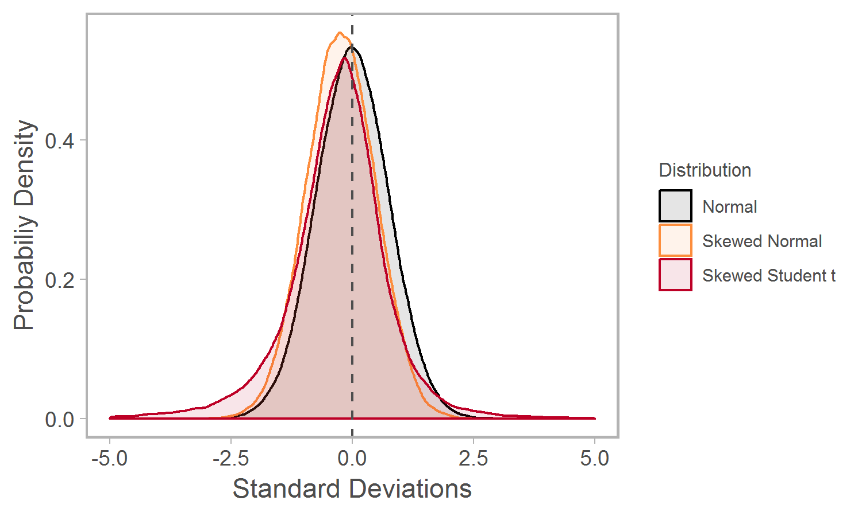

Figure 1. Distributions used to generate recruitment deviations in different productivity scenarios. All distributions have mean = 0 and standard deviation = 1. Both skewed distributions include parameter = log(0.65). The Student *t* distribution includes a fourth parameter = 3.

The closed-loop simulation incorporated two sources of mortality. The first mortality mechanism simulated harvest in mixed stock fisheries. Total allowable catch (TAC) in this fishery was calculated each year using a harvest control rule (HCR) that approximates the Total Allowable Mortality framework currently used to manage the Fraser River sockeye salmon fishery (Pestal, Huang & Cass 2011). Broadly speaking, this HCR uses in-season estimates of recruitment derived from test fisheries to adjust TAC and meet escapement goals specific to each MU. If in-season recruitment estimates exceed escapement goals, the HCR switches to a fixed maximum target mortality rate. Escapement goals vary among years due to persistent cycles present in several CUs and are adjusted upwards (i.e. TACs reduced) to account for mortality during upstream migration, as well as spatial overlap between abundant and depleted MUs. The second simulated source of mortality represented en route mortality that occurs after fish enter freshwater due to a combination of natural mortality (thermal stress, pathogen infection, predation) and unreported harvest (Grant *et al.* 2011). We modeled en-route mortality as a stochastic, CU-specific process because it appears to be correlated with migration phenology, in-river temperatures, and freshwater flow (Macdonald 2000; Cooke *et al.* 2004; Crossin *et al.* 2008). Details of the harvest control rule, mortality calculations, and parameter specifications are described in the Appendix.

We introduced additional stochasticity into the model via interannual variation in age at maturity, error associated with in-season abundance estimates (forecast error), en route mortality, and deviations between target and realized exploitation rates (implementation uncertainty). The results we present in the main text are based on simulations using the set of parameter inputs that we believe best represent the system and are consistent with similar studies simulating Pacific salmon dynamics (Holt and Bradford 2011; Fleischmann et al. 2013); however, we tested the effect of alternative values in a series of sensitivity analyses to ensure that our results were robust to this assumption. Details of how each process was parameterized are described in the Appendix and results of sensitivity analyses are provided in an online supplement.

We used CU-specific time series of recruit and spawner abundance to initiate the simulation model (i.e. the same data that were used in the retrospective analysis). The length of the simulation period was set at 40 years (approximately 10 sockeye salmon generations) and each OM was simulated 1000 times to ensure representative posterior distributions.

*Component variability and synchrony “treatments”*

The principal drivers of variability in aggregate abundance within the model are deviations from CU-specific stock-recruitment relationships (*w* in Equation 5). To explore the consequences of greater aggregate variability on management objectives, we manipulated the strength of recruitment deviations to create nine operating models defined by unique variance-covariance matrices **V**, with each representing a distinct component variability and synchrony “treatment” (Table 2). We created component variance treatments by adjusting CU-specific estimates of process variance up or down by 25%. We selected these adjustments because they were sufficient to produce changes in CVC,but constrained to values that are plausible for sockeye salmon (the maximum estimated mean value for across three sockeye salmon studies was 1.64 (Korman et al. 1995, Peterman et al. 2003, Holt and Peterman 2008) and the maximum here was 1.73). We parameterized synchrony treatments by adjusting the correlation coefficient to values consistent with 10-year moving window estimates of mean pairwise correlations in log(R/S) among CUs during periods of when productivity was weakly ( = 0.05; 1980s and 1990s) or moderately correlated ( = 0.50; 1950s, 1960s, and present). We specified a third high correlation treatment ( = 0.75) to represent a hypothetical scenario where synchrony increases.

Table 2. Parameterization of component variability (CVc) and synchrony () operating models.

|  |  |  |  |
| --- | --- | --- | --- |
|  | Low CVC | Moderate CVC | High CVC |
| Low |  |  |  |
| Moderate |  |  |  |
| High |  |  |  |

*Evaluating model performance*

We used a suite of performance measures (PMs) to assess how changes in CVC and impact the likelihood of achieving conservation- and catch-based management objectives. Conservation-based PMs are focused on recruit abundance, as well as biological benchmarks used to assess CU status. Consistent with Canada’s Wild Salmon Policy, we used 80% of the estimated spawner abundance necessary to produce maximum sustainable yield (*SMSY*, formula in Appendix) as the benchmark representing healthy status. Conversely, catch-based PMs are proxies DFO fishery managers may use to determine whether socio-economic objectives are met. For example, we used an aggregate TAC equal to 1,000,000 fish as a proxy for healthy fisheries since at this level of abundance managers are able to allocate quota to each major stakeholder group (i.e. First Nations, commercial, and recreational fisheries). A full list of performance measures and their definitions are described in Table 3. To evaluate differences in performance between OMs, we present median outputs among simulations, as well as 10th and 90th percentiles.

Table 3. Conservation- and catch-based performance metrics (PMs). PMs are presented as median values among trials.

|  |  |  |
| --- | --- | --- |
|  | Performance Metric | Definition |
| Conservation | Median recruitment | Median aggregate recruit abundance (i.e. summed across all CUs within a return year) during the simulation period. |
| Proportion of CUs above upper benchmark | The temporal mean proportion of CUs within a return year with spawner abundance greater than 0.8*SMSY. |
| Proportion of CUs extant | The proportion of CUs with spawner abundances above the extinction threshold at the end of the simulation period. |
| Catch | Median catch | Median aggregate catch (i.e. summed across all CUs within a return year) during the simulation period. |
| Catch stability | The inverse of the temporal coefficient of variation in aggregate catch (i.e. ). |
| Proportion of years above catch threshold | The proportion of years during the simulation period when aggregate TAC was greater than 1,000,000. |

Although we focused our analyses on aggregate PMs because CVC and synchrony are relevant at the metapopulation scale, the consequences of increased aggregate variability may vary among components due to intrinsic differences in productivity or carrying capacity, as well as their exposure to harvest in mixed stock fisheries. An exhaustive analysis of CU-specific differences was beyond the scope of this paper, however to illustrate potential differences we present simulated changes in median spawner abundance across CVC and synchrony treatments for two CUs: a low abundance, red status CU within the Early Summer Run MU (Bowron) and an abundant green status CU within the Summer Run MU (Chilko).

Finally, we stress that the goal of this study was to demonstrate relative differences in projected performance associated with trends in component variability and synchrony, not to accurately forecast the dynamics of individual Fraser River CUs or the aggregate as a whole.

**Results**

*Retrospective analysis*

Mean Fraser River sockeye salmon productivity (log(recruits/spawner)) declined from the late 1980s through 2005, the brood year predominantly responsible for producing the poor return in 2009. Although the aggregate exhibited several years of higher productivity, it has recently declined again and remains variable (Figure 2a). Aggregate spawner abundance and aggregate catch increased until the early 1990s before declining (Figure 2b,c), coincident with declines in productivity and exploitation rate. However, there is substantial interannual variability in both metrics due to several abundant, cyclic CUs. Particularly large returns were observed in 2010 and 2014 (catches for 2014 not shown).

Mean CVC (i.e. temporal variability in recruit abundance, weighted by a CU’s mean abundance) was low in the 1960s, 70s and 90s, but was elevated at the beginning of the time series (1950s) and has increased by approximately 50% since the early 2000s (Figure 2d). Similarly, synchrony in recruit abundance was relatively high in the 1950s, low and stable for approximately 20 years afterwards and increased through the 1980s, leading to a peak several years ago (Figure 2e.) As expected, changes in CVA mirror these patterns, showing a gradual increase followed by a jump to particularly high levels in the early 2000s (Figure 2f).

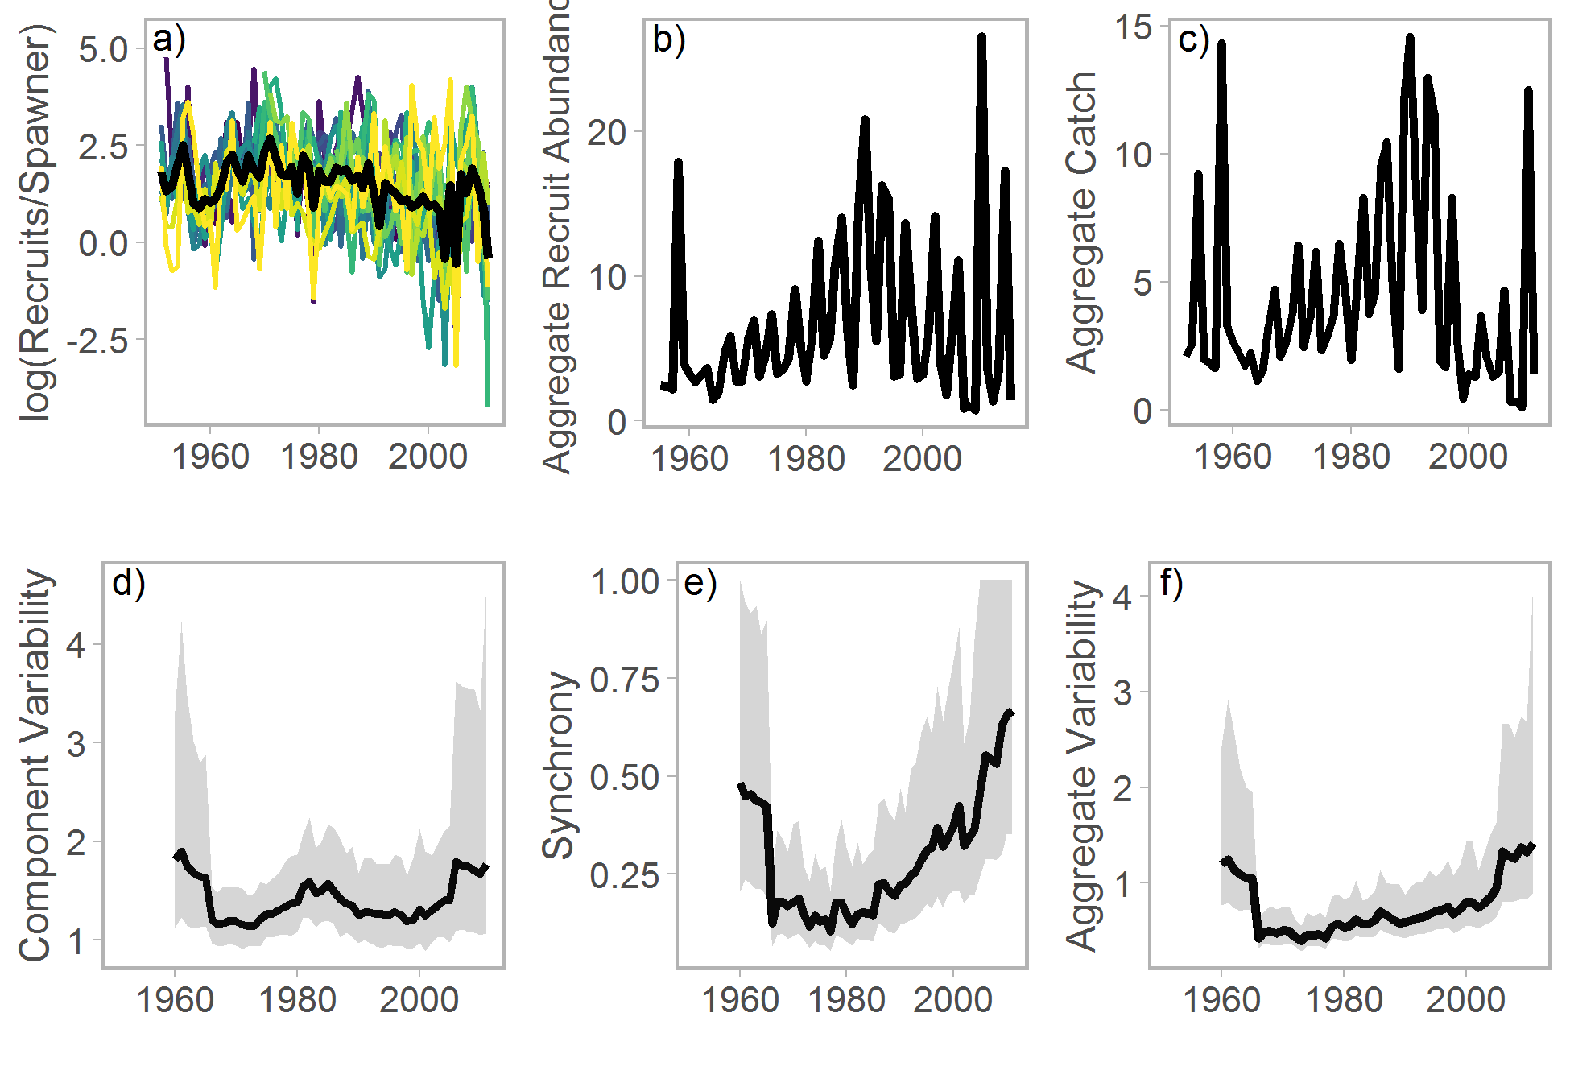

Figure 2. Observed trends in Fraser River sockeye salmon productivity (log (recruits per spawner)), aggregate spawner abundance, and aggregate catch (a-c). 12-year moving window estimates of the mean component coefficient of variation (CVC), synchrony index (), and aggregate variability (CVA) (d-f) of 11 CUs with time series extending back to 1948. Black lines represent median estimates and grey bands represent 90th percentile intervals.

*Forward simulation*

By specifying low, medium, and high values for and we were able to generate a range of CVC and synchrony scenarios (Figure 3). We use as a proxy for CVC and as a measure of synchrony in subsequent results. Due to stochasticity within the model, median trends in CVC and were lower than recently observed values, even when and were maximized. However, individual Monte Carlo trials exhibited temporal variation in CVC and consistent with the historical time series (Figure S1).

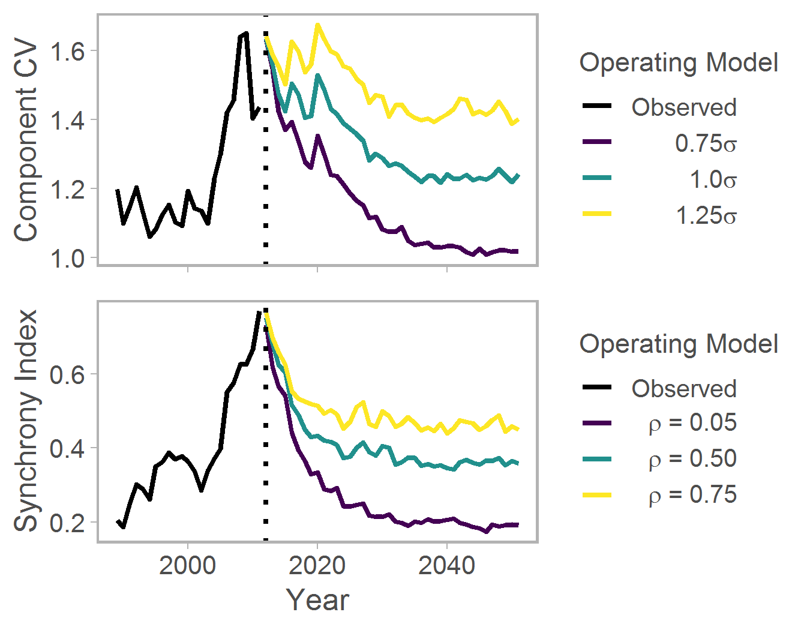

Figure 3. Trends in recruitment component variability and synchrony as a function of and , respectively. 12-year moving window Trends in the observed stock-recruitment dataset are shown in black, the dashed line represents the beginning of the simulation period, and colored lines represent different CVC and synchrony operating models. Lines represent medians across 250 trials.

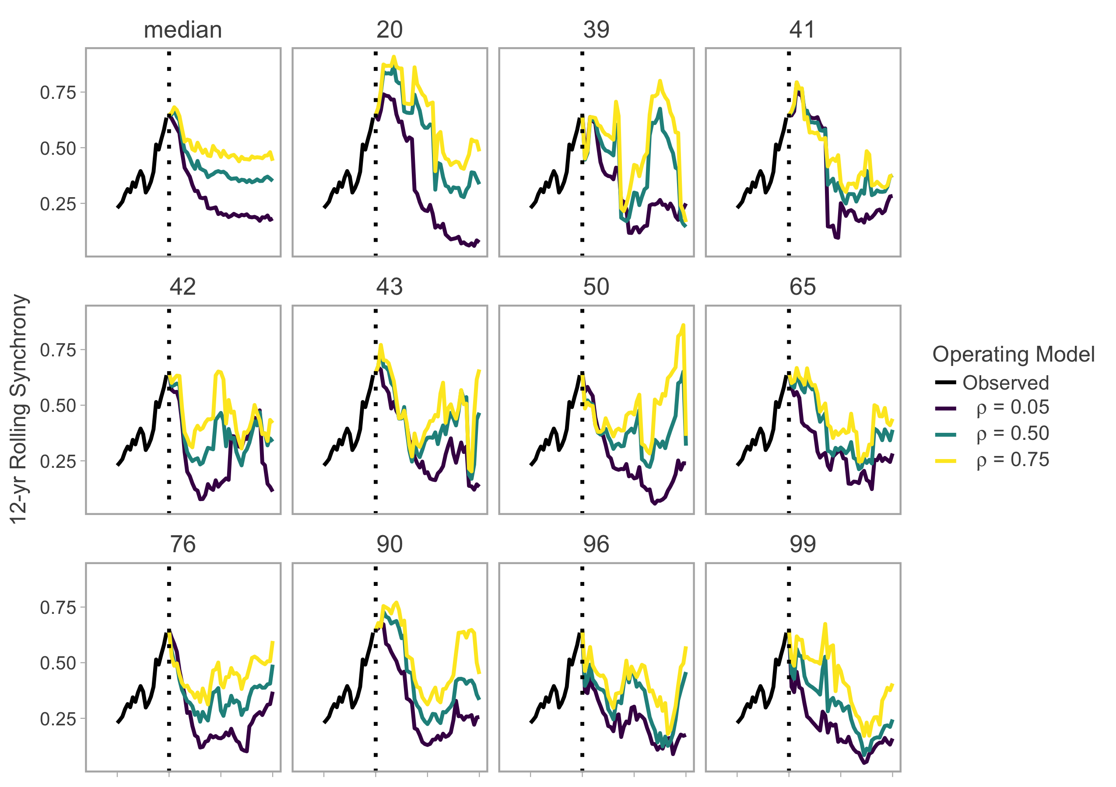

Figure S1. Trends in recruitment synchrony as a function of , respectively. The median trend among trials is shown in the top left and other panels represent a random subset of Monte Carlo trials.

The effects of aggregate variability on conservation-based PMs were strongly dependent on productivity scenario. When productivity was simulated at its reference value (i.e. median retrospective estimates and normally distributed process error) were relatively minor. Increases in synchrony led to moderate declines in recruit abundance, while increases in component variability led to moderate increases (Figure 4a). The proportion of CUs above their biological benchmark and the proportion of CUs extant at the end of the simulation period were stable across all aggregate variability scenarios (Figure 4b,c).

Unsurprisingly, conservation-based PMs declined under alternative productivity scenarios. However, the relative magnitude of these declines was moderated by aggregate variability in general and synchrony in particular. When process variance was simulated with a skewed normal distribution, median recruit abundance declined by approximately 50% when synchrony was increased to moderate levels (purple and green symbols Figure 4d). The proportion of CUs above their biological benchmark exhibited similar declines at higher synchrony levels (Figure 4e). Increases in CVC were associated with declines in recruit abundance and conservation status, but only when they co-occurred with moderate or high levels of synchrony (Figure 4d,e). The interaction between component variability and synchrony was most noticeable with regards to extirpation risk. The median proportion of extant CUs was stable as long as synchrony was low, but declined by ~5% when synchrony increased to moderate levels and by ~10% when both component variability and synchrony were at their maximum values (Figure 4f). Conservation outcomes worsened slightly when process variance was simulated from a skewed Student *t* distribution, but the overall patterns were similar to estimates when using the less extreme, skewed normal distribution (Figure 4g-i).

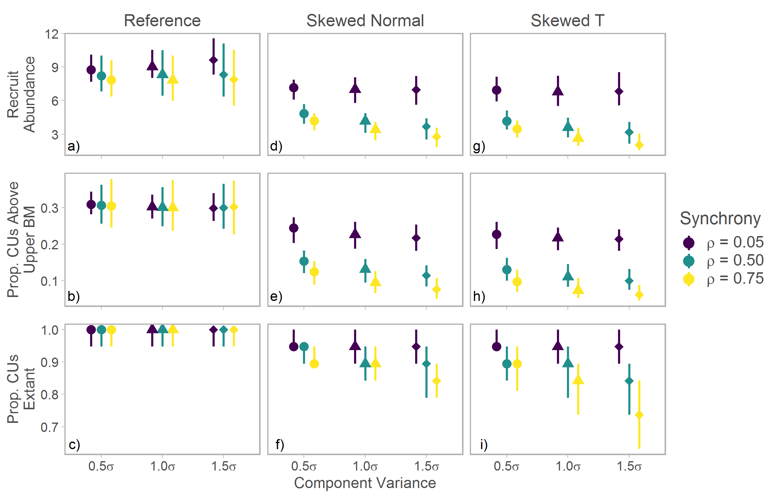

Figure 4. Effects of component variability and synchrony on conservation-based performance measures. Points represent medians and whiskers 90% posterior interval among 250 simulation runs.

The effects of aggregate variability also differed among catch-based PMs and productivity scenarios. Under the reference productivity scenario median catch size displayed a similar pattern to median recruit abundance, declining moderately at high levels of synchrony (Figure 5a). Increasing synchrony and component variability simultaneously also led to moderate declines in the proportion of years the target TAC was achieved, as well more severe declines in catch stability (Figure 5b,c). As with the conservation-based PMs, the impacts of aggregate variability on catch-based PMs were more severe under pessimistic productivity scenarios. When process variance was simulated with a skewed normal distribution median catches declined by 45-65% as aggregate variability increased (Figure 5d). Similarly the proportion of years that target TAC was achieved declined from 93% when component variability and synchrony were minimized to 43% at their maximum (Figure 5e). While declines in catch stability with aggregate variability were similar between the reference and skewed normal productivity scenarios, they were much more severe when process variance was simulated with a skewed Student *t* distribution (Figure 5c,f,i). Differences between the two pessimistic productivity scenarios were relatively minor for the remaining catch-based PMs (Figure 5g,h).

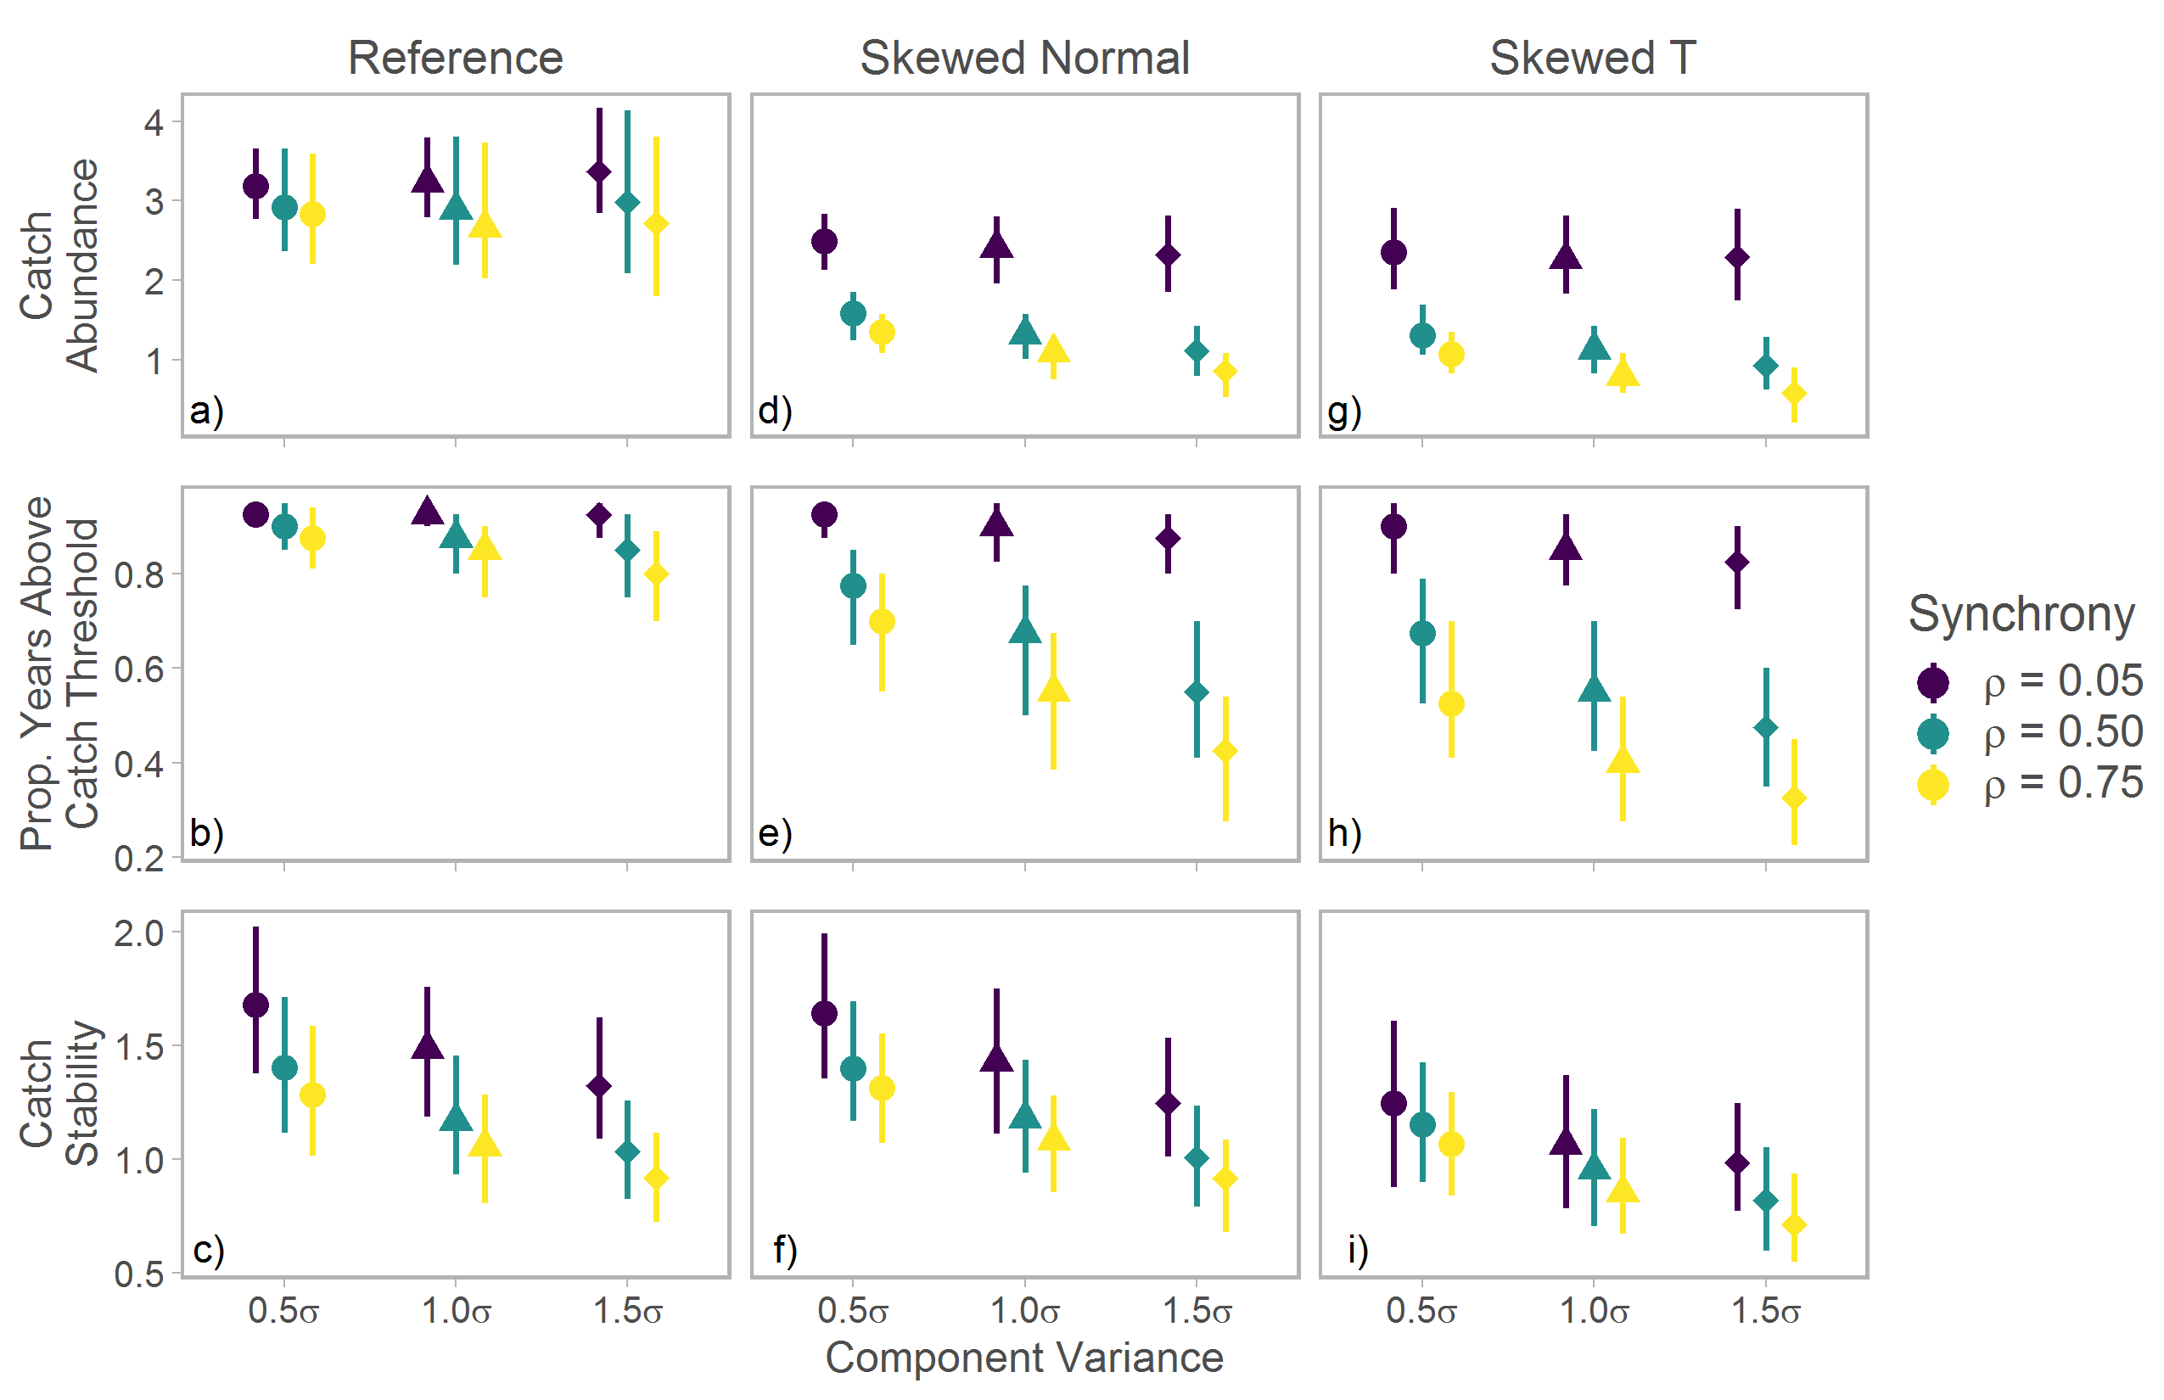

Figure 5. Effects of component variability and synchrony on catch-based performance measures. Points represent medians and whiskers 90% posterior interval among 250 simulation runs.

CU-specific median spawner abundances declined with greater component variability, although these effects were dwarfed by declines associated with alternative productivity scenarios. Shifts in median abundance relative to biological benchmarks were actually more severe in relatively healthy CUs (e.g. Chilko) because depleted CUs (e.g. Bowron) had a low likelihood of recovery even when dynamics were simulated with the reference productivity scenario (Figure 5). Median spawner abundance within CUs also declined with increasing levels of synchrony, but only under the two pessimistic productivity scenarios (Figure S2).

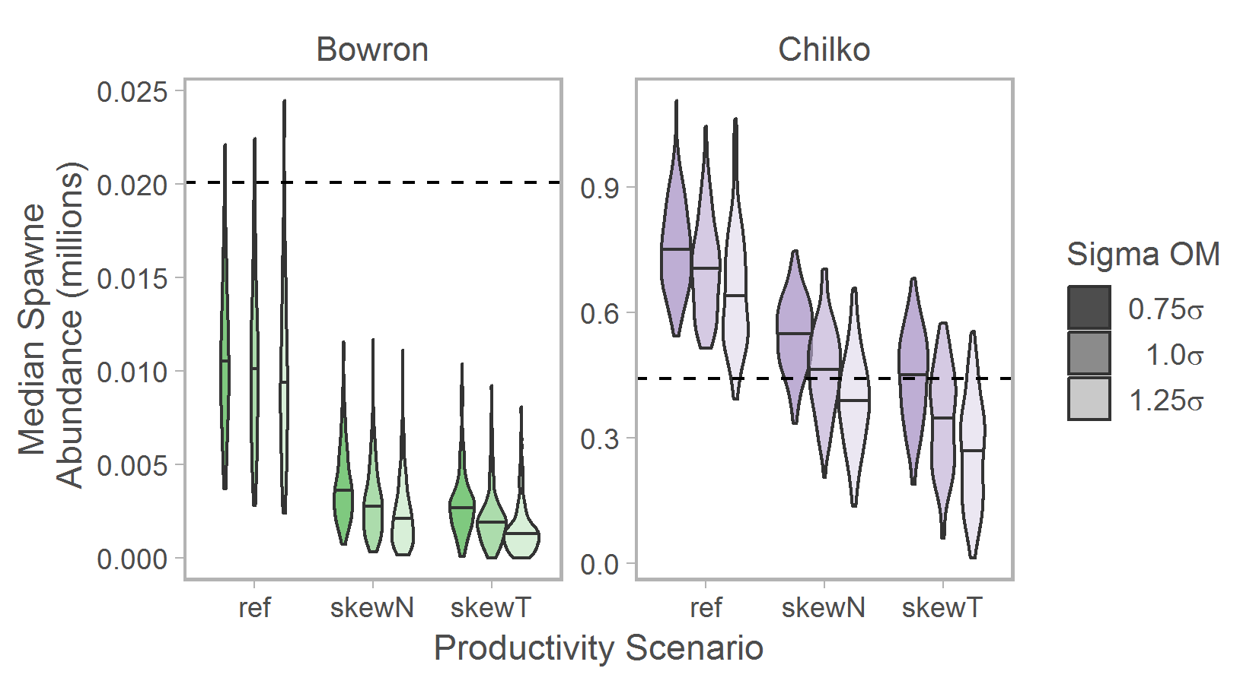

Figure 6. Distributions of CU-specific median spawner abundance (among 250 trials) across different levels of component variability (shading) and three productivity regimes for Bowron and Chilko CUs. The vertical dashed line represents each CU’s upper biological benchmark (0.8*Smsy). Simulations included moderate synchrony among CUs ( = 0.5). Note that y-axes differ between CUs.

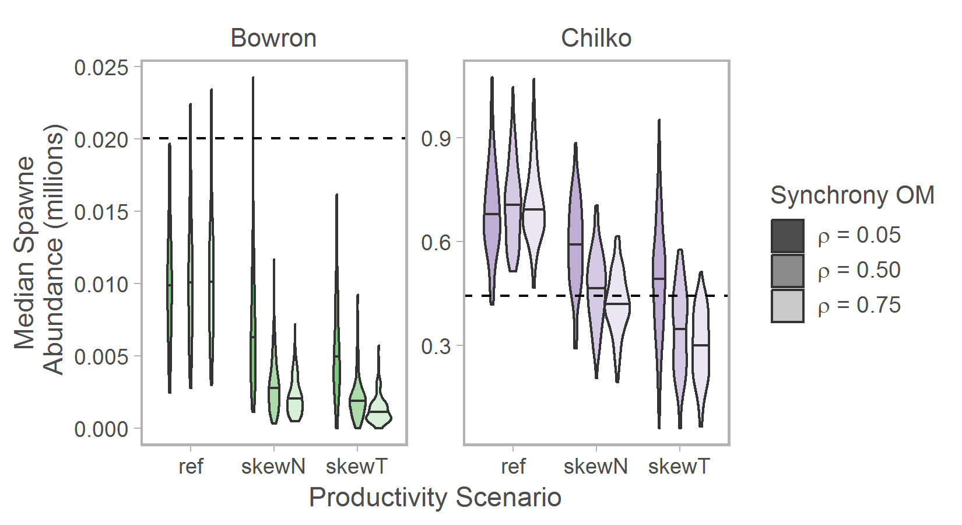

Figure S2. Distributions of CU-specific median spawner abundance (among 250 trials) across different levels of synchrony (shading) and two productivity regimes for Chilko (top) and Cultus (bottom) CUs. The vertical dashed line represents each CU’s upper biological benchmark (Smsy). Simulations included moderate synchrony among CUs (1.0). Note that x-axes differ between CUs.

**Discussion**

We present evidence that aggregate variability in recruit abundance within the Fraser River sockeye salmon metapopulation has increased in recent years due to increases in the mean variability of component stocks (CVC), as well as greater synchrony () among stocks. Stability and population productivity declined even as exploitation rates were reduced dramatically, resulting in less consistent catches and substantial socio-economic costs (Cohen 2012). We used stochastic, closed-loop simulations to determine that current levels of aggregate variability, coupled with poor productivity, will dramatically reduce the likelihood of achieving a wide range of conservation- and catch-based objectives.

A range of ecological processes may underpin changes in variability and synchrony in Fraser River sockeye salmon. Component variability (i.e. within CU temporal variation) may increase due to intermittent changes in local conditions, such as loss of spawning habitat (REF), high levels of mortality during incubation (REF), or changes in competition and predation during juvenile freshwater stages (REF). Conversely, increased synchrony within Pacific salmon aggregates is often directly associated with anthropogenic disturbance, particularly processes that increase genetic homogenization such as hatchery influences and hydropower development (Moore et al. 2010, Carlson and Satterthwaite 2015, Yamane et al. 2018).

While Fraser River sockeye salmon inhabit a heavily impacted watershed, the specific mechanisms that may have resulted in decreased stability are unclear. Hatchery contributions to the aggregate are minimal and there are no major hydroelectric features on the Fraser River mainstem (REFs). Increases in synchrony do, however, coincide with a period where marine survival is considered broadly unfavourable (Peterman and Dorner 2012; Thomson paper; Beamish paper). Given that freshwater survival has generally remained high (REF), synchronous declines in abundance may suggests that marine mortality has become more variable and relatively more important in regulating recruitment. Interestingly CVC and were also elevated early in the time series, suggesting recent anthropogenic development is unlikely to be the sole driver. Fraser River sockeye salmon may be particularly prone to synchrony due to a relatively simple age structure that minimizes buffering within populations by different cohorts.

Decreased stability within ecological aggregates can result in reduced abundance and substantial socio-economic costs (Satterthwaite and Carlson 2015; Yamane et al. 2018); however, our simulation model demonstrates that these impacts are heavily dependent on the underlying productivity regime. When population productivity was moderate (i.e. at reference levels), increases in CVC and resulted in greater uncertainty in median abundance and the probability that biological or catch-based benchmarks would be met – yet median status was unchanged. Unsurprisingly the one performance metric that was sensitive to increased aggregate variability regardless of productivity regime was catch stability. In other words weakened portfolios may produce relatively high catches on average, assuming productivity remains unchanged, but catches will increasingly be driven by boom-and-bust cycles that provide reduce socio-economic benefits (REF).

Conversely, under pessimistic productivity scenarios increases in aggregate variability had strong negative impacts on all performance metrics. To some extent these patterns were driven by reduced productivity independent of CVC or . For example, median recruit abundance declined by approximately X% between the reference and skewed normal productivity scenarios. Yet increased aggregate variability, and in particular greater synchrony, strongly exacerbated such declines. Moving from a low to moderate synchrony scenario resulted in a Y% decline in median recruit abundance and when high synchrony was paired with greater CVC abundance declined even further. PMs incorporating conservation- and catch-based benchmarks exhibited similarly severe responses to increased aggregate variability. When the simulations incorporated an increased likelihood of extreme events (i.e. “black swans”), the probability of meeting conservation- and catch-based objectives declined even further. Extirpations in particular became more common, with 25% of CUs going extinct under the most pessimistic scenario.

The results of our simulation analysis have important implications to management strategies that seek to incorporate systems-based approaches and leverage the benefits of portfolio effects. First, declines in productivity and aggregate stability will have multiplicative impacts on ecological portfolios. Management actions that are intended to address declines in abundance, but that fail to account for changes in covariance among component populations may underestimate risk or overestimate the likelihood of rebuilding. While greater aggregate variability may not significantly increase the likelihood of negative outcomes unless it is accompanied by a decline in productivity, this finding should be treated with caution. Changes in productivity are difficult to estimate for wild populations and given widespread declines in many exploited species (REF), it would be risky to assume stability. Furthermore, greater aggregate variability may result in negative consequences via management processes we were unable to model here (described in next paragraph). Thus we echo previous authors in suggesting estimates of portfolio effect strength should be paired with more commonly used metrics such as trends in abundance or fishing mortality rates during assessments.

Second, we observed strong impacts on performance metrics despite the Fraser River sockeye aggregate containing a large number of component stocks. Thus moderately high levels of component variability and synchrony may compromise even relatively diverse aggregates. Since aggregates with high levels of biodiversity intrinsically have greater potential for portfolio effects, stock assemblages that contain fewer individual stocks will likely be even more sensitive to increases in aggregate variability. A related issue is that

and a relatively complex harvest control rule Similarly considerable resources are devoted each year to ensuring Fraser River sockeye salmon escapement goals are met including closely monitored test fisheries, genetic stock identification techniques, and estimates of abundance throughout the migration and on spawning grounds. As a result, exploitation rates can be reduced when recruit abundance is lower than expected. Yet this framework is the exception rather than the rule in fisheries management. Many systems rely heavily on forecasted abundance or previous estimates of fishing mortality to determine catch rates. If management targets fail to track changes in aggregate variability, the likelihood of overharvest may increase, exacerbating the impacts of reduced productivity and a weak portfolio effect. Since greater aggregate variability frequently results in periodic years of abundant returns there will also likely be substantial pressure from stakeholders to maintain harvesting capacity, increasing the potential for overharvesting to occur.

The closed-loop model we created contains several necessary simplifications that could influence the relative effects of aggregate variability. For one, our conclusions are sensitive to the performance metrics selected to assess the aggregates health. We principally focused on median outcomes over the length of the simulation period (approximately ten generations). Alternative metrics that emphasize variability (other than catch stability) or changes in status over shorter time horizons may indicate more severe impacts of aggregate variability. We also chose to model alternative productivity via changes in the distribution of process variance. Preliminary analyses suggested that producing a decline in productivity by manipulating alpha directly resulted in weaker aggregate variability effects. However we believe that producing changes in average productivity via process variance is justified given evidence of strong negative recruitment deviations in many Pacific salmon aggregates (REF) and uncertainty about future changes in productivity. Finally, we modeled biological dynamics at a relatively coarse scale. Yet processes occurring during specific life history stages likely drive changes in CVC and . Developing a more complete life cycle model, though beyond the scope of the current study, would provide a means of assessing whether management interventions targeted at specific life history stages may reduce variability in adult recruit abundance.

Systems based approaches are increasingly advocated in disciplines, such as fisheries biology, where accounting for portfolio effects can stabilize the availability of ecosystem services. We agree that such approaches have merit and that there is intrinsic value in conserving as many dimensions of biodiversity as possible. We seek to demonstrate, however, that the benefits of focusing management efforts on ecological aggregates will be dependent upon variability within individual components, as well as their covariance. Since both processes may vary due to environmental and anthropogenic effects, portfolio effects are themselves dynamic. While a sufficiently precautionary approach could buffer management systems from changes in aggregate variability, it may be difficult to apply sufficiently conservative reference points given the strong negative impacts of greater variability when paired with reduced productivity. As suggested by others, we instead believe assessment programs should track changes in aggregate variability explicitly to allow management systems to adjust to observed declines (Thorson et al. reference).

Anderson, S.C., Branch, T.A., Cooper, A.B. & Dulvy, N.K. (2017) Black-swan events in animal populations. *Proceedings of the National Academy of Sciences*.

Burgner, R.L. (1991) Life history of Sockeye Salmon (*Oncorhynchus nerka*). *Pacific Salmon Life Histories* (eds C. Groot & L. Margolis).University of British Columbia Press, Vancouver, B.C.

Carlson, S.M. & Satterthwaite, W.H. (2011) Weakened portfolio effect in a collapsed salmon population complex. *Canadian Journal of Fisheries and Aquatic Sciences,* **68,** 1579-1589.

Cooke, S.J., Hinch, S.G., Farrell, A.P., Lapointe, M.F., Jones, S.R.M., Macdonald, J.S., Patterson, D.A., Healey, M.C. & van der Kraak, G. (2004) Abnormal migration timing and high en route mortality of sockeye salmon in the Fraser River, British Columbia. *Fisheries Research,* **29,** 22-33.

Crossin, G.T., Hinch, S.G., Cooke, S.J., Welch, D.W., Patterson, D.A., Jones, S.R.M., Lotto, A.G., Leggatt, R.A., Mathes, M.T., Shrimpton, J.M., Van Der Kraak, G. & Farrell, A.P. (2008) Exposure to high temperature influences the behaviour, physiology, and survival of sockeye salmon during spawning migration. *Canadian Journal of Zoology,* **86,** 127-140.

Doak, D.F., Bigger, D., Harding, E.K., Marvier, M.A., Malley, R.E.O. & Thomson, D. (1998) The statistical inevitability of stability-diversity relationships in community ecology. *American Naturalist,* **151,** 264-276.

Dorner, B., Peterman, R.M. & Su, Z. (2009) Evaluation of performance of alternative management models of Pacific salmon (*Oncorhynchus* spp.) in the presence of climatic change and outcome uncertainty using Monte Carlo simulations. *Canadian Journal of Fisheries and Aquatic Sciences,* **66,** 2199-2221.

Grant, S.C.H., MacDonald, B.L., Cone, T.E., Holt, C.A., Cass, A., Porszt, E.J., Hume, J.M.B. & Pon, L.B. (2011) Evaluation of uncertainty in Fraser Sockeye (*Oncorhynchus nerka*) wild salmon policy status using abundance and trends in abundance metrics. *Candian Science Advisory Secretariat Research Document,* **2011/087**.

Griffiths, J.R., Schindler, D.E., Armstrong, J.B., Scheuerell, M.D., Whited, D.C., Clark, R.A., Hilborn, R., Holt, C.A., Lindley, S.T., Stanford, J.A. & Volk, E.C. (2014) Performance of salmon fishery portfolios across western North America. *Journal of Applied Ecology,* **51,** 1554-1563.

Holt, C.A. (2009) Evaluation of benchmarks for conservation units in Canada's Wild Salmon Policy: Technical Documentation. *Canadian Science Advisory Secretariat Research Document 2009/059***,** 50 p.

Holt, C.A. & Folkes, M.J.P. (2015) Cautions on using percentile-based benchmarks of status for data-limited populations of Pacific salmon under persistent trends in productivity and uncertain outcomes from harvest management. *Fisheries Research,* **171,** 188-200.

Holtby, L.B. & Ciruna, K.A. (2007) Conservation units for Pacific salmon under the Wild Salmon Policy. *Canadian Service Advisory Secretariat Research Document,* **2007/070,** 358 p.

Larkin, P.A. (1971) Simulation studies of Adams River sockeye salmon (*Oncorhynchus nerka*). *Journal Fisheries Research Board of Canada,* **28,** 1493-1502.

Loreau, M. & de Mazancourt, C. (2008) Species synchrony and its drivers: neutral and nonneutral community dynamics in fluctuating environments *The American Naturalist,* **172,** E48-E66.

Macdonald, J.S. (2000) Mortality during the migration of Fraser River sockeye salmon (*Oncorhynchus nerka*): a study of the effect of ocean and river environmental conditions in 1997. *Canadian Technical Report of Fisheries and Aquatic Sciences,* **2315,** 120 p.

Mueter, F.J., Pyper, B.J. & Peterman, R.M. (2005) Relationships between Coastal Ocean Conditions and Survival Rates of Northeast Pacific Salmon at Multiple Lags. *Transactions of the American Fisheries Society,* **134,** 105-119.

Pestal, G., Huang, A.-M. & Cass, A. (2011) Updated methods for assessing harvest rules for Fraser River sockeye salmon (*Oncorhynchus nerka*). *Canadian Science Advisory Secretariat Research Document 2011/133***,** 175 p.

Peterman, Randall M. & Dorner, B. (2012) A widespread decrease in productivity of Sockeye Salmon (*Oncorhynchus nerka*) populations in western North America. *Canadian Journal of Fisheries and Aquatic Sciences,* **69,** 1255-1260.

Ricker, W.E. (1975) Computation and interpretation of biological statistics of fish populations. *Fisheries Research Board of Canada Bulletin,* **191**.

Satterthwaite, W.H. & Carlson, S.M. (2015) Weakening portfolio effect strength in a hatchery-supplemented Chinook salmon population complex. *Canadian Journal of Fisheries and Aquatic Sciences,* **72,** 1860-1875.

Schindler, D.E., Armstrong, J.B. & Reed, T.E. (2015) The portfolio concept in ecology and evolution. *Frontiers in Ecology and the Environment,* **13,** 257-263.

Schindler, D.E., Hilborn, R., Chasco, B., Boatright, C.P., Quinn, T.P., Rogers, L.A. & Webster, M.S. (2010) Population diversity and the portfolio effect in an exploited species. *Nature,* **465,** 609-612.

Thibaut, L.M. & Connolly, S.R. (2013) Understanding diversity-stability relationships: towards a unified model of portfolio effects. *Ecology Letters,* **16,** 140-150.

Tilman, D., Isbell, F. & Cowles, J.M. (2014) Biodiversity and ecosystem functioning. *Annual Review of Ecology, Evolution, and Systematics,* **45,** 471-493.

Yamane, L., Botsford, L.W. & Kilduff, D.P. (2018) Tracking restoration of population diversity via the portfolio effect. *Journal of Applied Ecology,* **55,** 472-481.