*Biological Sub-model*

*Larkin model*

The Larkin model (Larkin 1971) is an adaptation of the Ricker model that is intended to account for delayed density dependent effect between cycle lines. As a result, it includes multiple parameters and lagged spawner abundances.

Equation A1

where *i* represents a CU, *y* is a given year, *R* the number of recruits (number of offspring that return to spawn or are captured in the fishery), and *S* the number of spawners. The parameter represents the number of recruits produced per spawner at low abundance and the parametersrepresent density dependent interactions at different time lags. Like the Ricker model, the Larkin is generally linearized to account for normally distributed process error with mean 0 and standard deviation . Unlike the Ricker model, however, we did not generate autocorrelated process variance in Larkin stocks because appropriate parameter values for the autocorrelation coefficient are unavailable in the literature and validating a Larkin-model equivalent was beyond the scope of this study.

*Variation in age-at-maturity*

Although the majority of Fraser River sockeye salmon mature at age 4 (i.e. one year in the gravel, one year of lake residence, and two years of ocean residence), smaller proportions mature at ages 2, 3, and 5, with age structure varying among CUs. We modeled this process by calculating the number of recruits *R* spawning in year *t* in CU *i* as a function of the total number of adult recruits *R’* generated in previous years, multiplied by the mean proportion *p* of fish that return at a given age *g*:

Equation A2

We incorporated multivariate logistic variation in the proportion of mature fish returning at each age as:

Equation A3

where *y* is the brood year (equal to *t*-2, *t*-3, *t*-4 or *t*-5 in Eqn. A3), the summation in the denominator is over ages 2 to 5, is the CU-specific mean proportion of adult fish that return at a given age, is a parameter controlling interannual variability in the proportion returning at each age, and are standard normal deviates (Holt and Bradford 2011 REF; Table A1). We identified CU-specific parameters using time series of age-specific returns and a grid search.

*Management Sub-model*

*Harvest control rule*

Fraser River sockeye salmon are managed using a harvest control rule that adjusts total allowable catch (TAC) based on two fishery reference points (FRP) (Cass, Folkes & Pestal 2004; Pestal, Huang & Cass 2011). Both TACs and FRPs are defined at the management unit (MU) level (i.e. aggregates of conservation units) because MUs exhibit relatively consistent differences in migration timing that moderate their exposure to commercial marine fisheries (Grant & Pestal 2012). The overarching framework for this harvest control rule is referred to as a Total Allowable Mortality (TAM) rule because TACs are regularly reduced based on two factors. The first adjustment is intended to account for anticipated mortality experienced during in-river migrations to spawning grounds. This management adjustment is set as a proportion of the escapement target (referred to as a pMA) and attempts to ensure that a sufficiently large number of spawners “escape” the fishery to spawn, even if considerable en route mortality occurs. Although pMAs may shift interannually due to in-river conditions, we made the simplifying assumption that they were stable and parameterized MU-specific values using medians since 2000 (Table A2).

The second management adjustment is a harvest constraint based on the relative abundance of co-migrating MUs. Despite differences in average migration timing, MUs exhibit considerable spatial and temporal overlap. Harvest constraints are intended to minimize incidental harvest of CUs in less abundant MUs that may be co-migrating with abundant stocks. In reality, linear programming is used to decrease the TAC for abundant MUs as a function of the relative abundance of the MU (or MUs) that have adjacent migratory schedules (Pestal, Huang & Cass 2011). However, we simplified the process by which overlap constraints are estimated by simply applying a 25% reduction in TAC unless specific abundance benchmarks were met by all co-migrating MUs (described in detail below).

We used a simplified version of the TAM rule to calculate TACs based on in-season estimates of recruit abundance relative to two FRPs, resulting in the following three harvest strategies:

1. If a MU is below its lower FRP the TAC is calculated using a minimum exploitation rate (0.10 for all MUs except for the Late Run MU), which is intended to account for mortality due to test fishing and bycatch in mixed stock fisheries (even though MUs differ in run timing, substantial overlap persists). Overlap constraints (i.e. 25% reductions in TAC) are not applied when TACs are estimated using minimum exploitation rates.
2. If a MU is between its lower and upper FRP, a constant escapement harvest strategy is used to calculate TAC. The escapement target is the lower FRP, adjusted upwards based on estimates of en route mortality (i.e. the pMA). For example, if the FRP is 100,000 individuals and the pMA for that MU is 0.5 reflecting relatively high levels of loss en route, the TAC will be calculated assuming an escapement target of 150,000 spawners. The exception to this rule is that the target exploitation rate must be at least the minimum noted above and cannot exceed 0.6. An overlap constraint is applied unless the neighboring CUs are above their upper FRP after adjustment.
3. If a MU is above its upper FRP (after incorporating the pMA), the TAC is calculated using a maximum target exploitation rate of 0.6. As above, an overlap constraint is applied unless the neighboring CUs are above their upper FRP after adjustment.

MU-specific FRPs, which may vary by cycle line, are shown in Table A2 and an example TAM rule calculation is shown in Figure A1.

The in-season abundance estimates necessary to generate TACs are provided by test fisheries conducted at regular intervals as adult salmon migrate into nearshore areas (i.e. Johnston and Juan de Fuca straits). MU-specific abundance is estimated using genetic stock identification techniques conducted on a subsample of test fishery catches (Beacham et al. 2005). We simulated the in-season estimation process as

Equation A4

where the estimated abundance of recruits *Ȓ* in MU *m* and *y* is assumed to be a function of true recruit abundance *R* plus normally distributed observation error with mean and standard deviation 0.15.

We parameterized observation error using deviations between in-season and post-season estimates of salmon abundance from 2005-2011 (Pacific Salmon Commission, unpublished data). Multiple in-season TACs are produced for each MU and each year because abundance estimates are re-calibrated throughout the migration period. Therefore we compared the final in-season run size estimate generated after the estimate of migration timing was fixed (i.e. once the 50% migration date had been finalized) to post-season estimates of abundance, which incorporate data collected in freshwater migration corridors and on the spawning grounds. Since this time series was relatively short and ,ost MUs exhibited similar deviations, we used a mean value for ( = 1.2) for all MUs except Early Summers, which were frequently underestimated ( = 0.85).

*Fisheries and en route mortality*

Since the majority of fishing mortality occurs at sea, while en route mortality occurs in-river, we modeled each process sequentially. We note that while Fraser River sockeye salmon are also harvested in a variety of in-river fisheries, catches are relatively minor and were not considered in this analysis.

Realized exploitation rates can deviate from targets substantially due to variation in catchability, enforcement, or unreported catch. These processes collectively result in outcome uncertainty and can strongly influence the efficacy of management strategies (Holt & Peterman 2006). We incorporated outcome uncertainty in our model by generating realized catches *C* for each CU *i* within MU *m* as

Equation A5

where is the target TAC and an error term representing CU-specific outcome uncertainty (Table A1).

Similarly, we modeled en route mortality *D* as a stochastic, CU-specific process

Equation A6

where *E* represents the median and the standard deviation of observed en route mortality since 2000 for each CU. Reference values for mean en route mortality and its variance were parameterized using observed differences in abundance estimates between in-river and spawning ground sampling locations (2000-2016; Pacific Salmon Commission, unpublished data).

*Biological benchmarks*

Biological benchmarks are commonly used to assess population status relative to a desired state. In this study, we used a biological benchmark derived from stock-recruit relationships and referenced in Canada’s Wild Salmon Policy (DFO 2005). This benchmark is 80% of the estimated spawner abundance necessary to achieve maximum sustainable yield (*S*MSY) and represents a stock that is considered to be in the “green” or healthy zone (DFO 2005). We estimated using the Lambert W function following Scheuerell (2016)

Equation A7

Table A1. Parameter values and justifications for components of biological and management submodels.

|  |  |  |  |  |
| --- | --- | --- | --- | --- |
| **Parameter** | **Reference Value** | **Low Value** | **High Value** | **Justification** |
| (Eq. A3) | 0.1 | 0 | 0.5 | Observed interannual standard deviation in dominant age class (mean among CUs) |
| (Eq. A5 | 0.2 | 0 | 0.5 | Intermediate value used by Holt and Bradford (2011) parameterized using Fraser River fishery data |
| (Eq. A6) | Vary among CUs (range 0.17-0.48) | 0.5 * reference | 1.5 * reference | Observed interannual standard deviation of difference between estimates collected during in-river migration and spawning grounds |

Table A2. MU-specific fishery reference points (in millions of fish) across cycle lines.

|  |  |  |  |  |
| --- | --- | --- | --- | --- |
| **Management Unit** | **Cycle Line** | **Lower FRP** | **Upper FRP** | **Median pMA** |
| Early Stuart | All cycle lines | 0.108 | 0.1512 | 1.11 |
| Early Summer | 1 | 0.11 | 0.154 | 0.64 |
| 2 | 0.18 | 0.252 |
| 3 and 4 | 0.1 | 0.14 |
| Summer | 1 | 0.885 | 1.239 | 0.15 |
| 2 | 1.02 | 1.428 |
| 3 | 0.76 | 1.064 |
| 4 | 0.64 | 0.896 |
| Late | 1 | 0.35 | 0.49 | 1.73 |
| 2 | 1.1 | 1.54 |
| 3 and 4 | 0.3 | 0.42 |

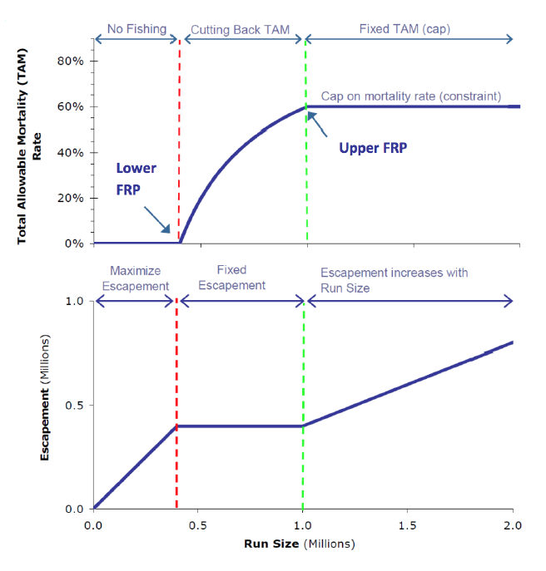

Figure A1. Changes in total allowable mortality (upper panel) and escapement target (lower panel) as a function of run size when using TAM rule harvest strategy. Here run size has been adjusted using pMA (from Pestal, Huang and Cass (2011)).

Cass, A., Folkes, M. & Pestal, G. (2004) Methods for assessing harvest rules for Fraser River sockeye salmon. *Canadian Science Advisory Secretariat Research Document 2004/025***,** 80 p.

DFO (2005) Canada's Policy for Conservation of Wild Salmon.

Grant, S.C.H. & Pestal, G. (2012) Integrated biological status assessments under the wild salmon policy using standardized metrics and expert judgement: Fraser River sockeye salmon (*Oncorhynchus nerka*) case studies. (ed. C.S.A. Secretariat).

Holt, C.A. & Bradford, M.J. (2011) Evaluating benchmarks of population status for Pacific salmon. *North American Journal of Fisheries Management,* **31,** 363-378.

Holt, C.A. & Peterman, R.M. (2006) Missing the target: uncertainties in achieving management goals in fisheries on Fraser River, British Columbia, sockeye salmon (*Oncorhynchus nerka*). *Canadian Journal of Fisheries and Aquatic Sciences,* **63,** 2722-2733.

Larkin, P.A. (1971) Simulation studies of Adams River sockeye salmon (*Oncorhynchus nerka*). *Journal Fisheries Research Board of Canada,* **28,** 1493-1502.

Pestal, G., Huang, A.-M. & Cass, A. (2011) Updated methods for assessing harvest rules for Fraser River sockeye salmon (*Oncorhynchus nerka*). *Canadian Science Advisory Secretariat Research Document 2011/133***,** 175 p.

Scheuerell, M.D. (2016) An explicit solution for calculating optimum spawning stock size from Ricker's stock recruitment model. *PeerJ,* **4,** e1623.