*Biological Sub-model*

*Larkin model*

The Larkin model (Larkin 1971) is an adaptation of the Ricker model that is intended to account for delayed density dependent effect between cycle lines. As a result, it includes multiple parameters and lagged spawner abundances.

Equation A1

where *i* represents a CU, *y* is a given year, *R* the number of recruits (number of offspring that return to spawn or are captured in the fishery), and *S* the number of spawners. The parameter represents the number of recruits produced per spawner at low abundance and the parametersrepresent density dependent interactions at different time lags. Like the Ricker model, the Larkin is generally linearized to account for normally distributed process error with mean 0 and standard deviation . Unlike the Ricker model, however, we did not generate autocorrelated process variance in Larkin stocks because appropriate parameter values for the autocorrelation coefficient are unavailable in the literature and validating a Larkin-model equivalent was beyond the scope of this study.

*Model with skewed process variance*

To parameterize forward simulations incorporating skewed recruitment deviations (representing a decline in productivity), we fit either a modified Ricker or Larkin model to each CU. These models were identical to Eq. 4 and A1, respectively except process error was modeled as

Eq. A2

Where represents the skewness parameter for CU *i*. We fit these models in a Bayesian

framework with weakly informative priors: Normal(0, 5) on and and

Student *t*(3, 0, 3) on and .

*Variation in age-at-maturity*

Although the majority of Fraser River sockeye salmon mature at age 4 (i.e. one year in the gravel, one year of lake residence, and two years of ocean residence), smaller proportions mature at ages 2, 3, and 5, with age structure varying among CUs. We modeled this process by calculating the number of recruits *R* spawning in year *y* in CU *i* as a function of the total number of adult recruits *R’* generated in previous years, multiplied by the proportion *p* of fish that return at a given age *g*:

Equation A2

We incorporated multivariate logistic variation in the proportion of mature fish returning at each age as:

Equation A3

where *y* is the brood year (equal to *y*-2, *y*-3, *y*-4 or *y*-5 in Eqn. A3), the summation in the denominator is over ages 2 to 5, is the CU-specific mean proportion of adult fish that return at a given age, is a parameter controlling interannual variability in the proportion returning at each age, and are standard normal deviates (Holt and Bradford 2011 REF; Table A1). We estimated CU-specific parameters using a simple grid search with time series of age-specific returns (see Table 1 in main text for time series start and end dates).

*Management Sub-model*

*Harvest control rule*

Fraser River sockeye salmon are managed using a harvest control rule that adjusts total allowable catch (TAC) based on in-season forecasts of total return abundances relative to two fishery reference points (FRPs) (Cass, Folkes & Pestal 2004; Pestal, Huang & Cass 2011). There are four management (MUs) for Fraser River Sockeye Salmon (Early Stuart, Early Summer, Summer, and Late Summer) that generally differ in timing of migration and, therefore, their exposure to marine fisheries that largely occur nearshore. As a result, TACs and FRPs are defined at the management unit (MU) level (aggregates of CUs) (Grant & Pestal 2012). The Fraser River sockeye salmon harvest control rule is referred to as a Total Allowable Mortality (TAM) rule because TACs are typically adjusted annually based on two additional sources of mortality. The first adjustment reduces the TAC to account for anticipated mortality experienced during in-river migrations to spawning grounds after the fishery in order to achieve desired escapement goals. Although in reality these en route mortality adjustments (called *pMA*s, proportional management adjustments) vary annually due to in-river conditions, we made the simplifying assumption that they were stable and parameterized MU-specific values using medians since 2000 (Table A2).

The second TAC adjustment is a harvest constraint based on the temporal overlap of co-migrating MUs and their abundances. MUs exhibit some temporal overlap in migration timing, most notably between Summers and Late Summers. Harvest constraints are intended to minimize incidental harvest of depleted MUs that co-migrate with abundant MUs. In reality, linear programming is used to decrease the TAC for abundant MUs as a function of the relative abundance of the MU (or MUs) that have adjacent migratory schedules (Pestal, Huang & Cass 2011). Because estimating these adjustments annually in our simulation model was not computationally feasible (typically requiring X minutes/hours to estimate), we simply applied a 25% reduction in TAC for each MU to account for these constraints unless specific abundance benchmarks were met by all co-migrating MUs, an approach applied previously in simulation by Pestal et al. 2011? (or 2004 report?) (described in detail below).

We used a simplified version of the TAM rule to calculate TACs based on in-season estimates of recruit abundance relative to two FRPs, where TAC varied according to the three zones in Fig. A1:

1. If a MU *m* is in Zone 1 the TAC is calculated using a minimum exploitation rate (0.10 for all MUs except for the Late Run MU). Overlap constraints (i.e. 25% reductions in TAC) are not applied when TACs are estimated using minimum harvest rates *h*min.
2. If a MU is in Zone 2 a constant escapement harvest strategy is used to calculate TAC. The escapement goal (*EG*) is the lower FRP, adjusted upwards based on estimates of en route mortality (*pMA*). For example, if the FRP is 100,000 individuals and the *pMA* for that MU is 0.5 reflecting relatively high levels of en route mortality, the TAC will be calculated assuming an escapement goal of 150,000 spawners. One exception to this rule is that the target harvest rate must be at least the minimum noted in step (1) and cannot exceed a cap of 0.6. An overlap constraint is applied unless the neighboring MUs are above their upper FRP after *pMA*.
3. If a MU is in Zone 3 above its upper FRP (after incorporating the *pMA*), the TAC is calculated using a maximum target exploitation rate of 0.6. As above, an overlap constraint is applied unless the neighboring CUs are above their upper FRP after *pMA*.

MU-specific FRPs, which may vary by cycle line, are shown in Table A2 and an example TAM rule calculation is shown in Figure A1.

The in-season abundance estimates necessary to generate TACs are provided by test fisheries conducted at regular intervals as adult salmon migrate into nearshore areas (i.e. Johnston and Juan de Fuca straits). MU-specific abundance is estimated using genetic stock identification techniques conducted on a subsample of test fishery catches (Beacham et al. 2005). We simulated the in-season estimation process as

Equation A4

where the in-season estimated abundance of returns *Ȓ* in MU *m* and *y* is assumed to be a function of true recruit abundance *R* plus normally distributed observation error with mean and variance .

We parameterized observation error using deviations between in-season and post-season estimates of returning salmon abundance from 2005-2011 (Pacific Salmon Commission, unpublished data). Multiple in-season TACs are produced for each MU and each year because abundance estimates are re-calibrated throughout the migration period. The actual in-season TAC that is primarily used to inform management targets varies interannually and is not clearly documented. We therefore selected an intermediate value that would represent management targets selected after fishing had begun, but before the bulk of fishing occurred. Specifically, we compared the final in-season run size estimate generated after the estimate of migration timing was fixed (i.e. once the 50% migration date had been finalized) to post-season estimates of abundance, which incorporate data collected in freshwater migration corridors and on the spawning grounds. Since this time series was relatively short and most MUs exhibited similar deviations, we used a mean value for ( = 1.2) representing an overestimate of return abundances in-season for all MUs except Early Summers, which were frequently underestimated ( = 0.85). We set = 0.15, representing mean SD among years in deviations between in-season and post-season estimates.

*Fisheries and en route mortality*

Since the majority of fishing mortality occurs at sea, while en route mortality occurs in-river, we modeled each process sequentially. We note that while Fraser River sockeye salmon are also harvested in a variety of in-river fisheries, catches are relatively minor and were not considered in this analysis.

Realized exploitation rates can deviate from targets substantially due to variation in catchability, enforcement, or unreported catch. These processes collectively result in outcome uncertainty and can strongly influence the efficacy of management strategies (Holt & Peterman 2006). We incorporated outcome uncertainty in our model by generating realized catches *C* for each CU *i* within MU *m* as

Equation A5

where is the target TAC and an error term representing CU-specific outcome uncertainty (Table A1).

Similarly, we modeled en route mortality *D* as a stochastic process that varied by CU as a function of the number of fish escaping the fishery ,

Equation A6

where *E* represents the mean and the standard deviation of observed en route mortality since 2000 for each CU. En route mortality was parameterized using observed differences in abundance estimates between in-river and spawning ground sampling locations (2000-2016; Pacific Salmon Commission, unpublished data).

Table A1. Parameter values and justifications for components of biological and management submodels.

|  |  |  |  |  |
| --- | --- | --- | --- | --- |
| **Parameter** | **Reference Value** | **Low Value** | **High Value** | **Justification** |
| (Eq. A3) | 0.1 | 0 | 0.5 | Observed interannual standard deviation in dominant age class (mean among CUs) |
| (Eq. A5 | 0.2 | 0 | 0.5 | Intermediate value used by Holt and Bradford (2011) parameterized using Fraser River fishery data |
| (Eq. A6) | Vary among CUs (range 0.17-0.48) | 0.5 * reference | 1.5 * reference | Observed interannual standard deviation of difference between estimates collected during in-river migration and spawning grounds |

Table A2. MU-specific fishery reference points (in millions of fish) across cycle lines.

|  |  |  |  |  |
| --- | --- | --- | --- | --- |
| **Management Unit** | **Cycle Line** | **Lower FRP** | **Upper FRP** | **Median pMA** |
| Early Stuart | All cycle lines | 0.108 | 0.1512 | 1.11 |
| Early Summer | 1 | 0.11 | 0.154 | 0.64 |
| 2 | 0.18 | 0.252 |
| 3 and 4 | 0.1 | 0.14 |
| Summer | 1 | 0.885 | 1.239 | 0.15 |
| 2 | 1.02 | 1.428 |
| 3 | 0.76 | 1.064 |
| 4 | 0.64 | 0.896 |
| Late | 1 | 0.35 | 0.49 | 1.73 |
| 2 | 1.1 | 1.54 |
| 3 and 4 | 0.3 | 0.42 |

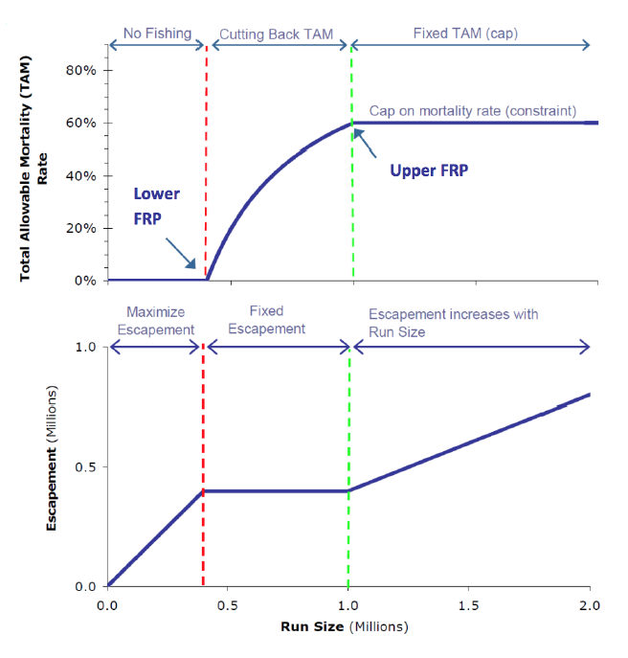

Figure A1. Changes in total allowable mortality (upper panel) and escapement target (lower panel) as a function of run size when using TAM rule harvest strategy. Here run size has been adjusted using pMA (from Pestal, Huang and Cass (2011)).

Cass, A., Folkes, M. & Pestal, G. (2004) Methods for assessing harvest rules for Fraser River sockeye salmon. *Canadian Science Advisory Secretariat Research Document 2004/025***,** 80 p.

DFO (2005) Canada's Policy for Conservation of Wild Salmon.

Grant, S.C.H. & Pestal, G. (2012) Integrated biological status assessments under the wild salmon policy using standardized metrics and expert judgement: Fraser River sockeye salmon (*Oncorhynchus nerka*) case studies. (ed. C.S.A. Secretariat).

Holt, C.A. & Bradford, M.J. (2011) Evaluating benchmarks of population status for Pacific salmon. *North American Journal of Fisheries Management,* **31,** 363-378.

Holt, C.A. & Peterman, R.M. (2006) Missing the target: uncertainties in achieving management goals in fisheries on Fraser River, British Columbia, sockeye salmon (*Oncorhynchus nerka*). *Canadian Journal of Fisheries and Aquatic Sciences,* **63,** 2722-2733.

Larkin, P.A. (1971) Simulation studies of Adams River sockeye salmon (*Oncorhynchus nerka*). *Journal Fisheries Research Board of Canada,* **28,** 1493-1502.

Pestal, G., Huang, A.-M. & Cass, A. (2011) Updated methods for assessing harvest rules for Fraser River sockeye salmon (*Oncorhynchus nerka*). *Canadian Science Advisory Secretariat Research Document 2011/133***,** 175 p.

Scheuerell, M.D. (2016) An explicit solution for calculating optimum spawning stock size from Ricker's stock recruitment model. *PeerJ,* **4,** e1623.