**Retrospective Summary**

We examined temporal changes in Fraser River sockeye salmon productivity (log(R/S)) using three metrics of metapopulation variability: 1) the mean coefficient of variation of the components within an aggregate (CVC), 2) the synchrony index (), which reflects the degree of similarity in the dynamics of an aggregate’s components, and 3) aggregate variability (CVA) which represents the cumulative effects of CVc and on temporal variability. We used 10-year moving windows to calculate trends in each metric for two Fraser River datasets. The first contained 11 CUs with time series of productivity extending to 1948, the second contained 18 CUs with time series extending to 1973.

Mean Fraser River sockeye salmon productivity declined from the late 1980s through 2005, the brood year which was predominantly responsible for producing the poor return in. Subsequently the aggregate exhibited several years of higher productivity, but the trend has remained variable and productivity has recently declined again (Fig. 2a). Mean CVC (i.e. the temporal variability of the “average” CU’s productivity) was relatively stable for most of the time series before showing an increase in the 1990s that steepened over several years (Fig. 2b). Productivity was highly synchronized in the first decade of the time series, followed by a variable, but generally asynchronous period. In the early 2000s, approximately when CVC reached unusually high levels, synchrony increased again (Fig. 2c). Changes in CVA mirror these patterns, showing a dramatic increase in the early 2000s (Fig. 2d).

Macintosh HD:Users:cam:github:synchSalmon:figs:Fig1_RetroTrends.pdf

Figure 1. Temporal variation in Fraser River sockeye salmon productivity, log(recruits/spawner). (a) Trends in observed productivity for 18 CUs with time series beginning between 1948 and 1973; heavy black line represents the unweighted mean. 10-year moving windows of (b) the mean component coefficient of variation, weighted by abundance, (c) the synchrony index, and (d) the coefficient of variation of the aggregate. Solid blacks lines represent trends for 11 CUs with time series extending back to 1948, light red lines represent trends for 18 CUs beginning in 1973.

**Forward-Simulation Summary**

*Model specification*

The closed-loop model forward simulates, with stochasticity, the dynamics of 19 Fraser River CUs. For CUs with evidence of cyclicity (based on the most recent WSP report), recruits are generated using a Larkin model; all other CUs use a Ricker model with weakly autocorrelated recruitment deviations (correlation coefficient fixed at 0.2). To parameterize each CU’s stock-recruit relationship we used median estimates of , , and from an independent analysis (Fraser River Sockeye Spawning Initiative).

Within the model yearly recruitment deviations are drawn from a multivariate normal distribution with mean 0 and standard deviation described by the variance-covariance matrix

where represents the variance of *n* CUs and the correlation among variance parameters. We generated a suite of operating models that varied and/or to assess the relative effect of different component variance and synchrony regimes on sockeye salmon population trajectories. To manipulate component variance, we adjusted CU-specific estimates of upwards or downwards with a fixed multiplier, while we created synchrony treatments by setting to specific values (Table 1). A third set of treatments (‘Interaction’) represented scenarios where both parameters were adjusted simultaneously. These parameter specifications resulted in appropriate shifts in and CVC relative to observed trends (Fig. 2, 3).

Table 1. Operating models used to explore the relative effect of component variance and synchrony regimes on population trajectories.

|  |  |  |  |
| --- | --- | --- | --- |
| Scenario | Low | Moderate | High |
| Synchrony ( |  |  |  |
| Component Variability (CVC) |  |  |  |
| Interaction |  |  |  |

Macintosh HD:Users:cam:github:salmon-sim:outputs:miscSensitivity:synchTests:focalTimeSeries.pdf

Figure 2. Trends in productivity’s synchrony index () simulated with low, reference or high values of . Black line represents observed trend and vertical dotted line the beginning of the simulation period. Colored lines represent median values across 1000 trials.

Macintosh HD:Users:cam:github:salmon-sim:outputs:miscSensitivity:synchTests:focalTimeSeries (dragged).pdf

Figure 3. Trends in mean component CV (CVC) of productivity simulated with low, reference or high values of . Black line represents observed trend and vertical dotted line the beginning of the simulation period. Colored lines represent median values across 1000 trials.

We also incorporated a second productivity scenario in our analysis intended to represent a period of broadly unfavorable environmental conditions for sockeye salmon, which could magnify the relative effects of CVC or synchrony on conservation outcomes. Rather than manipulate per capita productivity directly (i.e. forward simulating with smaller values), we sampled recruitment deviations from skewed, multivariate Student’s t-distribution (heavy-tailed) in a subset of years. Effectively this resulted in an increased frequency of recruitment failures due to strong, negative recruitment deviations. We sampled from this skewed distribution in an average of 30% of simulated years.

To adequately represent the framework used to manage Fraser River sockeye salmon we modeled four sequential sources of mortality: American fisheries, Canadian mixed-stock fisheries, en route mortality during freshwater migration, and terminal Canadian single-stock fisheries. Total allowable catches in both American and Canadian fisheries were calculated using a harvest control rule (HCR) that replicates the Total Allowable Mortality strategy used to allocate catches. In reality, in-season estimates of recruitment derived from test fisheries are used to adjust target exploitation rates and meet escapement goals specific to each management unit (MU). If in-season recruitment estimates exceed escapement goals, the HCR switches to a fixed maximum target mortality rate. Escapement goals vary among years due to the cycles present in several CUs and are typically adjusted downwards to account for mortality during upstream migration. This process was replicated in the simulation by generating a forecasted estimate of abundance using true return abundance plus normally distributed error. By default 85% of the Canadian TAC was allocated to mixed-stock fisheries and 15% to single-stock fisheries, which is approximately equivalent to historical averages. We introduced additional interannual stochasticity into the model via variation in age at maturity, en route mortality, and outcome uncertainty.

*Performance measures*

We evaluated the relative impact of different operating models on population trajectories using a suite of aggregate performance measures (PMs; Table 2). The selected PMs reflect a mixture of long-term conservation and socio-economic targets based on changes in abundance and catches.

Table 2. Definitions of focal performance measures.

|  |  |
| --- | --- |
| **PM** | **Definition** |
| Spawner abundance | Median number of spawners, across all CUs, per year over simulation period |
| Recruit abundance | Median number of recruits, across all CUs, per year over simulation period |
| CUs above lower/upper BM | Mean proportion of CUs above Sgen/ SMSY every year during the simulation period |
| Catch | Median total catch, across all fisheries and CUs, per year over simulation period |
| Fisheries open | Mean proportion of MUs with open fisheries (i.e. above lower reference point), per year over simulation period |
| Years above lower/upper catch threshold | Mean proportion of years in which TAC was greater than 500,000/1,000,000 |

High levels of synchrony were associated with declines in median spawner and recruit abundance (Fig. 4 left column). Under the reference productivity operating model median status was stable across synchrony treatments, although variability among trials increased considerably. However, when productivity was depressed, high levels of synchrony led to an increased probability of CUs remaining below Sgen/SMSY (Fig. 4 left column). CVC­ was positively correlated with spawner and recruit abundance (Fig. 4 center column), but had strong negative effects on the proportion of CUs above their biological benchmarks. For example, the median proportion of CUs above SGen in each year of the simulation period declined from 70 to 60% under conditions of high component variability. When productivity was depressed, median abundance and the proportion of CUs above biological benchmarks both declined; however, the patterns among CVC operating models were qualitatively similar (Fig. 4 center column). Increasing both and CVC led to increased variability among trials and both abundance- and benchmark-based PMs generally declined (Fig. 4 right column).

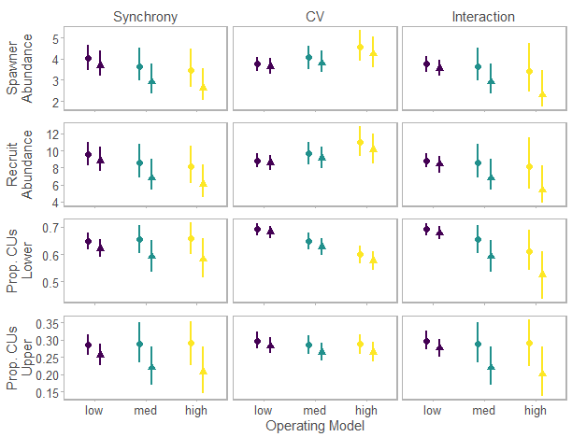

Figure 4. Status of the Fraser River aggregate relative to escapement-based performance metrics at the end of 60-year simulation period. Points represent the median value of abundance performance metrics (mean for proportional abundance metrics) during the simulation, then the median among 300 trials with whiskers representing 90% posterior intervals. Simulations including a reference productivity operating model are represented by closed circles, negative skewed productivity by closed triangles.

The effects of synchrony and CVC on median catch (Fig. 5 top row) closely mirrored patterns in spawner and recruit abundance – catches decreased at high levels of synchrony, but increased with increasing component variability. High levels of synchrony and CVC­ were both associated with a smaller proportion of MUs being above their lower fishery reference point (Fig. 5 second row). Increasing synchrony, but not CVC, also reduced the number of years that aggregate TAC was above lower (500,000 individuals) and upper (1,000,000) catch thresholds (Fig. 5 bottom two rows). There was also evidence of synergistic effects of synchrony and CVC on catch PMs. The proportion of MUs above their reference point and the proportion of years above lower/upper catch thresholds were considerably lower when both metrics were increased simultaneously (Fig. 5 right column). The low productivity scenario resulted in a general decline in status, but, unlike the escapement-based PMs, produced similar trends among synchrony or CVC operating models (Fig. 5).

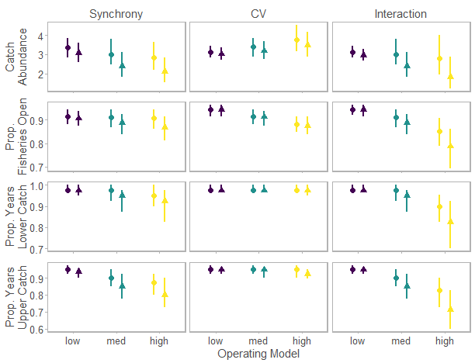

Figure 5. Status of the Fraser River aggregate relative to catch-based performance metrics at the end of 60-year simulation period. Points represent the median value of abundance performance metrics (mean for proportional abundance metrics) during the simulation, then the median among 300 trials with whiskers representing 90% posterior intervals. Simulations including a reference productivity operating model are represented by closed circles, negative skewed productivity by closed triangles.