*Larkin model*

The Larkin model is a modified version of the Ricker that accounts for delayed density dependence between cycle lines. As a result, it includes multiple parameters and lagged spawner abundances.

Equation A2

where *i* represents a CU, *y* is a given year, *R* the number of recruits (number of offspring that return to spawn or are captured in the fishery), and *S* the number of spawners. The parameter represents the number of recruits produced per spawner at low abundance and the parametersrepresent density dependent interactions at different time lags. Like the Ricker model, the Larkin is generally linearized to account for normally distributed process error with mean 0 and standard deviation . Unlike the Ricker model, however, we did not generate autocorrelated process variance in Larkin stocks because appropriate parameter values for the autocorrelation coefficient are unavailable in the literature and validating a Larkin-model equivalent was beyond the scope of this study.

*Harvest control rule*

Fraser River sockeye salmon are managed using a harvest control rule that adjusts total allowable catch (TAC) based on two fishery reference points (FRP). Both TACs and FRPs are defined at the management unit (MU) level (i.e. aggregates of conservation units) because MUs exhibit relatively consistent differences in migration timing that moderate their exposure to commercial marine fisheries. The overarching framework for this harvest control rule is referred to as a Total Allowable Mortality (TAM) rule because TACs are adjusted based on environmental conditions. Specifically, in-season estimates of recruit abundance are adjusted downwards to account for mortality that occurs in-river during migration to spawning grounds. This management adjustment is set as a proportion of the escapement target (referred to as a pMA) and attempts to ensure that a sufficiently large number of spawners is allowed to “escape” the fishery to reach spawning grounds, even if considerable en route mortality occurs. Given variability in how pMAs are generated in any given year, we assumed they were stable in our forward simulation and used median values since 2000 (Table A1).

The Fraser River Panel of the Pacific Salmon Commission meets weekly to assess each MU’s abundance relative to its FRPs, resulting in one of three harvest strategies:

1. If an MU is below its lower FRP the TAC is calculated using a minimum exploitation rate (0.10 for all MUs except Lates), which is intended to account for mortality due to test fishing and bycatch in mixed stock fisheries (even though MUs differ in run timing, substantial overlap persists).
2. If a MU is between its lower and upper FRP, a constant escapement harvest strategy is used to calculate TAC. The escapement target is the lower FRP, adjusted upwards based on estimates of en route mortality (i.e. the pMA). For example, if the FRP is 100,000 individuals and the pMA is 0.5 that year, reflecting relatively high levels of loss en route, the TAC will be calculated assuming an escapement target 150,000 spawners. The exception to this rule is the target exploitation rate must be at least the minimum noted above and cannot exceed 0.6.
3. If a MU is above its upper FRP (after incorporating the pMA), the TAC is calculated using a target exploitation rate of 0.6.

The in-season abundance estimates necessary to generate TACs are provided by test fisheries conducted at regular intervals as adult salmon migrate into nearshore areas (i.e. Johnston and Juan de Fuca straits). Total abundance is disaggregated into MU-specific abundance using genetic stock identification techniques conducted on a subsample landed test fishery catches (Beacham et al. 2005).

We simulated the in-season estimation process as

Equation A1

where the estimated abundance of recruits *Ȓ* in MU *m* and *y* is assumed to be a function of true recruit abundance *R* plus normally distributed observation error with mean and standard deviation 0.15.

Observation error was parameterized using deviations between in-season and post-season estimates of salmon abundance from 2005-2011 (Fraser River Panel reports). Given that estimates of in-season abundance are updated throughout the migration period, multiple in-season TACs are produced for each MU and each year. Therefore when parameterizing forecast uncertainty, we compared the final in-season run size estimate generated after the estimate of migration timing was fixed (i.e. 50% migration date had been finalized) to post-season estimates of abundance, which incorporate data collected in freshwater migration corridors and on spawning grounds. MU-specific FRPs, which may vary by cycle line, are listed in Table A1 and an example TAM rule calculation is shown in Figure A1. Most MUs exhibited similar deviations and was set to 1.2 for all MUs except Early Summers, which were frequently underestimated ( = 0.85).

Table A1. MU-specific fishery reference points (in millions of fish) across cycle lines.

|  |  |  |  |
| --- | --- | --- | --- |
| **Management Unit** | **Cycle line** | **Lower FRP** | **Upper FRP** |
| Early Stuart | All cycle lines | 0.108 | 0.1512 |
| Early Summer | 1 | 0.11 | 0.154 |
| 2 | 0.18 | 0.252 |
| 3 and 4 | 0.1 | 0.14 |
| Summer | 1 | 0.885 | 1.239 |
| 2 | 1.02 | 1.428 |
| 3 | 0.76 | 1.064 |
| 4 | 0.64 | 0.896 |
| Late | 1 | 0.35 | 0.49 |
| 2 | 1.1 | 1.54 |
| 3 and 4 | 0.3 | 0.42 |

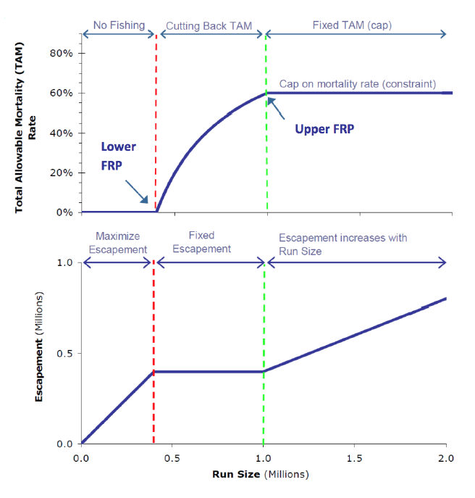

Figure A1. Changes in total allowable mortality (upper panel) and escapement target (lower panel) as a function of run size when using TAM rule harvest strategy. Here run size has been adjusted using pMA.

*Fisheries and en route mortality*

We modeled four sequential sources of mortality that were arranged to reflect the relatively discrete fisheries that target Fraser River sockeye salmon. The first represented American, mixed-stock fisheries. The TAC for these fisheries is fixed at either zero (for the Early Stuart MU) or 16.5% of the total TAC generated using the TAM rule framework (for all other MUs). The remaining portion of the TAC was split between two other fisheries – a Canadian mixed stock marine fishery and a Canadian single stock fishery that served as a proxy for multiple in-river fisheries (e.g. First Nations, demonstration, sport). Although the size of in-river fisheries varies interannually, as well as among CUs, we made the simplifying assumption that 85% of the Canadian TAC would be allocated to mixed-stock by default.

Realized exploitation rates can deviate from targets substantially due to variation in catchability, enforcement, or unreported catch. These processes, collectively referred to as outcome uncertainty, can strongly influence the efficacy of management strategies and the trajectories of different populations. We incorporated outcome uncertainty in our model by generating realized harvest rates *H* for each CU *i* within MU *m* in fishery *f* as

Equation A3

where is the target TAC, *R* the true abundance of recruits, and an error term representing CU-specific outcome uncertainty. Thus each CU within an MU had the same target harvest rate, but realized harvest rates would differ. Since there is no evidence to suggest a persistent bias in sockeye salmon catches, the error distribution had mean zero and standard deviation . Although is often assumed to be fishery specific (e.g. REFS) and larger in subsistence fisheries, local managers suggested there was no evidence that in-river fisheries would deviate more or less strongly from target catch rates (personal communication).

Since fisheries occur sequentially, realized catches are simply a function of each fishery’s harvest rate and the number of recruits escaping previous fisheries, e.g. for the Canadian mixed-stock fishery catch

Equation A4

Similar to the fisheries, en route mortality *D* was also modeled as a stochastic, CU-specific process occurring after Canadian mixed-stock fisheries and before Canadian single-stock fisheries.

Equation A5

where *E* represents the median and the standard deviation of observed en route mortality since 2000 for each MU.