**Methods**

*Sockeye salmon biology, fisheries and data sources*

Sockeye salmon is an anadromous, semelparous fish distributed throughout the northern Pacific. Populations in southern British Columbia typically rear as juveniles in freshwater lakes for one-two years, mature in the Gulf of Alaska, and return to spawn as two-five year olds (Burgner 1991). In Canada, Pacific salmon status is assessed at the scale of conservation units (CUs) – groups of spawning populations with a common life history strategy, adult migration phenology, genetic history, and juvenile rearing habitat (Holtby & Ciruna 2007; Grant *et al.* 2011). Sockeye salmon CUs typically contain fewer spawning populations and are more spatially restricted than other Pacific salmon due to their dependence on nursery lakes (Holtby & Ciruna 2007). The Fraser River sockeye salmon aggregate is composed of 24 CUs, which are grouped into four management units (MUs) based on adult migration timing (Grant *et al.* 2011). Like many Pacific salmon, Fraser River sockeye salmon are only targeted by commercial fisheries as they move through nearshore areas relatively close to their natal rivers. As a result, shifting marine fishery openings to coincide with a given migration phenology can be used to constrain effort at the MU, but not the CU, level. The Fraser River sockeye salmon MUs included in this analysis, along with their component CUs, are listed in Table 1.

The time series of salmon abundance we used for this analysis are derived from estimates of spawner and recruit (age-specific catch plus escapement minus an adjustment for en route mortality) abundance for 19 CUs (Grant et al. 2011), with individual time series beginning between 1948 and 1973 (Table 1). Escapement estimates were generated using a variety of techniques including fence counts, mark-recapture and visual surveys, and passive sonar methods (Grant et al. 2011). Catch is estimated in marine and freshwater fisheries for each CU and age class. Methods for estimating escapement and catch are reviewed in detail in Grant et al. (2011).

Table 1. Relevant sockeye salmon management units and component conservation units within the Fraser River aggregate.

|  |  |  |  |  |  |
| --- | --- | --- | --- | --- | --- |
| MU | CU | Stock | Status† | SR Model | Time Series |
| Early Stuart | Takla-Trembleur | Early Stuart | Red | Larkin | 1948-2011 |
| Early Summer | Bowron | Bowron | Red | Ricker | 1948-2011 |
| Shuswap-ES | Seymour | Amber | Larkin | 1948-2011 |
| Scotch | Amber | Ricker | 1980-2011 |
| North Barriere | Fennel | Amber | Ricker | 1967-2011 |
| Anderson-Seton | Gates | Amber/Green | Ricker | 1968-2011 |
| Nadina-Francois | Nadina | Amber/Green | Ricker | 1973-2011 |
| Pitt | Upper Pitt River | Green | Ricker | 1948-2011 |
| Summer | Takla-Trembleur | Late Stuart | Red/Amber | Larkin | 1948-2011 |
| Francois-Fraser | Stellako | Amber/Green | Ricker | 1948-2011 |
| Kamloops-ES | Raft | Amber | Ricker | 1948-2011 |
| Quesnel | Quesnel | Red/Amber | Larkin | 1948-2011 |
| Chilko | Chilko | Green | Ricker | 1948-2011 |
| Harrison (river-type) | Harrison | Green | Ricker | 1948-2011 |
| Late Summer | Shuswap-L | Late Shuswap | Amber/Green | Larkin | 1948-2011 |
| Lillooet-Harrison | Birkenhead | Amber | Ricker | 1948-2011 |
| Cultus | Cultus | Red | Ricker | 1948-2011\* |
| Seton | Portage | Red | Ricker | 1965-2011 |
| Harrison (upstream) | Weaver Creek | Red | Ricker | 1966-2011 |

*Synchrony metrics and retrospective analysis*

We examined temporal changes in three metrics of metapopulation variability (Loreau & de Mazancourt 2008; Thibaut & Connolly 2013). The synchrony index reflects the relative degree of similarity in the dynamics of an ecological aggregate’s components. It is defined as the total temporal variance of the components (i.e. sum of all elements of the variance-covariance matrix), divided by the variance of a hypothetical aggregate with the same component variances, but perfect covariance.

Equation 1 $φ= \frac{\sum_{ij}{v_{n}^{pop}(i, j)}}{(\sum_{i}{ {\sqrt{v_{n}^{pop}(i, i)})}^{2}}}= \frac{v_{n}^{agg}}{(\sum_{i}{ {\sqrt{v_{n}^{pop}(i, i)})}^{2}}}$

Here *v* denotes variance (over time) for populations *i* through *j* making up an aggregate. Thus the simplified numerator represents the variance of aggregate abundance, consisting of *n* populations, and the denominator is the variance of a hypothetical, perfectly synchronized population (Loreau & de Mazancourt 2008; Thibaut & Connolly 2013). The synchrony index $φ$ is analogous to comparing mean pairwise correlation coefficients, which have been used in similar analyses (e.g. Peterman and Dorner 2012), but $φ$ makes no distributional assumptions, is normalized (i.e. ranges between 0 and 1 rather than -1 and 1), and explicitly accounts for unequal variances among components (Thibaut & Connolly 2013).

The second metric is the mean of the component populations’ coefficients of variation (CVc), weighted by each component’s mean abundance.

Equation 2 ${CV}_{C}= \sum_{i}{\frac{m_{n}^{pop}(i)}{m_{n}^{agg}} \frac{\sqrt{v_{n}^{pop}(i, i)}}{m_{n}^{pop}(i)}}$

where *mpop*(*i*) is the mean abundance (through time) of population *i* and *magg* is the mean abundance of the aggregate.

Finally, we calculated the coefficient of variation for the aggregate (CVA) as a function of the first two metrics following Thibaut and Connolly (2013)

Equation 3 ${CV}_{A}= \sqrt{φ} {CV}_{C}$

This metric defines CVA as linearly proportional to CVC, with a constant of proportionality related to synchrony. Thus as synchrony increases CVA becomes more similar to CVC, while CVA is dampened when components vary asynchronously.

To explore changes in aggregate variability of Fraser River sockeye salmon, we generated time series of $φ$, CVC, and CVA using 10-year moving windows of per capita productivity, log(recruits/spawner). Since Fraser River CUs vary in the length of their spawner-recruit time series, we generated trends in these metrics using two datasets. The primary dataset consisted of 11 CUs with data extending back to the 1948 brood year, while the second contained 18 CUs with data beginning in the 1973 brood year (Table 1). To place these changes in a broader management context, we also present temporal changes in observed productivity, aggregate spawner abundance, and aggregate catch.

*Forward simulation*

*Structure of biological and management submodels*

We used a stochastic, closed-loop simulation model to explore how differences in aggregate variability may influence conservation outcomes for Fraser River sockeye salmon. The model includes CU-specific population dynamics and harvesting, as well as process and management implementation uncertainty. The dynamics of each CU were simulated using age-structured, stock recruit models which typically took the form of the Ricker model (Ricker 1975)

Equation 3 $R_{i,y}=S_{i,y}e^{α_{i}-β_{i}S_{i,y}}$

where *i* represents a CU, *R* the number of recruits (number of offspring that return to spawn or are captured in the fishery), and *S* the number of spawners in year *y*. The parameter $α$ represents the number of recruits produced per spawner at low abundance and $β$ the density-dependent parameter, the reciprocal of the number of spawners that produce maximum recruits. This model is commonly arranged to account for normally distributed process error $w_{i}$ as

Equation 4 $log⁡(\frac{R_{i,y}}{S_{i,y}})=α_{i}- β_{i}S_{i,y}+ w_{i}$

$w_{i}=normal(0, σ_{i})$

The productivity of a subset of CUs with cyclic dynamics (Table 1) was simulated using a Larkin model, a modified version of the Ricker model that accounts for interactions among brood years, i.e. delayed density-dependent effects (Larkin 1971; details in Appendix). Whether we estimated productivity for a given CU using a Ricker or Larkin model followed assignments made in the most recent Wild Salmon Policy assessment (DFO *in press*; Table 1).

To parameterize each CU’s stock-recruit relationship we used median estimates of $α$, $β$, and $σ$ generated from an external, CU-specific Bayesian stock recruit analysis (ref to FRSSI). To account for autocorrelation and incorporate covariation among CUs we simulated deviations from the stock-recruitment relationship as

Equation 5 $w_{i,y}=w_{i,y-1}s+ r_{i,y}$

$$r_{i} \sim MVN\left(0, V_{n}\right)$$

$$V_{n}= \left[\begin{matrix}σ_{1}σ_{1} & ⋯ & σ_{1}σ_{n}ρ \\ ⋮ & ⋱ & ⋮ \\ σ_{n}σ_{1}ρ & ⋯ & σ_{n}σ_{n}\end{matrix}\right]$$

where $w_{i,y-1}$ represents the previous year’s recruitment deviation, $τ$ represents an AR1 autocorrelation coefficient, and $r_{i,y}$ represents random error drawn from a multivariate normal distribution with mean 0 and standard deviation defined by the variance-covariance matrix **V** for *n* CUs. We assigned $τ$ a value of 0.2 for CUs modeled with a Ricker relationship, consistent with evidence of weak autocorrelation in the residuals of these models (results not shown). Note that recruitment deviations in Larkin models did not include an autocorrelation component because AR1 processes have not been validated in these models and the inclusion of delayed density dependence parameters, to some extent, accounts for such effects.

We also incorporated a second productivity scenario in our analysis intended to represent a period of broadly unfavorable environmental conditions for sockeye salmon, which could magnify the relative effects of changes in CVC or synchrony. Decreases in productivity are commonly modeled by shrinking $α$ relative to reference values (e.g. Dorner et al. 2009, Holt & Folkes 2015), representing a change to a less favourable productivity regime. Rather than manipulate per capita productivity in this way, we chose to create a scenario where mean productivity remained the same, but the frequency of recruitment failures increased. These could represent, for example, intermittent periods of poor marine survival that are thought to regularly result in synchronous, poor returns of Pacific salmon (Mueter, Pyper & Peterman 2005; Peterman & Dorner 2012). To simulate this process we sampled recruitment deviations from a skewed, multivariate Student *t* distribution (heavy-tailed) in a subset of years (Anderson *et al.* 2017). Deviations $r_{i}$ were fit with the following distribution

Equation 6 $r_{i} \sim MVT\left(0, V_{n}, v, γ\right)$

where **V** is defined as in Equation 5, *v* represents the degrees of freedom parameter, and $γ$ the skewness parameter. Lower values of *v* corresponding to heavier tails and as *v* approaches infinity, the *t* distribution approaches the normal distribution (Anderson *et al.* 2017). When $γ$ is negative the distribution is left-skewed, when it is positive it is right-skewed. We assigned relatively moderate values to both parameters $(v=7;γ=-1.5)$ that are consistent with relatively weak evidence of heavy tails (Anderson *et al.* 2017) and a mean estimate of skewness from models fit to CU-specific stock-recruitment residuals. In the skewed productivity scenario we sampled from the Student *t* distribution with a mean frequency of 0.3 and a multivariate normal distribution in all other years, resulting in an increased likelihood of recruitment failures in approximately one third of the simulation period.

To compare the skewed productivity scenario to more commonly simulated low productivity regimes, we also incorporated an operating model where average productivity is directly reduced by using smaller values of $α$. Specifically we used estimates from the 10th percentile of the posterior distribution of each CU’s $α$ estimates, rather than the median, to represent a transition to a persistently low productivity regime. This model generally produced declines in performance metrics that were more severe, relative to the reference productivity scenario, than the skewed scenario described above (results presented in Appendix).

The closed-loop simulation incorporated two sources of mortality. The first mortality mechanism simulated harvest in mixed stock fisheries. Total allowable catch (TAC) in this fishery was calculated each year using a harvest control rule (HCR) that approximates the Total Allowable Mortality framework currently used to manage the Fraser River sockeye salmon fishery (Pestal, Huang & Cass 2011). Broadly speaking, this HCR uses in-season estimates of recruitment derived from test fisheries to adjust TACs and meet escapement goals specific to each management unit (MU). If in-season recruitment estimates exceed escapement goals, the HCR switches to a fixed maximum target mortality rate. Escapement goals vary among years due to persistent cycles present in several CUs and are typically adjusted upwards (i.e. TACs reduced) to account for mortality during upstream migration and spatial overlap between abundant and depleted MUs. The second simulated source of mortality represented en route mortality that occurs after fish enter freshwater due to a combination of natural mortality (thermal stress, pathogen infection, predation) and unreported harvest (Grant *et al.* 2011). We modeled en-route mortality as a stochastic, CU-specific process because it appears to be correlated with migration phenology, in-river temperatures, and freshwater flow (Macdonald 2000; Cooke *et al.* 2004; Crossin *et al.* 2008). Details of the harvest control rule, mortality calculations, and parameter specifications are described in the Appendix.

We introduced additional stochasticity into the model via interannual variation in age at maturity, in-season abundance estimates error, en route mortality, and deviations between target and realized exploitation rates (implementation uncertainty). The results we present in the main text are based on simulations with the reference value for each parameter only; however, we tested the effect of alternative values in a series of sensitivity analyses to ensure that our results were robust to this assumption. Details of how each process was parameterized are described in the Appendix and results of sensitivity analyses are provided in an online supplement.

*Component variability and synchrony “treatments”*

The principal drivers of variability in aggregate abundance within the model are deviations from CU-specific stock-recruitment relationships (i.e. *w* in Equation 5). To explore the consequences of greater aggregate variability on recruitment potential, we manipulated the strength of recruitment deviations to create nine operating models defined by unique variance-covariance matrices **V**, with each representing a distinct component variability and synchrony “treatment” (Table 2). We created component variance treatments by adjusting CU-specific estimates of process variance $σ$ up or down by 25%. We selected these adjustments because they were sufficient to produce changes in CVC, but constrained $σ$ to values that are plausible for sockeye salmon. We parameterized synchrony treatments by adjusting the correlation coefficient $ρ$ to values consistent with 10-year moving window estimates of mean pairwise correlations in log(R/S) among CUs from historical observations, current observations, or values moderately higher than present.

Table 2. Parameterization of component variability and synchrony operating models.

|  |  |  |  |
| --- | --- | --- | --- |
|  | Low CVC | Moderate CVC | High CVC |
| Low $φ$ | $$0.75σ; ρ=0.05$$ | $$σ; ρ=0.05$$ | $$1.25σ; ρ=0.05$$ |
| Moderate $φ$ | $$0.75σ; ρ=0.5$$ | $$σ; ρ=0.5$$ | $$1.5σ; ρ=0.5$$ |
| High $φ$ | $$0.75σ; ρ=0.75$$ | $$σ; ρ=0.75$$ | $$1.5σ; ρ=0.75$$ |

*Evaluating model performance*

We first confirmed that each operating model produced the predicted changes in CVC and $φ$. We then used a suite of performance measures (PMs) to assess how changes in each metric altered the likelihood of achieving conservation- and catch-based management objectives. The first conservation-based PM we generated was recruit abundance, calculated as the temporal median number of individuals (at the aggregate level, i.e. summed across CUs) that were available to be harvested or to escape to their spawning grounds each year. The second and third conservation-based PMs incorporate biological benchmarks based on stock-recruit analyses, providing a more nuanced estimate of population status than absolute abundance. These were calculated as the mean proportion of CUs within the aggregate that were above their individual upper (*S*MSY) and lower (*S*Gen) biological benchmarks during the simulation period. SMSY is defined as the estimated spawner abundance necessary to achieve maximum sustainable yield, while SGen is the estimated spawner abundance necessary to recover to *S*MSY in one generation in the absence of fishing mortality (Holt 2009). The equations used to estimate these metrics are presented in the Appendix. Finally, we calculated the proportion of CUs extirpated at the end of the simulation period based on a quasi-extinction threshold of 100 individuals.

Catch-based PMs included median catch, a measure of interannual catch stability, and three PMs associated with fishery benchmarks. We quantified interannual catch stability $∆C$ as

Equation 7 ${∆C}_{t}={(\frac{abs\left(C_{t} - C_{t-1}\right)}{C_{t}})}^{-1}$

where *C* is aggregate catch in year *t*. We defined the first of the benchmark PMs as the mean proportion of MUs with recruit abundance greater than the minimum escapement target (i.e. the lower fishery reference point specified by the harvest control rule). The other two catch-based PMs are calculated as the proportion of years during the simulation period where total allowable catch (TAC) across all MUs was greater than 500,000 and 1,000,000 fish. When aggregate TAC is below the smaller value, managers struggle to allocate sufficient quota to priority stakeholders (i.e. food, social, and ceremonial harvest for various First Nations) and when it is above the larger value managers are able to allocate some degree of catch to the commercial sector. Note that while the proportion of fisheries open is based on “true” recruit abundance, representing a hypothetical omniscient manager, the PMs based on TAC thresholds incorporate uncertainty associated with the in-season forecast process.

Although we focused our analyses on aggregate performance metrics because CVC and synchrony are calculated across groups of populations or species, it is likely that the consequences of increased aggregate variability will vary among components due to differences in productivity or abundance. An exhaustive analysis of CU-specific differences was beyond the scope of this paper, however to illustrate potential differences we present simulated changes in median spawner abundance across CVC and synchrony treatments for two CUs: Cultus (a low abundance CU that is considered at risk) and Chilko (an abundant CU that regularly makes up a considerable portion of commercial catch).

Instead of priming the simulation with initial abundances sampled from random distributions, we used CU-specific time series of recruit and spawner abundance (i.e. the same data that were used in the retrospective analysis). We used these time series to ensure that each CU’s abundance reflected the best estimate of its current status and to seed cyclic CUs (i.e. those simulated with a Larkin model) with representative levels of variation among cycle lines. The length of the simulation period was set at 40 years (approximately 10 sockeye salmon generations) and each OM was simulated 1000 times (a supplementary analysis indicated variation in output metrics stabilized after 500-700 simulation runs). To evaluate differences in performance between OMs, we present median outputs among simulations, as well as 10th and 90th percentiles. We stress, however, that this study is not intended to accurately forecast the dynamics of Fraser River CUs or to predict the trajectory of the aggregate as a whole. Rather our goal is to demonstrate relative differences in projected performance associated with differences in component variability and synchrony.

**Results**

*Retrospective analysis*

Mean Fraser River sockeye salmon productivity (log(recruits/spawner)) declined from the late 1980s through 2005, the brood year predominantly responsible for producing the poor return in 2009. Subsequently the aggregate exhibited several years of higher productivity, but productivity has recently declined again and remains variable (Figure 1a). Aggregate spawner abundance and aggregate catch increased until the early 1990s before declining (Figure 1b,c), coincident with declines in productivity and exploitation rate. However, there is substantial interannual variability in the patterns of both metrics due to highly abundant, cyclic CUs and particularly large returns were observed in 2010 and 2014 (catches for 2014 not shown).

Mean CVC (i.e. the temporal variability of the “average” CU’s productivity) was stable for most of the time series before showing a sharp increase in the 1990s that steepened over several years (Figure 1d). Productivity was relatively highly synchronized in the first decade of the time series, followed by a variable, but generally asynchronous period. In the early 2000s, approximately when CVC reached its unusually high levels, synchrony increased again (Figure 1e). As expected, changes in CVA mirror these patterns, showing a dramatic increase in the early 2000s (Figure 1f). Patterns in spawner abundance, catch, and variability metrics were robust to time series length and the number of CUs incorporated.

Macintosh HD:Users:cam:github:synchSalmon:figs:Fig1_RetroTrends.pdf

Figure 1. Observed trends in Fraser River sockeye salmon productivity (log (recruits per spawner)), aggregate spawner abundance, and aggregate catch (a-c). 10-year moving window estimates of the mean component coefficient of variation (CVC), synchrony index ($φ$), and aggregate variability (CVA) (d-f). Solid black lines represent trends for 11 CUs with time series extending back to 1948, lighter red lines represent trends for 18 CUs beginning in 1973.

*Forward simulation*

By specifying low, medium, and high values for $σ$ and $ρ$ we were able to generate scenarios consistent with historical, current, and moderately elevated trends in CVC and the synchrony index $φ$ (Figure 2). These patterns were not strongly influenced by the productivity regime in the model (Figure 2).

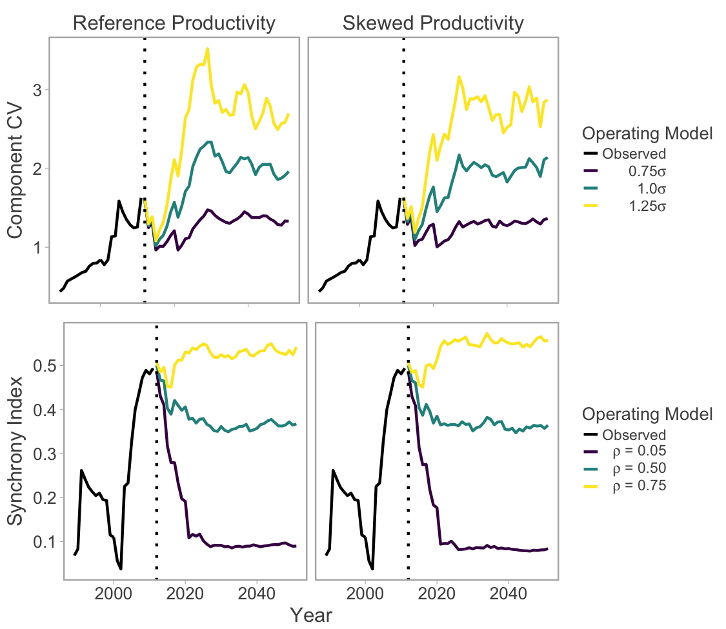

Figure 2. Changes in component variability and synchrony as a function of $σ$ and $ρ$, respectively. Trends in the observed stock-recruitment dataset are shown in black, the dashed line represents the beginning of the simulation period, and colored lines represent different CVC and synchrony operating models. Lines represent medians across 250 trials.

Changes in CVC and synchrony interacted to produce relatively strong impacts on certain conservation-based performance metrics, but had negligible or contrasting effects on others. For example, greater CVC increased median recruit abundance as long as synchrony remained low (purple points Figure 3a); however as synchrony increased, this pattern disappeared (yellow points Figure 3a). Conversely, higher levels of CVC were associated with a smaller proportion of CUs being above their lower biological benchmark (Sgen) and increasing synchrony only increased variability among trials (Figure 3b). A similar, albeit weaker, relationship occurred in the proportion of CUs above their upper biological benchmark (SMSY; Figure 3c), while the proportion of CUs that were extant at the end of the simulation was largely independent of component variability and synchrony (Figure 3d).

The negative effects of high CVC and synchrony on conservation-based PMs were notably stronger when the model included skewed process variance, representing intermittent recruitment failures. For example, when CVC and synchrony were increased simultaneously in the skewed scenario, median aggregate recruit abundance declined from approximately eight million individuals to five million, while the median proportion of CUs above their lower and upper benchmarks declined by more than 10% (Figure 3e,f,g). The effects of greater synchrony were particularly magnified in the skewed operating model relative to the reference productivity scenario and led to fewer CUs being above their biological benchmarks even when CVC was low (Figure 3f,g)

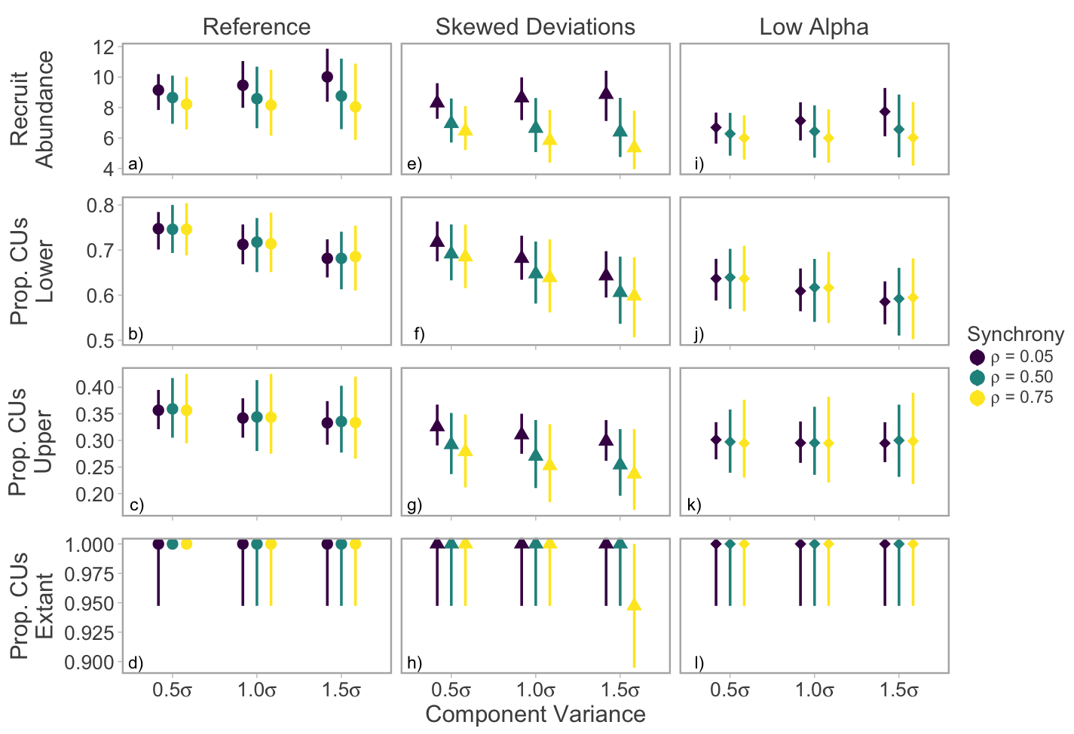

Figure 3. Effects of component variability and synchrony on conservation-based performance measures. Points represent medians and whiskers 90% posterior interval among 250 simulation runs.

The effects of greater component variability and synchrony also had severe effects on several catch-based PMs. Similarly to recruit abundance, median catches were positively correlated with component variability as long as synchrony remained low, but this relationship weakened or reversed as synchrony increased (Figure 4a). Interannual catch stability (i.e. the inverse of median interannual differences in catch) was strongly negatively correlated with both component variability and synchrony (Figure 4b). For example, median interannual fluctuations in aggregate catches increased from 45% (37-56% 90% PI) to 73% (59-83% 90% PI) when CVc and $φ$ were increased to their highest levels. The median number of MUs with fisheries that were open was relatively less sensitive, but still declined at higher levels of component variability and synchrony (Figure 4c). Finally, the proportion of years where aggregate TAC was below a critical threshold (1,000,000) increased by approximately 15% when component CV and synchrony were at high levels, suggesting managers would be less able to allocate some amount of TAC to all stakeholders (Figure 4d).

Interestingly the effects of switching from reference to skewed productivity deviations had weaker effects on catch PMs than conservation PMs. While median catches decreased considerably (Fig. 4e), the remaining PMs were relatively stable except when high CVC was coupled with moderate or high levels of synchrony (Fig 4g, 4h).

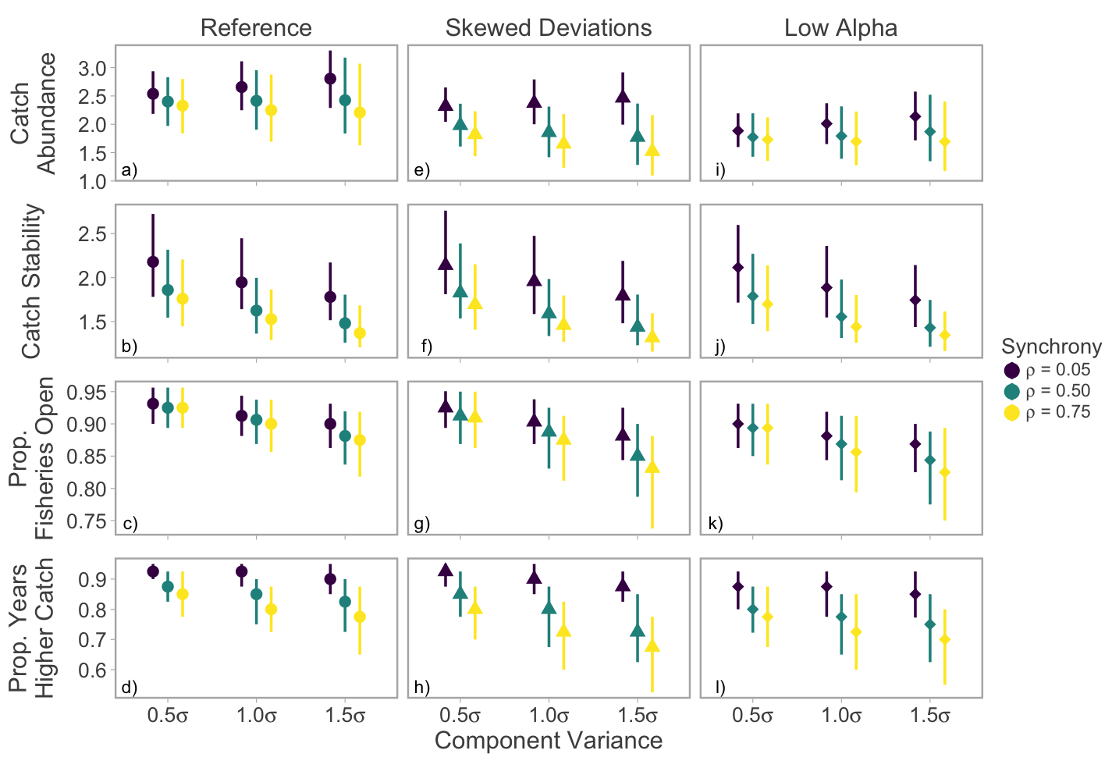

Figure 4. Effects of component variability and synchrony on catch-based performance measures. Points represent medians and whiskers 90% posterior interval among 250 simulation runs.

CU-specific median spawner abundances declined with greater component variability and when recruitment deviations were sampled from a skewed distribution. Shifts in median abundance relative to biological benchmarks were actually more severe in a relatively healthy CU (Chilko) because the depleted CU (Cultus) did not exhibit a high likelihood of recovery even when component variability was low and intermitted recruitment failures were not incorporated (Figure 5). Median spawner abundance within CUs did not exhibit strong declines when CVC was held constant and synchrony increased (Figure S1).

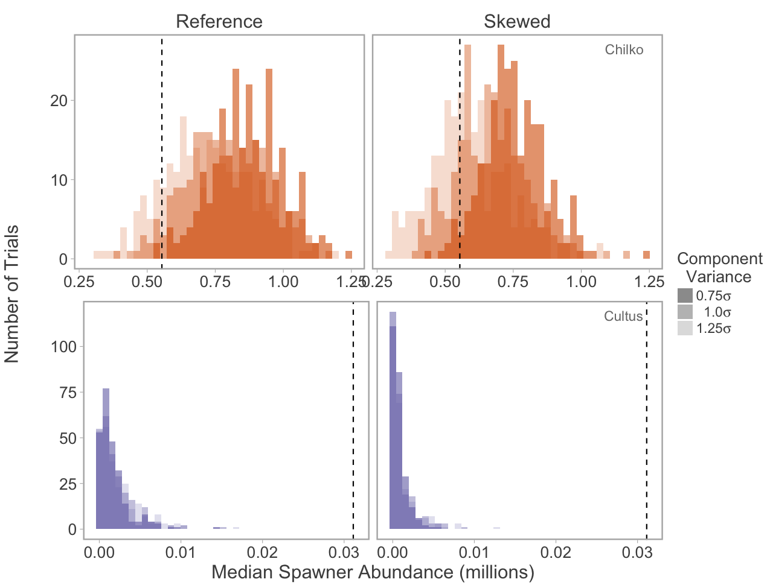

Figure 5. Distributions of CU-specific median spawner abundance (among 250 trials) across different levels of component variability (shading) and two productivity regimes for Chilko (top) and Cultus (bottom) CUs. The vertical dashed line represents each CU’s upper biological benchmark (Smsy). Simulations included moderate synchrony among CUs ( $ρ$ = 0.5). Note that x-axes differ between CUs.

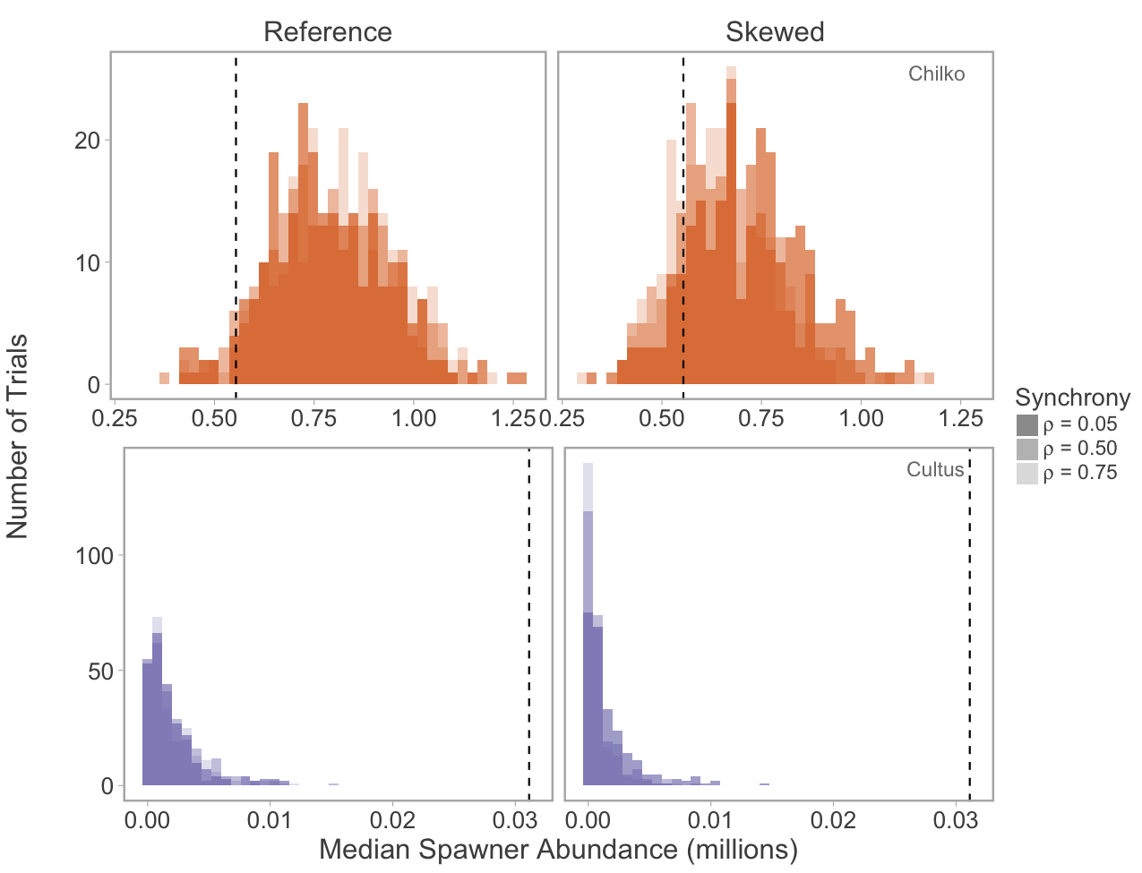

Figure S1. Distributions of CU-specific median spawner abundance (among 250 trials) across different levels of synchrony (shading) and two productivity regimes for Chilko (top) and Cultus (bottom) CUs. The vertical dashed line represents each CU’s upper biological benchmark (Smsy). Simulations included moderate synchrony among CUs (1.0 $σ$). Note that x-axes differ between CUs.

Anderson, S.C., Branch, T.A., Cooper, A.B. & Dulvy, N.K. (2017) Black-swan events in animal populations. *Proceedings of the National Academy of Sciences*.

Burgner, R.L. (1991) Life history of Sockeye Salmon (*Oncorhynchus nerka*). *Pacific Salmon Life Histories* (eds C. Groot & L. Margolis).University of British Columbia Press, Vancouver, B.C.

Cooke, S.J., Hinch, S.G., Farrell, A.P., Lapointe, M.F., Jones, S.R.M., Macdonald, J.S., Patterson, D.A., Healey, M.C. & van der Kraak, G. (2004) Abnormal migration timing and high en route mortality of sockeye salmon in the Fraser River, British Columbia. *Fisheries Research,* **29,** 22-33.

Crossin, G.T., Hinch, S.G., Cooke, S.J., Welch, D.W., Patterson, D.A., Jones, S.R.M., Lotto, A.G., Leggatt, R.A., Mathes, M.T., Shrimpton, J.M., Van Der Kraak, G. & Farrell, A.P. (2008) Exposure to high temperature influences the behaviour, physiology, and survival of sockeye salmon during spawning migration. *Canadian Journal of Zoology,* **86,** 127-140.

Dorner, B., Peterman, R.M. & Su, Z. (2009) Evaluation of performance of alternative management models of Pacific salmon (*Oncorhynchus* spp.) in the presence of climatic change and outcome uncertainty using Monte Carlo simulations. *Canadian Journal of Fisheries and Aquatic Sciences,* **66,** 2199-2221.

Grant, S.C.H., MacDonald, B.L., Cone, T.E., Holt, C.A., Cass, A., Porszt, E.J., Hume, J.M.B. & Pon, L.B. (2011) Evaluation of uncertainty in Fraser Sockeye (*Oncorhynchus nerka*) wild salmon policy status using abundance and trends in abundance metrics. *Candian Science Advisory Secretariat Research Document,* **2011/087**.

Holt, C.A. (2009) Evaluation of benchmarks for conservation units in Canada's Wild Salmon Policy: Technical Documentation. *Canadian Science Advisory Secretariat Research Document 2009/059***,** 50 p.

Holt, C.A. & Folkes, M.J.P. (2015) Cautions on using percentile-based benchmarks of status for data-limited populations of Pacific salmon under persistent trends in productivity and uncertain outcomes from harvest management. *Fisheries Research,* **171,** 188-200.

Holtby, L.B. & Ciruna, K.A. (2007) Conservation units for Pacific salmon under the Wild Salmon Policy. *Canadian Service Advisory Secretariat Research Document,* **2007/070,** 358 p.

Larkin, P.A. (1971) Simulation studies of Adams River sockeye salmon (*Oncorhynchus nerka*). *Journal Fisheries Research Board of Canada,* **28,** 1493-1502.

Loreau, M. & de Mazancourt, C. (2008) Species synchrony and its drivers: neutral and nonneutral community dynamics in fluctuating environments *The American Naturalist,* **172,** E48-E66.

Macdonald, J.S. (2000) Mortality during the migration of Fraser River sockeye salmon (*Oncorhynchus nerka*): a study of the effect of ocean and river environmental conditions in 1997. *Canadian Technical Report of Fisheries and Aquatic Sciences,* **2315,** 120 p.

Mueter, F.J., Pyper, B.J. & Peterman, R.M. (2005) Relationships between Coastal Ocean Conditions and Survival Rates of Northeast Pacific Salmon at Multiple Lags. *Transactions of the American Fisheries Society,* **134,** 105-119.

Pestal, G., Huang, A.-M. & Cass, A. (2011) Updated methods for assessing harvest rules for Fraser River sockeye salmon (*Oncorhynchus nerka*). *Canadian Science Advisory Secretariat Research Document 2011/133***,** 175 p.

Peterman, Randall M. & Dorner, B. (2012) A widespread decrease in productivity of Sockeye Salmon (*Oncorhynchus nerka*) populations in western North America. *Canadian Journal of Fisheries and Aquatic Sciences,* **69,** 1255-1260.

Ricker, W.E. (1975) Computation and interpretation of biological statistics of fish populations. *Fisheries Research Board of Canada Bulletin,* **191**.

Thibaut, L.M. & Connolly, S.R. (2013) Understanding diversity-stability relationships: towards a unified model of portfolio effects. *Ecology Letters,* **16,** 140-150.