GZDoom Multiplayer Launcher

Simple Multiplayer Launcher for GZDoom found here: <https://zdoom.org/index>

Features

* Hover over elements to find out more about it
* Host or Join
* Number of Players (1-8)
* Game Type (Co-op, Deathmatch, Alternative Deathmatch)
* Difficulty Level (1-5)
* Episode Selector (1-4)
* Map Selector (1-9)
* Broadcast to Master Server?
* IP Address
* Port Number
* Additional Commands

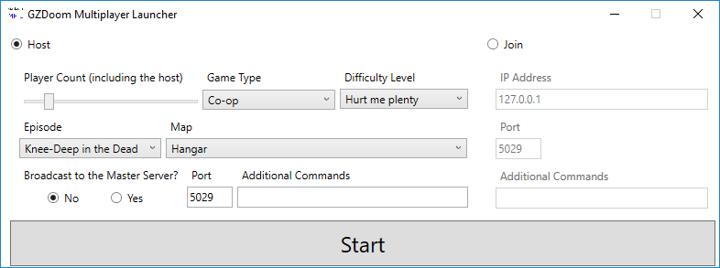

Usage

Place GZDoom Multiplayer Launcher in the root directory of your gzdoom folder then run.

Limitations/Future Improvements

* Currently only works on Doom shareware version, Doom full version, and Doom Ultimate with the default wad being loaded automatically.