How to use Cam’s Budget

This spreadsheet was created to keep track of a budget while searching for a job with no income from a primary job. This will help keep track of monthly expenses, the dollar amount left after each month, and how long you have before your starting funds are completely depleted.

Disclaimer: The amounts in this example are arbitrary and are in no way based in reality.

This spreadsheet contains two sheets, **Budget Sheet** and **Expenses**.

**Initial Setup**

Budget Sheet

Begin by updating your name in the blue box.

Any cells highlighted in yellow will be *input* cells.

Begin by configuring fixed monthly expenses and any additional income to be expected every month.

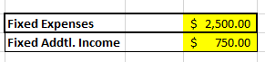

In the cells below, configure the names of the categories you would like to track for this budget as well as the dollar amount allocated to each category per month.

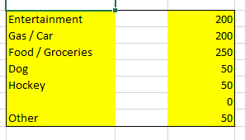

Below, you may set a total starting dollar amount while beginning the job search.



Next, enter the start date for the use of your new budget.

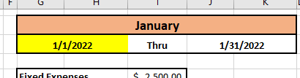

***Congratulations!*** Your budget sheet is set up and ready to use.

Expenses

Change your name on the top, and you are ready to begin using this sheet!

Every time you make a purchase, enter the dollar amount in the category in which you would like that purchase to apply. The **Budget Sheet** will automatically be updated to reflect the changes. Below is an example of how this should look.

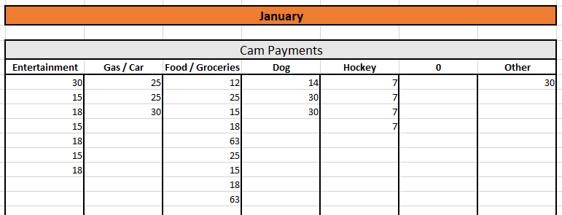

**Monthly Maintenance**

When you are ready to add an additional month, follow the steps below:

1) Highlight the columns for the most recent month (**including spaces between that and the previous month**).

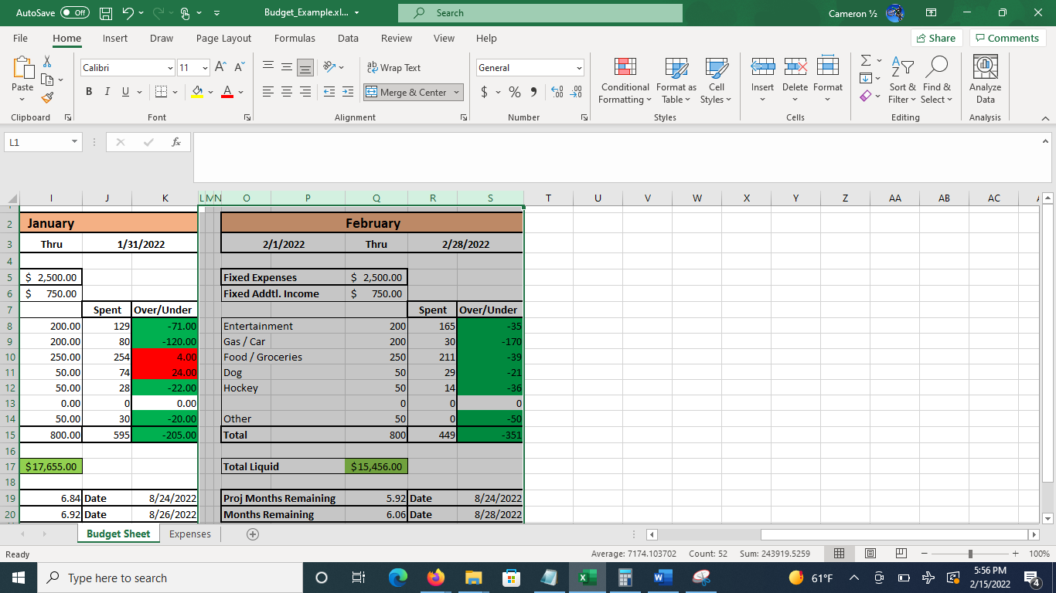

2) Choose copy.

3) Click on the top-left available cell after the most recent month.

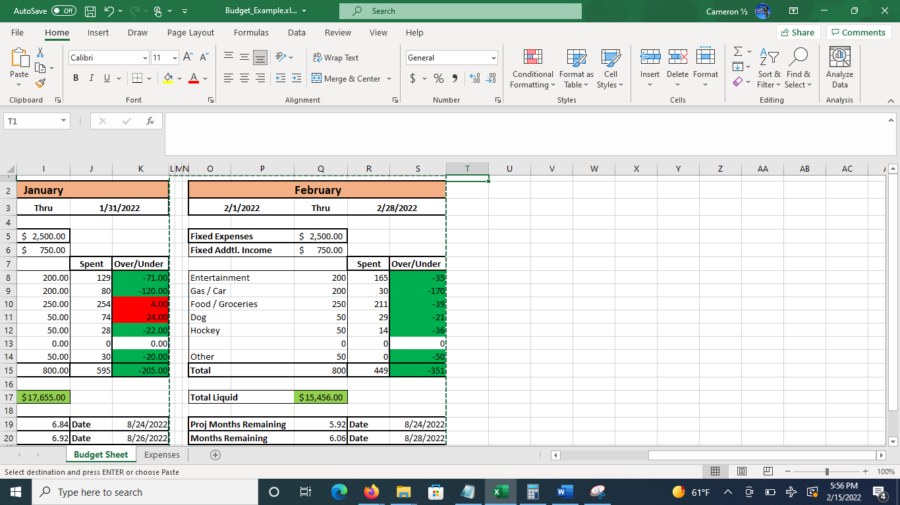

4) Choose paste. Everything should automatically update with current numbers and names for the next month.

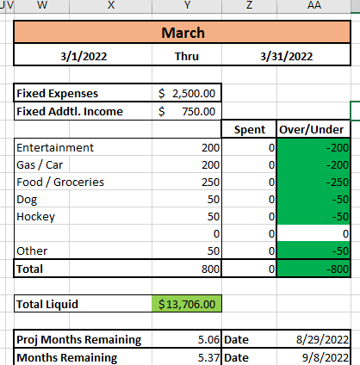

**This process is exactly the same for the Budget Sheet and the Expenses sheet!**

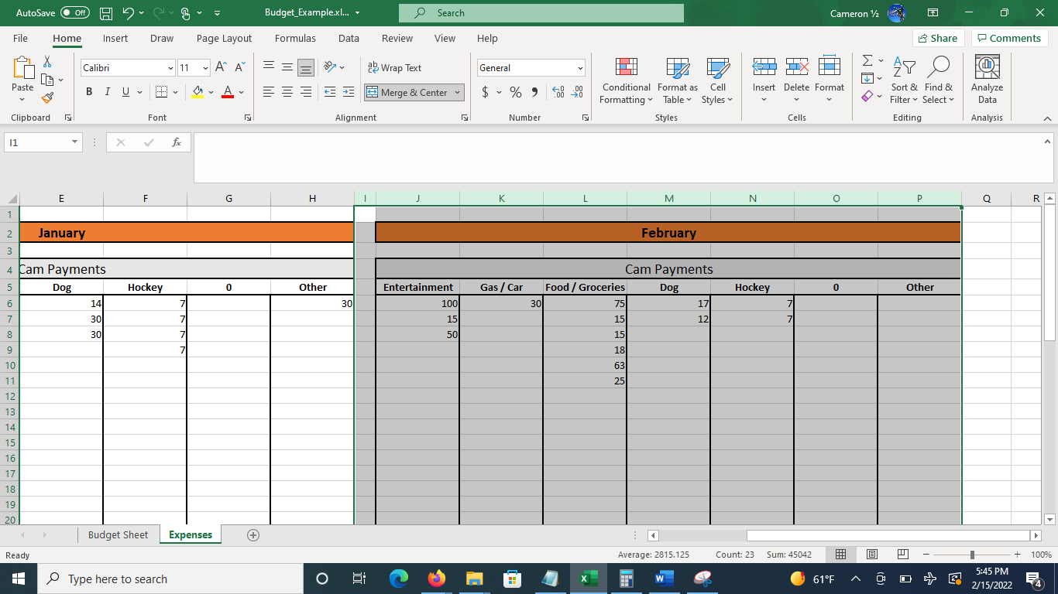

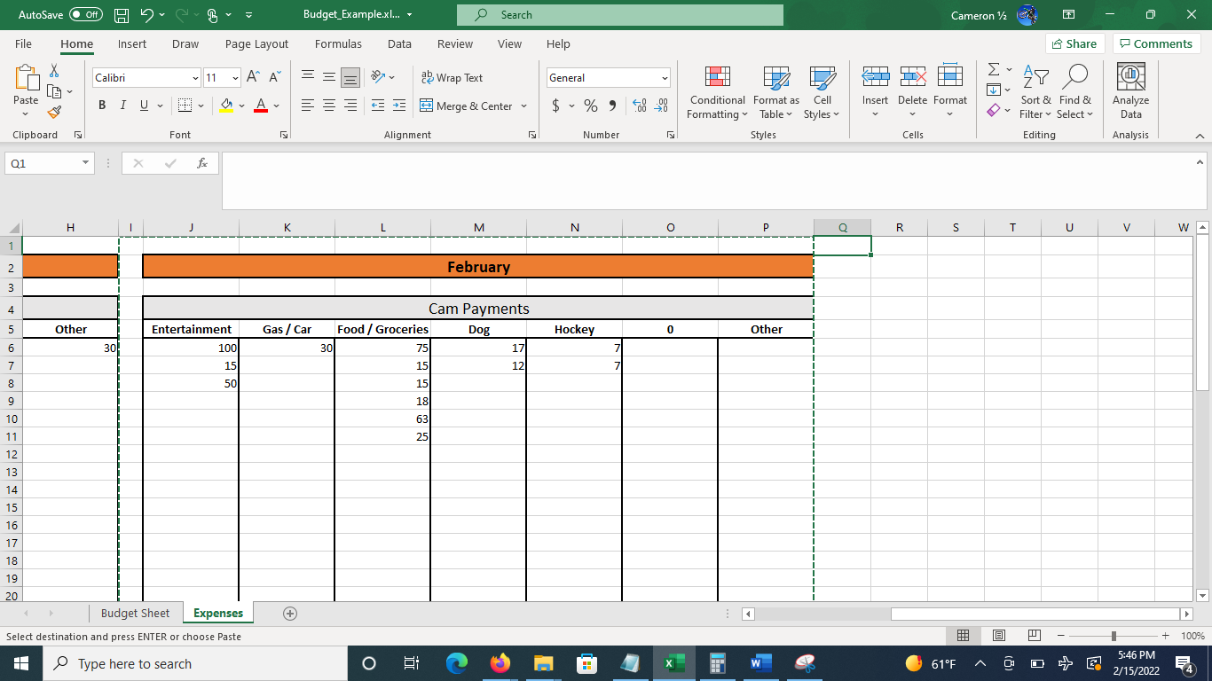 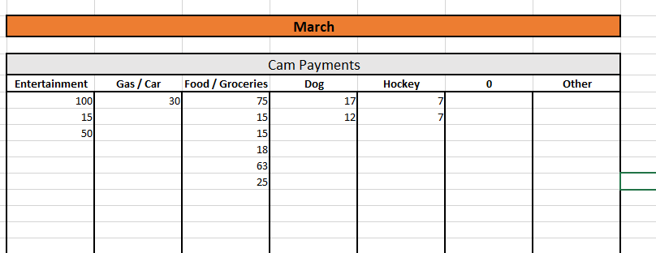

**Note: Expenses carry over. You can clear these by highlighting cells with values and pressing delete.**

**How to Read**

A month of budget info will look similar to that pictured below.

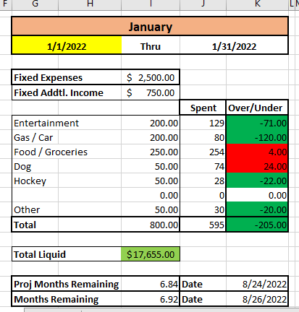

When a budget is under, it will display in green. When over budget, the value will display red.

Total Liquid is the dollar amount you have left at the **end of the month** after all expenses, additional incomes, and the amount you have spent during that month.

The ‘Proj Months Remaining’ field is calculated at the beginning of the month and will tell you how many months you have left and a date which you can expect to have your funds depleted completely as long as you spend exactly what you have budgeted during that month.

The ‘Months Remaining’ field takes the real values spent and calculates how many months you have left and a date which you can expect to have your funds depleted completely **at the end of that month**.