CET3004 – Robotics
Assignment-1
Robot Control: Path Tracking with PID Control

Name: Cameron Haynes
REG Number:1634902708

Introduction
This will be a 2D simulation in pygame (Python) that displays a PID controlled simulated robot that moves across a grid with a set of static obstacles using the A* pathfinding algorithm. This is applying control theory while being able to test different weights of the PID controller.
Methodology
The basic system architecture goes as follows: Planner(A*) → PID Controller → Robot Model → Simulation. The files are broken down as such: planner.py: generates path (A* algorithm) pid.py: computes control signals based on error robot.py: simulates motion using kinematic model simulator.py: visualizes motion and integrates all components. The factors effecting the sim are the sim speed, current position, vector (heading) and the time step. The parameters for the simulation will go as follows: a 20x20 grid size, a time step of 0.1, a set of 4-5 static obstacles with the goal being at coordinate (1,1) and the end being (18,18). The A* path will be generated using the Manhattan heuristic (|x1 − x2| + |y1 − y2|). |x1 − x2| refers to the difference between of the x coordinates in order to find the horizontal distance. |y1 − y2| refers to the difference between of the y coordinates in order to find the vertical distance. We can use the Manhattan heuristic as this can be mapped out as a series of straight lines as well as it being able to be directly applied to the A* search algorithim (Laalaoui, Y. and Bouguila, N. (2014)).
Implementation
The simulation will be done in python with pygame Pygame (n.d.) being the framework used.
Two PID controllers are used within the program, a heading PID which controls angular velocity (omega) and the speed PID which controls liner velocity (v). A PID controller has 3 controller parameters; Responsiveness (kP), Error state (kI) and Damping (kD). kP outputs a value equal to the error is the error is large. kI works on the historic value of the error meaning when the error is eliminated the kI wont increase in value. kD acts as an “anticipatory control" by acting as a estimate for future inward data. In summary for the parameters the higher the value of kP the faster the correction, the smaller the value of kI the more stable the path is and the higher the value of kD , more “damping” the more aggressive he prevention of any overshooting is. The controller has an anti wind-up to prevent large errors from being inputted due to input saturation, this is in the form of the variable integral_limit, which is set to 10. The heading error (heading_error) put between [-π, π] to prevent a sudden jump in the angled adjustments. The robots velocity are capped to max_speed and max_angular_velocity.

The calculation for the PID while to perform adjustments is calculated as such (in pid.py):
class PIDController:
def __init__(self, kp, ki, kd, integral_limit=10.0):
self.kp = kp
self.ki = ki
self.kd = kd
self.integral_limit = integral_limit
self.integral = 0.0
self.prev_error = 0.0

def update(self, error, dt):
p_term = self.kp * error
self.integral += error * dt
self.integral = max(min(self.integral, self.integral_limit), -self.integral_limit)
i_term = self.ki * self.integral
d_term = self.kd * (error - self.prev_error) / dt
self.prev_error = error
control = p_term + i_term + d_term
return control

This is a manual (trial-and-error) tuning. Three PID configs are presented in the program:

Figure 1
 | Heading (Kp, Ki, Kd) | Speed (Kp, Ki, Kd) | Behaviour
1. Under-damped | (3.5, 0.01, 0.3) | (1.2, 0.05, 0.1) | Fast but jittery
2. Over-damped | (0.8, 0.001, 2.5) | (0.3, 0.001, 1.0) | Smooth but slow
3. Well-tuned | (1.8, 0.005, 0.8) | (0.6, 0.02, 0.3) | Stable, smooth

Results
- Run 1 (Under Damped):
PID values in figure 1
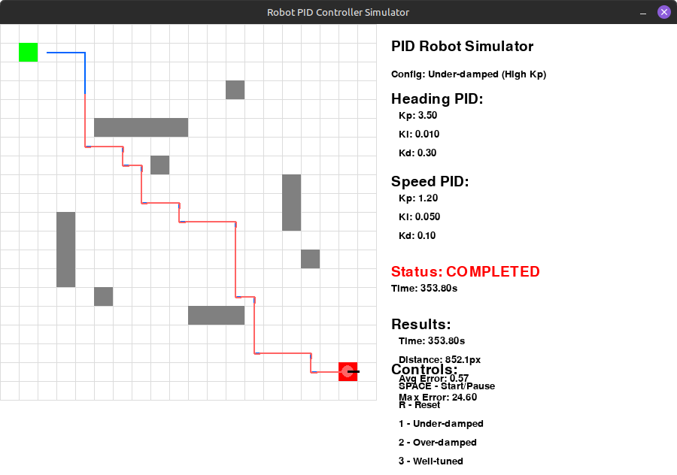
time_to_goal: 353.800
path_length: 852.115
avg_cross_track_error: 0.574
max_cross_track_error: 24.604
num_samples: 3537.000

- Run 2 (Over Damped):
PID values in figure 1
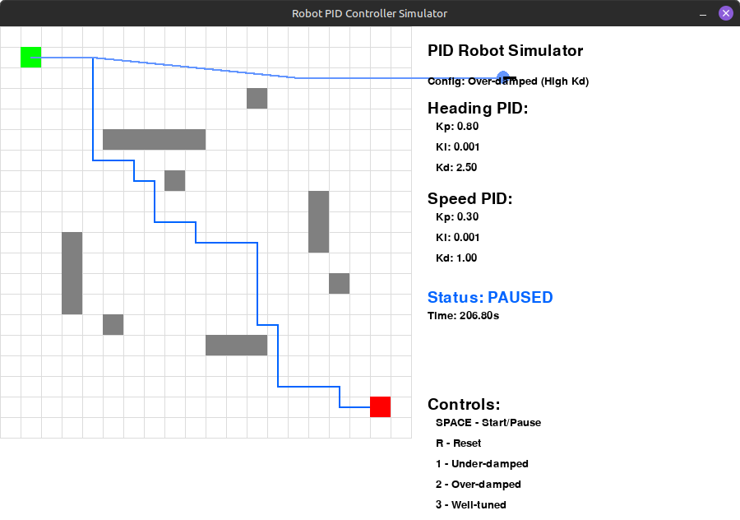
time_to_goal: N/A
path_length: N/A
avg_cross_track_error: N/A
max_cross_track_error: N/A
num_samples: N/A

- Run 3 (Well Tuned):
PID values in figure 1
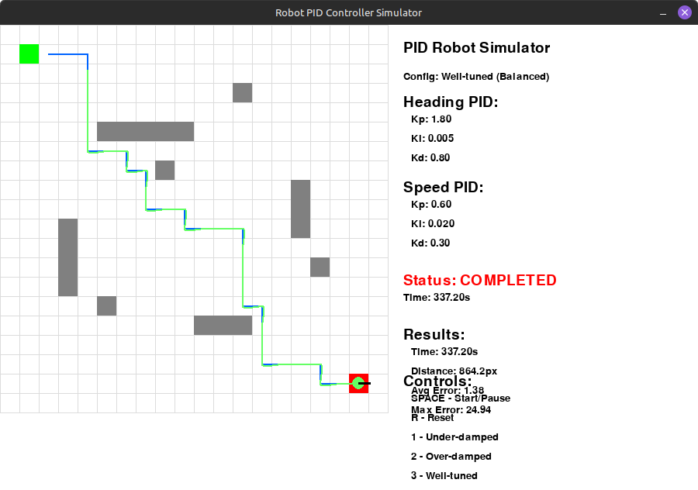
time_to_goal: 337.200
path_length: 864.204
avg_cross_track_error: 1.379
max_cross_track_error: 24.942
num_samples: 3371.000
Discussion
PID controllers in application can be used in movement based robots , such as quadrupedal robots like Boston dynamics robot dog “Spot” Gulz-Haake, S. and Malmquist, K. (2023). Dependent on said application the tuning may differ, reliant on factors such as the intended environment.
An environment may effect the best tuning for a PID, an example of this could be if the robot is designed to be deployed in adverse weather such as heavy rain and wind in which it will have to have a quick reaction to its environment therefore an under-damped controller may be best suited due to its ability to react faster than a over-damped controller. As well as this errors in the control systems may lead to a robot deviating from the intended course which may lead to cases of the robot creating an unsafe environment such as a tripping hazard, bumping into fragile objects in critical areas (e.g power plants) or direct harm to other life via a collision (Zhang et al., 2025).
An ethical discussion on autonomous robotics is one of great interest due to the questions it raises. One such question would be the accountability in autonomous robots. How are we to determine responsibility for the actions of a robot? There are many teams that go into creating a robot such as designers, manufactures, developers, maintainers and more. To give a fair adjudication on the responsibility can be complex due to context of the situation as well as any faults and who those faults are overlooked by. As well as his the deployment of these robots may lead to a major disruption within the work force meaning that workers may love their livelihoods by loosing a job they are capable at due to automation, which may lead to increased economic inequality as labour intensive jobs get replaced by automation.
An under-damped system the high proportional gain (kP) means the robot reacts quickly to errors with the downside of oscillating heavily which leads to the path not being smooth as shown in Test 1.
In the over-damped system the low proportional gain (kP) manifests in a weak error correction and the high derivative gain (kD) resists the motion of change heavily which both lead to a slow response. In test 2 this s shown to overshoot and not reach the target.
A well-tuned system the proportional gain(kP), derivative gain(kD) and integral (kI) are generally balanced in order to achieve a middle ground between speed and stability. This is shown in test 3 in which the max_error was kept to a similar amount than the under-damped system while having a longer track and only being approximately 2 seconds slower. The well-tuned system has a higher avg_cross_track_error than and under-damped as the error response inst as aggressive in a well-tuned system.

Conclusion
This 2d pygame simulation shows expected behaviour from these systems (under-damped, over-damped and well-tuned PID controllers) when navigating an environment using A* pathfinding. This simulation shows that an over-damped system may overshoot to the extent it may not reach the target while a under-damped system can become jittery due to the sensitive error correction while a well-tuned system is a middle ground between the two systems, balancing speed and accuracy. These systems are critical in robotics systems due to external factors such as safety of the environment and life around the robot, which means to get them correct for the circumstance is of upmost importance.

References
- Pygame (n.d.). Pygame Front Page — pygame v2.0.0.dev15 documentation. [online] www.pygame.org. Available at: https://www.pygame.org/docs/.
- Laalaoui, Y. and Bouguila, N. (2014). Pre-run-time scheduling in real-time systems: Current researches and Artificial Intelligence perspectives. Expert Systems with Applications, 41(5)
- Gulz-Haake, S. and Malmquist, K. (2023). Automation of High-accuracy Marking Tasks at MAX IV using the Quadrupedal Robot Spot. [online] Lub.lu.se. Available at: http://lup.lub.lu.se/student-papers/record/9113741
- Zhang, C., Zhang, X., Yang, W., Zhang, G., Wan, J., Lei, M. and Dong, Z. (2025). Safe Path Planning Method Based on Collision Prediction for Robotic Roadheader in Narrow Tunnels. Mathematics, [online] 13(3), p.522. doi:https://doi.org/10.3390/math13030522.

