Task2:
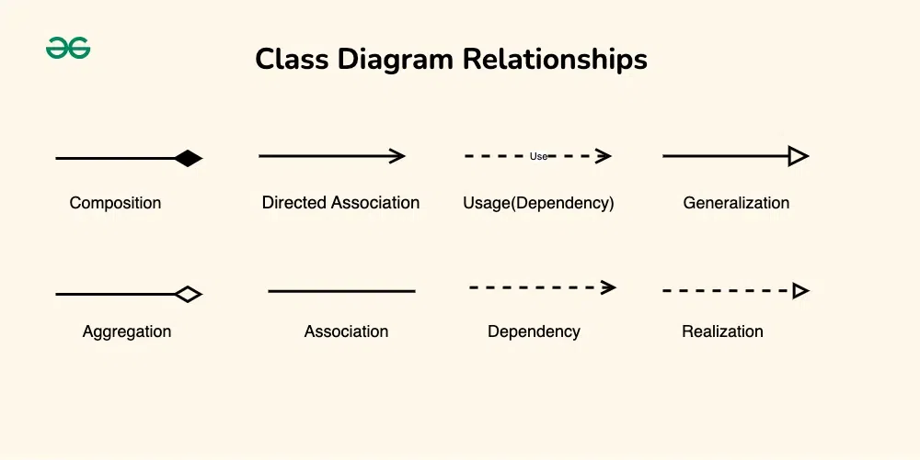Figure 1: https://www.geeksforgeeks.org/system-design/unified-modeling-language-uml-class-diagrams/
Outside the scope: Caring for humans
Dog can be considered as a class
Owner can be an attribute
Treatment can be a method
Cats and Dogs can inherit from a animal class

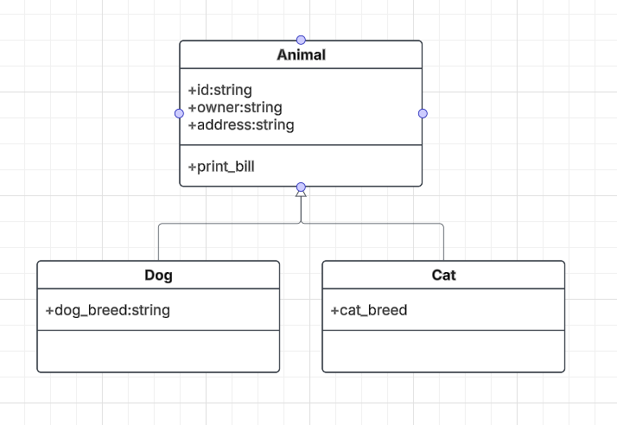
Task3:

