GEORGIA INSTITUTE OF TECHNOLOGY
School of Electrical and Computer Engineering
ECE 6562 — Final Project Proposal
Autonomous Control of Robotic Systems · Summer 2026
PROPOSAL DUE
Wednesday, June 10, 2026 — 11:59 PM ET
Submit a single PDF on Canvas. Each person should submit a proposal even if you are on a team.

Project & Team Information
Project Title | Multi-Sensor Radar-Camera Fusion
Team Member(s) | Cameron Thomas (cthomas386@gatech.edu) - Solo
GT Username(s) | cthomas386
Project Category | Estimation / Multi-target Tracking
Hardware / Compute | Pure simulation

1. Problem Statement & Motivation
In autonomous systems, relying on a single sensor introduces single points of failure and physical limitations. A radar can provide range and velocity tracking but suffers from poor angular resolution and false alarms from environmental clutter. A camera can provide highly precise angular bearing but lacks ranging. This project intends to explore heterogeneous track-level sensor fusion (or track-to-track fusion). The intent is to have a camera and radar run independent trackers and design a supervisor system that can robustly associate, align, and fuse the asynchronous and distinct track lists into a single global estimate.

2. Background & Related Work
Single-sensor target tracking using Global Nearest Neighbor (GNN) and Kalman filtering is well-established. [1] [2] The primary complexity here arises in the track-to-track association (T2TA) domain. When combining tracks from different sensors, the system must determine if radar track X and camera track Y represent the same object. This is achieved by calculating statistical distances, such as the Mahalanobis distance, across the shared state spaces (angles) and solving the assignment problem using the Hungarian (Munkres) algorithm. [4] Once associated, the tracks are fused using algorithms like Covariance Intersection (CI) [3], which accounts for unknown cross-correlations between the independent filters, ensuring the fused covariance remains consistent and doesn't become overconfident.

3. Proposed Approach
To establish the tracking environment, the simulation models N independent targets moving within a 2D Cartesian plane. Each target's kinematics are governed by a discrete-time Constant Velocity (CV) motion model:
x(k) = F * x(k-1) + w(k)
Where the true target state vector is defined in 2D Cartesian coordinates as x = [px, vx, py, vy]^T, representing position and velocity in the X and Y coordinates. F represents the state transition matrix, and w(k) is white Gaussian process noise with a covariance matrix Q.
The radar is modeled as an active sensor providing range (r) and azimuth (theta) measurements corrupted by zero-mean Gaussian noise v_rad, alongside uniform Poisson environmental clutter. The non-linear measurement model is expressed as:
z_rad = [r; theta] = [sqrt(px^2 + py^2); atan2(py, px)] + v_rad
Because the measurement space is non-linear relative to the Cartesian tracking state, an Extended Kalman Filter (EKF) is utilized.

The camera acts as a passive, bearing-only sensor providing a single high-accuracy azimuth measurement:
z_cam = [theta] = atan2(py, px) + v_cam

The central supervisor acts as a track-to-track fusion manager executing at a fixed update interval. It functions via a three-step sequence:
Coordinate Realignment: The supervisor queries the active local radar tracks and projects their 2D Cartesian position estimates into a 1D angular domain to align with the camera track space:
theta_rad_proj = atan2(py_est, px_est)

A cost matrix is constructed calculating the angular Mahalanobis distance between all active projected radar tracks and local camera tracks. The optimal global track pairing is solved using the Hungarian assignment algorithm via the scipy linear sum assignment utility.

Paired angular tracks are merged using Covariance Intersection (CI) to account for unknown cross-correlations between the independent sensor nodes. Using an optimization weight parameter omega (ranging from 0 to 1) calculated at each step to minimize the determinant or trace of the fused covariance, the supervisor yields a structurally consistent global track covariance P_fused and state estimate x_fused:

inv(P_fused) = omega * inv(P_rad_proj) + (1 - omega) * inv(P_cam)
x_fused = P_fused * (omega * inv(P_rad_proj) * theta_rad_proj + (1 - omega) * inv(P_cam) * theta_cam)

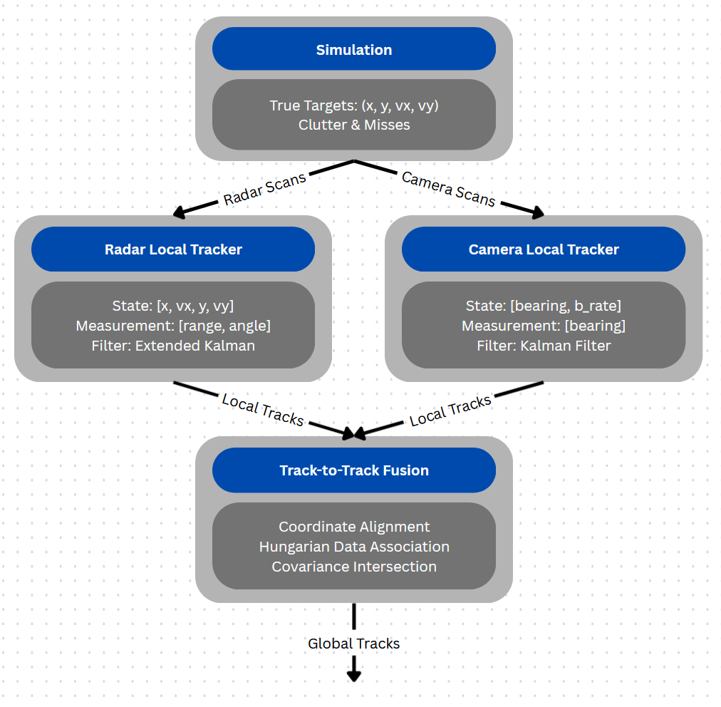

4. Novelty & Expected Contribution
This project presents a comprehensive empirical evaluation of a decentralized, heterogeneous late-fusion pipeline. The core contribution is the implementation and analysis of a track-to-track data association supervisor architecture operating over structurally disparate state spaces. This work will quantitatively characterize how track retention behavior and filter consistency degrade under varying sensor cross-correlations. The study will explicitly chart the boundaries where track-level association fails compared to raw single-sensor performance.

5. Evaluation Plan
Two primary metrics will be evaluated to measure success. First, pose root-mean-squared-error (RMSE) will be calculated to determine the difference between global fused track estimates and ground truth target states over time. Second, track retention latency will measure the average time delay between target birth in the simulation and stable confirmation by the global fusion manager.
To quantify the benefits of the sensor fusion, two baselines will be used. A radar-only baseline and a camera-only baseline will be used. The fused performance will be benchmarked against these.
For experiments, two main experiments will be employed. First, a clutter density sweep will be used to sweep the radar clutter Poisson rate from sparse to highly dense to observe at what point false alarms pollute the global track list. Second, a camera dropout stress test will simulate visual blackout zones where the camera cannot measure and the tracking will rely solely on remaining radar information. Measures of the fused tracking versus the baseline values during these tests will determine success if the RMSE and/or the tracking latency are lower than the individual baselines by a significant amount (say >= 5%).

6. Risks, Resources & Mitigation
As the project is pure simulation and will run within a python environment, no resources beyond local computers and python libraries will be required.
My main technical risk is going to be my lack of experience programming radar/tracking simulations and possibly setting the scope beyond what I can achieve as a solo developer. To mitigate this risk, I am doing extensive research into tracking algorithms [1] and python simulation [2] to support the development process and become more knowledgeable on the topic to better set milestones.
Another technical risk is sensor data being received by the fusion supervisor out of sync, this will be mitigated by making the simulation take measurements synchronously and send them to the supervisor at the same time interval.

7. References
[1] T. Yuan, Y. Bar-Shalom and X. Tian, "Heterogeneous track-to-track fusion," 14th International Conference on Information Fusion, Chicago, IL, USA, 2011, pp. 1-8.

[2] https://thekalmanfilter.com/extended-kalman-filter-python-example/

[3] S. J. Julier and J. K. Uhlmann, "A non-divergent estimation algorithm in the presence of unknown correlations," Proceedings of the 1997 American Control Conference (Cat. No.97CH36041), Albuquerque, NM, USA, 1997, pp. 2369-2373 vol.4, doi: 10.1109/ACC.1997.609105.

[4] Munkres, J. (1957). "Algorithms for the Assignment and Transportation Problems." Journal of the Society for Industrial and Applied Mathematics, vol. 5, no. 1, pp. 32–38.

© 2026 Jeff Hurley. All rights reserved. This template is provided solely for the personal educational use of students currently enrolled in ECE 6562 at the Georgia Institute of Technology. Redistribution, posting to public or course-sharing services, or use outside this course is prohibited. The Georgia Tech Academic Honor Code applies. Contact: jhurley@gatech.edu

