FPGA Parallelism – Lab 3
Cameron Thomas
HLS synthesized latency:
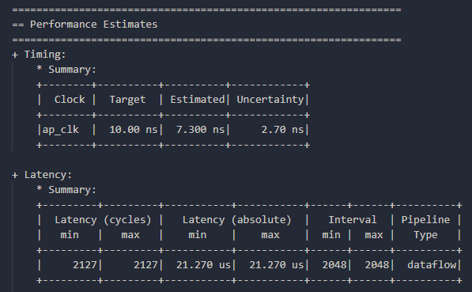
Co-simulation latency and clock period:
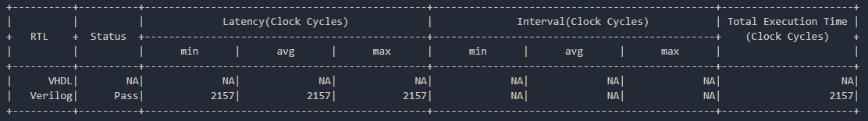
Post-implementation resource utilization:
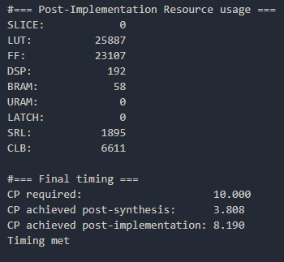
Final speedup ratio calculation:
2157 cycles * 8.190 post-imp. clock period = 0.01766583 ms
9.20587236 / 0.01766583 = 521.1117938 speedup

