FPGA Parallelism – Lab 4
Cameron Thomas
HLS synthesized latency:
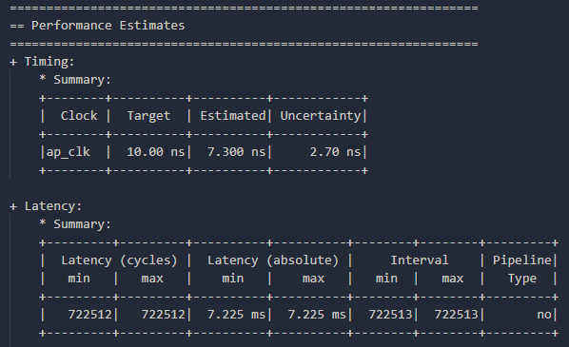
Co-simulation latency and clock period:
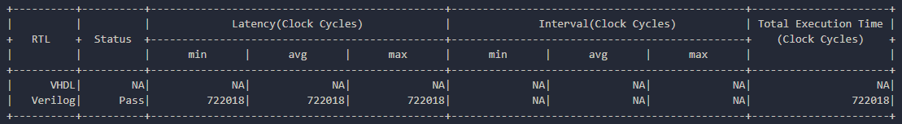
Post-implementation resource utilization:
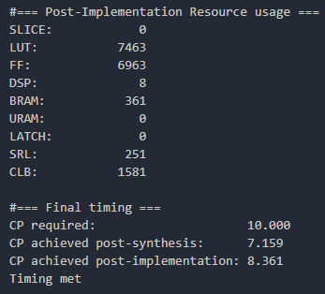
Final speedup ratio calculation:
722018 cycles * 8.361 post-imp. clock period = 6.0368 ms
8.25 / 6.0368 = 1.367 speedup

