FPGA Parallelism – Lab 2
Cameron Thomas
HLS synthesized latency:
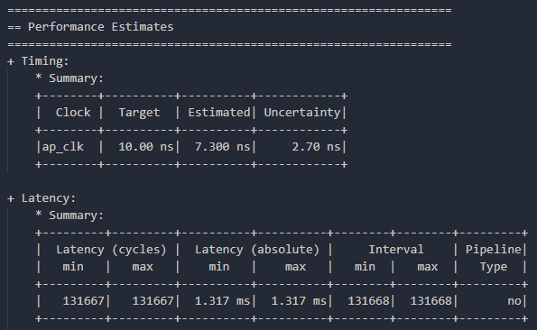
Co-simulation latency and clock period:
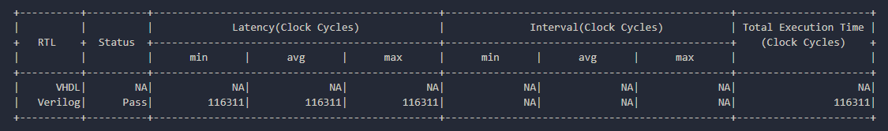
Post-implementation resource utilization:
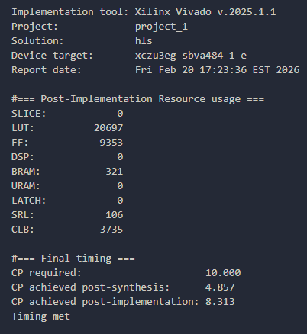
Final speedup ratio calculation:
116311 cycles * 8.313 post-imp. clock period = 0.96689 ms
143.5702 / 0.96689 = 148.5702 speedup

