# 1. Define Project Goals

Revamp the current website with an updated UI and additional features to improve user experience and align with current marketing goals.

# 2. Determine Outcomes

- Provide updated UI for index.html

- Provide updated UI for shop.html

- Create a cart.html to provide the option for online ordering

- Adhere to modern accessibility standards

- Add optional surveys to the order confirmation page

- Organize data collected during the order checkout process to simplify order fulfillment procedures.

# 3. Identify Risks and Constraints

- Additional data storage needed to support data collection.

- Time constraint: Project needs to be completed by 7/15/2023 to align with marketing goals.

# 4. Refine Your Strategy

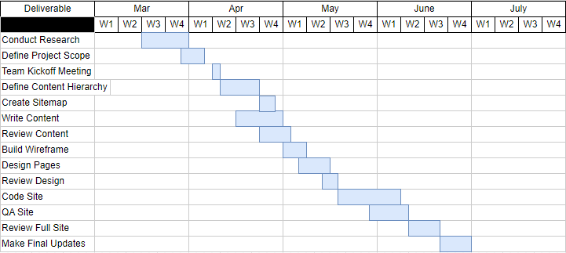

# 5. Estimate Your Budget

|  |  |  |  |  |
| --- | --- | --- | --- | --- |
| **Client Estimate** |  |  |  |  |
| **Project Len. Weeks** | **Hourly Rate** | **Expenses** | **Equipment** | **Total Estimate** |
| 14 | $75.00 | $500.00 | $1,000.00 | **$43,500.00** |

# 6. Create a Contingency Plan

IT department notified about data storage constraints – Decision on storage service by April 1, 2023.

Project timeline set to complete 2 weeks before deadline to account for any delays.

# 7. Document Your Milestones

- Define Content Hierarchy due April 21st

- Create Sitemap due April 25th

- Write Content due May 1st

- Review Design due May 18th

- Code Review due June 9th

- Final Updates July 1st