Project #4 – Interpret

National Risk Index and Categorical Bias Investigation

CIVE 202 Spring 2026

Group 9

Written Report

Intro
The goal of this project was to create our own method of natural disaster risk evaluation using Federal Emergency Management Agency (FEMA) National Risk Index (NRI) data. These values will then be compared to current NRI ratings, which give each county in the US a percentile score, relative to other counties. The differences in these ratings will allow us to evaluate the NRI data formulas with a sensitivity analysis to discover if there is a categorical bias present.

Risk Definition Methodology
For our original risk definition, we changed how the Community Resilience and Social Vulnerability variables affect the final risk assessment. The three variables used in our method are the Expected Annual Loss (EAL) Score and Community Resilience Score from the NRI dataset, as well as the Overall Social Vulnerability Percentile, from the CDC’s Social Vulnerability Index (SVI) dataset. First, the variables will be normalized by dividing the score in that category’s difference from the minimum score, by the size of the range of total possible scores:
Ex:
df['EAL_norm'] = (df[eal_col] - df[eal_col].min()) / (df[eal_col].max() - df[eal_col].min())
This normalization ensures that all 3 of the variables being considered are on the same scale. After normalization, the Community Resilience percentile score is subtracted from 1 to create that community’s “Lack of Resilience” (LOR) score.
Risk is generally defined as the probability of an event multiplied by the cost or impact that the event will impart on the area that it is affecting. So, for our original risk definition, we will multiply the normalized EAL by the SVI and LOR values. Counties will then be compared using this new risk score.
Formula:
$$Risk=Expected Annual Loss*Social Vulnerability Index*Lack of Resilience$$

Comparison to NRI risk calculation
FEMA’s model calculates risk index scores differently, by creating a value called the Community Risk Factor. This risk factor is the SVI divided by the Community Resilience Score of a place, which is then put through a transformation f(). This transformation maps the ratio of SVI to Community Resilience to a triangular distribution, which will result in a scalar between 0.5 and 2. The purpose of this function is to exacerbate the effects of Community Resilience and the SVI on events with greater EAL.
Formula from National Risk Index v1.20 Technical Document:
$$Risk=Expected Annual Loss*Community Risk Factor$$
$Where Community Risk Factor=f (\frac{SVI}{Community Resilience})$
Within the technical document, it states that the data triangulation function is used to mitigate errors when limited data is available. These data limitations may skew results in favor of areas that have better data observations.
By using the Lack of Resilience factor instead of the Community Risk Factor, we decrease the impact that monetary property value, specifically for structures, has on an area’s risk score. The intent is to avoid penalizing communities that are at a financial disadvantage. While the Community Risk Factor function does take this into account, it puts the SVI to Resilience ratio through many iterations, which provides more opportunity for that metric to become skewed and unfairly effect a place’s NRI score. We designed this new risk methodology to simplify this process. The only alterations done to the Community Resilience variable are normalization, which is not influenced by any of a community’s attributes, then subtraction from one which is also standard across the whole dataset.
The implications of this new model may be changes in emergency response speed and the distribution of natural disaster damage reconstruction funding. States and communities may also be able to take preemptive action to protect property and life in areas that have new, higher scores in order to mitigate the effects on less affluent areas.

Results comparison

Model Risk Score Comparisons
Colorado | Minnesota
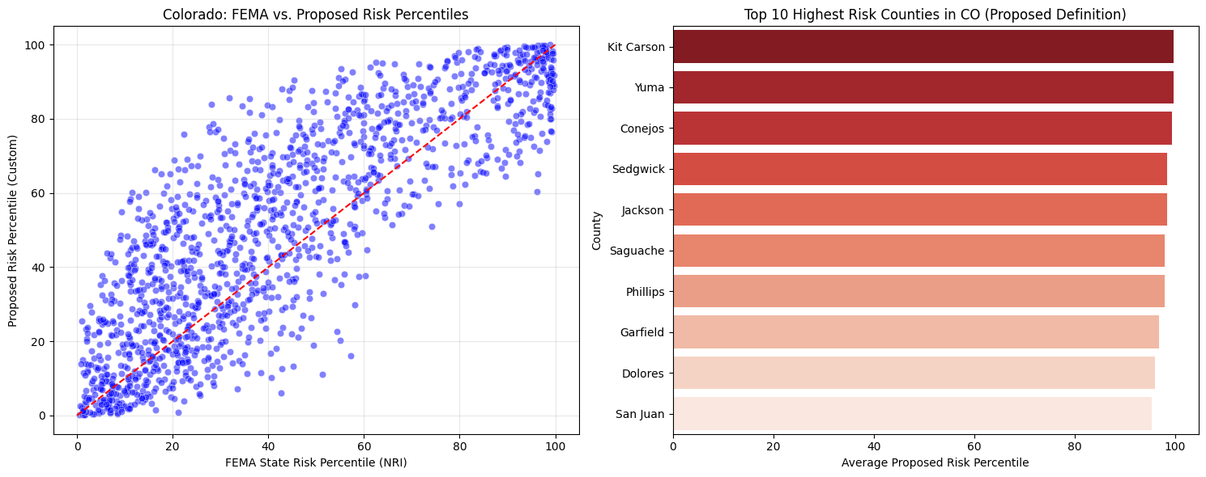 | 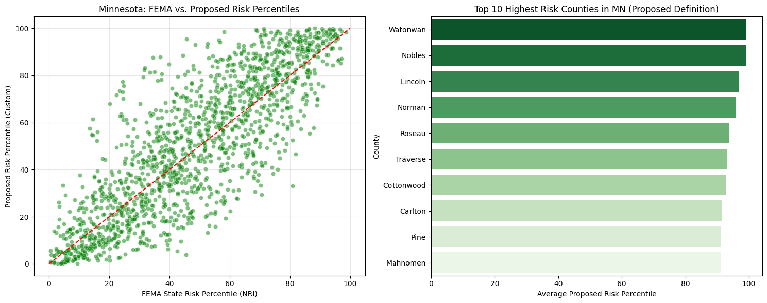

This graphs plot the current NRI score for Colorado and Minnesota counties on the x-axis and compare it with the output of our new risk model on the y-axis. The red line represents where the two models output the same score. We can see that overall, our original model produced higher risk ratings in Colorado , and a less dramatic but more dense crop of risk ratings slightly higher than the NRI rating in Minnesota. Where these higher risk ratings occur can be investigated by plotting each county’s score with Geopandas.

GeoPandas Maps Comparisons
Colorado
NRI | Original Risk Definition
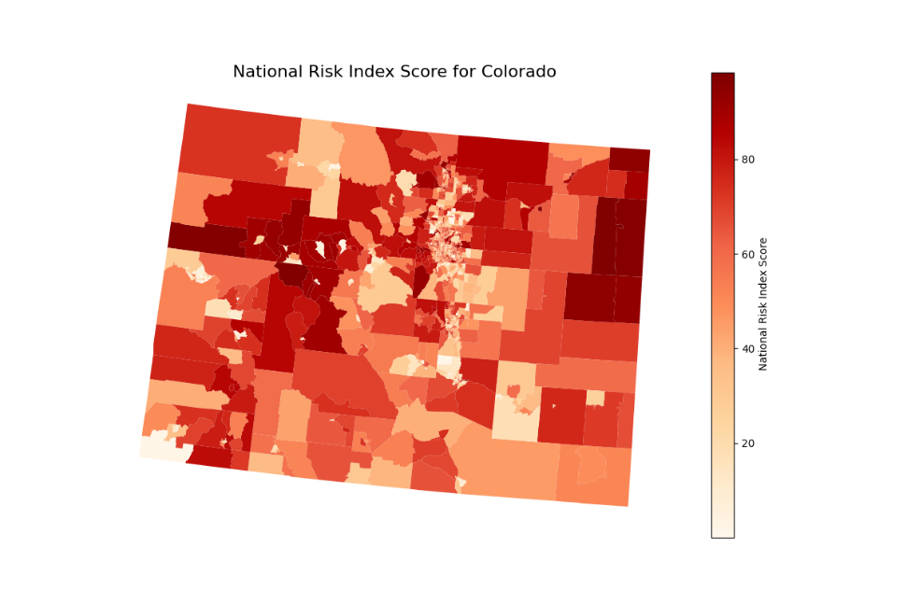 | 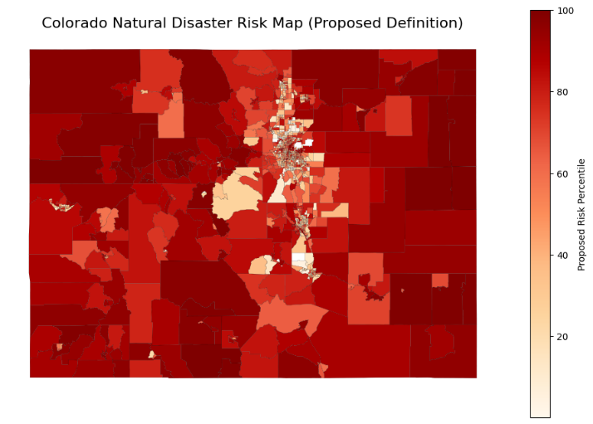
Minnesota
NRI | Original Risk Definition
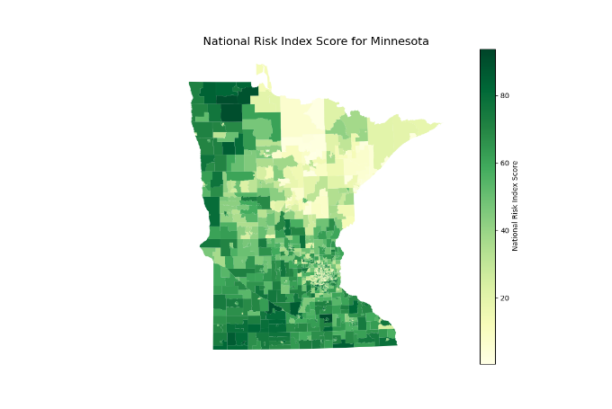 | 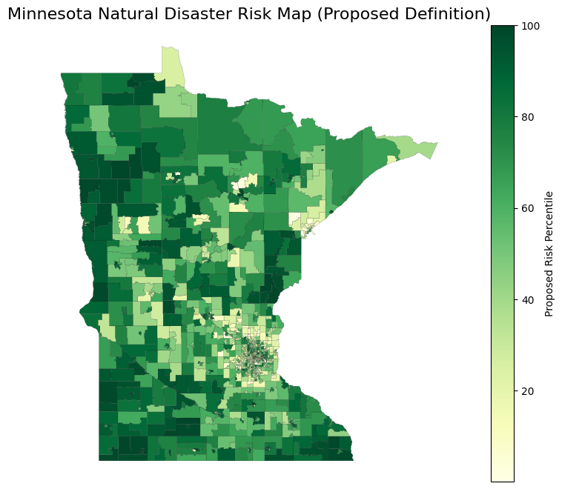

By comparing these heatmaps, we can see that the NRI model generally applies lower scores to more rural areas like southern Colorado and northern Minnesota. We can attribute this to the differences in methodology, and the NRI model placing less import on rural or lower-income regions, where the likelihood of natural disaster is not necessarily less, but creates a less dramatic financial effect. Our model also places more communities at higher risk overall. This may effect how FEMA aid is distributed between states, but this may just create a greater struggle for funding, because this increase in perceived risk will not increase the resources available.

