Elevator Pitch

Imagine finishing a tough climb and knowing exactly how you’re improving. My website solves the problem climbers face every day: there’s no simple, organized way to track real progress over time. This free platform lets climbers log routes they’ve completed, record how long each climb took, how many attempts it required, and even note conditions or techniques used. Now, instead of scattered notes or relying on memory, everything is stored in one clean dashboard. What makes it unique is the built-in visual analytics—easy-to-read graphs and progress charts that highlight trends, strengths, and areas for improvement. Climbers won’t just log their climbs; they’ll see patterns in performance and get clear insights into how to train smarter, climb stronger, and reach the next grade with confidence.

Climb Tracker Site Plan

Cam Smith

WDD 130

Overview

Purpose
To give rock climbers an easy, all-in-one place to track their progress and make goals to improve. They will have access to a log where they can log climbs and see them in a list.

Audience
Rock climbers of any level, as well as people who want to get into rock climbing.

Branding

Website Logo
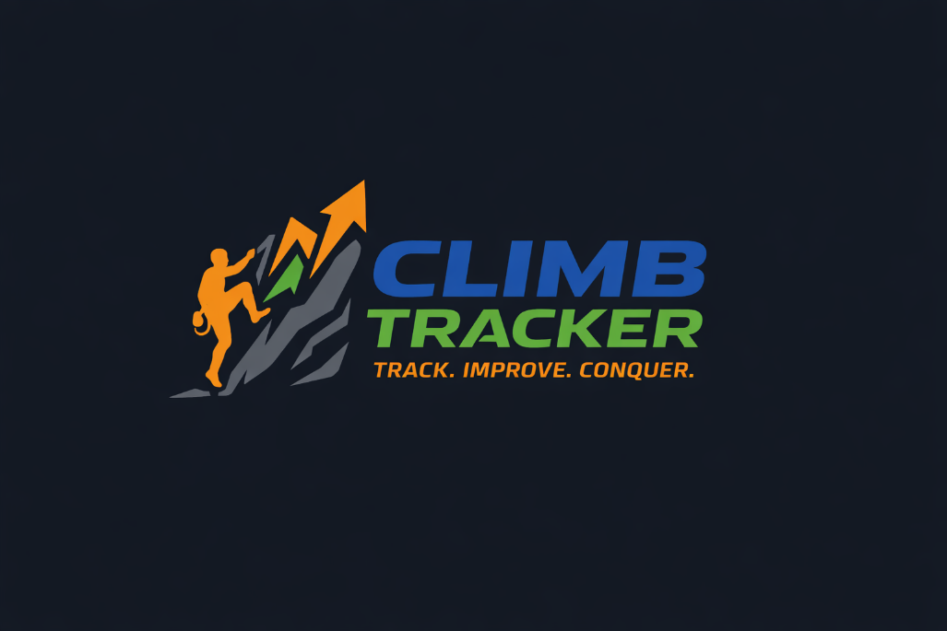

Style Guide

Color Palette
Primary | Secondary | Accent 1 | Accent 2
#1F3C88 | #2E2E2E | #2ECC71 | #F39C12

Typography

Heading Font: Libre Franklin

Paragraph Font: Libre Baskerville

Navigation
Home Log My Climb Track My Progress

Content

Home Page

Header/Nav – “Home”, “Log My Climb”, “Track My Progress”

h1 – “Every wall is an adventure”
h3 – “Remember them all with Climb Tracker”



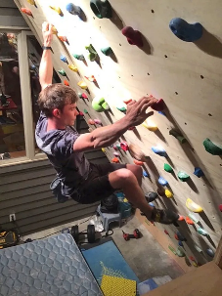
Picture 1 – “Track”


Picture 2 – “Improve”

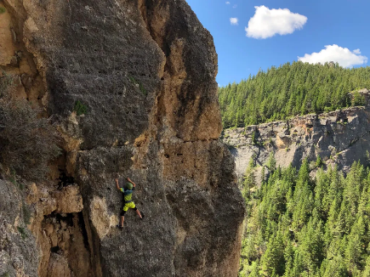
Picture 3 – “Conquer”

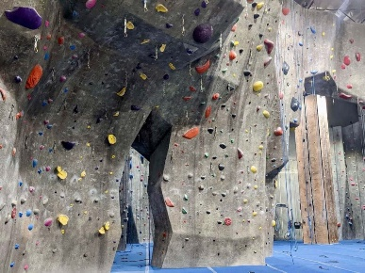
h4 – “Log your first climb!”
Paragraph – “Climb Tracker will help you not only remember your climbs, but use them to the fullest! Give Climb Tracker the details of each adventure and it will save them to a database for you to look back on and learn from!”

Button with hover– “Log My Climb”

Footer – “Lorem Ipsum 2026”
“Site Plan”
“Contact Us”

Log My Climb Page

Header/Nav – “Home”, “Log My Climb”, “Track My Progress”

h1 – “Log My Climb”

Form –

Field 1 – “Date”
Field 2 – “Grade”
Field 3 – “Attempts taken”
Field 4 - "Time taken”
Field 5 - "Techniques used”
Field 6 - "Notes”
Field 7 – “Picture upload”




Footer – “Lorem Ipsum 2026”
“Site Plan”
“Contact Us”

Track My Progress Page

Header/Nav – “Home”, “Log My Climb”, “Track My Progress”

h1 – “Track My Progress”

List – Will display dates and other info of the climbs. Press the climb to enlarge it and view all the information.

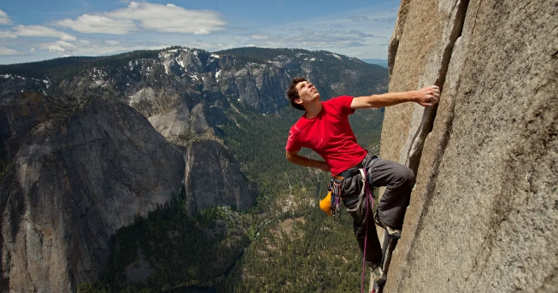

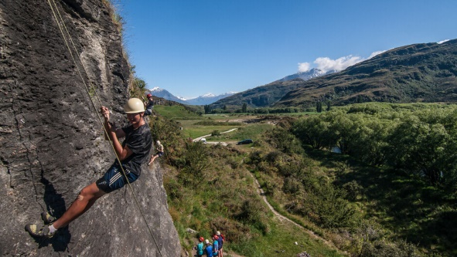
Footer – “Lorem Ipsum 2026”
“Site Plan”
“Contact Us”

Wireframes

Home

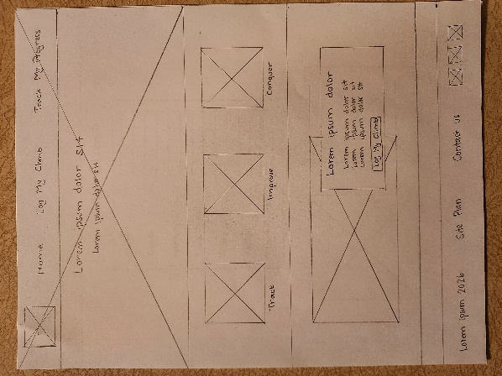
Log My Climb

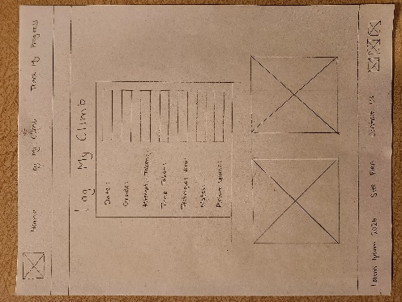

Track My Progress

