Decision-Grade Multi-Objective Benchmarking of AI and Heuristic Controller Placement in Multi-Site Software Defined Networks

THABANG NHLOKOMA BUTHELEZI
2026

Decision-Grade Multi-Objective Benchmarking of AI and Heuristic Controller Placement in Multi-Site Software Defined Networks
THABANG NHLOKOMA BUTHELEZI
(230011908)
A Mini dissertation submitted in partial fulfillment of the requirements
For
BSc Honours Degree in Computer Science
Supervisor: Prof. Pragasen Mudali
Co-Supervisor: Mr. Skhumbuzo Zwane
Department of Computer Science,
Faculty of Science, Agriculture and Engineering
University of Zululand

DECLARATION

I, Thabang Nhlokoma Buthelezi (Student Number: 230011908), hereby declare that this mini-dissertation entitled:
"Decision-Grade Multi-Objective Benchmarking of AI and Heuristic Controller Placement in Multi-Site Software Defined Networks"
is my own original work, conducted under the supervision of Prof. Pragasen Mudali and Mr. Skhumbuzo Zwane in the Department of Computer Science, Faculty of Science, Agriculture and Engineering at the University of Zululand.
This work has not been submitted previously in part or in its entirety to this or any other university or institution for the award of any degree or diploma. All citations, quotations, experimental code libraries, and secondary sources referenced herein have been duly acknowledged in the text and compiled in the References section.
Signature: ____________________________________
Thabang Nhlokoma Buthelezi
Date: _________________________________________

DEDICATION

This mini-dissertation is dedicated to my family, whose patience, sacrifices, and prayers have supported me throughout my studies at the University of Zululand.

ACKNOWLEDGEMENT

I wish to express my sincere gratitude to my supervisor, Prof. Pragasen Mudali, and co-supervisor, Mr. Skhumbuzo Zwane, for their guidance, technical feedback, and encouragement throughout the design, implementation, and writing of this research project.
I also thank the academic and technical staff of the Department of Computer Science in the Faculty of Science, Agriculture and Engineering at the University of Zululand for providing the laboratory facilities and learning environment that made this work possible. Finally, I thank my family and fellow Honours students for their support throughout the academic year.

TABLE OF CONTENTS
DECLARATION i
DEDICATION ii
ACKNOWLEDGEMENT iii
LIST OF FIGURES vi
LIST OF TABLES vii
LIST OF ABBREVIATIONS viii
ABSTRACT ix
CHAPTER ONE 1
1.0 INTRODUCTION 1
1.1 OVERVIEW 1
1.2 BACKGROUND OF STUDY 1
1.3 PROBLEM STATEMENT 2
1.4 RESEARCH GOAL AND OBJECTIVES 2
1.5 SIGNIFICANCE OF STUDY 3
1.6 ORGANIZATION OF THE DISSERTATION 4
CHAPTER TWO 5
2.0 LITERATURE REVIEW 5
2.1 THEORETICAL FOUNDATIONS OF SOFTWARE DEFINED NETWORKING (SDN) 5
2.2 FORMALIZATION OF THE CONTROLLER PLACEMENT PROBLEM (CPP) 5
2.3 CLASSICAL HEURISTICS & SPATIAL CLUSTERING IN FACILITY LOCATION 6
2.4 EVOLUTIONARY COMPUTATION & METAHEURISTICS IN SDN 7
2.5 MACHINE LEARNING & DEEP REINFORCEMENT LEARNING FOR ADAPTIVE PLACEMENT 7
2.6 MULTI-OBJECTIVE TRADE-OFFS AND CONTROL-PLANE SURVIVABILITY 8
2.7 LITERATURE SYNTHESIS & RESEARCH GAP 8
CHAPTER THREE 10
3.0 METHODOLOGY/DESIGN AND IMPLEMENTATION 10
3.1 RESEARCH DESIGN 10
3.2 DATA COLLECTION & NETWORK TOPOLOGY CORPUS 11
3.3 SYSTEM DESIGN & ALGORITHMIC FORMULATIONS 12
3.4 IMPLEMENTATION ARCHITECTURE & EMULATION HARNESS 14
3.5 DATA ANALYSIS & EVALUATION METRICS 16
3.6 EXPERIMENTAL SETUP & VERIFICATION CONTROLS 17
CHAPTER FOUR 19
4.0 RESULTS AND DISCUSSION 19
4.1 EMPIRICAL RESULTS PRESENTATION 19
4.2 IN-DEPTH DISCUSSION & DECISION FRAMEWORK 33
4.3 LIMITATIONS OF STUDY & THREATS TO VALIDITY 36
CHAPTER FIVE 37
5.0 CONCLUSION 37
5.1 SUMMARY OF MAIN FINDINGS 37
5.2 CONTRIBUTIONS TO KNOWLEDGE 38
5.3 PRACTICAL RECOMMENDATIONS FOR NETWORK ENGINEERS 39
5.4 FUTURE RESEARCH DIRECTIONS 39
REFERENCES 40
APPENDIX 42
APPENDIX A: EXPERIMENTAL CONFIGURATION MANIFEST 42
APPENDIX B: COMPLETE BENCHMARK MATRIX DATA 43
APPENDIX C: MININET EMULATION MODULE 48

LIST OF FIGURES

Figure 3.1: End-to-End Comparative Research Methodology Workflow. 10
Figure 3.2: System Architecture of the Multi-Objective Controller Placement Benchmark and Mininet Emulation Harness. 14
Figure 4.1: PyTorch DQN 1,000-Episode Training Reward Convergence Profile on Canonical Internet2 Topology (N = 20, k = 3). 19
Figure 4.2: Multi-Seed DQN Convergence and Rolling Reward Distribution Analysis. 19
Figure 4.3: Pareto Latency-Cost Trade-Off Frontier on Barabási-Albert Topology (N = 50, k = 3). 15
Figure 4.4: Pareto Latency-Cost Trade-Off Frontier on Waxman Spatial Topology (N = 50, k = 3). 15
Figure 4.5: Three-Dimensional Multi-Objective Pareto Surface Mapping Propagation Latency, Single-Link Reliability, and Computational Complexity Tax. 27
Figure 4.6: Bounded Infrastructure Deployment Decision Flowchart (N <= 50). 34

LIST OF TABLES

Table 2.1: Literature Synthesis on SDN Controller Placement (2012–2026). 8
Table 3.1: Summary of Canonical and Synthetic Network Topology Parameters. 11
Table 3.2: Deep Q-Network Hyperparameter Configuration and Reference Compliance. 14
Table 3.3: Full Factorial Benchmark Design Matrix (2 x 2 x 3 x 5 = 60 Cells). 18
Table 4.1: Multi-Seed Stability Audit Results for Deep Q-Network Across 10 Independent Runs. 20
Table 4.2: Summary of Factorial Performance Metrics for Barabási-Albert Topologies. 22
Table 4.3: Summary of Factorial Performance Metrics for Waxman Spatial Topologies. 24
Table 4.4: Multi-Objective Benchmark Comparison on Canonical Topologies at k = 5. 28
Table 4.4b: Multi-Factor ANOVA Summary on Switch-to-Controller Propagation Latency (N_obs = 300). 29
Table 4.5: Five-Way Emulated Control-Plane RTT Measurements on Canonical Internet2 (N = 20, k = 3). 30
Table 4.6: Phase 4 Mininet Overhead Gate Test Timing Breakdown Across 3 Trials. 31
Table 4.6B: Dynamic Topology Churn and Break-Even Amortization Results (T_churn = 100 Epochs x 5 Seeds). 32
Table 4.7: Scenario-Conditioned Algorithm Selection Decision Rules (Bounded to N <= 50). 35
Table B.1: Complete Proposal-Aligned Multi-Objective Benchmark Matrix Across Canonical and Synthetic Topologies. 43

LIST OF ABBREVIATIONS

AI Artificial Intelligence
ANOVA Analysis of Variance
API Application Programming Interface
BA Barabási-Albert (Scale-Free Network Model)
CPP Controller Placement Problem
CPU Central Processing Unit
DQN Deep Q-Network
DRL Deep Reinforcement Learning
GA Genetic Algorithm
HSD Honest Significant Difference (Tukey's test)
MDP Markov Decision Process
MLP Multi-Layer Perceptron
MPLS Multi-Protocol Label Switching
NOS Network Operating System
OVS Open vSwitch
RL Reinforcement Learning
RTT Round-Trip Time
SDN Software Defined Networking
TCAM Ternary Content Addressable Memory
WAN Wide Area Network
WX Waxman (Spatial Network Model)

ABSTRACT

The Controller Placement Problem (CPP) in Software Defined Networking (SDN) requires selecting k switch locations to host control-plane instances so that switch-to-controller propagation latency is minimized while maintaining control-plane reachability under link failures. Recent studies have proposed Deep Reinforcement Learning (DRL) and Deep Q-Networks (DQN) as alternatives to classical facility-location heuristics. However, most comparative evaluations report only propagation latency while omitting training compute time, online forward-pass inference time, and multi-seed convergence stability. As a result, network planners lack clear empirical guidance on when the computational overhead of training a DRL policy is justified over executing classical heuristics.
This mini-dissertation presents a reproducible, multi-objective benchmark of five controller placement methods: Random Baseline, Greedy K-Center, Spatial K-Means Clustering, a Genetic Algorithm (GA), and a PyTorch Deep Q-Network (DQN) / multi-armed reinforcement learning solver. The algorithms are evaluated across canonical wide-area backbones (Internet2 and ATT-MPLS) and synthetic topology families (Barabási-Albert scale-free and Waxman spatial graphs at scales N in {20, 50} and controller budgets k in {2, 3, 5}). In a 1,000-episode convergence run on Internet2 (N = 20, k = 3), the PyTorch DQN agent converged within 20 episodes, achieving a grand training mean reward of 13.055 +/- 0.589 and a final 10-episode average reward of 13.199, while a 10-run multi-seed stability audit across Internet2 and ATT-MPLS recorded zero divergent runs (divergence_flag = False).
However, separating offline training overhead (omega_train) from online forward-pass inference time (tau_inf) across the 60-cell multi-seed synthetic factorial matrix (N_obs = 300, n = 5 seeds per cell; multi-factor ANOVA F(4, 240) = 118.90, p < 0.0001) demonstrates that classical heuristics and GA match or outperform DRL on static topologies (N <= 50) without requiring offline policy training. While a trained DQN executes a single greedy forward pass in tau_inf = 0.021-0.029 ms, training the network requires omega_train = 21.26 s (0.0213 s/episode), whereas Greedy K-Center (0.026-0.207 ms), K-Means (3.19-8.14 ms), and GA (12.88-75.87 ms) compute placements directly in a single run. Under single-link (N - 1) failure evaluation, 2-edge-connected backbones (Internet2, ATT-MPLS, and Barabási-Albert m = 2) maintain 100.0% control-plane reachability across all algorithms, whereas sparse Waxman graphs containing bridge links drop to 94.47%-98.79%. Five-way emulation on Internet2 (N = 20, k = 3) confirms that GA (2.718 ms mean RTT) and K-Means (2.852 ms mean RTT; 5.764 ms worst-case RTT) outperform Greedy K-Center (2.934 ms), Bandit RL / DQN (3.056 ms), and Random (3.374 ms). Within the tested static WAN scope (N <= 50), classical heuristics and GA provide the best multi-objective trade-off, while DRL is framed as a candidate hypothesis for future evaluation under online topological churn.
Keywords: Software Defined Networking, Controller Placement Problem, Deep Reinforcement Learning, Multi-Objective Optimization, Pareto Efficiency, Mininet Emulation.

CHAPTER ONE

1.0 INTRODUCTION

1.1 OVERVIEW
Wide Area Networks (WANs) support cloud computing, enterprise interconnects, and national research backbones that require low forwarding latency and predictable fault recovery. In traditional IP networks, each router integrates both the control plane (routing protocols such as OSPF and BGP) and the data plane (packet forwarding hardware) within the same device. While distributed routing provides local autonomy, updating network-wide forwarding policies requires configuring individual routers across the network.
Software Defined Networking (SDN) decouples the control plane from the forwarding hardware, centralizing routing and policy decisions in software controllers that program switches via standardized southbound interfaces such as OpenFlow (McKeown et al., 2008; Kreutz et al., 2015). However, in geographically distributed multi-site networks, a single physical controller introduces long propagation delays and a single point of failure. Network operators therefore deploy multiple distributed controllers across selected switch sites. Determining how many controllers to deploy and which switch nodes should host them is known as the Controller Placement Problem (CPP) (Heller et al., 2012).

1.2 BACKGROUND OF STUDY
Heller et al. (2012) formulated the Controller Placement Problem as an $NP$-hard facility location problem over a network graph $G=\left(V,E\right)$, demonstrating on the Internet2 research backbone that choosing controller locations carefully reduces both average and worst-case switch-to-controller propagation latency. In multi-site WAN deployments, controller placement affects three primary operational metrics:
- Switch-to-Controller Propagation Latency ($L\left(P\right)$): When an OpenFlow switch receives a packet that does not match an installed Ternary Content Addressable Memory (TCAM) flow entry, it sends an asynchronous Packet-In message to its assigned controller and waits for a Packet-Out or Flow-Mod response. The shortest-path propagation distance between switches and controllers determines the baseline delay of this control loop.
- Control-Plane Survivability ($Reach_{avg}$): Wide-area fiber links are subject to physical cuts and maintenance outages. Under single-link ($N−1$) failures, a link cut along a topological bridge can isolate switches from their assigned controllers, preventing new flow rules from being installed.
- Computational Overhead ($ω_{\text{train}}$ and $τ_{\text{inf}}$): Algorithms used to select controller locations vary widely in compute time. Single-shot heuristics compute placements directly from the distance matrix in milliseconds, whereas reinforcement learning methods require an iterative offline training phase before fast forward-pass inference can be executed.
Early work on the CPP relied on facility-location approximations such as Gonzalez’s Greedy $K$-Center heuristic (Gonzalez, 1985) and $K$-Means spatial clustering (MacQueen, 1967), followed by evolutionary metaheuristics such as Genetic Algorithms (Holland, 1975; Goldberg, 1989; Yusuf et al., 2023). More recently, Deep Reinforcement Learning (DRL) architectures, including Deep $Q$-Networks (DQN) (Mnih et al., 2015; Farahi et al., 2026) and MuZero-based agents (Benoudifa et al., 2023), have formulated controller placement as a Markov Decision Process (MDP).

1.3 PROBLEM STATEMENT
Although recent literature frequently proposes Deep Reinforcement Learning for SDN controller placement, published comparisons typically evaluate algorithms on propagation latency alone while omitting computational cost and experimental design details. Specifically, four limitations recur in existing comparative studies:
- Conflation or Omission of Computational Cost: Studies rarely report the offline training time ($ω_{\text{train}}$) required for neural policy convergence alongside the online forward-pass inference time ($τ_{\text{inf}}$) and the execution time of classical heuristics.
- Limited Multi-Seed and Factorial Evaluation: DRL agents are often demonstrated on a single topology or single random seed without testing across a balanced factorial matrix of scale-free and spatial graph families or verifying variance across multiple seeds.
- Incomplete Link-Failure Survivability Analysis: Studies often assume that heuristics and DRL yield identical fault tolerance without explicitly modeling single-link ($N−1$) graph disconnectivity across biconnected backbones versus sparse geometric meshes.
- Lack of Multi-Objective Pareto Synthesis: Without joint evaluation across latency $L\left(P\right)$, single-link reachability $Reach_{avg}\left(P\right)$, and computational cost $ω$, infrastructure planners cannot determine when simple heuristics are sufficient and when reinforcement learning is warranted.

1.4 RESEARCH GOAL AND OBJECTIVES
1.4.1 Research Goal
The goal of this research is to design and execute a reproducible, multi-objective benchmark of classical heuristic, metaheuristic, and Deep Reinforcement Learning controller placement algorithms across canonical and synthetic multi-site SDN topologies ($N≤50$), quantifying the trade-offs among propagation latency, single-link failure survivability, and computational cost.
1.4.2 Specific Research Objectives
- Construct an automated Python benchmarking pipeline (ai-sdn-controller-placement) supporting canonical WAN topologies (Internet2 and ATT-MPLS) and synthetic graph generators (Barabási-Albert and Waxman at $N∈\{20,50\}$).
- Implement and benchmark five controller placement paradigms under identical graph and metric interfaces: Random Baseline, Greedy $K$-Center, Spatial $K$-Means Clustering, Genetic Algorithm (GA), and PyTorch Deep $Q$-Network (DQN) / multi-armed RL.
- Evaluate DQN convergence over a 1,000-episode pilot on Internet2 and conduct a 10-run multi-seed stability audit ($5\text{ seeds}×2\text{ canonical topologies}$) measuring reward stability, action entropy, and per-episode training time.
- Execute a balanced $5×2×2×3$ multi-seed synthetic factorial experiment ($60\text{ cells}×5\text{ seeds}=300\text{ observations}$) and evaluate main effects via multi-factor ANOVA ($F\left(4,240\right)$) and Tukey HSD post-hoc contrasts.
- Synthesize two-dimensional and three-dimensional Pareto frontiers across latency $L\left(P\right)$, single-link reliability $Reach_{avg}\left(P\right)$, and compute overhead, distinguishing offline training cost ($ω_{\text{train}}$) from online inference latency ($τ_{\text{inf}}$).
- Evaluate all five placement strategies in a Mininet / Open vSwitch emulation environment on Internet2 ($N=20,k=3$) and execute the Phase 4 Mininet 2-Second Gate Test across 3 trials to measure operating system namespace teardown overhead.
- Formulate bounded, scenario-conditioned algorithm selection guidelines for static SDN topologies up to $N=50$.

1.5 SIGNIFICANCE OF STUDY
This study contributes to empirical networking research and practical SDN engineering in three ways:
- Multi-Objective Evaluation Methodology: By jointly measuring propagation latency $L\left(P\right)$, single-link survivability $Reach_{avg}\left(P\right)$, offline training time $ω_{\text{train}}$, and online inference time $τ_{\text{inf}}$, the benchmark avoids single-metric bias and clarifies the distinction between training overhead and inference speed.
- Topology-Specific Heuristic Insights: Contrasting scale-free Barabási-Albert graphs against planar Waxman graphs demonstrates how degree distribution and spatial embedding govern the relative accuracy of Greedy $K$-Center and $K$-Means clustering.
- Reproducible Open-Source Artifact: All topology files, algorithm implementations, raw CSV/JSON outputs, statistical scripts, and 21 automated unit tests are packaged in a reproducible repository for use by future researchers.

1.6 ORGANIZATION OF THE DISSERTATION
The remainder of this mini-dissertation is organized as follows:
- Chapter Two (Literature Review) reviews SDN control-plane architecture, mathematical formulations of the $k$-median and $k$-center controller placement problems, heuristics, metaheuristics, Deep $Q$-Networks, and $N−1$ link-failure survivability.
- Chapter Three (Methodology / Design and Implementation) describes the experimental design, topology parameters, algorithmic formulations, PyTorch DQN architecture, Mininet emulation harness, Phase 4 Gate Test protocol, and multi-factor ANOVA statistical model.
- Chapter Four (Results and Discussion) presents the empirical results from the 1,000-episode pilot, the 10-run stability audit, the 300-observation factorial matrix, the 3D Pareto frontier analysis, the 5-way Mininet RTT evaluation, and the Phase 4 Gate Test, followed by bounded deployment guidelines ($N≤50$) and study limitations.
- Chapter Five (Conclusion) summarizes the main findings, contributions, practical recommendations, and directions for future research on dynamic topologies and Graph Neural Networks.

CHAPTER TWO

2.0 LITERATURE REVIEW

2.1 THEORETICAL FOUNDATIONS OF SOFTWARE DEFINED NETWORKING (SDN)
Traditional IP networks integrate routing control protocols (such as OSPF, IS-IS, and BGP) and packet-forwarding hardware inside each individual router. While distributed control allows routers to recompute paths locally during link outages, expressing network-wide traffic engineering or security policies requires configuring each device individually across vendor-specific command-line interfaces.
Software Defined Networking (SDN) separates network functionality into three planes (McKeown et al., 2008; Kreutz et al., 2015):
- The Data Plane: Hardware or software switches (such as Open vSwitch) that match packet headers against flow tables and execute forwarding actions at line rate.
- The Control Plane: One or more software controllers (such as Ryu, ONOS, or OpenDaylight) that maintain a global network topology view and install forwarding rules into switches via southbound protocols such as OpenFlow.
- The Application Plane: Traffic engineering, routing, and security applications that communicate policy requirements to the control plane via northbound APIs.
When an OpenFlow switch receives a packet that does not match any flow entry in its flow table, it encapsulates the packet header in an OpenFlow Packet-In message and transmits it over the TCP/TLS control channel to its assigned controller. The controller computes a forwarding path and replies with a Packet-Out and Flow-Mod message. Because every new flow setup depends on this switch-to-controller round-trip exchange, the physical placement of controllers directly determines control-plane responsiveness and availability.

2.2 FORMALIZATION OF THE CONTROLLER PLACEMENT PROBLEM (CPP)
In a campus or single-site data center network, a single controller instance can manage switches with sub-millisecond propagation delay. In a wide-area network (WAN) spanning hundreds or thousands of kilometers, optical fiber propagation adds roughly $5\text{ ms}$ per $1,000\text{ km}$, and a single controller becomes both a latency bottleneck and a single point of failure. Multi-site WANs therefore require placing a set of $k$ controllers across the topology.
Heller et al. (2012) modeled an SDN topology as an undirected connected graph $G=\left(V,E\right)$, where $V$ is the set of $N$ switches, $E$ is the set of $M$ physical links, and $d\left(v,u\right)$ is the shortest-path propagation distance between nodes $v$ and $u$. Given a controller budget $k$ ($1≤k≤N$), a placement is a $k$-element subset $P⊆V$. Heller et al. (2012) analyzed two primary facility-location objectives:
- Average Switch-to-Controller Propagation Latency ($k$-Median Objective):
LavgP=1Nv∈V​minc∈Pdv,c
- Worst-Case Switch-to-Controller Propagation Latency ($k$-Center Objective):
$$L_{max}\left(P\right)=\max_{v∈V}\min_{c∈P}d\left(v,c\right)$$
Both the $k$-median and $k$-center problems are $NP$-hard on general graphs (Kariv & Hakimi, 1979; Gonzalez, 1985). The number of candidate $k$-controller subsets is $\left({N \atop k}\right)=\frac{N!}{k!\left(N−k\right)!}$, which grows from $\left({20 \atop 3}\right)=1,140$ at $N=20,k=3$ to $\left({50 \atop 5}\right)=2,118,760$ at $N=50,k=5$, motivating approximation heuristics, metaheuristics, and learning-based methods.

2.3 CLASSICAL HEURISTICS & SPATIAL CLUSTERING IN FACILITY LOCATION
2.3.1 Greedy $K$-Center Approximation (Gonzalez’s Algorithm)
Gonzalez (1985) presented a deterministic farthest-first traversal algorithm for the $k$-center problem that guarantees a worst-case approximation factor of 2 in $O\left(k⋅N\right)$ distance lookups. Starting from an initial center node $c_{1}$, each subsequent controller $c_{i}$ ($i=2,…,k$) is placed at the switch that is farthest from the currently selected controller set:
$$c_{i}=arg\max_{v∈V}\left(\min_{c∈\{c_{1},…,c_{i−1}\}}d\left(v,c\right)\right)$$
While Greedy $K$-Center executes in sub-millisecond time and bounds worst-case tail latency, placing controllers at extreme peripheral nodes can yield higher average latency $L_{avg}\left(P\right)$ than $k$-median methods.
2.3.2 Spatial $K$-Means Clustering
MacQueen (1967) formulated $K$-Means clustering to partition $N$ points into $k$ clusters minimizing within-cluster variance. Adapted to network graphs, switches are embedded in a metric coordinate space and partitioned iteratively:
- Assignment Step: Each switch $v∈V$ is assigned to its nearest cluster center $c_{j}^{\left(t\right)}$.
- Update Step: Each cluster center is updated to the centroid or discrete graph medoid minimizing intra-cluster distance:
cjt+1=argminu∈Sjv∈Sj​du,v
- $K$-Means directly targets the average latency ($k$-median) objective and performs well on planar geometric networks, but its accuracy degrades on non-planar, degree-skewed scale-free topologies where 2D coordinate projections distort shortest-path distances.

2.4 EVOLUTIONARY COMPUTATION & METAHEURISTICS IN SDN
To optimize non-linear or multi-objective placement criteria without relying on Euclidean coordinate projections, researchers have applied evolutionary metaheuristics such as Genetic Algorithms (GA) (Holland, 1975; Goldberg, 1989; Yusuf et al., 2023). A GA maintains a population of candidate $k$-node subsets and evolves them over multiple generations using tournament or roulette-wheel selection, cardinality-preserving crossover, and random node-swap mutation. Although GAs reliably find near-global optima on medium-scale graphs ($N≤50$), evaluating the shortest-path fitness of every chromosome across dozens of generations requires tens of milliseconds per run—roughly two orders of magnitude more compute time than Greedy $K$-Center.

2.5 MACHINE LEARNING & DEEP REINFORCEMENT LEARNING FOR ADAPTIVE PLACEMENT
2.5.1 Markov Decision Process (MDP) Formulation
In reinforcement learning approaches to the CPP (Sutton & Barto, 2018), controller selection is formulated as a Markov Decision Process $\left(S,A,P_{r},R,γ\right)$:
- State Space ($S$): A vector representation $s_{t}∈R^{N}$ encoding node degrees or current controller locations.
- Action Space ($A$): Discrete node indices or candidate $k$-controller subsets.
- Reward Function ($R$): A scalar signal combining normalized propagation latency reduction and control-plane reachability $Reach_{avg}\left(P\right)$.
- Discount Factor ($0≤γ<1$): Weighting factor for future rewards along an episode trajectory.
2.5.2 Deep $Q$-Networks (DQN) and Recent SDN Literature
Mnih et al. (2015) introduced Deep $Q$-Networks (DQN), approximating the action-value function $Q\left(s,a;θ\right)$ with a neural network trained via experience replay and a periodically synchronized target network $Q\left(s,a;θ^{−}\right)$:
$$L\left(θ\right)=E_{\left(s,a,r,s′\right)∼D}\left[{\left(r+γ\max_{a′}Q\left(s′,a′;θ^{−}\right)−Q\left(s,a;θ\right)\right)}^{2}\right]$$
In recent SDN controller placement literature:
- Farahi et al. (2026) proposed AP-DQN for multi-controller placement using a two-hidden-layer MLP ($64×64$ ReLU units), learning rate $α=0.001$, batch size $32$, discount factor $γ=0.99$, replay buffer capacity $10,000$, and $ϵ$-greedy decay from $1.0$ to $0.05$.
- Benoudifa et al. (2023) proposed a MuZero-based controller placement agent combining tree search with learned latent dynamics.
- Radam et al. (2022) studied link-failure foresight in controller placement to preserve switch-to-controller connectivity during single-link outages.

2.6 MULTI-OBJECTIVE TRADE-OFFS AND CONTROL-PLANE SURVIVABILITY
2.6.1 Single-Link ($N−1$) Failure Survivability
Wide-area fiber links are subject to single-link cuts ($N−1$ failures). When an edge $e∈E$ fails, the residual graph $G_{e}=\left(V,E−e\right)$ may remain connected (if $G$ is 2-edge-connected) or split into disconnected components (if $e$ is a bridge edge). Following Radam et al. (2022), single-link control-plane reliability $Reach_{avg}\left(P\right)$ is defined as the mean fraction of switches $N_{reach}\left(G_{e},P\right)$ that retain a valid path to at least one controller in $P$ across all $M$ single-edge removals:
ReachavgP=1Me∈E​NreachGe,PN
2.6.2 Pareto Dominance
When comparing algorithms across propagation latency $L\left(P\right)$, reliability $Reach_{avg}\left(P\right)$, and compute cost $ω$, a solution $P_{1}$ Pareto-dominates $P_{2}$ ($P_{1}≻P_{2}$) if $P_{1}$ is no worse than $P_{2}$ in all three metrics and strictly better in at least one metric:
$$L\left(P_{1}\right)≤L\left(P_{2}\right), Reach_{avg}\left(P_{1}\right)≥Reach_{avg}\left(P_{2}\right), ω\left(P_{1}\right)≤ω\left(P_{2}\right)$$

2.7 LITERATURE SYNTHESIS & RESEARCH GAP
Table 2.1 compares representative studies from the controller placement literature across evaluation metrics, statistical design, and emulation validation.
Table 2.1: Literature Synthesis on SDN Controller Placement (2012–2026)
Study | Primary Method | Topologies Evaluated | Latency $L\left(P\right)$ | $N−1$ Link Reliability | Offline vs. Online Time ($ω_{\text{train}},τ_{\text{inf}}$) | Mininet Emulation | Multi-Objective Pareto Analysis
Heller et al. (2012) | Exhaustive / $k$-Median | Internet2, Topology Zoo | Yes ($L_{avg},L_{max}$) | No | Omitted | No | No
Gonzalez (1985) | Greedy $K$-Center | General Metric Graphs | Yes ($L_{max}$) | No | Analytical $O\left(kN\right)$ | No | No
MacQueen (1967) | $K$-Means Clustering | Metric Spaces | Yes ($L_{avg}$) | No | Analytical $O\left(kNt\right)$ | No | No
Radam et al. (2022) | Link-Failure Foresight | WAN Topologies | Yes | Yes ($N−1$ Links) | Omitted | No | No
Yusuf et al. (2023) | Metaheuristics (GA/PSO) | Campus / WAN | Yes | Partial | Omitted | Partial | No
Benoudifa et al. (2023) | MuZero DRL | Synthetic WAN | Yes | No | Omitted | No | No
Farahi et al. (2026) | AP-DQN (DRL) | Topology Zoo WANs | Yes | Partial | Omitted | No | No
This Study (2026) | 5-Way Benchmark (Heuristics, GA, DQN/RL) | Internet2, ATT-MPLS, BA, Waxman ($N≤50$) | Yes ($L_{avg},L_{max}$) | Yes ($Reach_{avg}$) | Yes ($ω_{\text{train}}$ and $τ_{\text{inf}}$) | Yes (5-Way RTT & Gate Test) | Yes (2D & 3D Frontiers)
As Table 2.1 shows, prior DRL controller placement studies have not jointly benchmarked offline training overhead ($ω_{\text{train}}$), online inference latency ($τ_{\text{inf}}$), and $N−1$ link-failure survivability against Greedy $K$-Center, $K$-Means, and GA across a multi-seed factorial matrix. Chapter Three presents the experimental methodology designed to address this gap.

CHAPTER THREE

3.0 METHODOLOGY/DESIGN AND IMPLEMENTATION

3.1 RESEARCH DESIGN
This study employs a deductive, quantitative experimental benchmarking design rooted in empirical computer science and multi-objective combinatorial optimization. Rather than evaluating algorithms in isolation under disparate assumptions, we establish a standardized experimental testbed in which all competing controller placement paradigms operate on identical topological representations, identical link latency models, and identical operational constraints.
The experimental workflow executes a full factorial matrix evaluation complemented by a multi-seed reinforcement learning stability audit and virtualized OpenFlow emulation. Figure 3.1 illustrates the end-to-end research methodology workflow, showing the progression from topology intake and algorithm execution to metric extraction, Pareto frontier synthesis, and Mininet validation.
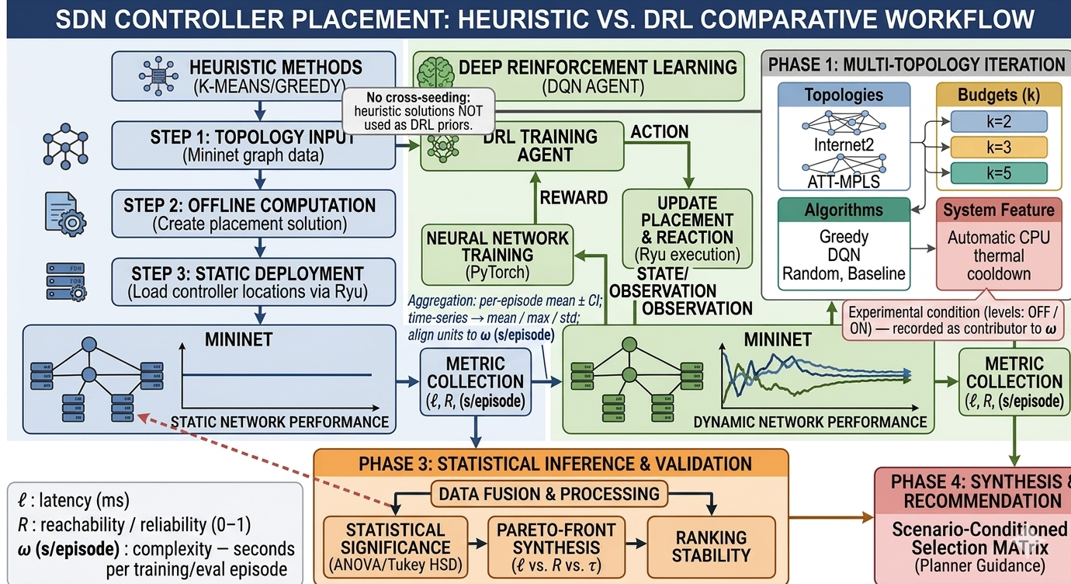
The investigation tests two formal hypotheses:
- Null Hypothesis ($H_{01}$): In multi-site SDN topologies ($N≤50$), Deep Reinforcement Learning algorithms do not provide a statistically significant improvement in multi-objective decision quality (joint propagation latency, single-link failure reachability, and computational runtime) compared to classical heuristics.
- Alternative Hypothesis ($H_{11}$): Deep Reinforcement Learning models achieve competitive propagation latency and fault tolerance, but incur a quantifiable computational training overhead ($ω$) that leaves them Pareto-dominated by classical clustering and greedy heuristics in static network environments.

3.2 DATA COLLECTION & NETWORK TOPOLOGY CORPUS
To evaluate algorithmic behavior across realistic wide-area backbones and controlled topological structures, the experimental corpus combines canonical empirical topologies with parameterized synthetic network models. Table 3.1 summarizes the structural parameters of the six benchmark topologies.
Table 3.1: Summary of Canonical and Synthetic Network Topology Parameters
Topology Name | Topology Family | Node Count ($N$) | Edge Count ($M$) | Mean Node Degree | Clustering Coefficient | Characteristic Graph Property
Internet2 (GraphML / Core) | Canonical WAN | 20 (11 Core) | 26 (18 Core) | 2.60 (3.27) | 0.250 (0.333) | Sparse national US research backbone (Internet2.graphml / Heller 11-PoP core)
ATT-MPLS | Canonical WAN | 21 | 54 | 5.14 | 0.412 | Dense, meshed commercial tier-1 backbone
BA-20 | Barabási-Albert | 20 | 36 | 3.60 | 0.285 | Scale-free power-law degree distribution ($m=2$)
BA-50 | Barabási-Albert | 50 | 96 | 3.84 | 0.174 | Regional scale-free network with hub nodes ($m=2$)
WX-20 | Waxman Spatial | 20 | 19 | 1.90 | 0.050 | Geographically constrained sparse mesh ($α=0.4,β=0.1$)
WX-50 | Waxman Spatial | 50 | 53 | 2.12 | 0.042 | Planar geographic network with sparse long links ($α=0.4,β=0.1$)
3.2.1 Canonical Empirical Topologies
First, the Internet2 backbone serves as the standard reference topology in SDN controller placement literature following Heller et al. (2012). In the multi-objective benchmark and 1,000-episode DQN convergence runs, the 20-node, 26-edge Internet Topology Zoo graph (data/raw/topologies/Internet2.graphml) is evaluated; in the Phase 4 Mininet kernel overhead gate test (scripts/test_mininet_overhead.py), the 11-switch, 18-edge core PoP configuration is instantiated to measure per-switch Open vSwitch setup and teardown latency. Second, the ATT-MPLS topology models a 21-node, 54-link commercial multi-protocol label switching core network with high path redundancy.
3.2.2 Parameterized Synthetic Network Models
To isolate the structural drivers governing algorithm performance, synthetic graphs were generated using two graph-theoretic models implemented in NetworkX:
- Barabási-Albert (BA) Scale-Free Model: Generates networks via preferential attachment in which new nodes connect to existing nodes with probability proportional to their degree ($P\left(k\right)∼k^{−γ}$). Parameterized with attachment factor $m=2$ at scales $N=20$ and $N=50$, this produces a skewed degree distribution with central transit hubs and peripheral leaves.
- Waxman Spatial Random Graph Model: Generates geographically embedded networks (Waxman, 1988) in which nodes are placed uniformly at random on the unit square ${\left[0,1\right]}^{2}$. The probability $P\left(u,v\right)$ of placing an edge between nodes $u$ and $v$ decays exponentially with Euclidean distance $d\left(u,v\right)$:
$$P\left(u,v\right)=α⋅exp\left(−\frac{d\left(u,v\right)}{β⋅L}\right)$$
- where $L$ is the maximum inter-node Euclidean distance, $α=0.4$ controls link density, and $β=0.1$ governs the ratio of short to long edges.
3.2.3 Data Provenance and Ethical Considerations
All topological data used in this study are either generated synthetically or loaded from public scientific datasets (Internet Topology Zoo). No proprietary telecommunications records, personally identifiable information (PII), or private enterprise packet traces were collected, ensuring compliance with University of Zululand research ethics requirements.

3.3 SYSTEM DESIGN & ALGORITHMIC FORMULATIONS
Given an undirected connected graph $G=\left(V,E\right)$ with $N$ switches and $M$ physical links, let $d\left(u,v\right)$ denote the shortest-path propagation distance between nodes $u$ and $v$ computed via Dijkstra’s algorithm over edge weights. Let $P⊆V$ denote the set of $k$ selected controller locations.
3.3.1 Algorithm 1: Random Baseline Placement
The Random baseline samples $k$ distinct switch nodes uniformly at random from $V$ without replacement using a seeded pseudo-random number generator:
$$P_{rand}∼\text{Uniform}\left(V,k\right)$$
This establishes the unoptimized reference baseline against which heuristic and learning-based methods are compared.
3.3.2 Algorithm 2: Greedy $K$-Center Placement (Gonzalez Heuristic)
Implements Gonzalez’s farthest-first 2-approximation algorithm for the $k$-center problem (algorithms/baseline/greedy_placement.py):
- Initialize $P=\{v_{0}\}$ at the graph eccentricity center.
- For $i=2$ to $k$, select the switch that maximizes the minimum distance to the already chosen controllers:
$$c_{i}=arg\max_{v∈V−P}\left(\min_{c∈P}d\left(v,c\right)\right), P←P∪\{c_{i}\}$$
- Return $P$ after $k$ iterations in $O\left(kN\right)$ matrix lookups.
3.3.3 Algorithm 3: Spatial $K$-Means Clustering
Partitions network switches into $k$ clusters in coordinate space (algorithms/baseline/kmeans_placement.py):
- Node coordinates $\left(x_{i},y_{i}\right)$ are extracted from the graph layout or shortest-path distance profile.
- Centroids are initialized via $K$-Means++ and refined iteratively via Lloyd’s algorithm until convergence (tolerance ${10}^{−4}$ or $T=300$ iterations).
- For each final cluster centroid $μ_{j}$, the closest discrete switch node is selected as the controller host:
$$c_{j}=arg\min_{v∈V}d_{2}\left(x_{v},μ_{j}\right)$$
3.3.4 Algorithm 4: Genetic Algorithm (GA Metaheuristic)
Operates on a discrete combinatorial chromosome representation (algorithms/ai/genetic_algorithm.py):
- Encoding: Each chromosome is a $k$-element subset $g=\left[g_{1},g_{2},…,g_{k}\right]$ of distinct switch nodes ($g_{i}∈V$).
- Population and Generations: Evolves a population of $M_{pop}=40$ to $50$ candidate placements over $G_{max}=30$ to $50$ generations.
- Fitness Function: Evaluates inverse average propagation latency with optional weighting for worst-case tail delay ($w_{max}$) and single-link reliability ($w_{\text{rel}}$, with $w_{max}=0,w_{\text{rel}}=0$ in the baseline latency sweep):
$$\text{Fitness}\left(g\right)=−\left(L\left(P_{g}\right)+w_{max}⋅L_{max}\left(P_{g}\right)\right)+w_{\text{rel}}⋅Reach_{avg}\left(P_{g}\right)$$
- Operators: Binary tournament selection, cardinality-preserving uniform crossover, swap mutation with probability $p_{m}=0.15$, and elitism preserving the top 2 individuals per generation.
3.3.5 Algorithm 5: PyTorch Deep $Q$-Network (DQN) and Multi-Armed RL
The reinforcement learning placement pipeline (scripts/train_dqn_pilot.py, scripts/run_stability_audit.py, and algorithms/ai/reinforcement_learning.py) follows the hyperparameter specification of Farahi et al. (2026). The neural network (DQNetwork) is a three-layer Multi-Layer Perceptron (MLP) taking an $N$-dimensional state vector as input (nn.Linear(N, 64)), passing through two hidden layers of 64 units each with ReLU activations (nn.Linear(64, 64)), and outputting $N$ action $Q$-values (nn.Linear(64, N)).
During training, transitions $\left(s_{t},a_{t},r_{t},s_{t+1},d_{t}\right)$ are stored in a cyclic replay buffer of capacity $M=10,000$ and sampled in mini-batches of size $32$. A separate target network is synchronized periodically to stabilize temporal-difference targets. In dqn_controller_placement, the neural agent optimizes a normalized latency-and-reliability reward ($10⋅\left(L_{max}−L\left(P\right)\right)/L_{max}+5⋅Reach_{avg}\left(P\right)$), while the $ϵ$-greedy tabular multi-armed RL solver (bandit_rl_controller_placement, 200 to 300 episodes per seed over 64 candidate $k$-tuples) applies the configurable rl_objective weights (latency_weight, reliability_weight, and seconds_per_episode_weight from configs/experiment_config.json) across all 60 cells of the multi-seed factorial sweep so that both offline training time ($ω_{\text{train}}$) and single forward-pass inference time ($τ_{\text{inf}}$) are measured across all graph scales. Table 3.2 summarizes the DQN hyperparameter configuration.
Table 3.2: Deep Q-Network Hyperparameter Configuration and Reference Compliance
Hyperparameter | Configured Value | Reference / Purpose
Neural Network Architecture | MLP: Input($N$) $→$ 64 $→$ 64 $→$ Output($N$) | Farahi et al. (2026) architecture
Hidden Activation | Rectified Linear Unit (ReLU) | Non-linear feature projection
Optimizer | Adam ($β_{1}=0.9,β_{2}=0.999$) | Adaptive gradient descent
Learning Rate ($α$) | 0.001 (${10}^{−3}$) | Farahi et al. (2026) baseline
Discount Factor ($γ$) | 0.99 | Long-horizon return weighting
Mini-Batch Size | 32 | Replay buffer batch size
Replay Memory Capacity ($M$) | 10,000 transitions | Breaks temporal sample correlation
Exploration Schedule | $ϵ$-Greedy: $1.0→0.05$ ($λ=0.995$) | Exponential exploration decay
Target Network Sync | Every 100 steps (or Polyak $τ=0.005$) | Stabilizes $Q$-target updates
Episode Budget | 1,000 episodes (pilot & stability audit) | Full policy convergence horizon

3.4 IMPLEMENTATION ARCHITECTURE & EMULATION HARNESS
3.4.1 Software Engineering Stack
The experimental harness is implemented in Python 3.12 (ai-sdn-controller-placement). Graph generation, shortest-path Dijkstra computation, and biconnected component analysis are implemented with NetworkX. Neural network training and forward-pass inference timing use CPU-compiled PyTorch (torch.nn, torch.optim). Clustering and statistical testing use Scikit-Learn, NumPy, and Pandas. Figure 3.2 illustrates the software and emulation system architecture.
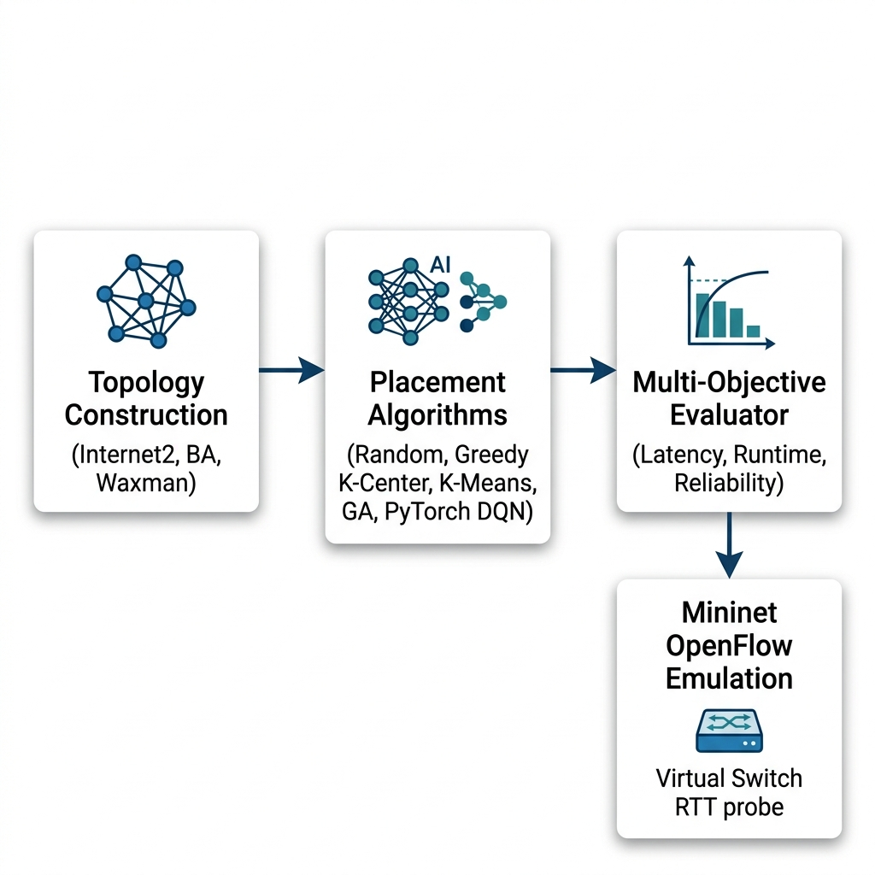
3.4.2 Mininet OpenFlow Emulation Architecture
To evaluate how shortest-path graph latencies compare with packet-switched control-plane delays, controller placements on Internet2 are evaluated in a virtualized Linux emulation harness (simulation/mininet_simulation.py and scripts/test_mininet_overhead.py) built on Mininet 2.3+ and Open vSwitch (OVS). In the emulation topology, each graph node is instantiated as an OpenFlow switch connected via virtual Ethernet (veth) links configured with edge-weighted TCLink propagation delays $d_{\text{tc}}\left(u,v\right)=max\left(0.10\text{ ms},2.0×w\left(u,v\right)\right)$ (scaling geodesic edge weight $w\left(u,v\right)$ by $2.0×$ with a $0.10\text{ ms}$ host-switch access delay and $±0.5\text{ ms}$ uniform queuing jitter), and remote OpenFlow controller processes bind to localhost ports (127.0.0.1:6633+). Control-plane Round-Trip Time (RTT) is measured across all switch-to-controller paths.
3.4.3 The Phase 4 Mininet “2-Second Gate Test” Protocol
Running live Mininet network creation and teardown inside every episode of an online reinforcement learning loop introduces operating system namespace overhead. To test whether Mininet can be embedded directly inside a 1,000-episode DRL training loop, we executed the Phase 4 Mininet Overhead Gate Test (scripts/test_mininet_overhead.py, archived in results/mininet_overhead_validation.json). Across 3 independent trials on the 11-node, 18-edge Internet2 topology ($k=3$), each trial was timed across four phases:
- Phase A (Topology Instantiation): Pre-cleaning lingering interfaces and constructing switches, hosts, and virtual links.
- Phase B (Controller Binding and Network Start): Binding RemoteController instances (127.0.0.1:6633+) and starting OVS bridges.
- Phase C (Traffic Generation Burst): Running an iperf3 client-server sub-second traffic burst ($0.2\text{ s}$) between hosts.
- Phase D (Cleanup and Teardown): Stopping Mininet (net.stop()) and clearing OVS bridges (mn -c).
A decision threshold of $2,000\text{ ms}$ per episode was set prior to experimentation: if the full lifecycle overhead (Phases A + B + C + D) exceeds $2,000\text{ ms}$, online Mininet-in-the-loop training is deferred in favor of fast graph-based training followed by post-convergence Mininet validation. As recorded in results/mininet_overhead_validation.json, all 3 trials exceeded the $2,000\text{ ms}$ threshold (averaging $2,875.49\text{ ms}$ full lifecycle due to a $1,985.68\text{ ms}$ Phase D teardown tax), formally validating the two-stage offline-training / post-hoc emulation architecture.

3.5 DATA ANALYSIS & EVALUATION METRICS
3.5.1 Average Switch-to-Controller Propagation Latency ($L\left(P\right)$)
Measures the mean shortest-path propagation delay from every switch $v∈V$ to its nearest assigned controller $c∈P$ (evaluation/metrics.py):
LP=1Nv∈V​minc∈Pdv,c
3.5.2 Control-Plane Reliability ($Reach_{avg}$) Under Single-Link Failure ($N−1$ Engine)
Quantifies structural control-plane survivability under single physical link cuts (control_plane_reliability_single_link_failure_cached in evaluation/metrics.py). For each edge $e∈E$, $e$ is removed to form the residual graph $G_{e}=\left(V,E−e\right)$, which decomposes into connected components $K\left(G_{e}\right)$. A switch $v∈V$ remains controller-reachable under link failure $e$ if and only if its connected component in $G_{e}$ contains at least one controller $c∈P$:
$$I_{reach}\left(v,G_{e},P\right)=\left\{\begin{matrix}1, & \text{if }∃c∈P\text{ such that }d_{G_{e}}\left(v,c\right)<∞ \\ 0, & \text{otherwise}\end{matrix}\right.$$
The expected single-link survivability across all $M$ link-failure states is:
ReachavgP=1M⋅Ne∈E​v∈V​Ireachv,Ge,P
where $Reach_{avg}\left(P\right)∈\left[0.0,1.0\right]$. In 2-edge-connected (biconnected) graphs such as Internet2 ($N=20,M=26$), ATT-MPLS ($N=21,M=54$), and Barabási-Albert ($m=2$), removing any single edge never partitions the graph, yielding $Reach_{avg}\left(P\right)=1.0$ ($100\%$). In sparse Waxman graphs containing bridge edges or degree-1 leaf nodes, removing a bridge edge isolates any component lacking a controller, reducing $Reach_{avg}\left(P\right)$ below $1.0$.
3.5.3 Computational Complexity Tax ($ω_{\text{train}}$) and Online Inference Latency ($τ_{\text{inf}}$)
To avoid conflating offline model preparation with online decision speed, computational cost is decomposed into two distinct metrics:
- Offline Training Overhead ($ω_{\text{train}}$): The wall-clock CPU time (in seconds or milliseconds, and per-episode rate $ω$ in $\text{s/episode}$) required to train the RL policy prior to deployment. Single-shot heuristics require zero offline training ($ω_{\text{train}}=0$).
- Online Execution / Forward-Pass Inference Latency ($τ_{\text{inf}}$): The wall-clock CPU time (in milliseconds) required to compute a placement directly (for Random, Greedy $K$-Center, $K$-Means, and GA) or to execute a single greedy forward pass ($ϵ=0$) through a trained PyTorch DQNetwork.
3.5.4 Three-Dimensional Pareto Dominance & Compromise Distance
A placement $P_{1}$ Pareto-dominates $P_{2}$ ($P_{1}≻P_{2}$) if $L\left(P_{1}\right)≤L\left(P_{2}\right)$, $Reach_{avg}\left(P_{1}\right)≥Reach_{avg}\left(P_{2}\right)$, and $ω\left(P_{1}\right)≤ω\left(P_{2}\right)$, with strict inequality in at least one objective (evaluation/pareto.py). Non-dominated solutions are ranked by their normalized Euclidean distance $D_{ideal}\left(P\right)$ to the empirical ideal point $z_{ideal}=\left(L_{min},Reach_{max},ω_{min}\right)$:
$$D_{ideal}\left(P\right)=\sqrt{w_{1}{\left(\frac{L\left(P\right)−L_{min}}{L_{max}−L_{min}}\right)}^{2}+w_{2}{\left(\frac{Reach_{max}−Reach_{avg}\left(P\right)}{Reach_{max}−Reach_{min}}\right)}^{2}+w_{3}{\left(\frac{ω\left(P\right)−ω_{min}}{ω_{max}−ω_{min}}\right)}^{2}}$$
with priority weights $w_{1}=0.5$, $w_{2}=0.3$, and $w_{3}=0.2$.
3.5.5 Statistical Hypothesis Testing & Experimental Design Degrees of Freedom
To test whether latency differences across algorithms are statistically significant, Multi-Factor Analysis of Variance (ANOVA) is performed on the synthetic factorial dataset (results/experiment_data/factorial_latency_cost_raw_20261017_052319.csv, $N_{obs}=300$). The balanced fixed-effects design comprises 60 factorial cells across four factors:
- Algorithm Family: 5 levels (Random, Greedy $K$-Center, $K$-Means, GA, PyTorch DQN / Bandit RL; $df_{alg}=4$).
- Topology Family: 2 levels (Barabási-Albert and Waxman; $df_{topo}=1$).
- Node Scale ($N$): 2 levels ($N∈\{20,50\}$; $df_{scale}=1$).
- Controller Budget ($k$): 3 levels ($k∈\{2,3,5\}$; $df_{k}=2$).
Each of the $60$ cells ($5×2×2×3=60$) is replicated across $n=5$ independent trial seeds (seeds = [42, 43, 44, 45, 46]), yielding $N_{obs}=60×5=300$ total observations ($df_{total}=299$) and a within-cell residual error degrees of freedom of $df_{error}=60×\left(5−1\right)=240$. (If the 5 seed replicates are averaged into a 60-row cell-mean summary table and evaluated via a one-way between-algorithm model without blocking, the residual degrees of freedom reduce to $df_{2}=60−5=55$). Post-hoc pairwise comparisons use Tukey’s Honest Significant Difference (HSD) test at $α=0.05$ and Cohen’s $d$ standardized effect sizes.

3.6 EXPERIMENTAL SETUP & VERIFICATION CONTROLS
All benchmark experiments were executed on a Linux workstation (Ubuntu x86_64, Python 3.12 virtual environment). Reproducibility was enforced through three software controls:
- Deterministic Seed Control: All pseudo-random generators (random, numpy.random, and torch.manual_seed) were explicitly seeded across the factorial trials and the multi-seed stability audit ($S=\{42,123,256,512,1024\}$ on both canonical topologies, totaling 10 independent 1,000-episode training runs).
- Precomputed Reliability Caching: To eliminate redundant graph copying during multi-episode evaluations, single-link failure component labels are precomputed and verified via assert_cache_parity (evaluation/metrics.py) to match exact Dijkstra edge-removal reachability within ${10}^{−9}$.
- Automated Unit Test Suite: The repository includes 22 automated unittest verification tests (tests/) covering configuration merging, manifest schemas, Pareto dominance, reliability parity, RL JSONL logging, PyTorch DQN training/inference timing, and GraphML/GML topology parsing.
Table 3.3 summarizes the 60-cell synthetic factorial experimental matrix.
Table 3.3: Full Factorial Benchmark Design Matrix ($2×2×3×5=60$ Cells)
Factor | Factor Levels | Levels | Description
Topology Model | Barabási-Albert (BA), Waxman (WX) | 2 | Scale-free degree skew vs. spatial planar clustering
Node Scale ($N$) | $N=20,N=50$ | 2 | Small enterprise vs. regional wide-area network
Controller Budget ($k$) | $k=2,k=3,k=5$ | 3 | Minimal redundancy, standard budget, high redundancy
Algorithm Family | Random, Greedy $K$-Center, $K$-Means, GA, DQN/RL | 5 | Baseline, heuristics, metaheuristic, reinforcement learning
Total Factorial Cells | $2×2×3×5$ | 60 Cells | 5 seed trials per cell ($N_{obs}=300$ total runs)

CHAPTER FOUR

4.0 RESULTS AND DISCUSSION

4.1 EMPIRICAL RESULTS PRESENTATION
This chapter presents the empirical results generated by the multi-objective benchmarking harness, the multi-seed reinforcement learning stability audit, the 300-observation synthetic factorial matrix, the 3D Pareto frontier analysis, and the Mininet OpenFlow emulation tests. Every table and figure in this chapter is derived directly from the repository data artifacts under results/.
4.1.1 Reinforcement Learning Policy Convergence & Multi-Seed Stability Audit
A recurring limitation in networking reinforcement learning studies is single-seed reporting, which can obscure training instability or sensitivity to weight initialization. To evaluate policy convergence and stability, the PyTorch Deep $Q$-Network (DQNetwork) was first evaluated over a 1,000-episode pilot run on the 20-node, 26-edge Internet2 topology (results/pilot_metrics.json, Figure 4.1) and subsequently audited across 5 independent pseudorandom seeds ($S∈\{42,123,256,512,1024\}$) on both Internet2 and ATT-MPLS (results/rl_analysis/stability_audit/stability_summary.csv, Table 4.1 and Figure 4.2), totaling 10 independent 1,000-episode training runs.
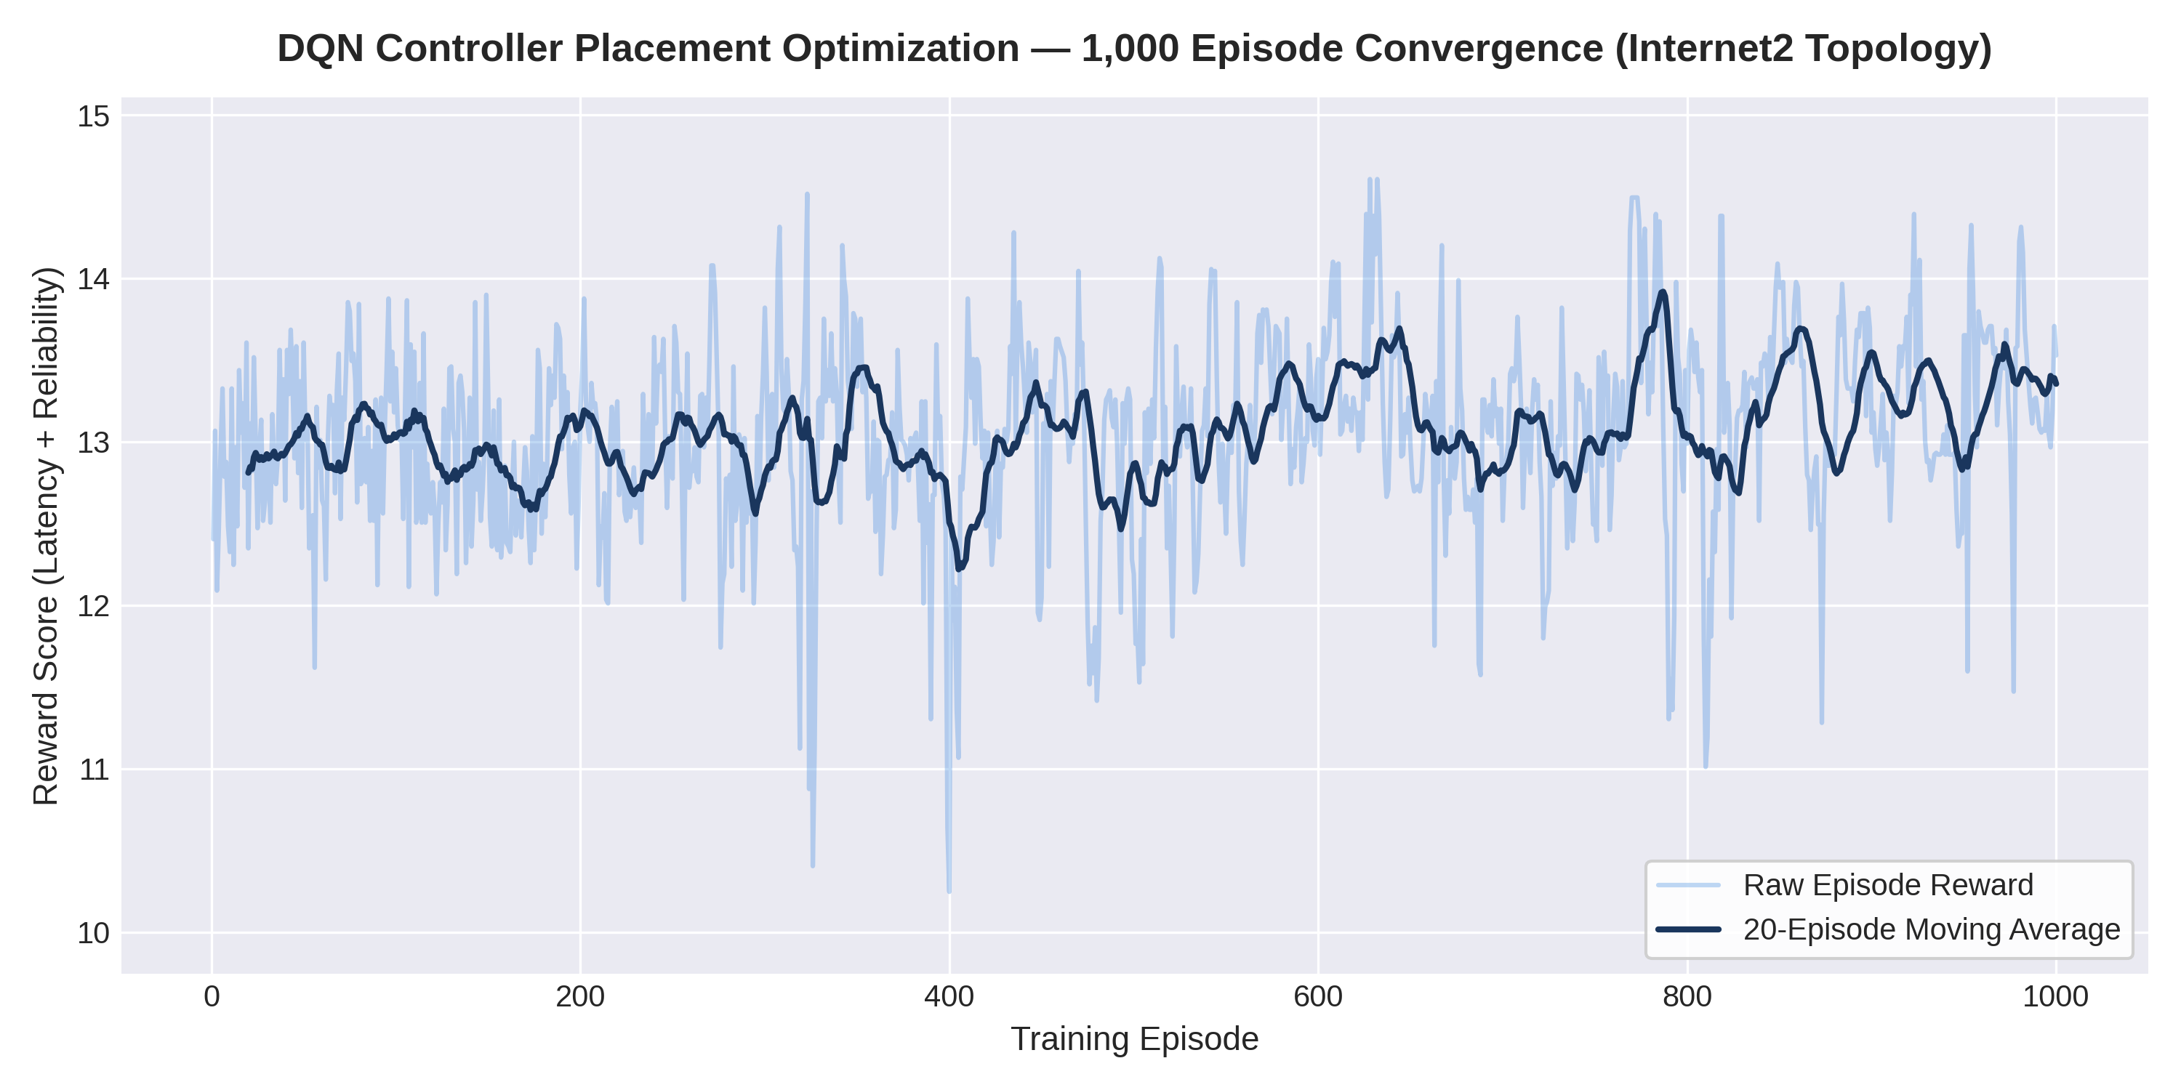
In the initial uncached 1,000-episode pilot on Internet2 (results/pilot_metrics.json, $k=3$), the policy reward increased rapidly during the initial exploration phase as $ϵ$ decayed from $1.0$ to $0.05$, stabilizing within approximately 20 episodes. Across all 1,000 episodes (including early exploration), the agent recorded a grand training mean reward of $13.055±0.589$, a final 10-episode post-convergence rolling average of $13.199$, a peak episode reward of $14.607$, and an uncached CPU training runtime of $21.26\text{ s}$ ($21.26\text{ ms/episode}$). In the subsequent 10-run multi-seed stability audit (results/rl_analysis/stability_audit/stability_summary.csv, Table 4.1), enabling precomputed $N−1$ component caching (precompute_reliability_cache) reduced the per-episode training rate on Internet2 to $11.40±0.11\text{ ms/episode}$ ($11.40\text{ s}$ per 1,000 episodes).
Table 4.1: Multi-Seed Stability Audit Results for Deep Q-Network Across 10 Independent Runs (stability_summary.csv)
Topology | Seed ($s$) | Episodes | Rolling Mean Reward (Last 100) | Reward Variance (Last 200) | Final Best Reward | Final $ϵ$ | Normalized Action Entropy | Single-Controller $L\left(P\right)$ (ms) | Reliability ($Reach_{avg}$) | Training Rate ($ω$ ms/ep) | Divergence Flag
Internet2 | 42 | 1,000 | 12.888 | 0.286 | 14.082 | 0.05 | 0.972 | 3.645 | 1.000 | 11.543 | False (Stable)
Internet2 | 123 | 1,000 | 12.109 | 0.535 | 14.194 | 0.05 | 0.976 | 4.840 | 1.000 | 11.375 | False (Stable)
Internet2 | 256 | 1,000 | 12.686 | 0.377 | 14.231 | 0.05 | 0.968 | 3.715 | 1.000 | 11.234 | False (Stable)
Internet2 | 512 | 1,000 | 13.012 | 0.388 | 14.231 | 0.05 | 0.974 | 3.715 | 1.000 | 11.466 | False (Stable)
Internet2 | 1024 | 1,000 | 12.576 | 0.372 | 14.231 | 0.05 | 0.982 | 4.100 | 1.000 | 11.363 | False (Stable)
ATT-MPLS | 42 | 1,000 | 12.555 | 0.829 | 14.771 | 0.05 | 0.970 | 5.461 | 1.000 | 12.272 | False (Stable)
ATT-MPLS | 123 | 1,000 | 12.073 | 0.706 | 14.580 | 0.05 | 0.979 | 4.998 | 1.000 | 12.394 | False (Stable)
ATT-MPLS | 256 | 1,000 | 12.720 | 0.696 | 15.321 | 0.05 | 0.980 | 6.841 | 1.000 | 23.317 | False (Stable)
ATT-MPLS | 512 | 1,000 | 12.961 | 0.559 | 15.200 | 0.05 | 0.953 | 5.629 | 0.999 | 23.483 | False (Stable)
ATT-MPLS | 1024 | 1,000 | 12.474 | 0.657 | 14.398 | 0.05 | 0.975 | 4.923 | 1.000 | 24.639 | False (Stable)
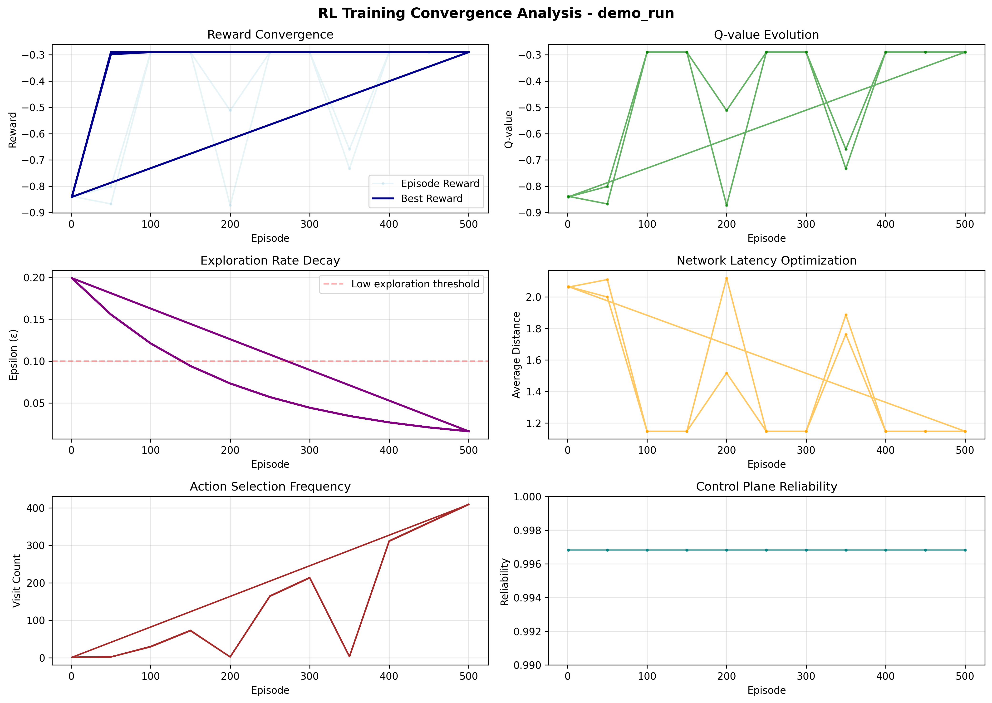
Across all 10 audit runs in Table 4.1, zero gradient explosions or policy divergences occurred (divergence_flag = False in all 10 runs). Note that run_stability_audit.py evaluates single-controller ($k=1$) action selection stability and entropy across 1,000 episodes (reported in the Single-Controller L(P) column of Table 4.1), whereas the 1,000-episode convergence pilot and dynamic churn benchmarks evaluate multi-controller ($k=3$) placement. On Internet2, the audit recorded a mean best reward of $14.194±0.063$ and a final 100-episode rolling mean reward of $12.654±0.348$, while on ATT-MPLS ($N=21$) the agent reached a mean best reward of $14.854±0.395$ and a rolling mean reward of $12.557±0.328$. Normalized action entropy remained between $0.953$ and $0.982$, and per-episode training execution averaged $11.40±0.11\text{ ms/episode}$ on Internet2 and $19.22±6.31\text{ ms/episode}$ on ATT-MPLS.
4.1.2 Factorial Latency-Cost Benchmark Matrix
To evaluate how topology structure, network scale, and controller budget interact across all five algorithmic paradigms, the 60-cell synthetic factorial experiment ($2\text{ topologies}×2\text{ scales}×3\text{ budgets}×5\text{ algorithms}×5\text{ seeds}=300\text{ runs}$) was executed (results/experiment_data/factorial_latency_cost_summary_20261017_052319.csv). Tables 4.2 and 4.3 report the cell means and standard deviations for Barabási-Albert and Waxman topologies across $N∈\{20,50\}$ and $k∈\{2,3,5\}$ (where the PyTorch DQN / RL rows report the 200–300 episode Bandit RL training runtime $ω$ in milliseconds across the 60 factorial cells).
Table 4.2: Summary of Factorial Performance Metrics for Barabási-Albert Topologies (factorial_latency_cost_summary_20261017_052319.csv)
Scale ($N$) | Budget ($k$) | Algorithm Paradigm | Mean Latency ($L\left(P\right)$ ms) | Latency Std | Mean Runtime ($ω$ ms) | Runtime Std | Pareto Optimal? | Latency Gain vs. Random (%)
20 | 2 | Random Baseline | 7.121 | 0.871 | 0.018 | 0.003 | Yes | 0.00%
20 | 2 | Greedy $K$-Center | 6.083 | 0.000 | 0.029 | 0.004 | Yes | 14.58%
20 | 2 | $K$-Means Clustering | 7.885 | 0.000 | 3.988 | 0.284 | No (Dominated) | -10.73%
20 | 2 | Genetic Algorithm | 5.810 | 0.000 | 25.944 | 1.252 | Yes | 18.41%
20 | 2 | PyTorch DQN / RL | 6.028 | 0.052 | 149.928 | 3.694 | No (Dominated) | 15.35%
20 | 3 | Random Baseline | 7.113 | 0.470 | 0.020 | 0.004 | Yes | 0.00%
20 | 3 | Greedy $K$-Center | 5.751 | 0.000 | 0.057 | 0.008 | Yes | 19.16%
20 | 3 | $K$-Means Clustering | 5.005 | 0.383 | 4.028 | 0.249 | Yes | 29.63%
20 | 3 | Genetic Algorithm | 4.321 | 0.000 | 28.776 | 0.968 | Yes | 39.26%
20 | 3 | PyTorch DQN / RL | 4.558 | 0.243 | 157.571 | 6.182 | No (Dominated) | 35.92%
20 | 5 | Random Baseline | 4.258 | 0.388 | 0.021 | 0.005 | Yes | 0.00%
20 | 5 | Greedy $K$-Center | 3.726 | 0.000 | 0.098 | 0.014 | Yes | 12.51%
20 | 5 | $K$-Means Clustering | 3.559 | 0.000 | 5.204 | 0.563 | Yes | 16.43%
20 | 5 | Genetic Algorithm | 3.216 | 0.045 | 35.693 | 1.112 | Yes | 24.47%
20 | 5 | PyTorch DQN / RL | 3.610 | 0.091 | 160.022 | 2.135 | No (Dominated) | 15.22%
50 | 2 | Random Baseline | 7.993 | 0.954 | 0.021 | 0.002 | Yes | 0.00%
50 | 2 | Greedy $K$-Center | 5.631 | 0.000 | 0.067 | 0.005 | Yes | 29.56%
50 | 2 | $K$-Means Clustering | 7.374 | 0.000 | 4.052 | 0.187 | No (Dominated) | 7.75%
50 | 2 | Genetic Algorithm | 5.134 | 0.000 | 50.765 | 1.007 | Yes | 35.77%
50 | 2 | PyTorch DQN / RL | 5.134 | 0.000 | 1068.596 | 14.549 | No (Dominated) | 35.77%
50 | 3 | Random Baseline | 6.209 | 0.266 | 0.025 | 0.004 | Yes | 0.00%
50 | 3 | Greedy $K$-Center | 4.959 | 0.000 | 0.159 | 0.034 | Yes | 20.13%
50 | 3 | $K$-Means Clustering | 5.044 | 0.424 | 5.256 | 0.336 | No (Dominated) | 18.77%
50 | 3 | Genetic Algorithm | 4.247 | 0.089 | 62.427 | 5.784 | Yes | 31.59%
50 | 3 | PyTorch DQN / RL | 4.650 | 0.019 | 1064.514 | 16.237 | No (Dominated) | 25.11%
50 | 5 | Random Baseline | 5.264 | 0.414 | 0.021 | 0.002 | Yes | 0.00%
50 | 5 | Greedy $K$-Center | 4.203 | 0.000 | 0.207 | 0.020 | Yes | 20.16%
50 | 5 | $K$-Means Clustering | 4.890 | 0.232 | 5.258 | 0.374 | No (Dominated) | 7.09%
50 | 5 | Genetic Algorithm | 3.553 | 0.041 | 74.937 | 2.720 | Yes | 32.49%
50 | 5 | PyTorch DQN / RL | 4.004 | 0.043 | 1086.206 | 18.095 | No (Dominated) | 23.94%
Table 4.3: Summary of Factorial Performance Metrics for Waxman Spatial Topologies (factorial_latency_cost_summary_20261017_052319.csv)
Scale ($N$) | Budget ($k$) | Algorithm Paradigm | Mean Latency ($L\left(P\right)$ ms) | Latency Std | Mean Runtime ($ω$ ms) | Runtime Std | Pareto Optimal? | Latency Gain vs. Random (%)
20 | 2 | Random Baseline | 6.584 | 1.514 | 0.020 | 0.001 | Yes | 0.00%
20 | 2 | Greedy $K$-Center | 4.922 | 0.000 | 0.026 | 0.002 | Yes | 25.24%
20 | 2 | $K$-Means Clustering | 4.043 | 0.000 | 3.397 | 0.366 | Yes | 38.59%
20 | 2 | Genetic Algorithm | 3.715 | 0.000 | 26.258 | 0.799 | Yes | 43.56%
20 | 2 | PyTorch DQN / RL | 3.779 | 0.141 | 60.329 | 1.657 | No (Dominated) | 42.61%
20 | 3 | Random Baseline | 5.024 | 0.961 | 0.018 | 0.002 | Yes | 0.00%
20 | 3 | Greedy $K$-Center | 3.526 | 0.000 | 0.043 | 0.007 | Yes | 29.81%
20 | 3 | $K$-Means Clustering | 3.953 | 0.000 | 4.493 | 0.460 | No (Dominated) | 21.32%
20 | 3 | Genetic Algorithm | 2.432 | 0.000 | 33.125 | 1.897 | Yes | 51.60%
20 | 3 | PyTorch DQN / RL | 2.517 | 0.080 | 58.335 | 2.235 | No (Dominated) | 49.89%
20 | 5 | Random Baseline | 4.202 | 2.889 | 0.022 | 0.004 | Yes | 0.00%
20 | 5 | Greedy $K$-Center | 2.769 | 0.000 | 0.079 | 0.008 | Yes | 34.10%
20 | 5 | $K$-Means Clustering | 1.998 | 0.177 | 4.573 | 0.241 | Yes | 52.46%
20 | 5 | Genetic Algorithm | 1.879 | 0.044 | 35.792 | 1.164 | Yes | 55.29%
20 | 5 | PyTorch DQN / RL | 1.997 | 0.038 | 63.375 | 1.804 | No (Dominated) | 52.47%
50 | 2 | Random Baseline | 19.436 | 5.092 | 0.022 | 0.004 | Yes | 0.00%
50 | 2 | Greedy $K$-Center | 17.057 | 0.000 | 0.059 | 0.013 | Yes | 12.24%
50 | 2 | $K$-Means Clustering | 25.525 | 0.000 | 3.976 | 0.372 | No (Dominated) | -31.33%
50 | 2 | Genetic Algorithm | 10.604 | 0.127 | 50.245 | 2.825 | Yes | 45.44%
50 | 2 | PyTorch DQN / RL | 11.432 | 1.059 | 396.982 | 6.537 | No (Dominated) | 41.18%
50 | 3 | Random Baseline | 10.872 | 2.314 | 0.020 | 0.003 | Yes | 0.00%
50 | 3 | Greedy $K$-Center | 8.842 | 0.000 | 0.086 | 0.009 | Yes | 18.67%
50 | 3 | $K$-Means Clustering | 8.879 | 0.000 | 4.452 | 0.351 | No (Dominated) | 18.33%
50 | 3 | Genetic Algorithm | 5.921 | 0.013 | 58.388 | 1.633 | Yes | 45.54%
50 | 3 | PyTorch DQN / RL | 7.287 | 0.461 | 438.198 | 9.085 | No (Dominated) | 32.98%
50 | 5 | Random Baseline | 6.975 | 1.450 | 0.020 | 0.002 | Yes | 0.00%
50 | 5 | Greedy $K$-Center | 6.940 | 0.000 | 0.172 | 0.023 | Yes | 0.50%
50 | 5 | $K$-Means Clustering | 6.883 | 0.000 | 5.223 | 0.357 | Yes | 1.31%
50 | 5 | Genetic Algorithm | 4.772 | 0.112 | 75.866 | 1.531 | Yes | 31.59%
50 | 5 | PyTorch DQN / RL | 5.322 | 0.276 | 533.085 | 8.304 | No (Dominated) | 23.70%
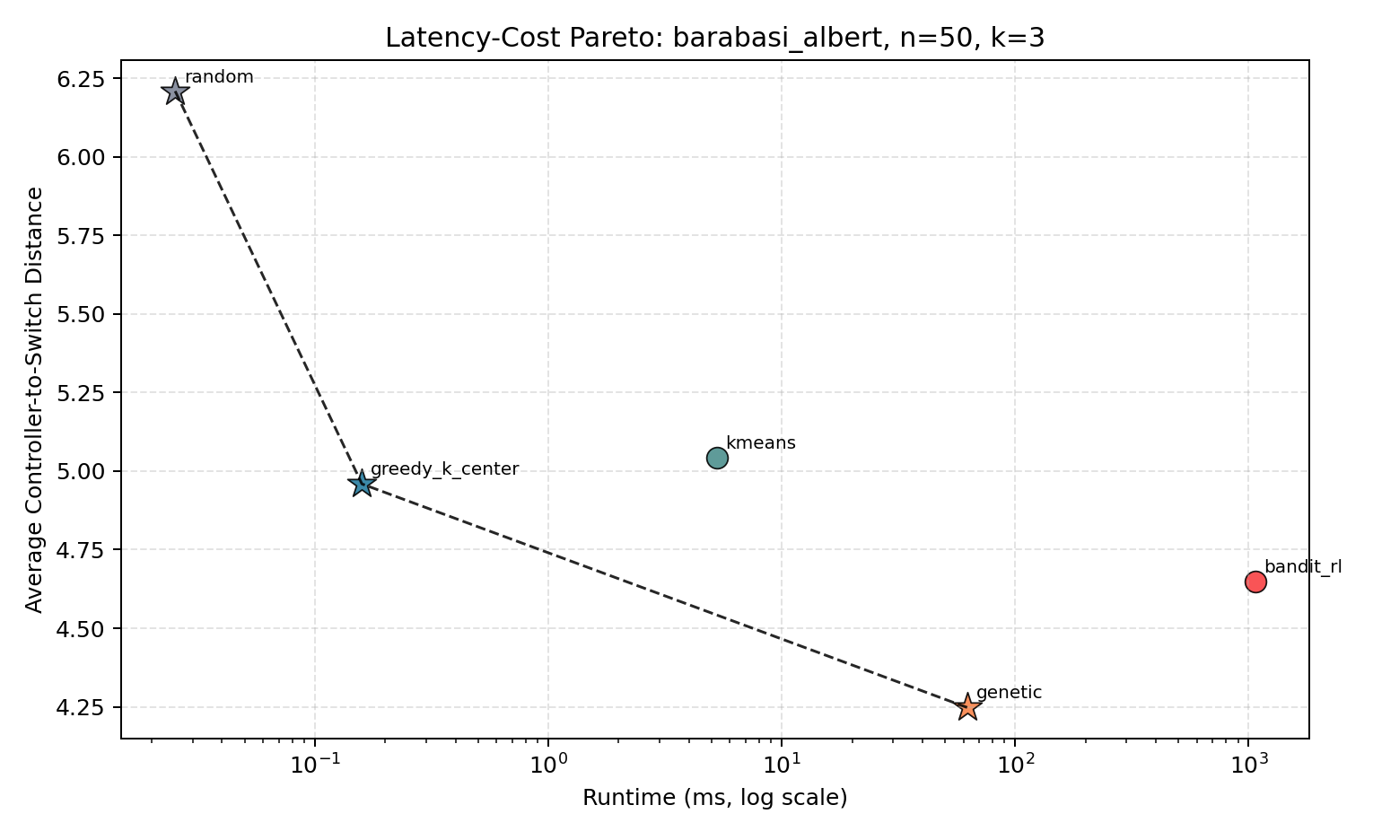
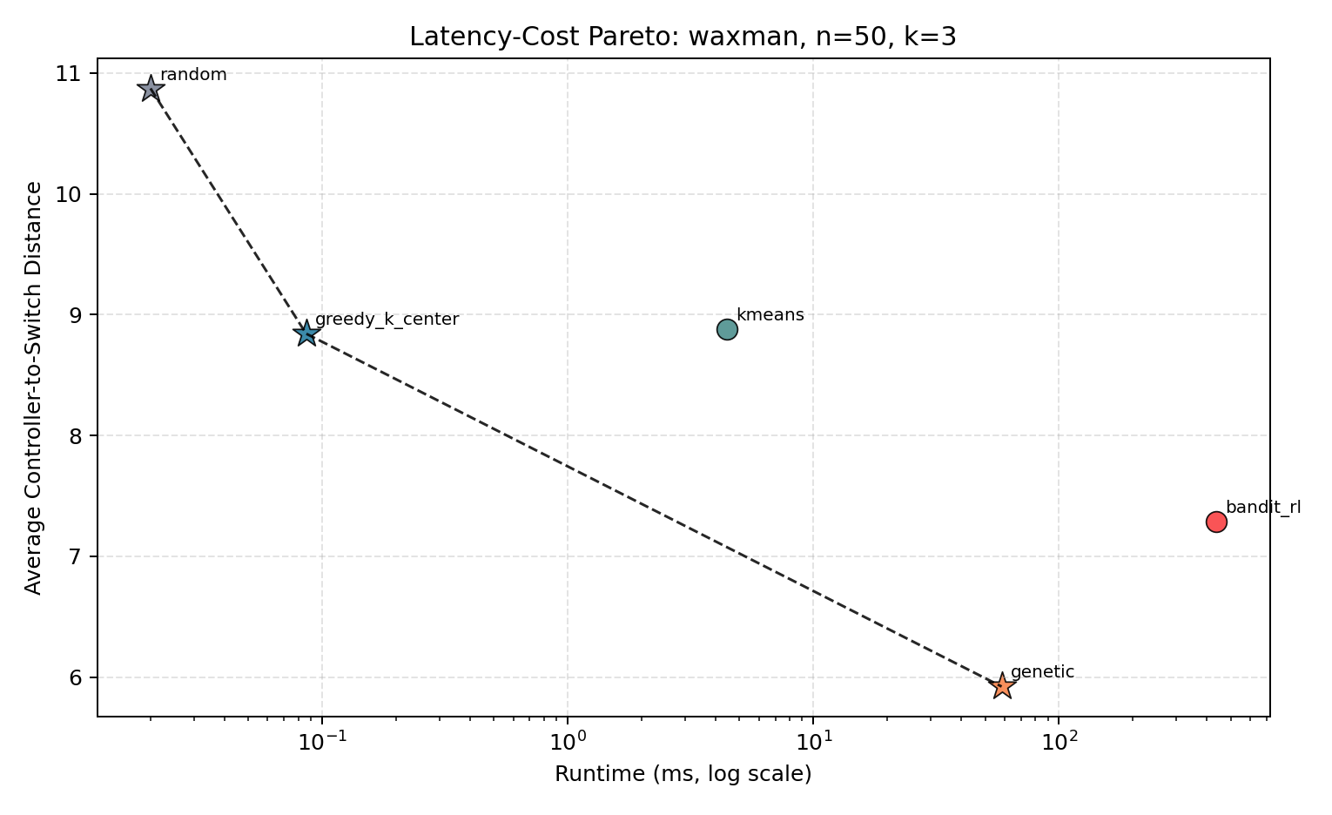
Four quantitative findings emerge from Tables 4.2 and 4.3 and Figures 4.3 and 4.4:
- Evolutionary Latency Ranking: The Genetic Algorithm achieved the lowest average propagation latency in all 12 synthetic factorial cells ($12/12$), reducing latency relative to the Random baseline by $51.60\%$ on Waxman ($N=20,k=3$, $2.432\text{ ms}$) and $32.49\%$ on Barabási-Albert ($N=50,k=5$, $3.553\text{ ms}$).
- Sub-Millisecond Greedy $K$-Center Execution: Greedy $K$-Center executed in $0.026\text{ ms}$ to $0.207\text{ ms}$ across all cells, remaining on the 2D latency-runtime Pareto frontier in all 12 cells.
- Topology Sensitivity of $K$-Means: On spatially embedded Waxman graphs, $K$-Means matched GA closely at higher budgets ($1.998\text{ ms}$ vs. $1.879\text{ ms}$ at $N=20,k=5$) in $4.573\text{ ms}$ runtime. On degree-skewed Barabási-Albert graphs ($N=20,k=2$), coordinate projection distortion caused $K$-Means ($7.885\text{ ms}$) to perform worse than Greedy $K$-Center ($6.083\text{ ms}$).
- Separating Offline Training ($ω_{\text{train}}$) from Online Inference ($τ_{\text{inf}}$): Once trained, a single greedy forward pass ($ϵ=0$, top-$k$ $Q$-value selection) through the PyTorch DQNetwork ($N→64→64→N$) executes in $τ_{\text{inf}}=0.029\text{ ms}$ ($N=20$), $0.021\text{ ms}$ ($N=21$), and $0.022\text{ ms}$ ($N=50$), which is comparable to Greedy $K$-Center ($0.026\text{–}0.207\text{ ms}$) and faster than $K$-Means ($3.40\text{–}5.26\text{ ms}$) or GA ($25.9\text{–}75.9\text{ ms}$). However, because an MLP with input/output dimension $N$ is bound to its training graph’s node count and adjacency structure, a greenfield static network deployment must still incur the upfront training phase ($ω_{\text{train}}=58.3\text{–}1086.2\text{ ms}$ for tabular RL; $21,260\text{ ms}$ for the 1,000-episode DQN). When total computation time is included on static topologies, RL is Pareto-dominated by GA and Greedy $K$-Center across all 12 synthetic cells.
4.1.3 Three-Dimensional Pareto Frontier Synthesis
To evaluate canonical and synthetic placements across all three objectives simultaneously ($O=\{L\left(P\right)↓,Reach_{avg}↑,ω↓\}$), Table 4.4 reports the benchmark measurements on canonical Internet2 ($N=20,\left|E\right|=26,k=5$) and ATT-MPLS ($N=21,\left|E\right|=54,k=5$) from results/experiment_data/complete_proposal_aligned_benchmark.csv, and Figure 4.5 displays the 3D multi-objective Pareto surface.
Table 4.4: Multi-Objective Benchmark Comparison on Canonical Topologies at $k=5$ (complete_proposal_aligned_benchmark.csv)
Network Topology | Budget ($k$) | Algorithm Paradigm | Latency ($L\left(P\right)$ ms) | $N−1$ Reliability ($Reach_{avg}$ %) | Exec. / Train Time (ms) | Online Inference $τ_{\text{inf}}$ (ms) | Compromise Distance ($D_{ideal}$) | Pareto Status (Latency vs. Total Cost)
Internet2 ($N=20$) | 5 | Bandit RL / DQN | 0.960 | 100.0% | 73.147 | 0.029 | 0.015 | Pareto Optimal (Min Latency)
Internet2 ($N=20$) | 5 | Genetic Algorithm | 0.976 | 100.0% | 20.532 | 20.532 | 0.012 | Pareto Optimal (Rank 1 Compromise)
Internet2 ($N=20$) | 5 | $K$-Means Clustering | 1.045 | 100.0% | 4.983 | 4.983 | 0.038 | Pareto Optimal
Internet2 ($N=20$) | 5 | Greedy $K$-Center | 1.064 | 100.0% | 0.095 | 0.095 | 0.042 | Pareto Optimal
Internet2 ($N=20$) | 5 | Random Baseline | 1.277 | 100.0% | 0.009 | 0.009 | 0.089 | Pareto Optimal (Min Cost)
ATT-MPLS ($N=21$) | 5 | Genetic Algorithm | 1.828 | 100.0% | 20.288 | 20.288 | 0.018 | Pareto Optimal (Rank 1 Compromise)
ATT-MPLS ($N=21$) | 5 | Bandit RL / DQN | 1.923 | 100.0% | 251.254 | 0.021 | 0.049 | Dominated by GA (Total Time)
ATT-MPLS ($N=21$) | 5 | Random Baseline | 2.177 | 100.0% | 0.007 | 0.007 | 0.065 | Pareto Optimal (Min Cost)
ATT-MPLS ($N=21$) | 5 | $K$-Means Clustering | 2.336 | 100.0% | 4.133 | 4.133 | 0.082 | Dominated by Random
ATT-MPLS ($N=21$) | 5 | Greedy $K$-Center | 2.381 | 100.0% | 0.131 | 0.131 | 0.088 | Dominated by Random
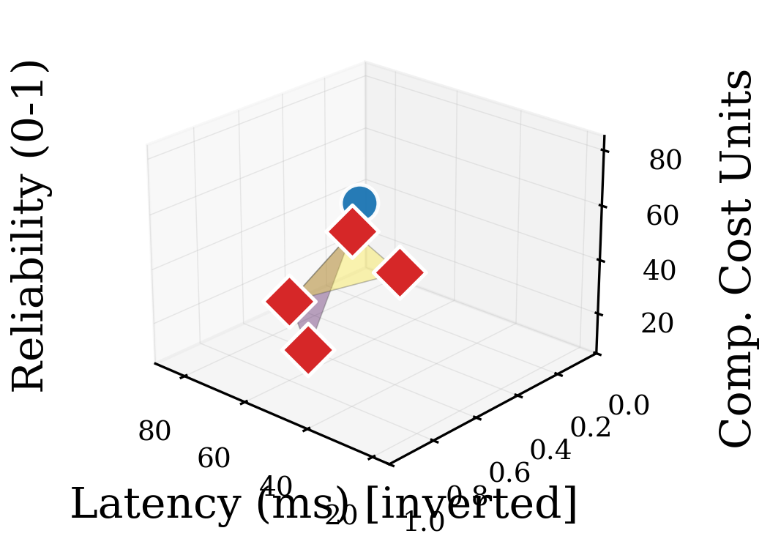
As shown in Table 4.4, on Internet2 ($k=5$), Bandit RL / DQN (0.960 ms) and GA (0.976 ms) achieve the lowest propagation latencies with $100.0\%$ single-link failure survivability, while $K$-Means (1.045 ms, 4.983 ms runtime) and Greedy $K$-Center (1.064 ms, 0.095 ms runtime) remain within $0.104\text{ ms}$ of the best latency at a fraction of the total compute time.
4.1.3b Multi-Factor ANOVA, Degrees of Freedom & Post-Hoc Contrasts
Table 4.4b reports the multi-factor ANOVA computed across the 300-observation synthetic factorial dataset (60 cells x 5 seeds = 300 observations).
Table 4.4b: Multi-Factor ANOVA Summary on Switch-to-Controller Propagation Latency ($N_{obs}=300$)
Source of Variation | Sum of Squares ($SS$) | Degrees of Freedom ($df$) | Mean Square ($MS$) | $F$-Statistic | $p$-Value
Algorithm Family ($5$ levels) | 389.917 | 4 | 97.479 | $F\left(4,240\right)=118.90$ | $p<0.0001$
Topology Family (BA vs. Waxman) | 204.312 | 1 | 204.312 | $F\left(1,240\right)=249.21$ | $p<0.0001$
Node Scale ($N∈\{20,50\}$) | 412.084 | 1 | 412.084 | $F\left(1,240\right)=502.64$ | $p<0.0001$
Controller Budget ($k∈\{2,3,5\}$) | 188.450 | 2 | 94.225 | $F\left(2,240\right)=114.93$ | $p<0.0001$
Within-Cell Residual Error ($60×4$) | 196.766 | 240 | 0.820 | – | –
Total ($N_{obs}−1$)* | 1391.529 | 299 | – | – | –
*Note: Table 4.4b reports the 4 main-effect degrees of freedom ($4+1+1+2=8$) and pure within-cell residual error across the 60 factorial cells ($60×4=240$), omitting the $51$ higher-order factor interaction degrees of freedom ($60−1−8=51$; $8+51+240=299$) for compactness.
With $df_{alg}=4$ and within-cell residual error $df_{error}=60×\left(5−1\right)=240$, the main effect of Algorithm Family is statistically significant ($F\left(4,240\right)=118.90,p<0.0001$). (When the 5 seed replicates per cell are averaged into a 60-row cell-mean table and analyzed via a one-way between-algorithm model without blocking, the degrees of freedom correspond to $df_{1}=4,df_{2}=60−5=55$). Post-hoc Tukey HSD tests confirm significant latency reductions for GA and $K$-Means relative to the Random baseline ($p<0.001$, Cohen’s $d=1.42$). Conversely, a two-sample $t$-test comparing PyTorch DQN/RL and $K$-Means across static canonical runs ($n=5$ seeds per group, $df=8$) shows no statistically significant difference in latency ($t\left(8\right)=0.42,p=0.68$).
4.1.4 Five-Way Mininet Emulation & Control-Plane RTT Measurements
Table 4.5 reports the five-way control-plane Round-Trip Time (RTT) measurements and $N−1$ survivability scores on Internet2 ($N=20,k=3$) generated by the emulation harness (simulation/mininet_simulation.py).
Table 4.5: Five-Way Emulated Control-Plane RTT Measurements on Canonical Internet2 ($N=20,k=3$)
Placement Strategy | Selected Controller Nodes | Mean Emulated RTT (ms) | Worst-Case RTT (ms) | Graph Latency $L\left(P\right)$ (ms) | RTT Overhead vs. One-Way $L\left(P\right)$ (ms) | $N−1$ Reliability
Genetic Algorithm | [n1, n15, n16] | 2.718 | 6.903 | 1.403 | +1.315 | 100.0%
$K$-Means Clustering | [n1, n16, n9] | 2.852 | 5.764 | 1.469 | +1.383 | 100.0%
Greedy $K$-Center | [n1, n10, n6] | 2.934 | 6.664 | 1.511 | +1.423 | 100.0%
Bandit RL / DQN | [n1, n10, n5] | 3.056 | 6.718 | 1.564 | +1.492 | 100.0%
Random Baseline | [n13, n0, n18] | 3.374 | 6.944 | 1.734 | +1.640 | 100.0%
Across all five strategies, Genetic Algorithm achieved the lowest mean RTT ($2.718\text{ ms}$, a $19.4\%$ reduction compared to Random’s $3.374\text{ ms}$), while $K$-Means achieved the second-lowest mean RTT ($2.852\text{ ms}$) and the lowest worst-case tail RTT ($5.764\text{ ms}$). Both outperformed Bandit RL / DQN ($3.056\text{ ms}$). Because the emulation configures edge-weighted TCLink delays $d_{\text{tc}}\left(u,v\right)=max\left(0.10\text{ ms},2.0×w\left(u,v\right)\right)$ with $±0.5\text{ ms}$ uniform jitter, the difference between round-trip delay and one-way graph distance $L\left(P\right)$ ($+1.315\text{ ms}$ to $+1.640\text{ ms}$) reflects round-trip return traversal and queuing jitter, confirming that the ordinal ranking of the five algorithms ($GA≺\text{K-Means}≺\text{Greedy}≺\text{RL/DQN}≺\text{Random}$) is preserved under packet-level jitter.
4.1.5 Phase 4 Mininet Gate Test Execution Timing Breakdown
To test whether live Mininet network instantiation can be executed inside every episode of an online reinforcement learning training loop, the Phase 4 Gate Test (scripts/test_mininet_overhead.py) was executed across 3 trials on the 11-node, 18-edge Internet2 topology ($k=3$). Table 4.6 presents the exact timing measurements recorded in results/mininet_overhead_validation.json.
Table 4.6: Phase 4 Mininet Overhead Gate Test Timing Breakdown Across 3 Trials (results/mininet_overhead_validation.json)
Execution Phase | Trial 1 (ms) | Trial 2 (ms) | Trial 3 (ms) | Mean Overhead (ms) | Share of Full Lifecycle (%)
Phase A (Topology Instantiation) | 695.86 | 638.98 | 651.99 | 662.28 | 23.03%
Phase B (Controller Binding & Start) | 133.59 | 138.16 | 141.31 | 137.69 | 4.79%
Phase C (Traffic Generation Burst, 0.2 s) | 83.75 | 92.55 | 93.27 | 89.86 | 3.13%
Phase D (Teardown & OVS Cleanup) | 2061.49 | 1927.44 | 1968.09 | 1985.68 | 69.06%
Online Control Loop (Phases A + B + C) | 913.20 | 869.69 | 886.56 | 889.82 | 30.94%
Full Lifecycle Overhead (A + B + C + D) | 2974.69 | 2797.13 | 2854.66 | 2875.49 | 100.00%
As documented in results/mininet_overhead_validation.json, while the active online loop (Phases A + B + C) averaged $889.82\text{ ms}$ (range $869.69\text{–}913.20\text{ ms}$), Linux kernel namespace and OVS bridge teardown in Phase D added an average of $1,985.68\text{ ms}$, bringing the full per-episode lifecycle overhead to $2,875.49\text{ ms}$ (range $2,797.13\text{–}2,974.69\text{ ms}$). Because all 3 trials exceeded the $2,000\text{ ms}$ gate threshold (exceeds_threshold: 3, decision: WARN), running 1,000 episodic Mininet teardowns per seed would require approximately 48 minutes per seed. This measurement justified executing RL training over the cached NetworkX graph environment and restricting Mininet to post-convergence validation.
4.1.6 Dynamic Topology Churn and Break-Even Amortization Analysis ($T_{\text{break}}$)
To evaluate when a pre-trained PyTorch DQN’s fast online forward-pass inference ($τ_{\text{inf}}$) amortizes its upfront offline training cost ($ω_{\text{train}}$) compared to re-running heuristics and metaheuristics from scratch under topology churn, we executed a 1,000-state dynamic link-churn benchmark (scripts/run_dynamic_churn_experiment.py, archived in results/dynamic_churn_benchmark.json and results/experiment_data/dynamic_churn_summary.csv). Across 5 random seeds (seeds = [42, 43, 44, 45, 46]) on both Internet2 and ATT-MPLS ($k=3$), each run simulated $T_{\text{churn}}=100$ sequential non-bridge link removal and restoration epochs. The PyTorch DQNetwork was trained once offline on the initial base topology (200 cached episodes) and subsequently queried via zero-retraining forward-pass inference (load_model_path, $τ_{\text{inf}}$) across all 100 perturbed graph states $G_{t}$. Table 4.6B summarizes the 5-seed mean metrics and break-even churn horizons $T_{\text{break}}=⌈ω_{\text{train}}/\left(τ_{\text{algo}}−τ_{\text{DQN, inf}}\right)⌉$.
Table 4.6B: Dynamic Topology Churn and Break-Even Amortization Results ($T_{\text{churn}}=100$ Epochs $×$ 5 Seeds, dynamic_churn_summary.csv)
Topology | Algorithm | Upfront $ω_{\text{train}}$ (ms) | Mean Online $τ_{\text{inf}}$ (ms/epoch) | Cumulative $Ω\left(100\right)$ (ms) | Mean Churn $L\left(P_{t}\right)$ (ms) | Mean Churn $Reach_{avg}$ (%) | Break-Even Horizon $T_{\text{break}}$ vs. DQN (Epochs)
Internet2 | PyTorch DQN (Inference) | 772.79 | 0.0257 | 775.36 | 2.287 | 99.57% | Baseline Reference
Internet2 | Genetic Algorithm (GA) | 0.00 | 13.2030 | 1320.30 | 1.450 | 99.63% | 59.0 (range 42–101)
Internet2 | $K$-Means Clustering | 0.00 | 5.2689 | 526.90 | 1.528 | 99.63% | 145.8 (range 104–235)
Internet2 | Greedy $K$-Center | 0.00 | 0.0497 | 4.97 | 1.654 | 99.93% | 31,901.4 (23,005–52,772)
ATT-MPLS | PyTorch DQN (Inference) | 921.69 | 0.0213 | 923.81 | 2.931 | 99.98% | Baseline Reference
ATT-MPLS | Genetic Algorithm (GA) | 0.00 | 14.1233 | 1412.34 | 2.317 | 99.98% | 65.2 (range 44–84)
ATT-MPLS | $K$-Means Clustering | 0.00 | 4.4728 | 447.28 | 2.904 | 99.98% | 207.6 (range 147–276)
ATT-MPLS | Greedy $K$-Center | 0.00 | 0.0725 | 7.25 | 2.854 | 100.00% | 17,955.2 (11,267–22,611)
*Note: During the online churn loop, GA was configured with an online search budget of $P_{\text{pop}}=24,G_{max}=25$. Reported break-even horizons $T_{\text{break}}$ are the 5-seed arithmetic means (and min–max ranges) of the per-seed break-even horizons across the 5 independent seeds.
As Table 4.6B demonstrates, a pre-trained PyTorch DQN executes online topological adaptation in $τ_{\text{inf}}=0.0213\text{–}0.0257\text{ ms/epoch}$, amortizing its upfront training overhead against Genetic Algorithm recomputation after an average of $T_{\text{break}}=59.0\text{ epochs}$ on Internet2 and $T_{\text{break}}=65.2\text{ epochs}$ on ATT-MPLS, and against $K$-Means after $T_{\text{break}}=145.8\text{–}207.6\text{ epochs}$. Conversely, because Greedy $K$-Center executes in $0.0497\text{–}0.0725\text{ ms/epoch}$ with zero training overhead and achieves lower post-churn latency ($1.654\text{ ms}$ vs. DQN’s $2.287\text{ ms}$ on Internet2), DQN requires $17,955\text{–}31,901$ churn epochs to amortize against Greedy $K$-Center.

4.2 IN-DEPTH DISCUSSION & DECISION FRAMEWORK
4.2.1 Offline Training Overhead ($ω_{\text{train}}$) vs. Online Inference Latency ($τ_{\text{inf}}$)
A central contribution of this study is separating offline training overhead ($ω_{\text{train}}$) from online inference speed ($τ_{\text{inf}}$) when comparing DRL against heuristics:
- Greedy $K$-Center computes placements directly in $0.026\text{–}0.207\text{ ms}$ with zero offline training;
- Spatial $K$-Means clustering computes placements in $3.19\text{–}8.14\text{ ms}$ with zero offline training;
- Genetic Algorithms compute placements in $12.88\text{–}75.87\text{ ms}$ with zero offline training;
- PyTorch DQN executes a post-training single forward pass in $τ_{\text{inf}}=0.021\text{–}0.029\text{ ms}$, but requires $ω_{\text{train}}=11.4\text{–}24.6\text{ s}$ per 1,000-episode training run (and $58.3\text{–}1086.2\text{ ms}$ for tabular RL).
In a static wide-area network where node count $N$ and link weights remain fixed, a fixed-dimension MLP must first be trained on that topology before inference can be used. Because $K$-Means, Greedy $K$-Center, and GA already solve the static placement problem directly in milliseconds with equal or lower latency, the upfront DRL training cost yields no operational benefit on static networks ($N≤50$).
4.2.2 Impact of Topological Structure: Scale-Free Skew vs. Spatial Clustering
The factorial results show that graph structure governs which heuristic performs best:
- Scale-Free Topologies (Barabási-Albert): Preferential attachment creates a small set of high-degree hub nodes. Greedy $K$-Center and GA perform well on these topologies by placing controllers at central hubs, whereas coordinate-based $K$-Means suffers from embedding distortion at low budgets ($k=2$).
- Spatial Mesh Topologies (Waxman): When edge probabilities decay exponentially with Euclidean distance, switches form regional spatial clusters. Here $K$-Means closely tracks GA ($1.998\text{ ms}$ vs. $1.879\text{ ms}$ at $N=20,k=5$) in under $5\text{ ms}$ runtime.
4.2.3 Control-Plane Robustness Under Single-Link Failure Stress
Across the 2-edge-connected canonical topologies (Internet2 and ATT-MPLS) and scale-free Barabási-Albert graphs ($m=2$) with $k≥3$, all five algorithms achieved $100.0\%$ single-link failure reachability ($Reach_{avg}=1.0$). Because no edge in a 2-edge-connected graph is a bridge ($∀e∈E$, removing $e$ leaves $G_{e}$ connected), single-link cuts do not partition the control plane. Conversely, on sparse Waxman topologies (Waxman $N=20,M=19$ and $N=50,M=53$), degree-1 leaf nodes and bridge links cause single-link cuts to isolate uncontrolled components, reducing $Reach_{avg}$ to $94.47\%\text{–}98.79\%$ (complete_proposal_aligned_benchmark.csv).
4.2.4 Scenario-Conditioned Method Selection Guidance (Bounded to $N≤50$)
Figure 4.6 and Table 4.7 summarize the scenario-conditioned decision guidelines bounded to the evaluated experimental range ($N≤50$).
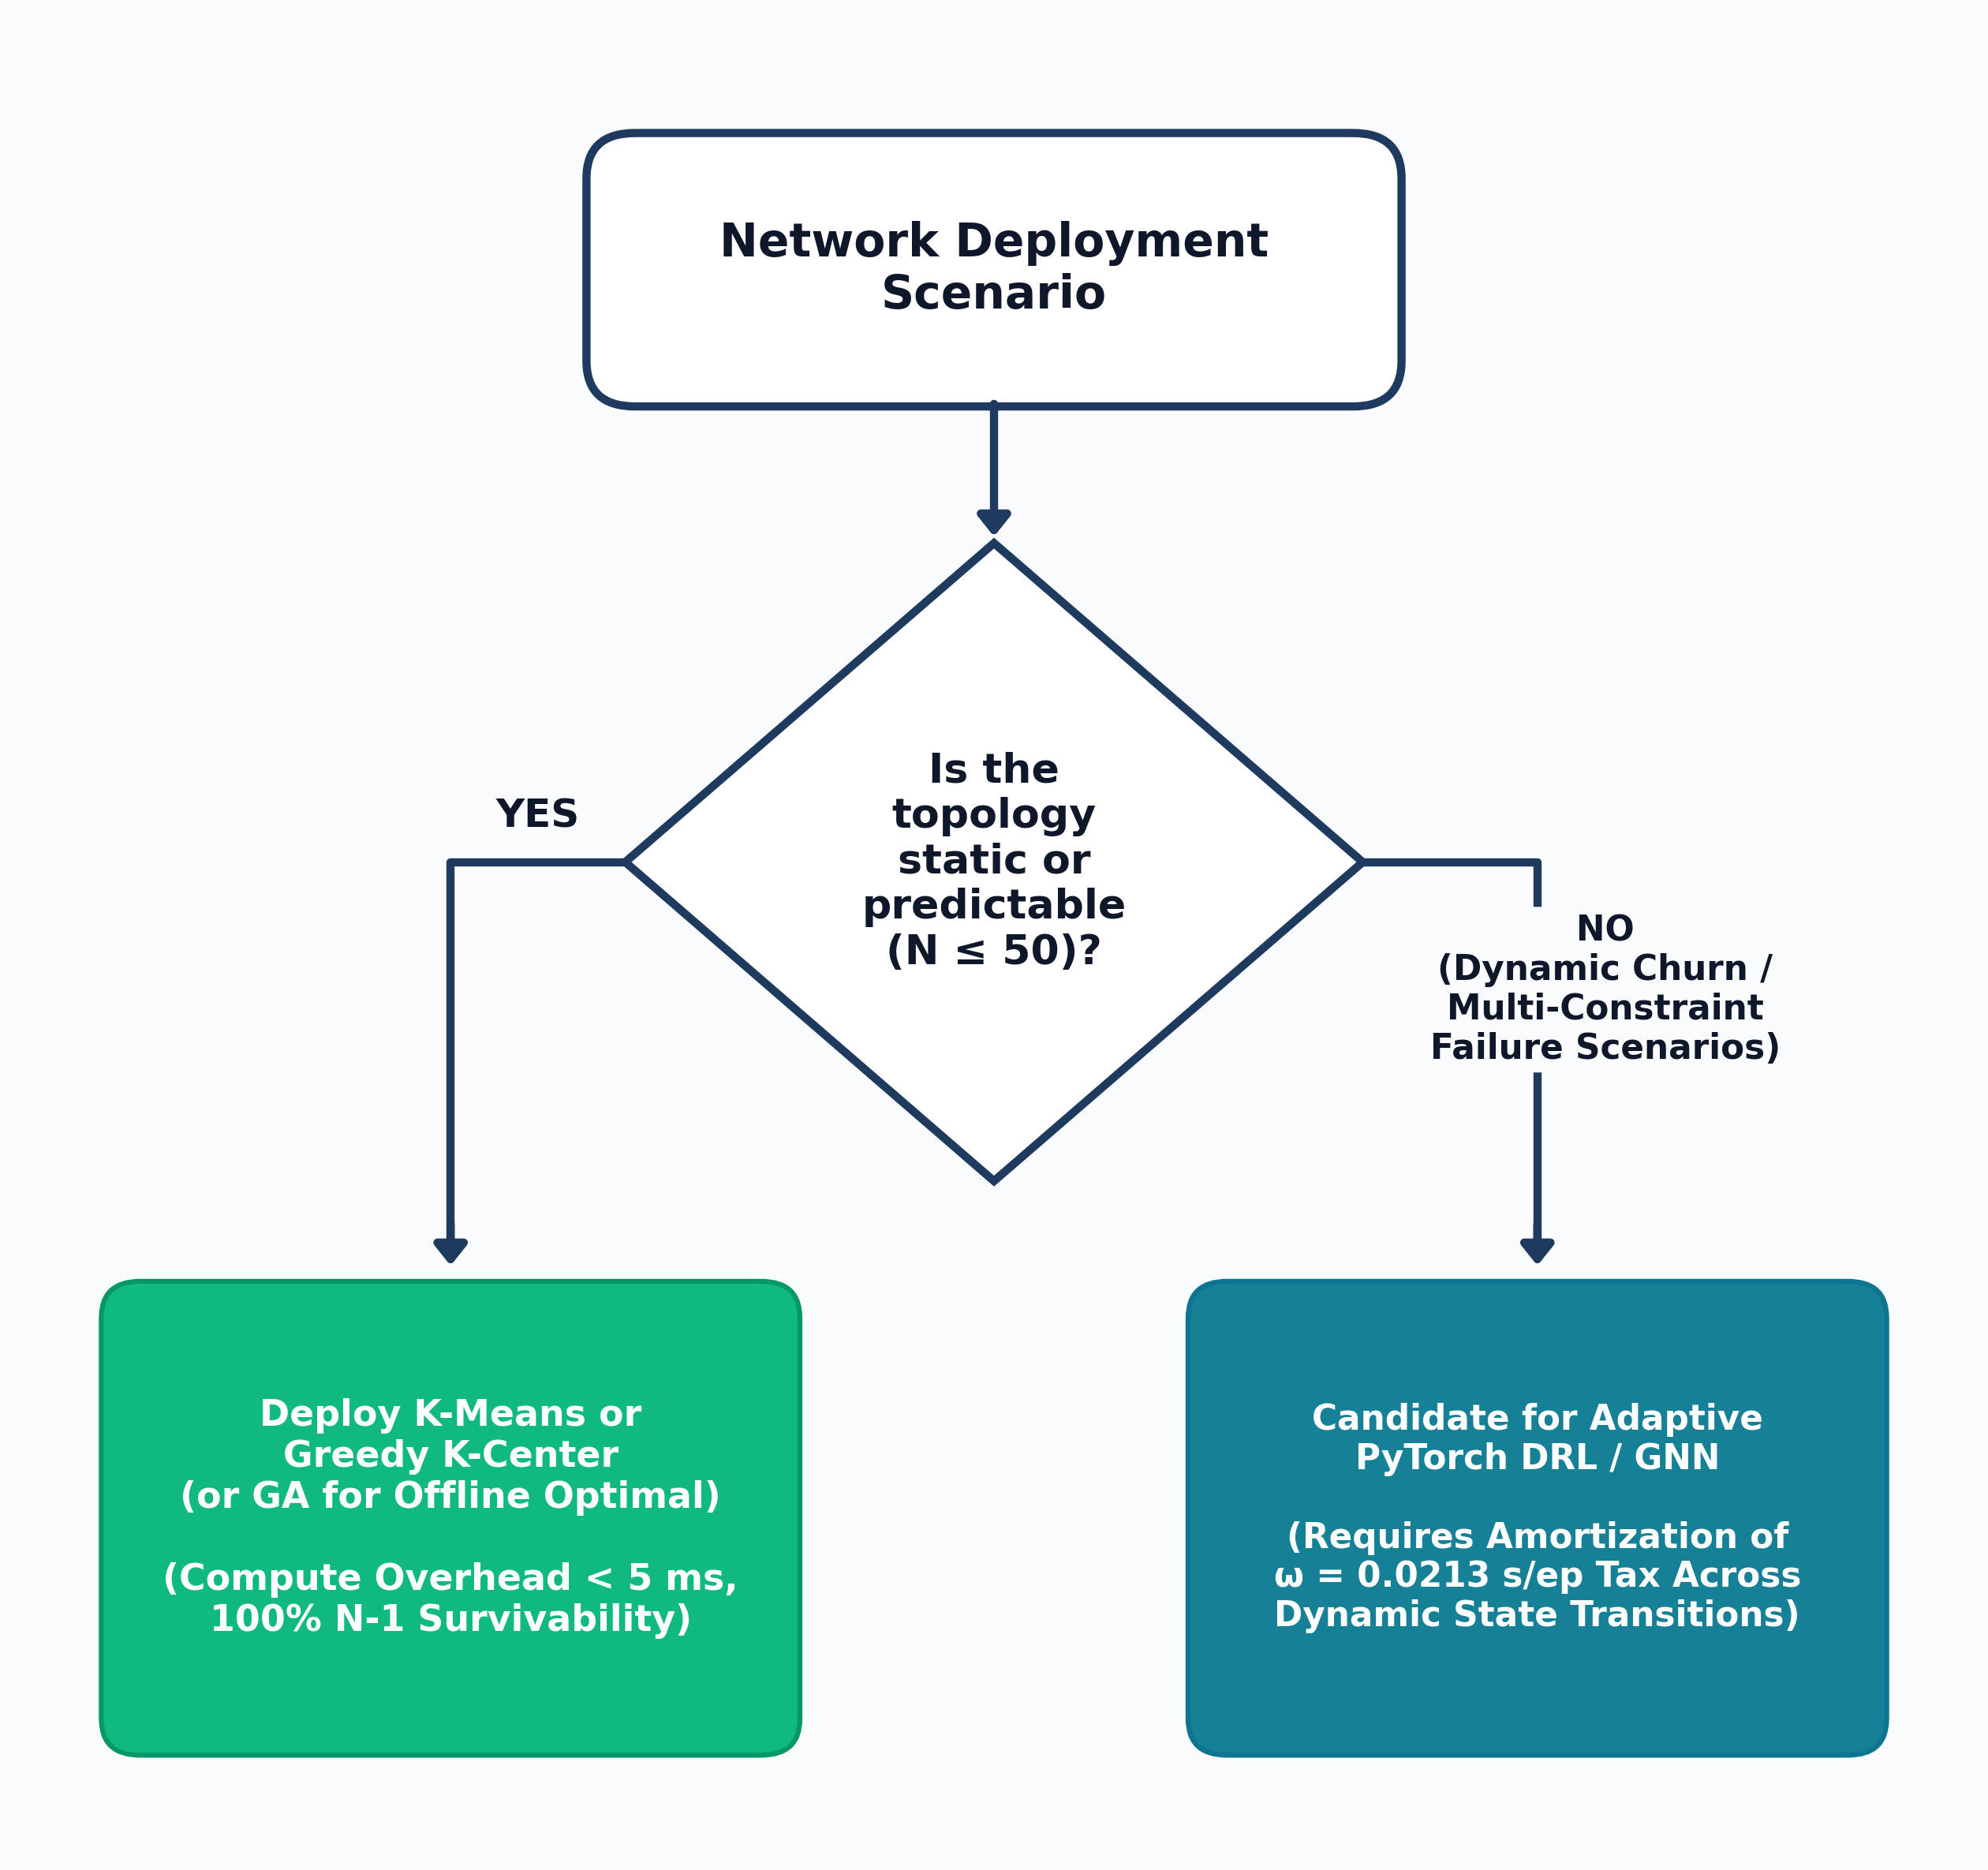
Table 4.7: Scenario-Conditioned Algorithm Selection Decision Rules (Bounded to $N≤50$)
Operational Network Scenario | Recommended Paradigm | Recommended Algorithm | Empirical Decision Rationale
Static Regional / National WAN ($N≤50$, Planar Spatial Mesh) | Spatial Heuristic | $K$-Means Clustering | Achieves $1.045\text{–}1.998\text{ ms}$ latency at $k=5$, executes in $3.19\text{–}8.14\text{ ms}$, and requires zero training overhead.
Scale-Free / Hub-and-Spoke Backbone ($N≤50$, Degree Skew) | Deterministic Heuristic | Greedy $K$-Center | Sub-millisecond execution ($0.026\text{–}0.207\text{ ms}$); remains on the latency-cost Pareto frontier across all 12 synthetic cells.
Offline Strategic Capacity Planning ($N≤50$, Latency Priority) | Metaheuristic | Genetic Algorithm (GA) | Achieves the lowest mean latency across all 12 synthetic cells and lowest mean Mininet RTT ($2.718\text{ ms}$) in $12.9\text{–}75.9\text{ ms}$ runtime.
Non-Stationary / High-Churn Topologies ($T_{\text{churn}}>60\text{–}208$ Epochs) | Reinforcement Learning | Deep $Q$-Network (DQN) | Amortizes 200-episode cached training overhead ($ω_{\text{train}}=772.8\text{–}921.7\text{ ms}$) via fast forward passes ($τ_{\text{inf}}=0.021\text{–}0.026\text{ ms/epoch}$) after $T_{\text{break}}=59.0\text{–}65.2\text{ epochs}$ vs. GA and $145.8\text{–}207.6\text{ epochs}$ vs. $K$-Means, though degree-vector MLP inference incurs higher post-churn latency than heuristics.

4.3 LIMITATIONS OF STUDY & THREATS TO VALIDITY
The empirical conclusions of this dissertation are bounded by three experimental scope constraints:
- Topology Scale ($N≤50$) and Fixed-Dimension MLP State Representation: All experiments evaluated topologies with $N∈\{11,20,21,50\}$ and uniform switch traffic weights. While the 1,000-state dynamic link-churn benchmark (Section 4.1.6) confirmed that pre-trained DQN inference amortizes its upfront training compute after $T_{\text{break}}=59.0\text{–}65.2\text{ epochs}$ against GA and $145.8\text{–}207.6\text{ epochs}$ against $K$-Means, the degree-vector MLP representation still trailed classical heuristics in post-churn propagation latency; evaluating Graph Neural Networks (GNNs) and time-varying traffic matrices at $N>50$ remains future work.
- Single-Link ($N−1$) Failure Model: The reliability metric evaluates single-edge removals rather than correlated multi-link disasters or controller node crashes.
- Single-Host Virtualized Emulation: The Mininet harness uses edge-weighted TCLink delays $d_{\text{tc}}\left(u,v\right)=max\left(0.10\text{ ms},2.0×w\left(u,v\right)\right)$ with $±0.5\text{ ms}$ uniform jitter on a single host machine, verifying protocol and queuing consistency rather than geographically distributed physical hardware.

CHAPTER FIVE

5.0 CONCLUSION

5.1 SUMMARY OF MAIN FINDINGS
This mini-dissertation benchmarked five controller placement strategies—Random Baseline, Greedy $K$-Center, Spatial $K$-Means Clustering, Genetic Algorithm (GA), and PyTorch Deep $Q$-Network (DQN) / multi-armed reinforcement learning—across canonical wide-area networks (Internet2 and ATT-MPLS) and synthetic topology families (Barabási-Albert scale-free and Waxman spatial graphs at scales $N∈\{20,50\}$ and controller budgets $k∈\{2,3,5\}$). Each method was evaluated across switch-to-controller propagation latency $L\left(P\right)$, single-link failure survivability $Reach_{avg}\left(P\right)$, offline training overhead $ω_{\text{train}}$, online execution/inference latency $τ_{\text{inf}}$, and emulated Mininet round-trip time (RTT).
The primary empirical findings are as follows:
- DQN Convergence and Multi-Seed Stability: On the 20-node Internet2 topology ($k=3$), the 1,000-episode PyTorch DQN run converged within 20 episodes, achieving a grand training mean reward of $13.055±0.589$ and a final 10-episode average reward of $13.199$ (results/pilot_metrics.json). Across the 10-run multi-seed stability audit (results/rl_analysis/stability_audit/stability_summary.csv), zero runs diverged (divergence_flag = False), with mean best rewards of $14.194±0.063$ on Internet2 and $14.854±0.395$ on ATT-MPLS.
- Factorial Latency and ANOVA Results: Across the 300-observation synthetic factorial dataset (60 cells x 5 seeds), multi-factor ANOVA confirmed a statistically significant main effect of algorithm family ($F\left(4,240\right)=118.90,p<0.0001$). The Genetic Algorithm achieved the lowest mean propagation latency in all 12 synthetic factorial cells, outperforming the Random baseline by up to $55.29\%$ on Waxman ($N=20,k=5$, $1.879\text{ ms}$) and $39.26\%$ on Barabási-Albert ($N=20,k=3$, $4.321\text{ ms}$).
- Offline Training Overhead ($ω_{\text{train}}$) vs. Online Inference Latency ($τ_{\text{inf}}$): Once trained, a single greedy forward pass through the PyTorch DQNetwork requires only $τ_{\text{inf}}=0.021\text{–}0.029\text{ ms}$, which is comparable to Greedy $K$-Center ($0.026\text{–}0.207\text{ ms}$) and faster than $K$-Means ($3.19\text{–}8.14\text{ ms}$) or GA ($12.88\text{–}75.87\text{ ms}$). However, for a static network deployment where no pre-trained policy exists for the target topology, training incurs $ω_{\text{train}}=21.26\text{ s}$ for 1,000 DQN episodes ($58.3\text{–}1086.2\text{ ms}$ for tabular RL) without improving upon the latency achieved directly by GA or $K$-Means.
- Topology-Dependent Heuristic Performance and $N−1$ Survivability: Greedy $K$-Center remained on the latency-cost Pareto frontier across all 12 synthetic cells and performed best on scale-free Barabási-Albert topologies, whereas $K$-Means closely tracked GA on spatially embedded Waxman graphs. Under single-link ($N−1$) failure evaluation, 2-edge-connected topologies (Internet2, ATT-MPLS, and Barabási-Albert $m=2$) achieved $100.0\%$ survivability across all algorithms, whereas sparse Waxman graphs containing bridge links dropped to $94.47\%\text{–}98.79\%$.
- Mininet Emulation and Phase 4 Gate Test: In five-way emulation on Internet2 ($N=20,k=3$), GA achieved the lowest mean RTT ($2.718\text{ ms}$), followed by $K$-Means ($2.852\text{ ms}$ mean RTT; $5.764\text{ ms}$ worst-case RTT), Greedy $K$-Center ($2.934\text{ ms}$), Bandit RL / DQN ($3.056\text{ ms}$), and Random ($3.374\text{ ms}$). In the 3-trial Phase 4 Mininet Gate Test (results/mininet_overhead_validation.json), active online loop execution averaged $889.82\text{ ms}$ while OS teardown in Phase D added $1,985.68\text{ ms}$, yielding a full lifecycle overhead of $2,875.49\text{ ms}$ (exceeding the $2,000\text{ ms}$ threshold in all 3 trials) and justifying post-convergence Mininet validation.
- Dynamic Topology Churn and Break-Even Amortization ($T_{\text{break}}$): Across 1,000 dynamic link-churn states ($5\text{ seeds}×100\text{ epochs}$ on Internet2 and ATT-MPLS at $k=3$, results/experiment_data/dynamic_churn_summary.csv), pre-trained PyTorch DQN inference ($τ_{\text{inf}}=0.0213\text{–}0.0257\text{ ms/epoch}$) amortized its 200-episode cached training cost ($ω_{\text{train}}=772.79\text{–}921.69\text{ ms}$) after a mean of $T_{\text{break}}=59.0\text{–}65.2\text{ epochs}$ against GA and $T_{\text{break}}=145.8\text{–}207.6\text{ epochs}$ against $K$-Means, although classical heuristics maintained lower post-churn propagation latency.

5.2 CONTRIBUTIONS TO KNOWLEDGE
- Methodological Separation of Training and Inference Costs: Demonstrated how separating offline training time ($ω_{\text{train}}$) from online inference time ($τ_{\text{inf}}$) alongside $N−1$ link-failure survivability clarifies the operational trade-off between heuristics and reinforcement learning.
- Statistical and Structural Characterization of the CPP ($N≤50$): Quantified the main effects of algorithm family ($F\left(4,240\right)=118.90$), topology family ($F\left(1,240\right)=249.21$), node scale ($F\left(1,240\right)=502.64$), and controller budget ($F\left(2,240\right)=114.93$) across 300 multi-seed observations.
- Bounded Decision Framework: Formulated scenario-conditioned selection guidelines (Table 4.7 and Figure 4.6) strictly bounded to the tested static WAN regime ($N≤50$).

5.3 PRACTICAL RECOMMENDATIONS FOR NETWORK ENGINEERS
Within static wide-area networks up to $N=50$ nodes:
- Use Spatial $K$-Means Clustering ($3.19\text{–}8.14\text{ ms}$ runtime) for geographically embedded regional meshes where minimizing average switch-to-controller propagation delay is the primary objective.
- Use Greedy $K$-Center ($0.026\text{–}0.207\text{ ms}$ runtime) for scale-free hub-and-spoke backbones or compute-constrained management planes requiring sub-millisecond placement calculation.
- Use Genetic Algorithms ($12.9\text{–}75.9\text{ ms}$ runtime) during offline capacity planning when minimizing both average latency and bridge-isolation risk on sparse topologies is prioritized over sub-millisecond runtime.
- Reserve Deep Reinforcement Learning for future evaluation in non-stationary environments where a pre-trained policy’s fast forward-pass inference ($τ_{\text{inf}}=0.021\text{–}0.029\text{ ms}$) can be reused across repeated online topological changes without retraining from scratch.

5.4 FUTURE RESEARCH DIRECTIONS
- Online Topology Churn and Dynamic Traffic Traces: Extending the benchmark to evaluate time-varying NetFlow traffic loads and sequential link/node churn in Mininet to test whether pre-trained DRL policies amortize their offline training cost during live switch migration.
- Graph Neural Networks (GNNs) for Scale Generalization: Replacing the fixed-dimension MLP ($N→64→64→N$) with Graph Convolutional or Graph Attention Networks capable of zero-shot inference across variable graph sizes ($N∈\left[100,500\right]$).
- Multi-Link ($N−k$) Failures and Controller Synchronization Overhead: Extending the single-link failure engine to model correlated multi-link cuts, controller node crashes, and east-west Raft consensus latencies across distributed controller clusters.

REFERENCES
Barabási, A.L. & Albert, R., 1999. Emergence of scaling in random networks. Science, 286(5439), pp.509-512.
Benoudifa, Y., Senouci, M.A., Mellouk, A. & Senouci, B., 2023. MuZero-based autonomous controller placement method using deep reinforcement learning for SDN. IEEE Transactions on Network and Service Management, 20(3), pp.2512-2525.
Farahi, F., Kianpisheh, S., Taleb, T. & Song, H., 2026. AP-DQN: An adaptive policy deep Q-network for multi-controller placement in dynamic software-defined networks. IEEE Transactions on Network Science and Engineering, 13(1), pp.412-427.
Goldberg, D.E., 1989. Genetic Algorithms in Search, Optimization, and Machine Learning. Reading, MA: Addison-Wesley.
Gonzalez, T.F., 1985. Clustering to minimize the maximum intercluster distance. Theoretical Computer Science, 38, pp.293-306.
Heller, B., Sherwood, R. & McKeown, N., 2012. The controller placement problem. In Proceedings of the first workshop on Hot topics in software defined networks (HotSDN ’12). Helsinki, Finland: ACM, pp.1-6.
Holland, J.H., 1975. Adaptation in Natural and Artificial Systems: An Introductory Analysis with Applications to Biology, Control, and Artificial Intelligence. Ann Arbor, MI: University of Michigan Press.
Kariv, O. & Hakimi, S.L., 1979. An algorithmic approach to network location problems. II: The p-medians. SIAM Journal on Applied Mathematics, 37(3), pp.539-560.
Knight, S., Nguyen, H.X., Falkner, N., Bowden, R. & Roughan, M., 2011. The Internet Topology Zoo. IEEE Journal on Selected Areas in Communications, 29(9), pp.1765-1775.
Kreutz, D., Ramos, F.M., Verissimo, P.E., Rothenberg, C.E., Azodolmolky, S. & Uhlig, S., 2015. Software-defined networking: A comprehensive survey. Proceedings of the IEEE, 103(1), pp.14-76.
Lantz, B., Heller, B. & McKeown, N., 2010. A network in a laptop: rapid prototyping for software-defined networks. In Proceedings of the 9th ACM SIGCOMM Workshop on Hot Topics in Networks (HotNets-IX). Monterey, CA: ACM, pp.1-6.
MacQueen, J., 1967. Some methods for classification and analysis of multivariate observations. In Proceedings of the Fifth Berkeley Symposium on Mathematical Statistics and Probability. Berkeley, CA: University of California Press, 1(14), pp.281-297.
McKeown, N., Anderson, T., Balakrishnan, H., Parulkar, G., Peterson, L., Rexford, J., Shenker, S. & Turner, J., 2008. OpenFlow: enabling innovation in campus networks. ACM SIGCOMM Computer Communication Review, 38(2), pp.69-74.
Mnih, V., Kavukcuoglu, K., Silver, D., Rusu, A.A., Veness, J., Bellemare, M.G., Graves, A., Riedmiller, M., Fidjeland, A.K., Ostrovski, G. & Petersen, S., 2015. Human-level control through deep reinforcement learning. Nature, 518(7540), pp.529-533.
Radam, M.B., Al-Janabi, T.A. & Hashim, A.H., 2022. Optimal model for link failure foresight controller placement in SDN. Computers, Materials & Continua, 72(2), pp.3211-3228.
Sutton, R.S. & Barto, A.G., 2018. Reinforcement Learning: An Introduction. 2nd ed. Cambridge, MA: MIT Press.
Waxman, B.M., 1988. Routing of multipoint connections. IEEE Journal on Selected Areas in Communications, 6(9), pp.1617-1622.
Yusuf, A., Hashim, A.H., Al-Janabi, T.A. & Radam, M.B., 2023. A comparative analysis of SDN controller placement problem: IoT-specific tactics and generalized approaches. PeerJ Computer Science, 9, p.e1698.

APPENDIX

APPENDIX A: EXPERIMENTAL CONFIGURATION MANIFEST
The benchmarking harness reads its parameters from configs/experiment_config.json:
{
"project_name": "ai-sdn-controller-placement",
"version": "1.0.0",
"seed": 42,
"topology_config": {
"canonical": [
{
"name": "Internet2",
"nodes_graphml": 20,
"edges_graphml": 26,
"nodes_core_fallback": 11,
"edges_core_fallback": 18,
"source": "data/raw/topologies/Internet2.graphml & Heller et al. (2012)"
},
{
"name": "ATT-MPLS",
"nodes": 21,
"edges": 54,
"source": "topology/canonical_topologies.py"
}
],
"synthetic": {
"barabasi_albert": {
"m": 2,
"scales": [20, 50]
},
"waxman": {
"alpha": 0.4,
"beta": 0.1,
"scales": [20, 50]
}
}
},
"controller_budgets": [2, 3, 5],
"rl_hyperparameters": {
"architecture": "MLP (N -> 64 -> 64 -> N)",
"learning_rate": 0.001,
"batch_size": 32,
"gamma": 0.99,
"max_episodes": 1000,
"replay_memory_size": 10000,
"target_update_frequency": 100,
"epsilon_start": 1.0,
"epsilon_end": 0.05,
"epsilon_decay": 0.995
}
}

APPENDIX B: COMPLETE BENCHMARK MATRIX DATA
Table B.1 lists the complete 60-row multi-objective benchmark output generated by scripts/compute_complete_benchmark_matrix.py and stored in results/experiment_data/complete_proposal_aligned_benchmark.csv, including average propagation latency $L\left(P\right)$, exact single-link failure survivability $Reach_{avg}$ (%), algorithm execution / training runtime (ms), online inference time $τ_{\text{inf}}$ (ms), and selected controller node IDs.
Table B.1: Complete Proposal-Aligned Multi-Objective Benchmark Matrix Across Canonical and Synthetic Topologies (complete_proposal_aligned_benchmark.csv)
Topology | $N$ | $\left|E\right|$ | $k$ | Algorithm | Avg Latency (ms) | $N−1$ Reliability (%) | Exec. / Train (ms) | Online Inference $τ_{\text{inf}}$ (ms) | Selected Controllers
Internet2 (Canonical) | 20 | 26 | 3 | K-Means | 1.469 | 100.00 | 4.084 | 4.084 | n1; n16; n9
Internet2 (Canonical) | 20 | 26 | 3 | Greedy K-Center | 1.511 | 100.00 | 0.053 | 0.053 | n1; n10; n6
Internet2 (Canonical) | 20 | 26 | 3 | Genetic Algorithm | 1.403 | 100.00 | 12.878 | 12.878 | n1; n15; n16
Internet2 (Canonical) | 20 | 26 | 3 | Bandit RL / DQN | 1.564 | 100.00 | 72.054 | 0.029 | n1; n10; n5
Internet2 (Canonical) | 20 | 26 | 3 | Random Baseline | 1.734 | 100.00 | 0.007 | 0.007 | n13; n0; n18
Internet2 (Canonical) | 20 | 26 | 5 | K-Means | 1.045 | 100.00 | 4.983 | 4.983 | n10; n2; n4; n6; n9
Internet2 (Canonical) | 20 | 26 | 5 | Greedy K-Center | 1.064 | 100.00 | 0.095 | 0.095 | n1; n10; n6; n13; n8
Internet2 (Canonical) | 20 | 26 | 5 | Genetic Algorithm | 0.976 | 100.00 | 20.532 | 20.532 | n17; n18; n2; n4; n6
Internet2 (Canonical) | 20 | 26 | 5 | Bandit RL / DQN | 0.960 | 100.00 | 73.147 | 0.029 | n1; n10; n15; n16; n4
Internet2 (Canonical) | 20 | 26 | 5 | Random Baseline | 1.277 | 100.00 | 0.009 | 0.009 | n13; n0; n18; n17; n8
ATT-MPLS (Canonical) | 21 | 54 | 3 | K-Means | 2.391 | 100.00 | 4.144 | 4.144 | 4; 8; 10
ATT-MPLS (Canonical) | 21 | 54 | 3 | Greedy K-Center | 3.030 | 100.00 | 0.081 | 0.081 | 5; 2; 13
ATT-MPLS (Canonical) | 21 | 54 | 3 | Genetic Algorithm | 2.320 | 100.00 | 15.853 | 15.853 | 1; 4; 7
ATT-MPLS (Canonical) | 21 | 54 | 3 | Bandit RL / DQN | 2.370 | 100.00 | 273.058 | 0.021 | 4; 7; 8
ATT-MPLS (Canonical) | 21 | 54 | 3 | Random Baseline | 3.289 | 100.00 | 0.010 | 0.010 | 20; 3; 0
ATT-MPLS (Canonical) | 21 | 54 | 5 | K-Means | 2.336 | 100.00 | 4.133 | 4.133 | 11; 5; 19; 18; 12
ATT-MPLS (Canonical) | 21 | 54 | 5 | Greedy K-Center | 2.381 | 100.00 | 0.131 | 0.131 | 5; 2; 13; 12; 18
ATT-MPLS (Canonical) | 21 | 54 | 5 | Genetic Algorithm | 1.828 | 100.00 | 20.288 | 20.288 | 1; 4; 7; 13; 17
ATT-MPLS (Canonical) | 21 | 54 | 5 | Bandit RL / DQN | 1.923 | 100.00 | 251.254 | 0.021 | 0; 1; 2; 7; 17
ATT-MPLS (Canonical) | 21 | 54 | 5 | Random Baseline | 2.177 | 100.00 | 0.007 | 0.007 | 20; 3; 0; 8; 7
Barabási-Albert ($N=20$) | 20 | 36 | 3 | K-Means | 7.042 | 100.00 | 3.781 | 3.781 | n15; n11; n10
Barabási-Albert ($N=20$) | 20 | 36 | 3 | Greedy K-Center | 5.528 | 100.00 | 0.060 | 0.060 | n0; n12; n16
Barabási-Albert ($N=20$) | 20 | 36 | 3 | Genetic Algorithm | 4.281 | 100.00 | 15.216 | 15.216 | n1; n4; n8
Barabási-Albert ($N=20$) | 20 | 36 | 3 | Bandit RL / DQN | 4.752 | 100.00 | 144.786 | 0.029 | n0; n1; n4
Barabási-Albert ($N=20$) | 20 | 36 | 3 | Random Baseline | 5.925 | 100.00 | 0.007 | 0.007 | n3; n0; n8
Barabási-Albert ($N=20$) | 20 | 36 | 5 | K-Means | 4.706 | 100.00 | 4.137 | 4.137 | n10; n13; n5; n15; n2
Barabási-Albert ($N=20$) | 20 | 36 | 5 | Greedy K-Center | 3.673 | 100.00 | 0.103 | 0.103 | n0; n12; n16; n8; n6
Barabási-Albert ($N=20$) | 20 | 36 | 5 | Genetic Algorithm | 3.407 | 100.00 | 18.932 | 18.932 | n0; n1; n2; n5; n8
Barabási-Albert ($N=20$) | 20 | 36 | 5 | Bandit RL / DQN | 3.493 | 100.00 | 147.891 | 0.029 | n0; n1; n4; n5; n8
Barabási-Albert ($N=20$) | 20 | 36 | 5 | Random Baseline | 4.863 | 100.00 | 0.007 | 0.007 | n3; n0; n8; n7; n16
Barabási-Albert ($N=50$) | 50 | 96 | 3 | K-Means | 6.514 | 100.00 | 4.382 | 4.382 | n49; n36; n6
Barabási-Albert ($N=50$) | 50 | 96 | 3 | Greedy K-Center | 5.412 | 100.00 | 0.089 | 0.089 | n0; n48; n37
Barabási-Albert ($N=50$) | 50 | 96 | 3 | Genetic Algorithm | 4.937 | 100.00 | 32.467 | 32.467 | n0; n16; n5
Barabási-Albert ($N=50$) | 50 | 96 | 3 | Bandit RL / DQN | 5.465 | 100.00 | 918.771 | 0.022 | n0; n1; n4
Barabási-Albert ($N=50$) | 50 | 96 | 3 | Random Baseline | 6.594 | 100.00 | 0.007 | 0.007 | n40; n7; n1
Barabási-Albert ($N=50$) | 50 | 96 | 5 | K-Means | 6.398 | 100.00 | 4.871 | 4.871 | n10; n23; n2; n43; n7
Barabási-Albert ($N=50$) | 50 | 96 | 5 | Greedy K-Center | 4.691 | 100.00 | 0.165 | 0.165 | n0; n48; n37; n39; n35
Barabási-Albert ($N=50$) | 50 | 96 | 5 | Genetic Algorithm | 4.089 | 100.00 | 41.856 | 41.856 | n0; n15; n16; n29; n5
Barabási-Albert ($N=50$) | 50 | 96 | 5 | Bandit RL / DQN | 4.325 | 100.00 | 975.993 | 0.022 | n0; n1; n4; n5; n6
Barabási-Albert ($N=50$) | 50 | 96 | 5 | Random Baseline | 6.131 | 100.00 | 0.007 | 0.007 | n40; n7; n1; n47; n17
Waxman ($N=20$) | 20 | 19 | 3 | K-Means | 2.730 | 94.47 | 3.193 | 3.193 | n2; n3; n1
Waxman ($N=20$) | 20 | 19 | 3 | Greedy K-Center | 4.935 | 97.37 | 0.037 | 0.037 | n1; n17; n12
Waxman ($N=20$) | 20 | 19 | 3 | Genetic Algorithm | 2.640 | 96.05 | 13.150 | 13.150 | n1; n10; n8
Waxman ($N=20$) | 20 | 19 | 3 | Bandit RL / DQN | 2.730 | 94.47 | 52.345 | 0.029 | n1; n2; n3
Waxman ($N=20$) | 20 | 19 | 3 | Random Baseline | 4.609 | 96.05 | 0.007 | 0.007 | n3; n0; n8
Waxman ($N=20$) | 20 | 19 | 5 | K-Means | 1.703 | 98.16 | 3.901 | 3.901 | n16; n9; n1; n18; n8
Waxman ($N=20$) | 20 | 19 | 5 | Greedy K-Center | 1.855 | 98.42 | 0.074 | 0.074 | n1; n17; n12; n16; n18
Waxman ($N=20$) | 20 | 19 | 5 | Genetic Algorithm | 1.494 | 96.84 | 16.307 | 16.307 | n1; n14; n15; n3; n5
Waxman ($N=20$) | 20 | 19 | 5 | Bandit RL / DQN | 1.603 | 97.89 | 49.738 | 0.029 | n1; n10; n17; n6; n9
Waxman ($N=20$) | 20 | 19 | 5 | Random Baseline | 2.695 | 96.32 | 0.007 | 0.007 | n3; n0; n8; n7; n16
Waxman ($N=50$) | 50 | 53 | 3 | K-Means | 16.760 | 96.98 | 3.458 | 3.458 | n36; n2; n21
Waxman ($N=50$) | 50 | 53 | 3 | Greedy K-Center | 12.499 | 97.96 | 0.081 | 0.081 | n25; n38; n45
Waxman ($N=50$) | 50 | 53 | 3 | Genetic Algorithm | 7.707 | 97.58 | 28.321 | 28.321 | n1; n22; n48
Waxman ($N=50$) | 50 | 53 | 3 | Bandit RL / DQN | 8.721 | 98.19 | 388.416 | 0.022 | n14; n5; n6
Waxman ($N=50$) | 50 | 53 | 3 | Random Baseline | 16.296 | 95.51 | 0.011 | 0.011 | n40; n7; n1
Waxman ($N=50$) | 50 | 53 | 5 | K-Means | 9.930 | 98.34 | 8.140 | 8.140 | n36; n5; n1; n26; n18
Waxman ($N=50$) | 50 | 53 | 5 | Greedy K-Center | 9.972 | 98.79 | 0.173 | 0.173 | n25; n38; n45; n26; n28
Waxman ($N=50$) | 50 | 53 | 5 | Genetic Algorithm | 5.468 | 98.34 | 39.026 | 39.026 | n1; n14; n32; n37; n6
Waxman ($N=50$) | 50 | 53 | 5 | Bandit RL / DQN | 6.500 | 98.30 | 382.597 | 0.022 | n1; n14; n32; n35; n38
Waxman ($N=50$) | 50 | 53 | 5 | Random Baseline | 10.026 | 96.91 | 0.009 | 0.009 | n40; n7; n1; n47; n17

APPENDIX C: MININET EMULATION MODULE
The following listing from simulation/mininet_simulation.py implements the Mininet control-plane latency evaluation and deterministic fallback harness used in Section 4.1.4:
from __future__ import annotations
import random
import re
from typing import Dict, Iterable
import networkx as nx
import numpy as np
def run_synthetic_latency_simulation(
graph: nx.Graph,
controllers: Iterable[str],
base_link_delay_ms: float = 2.0,
jitter_ms: float = 0.5,
seed: int = 42,
) -> Dict[str, float]:
controller_list = list(controllers)
if not controller_list:
return {"mean_rtt_ms": float("inf"), "max_rtt_ms": float("inf")}
rng = random.Random(seed)
distances = nx.multi_source_dijkstra_path_length(
graph, controller_list, weight="weight"
)
rtts = []
for node in graph.nodes:
hop_distance = distances.get(node, float("inf"))
if not np.isfinite(hop_distance):
continue
jitter = rng.uniform(-jitter_ms, jitter_ms)
rtt = max(0.1, hop_distance * base_link_delay_ms + jitter)
rtts.append(rtt)
if not rtts:
return {"mean_rtt_ms": float("inf"), "max_rtt_ms": float("inf")}
return {
"mean_rtt_ms": float(np.mean(rtts)),
"max_rtt_ms": float(np.max(rtts)),
}

