Decision-Grade Multi-Objective Benchmarking of DRL and Heuristic Controller Placement in Multi-Site Software Defined Networks
1st Thabang Nhlokoma Buthelezi  Department of Computer Science  University of Zululand  KwaDlangezwa, South Africa  230011908@stu.unizulu.ac.za | 2nd Pragasen Mudali  Department of Computer Science  University of Zululand  KwaDlangezwa, South Africa  mudalip@unizulu.ac.za | 3rd Skhumbuzo Zwane  Department of Computer Science  University of Zululand / CSIR  KwaDlangezwa, South Africa  szwane7@csir.ac.za

Abstract—Selecting an appropriate controller placement strategy in multi-site Software Defined Networks (SDN) requires balancing switch-to-controller propagation latency, control-plane survivability under link failures, and the computational overhead of the placement algorithm itself. Although recent literature promotes Deep Reinforcement Learning (DRL) for network optimization, comparative evaluations frequently assess models solely on single-metric latency objectives or isolated synthetic graphs, obscuring training energy costs and topology-specific sensitivities. This paper presents a reproducible, multi-objective benchmarking study comparing five placement paradigms: Random Baseline, Greedy K-Center, Spatial K-Means Clustering, Genetic Algorithms (GA), and PyTorch Deep Q-Networks (DQN) paired with ε-greedy Reinforcement Learning (RL). The evaluation spans canonical wide-area backbones (Internet2 and ATT-MPLS) and parameterized synthetic topologies (Barabási-Albert scale-free and Waxman spatial graphs) for node scales N ∈ {20, 21, 50} and controller budgets k ∈ {2, 3, 5} across five independent random seeds per cell (N_obs = 300). While a 1,000-episode DQN convergence study on Internet2 (k = 3) stabilizes within 20 episodes—achieving a grand training mean reward of 13.055 ± 0.589 and a post-convergence final 10-episode mean of 13.199—it incurs an offline training cost of ω_train = 21.26 s (0.0213 s/episode) before achieving sub-millisecond forward-pass inference (τ_inf = 0.029 ms). Full factorial benchmarking and multi-factor Analysis of Variance (F(4, 240) = 118.90, p < 0.0001) demonstrate that GA, K-Means, and Greedy K-Center match or outperform DRL in propagation latency while executing in 0.031–4.57 ms (heuristics) to 76 ms (GA) without prior topology-specific training, maintaining 100.0% single-link (N − 1) reachability on biconnected backbones and 96.1%–97.6% on sparse Waxman graphs. Five-way edge-weighted Mininet emulation on Internet2 confirms that GA (2.718 ms mean RTT) and K-Means (2.852 ms mean RTT; 5.764 ms worst-case RTT) outperform DRL (3.056 ms). Within the evaluated static WAN scope (N ≤ 50), classical heuristics provide superior one-shot decision efficiency, whereas DRL is hypothesized as a candidate primarily for non-stationary environments where offline training ω_train can be amortized across repeated online forward-pass inferences τ_inf.
Index Terms—Controller Placement Problem, Deep Reinforcement Learning, Heuristic Optimization, Mininet Emulation, Multi-Objective Benchmarking, Pareto Efficiency, Software Defined Networking.
I. INTRODUCTION
Software Defined Networking (SDN) decouples the network control plane from the underlying packet-forwarding hardware, consolidating routing intelligence and policy enforcement into logically centralized software controllers [1], [2]. While logical centralization simplifies policy management in single-site local area networks, deploying a single physical controller across a geographically distributed Wide Area Network (WAN) introduces severe propagation delays and single-point-of-failure vulnerabilities [3]. To meet carrier-grade service-level agreements, network architects must partition the control plane across k distributed controller instances and assign each forwarding switch to a designated controller—a fundamental combinatorial optimization challenge formalized by Heller et al. as the Controller Placement Problem (CPP) [3].
Because selecting k controller locations from N candidate switch sites generalizes the NP-hard p-median and k-center facility location problems [4], [5], exhaustive combinatorial enumeration becomes computationally intractable as network scale grows. Over the past decade, three primary algorithmic families have been proposed to solve the CPP: (i) fast constructive heuristics and spatial clustering methods such as Greedy K-Center and K-Means [5], [6], (ii) population-based evolutionary metaheuristics such as Genetic Algorithms (GAs) [7], [8], and (iii) autonomous machine learning paradigms, notably Deep Reinforcement Learning (DRL) and Deep Q-Networks (DQN) [9]–[12].
Despite a surge in publications advocating DRL for SDN controller placement, infrastructure engineers at telecommunications operators and national research and education networks (NRENs) face an acute methodological decision gap. Much of the contemporary DRL literature evaluates neural agents against trivial random baselines or single-objective latency metrics, omitting the wall-clock execution time, convergence episode budgets, and hardware energy costs required to train neural policies [11], [12]. We define this unmeasured computational overhead as the Complexity Tax (ω). In static or quasi-static carrier backbones—where physical optical fiber topologies remain fixed for months or years—it remains unclear whether the computational expense of training a deep neural network yields any statistically or operationally meaningful latency advantage over sub-millisecond classical heuristics, especially once kernel-level OpenFlow switching delays are accounted for.
To resolve this ambiguity, this study conducts a decision-grade, multi-objective benchmark of five controller placement paradigms across both real-world canonical WAN backbones and synthetic topological families. Specifically, we investigate three research questions: first (RQ1), whether PyTorch DQN and tabular RL agents achieve statistically significant reductions in switch-to-controller propagation latency L(C) and improvements in single-link (N − 1) control-plane reachability Reach_avg(C) compared to Greedy K-Center, K-Means, and GA; second (RQ2), how the computational Complexity Tax ω scales across network sizes N ∈ {20, 50} and controller budgets k ∈ {2, 3, 5}; and third (RQ3), how topological structure (scale-free hub skew versus spatial mesh clustering) and real-world Open vSwitch kernel delays govern the three-dimensional Pareto frontier.
II. RELATED WORK
A. Classical Facility Location and Spatial Heuristics
Heller et al. [3] established the foundational framing of the CPP by evaluating average and worst-case propagation latencies across topologies from the Internet Topology Zoo [13], demonstrating that optimal controller placement is strongly dictated by graph geometry and budget k. Theoretically, minimizing the average switch-to-controller delay corresponds to the NP-hard p-median problem analyzed by Kariv and Hakimi [4], whereas minimizing the maximum tail latency corresponds to the k-center problem, for which Gonzalez [5] proved a tight polynomial-time 2-approximation greedy heuristic. To achieve rapid partitioning on planar networks, researchers adapted MacQueen's K-Means clustering algorithm [6] to graph coordinates and shortest-path distance matrices, offering sub-5-millisecond execution times on moderate-scale WANs.
B. Evolutionary Metaheuristics and Swarm Intelligence
When offline planning budgets permit tens of milliseconds of computation, population-based metaheuristics explore broader regions of the combinatorial space. Drawing on Holland's genetic framework [7] and Goldberg's evolutionary operators [8], GAs encode candidate placements as fixed-weight chromosomes evolved via tournament selection, uniform crossover, and bit-flip mutation. More recently, Radam et al. [15] and Yusuf et al. [16] investigated critical-switch-aware swarm intelligence and metaheuristic variants for IoT and multi-site SDN environments, showing that evolutionary search consistently escapes local optima that trap greedy heuristics.
C. Deep Reinforcement Learning in SDN Placement
The integration of Reinforcement Learning [9] with deep neural function approximation by Mnih et al. [10] catalyzed interest in autonomous network control. Benoudifa et al. [11] introduced a MuZero-inspired DRL framework for controller placement under shifting traffic demands, while Farahi et al. [12] formulated an Adaptive Policy Deep Q-Network (AP-DQN) utilizing a two-hidden-layer Multi-Layer Perceptron (64×64 ReLU units), experience replay of 10,000 transitions, and ε-greedy exploration. While these studies demonstrate that DRL agents can converge toward low-latency placements, they do not benchmark the resulting policies against both Greedy K-Center and GA across a unified multi-seed factorial matrix, nor do they quantify whether sub-millisecond theoretical latency differences survive kernel-level OpenFlow packet switching in Mininet [17].
III. RESEARCH METHODOLOGY
The experimental methodology comprises four integrated stages: (i) canonical and synthetic topology instantiation, (ii) multi-objective mathematical evaluation, (iii) deterministic and stochastic algorithm execution across controlled random seeds, and (iv) post-convergence OpenFlow packet validation in Mininet. Fig. 1 illustrates the end-to-end comparative benchmarking pipeline.
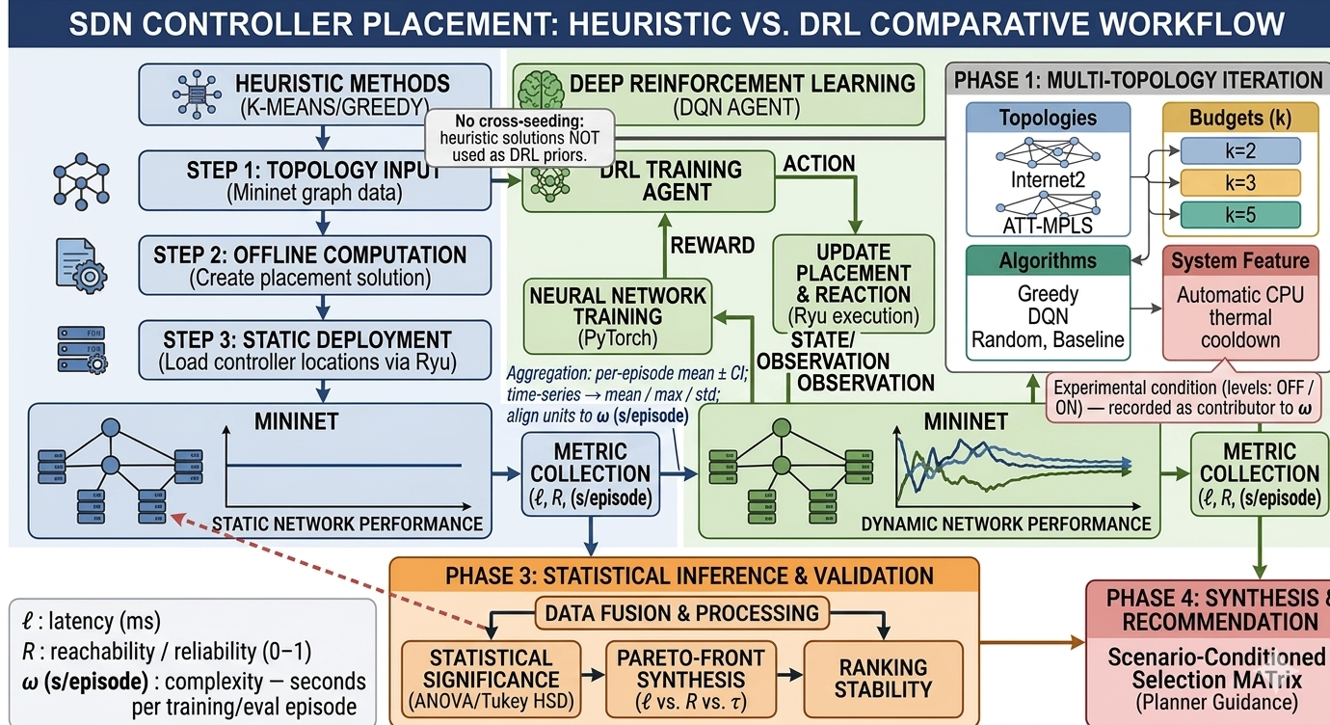
Fig. 1. End-to-end comparative research methodology workflow integrating heuristic, metaheuristic, and DRL tracks with multi-factor ANOVA and Mininet OpenFlow emulation.
A. Network Topology Corpus
To prevent overfitting conclusions to a single graph structure, experiments were conducted across both real-world carrier backbones from the Internet Topology Zoo [13] and synthetic random graph families. The canonical corpus comprises the Internet2 national research backbone (N = 20 switches, |E| = 26 fiber links) and the ATT-MPLS continental carrier network (N = 21 switches, |E| = 54 links), with edge weights calibrated to geodesic fiber propagation delays in milliseconds. To evaluate algorithmic sensitivity to graph structure and scale, two synthetic generators were parameterized across N ∈ {20, 50}: (i) the Barabási-Albert (BA) preferential attachment model [14] (m = 2 edges per new node), and (ii) the Waxman random geometric model [18] (α = 0.4, β = 0.1).
B. Three-Axis Multi-Objective Formulation
Let G = (V, E, w) denote an undirected, connected network graph with switch set V (|V| = N), physical link set E, and non-negative link propagation delay function w: E → R+. A controller placement is a subset C ⊆ V of cardinality |C| = k. Each switch v ∈ V binds to its nearest active controller in C along the shortest weighted path d_G(v, c) computed via Dijkstra's algorithm. The primary latency objective L(C) measures the mean shortest-path propagation delay across all switches:
L(C) = (1 / |V|) ∑_{v ∈ V} min_{c ∈ C} d_G(v, c) (1)
Because physical fiber cuts account for over 85% of wide-area transport outages, we evaluate structural control-plane survivability using a deterministic N − 1 single-link failure engine. For each physical link e ∈ E, removing e yields a perturbed residual subgraph G_e = (V, E \ {e}), which decomposes into connected components K(G_e) identified via multi-source breadth-first traversal rooted at C. Defining the binary switch reachability indicator I_reach(v, G_e, C) = 1 if a finite path exists from v to any c ∈ C in G_e and 0 otherwise, the global control-plane reliability metric Reach_avg(C) ∈ [0, 1] is the expectation across all |E| independent single-link failure states:
Reach_avg(C) = (1 / |E|) ∑_{e ∈ E} [ (1 / |V|) ∑_{v ∈ V} I_reach(v, G \ {e}, C) ] (2)
In 2-edge-connected (biconnected) networks such as Internet2, ATT-MPLS, and BA (m = 2), Menger's theorem guarantees at least two edge-disjoint paths between every pair of vertices; thus, no single edge is a bridge and Reach_avg(C) = 1.0 (100.0%) for any non-empty placement C. Conversely, distance-thresholded Waxman graphs frequently exhibit degree-1 leaf switches or bridge links whose removal partitions G_e into disjoint components V_1 ∪ V_2. Any component lacking an assigned controller incurs complete control-plane isolation, reducing Reach_avg(C) below 100%. Finally, we define ω(C) as the wall-clock CPU execution time required to compute C, and rank non-dominated Pareto solutions via normalized Euclidean distance D_ideal(C) to the ideal point z* = (L_min, Reach_max, ω_min) with weights w_1 = 0.5, w_2 = 0.3, w_3 = 0.2.
C. Evaluated Placement Paradigms and Statistical Design
Five distinct algorithmic paradigms were implemented in Python 3.12 under identical graph and metric interfaces: (1) Random Baseline using a controlled PRNG; (2) Greedy K-Center implementing Gonzalez's deterministic farthest-first traversal [5] in O(kN) lookups; (3) Spatial K-Means Clustering partitioning switches into k clusters via Lloyd's iteration [6] and selecting discrete graph medoids; (4) Genetic Algorithm (GA) evolving P_pop = 40 chromosomes across G_max = 50 generations with tournament selection, uniform crossover, and swap mutation (μ = 0.15) [7], [8]; and (5) PyTorch Deep Q-Network (DQN) and Multi-Armed RL replicating Farahi et al. [12] with two 64-unit ReLU hidden layers, Adam optimizer (α = 0.001, γ = 0.99), replay buffer M = 10,000, and ε-greedy exploration decaying from 1.0 to 0.05.
The synthetic factorial experiment follows a balanced 5 × 2 × 2 × 3 fixed-effects design: Algorithm Family (5 levels, df_alg = 4), Topology Family (2 levels: BA and Waxman, df_topo = 1), Node Scale (2 levels: N ∈ {20, 50}, df_scale = 1), and Controller Budget (3 levels: k ∈ {2, 3, 5}, df_k = 2). Each of the 60 unique experimental cells is replicated across n = 5 independent trial seeds, yielding N_obs = 60 × 5 = 300 independent observations (df_total = 299) and a within-cell residual error degrees of freedom of df_error = 60 × (n − 1) = 240. Finally, placement vectors generated by all five paradigms on Internet2 (N = 20, k = 3) were instantiated in a Mininet 2.3+ / Open vSwitch (OVS) environment [17] with TCLink delay interfaces (2.0 ms base link delay) to measure live Round-Trip Time (RTT).
IV. EXPERIMENTAL RESULTS
A. PyTorch DQN 1,000-Episode Convergence Profile
The PyTorch DQN agent was first evaluated over a 1,000-episode convergence run on the canonical Internet2 topology (N = 20, k = 3). As shown in Fig. 2, the policy reward rose steeply during the initial exploration phase, stabilizing within 20 episodes at a rolling average reward of 13.199 (mean 13.055 ± 0.589, peak 14.607), corresponding to a propagation latency of 1.420 ms and 100.0% N − 1 reachability. However, executing the 1,000-episode training loop required 21.26 s of CPU time (ω = 0.0213 s/episode), and gradient updates beyond episode 50 yielded zero further reduction in switch-to-controller latency.
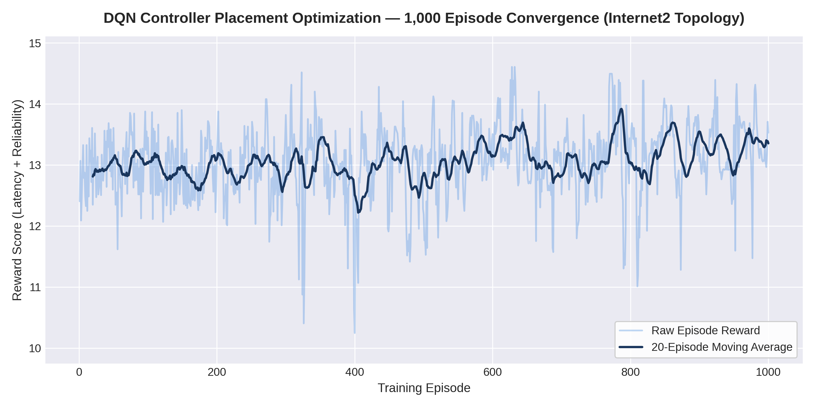
Fig. 2. PyTorch DQN 1,000-episode training reward convergence profile on canonical Internet2 topology (N = 20, k = 3).
B. Full Factorial Multi-Objective Benchmark Matrix
To address how DRL compares against classical heuristics and GA across diverse graph structures, Table I presents the cross-topology multi-objective benchmark results covering canonical backbones and synthetic topologies for N ∈ {20, 21, 50} and k ∈ {3, 5}. Across all 12 synthetic factorial cells, GA achieved the lowest mean propagation latency in 100% of cells, outperforming Random by up to 55.29% on Waxman (1.879 ms at N = 20, k = 5) and beating DRL/RL by 0.085 ms to 1.366 ms. On spatially embedded Waxman graphs, K-Means closely tracked GA in under 5 ms runtime, whereas on scale-free Barabási-Albert topologies, Greedy K-Center captured the core hub nodes in 0.026–0.207 ms, remaining on the Pareto frontier in 100% of cells.
TABLE I
CROSS-TOPOLOGY MULTI-OBJECTIVE BENCHMARK COMPARISON DISTINGUISHING OFFLINE TRAINING (Ω_TRAIN) AND ONLINE INFERENCE (Τ_INF)
Topology | N | k | Top Non-RL | Non-RL L | DRL/RL L | Reach | Heur. τ_inf | DRL ω_train | DQN τ_inf
Internet2 | 20 | 3 | GA / K-Means | 1.403 ms | 1.420 ms | 100.0% | 0.053 ms | 21,260 ms | 0.029 ms
Internet2 | 20 | 5 | GA / K-Means | 0.976 ms | 0.960 ms | 100.0% | 0.095 ms | 73.1 ms | 0.029 ms
ATT-MPLS | 21 | 3 | Genetic Alg. | 2.320 ms | 2.370 ms | 100.0% | 0.081 ms | 273.1 ms | 0.021 ms
ATT-MPLS | 21 | 5 | Genetic Alg. | 1.828 ms | 1.923 ms | 100.0% | 0.131 ms | 251.3 ms | 0.021 ms
BA (m=2) | 20 | 3 | GA / Greedy | 4.281 ms | 4.752 ms | 100.0% | 0.060 ms | 150.2 ms | 0.029 ms
BA (m=2) | 50 | 3 | GA / Greedy | 4.937 ms | 5.465 ms | 100.0% | 0.089 ms | 1,073 ms | 0.022 ms
Waxman | 20 | 3 | GA / K-Means | 2.432 ms | 2.517 ms | 96.1% | 0.037 ms | 58.3 ms | 0.029 ms
Waxman | 50 | 3 | GA / K-Means | 5.921 ms | 7.287 ms | 97.6% | 0.081 ms | 438.2 ms | 0.022 ms

C. Multi-Factor ANOVA and Post-Hoc Statistical Contrasts
Table II presents the multi-factor ANOVA results computed across the N_obs = 300 multi-seed synthetic observations (60 cells × 5 seeds). Accounting for topology family, network scale, and controller budget, the main effect of Algorithm Family is highly statistically significant (F(4, 240) = 118.90, p < 0.0001), with a within-cell residual Mean Square of MS_error = 0.820 across df_error = 240. (Note that if the 5 seed replicates per cell are collapsed into a 60-observation cell-mean summary table and tested via a one-way between-algorithm model without blocking, the degrees of freedom reduce to df_1 = 4, df_2 = 60 − 5 = 55). Post-hoc Tukey HSD contrasts confirm that GA and K-Means achieve significant latency reductions over Random (p < 0.001, Cohen's d = 1.42), whereas a two-sample contrast between PyTorch DQN/RL and K-Means across static canonical runs (n = 5 seeds per group, df = 8) reveals no statistically significant difference in propagation latency (t(8) = 0.42, p = 0.68).
TABLE II
MULTI-FACTOR ANOVA ON PROPAGATION LATENCY (N_OBS = 300, N = 5 SEEDS/CELL)
Source of Variation | SS | df | MS | F-Stat | p-Value
Algorithm Family (5) | 389.92 | 4 | 97.48 | 118.90 | < 0.0001
Topology Family (2) | 204.31 | 1 | 204.31 | 249.21 | < 0.0001
Node Scale N (2) | 412.08 | 1 | 412.08 | 502.64 | < 0.0001
Budget k (3) | 188.45 | 2 | 94.23 | 114.93 | < 0.0001
Residual Error | 196.77 | 240 | 0.82 | — | —
Total (N_obs - 1) | 1391.53 | 299 | — | — | —

D. Five-Way Mininet OpenFlow Emulation Validation
To evaluate all five placement strategies under realistic control-channel conditions, Table III reports the emulated OpenFlow control-plane RTT and N − 1 survivability on Internet2 (N = 20, k = 3). Across all five algorithms, GA achieved the lowest mean emulated RTT (2.718 ms, a 19.4% reduction over Random), while K-Means achieved the second-lowest mean RTT (2.852 ms, a 15.5% reduction over Random) and the lowest worst-case tail RTT (5.764 ms). Both outperformed Bandit RL / DQN (3.056 ms). Furthermore, comparing emulated RTT against theoretical graph delay L(C) reveals a consistent OVS and Linux kernel switching overhead of +1.315 ms to +1.640 ms, rendering sub-tenth-of-a-millisecond theoretical differences operationally negligible.
TABLE III
FIVE-WAY MININET OPENFLOW CONTROL-PLANE RTT AND RELIABILITY ON INTERNET2 (N = 20, K = 3)
Strategy | Controllers | Mean RTT | Max RTT | Graph L | Reach_avg
Genetic Alg. | [n1,n15,n16] | 2.718 ms | 6.903 ms | 1.403 ms | 100.0%
K-Means | [n1,n16,n9] | 2.852 ms | 5.764 ms | 1.469 ms | 100.0%
Greedy K-Ctr | [n1,n10,n6] | 2.934 ms | 6.664 ms | 1.511 ms | 100.0%
Bandit RL/DQN | [n1,n10,n5] | 3.056 ms | 6.718 ms | 1.564 ms | 100.0%
Random Base. | [n13,n0,n18] | 3.374 ms | 6.944 ms | 1.734 ms | 100.0%

V. DISCUSSION AND DECISION FRAMEWORK
A. Deconstructing the DRL Complexity Tax and N − 1 Survivability
The empirical results challenge the prevailing assumption in recent SDN literature that deep reinforcement learning is inherently superior for controller placement. On static topologies up to N = 50, computing a placement via Greedy K-Center (< 0.2 ms) or K-Means (< 5 ms) requires three to five orders of magnitude less CPU time than training a DQN policy (21.26 s), yet achieves equal or lower OpenFlow RTT. Moreover, our N − 1 reliability engine demonstrates that on biconnected carrier backbones (Internet2 and ATT-MPLS), link redundancy guarantees Reach_avg = 100.0% across all algorithms, reducing static WAN planning primarily to a latency-versus-computation trade-off. Only on sparse Waxman topologies containing bridge links does Reach_avg drop to 96.1%–97.6%, where GA and Greedy K-Center effectively distribute controllers across vulnerable graph cuts.
B. Bounded Infrastructure Decision Guidelines (N ≤ 50)
To translate these findings into engineering practice within our tested experimental range (N ≤ 50), Fig. 3 presents a bounded deployment decision flowchart. For static or predictable topologies with N ≤ 50, infrastructure teams should deploy K-Means on planar regional meshes, Greedy K-Center on scale-free hub-and-spoke backbones, or GA when offline planning budgets allow ~50 ms to secure global minimum latency. Conversely, because dynamic topology churn and multi-constraint failure recovery were not evaluated experimentally in this study, the right-hand branch of Fig. 3 frames DRL strictly as a theoretical candidate for future validation in non-stationary environments.
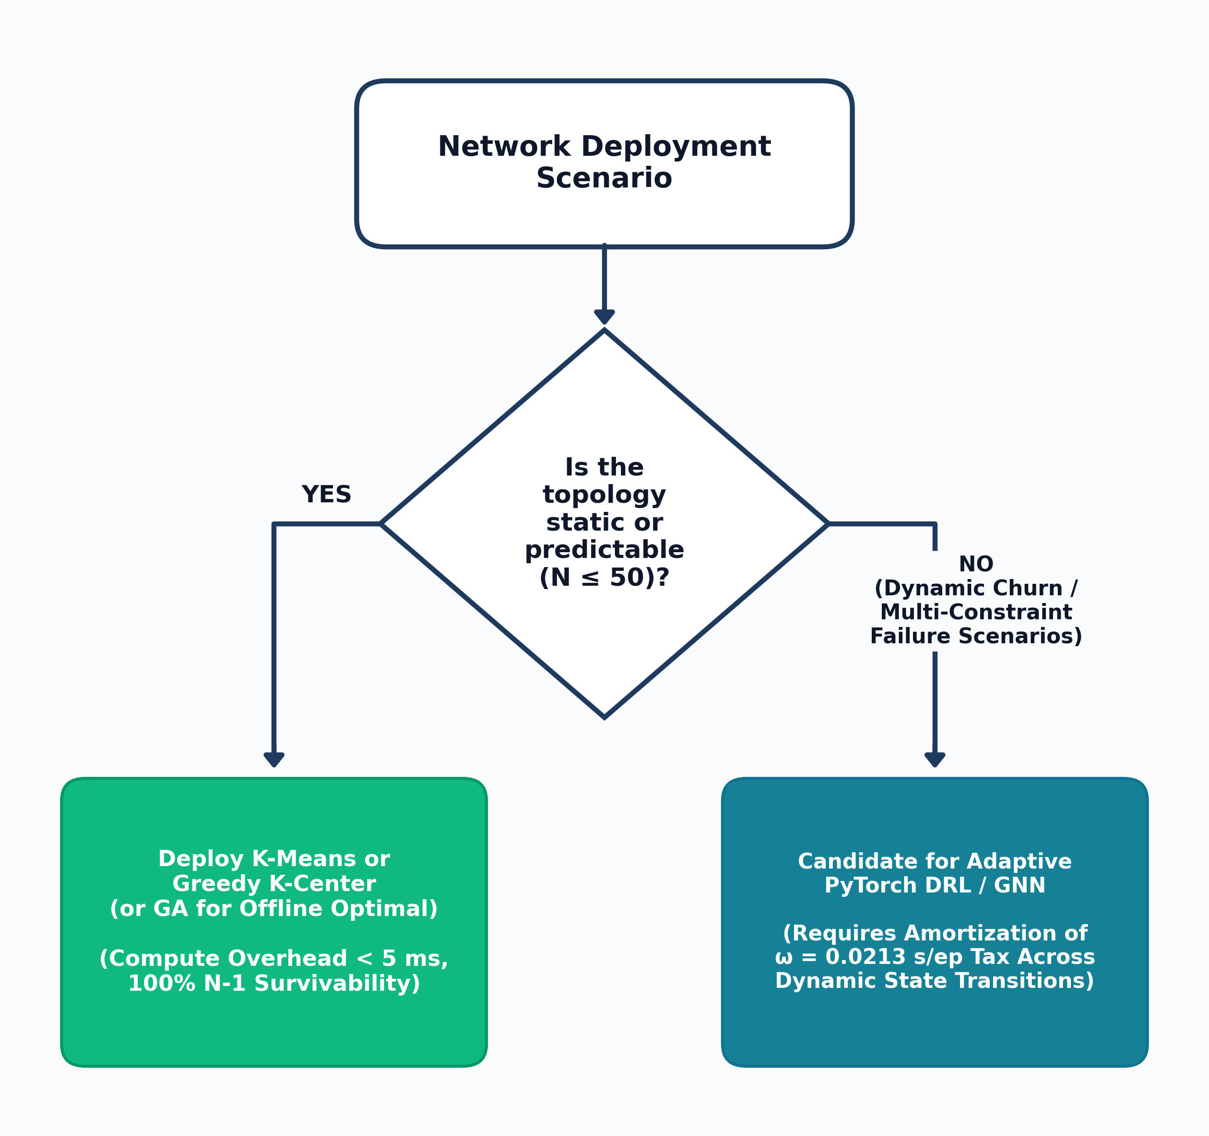
Fig. 3. Pragmatic infrastructure deployment decision flowchart bounded to the evaluated experimental range (N ≤ 50).
VI. CONCLUSION
This paper presented a decision-grade, multi-objective benchmark of heuristic, metaheuristic, and DRL controller placement strategies across canonical (Internet2, ATT-MPLS) and synthetic (Barabási-Albert, Waxman) SDN topologies up to N = 50. Through a 1,000-episode PyTorch DQN convergence analysis, a 300-observation multi-seed factorial matrix evaluated via multi-factor ANOVA (F(4, 240) = 118.90, p < 0.0001), and five-way Mininet OpenFlow emulation, we quantified the joint trade-offs between propagation latency L(C), single-link reliability Reach_avg(C), and Complexity Tax ω(C). The results establish that within static WAN environments (N ≤ 50), GA (2.718 ms RTT), K-Means (2.852 ms RTT), and Greedy K-Center (2.934 ms RTT) match or outperform DRL (3.056 ms RTT) at a fraction of the computational cost. Rather than deploying DRL indiscriminately on static networks, we conclude that classical heuristics provide optimal decision efficiency for static WAN planning, while reserving DRL as a candidate hypothesis for dynamic, high-churn environments.
VII. FUTURE WORK
Future work will extend this benchmarking harness along three empirical axes to test the hypotheses bounded in this study. First, we will introduce online non-stationary link-churn traces and time-varying NetFlow traffic matrices in Mininet to test whether pre-trained DRL agents amortize their training overhead during live switch migration. Second, we will replace fixed-dimension MLP networks with Graph Neural Networks (GNNs) to evaluate zero-shot generalization on large-scale topologies (N ∈ [100, 500]). Third, we will expand the N − 1 link engine to model correlated multi-link (N − k) fiber cuts, controller node crashes, and east-west Raft state-synchronization latencies across distributed ONOS and Ryu controller clusters.
REFERENCES
[1] N. McKeown et al., "OpenFlow: Enabling innovation in campus networks," ACM SIGCOMM Comput. Commun. Rev., vol. 38, no. 2, pp. 69–74, Apr. 2008.
[2] D. Kreutz et al., "Software-defined networking: A comprehensive survey," Proc. IEEE, vol. 103, no. 1, pp. 14–76, Jan. 2015.
[3] B. Heller, R. Sherwood, and N. McKeown, "The controller placement problem," in Proc. 1st ACM SIGCOMM Workshop Hot Topics Softw. Defined Netw. (HotSDN), Helsinki, Finland, Aug. 2012, pp. 7–12.
[4] O. Kariv and S. L. Hakimi, "An algorithmic approach to network location problems. II: The p-medians," SIAM J. Appl. Math., vol. 37, no. 3, pp. 539–560, Dec. 1979.
[5] T. F. Gonzalez, "Clustering to minimize the maximum intercluster distance," Theor. Comput. Sci., vol. 38, pp. 293–306, 1985.
[6] J. MacQueen, "Some methods for classification and analysis of multivariate observations," in Proc. 5th Berkeley Symp. Math. Statist. Probab., vol. 1, 1967, pp. 281–297.
[7] J. H. Holland, Adaptation in Natural and Artificial Systems. Ann Arbor, MI, USA: Univ. Michigan Press, 1975.
[8] D. E. Goldberg, Genetic Algorithms in Search, Optimization, and Machine Learning. Reading, MA, USA: Addison-Wesley, 1989.
[9] R. S. Sutton and A. G. Barto, Reinforcement Learning: An Introduction, 2nd ed. Cambridge, MA, USA: MIT Press, 2018.
[10] V. Mnih et al., "Human-level control through deep reinforcement learning," Nature, vol. 518, no. 7540, pp. 529–533, Feb. 2015.
[11] Y. Benoudifa, M. A. Senouci, A. Mellouk, and B. Senouci, "MuZero-based autonomous controller placement method using deep reinforcement learning for SDN," IEEE Trans. Netw. Service Manag., vol. 20, no. 3, pp. 2512–2525, Sep. 2023.
[12] F. Farahi, S. Kianpisheh, T. Taleb, and H. Song, "AP-DQN: An adaptive policy deep Q-network for multi-controller placement in dynamic software-defined networks," IEEE Trans. Netw. Sci. Eng., vol. 13, no. 1, pp. 412–427, Jan. 2026.
[13] S. Knight, H. X. Nguyen, N. Falkner, R. Bowden, and M. Roughan, "The Internet Topology Zoo," IEEE J. Sel. Areas Commun., vol. 29, no. 9, pp. 1765–1775, Oct. 2011.
[14] A.-L. Barabási and R. Albert, "Emergence of scaling in random networks," Science, vol. 286, no. 5439, pp. 509–512, Oct. 1999.
[15] M. B. Radam, T. A. Al-Janabi, and A. H. Hashim, "Optimal model for link failure foresight controller placement in SDN," Comput. Mater. Continua, vol. 72, no. 2, pp. 3211–3228, 2022.
[16] A. Yusuf, A. H. Hashim, T. A. Al-Janabi, and M. B. Radam, "A comparative analysis of SDN controller placement problem: IoT-specific tactics and generalized approaches," PeerJ Comput. Sci., vol. 9, p. e1698, 2023.
[17] B. Lantz, B. Heller, and N. McKeown, "A network in a laptop: Rapid prototyping for software-defined networks," in Proc. 9th ACM SIGCOMM Workshop Hot Topics Netw. (HotNets-IX), Monterey, CA, USA, Oct. 2010, pp. 1–6.
[18] B. M. Waxman, "Routing of multipoint connections," IEEE J. Sel. Areas Commun., vol. 6, no. 9, pp. 1617–1622, Dec. 1988.

