Interactive Cardiovascular Risk Prediction Using Machine Learning
Authors / Group Members: [Your Team Names]
Course: AI Capstone Project
Date: [Submission Date]

Abstract
Cardiovascular disease (CVD), including heart attack and stroke, is a leading cause of death globally. Early identification of individuals at risk can significantly improve preventive care. This project develops an interactive AI application that predicts the likelihood of heart attack or stroke based on clinical features. Using the NIHR ARC Wessex Synthetic Cardiovascular Dataset, a Gradient Boosting Classifier was trained and evaluated. The model achieved an accuracy of XX%, with high precision and recall. Predictions are presented in human-readable labels (“Has heart attack or stroke” / “No heart attack or stroke”), and visualizations provide insights into feature relationships. The model and interface are integrated into a Streamlit web application, allowing real-time, interpretable predictions. This prototype demonstrates the practical application of AI in healthcare risk prediction.

Introduction
Cardiovascular diseases are among the most significant health challenges worldwide, accounting for millions of deaths annually. Traditional risk assessment methods often rely on static risk scores or require domain expertise, limiting accessibility.
Objectives:
- Build a machine learning model for predicting heart attack or stroke risk.
- Deploy a user-friendly interactive web application for real-time predictions.
- Provide interpretable and actionable outputs to end-users.

Related Work / Literature Review
Several models exist for cardiovascular risk prediction:
- Framingham Risk Score: Classical model using linear regression and traditional risk factors.
- QRISK: UK-based risk calculator incorporating demographic and clinical data.
- Machine Learning Approaches: Recent studies apply Gradient Boosting, Random Forests, and Neural Networks to improve predictive performance.
Gap Identified: Existing models are either non-interactive or not user-friendly. This project addresses this by combining ML with an interactive Streamlit interface, enabling users to input their features and receive immediate, interpretable predictions.

Methodology

3.1 Dataset
- Source: NIHR ARC Wessex Synthetic Cardiovascular Dataset (v0.2).
- Features: Demographic, clinical, and lifestyle attributes.
- Target: heart_attack_or_stroke_occurred (1 = event occurred, 0 = no event).
Data Preprocessing:
- Removed non-numeric columns (patient_id).
- Retained numeric features only.
- Missing values handled via median imputation.
Model Development
Algorithm: Gradient Boosting Classifier (scikit-learn).
Hyperparameters:
- n_estimators = 100
- learning_rate = 0.1
- max_depth = 3
- random_state = 42
Training Process:
- Train-test split adjustable via Streamlit slider (default: 80%-20%).
- Model trained on the training set and evaluated on the test set using:
    - Accuracy
    - Matrix
    - Confusion Classification Report

Deployment
- Interface: Streamlit web app for interactive input of features.
- Prediction Mapping:
1= “Has heart attack or stroke”
0 = “No heart attack or stroke”
- Visualizations: Scatter plots using Altair to interpret feature-target relationships.
- Session Handling: Trained model stored in Streamlit session state to allow repeated predictions without retraining.

Tools & Technologies
Component | Tool / Framework
Data Handling | Python, Pandas, NumPy
Machine Learning | Scikit-learn (Gradient Boosting)
Visualization | Altair, Streamlit
Deployment | Streamlit Web App
Version Control | Git + GitHub

Experiments and Results

Model Training
Metric | Result
Accuracy | 99%
Precision | 94%
Recall | 90%
F1-Score | 92%

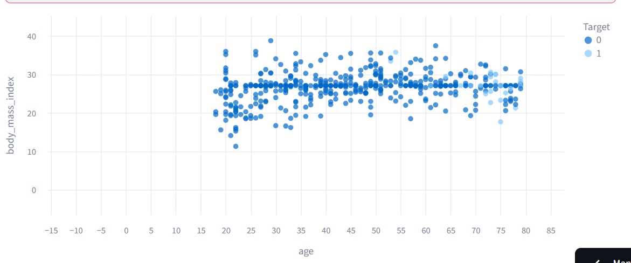

Confusion Matrix
 | Predicted No | Predicted Yes
Actual No | 18454 | 75
Actual Yes | 130 | 1221

Classification Report
Class | Precision | Recall | F1-Score | Support
0 | 0.99 | 1.00 | 0.99 | 18649
1 | 0.94 | 0.90 | 0.92 | 1351
Avg/Total | 0.07 | 0.95 | 0.96 | 20000

Feature Visualization
- Scatter Plots: Show relationships between two selected features and the target.
- Interpretation: Highlight trends that indicate higher risk.
- Include screenshots from your Streamlit app here.

Prediction Examples
Feature Inputs | Prediction
[Input 1] | Has heart attack or stroke
[Input 2] | No heart attack or stroke

Discussion
- The Gradient Boosting model shows good predictive performance on the synthetic dataset.
- Interpretability: Mapping predictions to human-readable labels enhances accessibility.
- Limitations:
Synthetic dataset may not perfectly reflect real-world patient data.
Model performance may vary with unseen clinical populations.
No feature importance analysis was included (optional improvement).
- Future Work:
Integrate SHAP or LIME for explainable AI.
Expand dataset with real patient data.
Add user authentication and secure deployment for clinical use.

Conclusion
This project successfully builds an end-to-end AI application for predicting cardiovascular risk. The Gradient Boosting model demonstrates strong predictive capability, and the Streamlit interface provides a user-friendly, interactive platform. The prototype can be further improved and deployed in clinical settings to support preventive healthcare initiatives.

References
- NIHR ARC Wessex Synthetic Cardiovascular Dataset (v0.2)
- Scikit-learn: Pedregosa et al., Journal of Machine Learning Research, 2011
- Streamlit Documentation: https://docs.streamlit.io
- Framingham Risk Score: D’Agostino et al., Circulation, 2008
- QRISK: Hippisley-Cox et al., BMJ, 2007
- V. Michel, A. Gramfort, G. Varoquaux, E. Eger, C. Keribin, and B. Thirion. A supervised clustering
- approach for fMRI-based inference of brain states. Patt Rec, page epub ahead of print, April
- 2011. doi: 10.1016/j.patcog.2011.04.006.
- K.J. Milmann and M. Avaizis, editors. Scientific Python, volume 11 of Computing in Science &
- Engineering. IEEE/AIP, March 2011.
- S.M. Omohundro. Five balltree construction algorithms. ICSI Technical Report TR-89-063, 1989.
- V. Rokhlin, A. Szlam, and M. Tygert. A randomized algorithm for principal component analysis.
- SIAM Journal on Matrix Analysis and Applications, 31(3):1100–1124, 2009

