Test document

Here is an example chart:

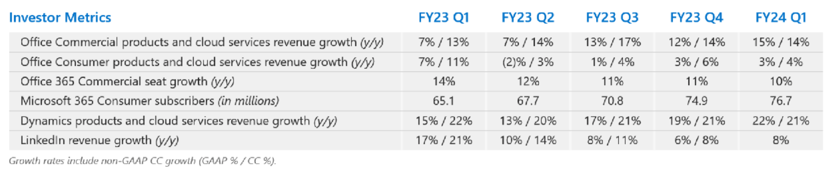

Done.