Crowdsource To Start

**"Agile Development and User-Centered Design - Volunteers Needed"**

Cambria brought together a multidisciplinary team using straightforward crowdsourcing methods. This involved a mass email to all employees defining the task of developing a prototype led by multidisciplinary team utilizing agile processes. This was an exciting challenge that we knew would spark the interest of many of our employees and the approach requirements of the assignment were consistent with Cambria's core values of people-centeredness. We requested volunteers within the firm and defined the roles we were seeking.

*EMAIL:* ***Agile Development and User-Centered Design - Volunteers Needed***

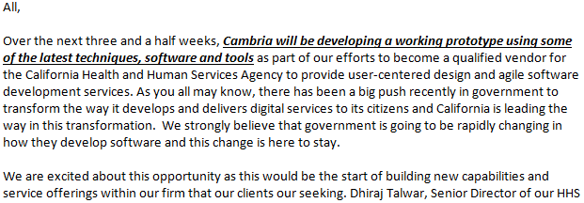......

*The original call to action*

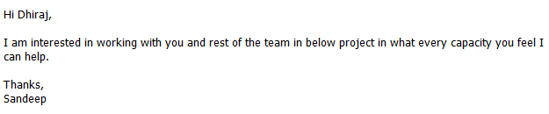

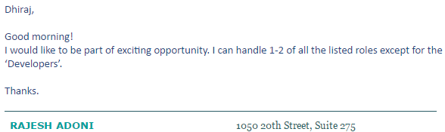

*A few of the responses we received*

