Class diagram
Shows the main classes and how they connect.
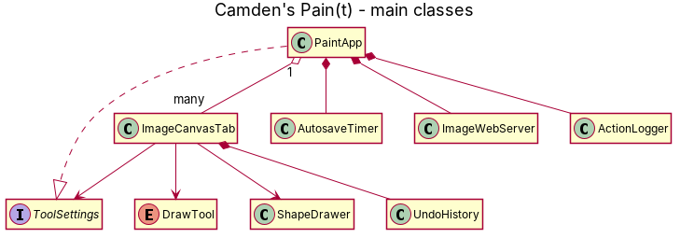

Activity diagram
Shows the steps of Save As.
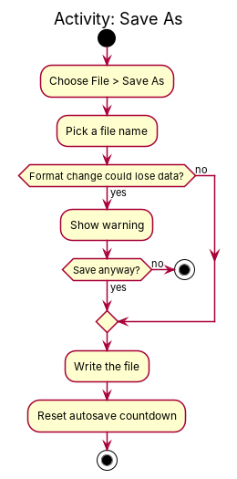

Sequence diagram
Shows how a log line moves from the program to the log file.
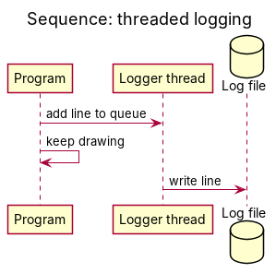

State diagram
Shows the states of the Select tool.


