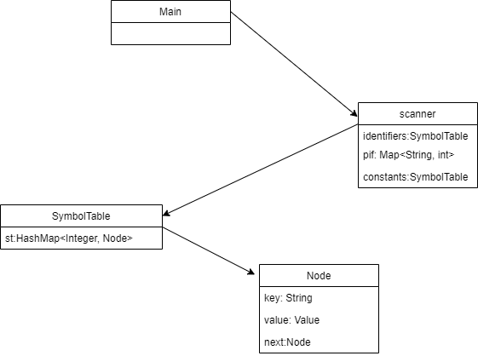

<https://github.com/CameliaZalum/lftc>

Documentation is in the repository.