# 实验三(Guide)

## 任务一：创建并运行内核线程（15min）

源码参考了优秀的指导书

kthread.c

#*include* <*linux/kthread.h*>

#*include* <*linux/module.h*>

#*include* <*linux/delay.h*>

MODULE_LICENSE("*GPL*");

#*define* BUF_SIZE 20

*static* *struct* task_struct *\**myThread = *NULL*;

*static* *int* print(*void* *\*data*)

{

*while*(!kthread_should_stop()){

    printk("*New kthread is running.*");

    msleep(2000);

  }

*return* 0;

}

*static* *int* __init kthread_init(*void*)

{

  printk("*Create kernel thread!\n*");

  myThread = kthread_run(print, *NULL*, "*new_kthread*");

*return* 0;

}

*static* *void* __exit kthread_exit(*void*)

{

  printk("*Kill new kthread.\n*");

*if*(myThread)

    kthread_stop(myThread);

}

module_init(kthread_init);

module_exit(kthread_exit);

Makefile

*ifneq* ($(*KERNELRELEASE*),)

  obj-m := kthread.o

*else*

  KERNELDIR ?= /root/raspberrypi-kernel

  PWD := $(*shell pwd*)

default:

  $(*MAKE*) -C $(*KERNELDIR*) M=$(*PWD*) modules

*endif*

.PHONY:clean

clean:

*-*rm *.mod.c *.o *.order *.symvers *.ko

Make编译

获取到.ko文件

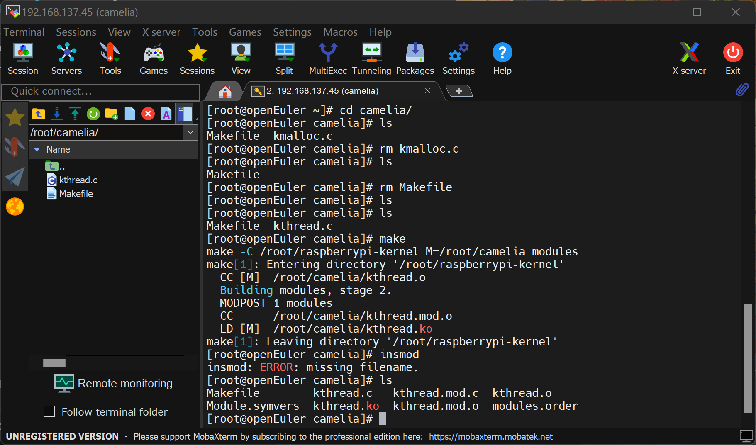

模块加载进内核insmod kthread.ko

查看加载内容 -- 创建新内核线程（第一项输出是上次没清除的）

卸载内核模块 再度查看内容 成功在模块退出时杀死线程

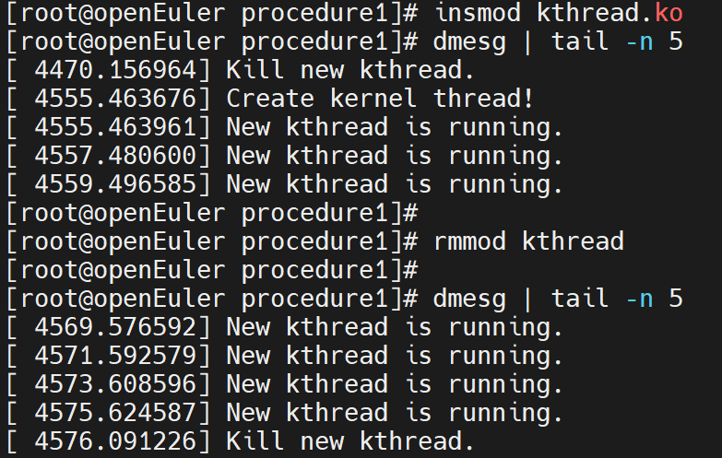

lsmod查看内核模块（加载与卸载模块前后对比图）

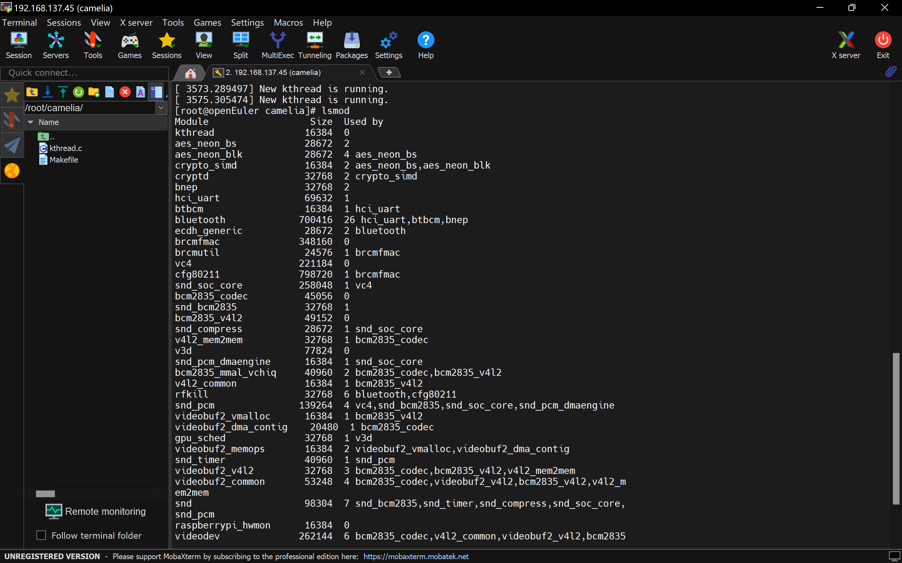

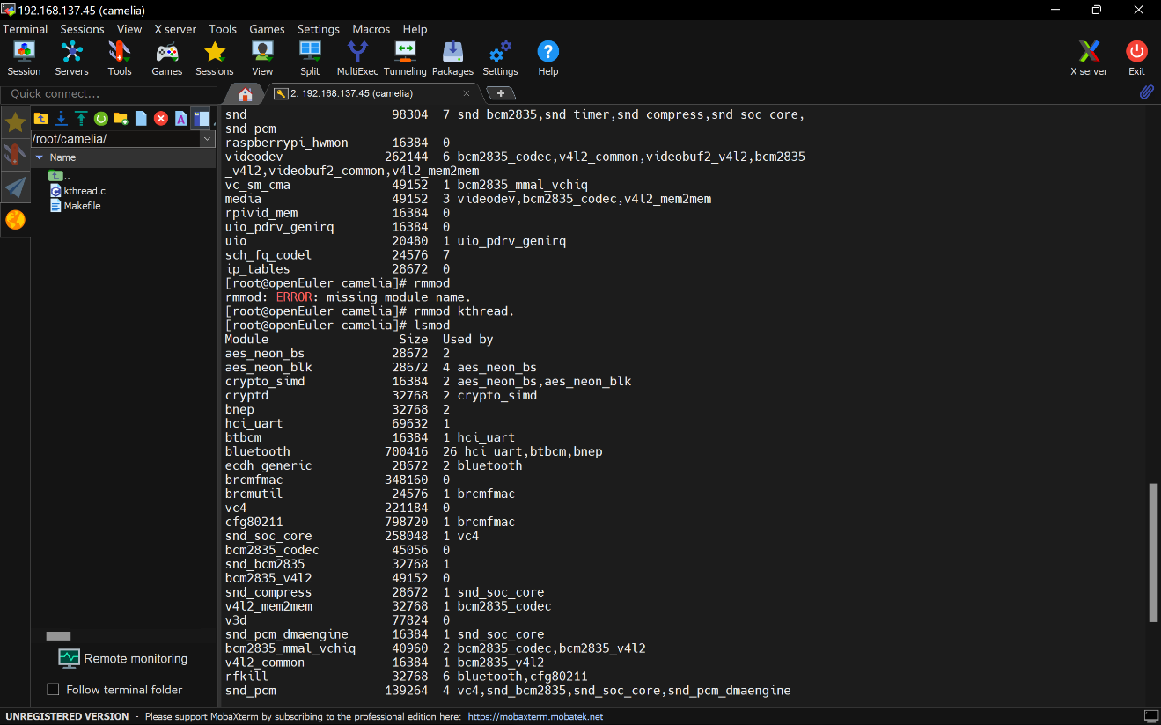

最终文件结构：

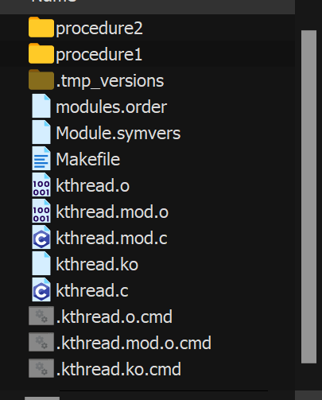

## 任务二：打印输出当前系统 CPU 负载情况

后续过程与任务一基本一致，不再赘述，仅提供源码与内核功能展示。

cpu_loadavg.c

#*include* <*linux/module.h*>

#*include* <*linux/fs.h*>

MODULE_LICENSE("*GPL*");

*char* tmp_cpu_load[5] = {'*\0*'};

*static* *int* get_loadavg(*void*)

{

*struct* file *\**fp_cpu;

  loff_t pos = 0;

*char* buf_cpu[10];

  fp_cpu = filp_open("*/proc/loadavg*", O_RDONLY, 0);

*if* (IS_ERR(fp_cpu)){

    printk("*Failed to open loadavg file!\n*");

*return* *-*1;

  }

  kernel_read(fp_cpu, buf_cpu, *sizeof*(buf_cpu), *&*pos);

  strncpy(tmp_cpu_load, buf_cpu, 4);

  filp_close(fp_cpu, *NULL*);

*return* 0;

}

*static* *int* __init cpu_loadavg_init(*void*)

{

  printk("*Start cpu_loadavg!\n*");

*if*(0 != get_loadavg()){

    printk("*Failed to read loadarvg file!\n*");

*return* *-*1;

  }

  printk("*The cpu loadavg in one minute is: %s\n*", tmp_cpu_load);

*return* 0;

}

*static* *void* __exit cpu_loadavg_exit(*void*)

{

  printk("*Exit cpu_loadavg!\n*");

}

module_init(cpu_loadavg_init);

module_exit(*cpu_loadavg_exit*);

Makefile

*ifneq* ($(*KERNELRELEASE*),)

  obj-m := cpu_loadavg.o

*else*

  KERNELDIR ?= /root/raspberrypi-kernel

  PWD := $(*shell pwd*)

default:

  $(*MAKE*) -C $(*KERNELDIR*) M=$(*PWD*) modules

*endif*

.PHONY:clean

clean:

*-*rm *.mod.c *.o *.order *.symvers *.ko

两张分别为加载后与退出后

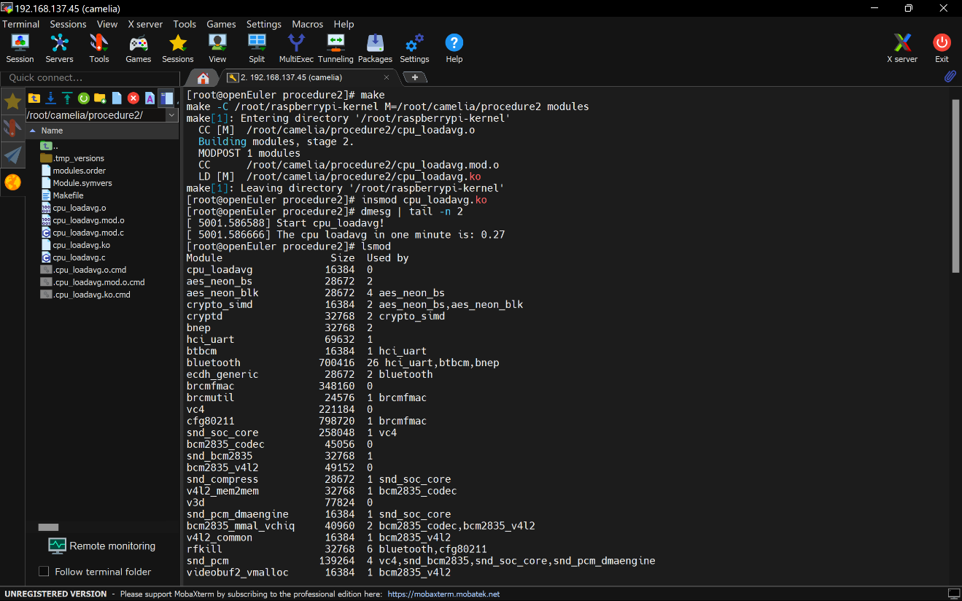

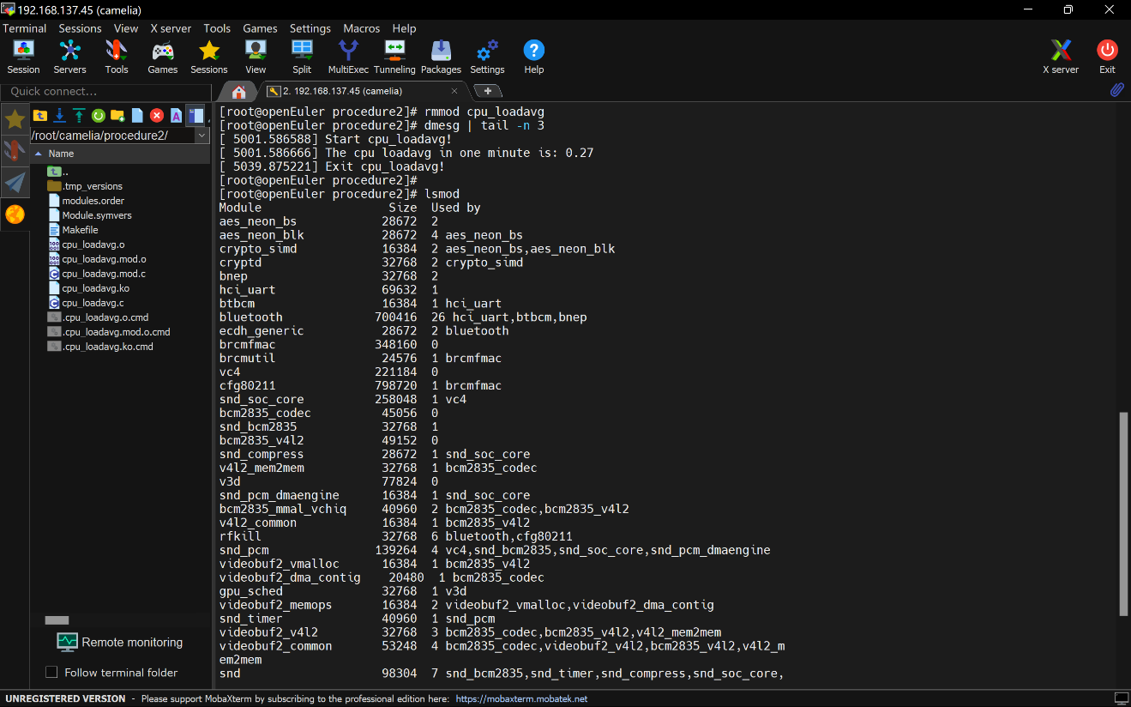

### 任务三：打印输出当前处于运行状态的进程的 PID 和名字

process_info.c

#*include* <*linux/module.h*>

#*include* <*linux/sched/signal.h*>

#*include* <*linux/sched.h*>

MODULE_LICENSE("*GPL*");

*struct* task_struct *\**p;

*static* *int* __init process_info_init(*void*)

{

  printk("*Start process_info!\n*");

  for_each_process(p){

*if*(p->state == 0)

      printk("*1)name:%s  2)pid:%d  3)state:%ld\n*", p->comm, p->pid, p->state);

  }

*return* 0;

}

*static* *void* __exit process_info_exit(*void*)

{

  printk("*Exit process_info!\n*");

}

module_init(process_info_init);

module_exit(*process_info_exit*);

Makefile

*ifneq* ($(*KERNELRELEASE*),)

  obj-m := process_info.o

*else*

  KERNELDIR ?= /root/raspberrypi-kernel

  PWD := $(*shell pwd*)

default:

  $(*MAKE*) -C $(*KERNELDIR*) M=$(*PWD*) modules

*endif*

.PHONY:clean

clean:

*-*rm *.mod.c *.o *.order *.symvers *.ko

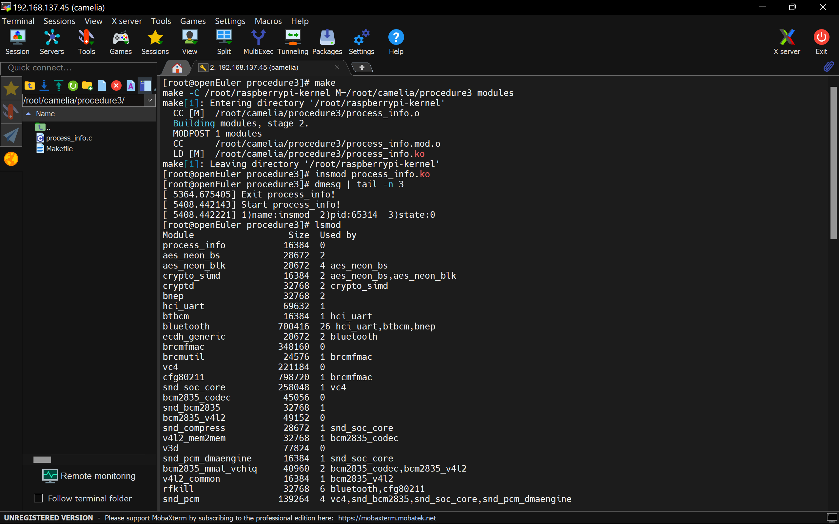

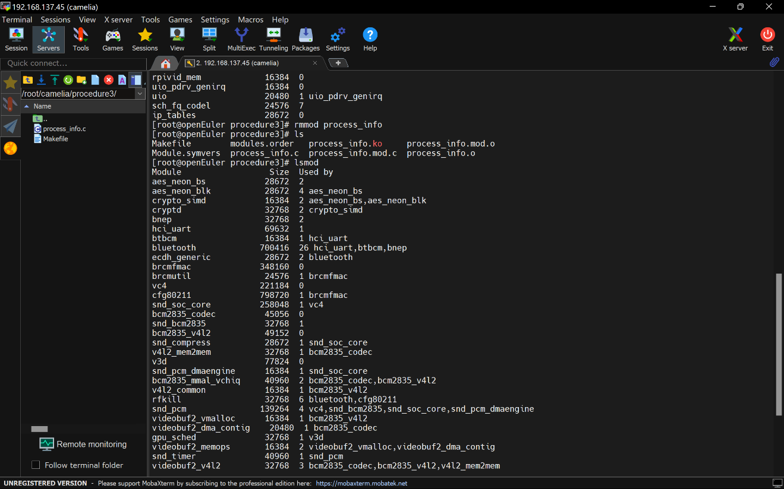

**任务4：使用 cgroup 实现限制 CPU 核数**

见下方流程截图

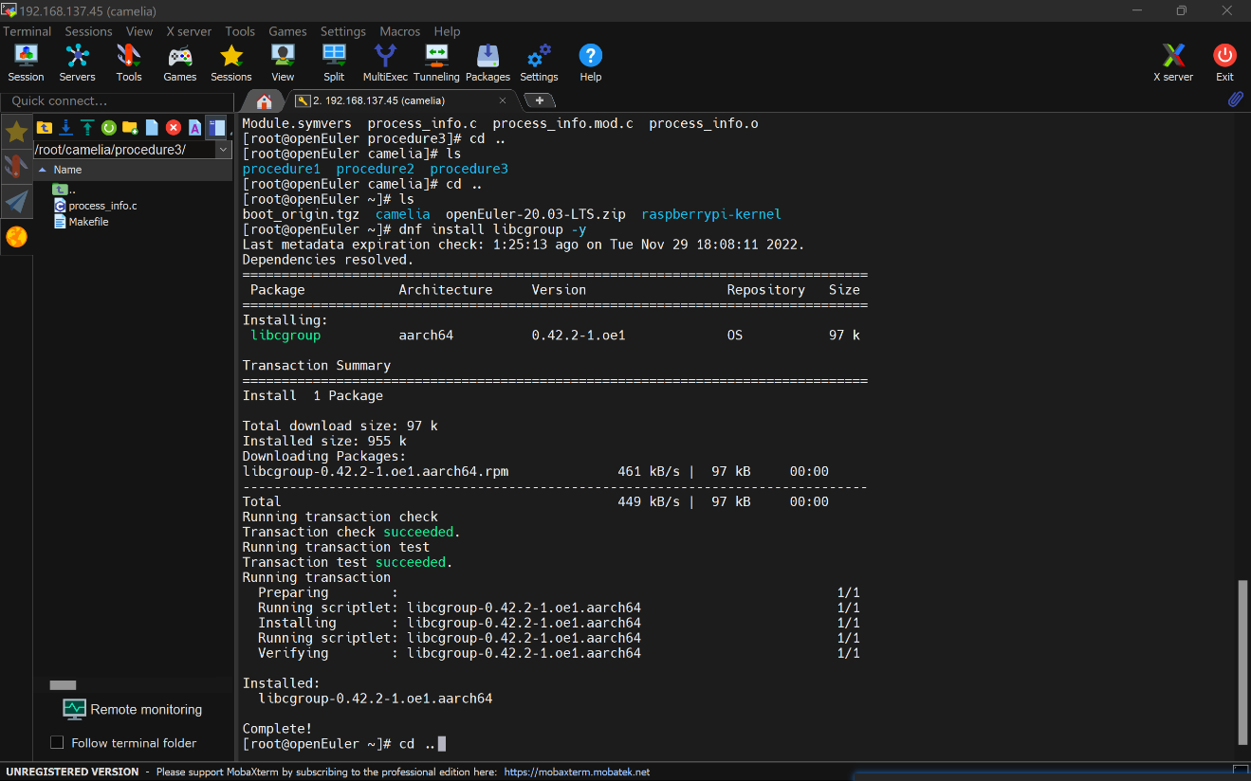

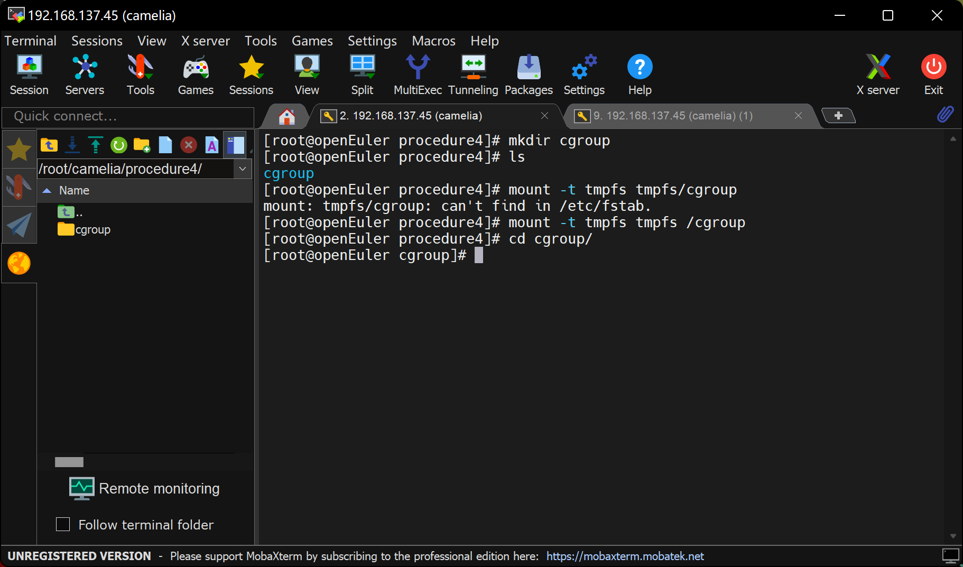

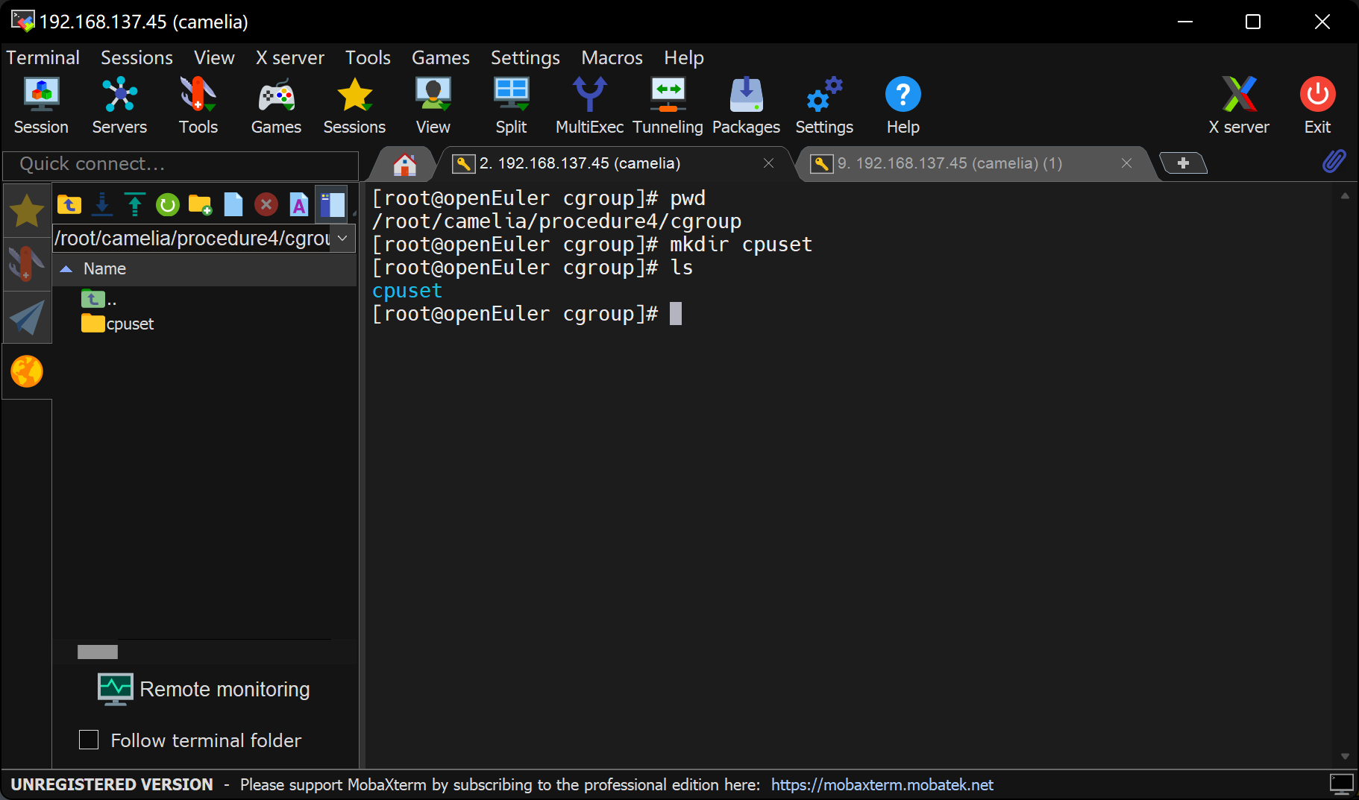

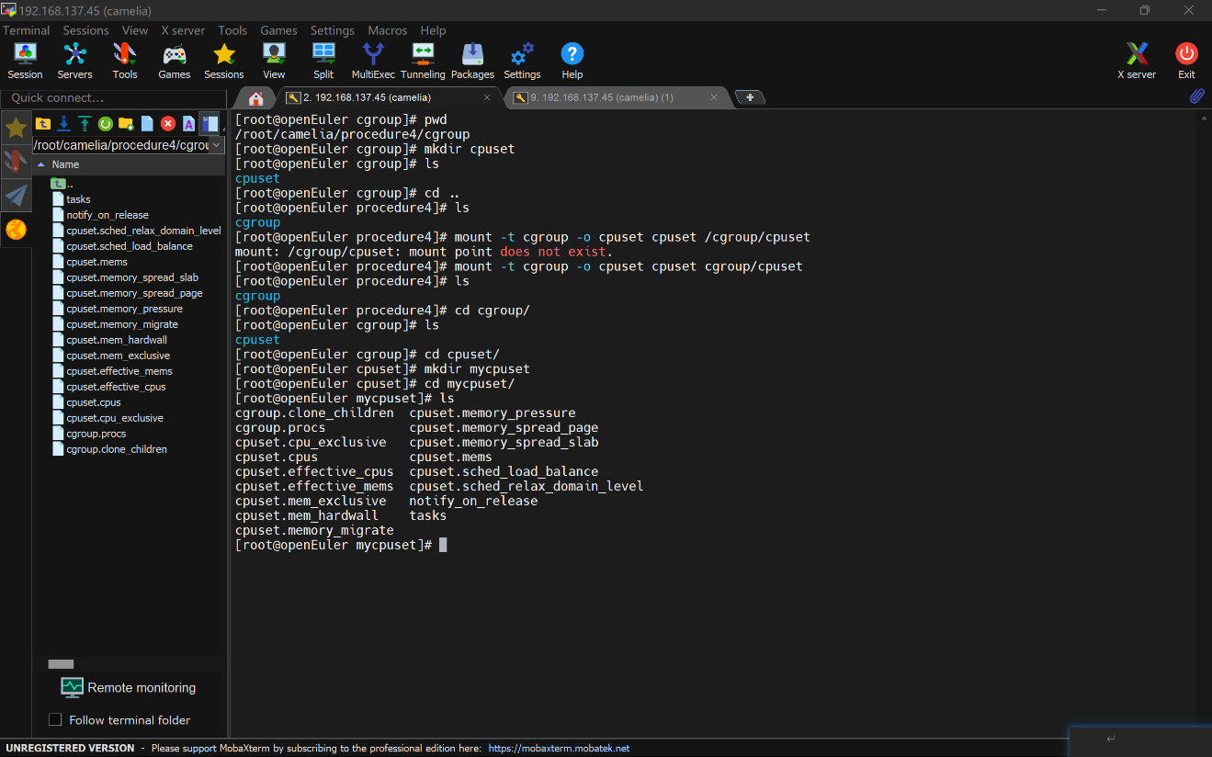

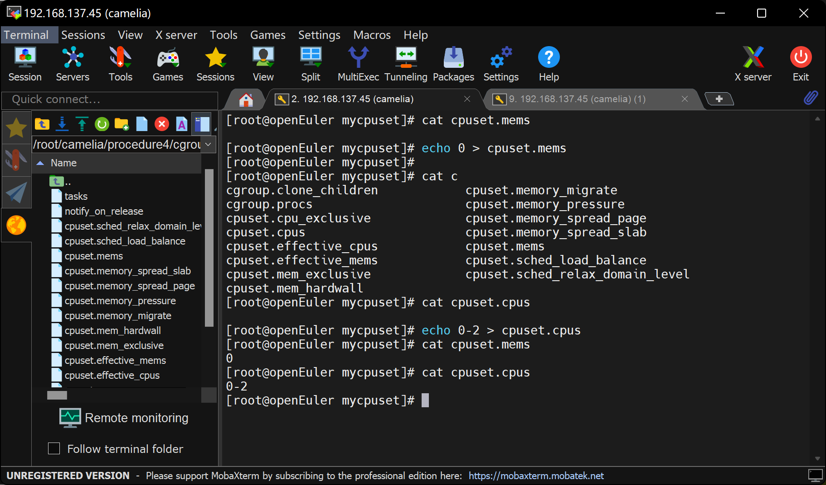

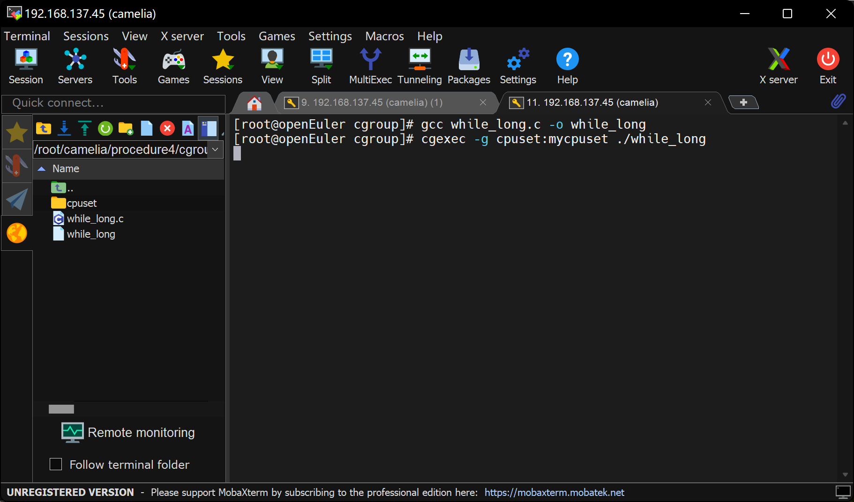

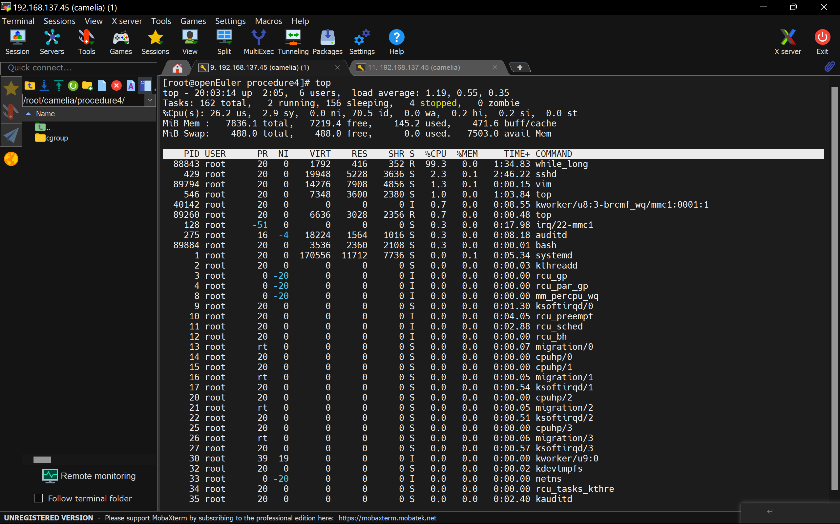

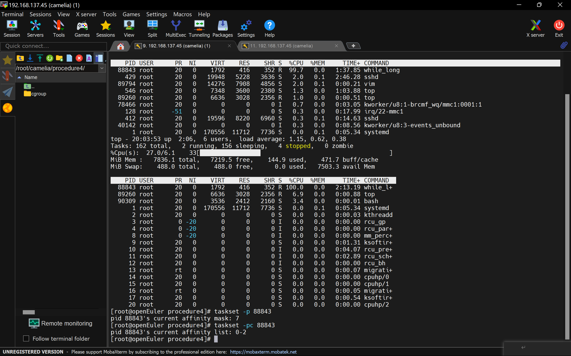

**任务5：使用 cgroup 实现不允许访问U盘**

无法完成

见下方详情

插入U盘

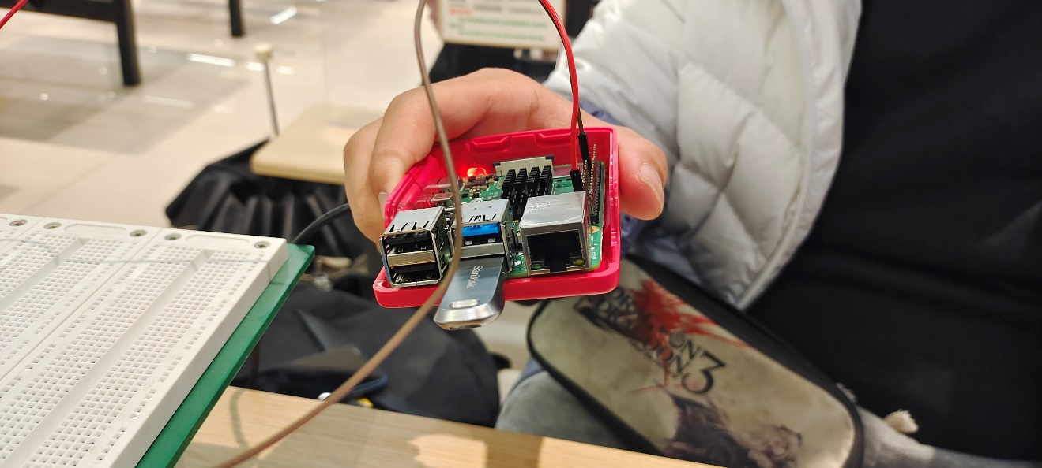

执行命令



得到分区信息，与插入U盘前并无二致

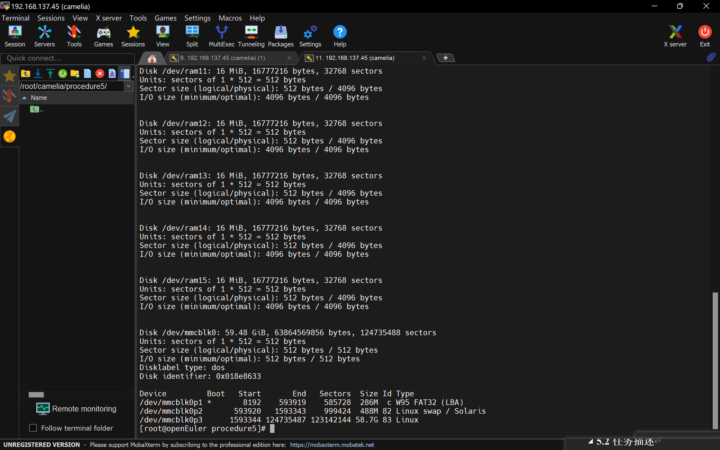

使用lsusb命令查看毫无作用

换U盘，接口亦无作用

据悉为系统对应版本（21.03）驱动所致

