**Assignment Two**

**Report**

-

09020328 Liang Wang

# **First: Sql And Screenshots**

Query1:

*SELECT* pname

*FROM* prof *INNER JOIN* dept *ON* prof.dname = dept.dname

*WHERE* dept.numphds < 50;

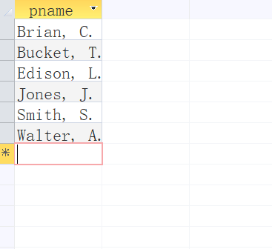

Query2:

*SELECT* student.sname

*FROM* student

*WHERE* (((student.gpa) *IN* (*SELECT* MIN(gpa) *FROM* student)));

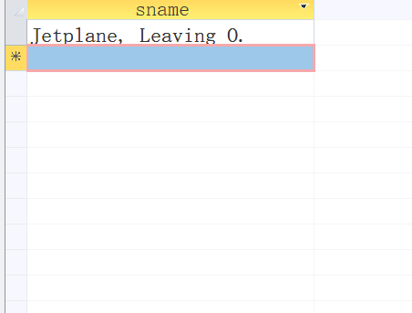

Query3:

*SELECT* enroll.cno, enroll.sectno, AVG(student.gpa) *AS* avg_gpa

*FROM* enroll *INNER JOIN* student *ON* enroll.sid = student.sid

*WHERE* enroll.dname = '*Computer Sciences*'

*GROUP BY* enroll.cno, enroll.sectno;

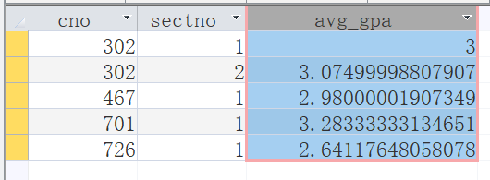

Query4:

*SELECT* n.cname, l.cno, section.sectno

*FROM* (*SELECT* *\** *FROM* (*SELECT* m.cname *FROM* (*SELECT* t.cname, COUNT(t.sid) *AS* [sum] *FROM* (*SELECT* *\** *FROM* enroll *INNER JOIN* course *ON* enroll.cno = course.cno *WHERE* enroll.dname = course.dname)  *AS* t *GROUP BY* t.cname)  *AS* m *WHERE* m.sum < 6)  *AS* n *INNER JOIN* course *ON* n.cname = course.cname)  *AS* l *INNER JOIN* [section] *ON* l.cno = section.cno

*WHERE* l.dname = section.dname;

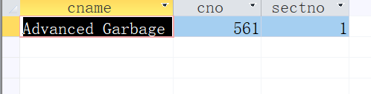

Query5:

*SELECT* *sid*,sname

*FROM* (*SELECT* COUNT(student.sid) *AS* les_par, student.sid, student.sname *FROM* enroll *INNER JOIN* student *ON* enroll.sid = student.sid *GROUP BY* student.sid, student.sname)  *AS* t

*WHERE* t.les_par = ( *SELECT* MAX(les_par) *FROM* (*SELECT* COUNT(student.sid) *as* les_par, student.sid, student.sname *FROM* enroll *INNER JOIN* student *ON* enroll.sid = student.sid *GROUP BY* student.sid, student.sname));

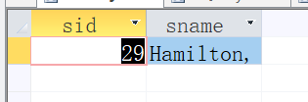

Query6:

*SELECT* dname

*FROM* major *INNER JOIN* student *ON* major.sid = student.sid

*WHERE* student.age < 18;

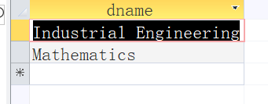

Query7:

*SELECT* student.sname, major.dname

*FROM* ((*SELECT* *\** *FROM* enroll *INNER JOIN* course *ON* course.cno = enroll.cno *WHERE* course.dname = enroll.dname *AND* course.cname *LIKE* '*\*College Geometry\**')  *AS* t *INNER JOIN* student *ON* t.sid = student.sid) *INNER JOIN* major *ON* major.sid = student.sid;

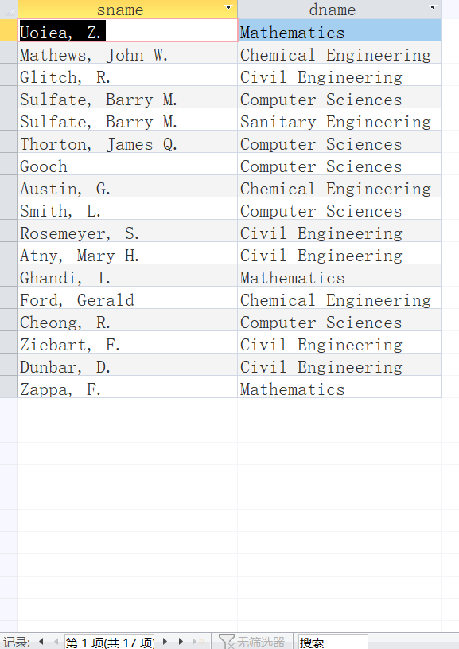

Query8:

*SELECT* dept.dname, dept.numphds

*FROM* dept

*WHERE* dept.dname *NOT* *IN* (*SELECT* major.dname *FROM* ((*SELECT* *\** *FROM* enroll *INNER JOIN* course *ON* course.cno = enroll.cno *WHERE* course.dname = enroll.dname *AND* course.cname *LIKE* '*\*College Geometry\**') t *INNER JOIN* student *ON* t.sid = student.sid) *INNER JOIN* major *ON* major.sid = student.sid);

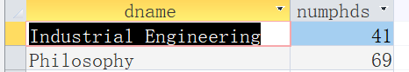

Query9:

*SELECT* student.sname

*FROM* (*SELECT* a.sid *FROM* (

(*SELECT* *\** *FROM* enroll *WHERE* enroll.dname = '*Computer Sciences*') a

*INNER JOIN*

(*SELECT* *\** *FROM* enroll *WHERE* enroll.dname = '*Mathematics*') b

*ON* a.sid = b.sid))  *AS* t *INNER JOIN* student *ON* t.sid = student.sid;

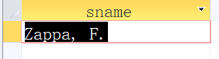

Query10:

*SELECT* Max(student.age)*-*Min(student.age) *AS* diff

*FROM* (*SELECT* *\** *FROM* major *WHERE* major.dname = '*Computer Sciences*')  *AS* t *INNER JOIN* student *ON* t.sid = student.sid;

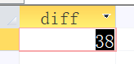

Query11:

*SELECT* major.dname, AVG(student.gpa) *AS* avg_gpa

*FROM* major *INNER JOIN* student *ON* major.sid = student.sid

*WHERE* major.dname *IN* (*SELECT* major.dname *FROM* major *INNER JOIN* student *ON* major.sid = student.sid *WHERE* student.gpa < 1.0)

*GROUP BY* major.dname;

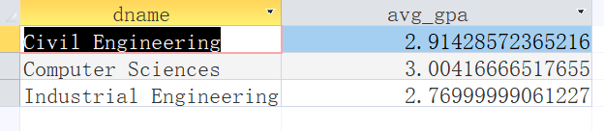

Query12:

*SELECT* student.sid, student.sname, student.gpa

*FROM* (*SELECT* *sid* *FROM* (*SELECT* COUNT(enroll.dname) *AS* num, enroll.sid *FROM* enroll *WHERE* dname = '*Civil Engineering*' *GROUP BY* enroll.sid)  *AS* t *WHERE* t.num *IN* (*SELECT* COUNT(course.dname) *FROM* course *WHERE* course.dname = '*Civil Engineering*'))  *AS* m *INNER JOIN* student *ON* m.sid = student.sid;

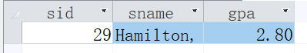

# **Conclusion**

* ~~No deliberation for efficiency provided that they can function well~~
* Sql is quite semantic, seems nothing left to further explain.